Form No. 24
Search for dark sectors in missing energy events
NA-64
CODE OF THEME: 02-1-1096-2010/2022
Universidad Tecnica Federico Santa Maria (UTFSM),Valparaiso, Chile S. Kuleshov, W. K. Brooks, H. Hakobyan, S. Kovalenko, G. Vasquez Arenas, P. Ulloa
Rheinische Friedrich-Wilhelms-Universität Bonn, Germany M. Ball, M. Hösgen, B. Ketzer
Institute for High Energy Physics, Protvino, Russia S.V. Donskov, V.A. Kachanov, Yu.V. Mikhailov, V.A. Poliakov,V.D. Samoylenko, A.P. Filin
Joint Institute for Nuclear Research (JINR), Dubna, Russia LHEP: T.L.Enik, A.A. Feschenko, G.D. Kekelidze, V.Yu. Karjavine, V.А. Kramarenko, V.M. Lysan, D.V. Peshekhonov, A.A. Savenkov,I.A. Zhukov, P.V.Volkov, A.V.Ivanov, V.Е.Burtsev, LNP: V.Frolov, Directorate: V.A. Matveev
P.N. Lebedev Physical Institute of the RAS (LPI), Moscow, Russia V.O. Tikhomirov, K. Zhukov
Institute for Nuclear Research of the RAS (INR), Moscow, Russia A.V. Dermenev, S.N. Gninenko, A.E. Karneyeu, M.M. Kirsanov, N.V. Krasnikov, L.V. Kravchuk, O. Petukhov, I.I. Tkachov, D.A. Tlisov, A.N. Toropin
Tomsk Polytechnic University (TPU), Tomsk, Russia R.R. Dusaev, V.E. Lyubovitsky, A.Yu. Trifonov, B.I. Vasilishin
ETH Zurich, Institute for Particle Physics, Zurich, Switzerland D. Banerjee, D.A. Cooke, P. Crivelli, B. Radics, A. Rubbia

NAMES OF PROJECT LEADER: V.Matveev
NAME OF PROJECT DEPUTY LEADER: D.Peshekhonov
DATE OF SUBMISSION OF PROPOSAL OF PROJECT TO SOD _________
DATE OF THE LABORATORY STC _________ DOCUMENT NUMBER _________
STARTING DATE OF PROJECT _________
(FOR EXTENSION OF PROJECT –– DATE OF ITS FIRST APPROVAL) _________
Form No. 25
PROJECT ENDORSEMENT LIST
Search for dark sectors in missing energy events
NA-64
02-1-1096-2010/2022
Project leader: Victor Matveev

APPROVED BY JINR DIRECTOR | ___________ | _____
ENDORSED BY
JINR VICE-DIRECTOR | ___________ | _____
JINR CHIEF SCIENTIFIC SECRETARY | ___________ | _____
CHIEF ENGINEER | ___________ | _____
HEAD OF SCIENCE ORGANIZATION DEPARTMENT | ___________ | _____
LABORATORY DIRECTOR | ___________ | _____
LABORATORY CHIEF ENGINEER | ___________ | _____
PROJECT LEADER | ___________ | _____
PROJECT DEPUTY LEADERS | ___________ | _____
ENDORSED
RESPECTIVE PAC | ___________ | _____

Form №26
Suggested time-table and resources necessary for realization of the Project

Search for light dark matter at the SPS CERN
 | Units of measure | Resource requirements for 2020-2022 | Laboratory resources
 |  |  | 1st year | 2nd year | 3rd year
Basic units and equipment: | Gas system, electronics (FEE), DAQ, detectors
Required recourses:  а) ООЭП of the Laboratory  б) Design department of the laboratory | standard hour standard hour
в) Accelerator  г) Reactor  д) Computer | hour  hour  hour
Operating costs | thousand US$
Funding source:  Budget expenditures  Including foreign funds | thousand US$  thousand US$ | 360  105 | 145  50 | 130  45 | 85  10
Contributions of collaborators  Grant contributions (INTAS+МНТЦ)  Contributions of sponsors  Contributions according agreements  Other sources | thousand US$  thousand US$  thousand US$  thousand US$  thousand US$
PROJECT LEADER

Form № 29

Estimated expenditures on the Project NA-64 “Search for dark sectors in missing energy events”
 | Expenditure items | Full cost | 1st year | 2nd year | 3rd year…
 | Direct expenses for the Project
6. | Materials | 145k$  common funds | 45  15 | 45  15 | 10  15
7. | Equipment | 95k$ | 45 | 30 | 30
8. | Construction/repair of premises | k$
9. | Payments for agreement-based research | k$
10. | Travel allowance, including:  a) non-rouble zone countries  b) rouble zone countries  c) protocol-based | 120k$ | 40 | 40 | 40
 | Total direct expenses  * including Belarus contribution | 360  105* | 145  50* | 130  45* | 85  10*

PROJECT LEADER V.A.Matveev
LABORATORY DIRECTOR V.D.Kekelidze
LABORATORY CHIEF ENGINEER-ECONOMIST G.G.Volkova

Introduction
One of the biggest puzzles in physics is that 85% of the matter in our universe is “dark”: it does not interact with the photons of the conventional electromagnetic force and is therefore invisible to our eyes and telescopes.
Several models of dark matter suggest the existence of dark sectors consisting of SU(3)_{C} x SU(2)_{L} x U(1)_{Y} singlet fields. These sectors of particles do not interact with the ordinary matter directly but could couple to it via gravity. In addition to gravity, there might be another very weak interaction between the ordinary and dark matter mediated by U'(1) gauge bosons A' (dark photons) mixing with our photons. In a class of models the corresponding dark gauge bosons could be light and have the γ-A' coupling strength laying in the experimentally accessible and theoretically interesting region. If such A' mediators exist, their di-electron decays A' → e+e- could be searched for in a light-shining-through-a-wall experiment looking for an excess of events with the two-shower signature generated by a single high energy electron in the detector. Our experiment aims to probe the still unexplored area of the mixing strength 10⁻⁵ < ε < 10⁻³ and masses M_{A'} < 100 MeV by using 50-150 GeV electron beams from the CERN SPS.

What project adds to the international scenario
NA-64 is a fixed-target experiment at the CERN SPS utilizing the active beam dump combined with the missing energy approach for the searches of invisible decays of dark photons (A') with the mixing strength 10⁻⁵ < ε < 10⁻³ and masses M_{A'} < 100 MeV, invisible decays of (pseudo)scalar mesons, in particular K_S , K_L -> invisible, and hadron and muon interactions resulting in invisible final states due to production of new penetrating particles. The experimental signature of this process –has never been experimentally tested before.
The advantage of our approach is that the sensitivity (or number of signal events) of the experiment is roughly proportional to the Z' couplig squared ε^2, associated with the Z' production in the primary interaction in the target. While in a classical beam dump experiment, it is proportional to ε^4, one ε^2 came from the Z' production, and another ε^2 is either from the probability of Z' decays or their interactions in a detector located at a large distance from the beam dump. The sensitivities of these two methods depend on the region under study in the (ε^2 ; m_Z') parameter space, background level for a particular process, available beam intensity, etc. In some cases, much less running time and primary beam intensity are required to observe a signal event with our approach.

JINR group responsibilities and activities

The JINR group is responsible for the tracking sub-system: coordinate detectors based on the thin-wall drift tubes (straw tubes).
- Documentation on the manufacturing of double-layer straw tube (2 and 6 mm diameters) chambers
with 20x20 cm² working area were developed;
- 6 frames for 2mm and 8 frames for 6mm straw tube chambers were manufactured;
- developed documentation on the read-out from both type of chambers (2mm and 6mm, 96 channels and 64 channels);
- manufactured 600 6mm straw tubes and 800 2mm straw tubes;
- all chambers were assembled, equipped and successfully tested with ion sources and with a real beam;
- prepared on-line monitor and visualization for the straw tube chambers, decoding and data acquisition software, chambers included in the NA-64 data-base;
- straw tube chambers described and included in the MC and reconstruction software of NA-64 experiment;
- JINR team participated in 3 NA-64 data taking runs as a responsible for the straw tube chambers.

Experiment status (report & plans)
During the runs in years 2016-2018 the NA64 collected data for search of A´ through the invisible decay mode. The data taking was carried out in an electron beam with the intensity of up to 10⁷ particles per spill with the duration of 4.8 seconds and particle energy of 100 GeV.
The data from years 2016 and 2017 have been processed and published, the total statistics is ~10¹¹ events, candidates for the signal corresponding to the signature of the dark photon have not been detected. Part of the year 2017 run was devoted to the search for a new hypothetical X-boson with the mass of 16.7 MeV, the existence of which could explain the result on the anomalous production of e⁺e ⁻ pairs in the decay of the excited state ⁸Be* obtained in the ATOMKI experiment. 5.4x10¹⁰ events were taken, hypothetical boson was not found, obtained data allowed to significantly increase the limit on the coupling constant of the X-boson with an electron, as well as on the mixing parameter of the A´ with the conventional photon.
During the run in 2018 an amount of 2х10¹¹ events were taken in a search for the invisible mode and 3х10¹⁰ - for the visible one, data are being analyzed. The same year a permanent experimental zone at CERN on the H4 channel was allocated for the experiment. Preparatory works on its arrangement started. The facility should be upgraded for more efficient operation with a high beam intensity and be prepared for the 2021 run, during which it is planned to increase significantly the statistics by registering more than 5x10¹¹ events for further searches for A´ and X-boson decays. 7 new 6mm double layers chambers 1200x600 mm² have to be produced and equipped by the 2021 run.
The NA64 research program is not limited to the data taking with electron beam. Currently, the collaboration is preparing a proposal for the measurements at the muon channel of the SPS accelerator, which could make a significant contribution to the solution of the (g-2)_{μ} problem of the anomalous magnetic moment of the muon. A test run might be carried out at the end of 2021, or the beginning of 2022.
In frame of the extending program with electron beam and preparation to the data taking with muon beam we plan to start development of new large area straw tube chambers, provide R&D with cosmic and ion-sources aimed on the improvement of the chamber characteristics, tests of electronics and DAQ modernization, take part in data analysis and MC simulation.
Publications during 2017-2019:

Search for invisible decays of sub-GeV dark photons in missing-energy events at the CERN SPS, NA64, Phys. Rev. Lett. 118 (2017) 011802

Search for vector mediator of Dark Matter production in invisible decay mode, NA64 collaboration, Phys.Rev. D 97 (2018) 072002;
- JINR team publication «Строу-камеры для эксперимента NA64» Письма в ЭЧАЯ, 2019.Т.16, №6(225), с.627-642
- NA64 Collaboration «Dark matter search in missing energy events with NA64», CERN-EP-2019-166
- NA64 Collaboration «Search for a new X(16.7) boson and dark photons in the NA64 experiment at CERN», CERN-EP-2019-284
FTE of the JINR group
FTE of the participants and FTE/number_of_participants_ratio were optimized/improved. In our initial document we had 4,7/13 FTE/number_of participants, while in the present version we came to 7,5/14
We attract 4 new young researches and now have 6 totally (instead of 3 in the initial document). All they are potential PhD students in NA64 data analysis, electronic & detector development. The contribution of the young researchers is 3,5 FTE.

SWOT analysis: no visible risks

Short project description
Search for the decay A’ → invisible
The interaction between γ's and A's is given by a kinetic mixing [1, 3, 4]:L_{int}= - ½ ε F_{μν} A'^{μν}, where F_{μν},A'^{μν} are the ordinary and the dark photon fields, respectively, and parameter ε is their mixing strength. The diagram for production of A' in the reaction e⁻ Z → e⁻ Z A', A’ → invisible is shown in Fig. 1.
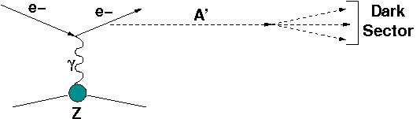

Figure 1. Diagram illustrating production of massive A' by electrons scattering off a nuclei (A,Z), in the reaction e⁻ Z → e⁻ Z A', with subsequent A' decay into dark sector states.
Part f of the primary energy is carried away by the dark photon, i.e. E_{A’} = fE₀. The dark photon, or its invisible decay products, penetrates the detector without interaction. The remaining part of the primary energy E_{e} = (1-f) E₀ is deposited in the target by the scattered electron. Thus, occurrence of A’ would appear as an excess of events whose signature is a single electromagnetic (e-m) shower in the target with energy E_{e} accompanied by the significant missing energy E_{miss} = E₀ – E_{A’} above those expected from the background [50, 51].
The process of the dark photon production and subsequent invisible decay, A’ → invisible is expected to be a very rare event. The total number of A's produced by n_{e} electrons in a target with thickness t >> X₀ is [11]:
n_{A'} ~ n_{e} C (ε² m_{e}²)/M_{A'}²,
where the parameter C ≈ 10 is only logarithmically dependent on the choice of target nucleus, m_{e} is the electron mass and M_{A'}- the A' mass. The spectrum is
dn_{A'}/dE_{A'} ~ k x (1+x² / {3 (1-x)}) ,
where k is a constant, and x=E_{A'}/E₀.
(For recent works on heavy particles production through photon exchange with a nucleus see also [57, 58].)
It is argued in [26], that the parameter C is actually C≈ 5. Nevertheless, one can see that, compared to the bremsstrahlung rate, the A' production is suppressed by a factor ≈ε² m_{e}²/M_{A'}². Therefore, for the parameter region of our interest, it is expected to occur with rate ≤10⁻¹³-10⁻⁹of the ordinary photon production rate. Hence, its observation presents a challenge for the detector design and performance.

The setup
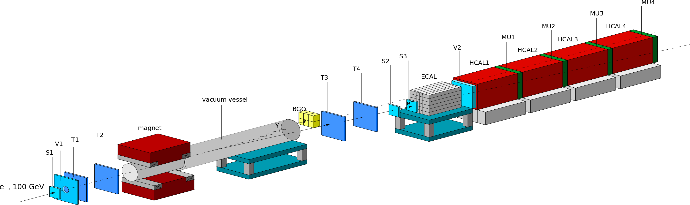
The experimental setup specifically designed to search for the A' → invisible decays is schematically shown in Fig. 2.
Figure 2. Schematic illustration of the current version of the NA-64 setup to search for A’ → invisible decays of the bremsstrahlung A’s produced in the reaction eZ → eZA’ of 100 GeV e⁻ incident on active ECAL target.
We work with 100 GeV beam energy, where the admixture of other charged particles in the beam (beam purity) is below 10⁻².
The detector utilizes beam defining scintillator (Sc) counters S1-S3, and magnetic spectrometer consisting of two successive dipole magnets and a low-material-budget tracker. The tracker includes two upstream Micromega chambers (T1, T2) and two down stream GEM stations (T3, T4) allowing for the measurements of e⁻ momenta with precision δp/p≈1% [53]. The magnet also served as an effective filter rejecting low energy component of the beam. The setup is additionally equipped with up to the 6 (2 X and 2 Y oriented) double layer straw chambers with a sensitive area of 200×200 mm² each based on Kapton tubes with wall thickness of 70 μm. To enhance the electron identification the synchrotron radiation (SR) emitted by electrons is used for their efficient tagging. A 15m long vacuum vessel between the magnets and the ECAL minimizeсabsorption of the SR photons before their detection immediately at the downstream end of the vessel by a SR detector (SRD). The latter can be either an array of BGO crystals or Pb-Sc sandwich calorimeter with a very fine segmentation [50]. By using SRD the level of the hadron contamination in the beam, π/e⁻≤ 10⁻²,can be further suppressed by a factor ~10³. The detector is also equipped with an active target, which is e-m calorimeter (ECAL) for measurement of the electron energy with an accuracy δE/E≈10%/√E. The ECAL is a matrix of 6x6 “shashlyk” type modules assembled from Pb and Sc plates with the wave-shifting read-out fibers inserted in spiral in order to avoid energy leak into the fibers if they would be inserted straight. Downstream the ECAL, the detector is equipped with high-efficiency veto counter V2, and a massive, hermetic hadron calorimeter (HCAL) of length 30λ_{int} (nuclear interaction lengths). The HCAL serves as a dump to absorb completely and measure the energy of hadronic secondaries, produced in the e⁻A interaction in the target. Three muon plane counters, MU1-MU3, located between the HCAL modules are used for final-state muon identification.
The signal candidate events should satisfy the following selection criteria:
- the incoming particle track should have a small angle with the beam axis to reject large angle tracks from possible upstream interaction;
- the energy deposited in the SRD should be within the SR range emitted by e⁻s and intime with the trigger;
- the lateral and longitudinal shape of the shower in the ECAL should be consistent with the one expected for a signal shower [54];
- no signal in the veto counter V2.
Background
The search for the A’ → invisible decays requires particular attention to the background. There are several sources which may mimic the A’ → invisible signal: upstream e⁻ interactions, μ→eνν and π, K→eν decays in-flight, energy leakage from particle punch-through in the HCAL, processes due to pile-up of two or more particles, instrumental effects due to energy loss through cracks in the upstream detector coverage, etc.
Table 1. The expected contributions to the total level of background from different sources estimated for beam energy 100 GeV.
Source | Expected level
Beam contamination:  - π, p, μ reactions and punch-through,…  - e⁻ low energy tail due to bremsstrahlung,  π,μ-decays in flight | < 10⁻¹³-10⁻¹²  < 10⁻¹²
Detector imperfectness:  ECAL+HCAL energy resolution, transverse hermeticity, holes, dead material, cracks… | <10⁻¹³
Physical:  - hadron electro production, e.g.  - e⁻A→e⁻A* + n,π,ρ,J/Ψ  - n punch-through, μ inefficiency  - the weakprocess e⁻ Z→e⁻ Zνν | < 10⁻¹³  < 10⁻¹³
Total | < 10⁻¹²

The background was estimated by Monte-Carlo simulation (MC) and with real data obtained during the beam tests in 2015-2016 [55]. For details see [55, 51].

Search for the decay A’ →e⁺e⁻
The experimental setup designed to search for A’ →e⁺e⁻decays is schematically shown in Figure 3.
The A' is emitted with respect to electron beam axis predominantly at an angle Θ_{A’} ≤ Θ_{e+e-}≈m_{A’}/E_{A'}, which is typically smaller than the opening angle of the A’→ e⁺e⁻ decay products Θ_{e+e-}. Thus, the approximation of A' emission collinear with the beam axis is justified; the same is done in many calculations [11].
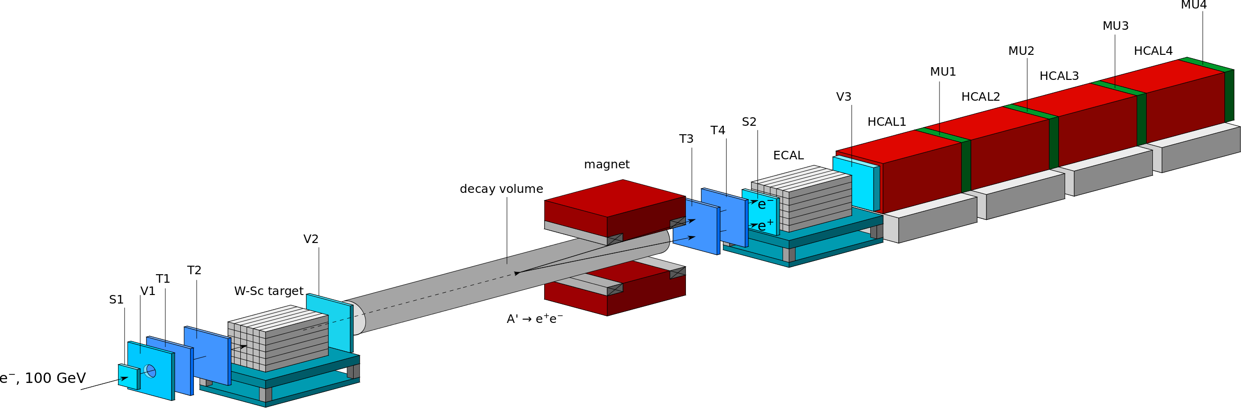

Figure 3. Schematic illustration of the setup proposed to search for dark photons in a light-shining-through-a-wall type experiment.
The corresponding A’−> e⁺e⁻ decay rate is given by:
Γ(A’−> e⁺e⁻) = α/3 ε² M_{A'} √ {1- 4m_{e}²/M_{A'}² (1+ 2 m_{e}² /M_{A'}²)} .
It is assumed that this decay mode is dominant and the branching ratio Γ(A’−> e⁺e⁻) / Γ_{tot} ≈ 1.
For this experiment the detector (see Fig. 3) is additionally equipped with a high density, compact e-m calorimeter (ECAL1) to detect e⁻ primary interactions. The decay volume (DV) and space after the downstream end of the DV up to the e-m calorimeter ECAL will be additionally equipped with high precision low-material-budget tracking detectors based on the straw tube technology (do not shown in the Fig. 3).
The method of the search is the following [59]. The dark photons A' are produced through the mixing with bremsstrahlung photons from the electrons scattering off nuclei in the W-Sc target, an e-m calorimeter with energy resolution ΔE/E ≃ 0.18/√E, X,Y resolution ≃ 3 mm, e/π rejection ~10⁻². This happens typically within the first few radiation lengths (X₀) of the target. The bremsstrahlung A' then penetrates the rest of the target and the veto counter V2 without interaction, and decays in flight into an e⁺e⁻ pair in the decay volume DV with diameter ≃30 cm and15 m length.
A fraction f of the primary electron energy, E₁ = f E_{0,}is deposited in the target calorimeter. Its downstream part serves as a dump to absorb completely the e-m shower tail. For radiation length ≤1 cm, and total thickness of the W-Sc target of≈30X₀ the energy leak into the V2 is negligibly small. The remaining part of the primary electron energy E₂ = (1-f)E₀ is transmitted through the “targetwall'' by the dark photon A', and deposited in the downstream calorimeter ECAL via the A' decay in flight in the DV, as shown in Fig.4. At high A' energies, E_{A'} ≥ 30 GeV, the opening angle Θ_{e+e-} ≈ m_{A’}/E_{A’} of the decay e⁺e⁻ pair is too small to be resolved as two e-m showers in the ECAL, so the pairs are mostly detected as a single electromagnetic shower. Thus, if m_{A’} ~ 50 MeV and E_{A’} = 50 GeV, one obtains Θ_{min} ~ 2 mrad, so the e⁺e⁻ pair can be resolved as two separated tracks in front of the ECAL.
The occurrence of A’→e⁺e⁻ decays would appear as an excess of events with two e-m-like showers in the two calorimeters that should satisfy the following selection criteria:
- the starting point of (e-m) showers in the W-Scand ECAL should be localized within a few first X₀s,
- the lateral and longitudinal shapes of both showers are electromagnetic like. The fraction of the total energy deposition in the W-Sc is f≤ 0.1, while in the ECAL it is (1-f)≥ 0.9,
- no energy deposition in the V2,
- the signal (number of photoelectrons) in the decay counter S2 is consistent with the one expected from two minimum ionizing particle (mip) tracks. At low beam energies, E₀≤30 GeV, two isolated tracks in the straw tube tracker are required,
- the sum of energies deposited in the W-Sc+ECAL is equal to the primary energy, E₁ +E₂ = E₀.
Background
The contributions from all background sources are summarized in Table 2 for beam energy 100 GeV. The dependence on the energy is rather weak. The total background level is conservatively estimated to be ≤ 3 10⁻¹³, and is dominated by the admixture of hadrons in the electron beam. Thus, a search accumulating ≈10⁻¹³ e⁻ events is expected to be essentially background free.
Table 2. Expected contributions from different background sources estimated for beam energy of 100 GeV.
Source of the background | Expected level
punch-through e⁻s or γs | ≤ 10⁻¹³
hadronic interactions | ≤ 2x10⁻¹³
μ interactions and decays | ≤ 10⁻¹⁴
accidentals | ≤ 10⁻¹⁴
Total | ≤ 3x10⁻¹³
For the background free case N_{A'}^{90%}(m_{A'}) = 2.3 events, the exclusion regions corresponding to accumulated electrons on the target10⁹, 10¹⁰, 10¹¹, 10¹²are shown in Fig. 5.
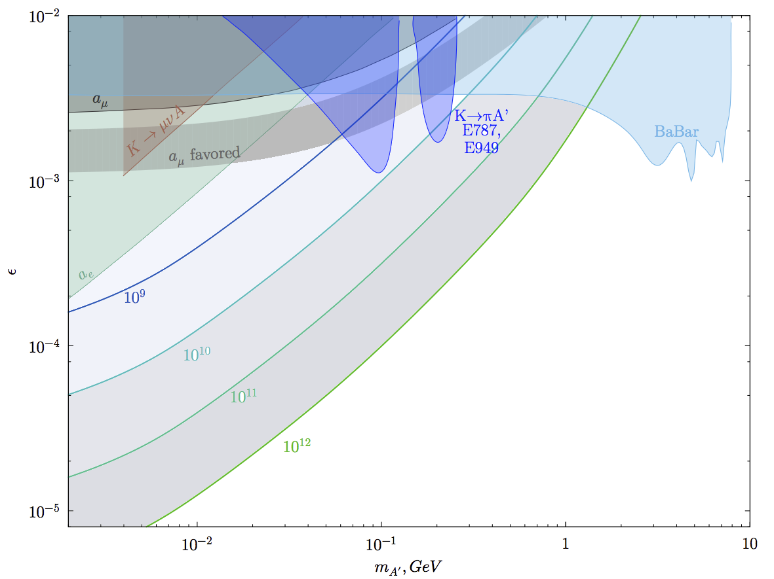

Figure 5. Constraints in the ε vs m_{A’} plane for invisibly decaying A' assuming they can decay invisibly to a pair of dark-sector states χχ, provided m_{A’} > 2 m_{χ}. The color lines show the expected 90% C.L. exclusion areas corresponding, respectively, to 10⁹, 10¹⁰, 10¹¹, 10¹² accumulated electrons at 100 GeV for the background free case. Various other constraints (shaded regions) are also shown [arxiv: 1604.08432]. The constraint from the BaBar mono-photon search is given as blue shaded region. Further limits are shown from the anomalous magnetic moment of the electron a_{e}, and muon a_{μ}, the rare kaon decay K⁺→π⁺ A' and leptonic decay K⁺→ μ⁺ν_{μ} A' searches.
For the background free case (N_{A'}^{90%}(m_{A'}) = 2.3 events), the exclusion regions corresponding to accumulated electrons on the target10¹¹,10¹², 10¹³ are shown in Fig.6.
Figure 6. Expected 90% C.L. exclusion areas in the (m_{A'};ε) plane for the accumulated electrons on the target of 10¹⁰, 10¹¹,10¹², 10¹³at 30 GeV. Shown are in gray all areas which are currently excluded by other searches, see text for details. Expected sensitivities of the planned APEX (full run), DarkLight and HPS experiments are also shown for comparison [61]. For a review of all experiments, which intend to probe a similar parameter space, see Ref. [61, 62] and references therein.
The statistical limit on the sensitivity of the proposed experiment is proportional to ε⁴. Thus, it is important to accumulate a large number of events. As it was shown, the size of the exclusion region is also sensitive to the choice of the length L' of the calorimetric target that should be as short as possible. Assuming the maximal secondary H4 beam rate n_{e} ≈ 5x10⁶ e⁻/spill at E₀ ≈ 30-50 GeV, we anticipate ≈3x10¹² collected e⁻s during ~ 3 months of run time.

Conclusion
Due to their specific properties, dark photons are an interesting probe of physics beyond the Standard Model both from theoretical and experimental point of view. We propose to perform a light-shining-through-a-wall experiment dedicated to аsensitive search for dark photons in the still unexplored intervals of the mixing strength 10⁻⁵≤ε≤ 10⁻³ and masses m_{A’} ≤ 100 MeV by using available electron beams from the CERN SPS. The experiment has the capability for a sensitive search for A's decaying invisibly to dark-sector particles such as dark matter. Our feasibility study shows that a sensitivity for the search of the A’ → invisible decay mode in terms of branching fraction Br(A’) = σ(e⁻Z→e⁻ZA’, A’→ invisible)/σ(e₋Z→e₋Zγ) at a level below a few parts in 10¹² is within reach. The intrinsic background due to the presence of low energy electrons in the beam can be suppressed by using a tagging system, which is based on the detection of synchrotron radiation of high-energy electrons. The search would allow covering a significant fraction of the yet unexplored parameters space for the A’ → invisible decay mode.
If A's exist, also their decays A’ → e⁺e⁻ could be observed by looking for events with two-shower topology of energy deposition in the detector. The key point is an observation of events with almost all beam energy deposition in the downstream ECAL calorimeter, located behind the “W-Sc wall''.
The sensitivity of the search for the A’ → e⁺e⁻ decay in terms of the ratio of the cross sections σ(e⁻Z→e⁻ZA’)/σ(e⁻Z→e⁻Zγ) at a level of ≤ 10⁻¹³ – 10⁻¹² could be achieved. In the case of non-observation, the expected exclusion areas are complementary to the ones from the planned APEX (full run), DarkLight, and other experiments intended to probe a similar parameter space [61, 62].
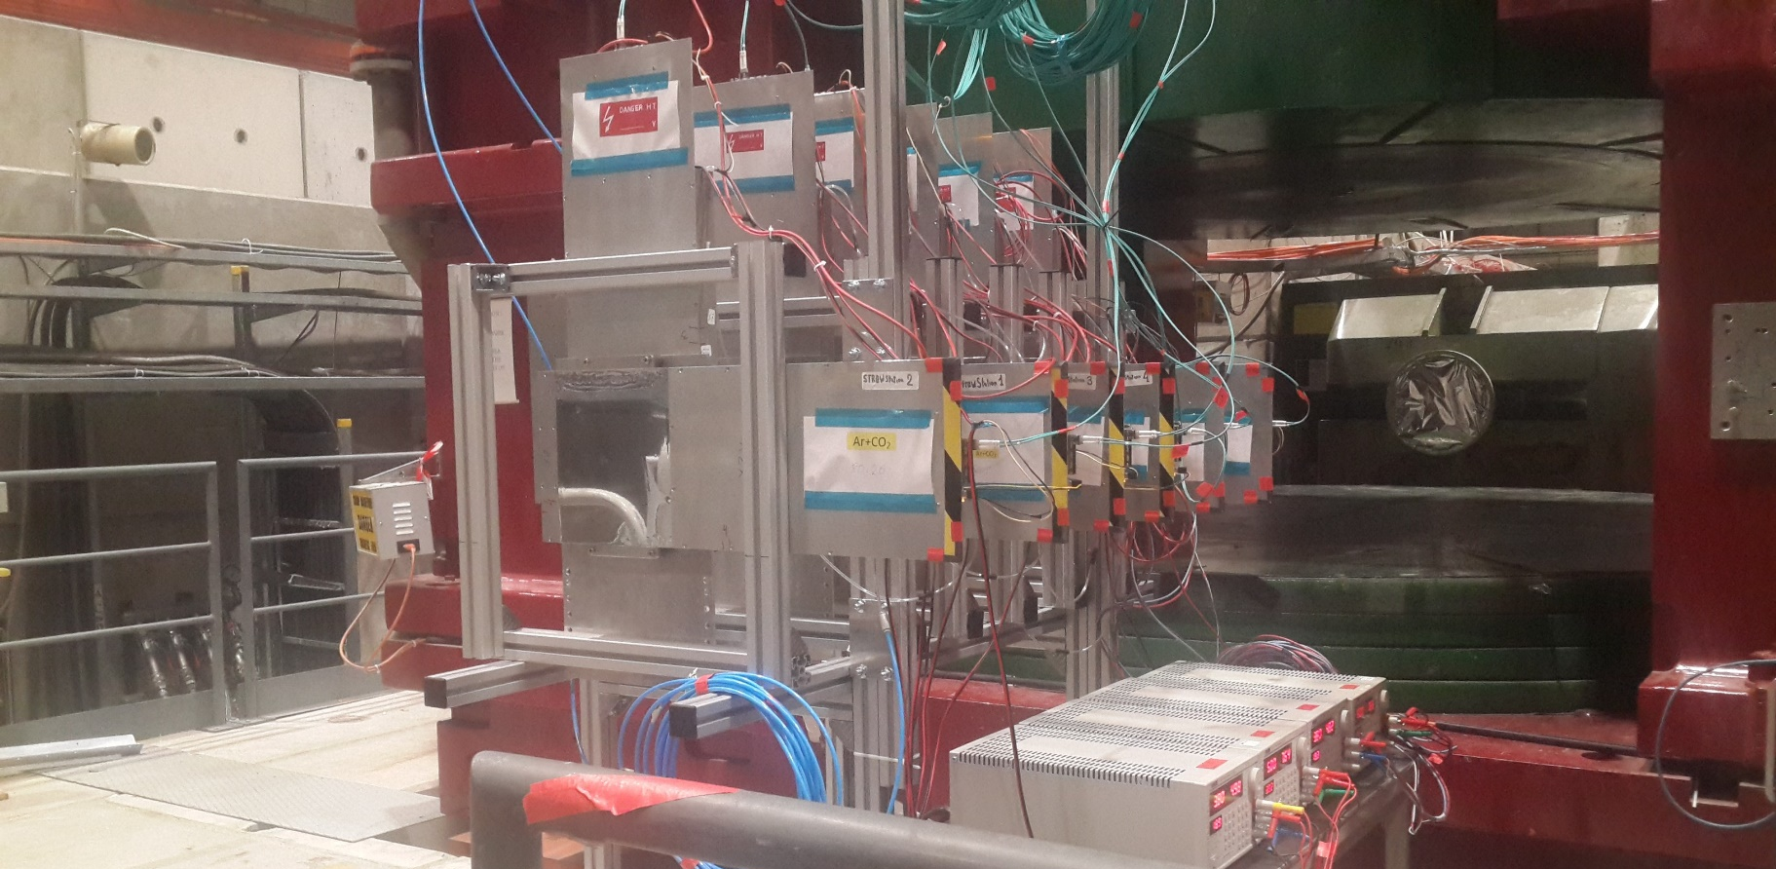

Figure 7. JINR straw tracker at the experimental hall during 2018 data taking run

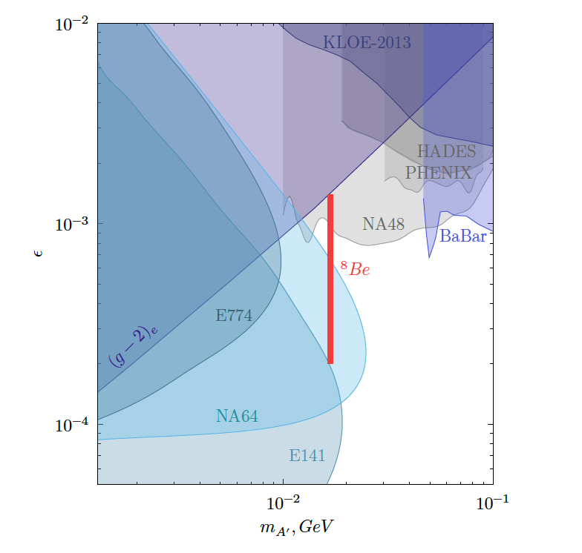
Figure 8. Part of the year 2017 and 2018 runs was devoted to the search for a new hypothetical X-boson with the mass of 16.7 MeV, the existence of which could explain the result on the anomalous production of e⁺e ⁻ pairs in the decay of the excited state ⁸Be* obtained in the ATOMKI experiment. 5.4x10¹⁰ 3x10¹⁰ events were taken, hypothetical boson was not found, obtained data allowed to significantly increase the limit on the coupling constant of the X-boson with an electron, as well as on the mixing parameter of the A´ with the conventional photon.
Reference
[1] L. B. Okun, Sov. Phys. JETP 56 (1982) 502 [Zh. Eksp. Teor. Fiz. 83 (1982) 892].
[2] P. Galison and A. Manohar, Phys. Lett. B 136 (1984) 279.
[3] B. Holdom, Phys. Lett. B 166, 196 (1986).
[4] J. Jaeckel and A. Ringwald, Ann. Rev. Nucl. Part. Sci.60, 405 (2010).
[5] J. Alexander et al., arXiv:1608.08632.
[6] N. Arkani-Hamed, D. P. Finkbeiner, T. R. Slatyer, and N. Weiner, Phys. Rev. D 79, 015014 (2009).
[7] G. W. Bennett et al. (Muon G-2 Collaboration), Phys. Rev. D 73, 072003 (2006).
[8] S.N.Gninenko and N.V.Krasnikov, Phys. Lett. B 513, 119 (2001).
[9] P.Fayet, Phys. Rev. D 75, 115017 (2007).
[10] M. Pospelov, Phys. Rev. D 80, 095002 (2009).
[11] J. D. Bjorken, R. Essig, P. Schuster, and N. Toro, Phys. Rev. D 80, 075018 (2009).
[12] F. Bergsma et al. (CHARM Collaboration), Phys. Lett. 166B, 473 (1986).
[13] A. Konaka et al., Phys. Rev. Lett. 57, 659 (1986).
[14] E. M. Riordan et al., Phys. Rev. Lett. 59, 755 (1987).
[15] J. D. Bjorken, S. Ecklund, W. R. Nelson, A. Abashian, C. Church, B. Lu, L. W. Mo, T. A. Nunamaker, and P. Rassmann, Phys. Rev. D 38, 3375 (1988).
[16] A. Bross, M. Crisler, S. H. Pordes, J. Volk, S. Errede, and J. Wrbanek, Phys. Rev. Lett. 67, 2942 (1991).
[17] M. Davier and H. Nguyen Ngoc, Phys. Lett. B 229, 150 (1989).
[18] C. Athanassopoulos et al. (LSND Collaboration), Phys. Rev. C 58, 2489 (1998).
[19] P. Astier et al. (NOMAD Collaboration), Phys. Lett. B 506, 27 (2001).
[20] S. Adler et al. (E787 Collaboration), Phys. Rev. D 70,037102 (2004).
[21] A. V. Artamonov et al. (BNL-E949 Collaboration), Phys. Rev. D 79, 092004 (2009).
[22] R. Essig, R. Harnik, J. Kaplan, and N. Toro, Phys. Rev. D 82, 113008 (2010).
[23] J. Blumlein and J. Brunner, Phys. Lett. B 701, 155 (2011).
[24] S. Gninenko, Phys. Lett. B 713, 244 (2012). [21]
[25] J. Blumlein and J. Brunner, Phys. Lett. B 731, 320(2014).
[26] S. Andreas, C. Niebuhr, and A. Ringwald, Phys. Rev. D86, 095019 (2012).
[27] S. Abrahamyan et al. (APEX Collaboration), Phys. Rev.Lett. 107, 191804 (2011).
[28] H. Merkel et al., Phys. Rev. Lett. 112, 221802 2014).
[29] H. Merkel et al. (A1 Collaboration), Phys. Rev. Lett. 106, 251802 (2011).
[30] B. Aubert et al. (BABAR Collaboration), Phys. Rev.Lett. 103, 081803 (2009).
[31] D. Curtin et al., Phys. Rev. D 90, 075004 (2014).
[32] J. P. Lees et al. (BABAR Collaboration), Phys. Rev. Lett. 113, 201801 (2014).
[33] G. Bernardi, G. Carugno, J. Chauveau, F. Dicarlo, M. Dris et al., Phys. Lett. 166B, 479 (1986).
[34] R. Meijer Drees et al. (SINDRUM I Collaboration), Phys. Rev. Lett. 68, 3845 (1992).
[35] F. Archilli et al. (KLOE-2 Collaboration), Phys. Lett. B706, 251 (2012).
[36] S. N. Gninenko, Phys. Rev. D 85, 055027 (2012).
[37] D. Babusci et al. (KLOE-2 Collaboration), Phys. Lett. B720, 111 (2013).
[38] P. Adlarson et al. (WASA-at-COSY Collaboration), Phys. Lett. B 726, 187 (2013).
[39] G. Agakishiev et al. (HADES Collaboration), Phys. Lett.B 731, 265 (2014).
[40] A. Adare et al. (PHENIX Collaboration), Phys. Rev. C91, 031901 (2015).
[41] J. R. Batley et al. (NA48/2 Collaboration), Phys. Lett.B 746, 178 (2015).
[42] A. Anastasi et al. (KLOE-2 Collaboration), Phys. Lett.B 757, 356 (2016).
[43] H. S. Lee, Phys. Rev. D 90 (2014) 9, 091702.
[44] E. Izaguirre, G. Krnjaic, P. Schuster, and N. Toro, Phys. Rev. D 88, 114015 (2013).
[45] M. D. Diamond and P. Schuster, Phys. Rev. Lett. 111, 221803 (2013).
[46] H. Davoudiasl, H. S. Lee, and W. J. Marciano, Phys. Rev. D 89, 095006 (2014).
[47] B. Aubert etal. [BaBar Collaboration], arXiv:0808.0017[hep-ex].
[48] B. Batell, M. Pospelov, and A. Ritz, Phys. Rev. D 80, 095024 (2009).
[49] B. Batell, R. Essig, and Z. Surujon, Phys. Rev. Lett. 113, 171802 (2014).
[50] S. N. Gninenko, Phys. Rev. D 89 (2014) 7, 075008.
[51] S. Andreas etal., arXiv:1312.3309 [hep-ex].
[52] R. Essig, J. A. Jaros, W. Wester, P. H. Adrian, S. Andreas, T. Averett, O. Baker and B. Batell et al., arXiv:1311.0029 [hep-ph]]; R. Essig, J. Mardon, M. Papucci, T. Volansky and Y.-M. Zhong, arXiv:1309.5084 [hep-ph].
[53] D. Banerjee, P. Crivelli and A. Rubbia, Adv. High Energy Phys. 2015 105730, (2015).
[54] S.N. Gninenko, N.V. Krasnikov , M.M. Kirsanov, and D.V. Kirpichnikov, arXiv:1604.08432.

[55] S.N.Gninenko et al., arXiv:1610.02988 [hep-ph].
[56] S.Agostinelli at al.[GEANT4 Collaboration], NIM A506, 250 (2003); J.Alisson et al., IEEE Trans. Nucl.
Sci. 53, 270 (2006)
[57] M. Masip, P. Masjuan and D. Meloni, JHEP 1301, 106 (2013) [arXiv:1210.1519 [hep-ph]].
[58] A. Radionov, Phys. Rev. D 88, 015016 (2013) [arXiv:1303.4587 [hep-ph]].
[59] S.N.Gninenko arXiv:1308.6521 [hep-ph].
[60] S. I. Bityukov and N. V. Krasnikov, Mod. Phys. Lett. A 13, 3235 (1998); Nucl. Instrum. Meth. A 534, 152 (2004).
[61] J. L. Hewett, H. Weerts, R. Brok, J. N. Butler, B. C. K. Casey, J. Collar, A. de Gouvea and R. Essig et al., arXiv:1205.2671 [hep-ex].
[62] R. Essig, J. A. Jaros, W. Wester, P. H. Adrian, S. Andreas, T. Averett, O. Baker and B. Batell et al., arXiv:1311.0029 [hep-ph]].
[63] E. M. Riordan, M. W. Krasny, K. Lang, P. De Barbaro, A. Bodek, S. Dasu, N. Varelas and X. Wang et al., Phys. Rev. Lett. 59, 755 (1987).
[64] A. Bross, M. Crisler, S. H. Pordes, J. Volk, S. Errede and J. Wrbanek, Phys. Rev. Lett. 67, 2942 (1991).
[65] S. Andreas, C. Niebuhr and A. Ringwald, Phys. Rev. D 86, 095019 (2012) [arXiv:1209.6083 [hep-ph]].
[66] A. Konaka, K. Imai, H. Kobayashi, A. Masaike, K. Miyake, T. Nakamura, N. Nagamine and N. Sasao et al., Phys. Rev. Lett. 57, 659 (1986).
[67] S. N. Gninenko, Phys. Rev. D 87, 035030 (2013) [arXiv:1301.7555 [hep-ph]].
[68] R. Meijer Drees et al. [SINDRUM I Collaboration], Phys. Rev. Lett. 68, 3845 (1992).
[69] G.Bertone et al., Phys.Rept. 405, 279 (2005) [hep-ph/0404175]
[70] J.L.Feng, Ann. Rev. Astron. Astrophys. 48, 495 (2010)
[71] A.E.Dorokhov and M.A.Ivanov, “Rare decay π⁰ → e⁺ e⁻: Theory confronts KTeV data” Phys. Rev. D (2007) 114007

