Questionnaire (for new projects)

UPGRADE OF THE CMS DETECTOR
CODE OF THEME 02-0-1083-2009-2023

A. Scientific merit
1. Goals of the experiment:

1a. Give a short description of the goals of the experiment

The “Compact Muon Solenoid” (CMS) is the general-purpose experiment, designed to study physics of pp collisions at the Large Hadron Collider (LHC). The CMS detector sits at one of four LHC collision points. It is a general-purpose detector; that is, it is designed to observe any new physics phenomena that the LHC might reveal.
Particle physicists study Nature at its most fundamental level by observing particle collisions. By understanding the properties of the various types of particles and the forces that govern them, we can learn about the origins of the Universe itself. Use the menu to explore the questions that particle physics is addressing.
The CMS provides extraordinary opportunities for particle physics based on its unprecedented collision energy and luminosity. The CMS Collaboration has a broad physics programme, ranging from measurements of the Standard Model and the recently discovered Higgs boson to confirm the mechanism of electroweak symmetry breaking, and search for extra Higgs bosons beyond the Standard Model, or otherwise, search for supersymmetric partners of the SM particles, dark matter candidates, extra dimensions in the Universe at TeV-energy scale, etc. Other important problem could be cleared with LHC which is looking for ways to unify the fundamental interactions, for example via extended gauge models. Also, the CMS physics programme includes the tests of Standard Model itself in the new energy region, studies of EWK and QCD processes, search for quark-gluon plasma etc.
Starting from 2027 the LHC will be running at High-Luminosity mode (HL−LHC) with luminosity of $L$ = 7.5×10³⁴ cm⁻²c⁻¹ that will allow increasing statistics by more than one order of magnitude ($L$_{int} ~ 3000 fb⁻¹) by the LHC Phase 2 end in 2038.
To ensure feasibility of the HL–LHC physics program a large-scale modernization of detector systems is required.
The CMS detector systems have to be upgraded to be able to run at significantly rising levels of radiation. The detectors, the trigger system and the event reconstruction, data acquisition and analysis systems will be able to process essential experimental data in high pile-up environment. The mean pile-up did not exceed 20–40 in Run 1 and Run 2, but it is expected to reach 60 in Run 3 and ≈ 140 in HL–LHC conditions. Thus, it will increase by about factor 5, what imposes additional requirements on the performance of the detector, the readout electronics and the data acquisition and analysis systems. It also requires the use of radiation-hard materials for detector elements and development of new methods for the experimental data analysis.

1b. Explain what the project adds to the international scenario.

JINR has been participating in the CMS experiment for over 25 years, taking part in the development of the detector concept. Within the framework of the Russian Dubna Member States collaboration, JINR was responsible for the design, construction and operation of the end hadron calorimeter (HE) and the forward muon station (ME1/ 1).
JINR physicists play an active role in the CMS physics program participating in the experimental data taking and analysis in the following areas:
- searches for physics beyond SM (low-energy gravity, dark matter, extended gauge models, etc) with the dimuon final states
- searches for physics beyond SM (extended Higgs sector, dark matter, lepton-flavour violation) with missing energy final states
- studies of Higgs boson properties and search for new scalar bosons beyond SM in the lepton decay channels
- studies of jet multiple production for searches of microscopic black holes and other BSM signals
- studies of muon pair production in Drell-Yan process to test SM at new energy scale, measurement of weak mixing angle and parton distribution functions (PDF)
- jet measurements for studies of hadronization, improvement of PDF and QCD coupling precision
The main goal of the JINR “Upgrade of the CMS Detector” project is contribution to the construction of the Highly Granularity Calorimeter (HGCal) and an upgrade of the ME1/1 Cathode Strip Chambers (CSC) of the CMS endcap muon system.
All work on the project is carried out within the framework of the obligations assumed in accordance with the Memorandum of Understanding for Collaboration in the Construction of the CMS Detector between CERN and JINR, relevant Addenda and Memorandum of Understanding on participation of JINR in the CMS Phase-2 HGCal Project at CERN.
After the modernization of the detector systems, the project implemented on the LHC discovery machine has a high potential to make a world-class discovery, as was done during the first stage of work (the discovery of the Higgs boson). LHC experiments are attractive to scientists all over the world, useful for popularizing science and for involving the younger generation in science.
CMS is one of the largest international innovation projects in many major fields of science, as well as in the field of technology for the design and creation of equipment for experimental research in the field of high-energy physics.
International cooperation within the framework of the CMS collaboration with a large number of research centers leading in the field of high-energy physics makes it possible to transfer modern technologies to a home institute. Good examples of such cooperation are:
− transfer of GEM (Gas Electron Multiplier) detector technology to JINR to study the properties of baryonic matter in the experiment (BM@N) at JINR;
− implementation of the track reconstruction algorithm for analyzing the experimental data of the BM@N experiment at JINR.
The experiment has one of the highest publication rates for experimental results in high-energy physics. In 2020, more than 100 articles were published. High citation rate of works.
JINR contribution to the CMS experiment has been well known since the establishment of the CMS. JINR participants in CMS made a significant contribution to the design, construction and modernization of the muon endcap system. At the same time, JINR scientists are actively involved in physics analysis, reconstruction and selection of events, data quality control, and development of basic software. As part of the research and optimization of the parameters of the endcap muon system detectors, JINR physicists have made a significant contribution to the development and implementation of the algorithm for the reconstruction of physics objects. The development of CMS projects for the modernization of detector systems was carried out with the active participation of JINR employees.

C. Plans and requests
2. Plans
Participation in construction of the high granularity calorimeter
The total amount of JINR (RDMS–DMS) contribution to CORE for these tasks is defined as 2 200 kCHF. JINR is responsible for:
- HGCal cooling plates production (assigned funding in CORE is 1210 kCHF);
- silicon sensors purchase (assigned funding in CORE is 700 kCHF);
- SiPM purchase (assigned funding in CORE is 200 kCHF);
- manufacturing of the cassette testing facility (assigned funding in CORE is 90 kCHF);
- testing of cassettes, assembly and commissioning of HGCal.
Within the framework of the agreement between JINR and CERN on participation in the development of high-granularity endcap calorimeters, the area of responsibility of JINR is participation in the development of the hadron part of HGCAL cassettes (mixed type CE-H). They include the following sections:
- production of low-temperature rooms for testing cassettes after assembly and transportation to CERN, 96 kUSD, including 90 kUSD of the JINR Directorate grant for 2021. Transportation of the cameras to CERN, installation and maintenance costs amount to 50 kUSD;
- design and construction of trigger counters and related electronics for testing HGCAL active modules with cosmic rays in low-temperature rooms. This requires the design of scintillation counters and the mechanical design of the trigger system, the development of a high-voltage power supply system for photomultipliers and related register electronics, the estimated cost of materials and equipment is 20 kUSD. Maintenance and operation of the equipment directly during the test tests of the cassettes for 4 years is 42 kUSD;
- testing of CE-H cassettes before installation in the HGCal absorber. According to the schedule, the work will require the participation of specialists from JINR for 4 years, 264 kUSD;
- Monte Carlo calculations of the response of calorimetric modules to an incoming minimally ionizing particle and developing algorithms for separation signals from particles against a noise background.

Upgrade of the ME1/1 Cathode Strip Chambers (CSC)
The main directions and tasks of JINR group participation in modernization of the endcap muon system CMS are as follows:
- Electronics upgrade during LS2 period and preparation to LS3 period
- design and construction of 120 new Low Voltage Distribution boards (LVDB-5);
- manufacturing of the 120 reference voltage cables;
- design and construction of the test stand for LVDB boards;
- design and production of 72 ME1/1 high voltage filters - to be installed during LS3;
- design and production of 36 ME1/1 patch panels - to be installed during LS3.
- MEx/1 CSC refurbishing, testing, assembly, and installation during LS2 period
- design and construction of the Endcap Muon System upgrade infrastructure (area and test stands);
- ME1/1 CSCs extraction;
- installation and tests of HV filters for ME1/1 CSCs;
- replacement and tests of the ME1/1 optical fibers (planned for LS3 period);
- modernization of the ME1/1 cooling system;
- production and installation of the new ME1/1 CSC cables and services;
- refurbishment, installation, and commissioning of MEx/1 muon chambers.
- Continue development and test of an algorithm for track segments reconstruction in the CSC chambers.
- Continue participation in CMS CSC ageing study at GIF++, CERN
- study of CSC characteristics in HL-LHC conditions with uncorrelated background;
- study of methods for eliminating the Malter current in CSC.
- Participation in the new gas mixture studies for endcap CSC.
The obligations of JINR in the CMS Muon system Phase-I Upgrade fulfilled in LS2 period. The responsibilities of JINR together with DMS countries (RDMS-DMS) in construction of the Phase-2 Muon System: “On-detector electronics and OTMBs” and “RE3/1 RE4/1 Chambers” is defined in Annex 3 of Addendum №13 to the Memorandum of Understanding for Collaboration in the Construction of the CMS Detector (CERN-MoU-2019-008) [9]. The total CORE JINR contribution (Annex 4 to MoU) accounted as 151 kCHF (76 kCHF – from JINR budget, 75 kCHF – from Georgia Technical University and Tbilisi State University budget).
In addition, the unexpected/extra JINR expenditures of 63 kCHF related to the manufacturing of the new cooling circuits and monitoring of the water leaks will be acknowledged as an advanced contribution in the M&O-B budget of the Muon System from 2021 in 2019.

3. Group size, composition and budget.

3a. List the JINR personnel involved in the project, including name, status (e.g. PI, researcher, post-doc, student, engineer, technician…) and FTE. Mention the total number of people in the collaboration.

The total number of people in the CMS collaboration is over 4000 particle physicists, engineers, computer scientists, technicians and students from around 200 institutes and universities from more than 40 countries.
The total number of participants from JINR is 44 employees, 21.5 FTE.
The list of participants includes 2 Full Members of the National Academies of Sciences of the Russian Federation and Uzbekistan (V.A. Matveev and B.S. Yuldashev), 8 doctors of science (I.A. Golutvin, V.Yu. Karjavine, V.V. Korenkov, A.I. Malakhov, G.A. Ososkov, V.A. Smirnov, O.V. Teryaev, S.V. Shmatov), 12 candidates of sciences (V.Yu. Alexakhin, S.V. Afanasiev, N.I. Zamiatin, A.V. Zarubin, I.N. Gorbunov, N.V. Gorbunov, A.V. Lanoyv, V.V. Palichik, T.A. Strizh, A. Petrosyan, A. Khvedelidze, Z. Tsamalaidze). The share of young employees under the age of 35 exceeds 20%. All young employees are actively working on the preparation of PhD theses.
Employment for participants of the JINR Project “Upgrade of the CMS Detector”
 | Name | FTE in  Upgrade Project | Activity | Other activities in CMS topic | Total FTE in CMS Topic
JINR Directorate
1 | V.A. Matveev,  Academician, Physicist | 0,1 | management |  | 0,1
JINR GA&C
2 | B.S. Yuldashev,  Academician, Physicist | 0,2 | upgrade works |  | 0,2
VBLHEP
3 | V.Yu.Alexakhin,  Candidate of Sciences, Physicist | 0,2 | data processing and analysis | physics analysis (0,7) | 0,9
4 | S.V.Afanasiev,  Candidate of Sciences,  Physicist | 0,3 | upgrade works |  | 0,3
5 | D.Budkovsky,  Doctoral Student | 0,2 | data processing and analysis | physics analysis (0,8) | 1,0
6 | P.D.Bunin,  Physicist | 1,0 | upgrade works and detector operations |  | 1,0
7 | M.G. Gavrilenko,  Physicist | 0,4 | upgrade works and detector operations | physics analysis (0,6) | 1,0
8 | A.O. Golunov,  Engineer Software | 0,8 | upgrade works and detector operations | computing (0,2) | 1,0
9 | I.A. Golutvin,  Doctor of Sciences,  Physicist | 1,0 | management |  | 1,0
10 | I.N. Gorbunov,  Candidate of Sciences,  Physicist | 0,2 | data processing and analysis | physics analysis (0,8) | 1,0
11 | N.V. Gorbunov,  Candidate of Sciences,  Engineer Software | 1,0 | upgrade works and detector operations |  | 1,0
12 | N.N.Evdokimov,  Engineer Electronics | 1,0 | upgrade works and detector operations |  | 1,0
13 | Yu.V.Ershov,  Engineer Mechanical | 1,0 | upgrade works and detector operations |  | 1,0
14 | A.Yu. Kamenev,  Physicist | 1,0 | upgrade works and detector operations |  | 1,0
15 | V.Yu. Karjavin,  Doctor of Sciences,  Physicist | 1,0 | management  and upgrade works |  | 1,0
16 | A.M. Kurenkov,  Engineer Mechanical | 1,0 | upgrade works and detector operations |  | 1,0
17 | A.V. Lanev,  Candidate of Sciences,  Physicist | 0,1 | data processing and analysis | physics analysis (0,9) | 1,0
18 | A.M.Makan'kin,  Engineer Software | 0,3 | upgrade works and detector operations |  | 0,3
19 | A.I. Malakhov,  Doctor of Sciences,  Physicist | 0,2 | upgrade works and detector operations |  | 0,2
20 | V.V. Perelygin,  Physicist | 1,0 | upgrade works and detector operations |  | 1,0
21 | V.A.Smirnov,  Doctor of Sciences,  Physicist | 0,9 | upgrade works and detector operations |  | 0,9
22 | E.V.Sukhov,  Engineer | 0,5 | upgrade works and detector operations |  | 0,5
23 | O.V.Teryaev,  Doctor of Sciences,  Physicist | 0,1 | physics analysis (0,1) |  | 0,1
24 | V.V. Ustinov,  Engineer | 0,5 | upgrade works and detector operations |  | 0,5
25 | V.V. Shalaev,  Doctoral Student | 0,2 | data processing and analysis | physics analysis (0,8) | 1,0
26 | S.V. Shmatov,  Doctor of Sciences,  Physicist | 0,1 | data processing and analysis | physics analysis (0,8),  computing (0,1) | 1,0
27 | N.I. Zamyatin,  Candidate of Sciences,  Engineer | 0,1 | upgrade works and detector operations |  | 0,1
28 | A.V. Zarubin,  Candidate of Sciences,  Physicist | 1,0 | upgrade works and detector operations |  | 1,0
29 | I.A. Zhizhin,  Doctoral Student | 0,2 | data processing and analysis | physics analysis (0,8) | 1,0
LIT
30 | A.O. Golunov,  Engineer Software |  | computing (0,5) |  | 0,5
31 | I.A. Filozova,  Engineer Software |  | computing (0,1) |  | 0,1
32 | A.Khvedelidze,  Candidate of Sciences,  Engineer Software | 0,5 | upgrade works and detector operations |  | 0,5
33 | V.V.Korenkov,  Doctor of Sciences,  Engineer Software | 0,4 | computing (0,4) |  | 0,4
34 | V. Mitsyn,  Engineer Software | 0,8 | computing (0,8) |  | 0,8
35 | D.A. Oleynik,  Engineer Software | 0,1 | computing (0,1) |  | 0,1
36 | G.A. Osokov,  Doctor of Sciences,  Physicist | 0,1 | data processing and analysis |  | 0,1
37 | V.V.Palchik,  Candidate of Sciences,  Physicist | 0,8 | data processing and analysis |  | 0,8
38 | A. Petrosyan,  Candidate of Sciences,  Engineer Software | 0,1 | computing (0,1) |  | 0,1
39 | R.N. Semenov,  Engineer Software | 0,1 | computing (0,1) |  | 0,1
40 | T.A. Strizh,  Candidate of Sciences,  Engineer Software | 0,1 | computing (0,1) |  | 0,1
41 | V. Trofimov,  Engineer Software | 0,8 | computing (0,8) |  | 0,8
42 | N.N.Voytishin,  Doctoral Student | 0,8 | data processing and analysis |  | 0,8
DLNP
43 | G. Adamov,  Engineer Software | 0,3 | upgrade works and detector operations |  | 0,3
44 | Z. Tsamalaidze,  Candidate of Sciences,  Physicist | 0,2 | upgrade works and detector operations |  | 0,2
Total |  | 21,5 |  |  | 31,8*
*) A number of CMS participants from JINR are missed in this list since they are not involved in the CMS Upgrade Project.

3b. Present the JINR group budget for the requested period of time of the project, specifying the main budget items (equipment, computing, salaries, common funds, travel…)

The cost estimate and pattern of charges are related to the official obligations of JINR to participate in the experiment in accordance with the Memorandum of Understanding for the Creation of the CMS detector between CERN and JINR (Memorandum of Understanding for Collaboration in the Construction of the CMS Detector), the relevant Annexes, and the Memorandum of Understanding on the participation of JINR in the project HGCal CMS:
- Common Fund expenditures on CMS Phase II Upgrade (CORE contribution is 289.855 kCHF, total amount for 2020–2025 is 434.783 kCHF);
- the cost of HGCal cooling plates (CORE contribution – 1210 kCHF);
- the cost of purchasing silicon sensors (CORE contribution – 700 kCHF);
- the cost of purchasing SiPM (CORE contribution – 200 kCHF);
- the cost of creating a stand for testing cassettes (CORE contribution – 90 kCHF;
- expenditures for testing cassettes, assembly and commissioning of HGCal;
- expenses for the upgrade of muon CSC stations (CORE contribution – 76 kCHF);
- costs for testing and commissioning of ME1/1, carrying out of R&D;
- operating expenses for the maintenance of the facility under the responsibility of JINR and its personnel, in accordance with the Memorandum on the Maintenance and Operation of the experimental complex (M&O category В) on the HGCal project (179 kCHF in 2022–2026).
The total amount of the contribution to CORE is 2276 kCHF, including Common Fund of 2565.855 kCHF.
The proposed schedule, required resources, and cost estimates for the “CMS DETECTOR UPGRADE” project are provided in Forms 26 and 29. The results of tenders for the purchase of materials and manufacturing may lead to a change in the total cost of work.

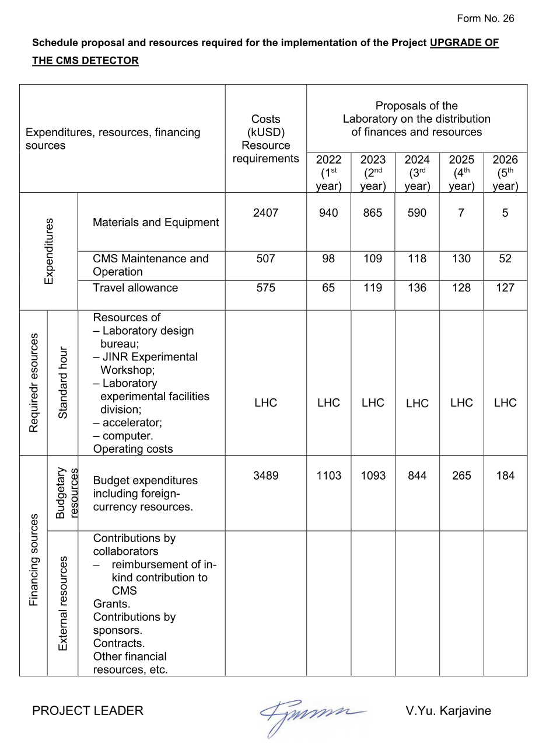
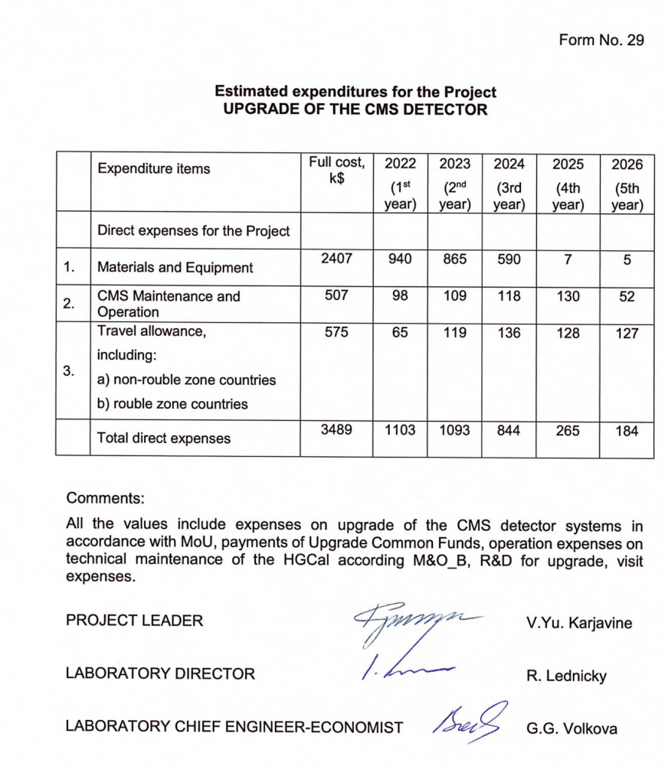
3c. Indicate the use or needs of JINR computing resources for the group and for the project if any.

Data storage, processing and analysis is performed in the framework of the distributed computing infrastructure within the Worldwide LHC Computing Grid (WLCG) Project. The Tier-1/Tier-2 grid-sites of the JINR Multifunctional information and computing complex as part of the WLCG is provided with a proper computing infrastructure for receiving, processing and storing experimental information from the CMS experiment at JINR and in Russian institutes that cooperate with CMS.

Cost of Resource Exchange
In 2020-2021, a contribution of 144,928 kCHF.
In 2020-2021, a contribution of 5.9 kCHF was made. Currently, the cost of M&O category B expenses is estimated based on the amount of the contribution to CORE. The collaboration discusses the transition to a calculation formula based on the number of project participants (PhD), which will entail a change in the cost price for this category.

