Annex 3.
Form of opening (renewal) for Project /
Sub-project of LRIP

APPROVED
JINR DIRECTOR
/
" " ___ 202_ г.

SCIENTIFIC AND TECHNICAL REASONING FOR THE OPENING / RENEWAL
OF PROJECT/SUB-PROJECT OF LARGE RESEARCH INFRASTRUCTURE PROJECT
IN RESEARCH AREA WITHIN THE TOPICAL PLAN FOR JINR RESEARCH

1. General information on the project/subproject of the large research infrastructure project
(hereinafter LRIP)
  - Theme code:

1.2 Project/sub-project of a MIP code (for renewed themes):
1.3 Laboratory: Dzhelepov Laboratory of Nuclear Problems

1.4 Scientific field: Elementary Particle Physics and High-Energy Heavy-Ion Physics (02)

1.5 The name of the Project/subproject of the LRIP: Development of a particle registration technique in future experiments with the participation of JINR

1.6 Project/ sub-project of the LRIP Leader(s): Yu.I. Davydov

1.7 Project/sub-project of the LRIP Deputy Leader(s) (scientific supervisor of the project/sub-project of the LRIP) Yu.A. Kultchitsky

2 Scientific rationale and organisational structure
2.1 Annotation

The development of experimental particle physics occurs in two main directions - increasing the energy of particle beams (energy frontier) and their intensity (intensity frontier). This requires the use of new materials, the development of advanced detectors and particle detection techniques, and the development of new methods of data analysis.
The project under consideration is aimed at the development of new detectors and new approaches for detecting and identifying particles. The project proposes to combine efforts in different directions in order to effectively use human and material resources.
The project involves the development of methods for creating and researching promising detectors. Work will be carried out to develop new gas detectors and study their parameters, to create and study prototype of calorimeters using both organic scintillators and crystals.
One of the objectives of the project is Monte Carlo simulation of electromagnetic calorimeters of various configurations in order to optimize their parameters. This problem is of interest for various experiments planned in the coming years.
The work planned within the project will be of interest to experiments in which JINR is already participating or plans to participate - future collider experiments at the Super C-Tau Factory (SCT) in Russia, at the Super Tau-Charm Facility (STCF) and at the Circular Electron Positron Collider (CEPC) in China, as well as experiments Mu2e-II, Comet (phase 2) and others.

2.2 Scientific justification (purpose, relevance and scientific novelty, methods and approaches, methodologies, expected results, risks)

Purpose of the project

Project participants have been fruitfully engaged in the development and research of new detectors and data analysis methods for a number of years. This work was carried out separately within the framework of various projects and activities. For more efficient use of human and financial resources, we propose to combine these activities within one project. The goal of the project is the development of detector systems for accelerator experiments and new approaches to particle registration and identification. The goals set in the project are aimed at solving problems arising in future collider experiments at the Super c-tau factory (SCT) [1] in Russia, at the Super tau-charm facility (STCF) [2] and the Circular Electron Positron Collider (CEPC) [3] in China, and at accelerators with fixed targets at intermediate and high energies, as well as in the search experiments Mu2e-II, Comet (phase 2). Special requirements are imposed on detectors planned for use in conditions of high intensity (the intensity frontier) and/or in conditions of high energies (the energy frontier) beams. In both cases, radiation-resistant detectors with high performance are required that can operate effectively in harsh radiation conditions.
One of the goals of the project is also to train qualified personnel. Bachelors, masters, and graduate students will participate in the project and will use the results obtained in their dissertations.

Relevance and scientific novelty

The development of modern experimental physics of elementary particles occurs in the direction of increasing the energy of particle beams (the energy frontier) and their intensity (the intensity frontier). In this regard, it is necessary to develop and create high-speed detectors capable of operating reliably and stably under conditions of high radiation loads, as well as the development of new approaches to modelling detectors and analyzing data from them. To do this, it is necessary to search for new materials and develop promising detectors and methods for detecting and identifying particles. Therefore, the task of searching for new materials, developing promising detectors and methods for detecting particles, and developing new methods of data analysis is urgent.

Methods and approaches, methodologies

I. Development of microstructure and straw gas detectors

During the development and operation of gas detectors in modern physical experiments, there is the possibility of breakdowns, potentially leading to damage or destruction of detector elements. One way to solve this problem is to use resistive elements in the design of detectors, which limit the current during breakdown and, thus, reduce the likelihood of damage to the detector. A similar solution is used, for example, in the TPC of the T2K experiment and in the New Small Wheel of the ATLAS experiment.
We have developed and tested prototypes of the Micromegas microstructured gas detector with a resistive anode coating and demonstrated their high resistance to breakdowns [4], and work is underway to study detectors based on well-type gas electron multipliers with a resistive anode (WEM).
An important direction in the development of gas track detectors is the use of thin-walled straw tubes. JINR has accumulated quite a lot of experience in creating detectors based on straw tubes made by ultrasonic welding. We have manufactured samples of straw tubes with a resistive cathode coating based on diamond-like carbon (DLC). Such tubes have a higher resistance to breakdowns and allow you to read the second coordinate along the wire from the outer strips. Samples of straw tubes with cathode readings were manufactured, and the first studies were carried out [5]. The left side of Fig. 1 shows a straw detector with strips applied to the tube. The right side of Fig. 1 presents the distribution of signals from the strips. The results demonstrate the promise of this direction.

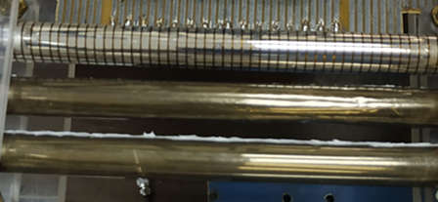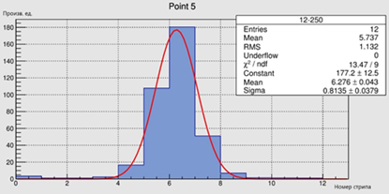

Fig. 1. General view of a straw tube with external strips (left). Distribution of signals on external strips when the tube is irradiated with a beta source (right).

The project will continue research work on the creation and testing of various types of microstructured gas detectors with resistive elements and coatings based on diamond-like carbon. An important task is to create stably operating detectors with high registration efficiency and capable of covering large areas. It is planned to develop technology for the production of microstructured gas detectors designed to operate under high beam rate. Gas detectors with parameters (gas gain greater than 20,000, energy resolution up to 20%, spatial resolution up to 200 μm) comparable to the best existing analogues with the possibility of production on the basis of DLNP JINR will be developed and created. Work will continue on the study of thin-walled straw detectors with resistive cathodes with data reading from external strips. Technology will be developed, prototypes of straw detectors with record thin walls will be created and studied in order to create detectors with a minimum amount of matter in the path of particles. This problem is of interest for the Mu2e-II experiment, which is considering the possibility of using straw detectors with a wall thickness of less than 12 microns, as well as for other experiments at planned accelerators.

II. Development, production and testing of prototypes of electromagnetic calorimeters.

One of the ways to increase high rate capacity and improve resolution is to create calorimeters with a high degree of granularity in the transverse and longitudinal directions. Granulation of calorimeters in the transverse direction is a standard method and is used in all experiments. Longitudinal granulation is less common, although such calorimeters have their advantages. Thus, if there are low- and high-energy particles in an event, the former will leave almost all of their energy in the first layer of the calorimeter. High-energy particles will leave part of their energy in the first layer, and the remaining energy will be released in the inner layers of the longitudinally granular calorimeter. This longitudinal granulation of cells may be useful for improving time and energy resolution in calorimeters in experiments planned at future colliders.

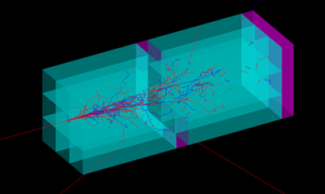

Fig. 2. Sample electromagnetic calorimeter with simulated showers. The prototype consists of two sections, each section is assembled from nine PbWO4-UF crystals measuring 1x1x4 cm³.

Longitudinal granulation can be extremely useful in electromagnetic calorimeters made from inorganic scintillators. The work [6] discusses prototypes of an electromagnetic calorimeter built using PbF2 and PbWO4-UF crystals with dimensions of 1x1x4 cm³. In addition to granularity in the transverse direction, determined by the 1x1 cm² cross-section of individual crystals, the calorimeter is also sectioned in depth. Each section is 4 cm long, and the number of sections may vary depending on the range of energy being measured. Signals from each section are readout using SiPMs and recorded independently. Figure 2 shows a prototype of a sectional electromagnetic calorimeter with simulated showers. Each section is assembled from 9 PbWO4-UF crystals measuring 1x1x4 cm³. We plan to conduct studies of prototype longitudinally segmented electromagnetic calorimeters using LYSO and other crystals to determine time and energy resolution. Research will be carried out using electron beams (Linac-200 at JINR and other centers). Such studies may be of interest to future experiments planned at Linac-200, as well as experiments at future colliders.

III. Radiation resistance of materials and electronics

One of the important areas of work is the search for radiation-resistant materials for use in advanced detectors. Previously, we conducted studies of the radiation resistance of organic and inorganic scintillators [7, 8], the results of which may be of interest for many experiments. Thus, when studying the radiation resistance of scintillation crystals of pure BaF₂ and those doped with yttrium, we discovered the effect of a greater loss of light output by the fast component compared to the slow one after irradiation with neutrons on channel No. 3 of the IBR-2M reactor, as shown in Fig. 3 [8]. Obviously, a more detailed study of this effect is required.
We plan to continue studying the radiation resistance of pure and yttrium-doped BaF₂ crystals, LYSO crystals, and others of interest.

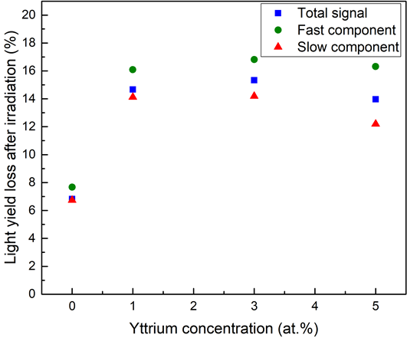
Fig.3. Loss of light output in samples of pure and yttrium-doped BaF2 crystals after neutron irradiation.

At the moment, wide-bandgap III-V semiconductors are the most promising material for the manufacture of radiation-resistant microwave devices in the space and nuclear industries. The measured displacement energy value for a GaN atom of 19.2 eV is relatively high compared to other widely used types of semiconductors (Si, GaAs, etc.) (see Fig. 4). Accordingly, this material has a higher resistance to external influences, including radiation.
The project proposes to manufacture amplifier samples based on discrete GaN and GaAs elements and perform an experimental comparison of the radiation resistance for these amplifiers , as well as to manufacture and test samples of integrated circuits manufactured using the GaN process on various types of substrates (Si, sapphire, SiC, etc.).

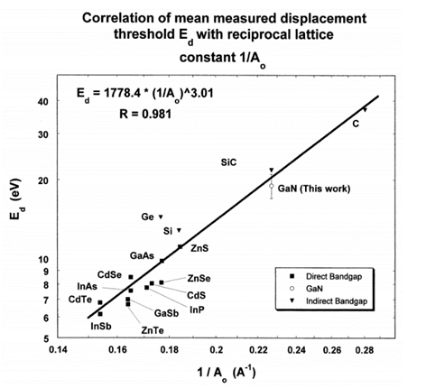

Fig.4. Measured displacement energy for various semiconductors as a function of the reciprocal lattice parameter. Higher values of displacement energy correspond to higher radiation resistance of the material [9].

A low-noise radiation-resistant front-end preamplifier for advanced calorimeters is of interest for many experiments operating in harsh radiation conditions. The design, modelling and manufacturing of a low-noise radiation-resistant preamplifier circuit using discrete GaN (GaAs) elements for silicon photomultipliers will be carried out. It is also planned to produce a low-noise radiation-resistant preamplifier in an integrated design using the GaN/GaAs process technology, with the prospect of use in various experiments.
As part of the project, it is planned to study the radiation resistance of various samples when irradiated with neutrons on the IBR-2M, electrons on the LINAC-200 beam, and gamma sources. BaF₂, LYSO:Ce (Lu_{2x}Y_{2-2x}SiO₅:Ce) crystals, individual components, and front-end electronics will be studied. These studies may be of interest for various experiments, including Mu2e-II, Comet (phase 2), and experiments at new planned accelerators.

IV. New scintillation materials for detecting thermal neutrons

To date, our group has completed a series of works on the creation of heterogeneous neutron scintillators based on lithium glasses [10]. A heterogeneous scintillator consists of lithium glass grains filled with an optical compound. Acrylic resin, epoxy resin, or silicone compound were used as optical fillers. During the simulation, the grain sizes of lithium glass varied from 0.2 mm to 0.8 mm. Heterogeneous scintillator samples with grain sizes of 0.3 mm and 0.4 mm were prepared. As a result of research, it was possible to reduce the sensitivity of such scintillators to the gamma background by two orders of magnitude compared to a homogeneous lithium glass scintillator while reducing the neutron detection efficiency to 50% (Figs. 5 and 6). The results were published in four publications and presented at Laboratory seminars.
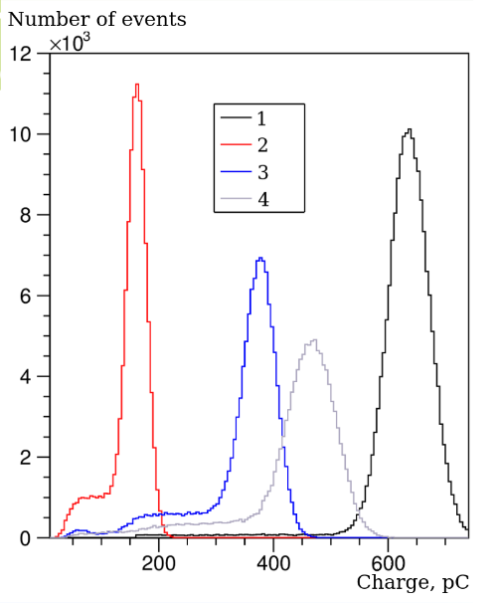

Fig. 5. Spectra of signals recorded in a beam of thermal neutrons from samples of heterogeneous scintillators with a concentration of glass fragments of 30%. Type of compound: 1 - monolithic glass; 2 - acrylic resin; 3 - epoxy resin; 4 - silicone compound.

In further research, when creating composites, granular neutron scintillators produced by the Russian Federation will be used, created on the basis of crystals of zinc sulfide, lithium fluoride and boron oxide. The scintillator structure will be modelled and optimized using the GEANT package, and samples will be manufactured and tested with neutron beams and gamma sources. Software will also be created to process signals from such scintillators.
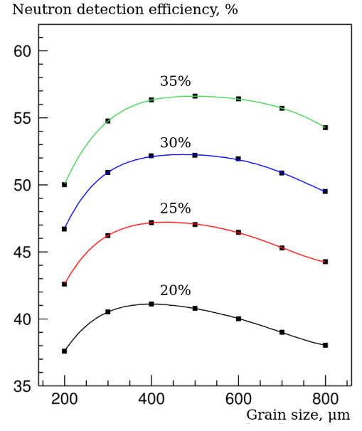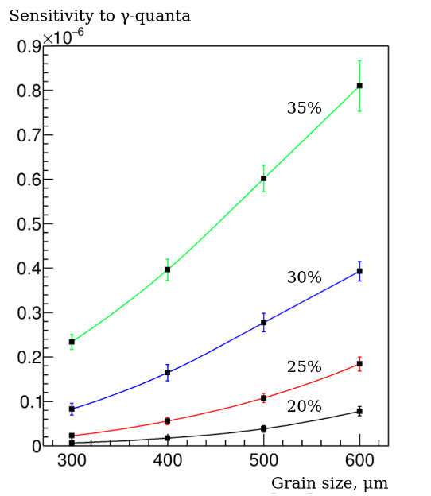
Fig.6. Thermal neutron detection efficiency and gamma ray sensitivity depend on lithium glass grain size and concentration.

The goal of these works is to create new scintillation materials with high neutron conversion efficiency, low gamma sensitivity and high transparency.

V. Optimizing the operation of scintillation detector systems

Participants in this project made a decisive contribution to the creation of a scintillation detector system for the muon trigger at the CDF facility (Fermilab, USA). Let us recall that this was the first case of using WLS optical fibers for large-sized scintillation detectors used not in calorimetric systems. A number of studies have also been carried out to investigate the natural aging of scintillators, which was successfully applied in further work. It was this experience that was used to carry out a large amount of work on the development and creation of a muon system (CRV) for the Mu2e experiment based on rectangular cross-section scintillation strips with signals readout using WLS fibers placed in holes in the scintillators [11]. Such modules are now installed in the Mu2e detector. A cross-section of the Mu2e CRV module is shown on the left side of Fig. 7. We created a similar prototype with fibers located in grooves for the Comet project.

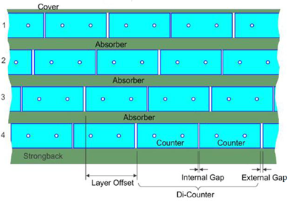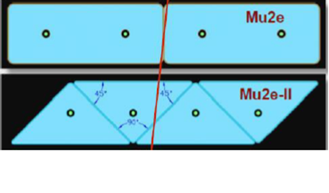
Fig.7. A cross-section of the CRV module of the Mu2e experiment (left). On the right is a comparison of CRV system options made from strips with rectangular and triangular cross-sections.

Increases in muon beam intensity by an order of magnitude in the future Mu2e-II and Comet (phase 2) data sets will require upgrades to existing detectors. Mu2e is looking at triangular-shaped scintillators as an alternative that can improve performance and provide the required detection efficiency in harsh radiation environments.

It is planned to conduct a study with strips of triangular cross-section to evaluate light collection depending on the distance from the center of the strip to the particle track (transverse scanning) with cosmic muons and with a radioactive source. The efficiency of a module consisting of four layers of triangular strips will be simulated and compared with the efficiency of a similar module made of rectangular cross-section scintillation strips. As a result of the work carried out, the applicability of modules based on strips with a triangular cross-section for the second phase of the Mu2e-II project will be assessed. These results may also be useful for the CRV system of the COMET project in phase 2, as well as for other experiments using muon systems.
Also of great interest are studies of the “scintillator+SiPM+fron-tend” system with the goal of minimizing response time (increasing detector speed) and achieving a time resolution of 50 ps. These developments will be carried out using SiPMs from various manufacturers. Such studies may be of interest for many experiments where time stamping is required.

VI. Development and application of Monte Carlo methods for modelling prototypes of electromagnetic and hadronic calorimeters

Participants in the proposed project previously made a decisive contribution to the design, development of methods for testing the hadron tile calorimeter of the ATLAS experiment and obtaining test results from it, as well as the assembly of the calorimeter in the cavern of the Large Hadron Collider (LHC) and its commissioning [12].
A series of detailed studies of the characteristics of the prototype and real modules of the hadronic tile calorimeter (Fig. 8) was carried out, as well as together with an electromagnetic liquid-argon calorimeter - a combined calorimeter - under irradiation with beams of pions, protons, electrons, and muons with energies from 3 to 350 GeV of the SPS accelerator (CERN) [13,14].

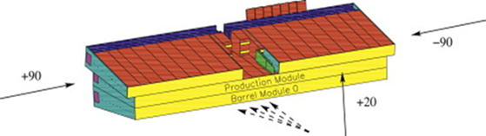

Fig.8. Scheme of assembly of hadronic tile calorimeter modules for testing.

In the course of studying the parameters of the tile calorimeter, the energy scale of the calorimeter was determined. In this case, the front cells were scanned at an angle of 20°, and at pseudo-rapidity, the cells of the lateral sides were scanned at an angle of 90° (Fig. 8). Energy linearity and energy resolution were measured.
The distribution of the normalized response of the calorimeter to pions as a function of energy is obtained. The non-compensated value of the calorimeter is e/h=1.33±0.06±0.02, which is typical for iron scintillation calorimeters.
Studies have been carried out on the transverse and longitudinal profiles of hadron showers recorded by the prototype calorimeter and the combined ATLAS calorimeter [15,16]. Using fine scanning with a pion beam at an energy of 100 GeV, a detailed picture of the behavior of the transverse and longitudinal profiles of the hadron shower was obtained. The radial energy densities were restored for four sections along the depth of the calorimeter and for the entire calorimeter. A three-dimensional parametrization of the hadron shower has been developed, and a formula has been derived to describe the hadron shower from the beginning of the calorimeter.
A nonparametric method for recovering the energy of a combined calorimeter [17] was also developed and applied, which uses the known uncompensated ratios of calorimeters and electronic calibration constants. This method does not require defining any parameters using minimization and can easily be used as a first-level trigger.
A method has been developed for determining the non-compensation of electromagnetic calorimeters. The non-compensation of the central electromagnetic calorimeter of the ATLAS experiment was determined, which was e/h=1.74±0.04.
The evolutionary algorithm was applied by the participants of the proposed project to optimize the hyperparameters of an artificial neural network designed to separate the pp → tH signal from background events. Optimization was performed separately for the Standard Model signal and the signal for the case beyond the Standard Model.

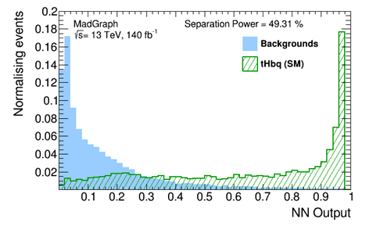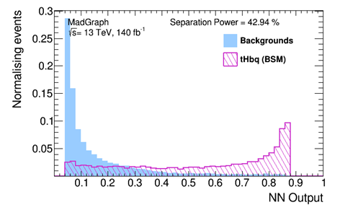

Fig.9. Normalized distribution of network response for training and test samples for the SM signal (left) and for the signal beyond SM (right).

The normalized distribution of the neural network response for the training and test samples for the Standard Model signal and for the signal beyond the Standard Model is shown in Fig. 9. Here, the NN output neural network response with hyperparameters optimal for the SM signal is shown, and the separation power is calculated using the formula:
$$Separationpower=\frac{1}{2}\left(\frac{\sum_{i=0}^{nbins}{{\left(s_{i}-b_{i}\right)}^{2}}}{s_{i}+b_{i}}\right)×100$$

So, extensive experience in working with electromagnetic and hadron calorimeters was accumulated by the participants in this project in the ATLAS experiment at the Large Hadron Collider. The following new methods were developed and applied to study the properties of electromagnetic and hadronic calorimeters:

- A precision non-parametric method for measuring energy in a calorimetric complex, which made it possible to achieve record energy linearity.
- A method for measuring the non-compensation of an electromagnetic calorimeter, which made it possible to measure the amount of non-compensation for the ATLAS liquid-argon electromagnetic calorimeter.
- A method for three-dimensional parameterization of a hadron shower, which made it possible to measure the radial energy density of a hadron shower depending on its longitudinal coordinate.
- Method for describing the longitudinal density of a hadron shower in a combined calorimeter.
- A method was developed and, on its basis, electromagnetic calibration of hadron calorimeter modules was carried out in electron beams with energies from 10 to 350 GeV, which made it possible to establish the energy scale of the calorimeter with excellent accuracy.
- A modification of the local hadronic calibration method for combined calorimeters was developed, which made it possible to obtain record energy resolution and linearity for the created calorimetric complex.
- A neural network method for calculating energy losses in the dead matter of the calorimetric complex was developed and applied in the analysis of experimental data, which made it possible to significantly improve the energy resolution of the calorimetric complex.
- Experimental studies of the linearity, energy resolution, non-compensation, and leakage of the hadron shower beyond the hadronic and combined (electromagnetic and hadronic) calorimeters were carried out in beams of electrons, muons, pions and protons with energies from 3 to 350 GeV at the SPS accelerator.

Currently, the preparation of several accelerator projects is being considered (SCT Factory in Russia, STCF and CEPC in China). JINR has expressed interest in participating in experiments at these accelerators, in the experimental facilities of which calorimeters will occupy an important place.
Within the framework of the proposed project, it is planned to perform the following tasks for modelling, studying the properties, and optimizing electromagnetic and hadronic calorimeters that will arise during the development of calorimeters in experiments at SCT, STCF, and CEPC:

- Creation of software for a detailed description of electromagnetic and hadron calorimeters using the GEANT4 package and for modelling their response to electrons and hadrons using modern Monte Carlo generators. The task will be performed for several options of calorimeters for experiments at future colliders.
- Conducting an analysis of simulated data to determine the influence of dead matter in the design of electromagnetic and hadronic calorimeters on the energy resolution and linearity of the calorimeter response.
- Optimization of the design and construction of electromagnetic and hadronic calorimeters based on the results of the conducted research in order to improve their characteristics. Calorimeters for experiments at future colliders will be considered.
- Study of the properties of prototypes and full-scale electromagnetic and hadronic calorimeters depending on the energy, angle of incidence, and pseudo-rapidity of particles with full modelling of proton-proton, proton-deuteron, deuteron-deuteron, proton-nuclear, and nucleus-nucleus interactions in order to develop and implement effective methods of reconstruction of the calorimeter response to particles and jets.

Expected results

As a result of the project, the following tasks will be solved:

1) Microstructural gas detectors of the Micromegas type with a gas gain of more than 20,000, energy resolution up to 20%, spatial resolution up to 200 μm, and well-type (WEM) with a resistive anode coating will be developed and studied. Straw detectors with resistive cathodes and readout from external strips are to be developed. A manufacturing technology will be developed, and prototypes of straw detectors with a wall thickness of 12 microns or less will be created and studied.
The work completion period is 2025-2029.

2) Prototypes of a sectional electromagnetic calorimeter using LYSO and other types of crystals will be modelled, created, and tested.
The completion date for the work is 2025-2029.

3) New data will be obtained on the radiation resistance of crystals used in electromagnetic calorimeters. Electronic circuits will be developed, and low-noise radiation-resistant preamplifiers based on discrete GaN (GaAs) elements for SiPM will be modelled, manufactured, and tested for radiation resistance. These studies are of interest for experiments performed at high intensities, including those at HL-LHC, Mu2e-II, and others.
The work completion period is 2025-2029.

4) Simulation of a muon system based on triangular cross-section scintillators will be carried out, prototypes will be created and investigated, and their parameters will be compared with the parameters of similar systems with rectangular cross-section scintillators. The work is of interest primarily for Mu2e-II and Comet (phase 2), as well as other experiments using muon veto systems.
The work completion period is 2025-2028.

5) An optimization will be carried out, and a “scintillator + SiPM + front-end electronics” system with high speed and a time resolution of 40-50 ps will be created.
The work period is 2025-2028.

6) New heterogeneous detectors will be developed to detect thermal neutrons with sensitivity to gamma rays suppressed by 2-3 orders of magnitude.
The work period is 2025-2027.

7) The design will be developed, prototypes of electromagnetic calorimeter modules will be created, they will be studied with cosmic muons and on accelerator beams, and test results will be studied in comparison with predictions of Monte Carlo models for prototypes and full-scale electromagnetic calorimeter modules. For this purpose, software will be developed for Monte Carlo simulation and analysis of experimental data for prototypes and full-scale modules of electromagnetic calorimeters for planned experiments at future accelerators (STCF, CEPC).
The work completion period is 2025-2029.

8) The properties of prototypes and full-scale electromagnetic and hadron calorimeters will be studied depending on the energy, angle of incidence, and pseudo-rapidity of particles with full simulation of proton-proton, proton-deuteron, deuteron-deuteron, proton-nuclear, and nucleus-nucleus interactions in order to develop and implement effective methods for reconstructing the calorimeter response to particles and jets under future experimental conditions.
The work completion period is 2025-2029.

9) Simulated data will be analyzed to determine the amounts of dead matter in the design of electromagnetic and hadronic calorimeters and their impact on the energy resolution and linearity of the response of calorimeters for experiments at future accelerators (STCF, CEPC).
The work completion period is 2025-2029.

The results obtained during the work within the framework of the project will be included in at least 5 master's theses and at least 3 PhD theses.

Risks

The risks of failure to complete the project in full include insufficient funding and logistical problems with the acquisition of materials and equipment for creating prototype detectors. The risk of not achieving the planned time resolution in a “scintillator + SiPM + front-end electronics” system also includes the inability to use some types of SiPM. The risk of failure in creating prototype straw detectors with wall thicknesses less than 12 microns is associated with the likelihood of not obtaining aluminized Mylar of the required thickness and quality.
The strengths of the project, of course, include the extensive experience in simulation, development of software, simulation methods and data analysis, development of new detectors and methods for their research that the project participants have. The strength of the project is also the availability of a beam of electrons (Linac-200) and neutrons (IBR-2M), as well as a certified laboratory for working with radioactive sources.

References:

1. Project of Super c-tau Factory, https://ctd.inp.nsk.su/c-tau/.
2. STCF, Conceptual Design Report, https://arxiv.org/abs/2303.15790.
3. CEPC, Circular Electron Positron Collider, http://cepc.ihep.ac.cn/.
4. V.G. Baev et al., Improving the robustness of Micromegas detector with resistive DLC anode for the upgrade of the TPC readout chambers of the MPD experiment at the NICA collider. Nucl.Instrum.Meth.A 1031 (2022) 166528
5. V.V. Akulich et al., Straw with Resistive DLC Cathode and Cathode Readout, Instrum.Exp.Tech. 66 (2023) 6, 896-903.
6. C.Cantone et al., Front. Phys. 11:1223183 (2023).
7. V. Baranov et al., Effects of neutron radiation on the optical and structural properties of blue and green emitting plastic scintillators, NIM B436, 236-243 (2018).
8. V. Baranov, Yu.I. Davydov, I.I. Vasilyev, Light outputs of yttrium doped BaF₂ crystals irradiated with neutrons, JINST 17 (2022) 01, P01036.
9. A. Ionascut-Nedelcescu, C. Carlone et al., “Radiation Hardness of Gallium Nitride”, IEEE TNS, vol. 49, no. 6, Dec. 2002.
10. E. S. Kuzmin, G. D. Bokuchava, I. Yu. Zimin, A. A. Kruglov, and N. A. Kuchinsky, Instrum. Exp. Tech., 2022, Vol. 65, No. 4, pp. 583. DOI: 10.1134/S0020441222040212.
11. L. Bartoszek et al., (Mu2e Collaboration). Mu2e Technical Design Report, e-Print: 1501.05241 [physics.ins-det] 2015.
12. P.Adragna et al, The ATLAS hadronic tile calorimeter: From construction toward physics; Trans. Nucl. Sci. 53 (2006) 1275-1281.
13. E.Abat et al, Response and Shower Topology of 2 to 180 GeV Pions Measured with the ATLAS Barrel Calorimeter at the CERN Test–beam and Comparison to Monte Carlo Simulations, ATL-CAL-PUB-2010-001.
14. ATLAS Collaboration; Results from a new combined test of an electromagnetic liquid argon calorimeter with a hadronic scintillating-tile calorimeter, NIM A 449 (2000) 461-477.
15. Y.A.Kulchitsky, V.B.Vinogradov, Analytical representation of the longitudinal hadronic shower development, NIM A413 (1998) 484-486, JINR-E1-98-47, hep-ex/9903019.
16. ATLAS TileCal Collaboration, Hadronic shower development in iron scintillator tile calorimetry, NIM A443 (2000) 51-70.
17. Y.A.Kulchitsky et al, Hadron energy reconstruction for the ATLAS barrel prototype combined calorimeter in the framework of the non-parametrical method, JINR-E1-2000-73, hep-ex/0004009.

2.3 Estimated completion date: 2025-2029

2.4 Participating JINR laboratories: DLNP, VBLHEP, FLNP.
2.4.1 MICC resource requirements
Computing resources | Distribution by year
 | 1st year | 2nd year | 3rd year | 4th year | 5th year
Data storage (TB)
- EOS
- Ribbons
Tier 1 (core-hour)
Tier 2 (core-hour)
SC Talker (core-hour)
- CPU
- GPU
Clouds (CPU cores)

2.5. Participating countries, scientific and educational organisations

Organisation | Country | City | Participants | Type  of agreement
IP NASB | Belarus | Minsk | Kurochkin Yu.A. +3 | Collaboration
INP BSU | Belarus | Minsk | Misevich O.V. +3 | Collaboration
IE NASB | Belarus | Minsk | Baev V. +3 | Collaboration
IP, Min. Science and Education | Azerbajan | Baku | Nagiev S. +3 | Collaboration
SamSU | Uzbekistan | Samarkand | Safarov A.N.+3 | Collabortaion
LNF | Italy | Frascati | Miscetti S. +5 | Collaboration

2.6. Co-executing organisations (those collaborating organisations/partners without whose financial, infrastructural participation the implementation of the research programme is impossible. An example is JINR's participation in the LHC experiments at CERN).

3. Staffing
3.1. Staffing needs in the first year of implementation

№№  n/a | Category  employee | Core staff,  Amount of FTE | Associated  Personnel  Amount of FTE
1. | scientific staff | 15.7
2. | engineers | 3.8
3. | professionals
4. | employees
5. | workers
 | Total: | 19.5

3.2. Human resources available
3.2.1. JINR core staff

№№  п/a | Category  of employees | NAME | Division | Position | Amount  of FTE
1. | scientific staff | Davydov Yu.I. | DLNP | Head of dept. | 0.7
2. |  | Artikov A.M. | DLNP | Head of sector | 0.8
3. |  | Atanov N.V. | DLNP | Researcher | 0.7
4. |  | Atanova O.S. | DLNP | Junior researcher | 0.7
5. |  | Afanaciev K.G. | DLNP | Researcher | 0.8
6. |  | Baranov V.Yu. | DLNP | Researcher | 0.8
7. |  | Boikov A.V. | DLNP | Junior researcher | 0.6
8. |  | Vasilyev I.I. | DLNP | Researcher | 0.7
9. |  | Gritsay K.I. | DLNP | Researcher | 0.3
10. |  | Guseinov N.A. | DLNP | Senior researcher | 0.7
11. |  | Zimin I.Yu. | DLNP | Researcher | 0.8
12. |  | Kiseeva V.I. | DLNP | Junior researcher | 0.7
13. |  | Krylov V.A. | DLNP | Researcher | 0.3
14. |  | Kravchuk N.P. | DLNP | Senior researcher | 0.8
15. |  | Kulchitsky Yu.A. | DLNP | Head of sector | 0.5
16. |  | Kuchinsky N.A. | DLNP | Senior researcher | 0.7
17. |  | Malyshev V.L. | DLNP | Researcher | 0.7
18. |  | Plotnikova E.M. | DLNP | Researcher | 0.5
19. |  | Simonenko A.V. | DLNP | Senior researcher | 0.8
20. |  | Suslov I.A. | DLNP | Senior researcher | 0.5
21. |  | Tereshko P.V. | DLNP | Researcher | 0.5
22. |  | Tropina A.I. | DLNP | Junior researcher | 0.7
23. |  | Khomutov N.V. | DLNP | Researcher | 0.6
24. |  | Chokheli D. | DLNP | Senior researcher | 0.4
25. |  | Bulavin M.V. | FLNP | Head of sector | 0.1
26. |  | Enik T.L. | VBLHEP | Head of group | 0.1
27. |  | Kolesnikov A.O. | VBLHEP | Head of service | 0.1
28. |  | Movchan S.A. | VBLHEP | Head of sector | 0.1
29. | engineers | Kuzmin E.S. | DLNP | Senior engineer | 1.0
30. |  | Moskalenko V.D. | DLNP | engineer | 1.0
31. |  | Rogozin V.A. | DLNP | engineer | 1.0
32 |  | Shalyugin A.N. | DLNP | Senior engineer | 0.8
 | professionals
 | workers
 | Total: |  |  |  | 19.5

3.2.2. JINR associated personnel

№№  п/a | Category of employees | Partner organisation | Amount of FTE
1. | Scientific employees
2. | engineers
3. | professionals
4. | workers
 | Total:

4. Financial support
4.1 Total estimated cost of the project/sub-project of the LRIP
Forecast of the total estimated cost (specify cumulatively for the whole period, excluding FPC).
The details are given in a separate form.

400000 $US for 5 years

4.2 Extrabudgetary funding sources
Estimated funding from co-executors/customers - total.

Project (sub-project of the LRIP) Leader __________/_Davydov Yu.I.__/

Date of submission of the project (sub-project of the LRIP) to DSOA: _________
Date of decision of the laboratory's STC: _25.04.2024__ document number: _#2024-7__
Year of the project (subproject of the LRIP) opening: _____2025_______
(for renewable projects) -- Project start year: _______

Schedule proposal and resources required for the implementation
of the Project / Sub-project of the LRIP
Names of costs, resources,  sources of funding |  |  | Cost (thousands  of dollars)  resource requirements | Cost,  distribution by year
 |  |  |  | 1st year | 2nd year | 3rd year | 4th year | 5th year
 |  | International cooperation (IC) | 100 | 20 | 20 | 20 | 20 | 20
 |  | Materials | 300 | 80 | 70 | 60 | 45 | 45
 |  | Equipment and third-party services (commissioning)
 |  | Commissioning work
 |  | Services of research organisations
 |  | Acquisition of software
 |  | Design/construction
 |  | Service costs (planned in case of direct project affiliation)
Resources required | Normo-hours | Resources
 |  | - the amount of FTE,
 |  | - accelerator/installation, | 750 | 150 | 150 | 150 | 150 | 150
 |  | - reactor,…. | 1500 | 300 | 300 | 300 | 300 | 300
Sources of funding | Budgetary resources | JINR budget (budget items) | 400 | 100 | 90 | 80 | 65 | 65
 | Extrabudgetary (supplementary estimates) | Contributions by  co-contractors  Funds under contracts with customers  Other sources of funding

Project (sub-project of the LRIP) Leader_________/_Davydov Yu.I._/

Laboratory Economist _________/_Usova G.A._______/

APPROVAL SHEET FOR PROJECT
Development of a particle registration technique in future experiments with the participation of JINR
DESIGNATION OF THE PROJECT
PROJECT CODE
THEME CODE
NAME OF THE PROJECT LEADER: Davydov Yu.I
AGREED
JINR VICE-DIRECTOR | ___________  SIGNATURE | Kekelidze V.D.  NAME | _________  DATE
CHIEF SCIENTIFIC SECRETARY | ___________  SIGNATURE | Nedelko S.N.  NAME | _________  DATE
CHIEF ENGINEER | ___________  SIGNATURE | Gikal B.N.  NAME | _________  DATE
LABORATORY DIRECTOR | ___________  SIGNATURE | Yakushev E.A.  NAME | _________  DATE
CHIEF LABORATORY ENGINEER | ___________  SIGNATURE | Yakovenko S.L.  NAME | _________  DATE
LABORATORY SCIENTIFIC SECRETARY  THEME LEADER | __________  SIGNATURE | Simonenko I.V.  NAME | _________  DATE
PROJECT LEADER | ___________  SIGNATURE | _________  NAME | _________  DATE
 | ___________  SIGNATURE | Davydov Yu.I.  NAME | _________  DATE
APPROVED BY THE PAC | ___________  SIGNATURE | _________  NAME | _________  DATE

