**SCIENTIFIC AND TECHNICAL REPORT**

**SCIENTIFIC THEME 02-0-1127-2016/2021 in 2016–2018**

**Advanced Studies on Systems of New-Generation Accelerators and Colliders for Fundamental and Applied Research**

**Theme leader G. Shirkov**

**Deputy theme leader J. Budagov**

**Abstract**

Theme urgency

The given theme is a development of the 02-0-1067-2007/2015 theme “Advanced Studies in New Generation of Electron-Positron Accelerators and Colliders for Fundamental and Applied Research”. R&D in the scope of accelerator elements and devices in the field of precision laser metrology, photoinjecting systems, electron linacs and free electron lasers are being successfully conducted in the frame of the theme. In addition, the theme includes preparation of the proposals of the JINR participation in international collaborations for future high-energy colliders and the engineering education programs in various accelerator technics fields.

Main activities

*Precision Laser Metrology for Accelerators and Detector Complexes* involves the development of new metrological instruments and upgrading of the existing ones, i.e.:

* distributed network of six Precision Laser Inclinometers
* the Interferometric Distance Meter on the basis of high-frequency amplitude modulation of the laser beam power;
* The 130 m Laser Fiducial Line adapted to the conditions of the DLNP Metrological Laboratory.
* an additional activity: the operating prototype of the Research Platform in the DLNP Metrological Laboratory, seismologically-stabilized from angular oscillations of the Earth surface.

The proposed new concept metrological devices, as it is supposed, will make the new generation basis of the future elemental robotic measuring system in experiments at the Large Hadron Collider.

*Photoinjecting systems R&D* is dedicated to the development of the JINR introduced “transmission” conception (backside illuminated cathode based on a quartz/sapphire plate or a metal mesh which is a substrate for thin film made of a photomaterial). Investigations of the quantum efficiency of the perspective photocathodes fabricated in collaboration with IEE SAS (Slovakia, Bratislava) are being conducted at the photogun bench (electron energy of up to 30 keV). Photoinjector prototype (electron energy of up to 400 keV and the unique laser driver developed in collaboration with IAP RAS) construction is being continued.

*Electron linac program* is dedicated to the development, achievement of the designed parameters and commissioning of the LINAC-200 electron accelerator, and its experimental and education applications.

*Free electron lasers R&D* includes studies of FEL physics, development and construction of diagnostic and accelerator systems applied for ultra-short dense bunches in the linear electron accelerators.

**List of activities**

1. Project: The Precision Laser Metrology for Accelerators and Detector Complexes (leader J. Budagov, deputy M. Lyablin).
2. LINAC-200 electron accelerator (leaders G. Shirkov and V.V. Kobets).
3. Photoinjecting systems R&D (leaders N. Balalykin, M. Nozdrin).
4. Free electron lasers R&D (leaders E. Syresin, O. Brovko, M. Yurkov).
5. Preparation of the proposals and start of the JINR participation in international collaborations for future high-energy colliders (leaders G. Shirkov, A. Kovalenko).

**Results expected upon completion of the theme**

1. Creation of the NETWORK of 6 Precision Laser Inclinometers (PLI), creation of the prototype of Amplitude Interferometric Distance Meter for the length of 16 m, creation of the prototype of Laser Fiducial Line for the length of 130 m, creation of the prototype of Seismically-stabilized Research Platform based on PLI.
2. Investigation of the various carbon-based transmission photocathodes (mainly carbon-based), installation of the second beamline with the 213 nm laser at the photogun bench, development of the photoinjector bench: 150 keV electron energy achievement, development of the radiation safety, interlock and control systems.
3. Development, design parameters achievement and commissioning of the LINAC-200 linear electron accelerator with the aim of its experimental and education applications. Optimization of the accelerator parameters for users.
4. Maintenance of the FLASH infrared undulator and participation in its experimental program, as well as in the new undulator development; development of photon diagnostic for FLASH, FLASH2 and XFEL and experiments participation. Experimental investigations at formation of 3D ellipsoidal shape electron bunches with small emittances in PITZ with new laser system.
5. Preparation of the proposals and start of the JINR participation in international collaborations for future high-energy colliders.
6. **Project: The Precision Laser Metrology for Accelerators and Detector Complexes**

**(leader J. Budagov, deputy M. Lyablin).**

Urgent issues of modern high energy physics and progress in accelerator technology resulted in the development of a unique research complex: the collider LHC with spectrometric systems ATLAS, CMS, ALICE. At present the diameter of the beams focused in the zone of their collisions in these experiments is 20 µm. This value defines the “precision scale” of metrological instruments applied in collider experiments. In the increased radiation conditions at the LHC, metrological measurements are supposed to be possible if remote-controlled robotic complexes are available.

Taking into account the collider dimensions (8.5 km), the spectrometer dimensions (ATLAS –46 m long, diameter 25 m), tough radiation conditions we can suppose that, probably, the laser beam will be the only “measuring instrument” that will allow the necessary precision.

On the basis of completed R&D’s and achieved experimental results of 2016-2018 [1-8], in the extension (2019-2021) of the Project we propose three metrological instruments: the Precision Laser Inclinometer (PLI), the Interferometric Distance Meter (IDM), the Laser Fiducial Line (LFL). These new instruments are supposed to form the elemental basis of the remote-controlled Robotic Measuring Complex (RMC).

Measurement of the dimensional stability of the wall and floor position in the ATLAS measurement hall showed their high instability [9]: for the floor – 150 µm per year, for walls 500 µm per year. Practically, less than in a month such considerable geodesic change takes place in the experiment net that need renovation. In short periods when the collider experiments shut down the measurements are impossible or very difficult; RMC proposed in the Project can improve the situation.

The Precision Laser Inclinometer developed at DLNP is the world first angular seismograph that registers microseismic oscillations of the Earth surface with the accuracy of 2.4∙10 11 rad/Hz1/2 in the frequency range [10 6 Hz;4 Hz], that provides registration of all known microseismic phenomena. Two inclinometers have been launched and measure steadily angular inclinations of the Earth surface in tunnel TT1 at CERN (Geneva, Switzerland) and in the International Geophysical Observatory (Garni, Armenia). In 2018 the development of working samples of six PLI will be finished that will make the basis of the first in the world Distributed Network of Detector of angular oscillations of the Earth surface.

In the activities on the IDM the measurements on the short-distances about 10 micron have been realized with achieved measurement accuracy of 0.03 µm. We introduced this method into the practically used procedure of the PLI calibration. As for today, a prototype of 5 m IDM has been developed in the thermo-isolated laboratory; the full scale scientific research cycle will be finished in the DLNP Metrological Laboratory which is under completion.

The LFL measurements showed full possibility to integrate of this method in existing theodolitic measurements. The accomplished experiments in the 50 m length in aerial environment showed coincidence of data with the theodolitic system in the error limit of theodolitic measurements of 30 µm [10].

In DLNP the development of a metrological laboratory is coming to its finish; it is equipped with a precision climate system of aerial environment in the volume of 23×6×3 m3.

1. **LINAC-200 electron accelerator (leaders G. Shirkov and V.V. Kobets).**
2. The 4th accelerating station beamline was assembled, vacuum tests were performed. The designed residual gas pressure of 3×10-8 Torr is reached. The reworked klystron modulator control units of fourth stations were developed, fabricated and mounted. Accelerating station feeder system was mounted at the nominal position. Cooling systems of the two accelerator klystron stations were modernized. Preparation works at 3rd and 4th accelerating stations were finished.

**Accelerator construction completed, startup was carried out (August 2017).** Maximum obtained current and charge values after 4 accelerating sections (see Fig. 1) are presented in Table 1 (pulse length 2 μs). 25 Hz repetition rate operation started.

|  |
| --- |
|  |
| Fig 1. Schematic layout of the Linac-200 electron accelerator and the obtained current values after each accelerating station. |

1. Users’ experiments:
   1. Beam tests of crystal scintillators for Mu2e experiment using extremely low intensity electron beam.
   2. Study of radiation hardness of GaAs and Si pad detectors. The study is a part of R&D of forward calorimeter for the experiments at the future electron-positron colliders in the frame of the FCAL international collaboration. Remarkably, the accelerator successfully operated at 10 Hz repetition rate for 5–8 hours almost every day during 1.5 months during this beam test, which is the first run of such duration since the delivery from NIKHEF.

**Table 1. Linac-200 current and charge values at different energies**

|  |  |  |  |
| --- | --- | --- | --- |
| **Acc. section** | **Energy, MeV** | **Pulse current, mA** | **Charge, nC** |
| **A0BB** | 22 | 10 | 20 |
| **B2AA** | 50 | 5 | 10 |
| **B4A** | 110 – 120 | 3 | 6 |
| **A6A** | 200 | 1.5 | 3 |

A set of dedicated hands-on engineering courses aimed at preparing students for work at Linac-200 was developed: Electronics, RF Technology, Vacuum Technology, Controls and Automation, Nuclear Physics and Dosimetry.

Mounting of the first stage of the Linac-200 electron accelerator training beamline is completed. (Fig. 1). First beam was observed (Fig. 2): current of 400 µA, charge of 800 pC [1].

|  |  |
| --- | --- |
|  | Автоматически созданный замещающий текст: јј 2јіѕ —1.9200јіѕ  N, Ostop  25/ 25 1ОО% ‘ : Г : ПtіІіtіеѕ Copy . . . . . : : Config. СаІіЬгаtіоп ...... ГЅе .  Сїіј) DC 400мV Пї1О.ОмV 2:5.OOmV BW З:20.ОмV 8Ч 4: ІООмУ OW Renote DC5OQ  С5ОQ DCEOQ DCSOQ 01ѕ —20@ 4 lOJliWots —ЗЗ2іWоfѕ —19Вмј ____ 1:1.03422Нz 25МЅ 500 points RТС:2016/12/О7 17:23:45 |
| Fig. 1. Overview of the Linac-200 training beamline. | Fig. 2. First beam (yellow) at the training beamline. |

References

1. M.A. Nozdrin et al. Proc. IPAC2017, 2455–2457.

**3. Photoinjecting systems R&D (leaders N. Balalykin, M. Nozdrin).**

1. Photoinjector support was designed and manufactured. Main photoinjector systems (vacuum, diagnostics, HV) were mounted and commissioned [1]. Photoinjector beamline was assembled and passed vacuum tests. The residual gas pressure of 6.5×10-8 torr was reached. Laser driver beam to photocathode transportation line was mounted. Startup of the photoinjector bench was carried out (April 2017) [2]. Charge of 15 nC (in the bunch train) was extracted. This corresponds to 200 mA bunch (τ = 10 ps) current, 20 µA bunch train (τ = 800 µs) current and 150 nA average current (f = 10 Hz). Experiment setup is shown at Fig. 1, current pulse oscillogram — at Fig. 2.
2. The second emittance measurement station based on multi-wire detectors was launched at the photogun bench. Experimental estimation of the transverse emittance vs bunch charge was conducted (Fig. 3).

|  |  |
| --- | --- |
|  |  |
| Fig. 1. Photoinjector bench startup setup scheme | Fig. 2. Bunch train current (ch2) |

|  |
| --- |
|  |
| Fig. 3. Experimental estimation of the transverse emittance [mm mrad] vs bunch charge [pC]. |

1. Various transmission photocathodes investigations in collaboration with IEE SAS (Bratislava, Slovakia) were conducted:
   1. Transmission photocathodes based on quartz glass coated with N or P‑doped SiC thin films prepared by HWCVD technology [3].
   2. Transmission photocathodes based on stainless steel mesh and quartz glass coated with N-doped DLC films prepared by reactive magnetron sputtering [4].
   3. PECVD silicon carbide films on quartz glass as prospective transmission photocathodes [5].
   4. Reactive magnetron sputtering of N-doped carbon thin films on quartz glass for transmission photocathode applications [6].
2. The new beam imaging setup [7] was tested for laser beam visualization at the photogun bench (including virtual cathode setup) and electron beam visualization at Linac-200 accelerator. The setup is based at the high-sensitivity CCD camera Prosilica GC1380, DESY developed AVINE software suite is used for imaging. The laser beam image at the virtual cathode is shown at Fig. 4, the Linac-200 beam image — at Fig. 5.

|  |  |
| --- | --- |
|  |  |
| Fig. 4. LS-2134 laser beam at the virtual cathode. | Fig. 5. Linac-200 beam. |

References

1. N.I. Balalykin et. al. PEPAN letters, Vol. 13, No. 7 (2016).
2. N.I. Balalykin et al. To be published in PEPAN letters in 2018.
3. J. Huran et al. Proc. ADEPT 2015.
4. N.I. Balalykin et al. J. Phys. Conf. Ser. 700 012050 (2016).
5. J. Huran et al. Proc. ADEPT 2017.
6. N.I. Balalykin et al. To be published in J. Phys. Conf. Ser. in 2018.
7. M.A. Nozdrin et al. Proc. PCaPAC 2016.
8. N.I. Balalykin et al. Physics–Uspekhi 60 (10) 1051–1058 (2017).

**4. Free electron lasers R&D (leaders E. Syresin, O. Brovko, M. Yurkov).**

JINR constructed and installed FLASH infrared undulator (Fig.1). JINR experts participated in experimental investigations at the FLASH with infrared undulator and measurements of longitudinal bunch profile on basis of this radiation.



Fig. 1 Infrared undulator constructed at JINR and installed in FLASH.

JINR experts designed, tested, installed and upgraded the microchannel plate detectors (MCP) detector (Fig.2) at the FLASH. JINR performs maintenance and upgrade of the MCP detector at FLASH. JINR experts participate in experiments with MCP-detector at the FLASH operated at wave length of 6-50 nm for diagnostic of electron bunches.

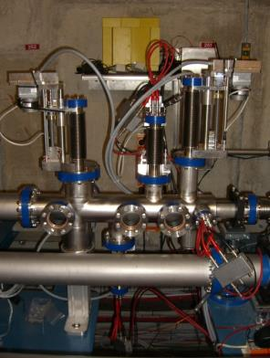

Fig. 2 MCP detector in FLASH (DESY).

Design, manufacturing of electronics, assembling, test and installation of the MCP detector (Fig.3) at FLASH2 was performed by JINR. JINR performs maintenance and participate in experiments with the MCP detector at FLASH2 and investigation of SASE regime in FLASH2



Fig. 3 MCP detector in FLASH2 (DESY).

JINR developed MCP detectors operating in X-ray energy range for XFEL. Test experiments with XFEL microchannel plate detectors (Fig.4) on synchrotron sources PETRA III were performed.

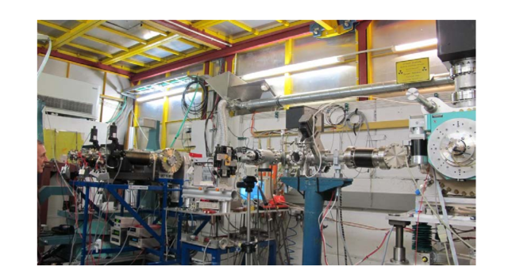

Fig. 4 XFEL MCP detector during PETRA III (DESY) test experiments.

The detectors of microchannel plates were installed in XFEL tunnel for SASE1 and SASE3 lines, first experiments with XFEL SASE1 microchannel plate detector operated at wave lengths of 0.05-0.4 nm were performed.

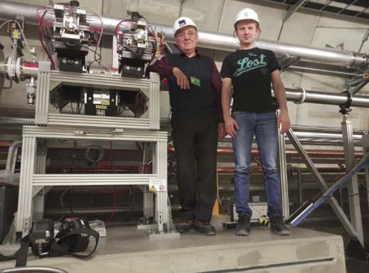

Fig.5 SASE 1 MCP detector in XFEL tunnel

IAP RAN in collaboration with JINR were developed laser system applied for formation 3D ellipsoidal laser pulses in PITZ photo injector system. Experimental investigations were done at formation of 3D ellipsoidal shape electron bunches (Fig.6) with small emittances in PITZ with new laser system.

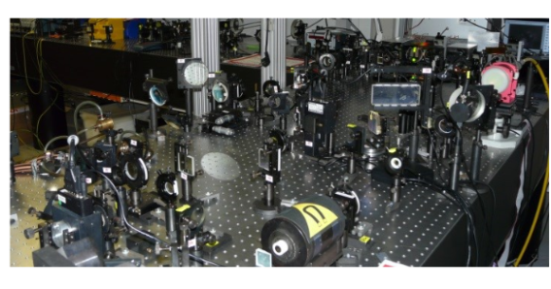

Fig. 6 Optical laser system at formation of PITZ (DESY, Zeuthen) 3D ellipsoidal shape electron bunches.

**5. Preparation of the proposals and start of the JINR participation in international collaborations for future high-energy colliders (leaders G. Shirkov, A. Kovalenko).**

In accordance with approved Addendum to the MoU on the JINR participation in the FCC design study at CERN, the design of 6 T superconducting dipole for the future SPS upgrade is carrying out. This option gives increasing the accelerator energy from the current 450 GeV to 1.3 TeV. The renewed synchrotron would operate in a cycled mode also to feed experimental areas, much like the SPS nowadays. Due to this specific cycled operation, innovative design and development approaches will be required to cope with the AC losses in the superconducting cables and reaching the highest possible critical wire and cable critical current. Some of the other design parameters of the model are the following: aperture - 80 mm diameter; the field ramp rate of 0.2 - 0.5 T/s; the wire – NbTi @1.9 K; the total thermal losses less of 2 W/m at 4.2 K equivalent while ramping. The design is in progress. The results were presented at the FCC Week 2017 [1] and FCC Week 2018 [2]

1. A.D. Kovalenko (JINR), A.Milanese (CERN), 6 T Dipole for the SPS Upgrade, FCCWeek2017: May 29 – June 03, Berlin 2017.
2. A.D. Kovalenko (JINR), A.Milanese (CERN), 6T Pulsed Dipole for the SPS Upgrade, FCC Week 2018, Amsterdam, April 11, 2018.

**Theme leader / \_\_\_\_/**

**“ “ 2019**