Status of the Factory of Superheavy Elements

Separators

A. Popeko
The first experimental facility, aimed at continuing study of the superheavy nuclei at the SHE Factory, is a new gas-filled separator DGFRS-2.The separator was designed in FLNR and manufactured by SIGMAPHI (France). In 2018, installation of the main components of the separator has been completed (Fig. 2).The first quadrupole lens Q₁ focuses vertically the nuclei knocked out of the target to increase the efficiency of their transport through the gap of the magnet D₁, where the products of the complete-fusion reactions (ERs) are separated from the bulk of the beam particles and the products of background reactions.The ERs are then focused by two quadrupole lenses Q₂and Q₃. The magnet D₂is installedfor additional separation of ERs from background particles.
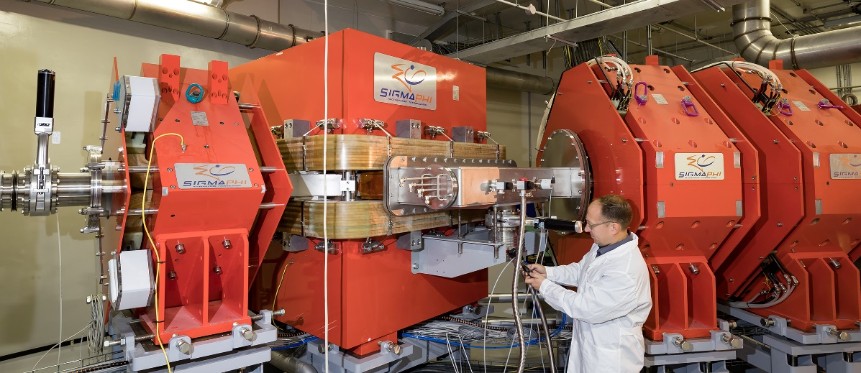
Fig. 2. Gas-filled recoil separator (DGFRS-2) at SHE Factory
Other essential components of DGFRS-2 have been designed and manufactured: these are the system of differential pumping of gas that is to provide gradient of pressurefrom 1 Torr in the separator to 10⁻⁷ Torr in the beam line together with the rotating entrance window and the target modules; at the end of the year we expectdelivery of detection system module and of the supports for the parts of the beam line and detector module.Also are mounted the power and signal cables to provide power supply and control of magnets and vacuum system of DGFRS-2, water cooling pipes are assembled and the compressed airline is brought to the setup. The test launch of magnets and parts of the differential pumping systemwas carried out. An electronic system for registration of the synthesized nuclei was developed and constructed.

