Status of the Factory of Superheavy Elements

DC-280 cyclotron

I. Kalagin

The construction of the basic configuration of Factory of Superheavy Elements (SHE) was completed. The building of the SHE Factory was construction. The automated system for radiation control and extra large integral systems are currently being adjusted, and the works on their connection with the automated cyclotron control system are also approaching the final phase. The commission of the Rostechnadzor (Federal Environmental, Industrial and Nuclear Supervision Service of Russia) inspected the building of the SHE Factory in October 2018. The documentation is now being prepared for the receipt of a Statement of Compliance and the Rostechnadzor permit for the commissioning of the building. The documentation is ready to be sent to the FMBA (Federal Biomedical Agency) of Russia to obtain a permit for integrated commissioning works with the acceleration of the ion beam at the DC-280 cyclotron (Fig. 1) and to prepare a sanitary and epidemiological conclusion for the approval of works at the DC-280 cyclotron. The autonomous commissioning of the cyclotron systems was performed, and the integrated commissioning works without the acceleration of the ion beam began at the DC-280 cyclotron. The acceleration of the ion beam and dosimetric measurements both inside and outside of the building necessary to apply for the sanitary and epidemiological conclusion will begin upon the receipt of the permit from the FMBA of Russia.
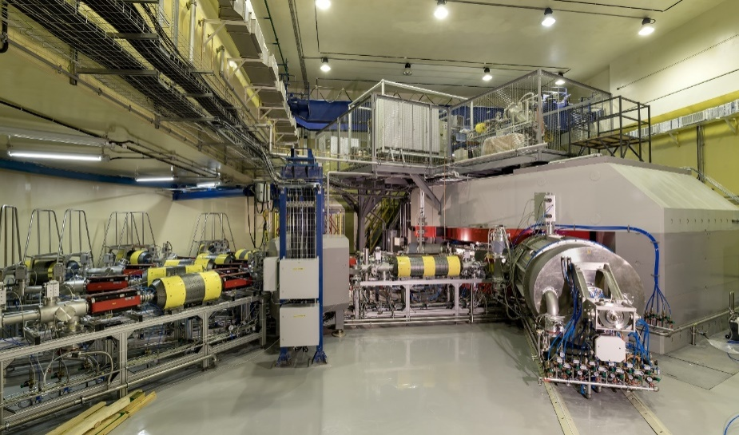
Fig. 1. Cyclotron DC-280

