Creation of a precision magnetic spectrometer SCAN-3 and research of
non nucleon degrees of freedom in nuclei, nucleon correlations and
nuclear fragmentation at the internal target of the Nuclotron.

Annotation of the project SCAN-3

List of participants

Institute of Physics, Slovak Academy of Sciences, Bratislava, Slovak Republic
J. Kliman, V. Matousek, S. Gmutsa

Horia Hulubei National Institute of R&D for Physics and Nuclear Engineering (IFIN-HH) Bucharest, Romania
F. Constantin, M. Cruceru, G. Niolescu, L.Ciolacu

Insitute for Space Science, Bucharest-Magurele, Romania
M. Paraipan

Joint Institute for Nuclear Research, Dubna, Russia
S.V. Afanasiev*, Yu.S. Anisimov, A.A. Baldin , V.Bekirov, A.I. Berlev , I.V. Boguslavsky, D.K. Dryablov, B.V. Dubinchik, A.F. Elishev, T.L. Enik, O.V. Fateev, I.A.Jukov, G.D. Kekelidze, V.A. Kramarenko, Yu.F. Krechetov, Z. P. Kuznecova, S.N. Kuznechov, A.S. Kuznechov, V.V. Lysan, A.I. Malakhov, S.S. Parzhitsky, D.K. Sakulin, V.A. Smirnov, S.S. Shimansky, E.V.Sukhov, E.V. Vasilieva, V.V.Ustinov

Faculty of Science, University of P.J. Safarik, Kosice, Slovak Republic
S. Vokal, K. Michalichkova , J. Vrlakova

P.N. Lebedev Physical Institute, Moscow, Russia
V.A. Baskov, A.I. Lebedev, A.I. L’vov*, L.N. Pavlyuchenko, V.V. Polyansky, S.S. Sidorin, G.A. Sokol

Institute of Physics and Technology, Tomsk Polytechnic University, Tomsk, Russia
I.V. Glavanakov, A.N. Tabachenko

Jizzakh State Pedagogical Institute, Jizzakh, Uzbekistan
D.M. Jomurodov, R.N. Bekmirzaev

Samarkand State University, Samarkand, Uzbekistan
R.M. Ibadov, M.U. Sultanov

* Project coordinators

- General aims of the project
This project is aimed at studies of highly excited nuclear matter created in nuclei by a high-energy deuteron beam. The matter is studied through observation of its particular decay products − pairs of energetic particles with a wide opening angle, close to 180º. A new precision hybrid magnetic spectrometer SCAN-3 is to be built for detecting charged (π±, K±, p) and neutral (n) particles produced at the Nuclotron internal target in dA collisions. Detection and spectrometry of such pairs will enable to fulfill
- studies of low-energy ηA interaction and a search for η-bound states (η-mesic nuclei);
- studies of the Δ-isobar produced and stopped inside the nuclear matter.

Beyond that detection of the pairs will enable to fulfill
- studies of np and pp correlations;
- studies of single and pair cumulative processes;
- studies of heavy nuclei fragmentation to low-energy fragments.

- Physics motivation

  - Studies of ηA interaction and η-mesic nuclei

Currently, studies of interactions of η- (and η′-) mesons with nucleons and nuclei attract a lot of interest (see, e.g., [1]). Due to a very short life time of these mesons, information on their elementary interactions can be inferred only indirectly − for example, from a coupled-channel analysis of the reactions πN→πN, π⁻p→ηn, γp→πN, γp→ηp assuming a multichannel resonance model and factorization. Results obtained in this way strongly depend on details of the model used, so that, for example, the s-wave ηN-scattering length a_{ηN} inferred in different works varies from Re a_{ηN} = 0.27 fm to 0.98 fm [2]. The positive sign of Re a_{ηN} leads to ηA attraction and can result in formation of bound states _{η}A [3]. Depending on the strength of the ηN and ηA interactions a whole range of the _{η}A bound states with different A have been predicted including very light states with A ≥ 2.
Very often properties of the ηA interaction are derived from the underlying ηN interaction fixed from phenomenological analyses. Modification of the ηN interaction in nuclei is essential ingredient of such derivations which have to take into account: 1) a strong energy dependence of the underlying ηN scattering amplitude for moving nucleons in the nucleus; 2) modifications of self-energy effects in nuclei for involved intermediate mesons and baryons [2,4].
In a more fundamental approach, the η/η′-A interaction can be understood at the quark-gluon level as a result of interaction of light quarks in the mesons with the scalar-isoscalar mean field (the σ-field, apart from the ω-field). The effective masses of η/η′ in the nuclear matter and hence the η/η′-A attractive potential are affected by the SU(3)-singlet component in the mesons and therefore are affected by nonperturbative contributions of gluons related with the axial U(1) dynamics in the nuclear matter [5].
All that gives a very good reason for further theoretical and experimental studies of the η/η′-A interaction, including a determination of spectra and decay modes of the bound states. Also, data on the ηA interaction, including data on the binding energies, can essentially constrain the ηN-interaction and the ηN-scattering amplitude.
The very first attempt to observe η-mesic nuclei was done long ago in the missing mass experiment A(π⁺, p)X [6]. No peak of the then predicted [3] strength and width was found. Soon a better strategy for searches for _{η}A was proposed [7]. It was based on detecting decay products of _{η}A: correlated πN pairs ejected in the process of one-nucleon annihilation
ηN→πN
of the captured (stopped) η-meson, transversely to the beam. Thus, a signature of formation and decay of _{η}A can be a πN pair with an opening angle close to 180º and characteristic kinetic energies
T_{π} ≈ 313 MeV, T_{N} ≈ 94 MeV
(up to effects of Fermi motion and elastic rescattering of particles in the nucleus). Annihilation of the captured η-mesons in the nucleus can result in a peak in the distribution of the total energy E_{π} + E_{N} of the pair that lies below threshold of the ηN channel (see Fig. 1). A signature of η-mesic nucleus just consists in the presence of a peak in the total energy of the pair that lies at E_{π} + E_{N} < m_{η} + m_{N} = 1486 MeV. Precise measurements of the position and the width of the peak would allow one to establish the very existence of the bound state and to determine its properties.

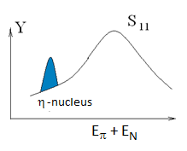
Fig. 1. Schematic distribution of πN pairs over their total energy.
Following this scheme, two similar experiments have been done (with participation of some members of the present project). In experiment at the LPI electron synchrotron [7], together with the channel π±n also pn pairs have been detected. Such pn pairs having the kinetic energies
T_{p} ≈ T_{n} ≈ 270 MeV
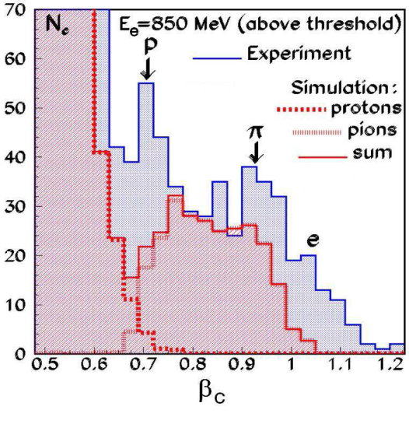can arise due to two-nucleon annihilation ηNN→NN of η. Important finding of the experiment [7] was that the yield of the pn pairs was approximately equal to the yield of the π±n pairs while the background in the pn channel was essentially less (see Fig. 2 that shows distribution of charged components of the detected pairs over velocity; two peaks of approximately equal strength correspond to pn and πn pairs). Therefore, a search for η-mesic nuclei through the pn decay channel was proved to be a very attractive option. Energy resolution of the built setup [7] was not sufficient to determine whether the observed peak lies under threshold and is indeed related with formation of a bound state, the η-mesic nucleus. Further, more precise experiments are evidently needed along this line.
Fig. 2. Distribution of protons and charged pions over velocity in the experiment [7].

In the second experiment [8] performed at the Nuclotron, a deuteron beam, an internal target, and scintillator TOF and ΔE-E detectors have been used. The achieved energy resolution was also not sufficient to draw a firm conclusion on formation of η-mesic nuclei. Important finding of that experiment was that the yield of the correlated πN pairs was clearly seen on the top of background existing in dA collisions (see Fig. 3 where some results are shown). This finding allows us to plan a new version of the experiment, in which the energy resolution is seriously improved due to using a magnetic spectrometer.

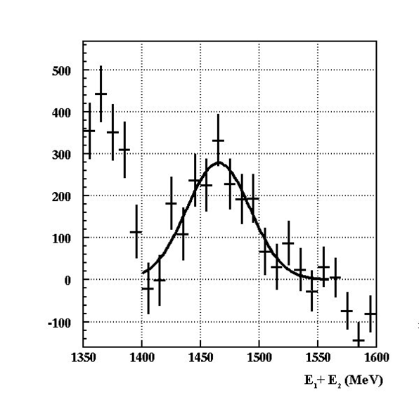
Fig.3. Total energies of the correlated π⁻р pairs [8]. Background is subtracted.

Recently a search for η-mesic nuclei had been performed at the COSY-GEM setup [9] using the reaction
p + ²⁷Al → ³He + ²⁵_{η}Mg → ³He + p + π⁻ + X.
A peak was found in the missing mass spectrum of (p, ³He) that corresponds to formation of the state with the binding energy of about 13 MeV and the width of about 10 MeV. Since the cross section of the chosen reaction channel with formation of the ³He fragment is extremely small (about 0.5 nb), the obtained data had rather low statistics. In our proposal we suggest to explore reactions
d + ¹²С → η-mesic nucleus + X → π + N + X,
d + ¹²С → η-mesic nucleus + X → N + N + X

that have larger cross sections by 3 orders of magnitude.

  - Studies of Δ in nuclei

One of practically unsettled aspects of the behavior of the Δ in nuclei concerns a hypothetic quasi-bound Δ-nucleus state. The ΔN interaction as well as the NN one is attractive. Therefore, the Δ-isobar and the residual of the nucleus can form a highly excited short-living state, the Δ-nucleus, provided the momentum of the isobar is not large in comparison with a characteristic nucleon momentum. If the width of the quasi-bound Δ-nucleus is much less than the width of the free Δ, there must be relatively narrow peaks in the energy spectra of decay products of the Δ in nuclei: correlated πN and NN pairs emerging in subprocesses
Δ → πN and ΔN → NN.
A possible existence of the Δ-nucleus states had been predicted in some theoretical works. In particular, a quasi-bound ΔN-state with the quantum numbers T=2, J^{P}=2⁺ was predicted in [10]. Today experimental situation here is not unambiguous. Experiments with photon and electron beams [11-15] and their analysis [16] do indicate the existence of Δ-nucleus states. On the other hand, the dedicated experiment [17] done with the pion beam did not find Δ-nucleus states provided their width is more than 20 MeV. In order to elucidate the question of existence of Δ-nuclei and their properties further experimental work is certainly needed.
In the framework of the present project we propose to study, with the same setup, the reactions
d + ¹²С → ∆-nucleus + X → π + N + X,
d + ¹²С → ∆-nucleus + X → N + N + X
on the internal carbon target in the kinematic region where Δ-nuclei can be formed most efficiently. Decay products of the Δ-nuclei, πN and NN pairs, will mostly have the opening angle close to 180º. Like in the experiment on studying η-mesic nuclei, the NN decay channel can also be studied. It has the advantage of having a lower background in comparison with that in the πN channel.

- Layout of the setup

We propose to extent a setup used at the Nuclotron in our previous studies in order to achieve the energy resolution for both charged and neutral components of the correlated πN and NN pairs of σ ≈ 5 MeV. To this aim we plan to construct a magnetic spectrometer (M arm) and two sectioned neutron detectors with a TOF base up to 6 m (P and K arms), see Fig. 4.
Technical parameters of the detectors, including their space and time resolution, have been specified using GEANT simulations [18].
Data acquisition system is to be built using VME modules produced in JINR.

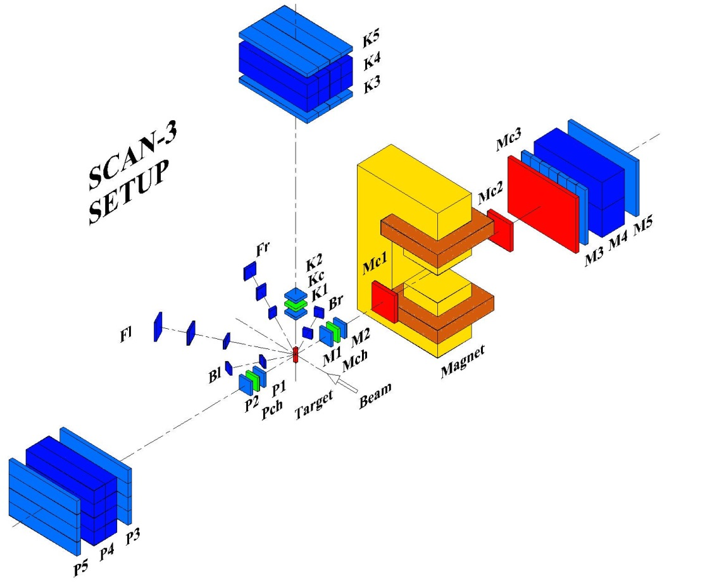
Fig. 4. Layout of the SCAN-3 setup.

Fr, Fl, Br, Bl – scintillator monitor counters;
P1-P3, K1-K3, M1-M3 – trigger time-of-flight scintillator detectors;
Pch, Kch, Mch – threshold Cherenkov detectors;
Мс1, Мс2 – drift chambers;
Мс3 – multiwire proportional chamber;
M4 –scintillator total absorption detector;
Р4, K4 – two sets of scintillator neutron counters;
Р5, K5, М5 – veto detectors.

- Yield estimates

Our yield estimates are based on the following parameters of the Nuclotron and the setup:
- ∅8 µm internal carbon target (a filament);
- the number of inelastic d¹²С collisions N_{inel} ~ 10⁸ s⁻¹ (this gives the luminosity
L = N_{inel} / σ_{inel} = 2.5·10³² cm⁻² s⁻¹ if the total d¹²С inelastic cross section σ_{inel} = 0.4 barn);
- the solid angle of the M arm Ω_{M} ~ 2 ⋅ 10⁻² sr;
- the solid angle of the P and K arms Ω_{P} ~ 3 ⋅ 10⁻² sr.

Using theoretical estimates of the total cross section of η-nuclei formation based on one-pion-exchange model (σ_{η} ~ 2 µb), as well as estimates of angular distributions of the correlated πN and NN pairs, we expect the following yields of events with formation and decay of η-nuclei:

Y(π⁻p) ~ 40 hour⁻¹, Y(π⁺n) ~ 12 hour⁻¹, Y(pn) ~ 12 hour⁻¹, Y(pp) ~ 2 hour⁻¹.

at the deuteron-beam energy ≈ 2 GeV/u. The main backgrounds come from random coincidences. From the GEANT-4 simulations we expect that they are less than the above signal yields − in agreement with our previous results obtained at the Nuclotron [8].

Concerning events of the Δ-nuclei formation, our yield estimates are based on theoretical calculations of the differential cross section of Δ-nuclei formation followed by a decay to πN: d⁴σ/(dE_{π} dΩ_{π} dE_{N} dΩ_{N}) ≈ 50 nb/(MeV sr)². Then we expect

Y(π±p) ~ 280 hour⁻¹

for the deuteron energy of about 1 GeV/u. The yield of the pN-pairs is preliminary estimated to be ≥ 10% of the π±p yield, with the background being by the factor of ≈ 10 less. Using the GEANT-4 code, we estimated the background of random coincidences to be ~7 hour⁻¹ for π±p pairs and ~2 hour⁻¹ for pN.

- Conclusions

The first main aims of the present project are:
- building of a magnetic spectrometer for detection of charged components of the correlated pairs with the energy resolution of 4-5 MeV;
- building of a precision time-of-flight neutron detector with a similar energy resolution;
- studies of correlated hadron pairs ejected from the target in dA collisions;
- studies of the S₁₁(1535) and Δ(1232) resonances in the nuclear matter;
- a search for η-nuclei and Δ-nuclei in dA-collisions through narrow resonance peaks in the total energy spectra of the correlated pairs;
- determination of binding energies and widths of η in nuclei;
- measurements of the cross section σ(_{η}A) of η-nuclei formation in dA collisions; measurements of the A-dependence of σ(_{η}A);
- measurements of relative rates of π⁻p и pN events;
- measurements of the cross section of Δ-nuclei formation in dA collisions;
- determination of binding energies and widths of quasi-bound states of Δ in nuclei;
- measurements of relative rates of π⁺p, π⁻p and pN events.

References

[1] The 2nd Intern. Symp. on Mesic Nuclei (Cracow, 2013). Acta Phys. Polon. B45 (2014) 595-843.
[2] Q. Haider and L.C. Liu, Phys. Rev. C66 (2002) 045208.
[3] Q. Haider and L.C. Liu, Phys. Lett. B172 (1986) 257.
[4] T. Inoue and E. Oset, Nucl. Phys. A710 (2002) 354.
[5] S.D. Bass and A.W. Thomas, Acta Phys. Polon. B45 (2014) 627.
[6] R.E. Chrien et al., Phys. Rev. Lett. 60 (1988) 2595.
[7] V.A. Baskov et al., Proc. of Science PoS Baldin-ISHEPP-XXI (2012) 102; arXiv: 1212.6313;
Yad. Fiz. and Engineering, Vol. 6 (2015) p. 92 (in Russian).
[8] S.V. Afanasiev et al., Nucl. Phys. B (Proc. Suppl.) 245 (2013) 173.
[9] A. Budzanowski et al., Phys. Rev. C79 (2009) 012201(R).
[10] H. Arenhövel, Nucl. Phys. A 247 (1975) 473.
[11] P. E. Argan et al., Phys. Rev. Lett. 29 (1972) 1191.
[12] V.N. Eponeshnikov and Yu.F. Krechetov, JETP Lett. 29 (1979) 442 (in Russian).
[13] M. Liang et al., Phys. Lett. B 411 (1997) 244.
[14] I.V. Glavanakov et al., JETP Lett. 81 (2005) 546 (in Russian).
[15] P. Bartsch P. et al., Eur. Phys. J. A 4 (1999) 209.
[16] I.V. Glavanakov, Phys. At. Nucl. 72 (2009) 1823.
[17] W. Brückner et al., Nucl. Phys. A 469 (1987) 617.
[18] S.V. Afanasiev et al. Int. J. Mod. Phys.: Conf. Series, 39 (2015) 156009.

