First experiments with radioactive beams at ACCULINNA-2 fragment separator

A.S. Fomichev / M.S. Golovkov

First experiments with high intensive 8He and 9Li radioactive beams obtained at the new fragment separator ACCULINNA-2 [1] at the U-400M cyclotron were carried out in 2018/2019. The fragmentation reaction 11B (33.4 AMeV) + Be (1 mm) was used for the production 8He (I ~ 105 pps) and 9Li (I ~ 106 pps) beams focused on the physical target (cryogenic D2, T=27 K, P=1.1 atm and 2.4 atm, respectively) in a spot with a diameter of ~ 16 mm (FWHM).

A flagship experiment dedicated to search for the enigmatic nucleus 7H and study of correlations between its decay products *t*+*4n* were the subject of the first run. The 8He (26 AMeV) + d → 3He + 7H reaction was chosen to populate the 7H ground and exited states. The key stone to detect low energy 3He in the range of 9÷20 MeV was a set of four ΔE-E-E telescopes, each telescope being assembled out of three Si strip detectors – a 20-micron SSD and a couple of 1000-micron SSDs (where the second 1000-micron detector operated as veto), see Fig.1. Based on the preliminary data analysis one can conclude that the telescopes separate well the 3He events in the presence of large amount of 4He particles (Fig.2). To measure tritons moving at forward angles in narrow cone, θ ≤ 6 degrees, another telescope was installed at a far distance ~ 320 mm in front of the target. It consisted of one 1500-micron thick DSSD and a set of 16 CsI(Tl)/PMT modules. The triton telescope provided angular resolution ~ 0.5 degree and energy resolution ~ 2%. In addition, the array of 44 stilbene crystals [2] was used for neutron detection (TOF and angles) at forward direction.

Compared to the previous works [3, 4] dedicated to search for 7H in the (d,3He) reaction the novelty of the used setup was the measurement of the angles and energies of the tritons and neutrons with a good accuracy and the use of these data for correlation analysis. Events with a coincidence of the detected 3He and 3H were considered as candidates for the 7H event. The number of coincidences of the decay products allowed us to estimate the reaction cross section. Measuring the spectra of 3He recoils emitted at small angles allows one to reconstruct the 7H missing-mass spectrum at a sensitivity level of dσ/dΩ ~ 5 μb/sr. The angles and energies of 3He and 3H(n) as well obtained in coincidence were informative for the analysis of various correlations.

The second run was focused on the study of low-lying states of 10Li populated in the reaction 9Li(d,p)10Li → n+9Li. The principal value of this experiment was the detection of protons, emitted backwards in laboratory system, in coincidence with neutrons moving in forward direction, see Fig.3. To define energy resolution of this setup and normalization of the missing mass 10Li spectrum the additional measurement in the reaction 6He(d,p)7He → n+6He was carried out. Having a good statistics (about 500 triple coincidences *p-n-9Li*) and experimental energy resolution of ~ 200 keV (FWHM) over the 10Li excitation energy, new information about low-lying states of 10Li is expected from these data, see Fig.4. It also should help to clarify the question mentioned recently by Cavallaro and co-authors regarding the high-lying structures at 1.5 and 2.9 MeV in the 10Li spectrum [5].

Preliminary results of both measurements and nearest work plan at ACCULINNA-2 fragment separator will be reported as well.

1. A.S. Fomichev et al., Eur. Phys. J. A 54 (2018) 97.

2.  A.A. Bezbakh et al., Instrum. Exp. Tech. 61 (2018) 631.

3. M.S. Golovkov et al., AIP Conf. Proceedings 912 (2007) 32.

4. E.Yu. Nikolskii et al., Phys. Rev. C 81 (2010) 064606.

5. M. Cavallaro et al., Phys. Rev. Lett. (2017) 012701.

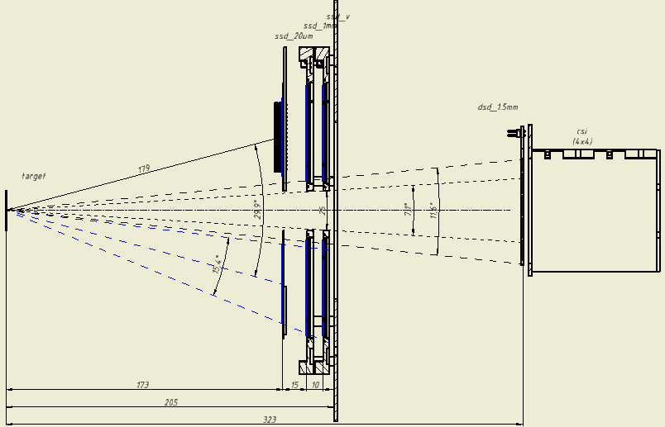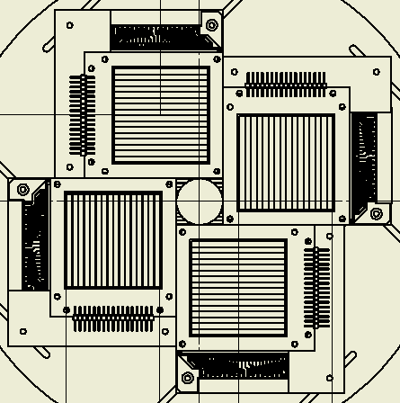

Fig. 1. Layout of the experimental setup for charged particles detection in the reaction 2H(8He,3He)7H. Views from the side and from the front are correspond to the top and bottom panels, respectively.

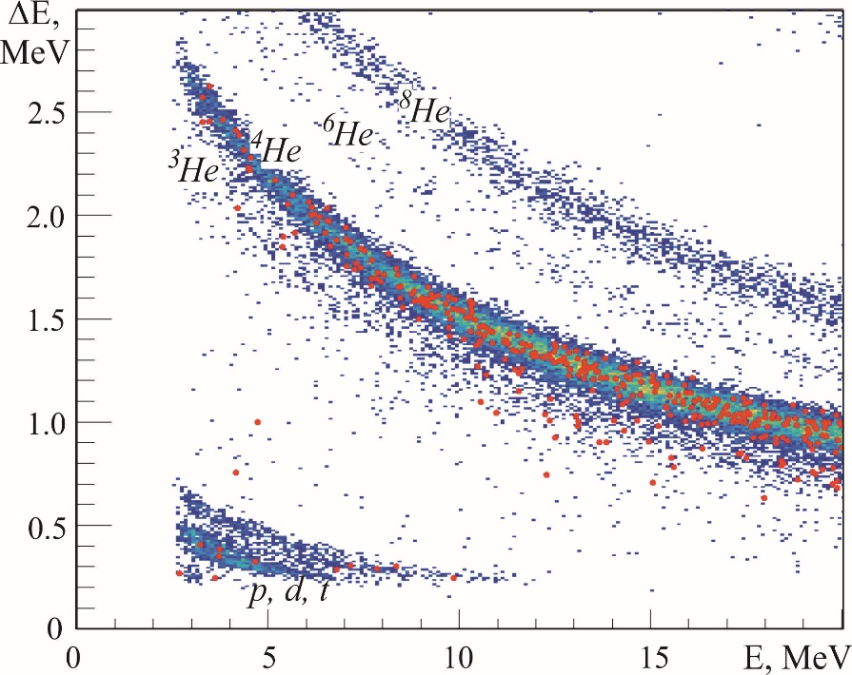

Fig. 2. Typical ID-plot for particle identification obtained from the measurements of energy losses in 20 μm Si detector and corresponding residual energies in 1000 μm Si detector. Coincidences with fast tritons (Et > 65 MeV) are shown by red points.





Fig. 3. Layout of the experimental setup for detection of charged particles and neutrons in the reactions 9Li(d,p)10Li → n+9Li and 6He(d,p)7He → n+6He (top panel). Annular DSSD (1000 μm thick segmented by 16 sectors and 16 rings) for protons detection (bottom panel).

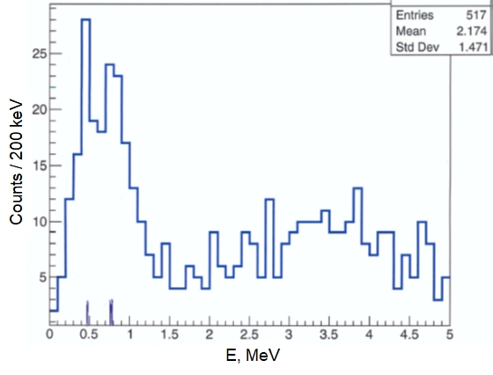

Fig. 4. Preliminary results of 10Li study in the 9Li(d,p)10Li reaction at 28 MeV/nucleon based on the triple coincidences *p-n-9Li.*