NA-64 experiment - JINR participation and obligations
Joint session recommendations
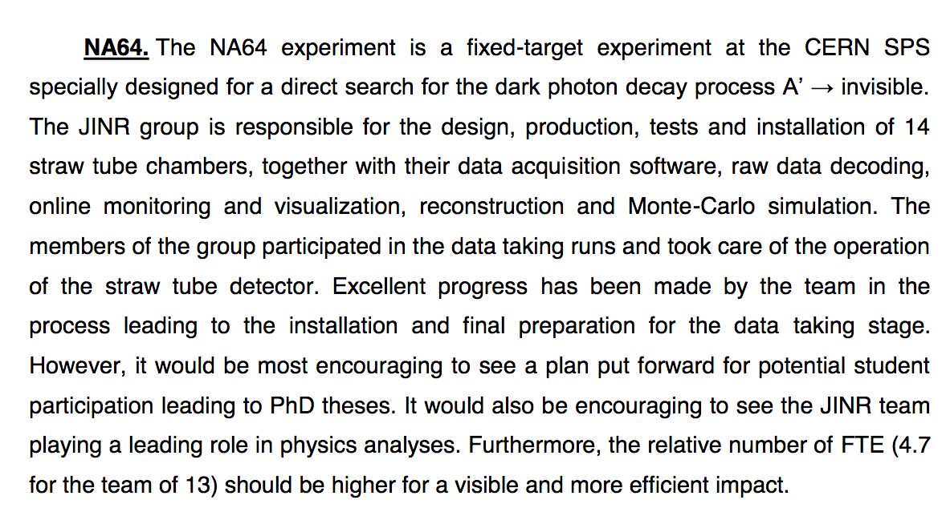
51th session recommendations
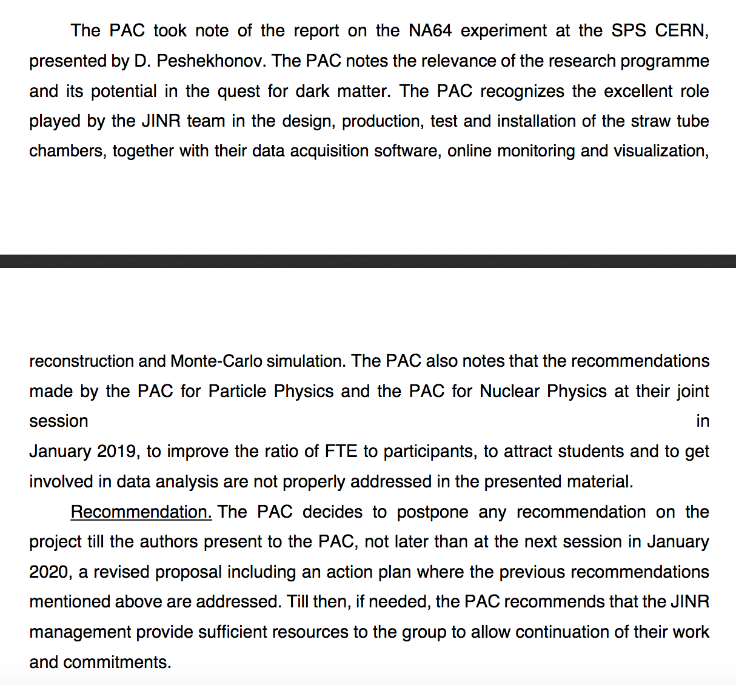
- FTE and number of participants (new persons marked by this color and style)
1.1 detector
JINR team joined NA64 in 2017th with the main responsibility: creation of the straw tube chambers (ST) for the experiment tracker. It affected on the initial team structure. The group led by Georgy Kekelidze specializes on this detector technology and has obligations on the detector production and R&D in the list of the projects such as CBM/FAIR, NICA, NA-64, SHIP and other. We plan to make 14th new straw tube chambers. Taking all this into account relative FTE for the:

G.Kekelidze (0,4 – detector expert), V.Kramarenko (0,4 – ½ position, detector expert), V.Lysan (0,8 – detector expert), A.Savenkov (0,3 - technition), I.Zhukov (0,8- technition), T.Enik (0,2 – detector expert), V.Burtsev (0,5 – electronics expert), E.Martovitsky (0,5 – detector & electronics)
looks reasonable. In total FTE = 3,9 (8 (7,5) persons)
  - Theory
From the very beginning JINR team takes part in the project scientific program motivation, development and support.

V.A.Matveev (0,1) and N.V.Krasnikov (0,5 – ½ position 100%) initiated the idea and methodology of the NA64 experiment.
In total FTE = 0,6 (2 (1,5) persons)
  - Physics analysis
We are permanently looking for the new young physicist to join our team for MC simulation and data analysis (tracking; e-beam data: invisible & visible decay modes data, 2021 run setup simulation; mu-beam: setup and physics simulation). This is a current situation:

P.Volkov (0,5 – ½ position 100%), E.Mosolova (0,5 – ½ position 100%), E.Kasianova (1,0 - 100%), R.Akhunzianov (0,5)

P.Volkov signal/background separation (result: 2 orders improvement of S/B ratio)
E.Mosolova (beginner) – MC simulation and data analysis
E.Kasianova (beginner) – MC simulation and data analysis
R.Akhunzianov (well qualified) – data analysis (takes part in COMPASS)
In total: FTE = 2,5 (4 (3) persons)
  - management and support
N.Krasnikov - responsibility on the theory in the NA64 Collaboration Board (CB)
V.A.Matveev is the JINR team leader
D.Peshekhonov (0,3) is responsible on the ST in the NA64 CB and JINR team co-leader
V.Frolov (0,2) is the NA64 experiment DAQ expert
FTE = 0,5 (2 persons)
2. Young researchers, students and PhD students
NA64 participants (JINR team) younger than 35 years old:
E.Mosolova – is a MS student (StP univ.) - analysis,
E.Kasianova - just graduated from the university, potential PhD student - analysis,
R.Akhundzianov - qualified young researcher (COMPASS), potential PhD student - analysis,
E.Matrovitsky – young researcher, potential PhD student - electronics & detectors,
V.Burtsev – young researcher, potential PhD student – electronics,
P.Volkov – young researcher (½ MSU), analysis,

A.Solin – young researcher, JINR collaborant from Belarus State University, electronics

We have 6 young researches, 4 new, 3 of them start work on the analysis, almost all are potential PhD students.
International conference reports: NEC2019 “Electronics options for the straw tracker”
Publications: “Straw chambers for the NA-64 experiment”, approved in PEPAN Letters

Short summary:
1. FTE and number of participants
FTE of the participants and FTE/number_of_participants_ratio were optimized/improved. In our initial document we had 4,7/13 FTE/number_of participants, while in the present version we came to 7,5/14
2. Young researchers attracting & potential PhD students involvement
We attract 4 new young researches and now have 6 totally (instead of 3 in the initial document). All they are potential PhD students in NA64 data analysis, electronic & detector development. The contribution of the young researchers is 3,5 FTE.
3. Participation in physics analysis
We joined the analysis of 2018 data. We also plan to analise new data (run 2021, 2022,..), work on the MC simulation for the upgrade and modernization of NA64 setup. In addition we joined the activities on the electron beam run to be able provide precise measurements for the dark photon visible decay mode. We are contributing to the design and preparation of the new setup for operation with the muon beam.
We are planing presentations at the PAC and conference of young scientists in Dubna and at international conferences.

