Extract
from the protocol of the meeting 2020-4
of Scientific-Technical Committee of DLNP
April 16, 2020 y.

ATTENDEES: 29 STC members of 38.

- D.R. Zinatulina presented the project “Muon Ordinary capture for the NUclear Matrix elemENTs in ββ decays”. Project MONUMENT.
- We listened to the review of the project prepared by Fedor Šimkovic (COMENIUS UNIVERSITY, Bratislava, Slovakia).
The review is positive.
- We listened to the review of the project prepared by B.A. Chernyshev (MEPhI). The review is positive.

RESOLVED: To approve the project “Muon Ordinary capture for the NUclear Matrix elemENTs in ββ decays”. Project MONUMENT. (UNANIMOUSLY).

It was recommended to the DLNP Directorate to sign the project and forward the project materials to the JINR Directorate for further passage of the project confirmation and approval procedure.
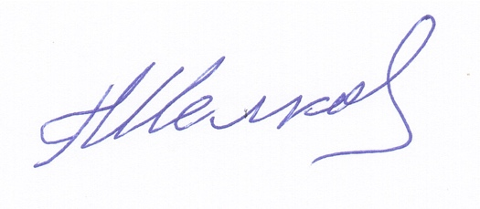

Chairman of the
STC DLNP Chelkov G.A.
April 16, 2020

