Executive Summary

Despite the intensive searches at the LHC and in non-accelerator experiments, the Dark Matter (DM) is still a great puzzle. Though stringent constraints obtained on DM coupling to Standard Model (SM) particles have ruled out many DM models, little is known about the origin and dynamic of the dark sector itself. One difficulty so far is that DM can be probed only through its gravitational interaction with visible matter. An existing possibility that could make a breakthrough, is that in addition to gravity an interaction between the dark sector and visible matter particles transmitted by a vector boson A’ (dark photon) might exist. Such A’ could have a mass ≤ 1 GeV – associated with a spontaneously broken gauged U(1)_{D} symmetry – and couple to the SM through kinetic mixing with the ordinary photon, -½εF_{μν}A’^{μν} , parameterized by the mixing strength ε<< 1 [1-3]. This has motivated worldwide theoretical and experimental efforts toward investigation of dark forces and other portals between the visible and dark sectors [4, 5].
Additional motivation for these efforts has been provided by hints on astrophysical signals of DM [6], as well as the 3.6 σ deviation from the SM prediction of the muon anomalous magnetic moment (g-2)_{μ} [7], which can be explained by a sub-GeVA’ with the coupling ε≈ 10⁻³ [8-10]. Such small values of ε could naturally be obtained from loop effects of particles charged under both the dark and SM U(1) interactions with a typical 1-loop value ε=eg_{D}/16π² [3], where g_{D} is the coupling constant of the U(1)_{D} gauge interaction. If the A’ is the lightest state in the dark sector, then it would decay mainly visibly, i.e. typically to SM leptons l = e, μ or hadrons, which could be detected. Previous beam dump [11-26], fixed target [27-29], collider [30-32], and rare meson decays [33-42, 71] experiments have already put stringent constrains on the mass m_{A’} and ε of such dark photons excluding, in particular the parameter region favoured by the (g-2)_{μ} anomaly.
However, in presence of light dark states, in particular dark matter, with masses <m_{A’}, A’ would predominantly decay invisibly into those particles provided that g_{D}>εe. Models introducing such invisible A’ offer new intriguing possibilities to explain the (g-2)_{μ} and various other anomalies [43] and have been subjected to different experimental constraints [44-47]. The most severe limits on the invisible sub-GeVA’s decays have been obtained from the beam dump experiments LSND [48] and E137 [49], however under certain assumptions on the strength of the coupling g_{D} and properties of the DM decay products.
The NA64 experiment is specially designed for a direct search of decays A’ → invisible at the CERN SPS. In this search no assumptions on the nature of the transition A’ → invisible is made.
The NA-64 experiment has also a capability to search for decays of the produced massive dark photons A' into e⁺e⁻ pairs. If the mass of the dark photon M_{A'} ≤ 100 MeV, then the only possible decay into visible particles would be e⁺e⁻ pair production, A’ → e⁺ e⁻. The experimental signature of this process – two very close tracks after the target and e-m shower in the detector - has never been experimentally tested before.
The NA-64 experiment exploits the upgraded 100 GeV secondary electron from the H4 beam line at the CERN SPS. The beam has maximal intensity of (3-4) 10⁶ per SPS spill of 4.8 s length produced by the primary 450 GeV proton beam with an intensity of 10¹²protons on target.
Our feasibility study shows that a sensitivity for the search of the A’→invisible decay mode, in terms of the product σ(e⁻Z → e⁻Z A')/σ(e⁻Z → e⁻ Z γ)xΓ(A’→invisible), at a level below 10⁻¹¹-10⁻¹² could be achieved. The intrinsic background due to the presence of low energy electrons in the beam can be suppressed by using a tagging system based on detection of the synchrotron radiation emitted by the high-energy electrons.
The proposed search could allow to cover a significant fraction of the yet unexplored parameters space for both A’→invisible and A’→ e⁺ e⁻ decay modes.

The first stage of the project is devoted to a search for the decay A’ → invisible.

The experimental setup is shown in Fig.1.
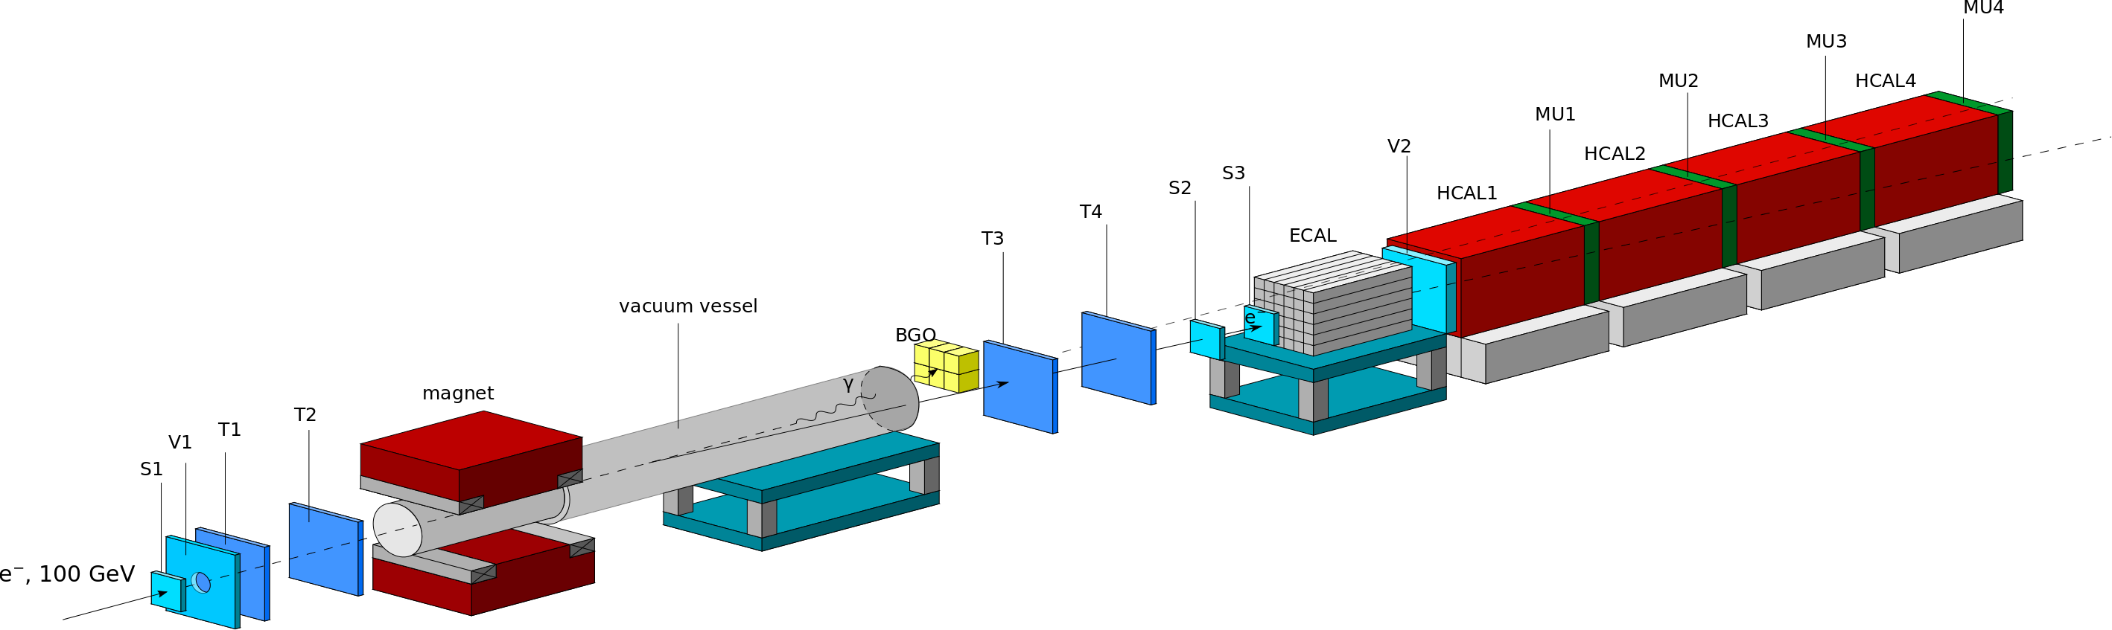

Figure 1. Schematic illustration of the current version of the NA-64 setup to search for A’ → invisible decays of bremsstrahlung A’s produced in the reaction eZ→eZA’ by 100 GeV e⁻ incident on active ECAL target.

The dark photon A’ could be produced via kinetic mixing with bremsstrahlung photon in the reaction of high-energy electron scattering off nuclei in the active target ECAL. Then it decays into invisible dark matter particles.Part f of the primary energy is carried away by the dark photon, i.e. E_{A’} = fE₀. The dark photon, or its invisible decay products, penetrate the detector without interaction. The remaining part of the primary energy E_{e} = (1-f) E₀ is deposited in the target by the scattered electron. Thus, occurrence of A’ would appear as an excess of events whose signature is a single electromagnetic (e-m) shower in the target with energy E_{e} accompanied by a significant missing energy E_{miss} = E₀ – E_{A’} above those expected from the background [50, 51].

The second stage of the project aimsat a search of the decay A’ →e⁺e⁻.

The experimental setup is schematically shown in Figure 2.

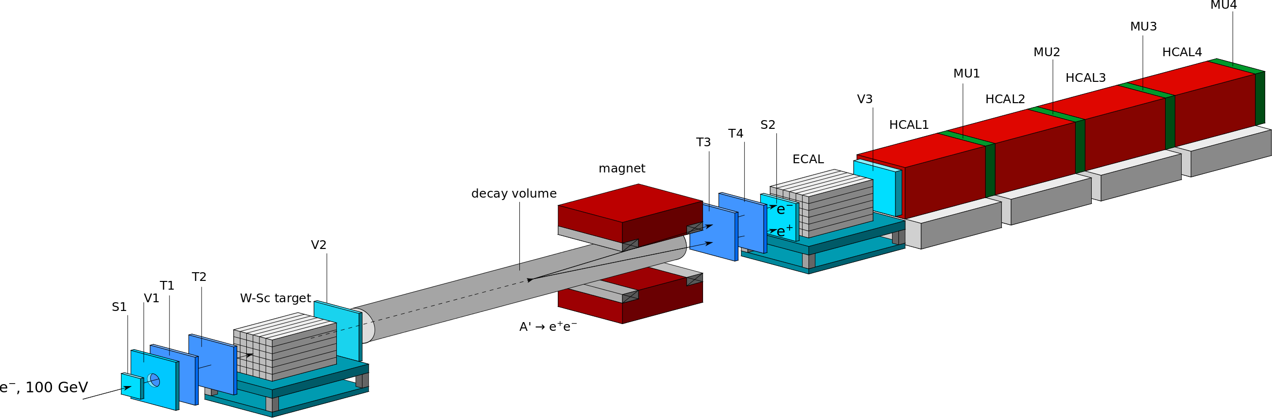

Figure 2. Schematic illustration of the setup proposed to search for dark photons in a light-shining-through-a-wall type experiment.

The method of the search is the following [52]. The dark photons A' are produced through mixing with the bremsstrahlung photons from the electrons scattering off nuclei in the W-Sc target (e-m calorimeter with energy resolution ΔE/E ≃ 0.18/√E, X,Y resolution ≃ 3 mm, e/π rejection ~10⁻²). This happens typically within the first few radiation lengths (X₀) of the target. The bremsstrahlung A' then penetrates the rest of the target and the veto counter V2 without interaction, and decays in flight into an e⁺e⁻ pair in the decay volume DV with diameter ≃30 cm and 15 m length.
A fraction f of the primary electron energy, E₁ = f E_{0,} is deposited in the target calorimeter. Its downstream part serves as a dump to absorb completely the e-m shower tail. For radiation length ≤1 cm, and total thickness of the W-Sc target of ≈30X₀, the energy leak into the V2 is negligibly small. The remaining part of the primary electron energy E₂ = (1-f)E₀ is transmitted through the “target wall'' by the dark photon A', and deposited in the downstream calorimeter ECAL via the A' decay in flight in the DV. At high A' energies, E_{A'} ≥ 30 GeV, the opening angle Θ_{e+e-} ≈ m_{A’}/E_{A’} of the decay e⁺e⁻ pair is too small to be resolved as two e-m showers in the ECAL, so the pair is mostly detected as a single electromagnetic shower. Thus, ifm_{A’} ~ 50 MeV and E_{A’} = 50 GeV, one obtains Θ_{min} ~ 2 mrad, so the e⁺e⁻ pair can be resolved as two separated tracks in a fine grained straw tube tracker in front of the ECAL.

Sensitivity estimation
To estimate the sensitivity of the proposed experiments a feasibility study based on GEANT4 [53] MC simulations has been performed.
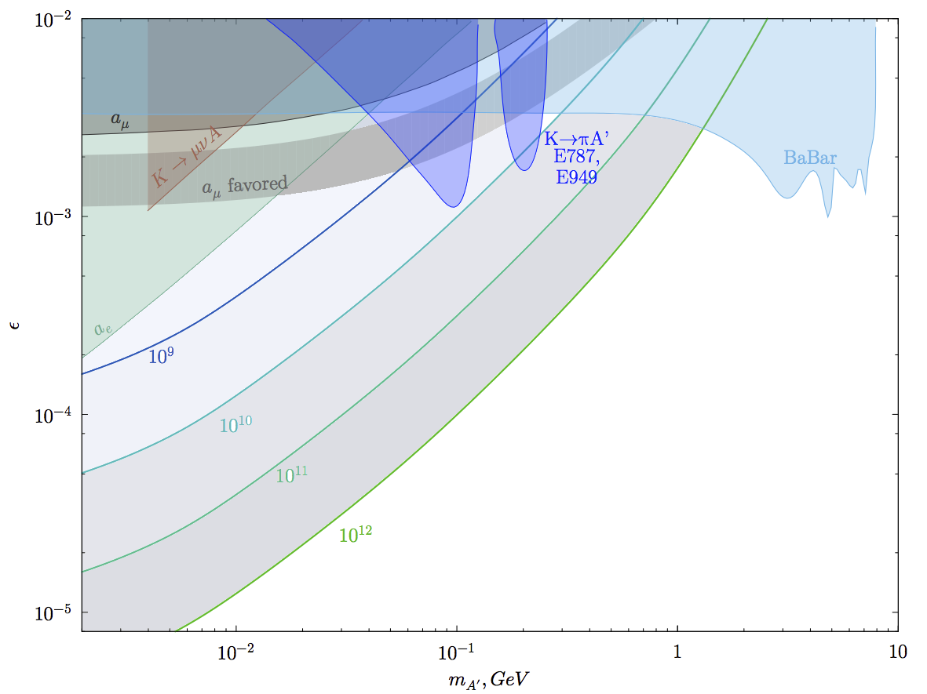

Figure 3. Constraints in the ε vs m_{A’} plane for invisibly (left) and e⁺e⁻ (right) decaying A'. The color lines show the expected 90% C.L. exclusion areas corresponding, respectively, to 10⁹, 10¹⁰, 10¹¹and10¹² accumulated electrons for the background free case.

The statistical limit on the sensitivity of the proposed experiments is set mostly by the value of ε and by the possible background. Thus, it is important to accumulate a large number of events. We anticipate up to ≈ 1-3 10¹² collected e⁻s during ~ 3 months of run time for each experiment.
Even if no excess of signal events is found, the obtained results can be used to impose constrains on the γ-A’ mixing strength as a function of the dark photon mass. The exclusion regions corresponding to accumulated statistics 10⁹, 10¹⁰, 10¹¹and 10¹² e⁻ are shown in Fig. 3 for both decay signatures.

JINR contribution to the NA-64 experiment

The NA-64 experiment is approved by the CERN SPSC for realization.
Fccjrding to the signed MoU the JINR group is responsible for the manufacturing and operation of the tracking sub-system: coordinate detectors based on thin-wall drift tubes - straw tubes. It is expected that the setup will be equipped with X and Y oriented double layer straw tube chambers with a sensitive area of 200×200 mm² eachbased on Kapton tubes with a wall thickness of 70 μm. Several types of chambers are foreseen: with straw tubes of 6 mm, 4 and 2 mm diameter. At least four double layer straw tube chambers will be installed in addition to the two upstream Micromegas chambers (T1, T2) and two downstream GEM stations (T3, T4). Some more straw tube chambers may be installed in the decay volume to improve separation of the electron tracks from the decay A’→e⁺e⁻.
To verify that the construction of the proposed high-resolution straw tube chambers is feasible, straw tubes with 2 mm diameter have been produced and tested. A chamber prototype with 2mm straw tubes has been manufactured and is under tests (Fig. 4).

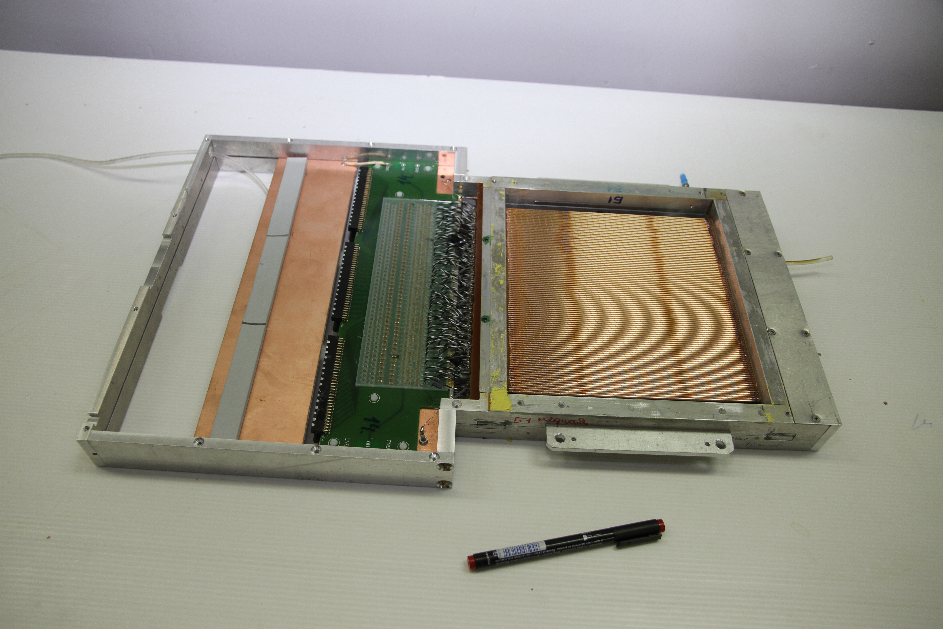
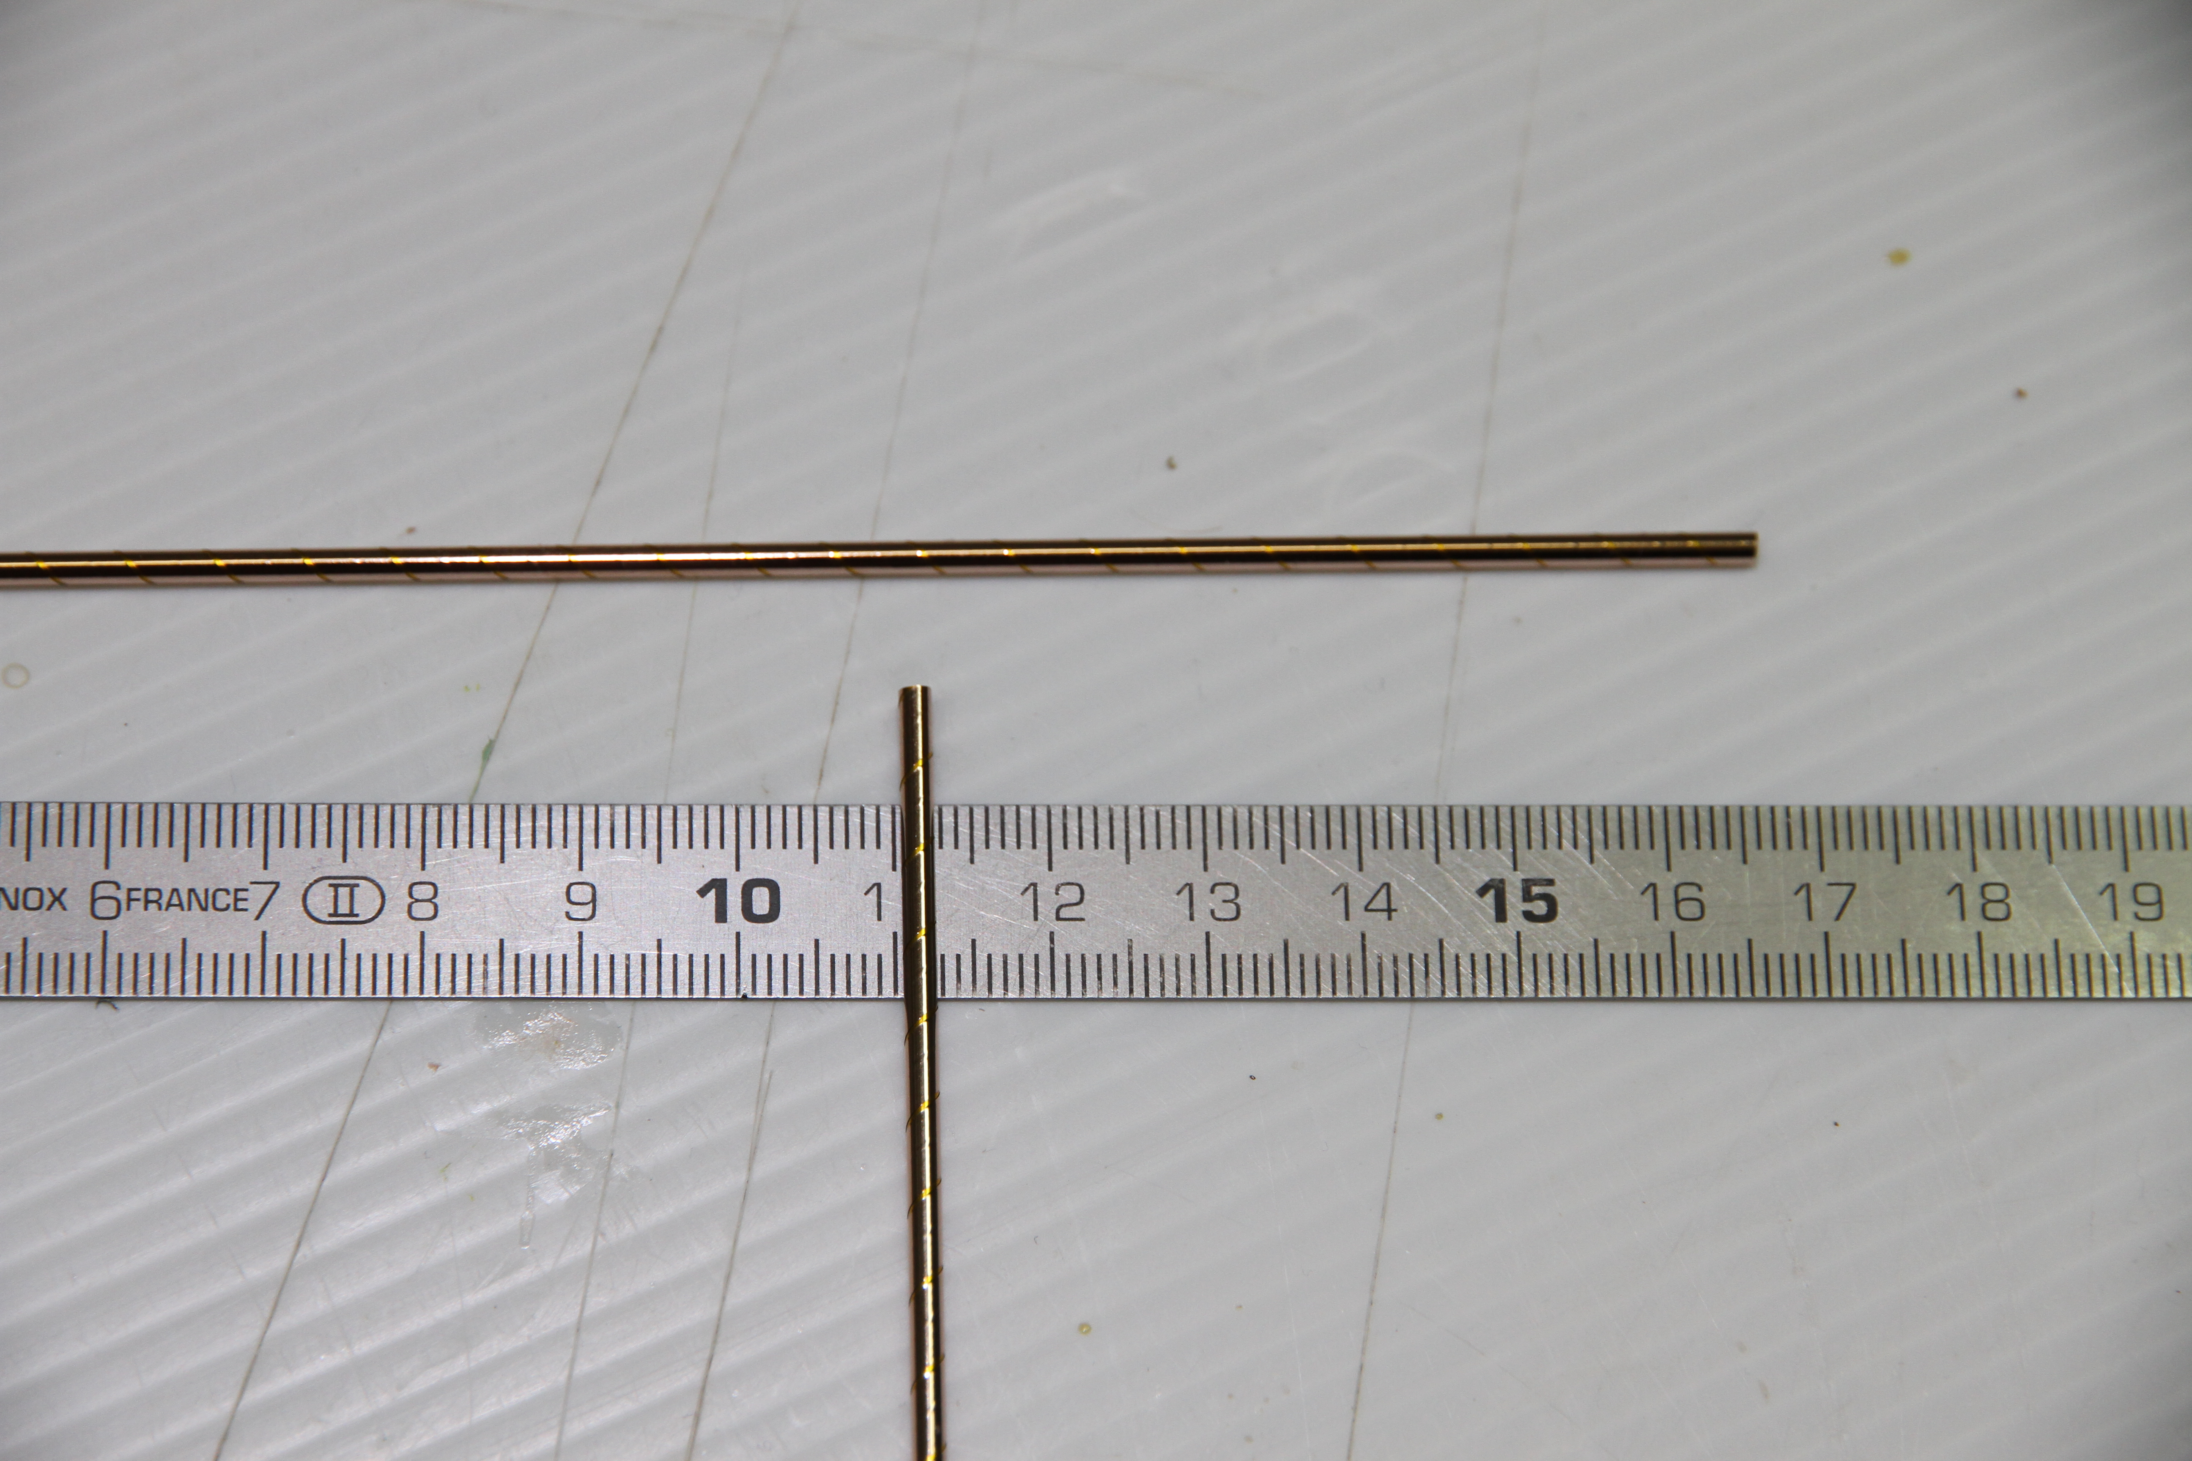
Figure 4. Kapton straw tubes with wall thickness of 70 μm and 2 mm diameter (left); prototype of the double layer straw tube chamber with sensitive area of 200×200 mm² (right).

Preliminary schedule of the experiment

The search for the decay A’ →invisible began operations in 2016. The statistics obtained is estimated as 3-5x10¹⁰ e⁻ on the target. The data analysis is in progress.
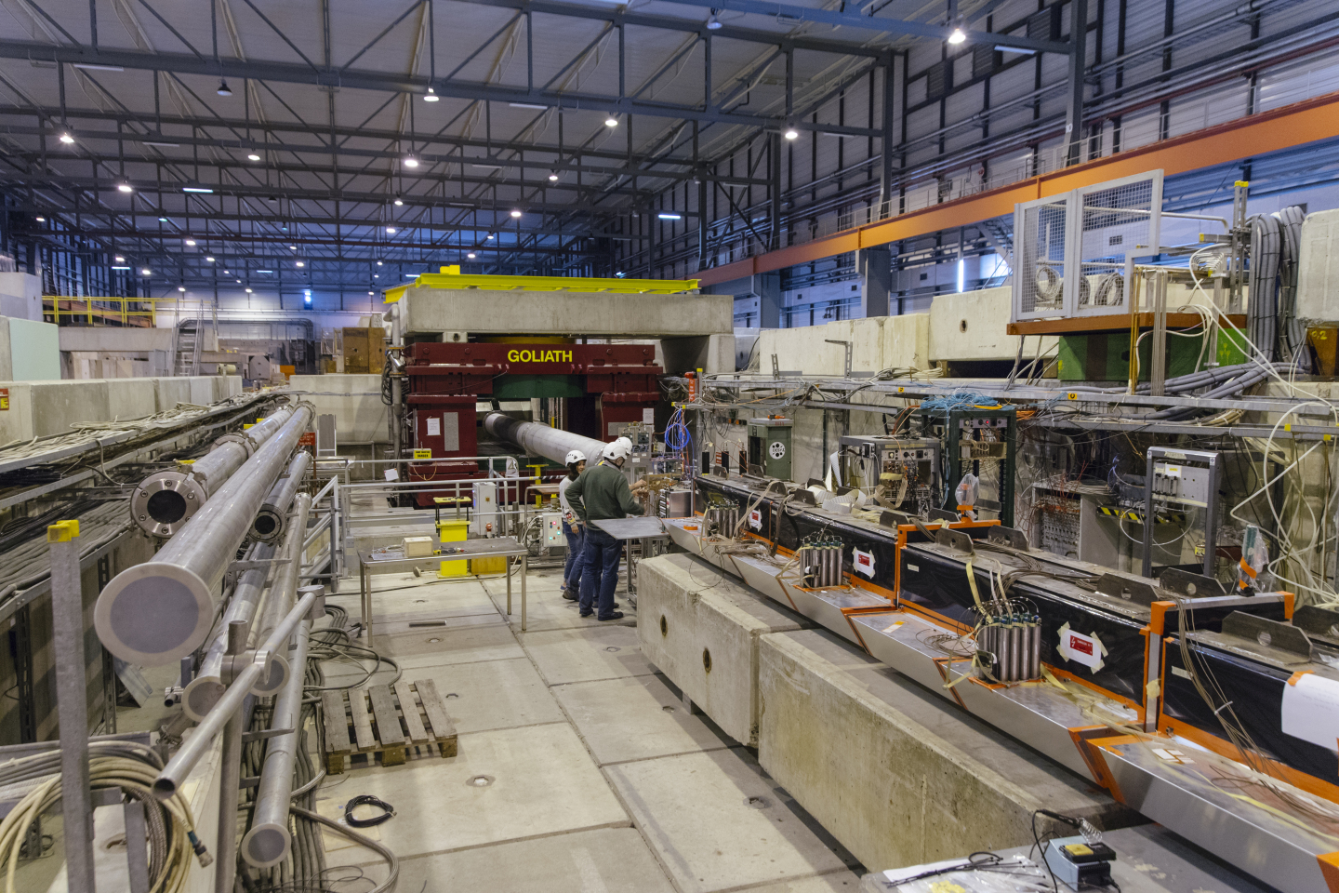

Possible schedule for reaching the final sensitivity of ≤10⁻¹² is mainly driven by theavailability of the required intensity of the electron beam. It has to providetotal number of collected electrons n_{etot}≈ 10¹² -10¹³. We anticipate toobtain ≈3x10¹² collected e⁻s within~ 3 months of run time.The requiredstatistics is summarized in Tables 1 and 2.

Table 1. Search for the decay A’ → invisible

Secondary beam | Energy, GeV | Number of events
π | 30-50  100 | 10¹⁰  10⁹
μ | 30-50  100 | 10⁹  10⁹
e⁻ | 30-50  100 | 10⁹ - 10¹²  10⁹ - 10¹²

Table 2. Search for the decay A’ →e⁺e⁻

Secondary beam | Energy, GeV | Number of events
π | 30-50  100 | 10¹⁰  10⁹
μ | 30-50  100 | 10⁹  10⁹
e⁻ | 30-50  100 | 10¹² - 10¹³  10¹¹ - 10¹²

The experimental phase during 2017-2019 aims at performing search for both decays A’ → invisible and A’ →e⁺e⁻. We expect to have during this phase 12 weeks of data taking: 6 in 2017 for the invisible decay mode and 6 in 2018 for the decay mode A’ →e⁺e⁻. Upon encouraging results and respective recommendations of the SPSC, the team is ready to consider extending the run time by a factor of 2-3.

Expenses on the project realization (JINR participation and obligations) in k$

N | Purpose of expenses | 1st year | 2^{d} year | 3^{d} year | Full cost
 | Direct expenses
 | Accelerator
 | Design bureau
 | Computing
 | Materials | 15 | 15 | 10 | 40
 | Equipment | 15 | 15 | 10 | 40
 | Collaboration funds | 10 | 10 | 10 | 30
 | Contracts for R&D
 | Business trips | 40 | 40 | 30 | 110
 | а) non-rouble zone | 40 | 40 | 30 | 110
 | б) rouble zone
 | в) by protocols
 | Total: | 80 | 80 | 60 | 220

References

[1] L. B. Okun, Sov. Phys. JETP 56 (1982) 502 [Zh. Eksp. Teor. Fiz. 83 (1982) 892].
[2] P. Galison and A. Manohar, Phys. Lett. B 136 (1984) 279.
[3] B. Holdom, Phys. Lett. B 166, 196 (1986).
[4] J. Jaeckel and A. Ringwald, Ann. Rev. Nucl. Part. Sci.60, 405 (2010).
[5] J. Alexander et al., arXiv:1608.08632.
[6] N. Arkani-Hamed, D. P. Finkbeiner, T. R. Slatyer, and N. Weiner, Phys. Rev. D 79, 015014 (2009).
[7] G. W. Bennett et al. (Muon G-2 Collaboration), Phys. Rev. D 73, 072003 (2006).
[8] S.N.Gninenko and N.V.Krasnikov, Phys. Lett. B 513, 119 (2001).
[9] P.Fayet, Phys. Rev. D 75, 115017 (2007).
[10] M. Pospelov, Phys. Rev. D 80, 095002 (2009).
[11] J. D. Bjorken, R. Essig, P. Schuster, and N. Toro, Phys. Rev. D 80, 075018 (2009).
[12] F. Bergsma et al. (CHARM Collaboration), Phys. Lett. 166B, 473 (1986).
[13] A. Konaka et al., Phys. Rev. Lett. 57, 659 (1986).
[14] E. M. Riordan et al., Phys. Rev. Lett. 59, 755 (1987).
[15] J. D. Bjorken, S. Ecklund, W. R. Nelson, A. Abashian, C. Church, B. Lu, L. W. Mo, T. A. Nunamaker, and P. Rassmann, Phys. Rev. D 38, 3375 (1988).
[16] A. Bross, M. Crisler, S. H. Pordes, J. Volk, S. Errede, and J. Wrbanek, Phys. Rev. Lett. 67, 2942 (1991).
[17] M. Davier and H. Nguyen Ngoc, Phys. Lett. B 229, 150 (1989).
[18] C. Athanassopoulos et al. (LSND Collaboration), Phys. Rev. C 58, 2489 (1998).
[19] P. Astier et al. (NOMAD Collaboration), Phys. Lett. B 506, 27 (2001).
[20] S. Adler et al. (E787 Collaboration), Phys. Rev. D 70,037102 (2004).
[21] A. V. Artamonov et al. (BNL-E949 Collaboration), Phys. Rev. D 79, 092004 (2009).
[22] R. Essig, R. Harnik, J. Kaplan, and N. Toro, Phys. Rev. D 82, 113008 (2010).
[23] J. Blumlein and J. Brunner, Phys. Lett. B 701, 155 (2011).
[24] S. Gninenko, Phys. Lett. B 713, 244 (2012). [21]
[25] J. Blumlein and J. Brunner, Phys. Lett. B 731, 320(2014).
[26] S. Andreas, C. Niebuhr, and A. Ringwald, Phys. Rev. D86, 095019 (2012).
[27] S. Abrahamyan et al. (APEX Collaboration), Phys. Rev.Lett. 107, 191804 (2011).
[28] H. Merkel et al., Phys. Rev. Lett. 112, 221802 2014).
[29] H. Merkel et al. (A1 Collaboration), Phys. Rev. Lett. 106, 251802 (2011).
[30] B. Aubert et al. (BABAR Collaboration), Phys. Rev.Lett. 103, 081803 (2009).
[31] D. Curtin et al., Phys. Rev. D 90, 075004 (2014).
[32] J. P. Lees et al. (BABAR Collaboration), Phys. Rev. Lett. 113, 201801 (2014).
[33] G. Bernardi, G. Carugno, J. Chauveau, F. Dicarlo, M. Dris et al., Phys. Lett. 166B, 479 (1986).
[34] R. Meijer Drees et al. (SINDRUM I Collaboration), Phys. Rev. Lett. 68, 3845 (1992).
[35] F. Archilli et al. (KLOE-2 Collaboration), Phys. Lett. B706, 251 (2012).
[36] S. N. Gninenko, Phys. Rev. D 85, 055027 (2012).
[37] D. Babusci et al. (KLOE-2 Collaboration), Phys. Lett. B720, 111 (2013).
[38] P. Adlarson et al. (WASA-at-COSY Collaboration), Phys. Lett. B 726, 187 (2013).
[39] G. Agakishiev et al. (HADES Collaboration), Phys. Lett.B 731, 265 (2014).
[40] A. Adare et al. (PHENIX Collaboration), Phys. Rev. C91, 031901 (2015).
[41] J. R. Batley et al. (NA48/2 Collaboration), Phys. Lett.B 746, 178 (2015).
[42] A. Anastasi et al. (KLOE-2 Collaboration), Phys. Lett.B 757, 356 (2016).
[43] H. S. Lee, Phys. Rev. D 90 (2014) 9, 091702.
[44] E. Izaguirre, G. Krnjaic, P. Schuster, and N. Toro, Phys. Rev. D 88, 114015 (2013).
[45] M. D. Diamond and P. Schuster, Phys. Rev. Lett. 111, 221803 (2013).
[46] H. Davoudiasl, H. S. Lee, and W. J. Marciano, Phys. Rev. D 89, 095006 (2014).
[47] B. Aubert etal. [BaBar Collaboration], arXiv:0808.0017[hep-ex].
[48] B. Batell, M. Pospelov, and A. Ritz, Phys. Rev. D 80, 095024 (2009).
[49] B. Batell, R. Essig, and Z. Surujon, Phys. Rev. Lett. 113, 171802 (2014).
[50] S. N. Gninenko, Phys. Rev. D 89 (2014) 7, 075008.
[51] S. Andreas etal., arXiv:1312.3309 [hep-ex].
[52] S.N.Gninenko arXiv:1308.6521 [hep-ph].
[53] S.Agostinelli at al.[GEANT4 Collaboration], NIM A506, 250 (2003); J.Alisson et al., IEEE Trans. Nucl.

