Measurement of the Rare Decay at the CERN SPS
NA62 Project (Collaboration NA62)

Report for 2016

List of organizations and participants
Belgium: Université Catholique de Louvain (Louvain-La-Neuve);
Bulgaria: University of Sofia St. Kliment Ohridski, Faculty of Physics (Sofia);
Canada: TRIUMF, University of British Columbia (Vancouver);
Czech Republic: Charles University (Prague);
Germany: Johannes-Gutenberg-Universitat Mainz (Mainz);
Italy: Università di Ferrara (Ferrara), Universita e INFN (Florence), Istituto Nazionale di Fisica Nucleare (INFN), Laboratori Nazionali di Frascati (Frascati), Universita e INFN (Naples), Universita e INFN (Padua), Universita e INFN (Perugia), Sezione di Pisa, INFN (Pisa), Universita degli Studi di Roma Tor Vergata, Sezione di Roma Tor Vergata, INFN (Rome), Universita e INFN, Roma I, Sezione di Roma I, INFN (Rome), Universita e INFN (Turin);
Mexico: Universidad Autónoma de San Luís Potosi, Instituto de Fisica (San Luis Potosi);
Romania: Horia Hulubei National Institute of Physics and Nuclear Engineering (Bucharest-Magurele);
Russia: Joint Institute for Nuclear Research – JINR (Dubna), Institute for Nuclear Research RAS (Moscow), Institute for High Energy Physics, Russian Federation State Research Centre (Protvino);
Slovakia: Comenius University (Bratislava);
Switzerland: Conseil Européen pour la Recherche Nucléaire - CERN (Geneva)
United Kingdom: University of Birmingham (Birmingham), University of Bristol, H. H. Wills Physics Laboratory (Bristol), University of Glasgow (Glasgow), University of Liverpool, Oliver Lodge Laboratory (Liverpool);
United States of America: Boston University (Boston), George Mason University (Fairfax), SLAC National Accelerator Laboratory (Menlo Park), University of California Merced (Merced), Brookhaven National Laboratory (BNL) (Upton).

Laboratory of High Energy Physics

S. Gevorkian, L. Glonti, E. Goudzovski, T. Enik, V. Elsha, S. Kakurin, V. Kekelidze, E. Kislov, S. Kolesnikov, D. Madigozhin, M. Misheva, N. Molokanova, S. Movchan, I. Polenkevich, Yu. Potrebenikov, S. Shkarovskiy, A. Zinchenko

Project leaders: Kekelidze V.D. (LHEP)
Potrebenikov Yu.K. (LHEP)

Introduction

The goal of all stages of the project is the participation in realization of the NA62 experiment at SPS CERN, where a measurement of the very rare kaon decay is planned to make a decisive test of the Standard Model (SM) by means of the 10%-precision measurement of the Cabibbo-Kobayashi-Maskawa (CKM) matrix parameter V_{td}.
The purpose of the NA62 experiment, a detailed description of which is given in the Technical Project [1], is to register about 100 events of decay in about 2 years of data taking and to keep the total systematic uncertainty small. To this purpose, at least 10¹³ K⁺ decays are required, assuming a 10% signal acceptance and the branching ratio of 10⁻¹⁰. Small systematic uncertainty requires a rejection factor for generic kaon decays at the order of 10¹², and the possibility to measure registration efficiencies and background suppression factors directly from the data. The possibility to work in an intense kaon beam, reliability of signal extraction and background suppression are the main criteria of success in preparation and carrying out of the NA62 experiment.
Large statistics of kaon decays, which is planned to record in the proposed experiment, and the presence of detectors for accurate measurement of the decaying charged kaon kinematics and their decay products make it possible to search for a series of other rare kaon decays and to study their characteristics, including a check the prediction [2] about the existence of Goldstone fermion superpartners ‒ pseudoscalar sgoldstino P.

NA62 Spectrometer based on straw tubes

In the frameworks of NA62 Collaboration the JINR and CERN groups are jointly responsible for the NA62 Magnetic Spectrometer development, production, calibration and operative support.
The spectrometer configuration based on the straw tracker has been adopted for the detection and measurement of charged decay products upstream the RICH counter. To minimize the multiple scattering of the outgoing decay products the spectrometer detectors are installed in vacuum. It is designed without internal frames and flanges in order to minimize hadron interaction probability in the regions with the highest rate. The straw tracker consists of 4 chambers based on straw tubes and positioned upstream and downstream MNP33 spectrometer magnet. Each chamber consists of four coordinate views - X, Y, U, V.
The following constraints defines the main detector requirements:
- a spatial point resolution is better than ≤130 μm per coordinate and ≤80 μm per space point;
- less than 0.1% of radiation length (X₀) for each coordinate view (0.5% of radiation length for one chamber),
- a detector is able to work in vacuum (P≤10⁻⁵ mbar) with a minimum gas load for the vacuum system (leak rate ≤ 10⁻¹ mbar⋅l/s).

The detector sensitive elements are made of the ultra-light straw tube ~2.4 m long (2.1 m of effective length) and 9.8 mm in diameter. The tubes are manufactured from 36 µm thin polyethylene terephthalate (PET) foils, coated inside the tube with two thin metal layers (0.05 μm of Cu and 0.02 μm of Au) in order to provide electrical conductivity on the cathode and to improve the straw tube gas diffusion. The anode wire (Ø=30 mm) is made of gold-plated tungsten.
Spectrometer front-end (FE) electronics is based on the CARIOCA chip [3]. This chip consists of 8 analogue channels. Each channel consists of a fast preamplifier, a semi-Gaussian shaper, a tail cancellation circuitry, base line restorer and a discriminator.
Detector is divided into cells with a 16 straws per each. Each cell has independent gas and high voltage connectors. 16-channels FE board follows the configuration of the 16-straw detector cell. Differential output signals from the FE board is transmitted by communication cables to the intermediate Straw Readout Board (SRB). Two SRBs provide a data collection from each view of the straw module, so Spectrometer uses 32 SRB in total.
Studies performed in 2010-2012 with the three different straw prototypes have allowed us to estimate the achievable characteristics of the detector with the different gas mixtures and various read-out electronics, radiation resistance of straw tubes, as well as to design the optimal scheme of straw positioning inside the mechanical framework that allows to achieve a high (more than 99.9%) efficiency of tracks registration by the spectrometer detectors. These prototypes are also allowed to check the complete technology of the straw modules assembling and testing. The corresponding works are described in the report on the 2010-2012 stage of the NA62 project.
Designers from Dubna and CERN together carried out major design and calculations of detector mechanical structures. Straw module aluminum frames have been produced on the EUROMEC factory (Italy). A mass production of 7168 straw tubes and the assembling of aluminum modules for straw spectrometer have been fully completed during the realization of NA62 project in 2013-2015. The majority of these straws of original length of 2.7 meters was made in Dubna on the unique ultrasonic welding machine constructed here. Straw modules assembling have been carried out at CERN by technicians and engineers both from CERN and Dubna, in Dubna – by JINR experts. 4 of 8 modules were assembled at JINR, and 4 other ones ‒ at CERN with a significant contribution of experts from Dubna.
The last straw chamber has been delivered to CERN and installed in 2014. The actual positions of chambers have been measured with respect to the nominal beam axis with an accuracy of 0.3 mm. After the successful development of working SRB firmware in 2015 the stable operative Spectrometer became a basic NA62 detector that provides a key information about the charged tracks for the NA62 data taking as well as for the control and calibration of all the other detector elements.

Study of noises and thresholds
Each FEE channel of the NA62 Spectrometer is characterized by the “noise scan” that is a dependence of noise rate on the threshold of corresponding CARIOCA channel discriminator. The level of threshold should be chosen in such a way, that the noise rate is not too high with respect to the expected rate of physical hits caused by the charged tracks. For any reasonable NA62 beam intensities the noise level of the order of 100 Hz can be regarded as a quite low one. So the simplest approach implemented from the very beginning of NA62 data taking was the choice of threshold at the level, that corresponds to 100 Hz noise rate limit. This simple approach does not give a clear value of threshold in terms of effective charge, that in general may lead to the variation of measured time resolutions between the straws connected to different CARIOCA chips. In order to clarify this issue and to improve the thresholds setting procedures, a special study of the noises has been performed on the basis of noise scans registered in the runs of 2015 and 2016.
A special analysis application with a suitable GUI has been developed on the basis of C++and Root, that is able to visualize all the noise scans for individual straws grouped in the FEE “covers” corresponding to the detector cells. The first result of this visualization (crosses on the Fig. 1) was the discovery of cross talk effects that introduce in some cases a shifts into the thresholds setting procedure based on 100 Hz noise level.
The reason for these large cross talks was artificial: noise scans initially have been done in one pass for the full FEE chip with a parallel change of the same discriminator threshold settings for all the channels. In this case, due to the quite different positions of individual channel baselines μ, the level of noise rate for one channel may be very high as the current value of threshold corresponds to the highest possible noise rate, while for the neighboring channel the rate may be close to 100 Hz for the same discriminator threshold. As a result the cross talk noise caused by the first channel may be even higher that the own noise of the second straw, that sometimes may distort its threshold setting.

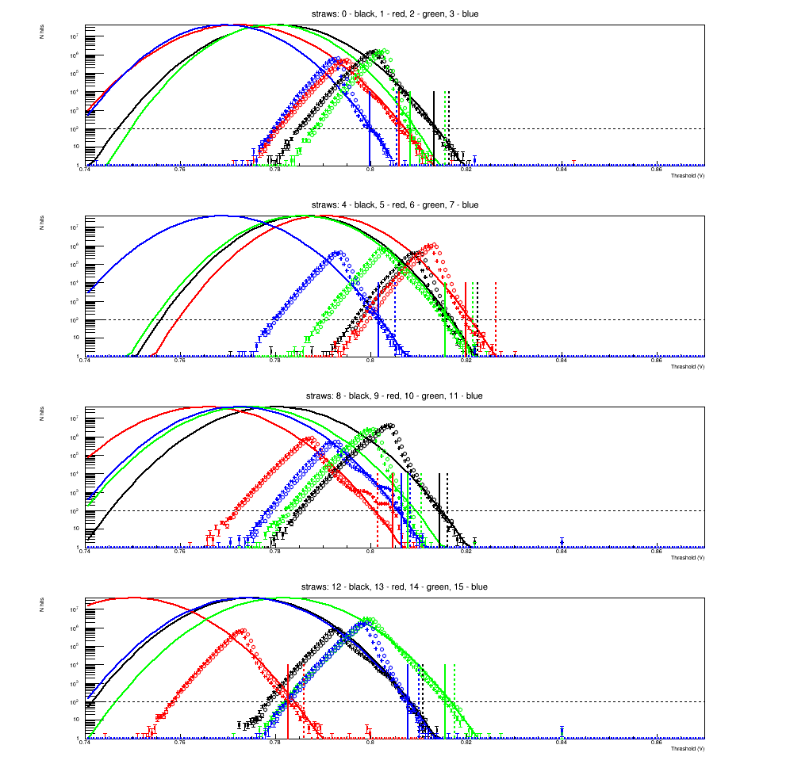

Figure 1. The example of the noise scans registered for 16 straw channels of a single CARIOCA chip. Crosses: data are collected in parallel using the same thresholds for all the channel discriminators. Circles: the noise scans were registered for each channel separately with a very high thresholds in the other straws. A visible secondary bumps on some right branches for the parallel scans reflect the presence of artificial cross-talks, that may induce a shift into the threshold procedure output. Solid vertical lines show the noise-based (100 Hz) thresholds. Dashed lines correspond to the alternative threshold settings (see text) with an offset (v-μ)=36 mV.

So the general noise scans procedure has been corrected in such a way, that each channel in the chip has been scanned separately with a very high constant thresholds settings for all other channels (circles on the Fig. 1). After this change the large visible cross-talk effects have disappeared, and the 100 Hz thresholds became essentially less distorted from the assumed value.
In order to investigate the possible influence of such a thresholds setting procedure on the data taking quality the alternative technique has been developed on the basis of theoretical consideration of noises [4]. In that framework, the ideal noise scan may be represented as a Gaussian function with a fixed maximum value (so called Rice frequency F_{R} = 39.6 MHz for CARIOCA):

F = F_{R} exp( -(v — μ)2/(2σ2) ), (1)

where v is the tested threshold of the channel discriminator, σ is a noise Gaussian width and μ is a position of Gaussian peak, that defines a signal baseline for the given straw channel. It is a place of «theoretical» maximum of the noise scan, that is invisible on the measured scans due to the inversion in CARIOCA scheme: at some low enough threshold the CARIOCA channel starts to work in the inverted mode for the noise generation (left branches of the Fig. 1 noise scans), while the signal amplification does not happen here, so both the cross talks and the self-excitation does not become a considerable effect on these left branches.
Self-excitation is observed as the presence of a larger slope near the visible peak of the right branches for many of the channels (so the threshold settings definitely must avoid that areas). This is why the noise-related σ values are extracted much better from the Gaussian fit of the left branches, while the baseline position μ is obtained from the fit of the very ending points of the rights branches with a fixed yet individual channel σ.
The idea of alternative thresholds setting procedure was to set them on the given fixed offset (v-μ) from the baseline μ rather than to choose them at the given noise rate F. The noise-dependent setting depends also on σ variations between the channels, while the fixed offset from the baseline (v-μ) is the true threshold-related value that defines a signal time resolution. From MC simulation it is known, that in the case of rather high thresholds (in comparison with a signal) a big variation of this offset (of the order of its average value) may essentially change the resulting resolution.
So the alternative procedure for the thresholds settings with a fixed (v-μ) has been developed in the framework of the noise analysis tool. On the Fig. 1 one can see the results of the alternative thresholds setting as a dashed vertical lines, here the fixed offset of 36 mV has been used. This offset value is chosen in such a way, that the average noise rate per channel is smaller than 100 Hz, and a single channel noise does not exceed 2000 Hz (see Fig. 2, lower plot).
But the tests on data in the Run 2016 did not show a considerable difference of the data quality between these two approaches to the thresholds setting. Only if one apply an a priory too high constant threshold offset (60 mV instead of 36 mV), one could distinguish the alternative threshold settings and a the initial, noise-based one, by check of the experimental leading time distribution for the individual straws. Nevertheless, it was an important check that has clarified the issue of the possible resolution variations due to the noise-dependent threshold, and in similar circumstances this kind of check should always be done.
A reason of the small resolution sensitivity to the noise-related variation of thresholds may be clarified from the Fig. 2, that illustrates a results of the Gaussian fits for all the NA62 Spectrometer channels. Upper plot represents the distribution of extracted widths σ for each Spectrometer channel. Left peak corresponds to the channels without real straws that are not used for data taking. The right peak has a width that corresponds to just a 5% of its average value. One can extract from the formula (1), that the relative variation of (v-μ) offsets for 100 Hz threshold due to σ variation is equal to the relative σ variation, and so δ(v-μ)/(v-μ) is also of the order of 5%. It is a quite small variation for the signal threshold, that may cause just a negligible resolution effect even for the high thresholds.

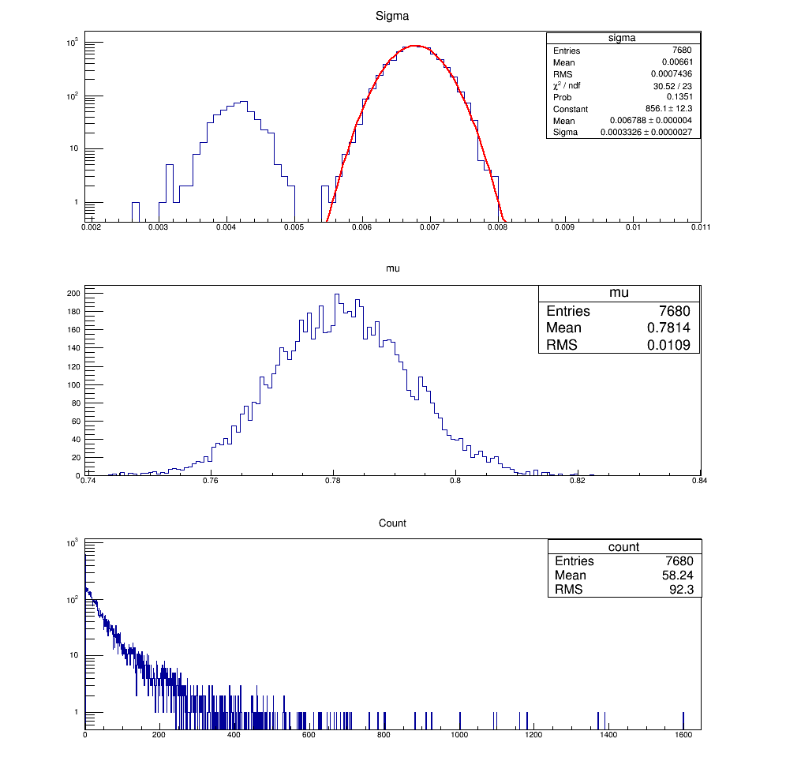

Figure 2. Upper plot: distribution of the noise scan Gaussian widths σ for all the FEE channels including unused ones with a smaller widths. Middle plot: distribution of the baseline positions μ for all the channels. Lower plot: distribution of the channel noise rates for each channels in assumption, that its threshold is set to the value of v = μ + 36 mV.

The developed in the JINR group noises analysis tool is used in 2016 Run for the Spectrometer FEE thresholds setting, providing the graphical interface both for the noise-based and baseline-related thresholds calculation on the basis of noise scans.

Spectrometer time measurement stability control

The reconstruction of track in Spectrometer is based on the measurement of hit leading drift time that is defined with respect to the physical track passage in the straw gas media. Any variation of the time offset introduced by the hit registering process or by the signal propagation may distort the drift time and cause a change of the measured distance between the hit and the straw anode wire. That is why the time offsets (called t₀) are regularly re-evaluated during the run for each CARIOCA board separately.
While the physical signals propagation is defined by the stable properties of setup, the firmware of NA62 SRB during the 2015 run as well as during the first part of 2016 has introduced sometimes a big changes into the time offset mainly due to the unstable initialization when an automatic choice of the trigger matching parameters is done. The step of the time offset change is close to 25 ns, that is quite enough to distort essentially the reconstruction results when this change happen inside the run or when t₀ values from one big run are extrapolated to the following small runs. In these cases the usual t₀ evaluation procedure based on the assumption about the time measurement stability becomes wrong.
Fortunately, these jumps may be detected off line and the corresponding correction could be introduced into the calibration and reconstruction process. The NA62 JINR group has developed a technique for the detection of these t₀ jumps during the fast off line analysis performed after the standard NA62 reprocessing. The obtained jumps database is then implemented in order to correct the straw calibration for the final stages of data reprocessing. The example of successful correction of the t₀ jumps is shown on the Fig. 3.
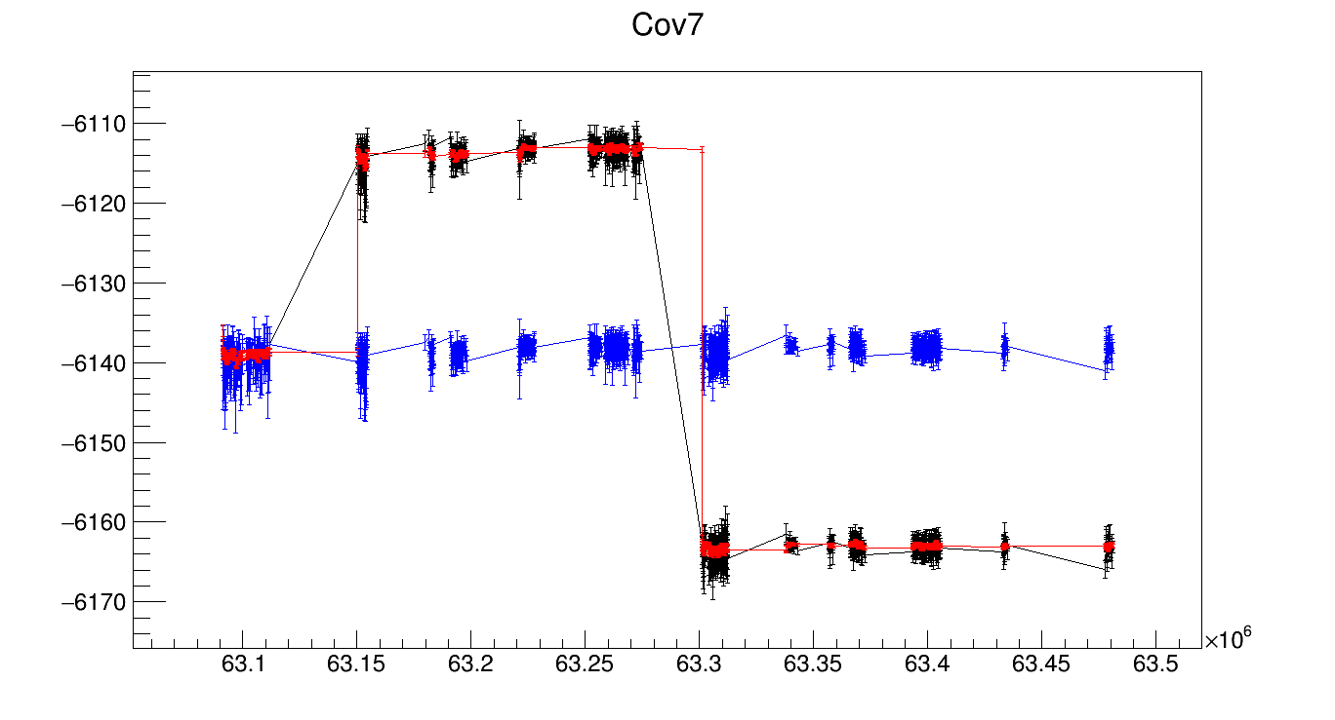 (time-stamp - 14×10⁸)

Figure 3. Example of the successful automatic t₀ correction by means of JINR group software for the specific FEE chip (cover 7). Vertical axis represents a technical raw time of the leading drift time distribution maximum. Black points and connecting lines: before the correction. Red points and lines: the reconstructed behavior of the cover t₀. Blue points and lines: the peak time after correction.

The software developed by the JINR group for the NA62 Spectrometer time measurement stability control is constantly used for the time corrections during the Run of 2016.

Interactive software tool Strawmap for the individual straws data quality analysis
In order to have a convenient access to the available data related to the individual straws, a special visualization Strawmap tool has been developed in 2016. It provides a visual map (see Fig. 4) of all the 7168 straws in terms of their geometrical positions inside the corresponding cells and modules (all the views are rotated in such a way, that the direction from left to right corresponds to the increasing of NA62 Monte Carlo straw index). Cell numbers and HV channels are also shown on the main Strawmap window. The straw electronic address (Chamber, SRB, FEE cover and the channel index in the cover ) is immediately available on click over the corresponding straw symbol (a small circle). Earlier, without this graphical tool, even a finding of relation between the given straw position and electronic channel was a nontrivial task during the run, when the time for express-analysis is limited.

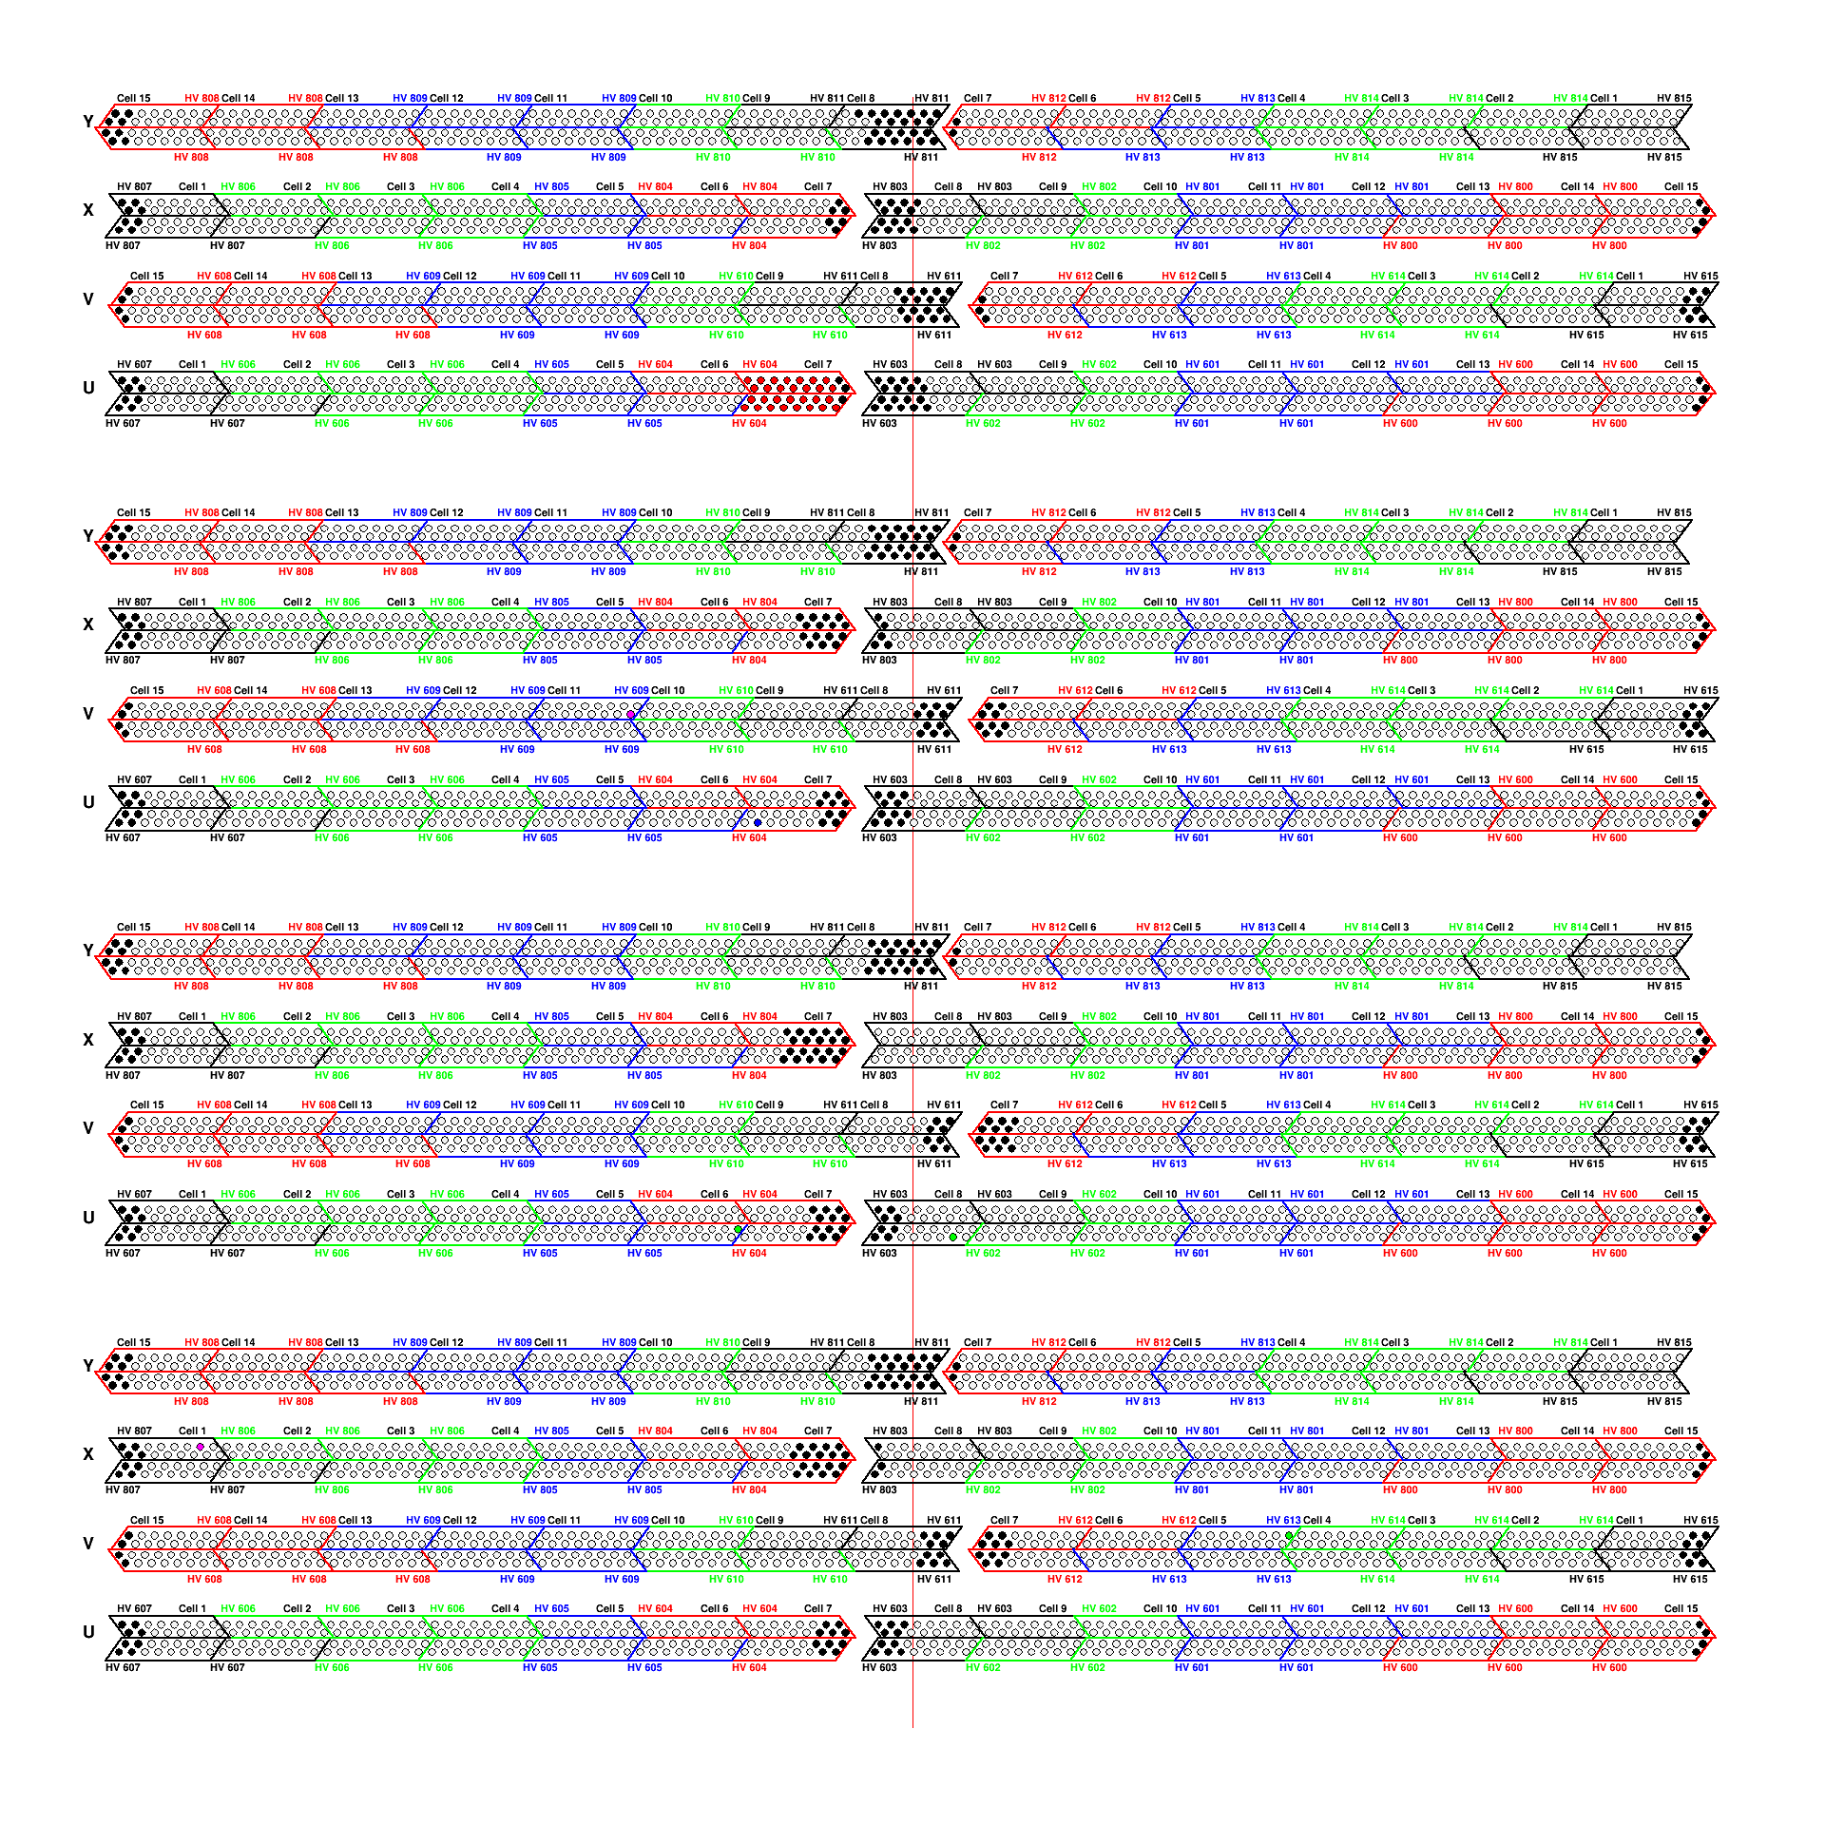
Figure 4. The main window of the Strawmap interactive tool developed for the fast control of individual straw data quality. Filling colors for the straw symbols (circles) reflect the current known straw features or problems: black – absent in the cell (by design) or dead straw; red – increased time resolution, green – straw recovered after the last detection of some problem, blue – a big relative shift between the wire and the tube center, purple – currently problematic leading time distribution (mainly due to the t₀ jump inside the run).
Apart from the general orientation in the straw electronic channels and positions, the developed Strawmap tool gives the following possibilities for the individual straw on-click inspection (see Fig.5) on the basis of a chosen run data:
- The noise scans and threshold settings (see above).
- The leading drift time distribution for a given straw (top plot on the Fig. 5).
- The drift time for hits tagged by the simultaneous hit in the staggered straw, that gives a possibility to detect an asymmetry of the wire positioning with respect to the tube (bottom plot on the Fig. 5). This asymmetry almost doesn't affect the track coordinates measurement, but it has some potential influence on the Spectrometer efficiency (finally found to be also small).
- A comparison between two straw leading time distributions after their t₀ equalization, that helps to detect a difference in the time resolution between two channels. (Fig.6)
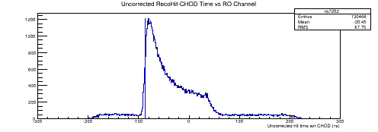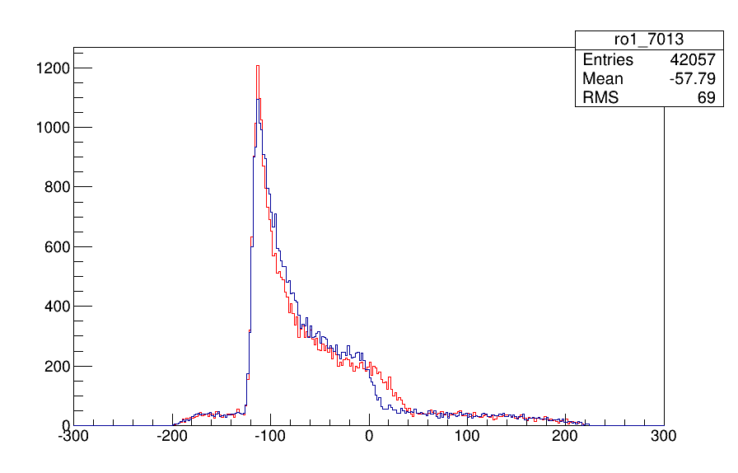
Figure 5. An example of individual straw leading drift time distribution (top) and the comparison between the tagged left (blue) and right (red) hit drift times for the given straw (bottom). A difference between the left and right tails is very sensitive to the wire position with respect to the straw tube, while the time distribution near the main peak is distorted in both cases by the bias in the left-right tagging for the hits, that are close to the wire.
Apart from that, a considerable contribution has been done into the development of leading time distributions parameterization by means of the fit with a parameters most suitable for t₀ estimation. Also the various investigations of straw data quality are performed permanently during the run of 2016. The results of all these studies has been reported in 6 talks given by JINR group members on the Straw working group of NA62 Collaboration. As an intermediate result, the current resolution of the charged track momentum measurements (that involves, apart from Spectrometer, also the kaon Gigatracker – beam spectrometer, result) is compatible with the resolution foreseen by NA62 design – even without a special alignment and precise calibration that will be done, of course, for the final NA62 result.

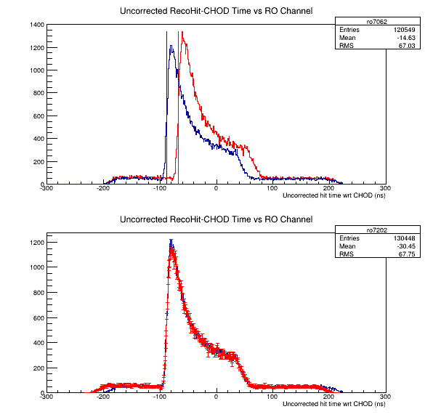
Figure 6. A comparison between the leading drift time distributions of two straws from the different cells and views. Top plot – without the t₀ equalization, bottom – after the equalization.

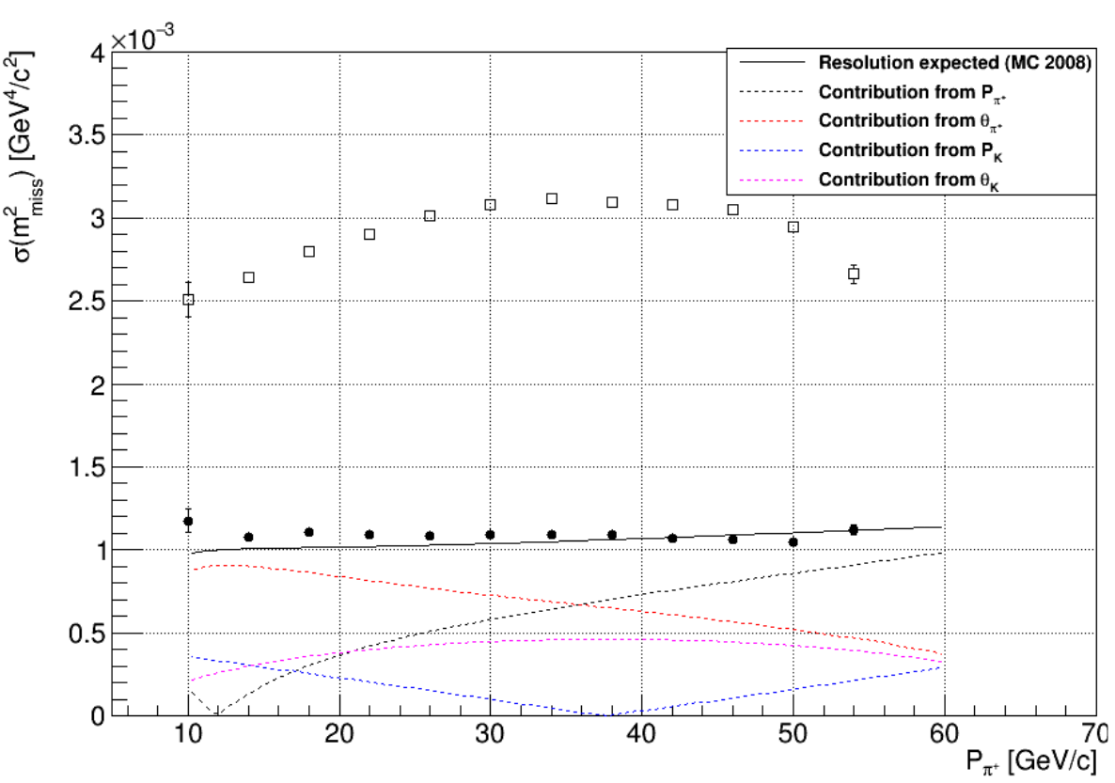
Figure 7. Resolution of the reconstructed missing mass of π⁺π⁰ decay ignoring π⁰. The missing mass is reconstructed on the basis of spectrometer only (□) and both spectrometer and Gigatraker (●). The black solid line - the Monte Carlo result.

Development of the Spectrometer Detector Control System

NA62 JINR group is responsible for the development of the Detector Control System (DCS) in the Spectrometer section. Its implementation makes it possible for the users of different access levels to perform a visual control of the Spectrometer power supply both in High Voltage (HV) and Low Voltage (LV) parts as well as to restore the normal detector performance after the possible problems. Development and implementation of the interface and functionality of this part of the system has been fully implemented by members of the JINR group. Fig. 8 shows an example of the corresponding Graphical User Interface (GUI) when some problems are detected and should be solved.

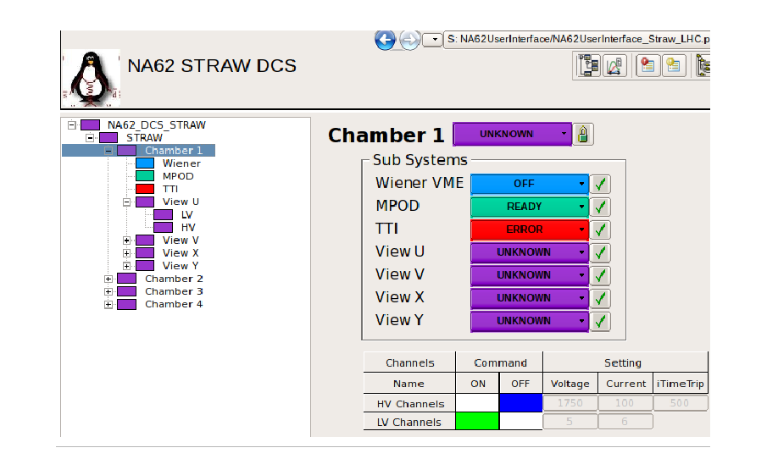
Figure 8. An example of the view of the Spectrometer DCS GUI screen signaling about the current problems.

Participation in the Run 2016

During the run of 2016 the NA62 JINR group members have participated in 82 shifts. Sergei Shkarovskiy from our group was one of two on-call experts for the Spectrometer in general, and also he was main expert on the Spectrometer Detector Control System. He has given 5 talks on the Spectrometer DCS development during the 2016.

NA48/2 and NA62 data analysis

NA48/2 and NA62 experimental data obtained in 2003 – 2007 were analyzed in parallel with a straw detector calibration and data quality investigations:

- The final result of the search for the dark photon A' in π⁰ decays collected by NA48/2 experiment has been published [8,18]. It is based on 17 million of π⁰→γe⁺e⁻ decay candidates assuming a possible A' production in the pion decay with a consecutive decay to the e⁺e⁻ pair, that could compose a narrow peak in the dilepton invariant mass spectrum. No signal is observed, but the obtained upper limits on the mixing parameter ε², defining A' interactions with a usual particles, is the most stringent currently in the A' mass region of 9-70 MeV/с².
- A searches for lepton number violation and resonances in the K± → πμμ decays at the NA48/2 experiment has been performed [16,17,19].
- The result of neutral pion form factor measurement based on NA62 data collected in 2007 has been obtained [20].
- The measurement of form factors of Ke3 and Kµ3 decays based on NA48/2 data on the stage of final internal reviewing process in the Collaboration. Dubna group is responsible for the final paper preparation.
- The analysis of rare decay K± → π±π⁰e⁺e⁻ based on NA48/2 data is on the final stage, the preliminary value of the measured branching fraction of this decay
Br(π±π⁰e⁺e⁻) = (4,06 ± 0,17) × 10⁻⁶ is measured [14]. It is the first experimental evidence of this channel.
- The study of K_{µ4}⁰⁰ rare decay, earlier unobserved, is in progress on the basis of NA48/2 data, a statistically significant signal is observed, a Monte Carlo simulation of both the signal and background samples is done, and the technique for the branching ratio measurement is developed.

In parallel with the experimental works the following methodical and theoretical results have been obtained:

- The mechanical phenomenon of straw curving in the external vacuum is understood quantitatively as a result of instability with respect to the small initial deviation from the ideally straight cylinder. The minimum tension criterion for the straw stability in vacuum is evaluated: T > PπR2, where T is the straw tension, P is pressure excess inside the tube and R is the straw radius. The tension T of a straw with a fixed ends (as it is in the NA62 Spectrometer) is increased with a higher P due to the transverse enlargement leading to the longitudinal shortening (defined by the Poisson ratio) compensated finally by the increased tension T. But the pressure inside straw leads to the decreasing of “effective tension” value : (T–PπR2), that defines a transverse force applied to the transversally shifted straw element. As a result the straw lowest oscillation frequency becomes lower when the pressure is increased, that makes a false impression of the straw tension decreasing for a higher P.
- A device for the measurement of wire positions in gas wire chambers has been designed and built on the basis of the corresponding research [6]. Wire position is extracted from the image made in the passing or reflected light by means of photography. The wire remains visible even through the metalized straw wall if the light has a proper direction and intensity. A special image-analysis software is developed and implemented in order to make the calibrated absolute position measurement on the basis of registered images.
- Photo production of ω mesons off nuclei and impact of vector mesons polarization on meson-nucleon interaction have been studied [10,21,22].

The obtained results have been presented in 2016 at the international conferences, including 12 talks given by the representatives of JINR group [11-22]. The NA62 Collaboration meeting has been organized in Dubna in August 2016, where many important current results have been presented and an impressive educational and social program has contributed into the promotion of JINR as a world-class scientific center. In total 7 scientific presentations on the Dubna meeting has been given by the JINR group representatives.
Apart from that, a review of the kaon decay studies made during the last decades, prepared by the group members, has been published in the “Physics of Elementary Particles and Atomic Nuclei” journal [9]. Also JINR group members have obtained the patent for invention [5] and an official positive decision about the patent [6].
Under the supervision of JINR group member in 2016 a student of Dubna University and Kazakh State University Dosbol Baigarashev has defended his thesis for bachelor degree.
In the frameworks of the NA62 Project of 2016 – 2018 the following works are foreseen for the rest of the Project period:

- to collect experimental data during the runs of 2017 – 2018;
- to make the necessary calibration and alignment of straw detector;
- to perform the data quality studies for the straw detector;
- to take part in the development of straw detector simulation needed in order to solve the main tasks of the experiment;
- to perform the data processing and the analysis of collected experimental data and to obtain a first physical results of the experiment;
- to provide an operative support for the running straw detector as well as for its low-voltage and high-voltage power supply systems during the runs.

References

- NA62 COLLABORATION; F. Hahn et al. NA62 Technical Design Document. NA62-10-07, CERN, 2010, 414 pp.
- D.S. Gorbunov, V.A. Rubakov. Phys.Rev.D 73:035002, 2006.
- D. Moraes F. Anghinolfi, P. Deval, P. Jarron, W. Riegler, A. Rivetti, B. Schmidt CARIOCA - a fast binary front-end implemented in 0.25_m CMOS using a novel current-mode technique for the LHCb muon detector. Proceedings of the 2001 IEEE International Symposium on Circuits and Systems. 6-9 May 2001, Sydney, Australia. V.1. P.360-363.
- A.P. Kashchuk, Instrum.Exp.Tech. 55 (2012) 440-447.
- S.A.Movchan et al. A device for the production of cylinder tubes for the gas-filled drift detectors of ionizing radiation. Patent #2555693. 8.06.2016.
- L. Glonti et al. A device for the measurement of wire positions in gas wire chambers. Decision to issue a Patent 15.09.2016.
- N.I. Azorskiy et al. Design and test results of the first prototype detector based on thin-walled drift tubes for the NA62 experiment. Instrum. Exp. Tech. 58 (2015) 593-601 [Prib. Tekh. Eksp. 2015 (2015) 11-19].
- J.R. Batley et al. (NA48/2 Collaboration). Search for the dark photon in π⁰ decays. Phys. Lett. B746 (2015) 178-185.
- A. Ceccucci, E. Goudzovski, V. Kekelidze, D. Madigozhin and I. Potrebenikov. Kaon decay studies at CERN SPS in the last decades. Phys. Part. Nucl. 47 (2016) 567-590.
- E. Chudakov, S. Gevorkyan, A. Somov. Photo production of ω mesons off nuclei and impact of polarization on the meson-nucleon interaction. Phys. Rev. C93 (2016) 015203.
- L. Glonti, M. Misheva, Y. Potrebenikov, V. Samsonov, S. Movchan, T. Enik, A. Kolesnikov. Determination of the anode wire position by visible light in a new type straw for NA62 experiment tracker. [13th Pisa Meeting on Advanced Detectors: Frontier Detectors for Frontier Physics. 2015. La Biodola, Isola d'Elba, Italy.] Nucl. Instrum. Meth. A824 (2016) 532-534.
- N. Azorskiy et al. A drift chamber with a new type of straws for operation in vacuum. [13th Pisa Meeting on Advanced Detectors: Frontier Detectors for Frontier Physics. 2015. La Biodola, Isola d'Elba, Italy.] Nucl. Instrum. Meth. A824 (2016) 569-570.
- N. Azorskiy et al. The NA62 spectrometer acquisition system. [TWEPP 2015. Lisbon, Portugal] JINST 11 (2016) C02064, 10 pp.
- S. Shkarovskiy. NA62 Spectrometer to search for K±→π±νν decay. 14-th Topical Seminar on Innovative Particle and Radiation Detectors. Siena. Italy. 2016.
- M.H. Misheva et al. Fisrt observation and study of K±→π±π⁰e⁺e⁻ decay at the NA48/2 experiment. Proc. of 50th Rencontres de Moriond, QCD and high energy interactions: La Thuile, Italy. (2015) 237-240.
- D. Madigozhin et al. Searches for lepton number violation and resonances in the K±→πμμ decays at the NA48/2 experiment. [New Trends in High-Energy Physics. Budva, Becici, Montenegro. 2016.]
- A. Zinchenko et al. Searches for lepton number violation and resonances in the K±→πμμ decays by NA48/2 at CERN. [14-th International Conference on Meson-Nucleon Physics and the Structure of the Nucleon. July 25-30, 2016, Kyoto, Japan.]
- E. Goudzovski. Search for the dark photon in π⁰ decays. [PLANCK 2015, Ioannina, Greece, 25–29 May 2015.] PoS (PLANCK 2015) 053.
- E. Goudzovski. Kaon experiments at CERN: recent results and prospects (invited talk). [MESON 2016, Krakow, Poland, 2–6 June 2016.]
- E. Goudzovski. Neutral pion form factor measurement at NA62. [ICHEP 2016, Chicago, US, 3–10 August 2016.]
- S.R Gevorkyan. The impact of vector mesons polarization on meson-nucleon interaction. [16th Workshop on High Energy Spin Physics (DSPIN-15)] J.Phys.Conf.Ser. 678 (2016) 012033.
- S.R Gevorkyan. Vector mesons polarization vs color transparency. [Baldin ISHEPP, 2016, Dubna, Russia]. Book of Abstracts of the Baldin seminar. (2016) 57.

