TRANSLATED from Russian

TECHNICAL PROJECT

OF THE OBJECT "NICA COMPLEX"

Section: TECHNICAL SPECIFICATION

(PASSPORT)

OF THE "NICA COMPLEX" OBJECT

It is prepared in addition to the following documents:

- "Justification and the roadmap of the NICA Complex megaproject" dated September 15, 2011.

(sent to the Ministry of Education and Science of the Russian Federation on September 19, 2011, letter №010-28/1134);

- "Main provisions of the technical project of the basic configuration of the complex of superconducting rings with colliding beams NICA" (Annex 1 to the Agreement between the Government of the Russian Federation and the international intergovernmental research organization Joint Institute for Nuclear Research on the establishment and operation of the complex of superconducting rings with colliding heavy ions beams NICA).

28 December 2018

Under the general editorship of the Director of the Laboratory of High Energy Physics (VBLHEP) JINR V. D. Kekelidze and Deputy Director of VBLHEP JINR Yu. K. Potrebenikov. People responsible for the subsections of the document are listed in the table

Section | Sectons editors |  | Signature
Aims and objectives of the NICA complex | Sorin A.S.  The leader of the theme 1065 | sorin@theor.jinr.ru  Tel. 216-59-40
Scientific program | Teryaev O. V.  The leader of theoretical researches | teryaev@jinr.ru  Tel. 216-21-66
Accelerating complex | Meshkov I. N.  Scientific leader of the project of the accelerator complex | meshkov@jinr.ru  Tel. 216-51-93
 | Trubnikov G. V.  The leader of the Nuclotron-NICA project | trubnikov@jinr.ru
 | G. G. Khodzhibagiyan,  The head of the projects of magnetic cryostat systems | hamlet@jinr.ru  Tel. 216-46-86
 | Kovalenko A.D.,  Person responsible for polarized beams control systems | kovalen@dubna.ru  Tel. 216-22-24
 | Butenko A. V.  Deputy project manager Nuclotron-NICA | butenko@jinr.ru  Tel. 216-37-22
 | Sidorin A. O.,  Deputy project manager Nuclotron-NICA | sidorin@jinr.ru  Tel.216-39-10
 | Syresin E. M.,  Chief engineer of the NICA accelerating complex | esyresin@jinr.ru  Tel. 216-53-21
MPD facility | Golovatyuk V. M.,  MPD deputy project manager | golovatyuk@jinr.ru  Tel. 216-65-51
BM@N facility | Kapishin M. N.,  The leader of the BM@N project | kapishin@jinr.ru  Tel. 216-28-61
SPD facility | Tsenov R.,  Head of the team preparing the SPD project | tsenov@jinr.ru  Tel. 216-39-04
Innovation unit | Syresin E. M. | esyresin@jinr.ru  Tel. 216-53-21
Computer unit and  computer network  of the NICA complex | Dolbilov A.V., head of works on the development of the NICA complex network and computing infrastructure | dolbilov@jinr.ru  Tel. 216-24-70
 | Yu. K. Potrebenikov, the coordinator of works on the development of the network and computing infrastructure of the NICA complex | potreb@jinr.ru  Tel.216-34-41
Building, research and engineering infrastructure of the NICA complex | Agapov N. N.,  VBLHEP Chief Engineer | agapov@lhe.jinr.ru  Tel. 216-58-59
 | Dudarev, A.V.,  deputy chief engineer  JINR | dudarev@jinr.ru  Tel. 216-32-41
 | Semin N. V.,  deputy VBLHEP chief engineer | semin@jinr.ru  Tel. 216-58-07
 | Trubnikov B. A., Assistant VBLHEP Director | alekstru@jinr.ru  Tel. 216-30-55

GENERAL INFORMATION

The Customer is Joint Institute for Nuclear Research (JINR).

The NICA Complex project (hereinafter the Complex) is implemented by the Laboratory of High Energy Physics (LHEP) with the support of JINR services, contractors and international collaborations.

The area of construction of the Complex – LHEP site of JINR, Dubna.

The location of buildings and structures of the complex on the VBLHEP site are shown in the diagram (Fig. 1), their description and purpose are given in Table 1.

General design organizations of the civil construction complex: ZAO "Kometa"; ZAO "Arena", ZAO "Giprokislorod", etc., a detailed design of the main technological systems is performed by VBLHEP.

Orders for the specialized equipment are performed on technological sites of VBLHEP, at the Experimental Workshops (EW) of LHEP and at third-party organizations, including foreign enterprises.

Construction, design, as well as partially installation works are carried out by third parties under the control of CCD JINR.

The total area for equipment, development of experimental and technological sites, experimental zones, computing capacities and workplaces is 84 330 m².
Including:
- building 17 (collider and two experimental pavilions) - 30 800 m²
- building №1 (Nuclotron) - 23 900 m²
- building 205 (testing and experiment area on the extracted beams) - 8 900 m²
- industrial and office premises - 26 530 m²
Total power consumption by power supply:
- at the stage of construction of the Complex | - 16.120 |  | MW;
- after commissioning of the Complex | - 34.734 |  | MW;

The construction of the Complex is carried out in three stages:
- the first stage- "The Starting Configuration of the NICA Complex", is determined by the commissioning of the Booster and start of experiments on extracted beams;
- the second stage - "Basic Configuration of the NICA Complex", will be implemented with the completion of the main construction and installation works, the launch of the Collider and the first experimental facility of the Collider;
- the third stage- "Full Configuration of the NICA Complex", is characterized by the achievement of the design parameters of the accelerator complex and the commissioning of the second facility at the Collider.

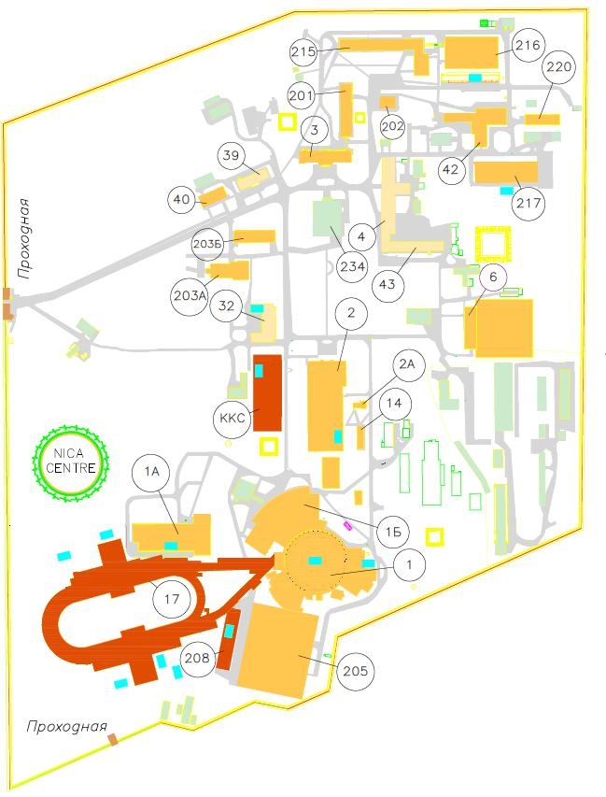

Fig. 1. Layout of buildings and premises at the VBLHEP site, used for construction and operation of the NICA complex. Red color indicates newly constructed ones, green – under design, yellow – under reconstruction, blue – transformer stations.

Table 1.

Numbers of VBLHEP buildings and their purpose in the project NICA Complex

Buildings | Status of the object  (MO – main, AO – auxiliary) | Intention | Facilities and technological areas | Available | Under construction | Reconstruction
Bld. 1 | MO | Accelerator complex | Nuclotron, injection complex, Booster ring, control panel
Bld. 1A | MO | Energetic building, MPD and SPD control panels | Power sources of the accelerator complex, MPD and SPD control panels
Bld. 1B | MO | Cryogenic complex | Control panel, compressors
Bld. 2 | MO | Accelerator complex control panel | Control panel
Bld. 2A | MO | Oil storage | As part of the cryogenic complex
Bld. 3 | AO | Office building
Bld. 4 | AO | Express workshops | Machining, welding, assembly and painting areas
Bld. 6 | AO | Main step-down substation
Bld. 14 | MO | On-line cluster | Collection and transmission of experimental data
Bld. 17 | MO | Accelerator complex | Collider ring, MPD, SPD electron cooling system, Nuclotron, Booster
Bld. 32 | AO | Express workshops | Cryostat assembly and manufacture area
Bld. 39 | AO | Administrative
Bld. 40 | MO | MPD and TPC detectors assembly and testing | MPD and TPC detectors assembly and testing area
Bld. 42 | MO | MPD detectors assembly and testing | Assembly and testing of high voltage equipment of the NICA complex. Assembly area of ECAL MPD. Assembly area of TOF and RPC
Bld. 201 | MO | Development of electronic elements of detectors | Areas for development of the complex cluster prototype
Bld. 202 | AO | Development and testing of detectors | Development and testing area for elements of MPD and SPD detecting systems
Bld. 203A | MO | Magnets testing | Magnets testing area
Bld. 203B | MO | Development and testing of sources for the accelerator complex | Sources testing area
Bld. 205 | MO | Facilities for applied research | Complex of facilities for applied research HIPER NIS, BM&N
Bld. 208 | MO | Power supply of facilities | Power sources of experimental facilities
Bld. 215 | AO | Office center | Conference complex, areas for development of the prototype of the complex cluster
Bld. 216 | MO | Off-line NICA cluster | Area for development of silicon detectors
Bld. 217 | MO | SP-magnets assembly and testing, TPC assembly | SP-magnets assembly and testing area, TPC assembly area
Bld. 220 | MO | Assembly and testing of elements of detector systems | Area for straw and micro-strip detectors assembly, ECAL MPD assembly area
CCS |  | Cryogenic compressor station | Cryogenic compressor station
Nica Centre | MO | Office center, conference center, data taking and processing center | Computer cluster for modelling, processing and storing experimental data
Bld. 234 | AO | Canteen | Canteen

Contents

Introduction - goals and objectives of the NICA complex

- Scientific research program

- Accelerator unit

- MPD facility

- The BM@N facility

- The SPD facility

- Innovation unit

- Network and computing infrastructure for the NICA complex

- Construction, research, and engineering infrastructure of the NICA complex

8.1. Construction infrastructure of the complex

8.2. Cryogenic infrastructure

8.3. Infrastructure of power supply and energy saving engineering systems

8.4. High-tech assembly and testing line of SP magnets

- Schedule of the establishment of objects of the NICA complex and estimation of their cost

9.1. Schedule of the establishment of the main objects of the NICA complex

Annex 1. Estimation of material costs for the establishment of the main objects of the NICA complex

Introduction - goals and objectives of the NICA complex

The purpose of the project "NICA Complex" (hereinafter – the NICA complex or Complex) is to develop a world-class experimental base in the Russian Federation to conduct fundamental research on a number of most important issues of modern high energy physics and perform relevant applied research, to ensure the participation of scientists from scientific organizations of the participating countries in these studies, as well as countries that have joined the project.
The following main facilities are constructed, developed and operated as part of the Complex:

Accelerator unit including
- superconducting synchrotron Nuclotron and channels for beams extraction and transition;
- injection complex (ion and polarized particle sources, linear accelerators);
- superconducting synchrotron, the Booster of the NICA complex (further – Booster);
- superconducting collider of heavy ions and polarized particles of the NICA complex (hereinafter - the Collider).

Experimental facilities, including
- MPD (MultiPurpose Detector) – for studies of dense baryonic matter on colliding beams;
- BM@N (Baryonic Matter at Nuclotron) – to conduct physical research in the field of dense baryonic matter with Nuclotron extracted beams;
- SPD (Spin Physics Detector) – to study the spin structure of nucleon on colliding polarized beams.

Innovation unit including
- experimental zones, channels and set-ups for innovative and applied research, development of microelectronics, solving a number of biomedical and material science problems.

Computer-information unit, including

- distributed information and computing complex for modeling, processing, analysis, and storage of accumulated data with networking infrastructure and a set of information services.
Fundamental research carried out at the NICA complex requires the establishment and functioning of international collaborations that include scientists, engineers and specialists from participating countries of the project. Innovative and applied activity also engage to JINR teams of specialists from different countries aimed at solving a wide range of tasks. Preliminary estimates of the number of specialists who visit the Institute for work over a year already on stage of the start of the base configuration of the Complex will be at least 1000 and in the future, during the development of the Complex, this number should increase by 3 – 5 times. All project participants should be provided with offices and appropriate infrastructure (computing, meeting and seminar rooms, canteens, etc.).

To solve these tasks, it is required to establish an appropriate construction, research and engineering infrastructure, including:

- building №1 (the former building of the Synchrotron) Nuclotron, Booster, the injection complex with particle sources and two linear accelerators, particles transport channels to the Booster and to Nuclotron;
- building 17 of the collider with tunnels of beam transport channels from Nuclotron, experimental pavilions of MPD and SPD detectors, pavilion of Collider beam electron cooling system and other buildings constructed or reconstructed for the operation of the whole complex;
- experimental pavilion (building 205) for researches on extracted beams of particles and for special testing zones of the developed equipment;
- cryogenic complex with a new building of cryogenic compressor station;
- infrastructure of power supply and energy saving engineering systems;
- high-tech assembly and testing line for superconducting (SP) magnets of the Nuclotron type;
- innovation center -- NICA center;
- distributed computer complex with high-speed technological and local computing networks;
- beam transport channels in specialized areas of the innovative and applied investigations on linear accelerators and Nuclotron extracted beams.

The layout of the main accelerators and experimental facilities of the complex is shown in Fig. 2.
This document contains a description of the research program using the capabilities of the Complex, a brief description of the main objects of the Complex with their basic technical parameters and stages of its establishment, as well as links to documents containing a detailed technical description of these objects.
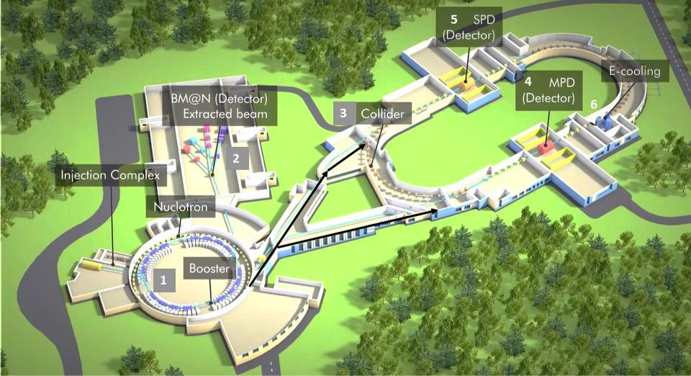

Fig. 2. Layout of the main accelerators and experimental facilities of the NICA complex

- Scientific research program
Researches on the NICA complex covers a wide range of phenomena in the field of structure with the strongly interacting matter, that is manifested in reactions with heavy ions, polarized hadrons, and light nuclei. The main directions of the research program are:
- Search and experimental study of phase transitions and critical phenomena in strongly interacting nuclear matter at extreme baryonic densities
Such matter existed only at early stages of the origin of the Universe. At lower temperatures, it can also appear in the nuclei/inside of neutron stars. Computations in lattice quantum chromodynamics predict phase transitions of deconfinement and reconstruction of chiral symmetry at a sufficiently high energy density leading to the formation of quark-gluon matter. Currently, lattice methods do not extend to the region of high baryonic densities, typical for heavy ion collisions at the Complex. The possibility to achieve the maximum baryonic density in accelerator experiments at the energies of the Complex is confirmed by both model theoretical calculations and experimental data at CERN. The energy range of the Complex is quite wide (see the phase diagram in Fig. 1.1) to study both the hadron phase and the quark-gluon phase. The temperature and the baryonic density normalized to “normal” on the axes are the main indirectly observed characteristics that indicate the manifestation of statistical regularities in heavy ion collisions. The boundary between the hadron and quark-gluon phases can be manifested in various experiments, astrophysical and cosmological phenomena.

It is essential not only to detect the phase transition but also to clarify its nature. The latter may include both a crossover and a first-order phase transition leading to a critical end point (CEP - Critical End Point - Fig.1.1). Neither the first-order phase transition nor the critical end point were observed experimentally. Therefore, the search for them is one of the main tasks of the scientific program.
Due to the fact that theoretical results are limited that is associated, in particular, with that lattice computations at finite baryonic density are in a formative state, the experiments will begin with the study of diagnostic observables previously studied at the RHIC and SPS accelerators. Observables will include particle yields and spectra, event-by-event multiplicity and transverse momentum fluctuations, and various combined distributions. Measurements will be carried out at different energies and types of particles. Femtoscopic correlations, the directed, elliptic and higher fluxes for different hadrons, leptons and photons, charge and spin asymmetries will be investigated.
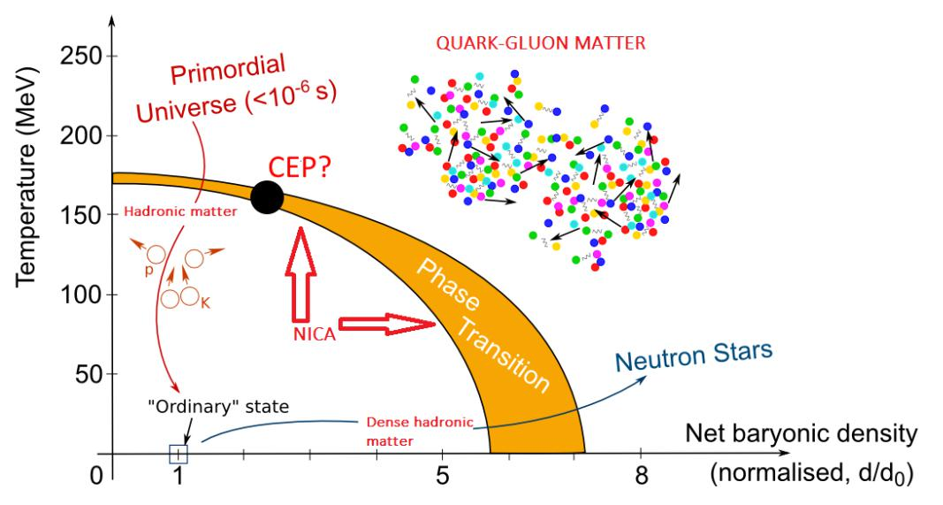
Fig. 1.1. Phase diagram of the baryonic matter
- Experimental study of the spin structure of nucleon and light nuclei
The modern description of the spin hadron structure is carried out by means of a set of distribution functions that depend on both spin and transverse momentum, with a special role played by correlations between different transverse characteristics. The program of the Complex includes the study of a complete set of transverse momentum-dependent functions of the leading power twist using various rigid probes-dileptons (in the process of Matveev-Muradyan-Tavkhelidze-Drell-Yan), quarkonia, direct photons, hadrons with large transverse momentum. Transverse-momentum integrated parton distributions and quark-gluon correlators will also be investigated. A special role will be given to tensor polarized deuteron distributions as the presence of corresponding beams is a unique feature of the Complex.

- Investigation of polarization effects in heavy ion collisions and few nucleon systems.
Hyperon polarization is a sensitive probe of the dynamics of the hadron and quark-gluon medium, including its acute characteristics such as hydrodynamic vorticity and helicity. The theoretical methods developed at JINR predict the achievement of its maximum values in the energy range of the Complex, which is confirmed by the RHIC data. The program includes a study of the polarization of hyperons formed in different kinematic regions, depending on the type of nuclei, energy, and centrality. It is planned to conduct a detailed comparison of polarization effects in reactions with hadrons, light and heavy nuclei. Tensor polarization of vector mesons and dileptons will also be systematically investigated.

- Investigation of reaction dynamics and studying modifications of hadron propertiesin nuclear matter.
Theoretical studies indicate the possibility of partial restoration of chiral symmetry, leading to modifications of hadron spectral functions in a dense medium. Most sensitive probes of this modification for vector mesons are dileptons, which characteristics, including angular distributions (tensor polarization), are sensitive to the state of the medium at the moment of interaction and are not distorted by strong interactions at later stages of the process. Currently, there are no data on dileptons with an invariant mass in the region of several GeV. The program of the Complex will eliminate this drawback, which is especially important due to the fact that the maximum density of hadrons is achieved in this region.

- Study of the structure of the nuclei at short inrnucleon distances, near-threshold strange hyperons production and search for hypernuclei of the Nuclotron extracted ion beams with fixed targets.
Fluctuations at short distances, which are also related to the concepts of fluctons and cumulative processes developed at JINR, can be studied in reverse kinematics, in the scattering of nuclear beams on a hydrogen target, which makes it possible to detect all particles in the final state. Scattering of polarized deuterons can be used for direct check of tensor nature of fluctuations. Enhanced strangeness in heavy ion collisions compared to elementary processes is a sensitive probe of phase transitions. This phenomenon is most clearly manifested in the formation of hypernuclei, which is supposed to be studied both in the Collider mode under conditions of maximum baryon density and on fixed targets.

- Development of theoretical models of the studied processes and theoretical support of experiments.
Theoretical studies will combine a detailed simulation of processes in specific conditions of experiments at the Complex with exploratory developments including the development of new theoretical methods, in particular, non-perturbative and lattice quantum chromodynamics.
The research program is presented in the "White paper" of the NICA project http://theor0.jinr.ru/twiki/pub/NICA/WebHome/WhitePaper_10.01.pdf and published as a separate volume of the European Physical Journal: D. Blashke et. al. Exploring strongly interacting matter at high densities - NICA White Paper. EPJ A. V 52, N8, 2016. 267 p.

- Accelerator unit

2.1. General aspects of the accelerator facility
Accelerator facility (or accelerating complex NICA) of the project "NICA complex (Fig. 2.1) provides accelerated beams of charged particles to experimental setups of the NICA complex to carry out program of investigations in the field of relativistic nuclear physics, spin physics, radiobiology and applied research. NICA accelerator complex is unique in its composition and structure of ion beams used, flexibility at realization of research programs, luminosity in the study of particle interactions in the energy range achievable at the complex.
The NICA accelerator complex consists of two injection chains of light (A/Z = 1÷3) and heavy (A/Z = 1 ÷ 6) ions, Booster and Nuclotron synchrotrons, two Collider superconducting storage rings and beam transport channels between these elements.
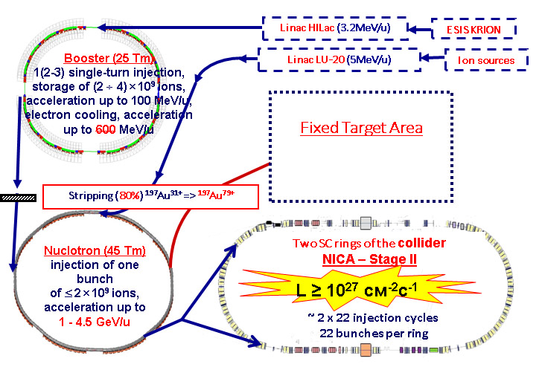

Fig. 2.1. NICA facility and its components

The injection chain of light ions creates, accelerates and transports ions to Nuclotron; the injection chain of heavy ions also transports them to the Booster from which they are transported to Nuclotron after acceleration. Nuclotron provides broad-spectrum ion beams (from protons to gold) to facilities of applied research, the BM@N experiment and the Collider using the systems of slow and fast beam extraction corresponding channels of particle transfer.
The main facility of the complex, providing experiments at the MPD and SPD facilities is Collider. It consists of two storage rings placed on top of each other with two interaction points (IP). Beam collisions are performed at a zero angle.

2.2. Light ion injection chain
The injection chain for light ions is designed for injections of beams of various ions from protons to Mg, polarized proton beams with energies up to 12 MeV and deuterons with energies up to 6 MeV/n into Nuclotron. The chain consists of the following main elements:

- a set of ion sources: the laser source, duoplasmatron, the source of polarized particles (Table 2.1);
- high-frequency resonant linear accelerator LU-20;
- distribution channels of the beams between the elements of the chain.

Depending on the experiment being performed, one of the following may be used: three ion sources: the laser source, duoplasmatron, the source of polarized particles. Source parameters are given in Table 2.1.
Table 2.1
Parameters of light ion sources
Source | Laser | Duoplasmotron |  | SPI*
Particles | Light ions up to Mg¹⁰⁺ | Н⁺, D⁺ | Не²⁺ | ↑Н⁺, ↑D⁺
Particles per pulse | ~ 10¹¹ | ~ 5·10¹² | ~10¹¹ | 5·10¹¹
Pulses repetition rate, Hz | 0.5 | 1 | 1 | 0.2
* SPI – a source of polarized ions

The upgraded accelerator LU-20 (Table 2.2) provides the acceleration of ions with the ratio of mass number to charge 1 ≤ a/Z ≤ 3.
Further, at the stage of implementation of the Full configuration of the NICA complex, it is planned to replace the LU-20 with a modern accelerator with an increase in ion energy to 7 MeV/n.

2.3. Heavy ion injection chain
The injection chain for heavy ions is designed for injection of ion beams up to gold with energy up to 3.24 MeV/n into the Booster. It consists of the following main elements:
- source of the highly-charged ions KRION-6T;
- high-frequency resonant linear accelerator;
- beam transfer channels between the elements of the chain.
Table 2.2.

LU-20 parameters
Main parameters | Value
Accelerating structure | SUQF* + Alvarez
A/Z accelerated ions | 1 ÷ 3
Output energy, MeV/n | 5
Output beam current, mA | 5 ÷ 10
Output emittance (effective), π·mm·mrad | 40
Acceptance, π·mm·mrad | 220
Ion injection energy  A/Z = 1 ÷ 3, keV/n | 150
Capture efficiency, % | 50
Operating frequency, MHz | 145
Length, m | 22
- SUQF – spatially uniform quadrupole focusing
The cryogenic source of multicharged heavy ions (KRION) has a focusing structure of the Electron String Ion Source (ESIS) type (Table 2.3). It is the original development of the VBLHEP, JINR.
Table 2.3

Heavy ion source parameters
Main parameters | Value
Particles in the main mode | Au31⁺
Particles per pulse | ~ 2,5·10⁹
Operating frequency of repetition of the cycles in Hz | 3 per 5 s
Maximum repetition rate of the cycles in Hz | 10

HILAc (Heavy Ion Linear Accelerator) (Table 2.4) accelerates ions with a mass-to-charge ratio of 1 ≤ a/Z ≤ 6.
Table 2.4
HILAC parameters
Main parameters | Value
A/Z range of accelerated ions | 1 ÷ 6
Output energy (A/Z = 6), MeV/n | 3.24
Output beam current, mA | 10
Structure type (number of sections) | RFQ (1) + IH DTL (2)

At the output of the source, there are ions of five adjacent charge states. The final separation of the target charge state is performed in the transfer channel from HILAc to the Booster.

2.4. Booster

The SC Booster synchrotron is the main injector of heavy ions into Nuclotron. Its main objectives are:
- ion accumulation at injection energy (up to 2·10⁹ ions ¹⁹⁷Au³¹⁺);
- effective acceleration of partially stripped ions because of achieving ultra-high vacuum in the beam chamber;
- the formation of the required phase volume of the beam using an electron cooling system;
- acceleration of heavy ions to the energy required for their efficient stripping;
- fast (single-turn) output of the accelerated beam for its injection into Nuclotron.
The beam from the Booster is transferred to Nuclotron via a special channel for transporting charged particles. Before injection into Nuclotron, heavy ions are completely stripped on the target installed in the channel and separated by its charge. Non-target charge ions are transferred to a special absorber.
The Booster with the perimeter of 210.96 m and a structure of four superperiods (Table 2.5) is placed inside the yoke of the Synchrophasotron magnet (Fig. 2.2).
The maximum field of Booster dipole magnets is 1,8 T (magnetic rigidity is 25.2 T.m), which corresponds to the energy of 578 MeV/n ions ¹⁹⁷Au³¹⁺.
Magnetic structure of the Booster consists of 4 superperiods, each of which includes 5 regular periods and one period not containing dipole magnets. The regular period includes focusing and defocusing quadrupole lenses, two dipole magnets and four small free gaps designed to accommodate multipole correctors, halo collimators of beams circulating in the Booster and diagnostic equipment. These elements of the magnetic system belong to the structural elements of the Booster and comprise a magnetic cryostat system (hereinafter – MCS, Table 2.6).
Table 2.5

Main parameters of the Booster
Parameter | Value
Accelerated particles | ions, p↑, d↑
Maximum energy of accelerated ions 197Au31+, MeV/n | 578
Intensity of a beam of Au, ions/cycle | 2,5·10⁹
Cycle time when working with the Collider, s | 4.02
Perimeter, m | 210.96
Injection energy, MeV/n | 3.24
Magnetic rigidity, T·m | 25.2
Field of dipole magnets, T | 1.8
Pace of growth of the field, T/s | 1.2
Frequency of the accelerating voltage, kHz | 587 ÷ 2525
Injection into the Booster | Single-turn, multi-turn
Beam extraction | Single-turn
Pressure of the residual gas in the beam chamber, Torr | 10^{–11}

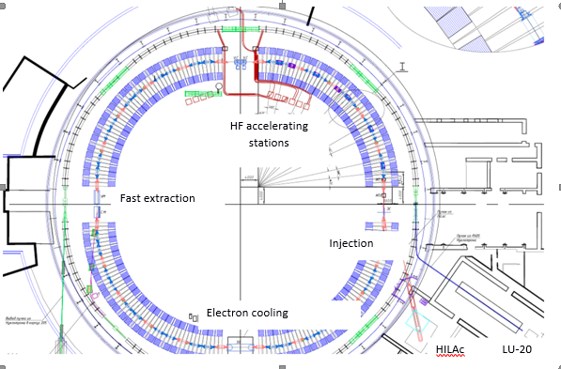
Fig. 2.2. The layout of the MCS and other elements of the Booster

Table 2.6

Structure parameters of the Booster

Parameter |  | Value
Number of superperiods |  | 4
Number of periods in the superperiod |  | 6
Number of long straight sections |  | 4
Length of a straight section, m |  | 7
Lengths of short straight |  | 0.7/0.85/0.95
sections, m
Injection energy, MeV/n |  | 3.24
Betatron numbers |  | 4.8/4.85
Maximum value of β-functions, m |  | 13.3
Maximum of dispersion function, m |  | 4
The Lorentz factor corresponding to the |  | 4.487
critical energy , γ_{tr}
Chromaticity |  | −5,1/−5,5
Horizontal acceptance, π·mm·mrad |  | 150
Vertical acceptance, π·mm·mrad |  | 58
Booster dipole magnets are curved, the radius of curvature along the central (axial) line is 14.09 m.

The long straight sections contain built-in elements, which include beam input and output devices, accelerating stations of the accelerating high-frequency system and the electron beam cooling system (Figure 2.2).

The duration of the working cycle of the Booster is 4.02 s (Fig. 2.3 – the so-called "standard cycle". If necessary, a technological pause between cycles of up to 1 s is possible.

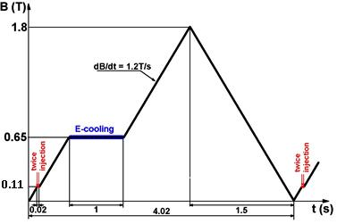

Fig. 2.3. Diagram of the working cycle of the Booster during acceleration of heavy ions

At the 1st stage of the working cycle with the duration of 0.45 s, the injected beam is adiabatically captured in the separatrix of the accelerating HF voltage and accelerated from 3,2 4 MeV/n to 65 MeV/n at the 5th rate of the accelerating voltage.
The frequency of the accelerating voltage varies from 587 kHz to 2525 kHz. At the magnetic field plato, the HF voltage is adiabatically switched off and the beam is cooled for ~ 1 s. At the second stage with the duration of 1.2 s, the ions are adiabatically captured and accelerated to 578 MeV/n at the 1st multiplicity of accelerating HF voltage, the frequency of which varies from 505 kHz to 1117 kHz.
Several injection methods have been developed for injection into the Booster, which will allow increasing the beam intensity if necessary. As the main method single-turn injection is adopted. Additional methods are one single-turn injection and miltiple single-turn injections. The design repetition rate of multiple single-turn injection stages is 10 Hz.

2.5. Ion superconducting synchrotron Nuclotron
The superconducting synchrotron Nuclotron with a magnetic rigidity of 38.5T⋅m is the main accelerator of the NICA complex (Table 2.7) and operates in one of three modes:
- acceleration of heavy ions for accumulation in the Collider;
- acceleration of polarized proton or deuteron beams for accumulation in the Collider;
- acceleration of different types of ions for experiments on the internal target and fixed targets in the experimental hall.
Table 2.7.

Main Nuclotron parameters
Parameter | Value
Accelerated particles | p↑, d↑, nuclei up to Au
Maximum energy of accelerated ions 197Au79+, GeV/n | 3.81
Extracted beam intensity 197Au79+, particles/cycle | 1·10⁹
Duration of slow extraction, s | up to 10
Injection energy, MeV/n | 5 (p↑, d↑),  578 (Au nuclei)
Perimeter, m | 251.52
Magnetic rigidity, T·m | 38.5
Field of dipole magnets, T | 0.03 ÷ 1.8 (p↑, d↑)  0.46 ÷ 1.8 (nuclei)
Number of periods | 8
Betatron number | 7.4
Cycle duration when working with the Collider, s | 4.02
Rate of rise of the magnetic field, T/s | 1.0
Injection type | Single-turn
Beam extraction | Single-turn or slow extraction
Pressure of the residual gas in the beam chamber, Torr | 10⁻⁹

In mode 1, Nuclotron operates as an element of the Collider injection chain and accelerates a single bunch of completely stripped heavy ions (Au79+) from 0.57 to 1 ÷ 3.8 GeV/n. The intensity of the bunch is 1 ÷ 1.5·109 ions. Particle losses in the acceleration process do not exceed 10%. Rate of rise of the magnetic field is not more than 1 T/s.
In mode 2, Nuclotron accelerates polarized particles from the energy of 5 MeV/n up to the energy corresponding to its maximum magnetic rigidity. The intensity of the bunch is several units of 1010 particles.
In mode 3, Nuclotron operates similarly to the previous two ones with the beam extraction to the BM@N experimental setup and/or the radiobiological and applied research zones. The average flow of accelerated ions at slow extraction is up to 107 particles per second.
The maximum field of Nuclotron dipole magnets corresponding to the mode of its stable long-term operation is 1.8 T (magnetic rigidity is 38.5 T⋅m). This corresponds to the kinetic energy of protons of 10.7 GeV, 5.3 GeV/n deuterons and light ions (with the ratio of charge number to mass Z/A = 1/2), 3,6 GeV/n for ions with Z/A = 1/3 (for example, Xe с A = 124, Z = 42) and 3,8 GeV for gold nuclei.
MCS of Nuclotron with the perimeter of 252.52 m consists of 8 superperiods including turning sections and a long straight section. In long straight sections there are built-in elements, which include:
- two beam injection systems (for injection of light ions from LU -20 and heavy ions from the Booster);
- the system of slow beam extraction to the experimental hall;
- system of fast (single-turn) beam extraction for transfer to the Collider;
- two accelerating high-frequency stations,
- internal target station that is used to measure the degree of beam polarization.

2.6. Collider
The Collider of the NICA complex provides experiments in the colliding beam mode. The main parameters of the Collider are given in Table 2.8.
To provide the maximum possible energy in the Collider (corresponding to its maximum magnetic rigidity), a slow acceleration of the beam particles extracted from Nuclotron and accumulated on the extraction energy (optimized depending on the parameters of the beam extracted from Nuclotron) is provided.
Table 2.8
Main parameters of the Collider
Parameter | Value
Accelerated particles | p↑, d↑, Au⁷⁹⁺
Total energy √sNN at the collision point of two nucleons, GeV | 4-11
The energy of accelerated ions ¹⁹⁷Au³¹⁺ in each ring, GeV/n | 1-4.5
Perimeter, m | 503.04
Injection energy, GeV/n | 1-3.8
Maximum magnetic rigidity, T·m | 44.5
Field of dipole magnets, T | 1.8
Magnetic field growth rate, T/s | 0.1
Injection type | Single-turn, multiple
Discharge (reset) of the beam | Single-turn
The pressure of the residual gas in the beam chamber, Torr | 10-11

Collider rings have the shape of a stadium (“racetrack") with a perimeter of 503.04 m and are located one above the other at a distance of 0.32 m. The basis of the magnetic system consists of two-aperture dipole and quadrupole magnets, quadrupole magnets of the final (before the interaction points) beam focusing, dipole magnets of vertical beam convergence/divergence system. Moreover, the Collider rings include 136 corrective magnets.
To accumulate beams and ensure their long lifetime in the Collider ("luminosity lifetime”) electron (in the energy range from 1 to 4.5 GeV/n) and stochastic (in the energy range from 3 to 4.5 GeV/n) particles cooling systems are used.
The following devices are located in the straight sections of the Collider:
- MPD and SPD detectors;
- elements of the beam injection system (septum and impact magnet);
- devices of emergency beams discharge;
- elements of the high-frequency accelerating system;
- the system of electron beam cooling;
- devices of stochastic beam cooling system (pick-up stations and kickers);
- feedback system devices;
- control systems for proton and deuteron polarization, as well as polarimetry.
The strategy of obtaining the design luminosity is illustrated in Table 2.9 by the example of Au⁷⁹⁺ ions.
Table 2.9

Parameters of the collider in the mode of collisions of gold nuclei (Au⁷⁹⁺).
Parameter | Value
Number of bunches | 22
RMS length of a bunch | 0.6
β-function at the interaction at the interaction point, m | 0.6
Energy Au⁷⁹⁺, GeV / n | 1.0 3.3 4.5
Number of ions in the bunch | 0.2·10⁹ 2.4·10⁹ 2.3·10⁹
RMS pulse scatter, Δp/p | 0.6·10⁻³ 1.2·10⁻³ 1.6·10⁻³
RMS emittance,  π·mm·mrad | 1.10/1.10 1.10/0.9 1.10/0.8
Time of the beam size growth due to intra-beam scattering, s | 160 530 1700
Luminosity-I, cm⁻²·с¹ | 0.6·10²⁵ 1.0·10²⁷ 1.0·10²⁷

Three high-frequency (HF) systems are used to ensure beam accumulation and the formation of short particle bunches:
- HF-1 system, forming periodic pulse (“barrier”) voltage with the amplitude up to 5 kV, used for accumulation of the required intensity of the beam;
- HF-2 - the system that generates the harmonic voltage at the 22nd harmonics frequency rate with amplitude up to 100 kV. It is used for formation of the required number of bunches, and preliminary beam focusing;
- HF-3 - the system that generates the harmonic voltage at the 66th harmonics frequency rate with amplitude up to 1 MV compressing bunches of particles up to the design length (0.6 m).

2.7. Stages of the establishment of the accelerator unit of the NICA complex

The following main works on the establishment of the accelerator unit of the Complex will be completed as a result of the stage "The starting configuration of the NICA complex":

- both injection chains will be installed and commissioned;
- the Booster will be installed and commissioned and the beams of heavy ions up to gold acceleration in it will be achieved;
- Booster-Nuclotron and Nuclotron BM@N transport channels will be installed and commissioned.
At the same stage, the BM@N experiments carried out using the first injection chain to accelerate heavy ions (up to krypton) in LU-20 and transfer them to Nuclotron.

At the "Basic configuration of the NICA Complex" stage, the collider is put into operation and the MPD experimental facility is operated on it. At this stage:

- a channel for transporting particles from Nuclotron to the collider will be installed and put into operation;
- the magnetic-cryostat superconducting focusing system of the collider will be installed and put into operation, and the working values of the magnetic fields and the pressure of the residual gas in its vacuum chambers will be achieved;
- beam injection and emergency beam discharge systems;
- HF -1 stations (one for each ring) providing accumulation of ions accelerated and transferred from Nuclotron;
- two HF-2 stations per ring, which focus ions into bunches and synchronize bunch collisions between two rings;
- the feedback system compensating coherent oscillations of ion beams;
- two channels (one per ring) of the stochastic ion cooling system.

The following conditions will be met:
- collision of ion beams of the same type with the following set of ions: carbon, argon, krypton, xenon, gold;
- the total energy of two colliding ions in the range 4-11 GeV/n;
- the maximum luminosity depending on the energy will be from 1·10²⁴ up to 1·10²⁵ cm⁻²c⁻¹·
At the "Full configuration of the NICA complex" stage:
- two additional HF-2 stations per ring will be installed and put into operation that allow more effectively producing a group of ions in the bunches and synchronization of collisions of bunches of two rings;
- 8 HF-3 stations per ring, allowing for the formation of short bunches of ions;
- the electron ion cooling system is installed and put into operation;
- additional channels of the electron ion cooling system have been put into operation.
As a result, the following characteristics of the collider will be achieved:
- design luminosity up to 1·1027 см-2·с-1 (Table. 2.9);
- the mode of asymmetric colliding beams (of light ions with heavy ones);
- mode of polarized colliding beams (protons and deuterons) providing research in the field of spin physics in the collider colliding beams; the collider is equipped with devices to control the motion of polarized particles with the preservation or controlled change in the direction of polarization, as well as devices for diagnosing the degree of polarization.
The description of technical specifications of the accelerator complex is given in the following documents:

- Conceptual design of the NICA complex, Dubna, 2010 and 2013:
– E. Ahmanova, A. Eliseev, Yu. Filatov, T. Katayama, A. Kuznetsov, H. Khodzhibagiyan, S. Kostromin, O. Kozlov, O. Kunchenko, V. Lebedev, V. Mikhailov, I. Meshkov, V. Monchinsky, E. Muravieva, S. Nagaitsev, A. Philippov, R. Pivin, A. Sidorin, A. Smirnov, N. Topilin, G. Trubnikov, Yu. Tumanova, S. Yakovenko, P. Zenkevich, Concept of the NICA Collider (Ed. I. Meshkov), Dubna: JINR, 2010. ‒ 60 p. ISBN 978-5-9530-0239-4
– Conceptual project of the NICA accelerator complex under general editorship of I. N. Meshkov, G. V. Trubnikov, JINR, Dubna, 2013.
- The summary volume of the technical design of the NICA accelerator complex is available at: http://nucloweb.jinr.ru/nica/CDR.html. A detailed description of the technical characteristics of the NICA accelerator complex is given in the following publications:

  - V. Kekelidze, R. Lednicky, V. Matveev, I. Meshkov, A. Sorin, G. Trubnikov , NICA project at JINR, Physics of Particles and Nuclei Letters, v. 9, 2012.
  - V.D.Kekelidze, A.D.Kovalenko, R.Lednicky, V.A.Matveev, I.N.Meshkov, A.S.Sorin, G.V.Trubnikov , Project NICA at JINR, Nuclear Physics A, v. 904–905, 2013
  - Technical project of the NICA accelerating complex, edited by I. N. Meshkov, G. V. Trubnikov, TT. I-IV, Dubna, 2015.
  - N. N. Agapov, V. D. Kekelidze, A. D. Kovalenko, R. Lednický, V. A. Matveev, I. N. Meshkov, V. A. Nikitin, Yu. K. Potrebennikov, A. S. Sorin, G. V. Trubnikov,

Relativistic nuclear physics at JINR: from Synchrophasotron to the NICA collider, Advances in Physical Sciences, Vol. 186, No. 4, 2016, p. 405.

- MPD facility

3.1. MPD facility purpose

The MPD facility is designed for experiments on colliding beams of the NICA collider for a detailed study of the QCD phase diagram at high densities and temperatures including the search for new states of hadron matter and phase transitions. In order to achieve this, it is planned:
- yield of strange particles, baryons and anti-baryons;
- event-by-event fluctuation of multiple particle production, transverse momentum, ratios of particle yields;
- anisotropic and collective flows;
- pulse correlations (femtoscopy);
- production of lepton pairs and soft photons;
- polarization phenomena.
In order to carry out these studies, the detectors of the facility must provide effective identification of the products of nuclear collision and measurement of their parameters at high loads in a wide range of phase space.

3.2. The overall design of the facility
The facility must include:
- the system for measuring particle momentum in the range p = 0,1-2 GeV;
- particle identification system for the separation of protons, π-mesons, К-mesons and electrons in the pulse range 0.1-3 GeV/s;
- the system for restoring the primary interaction vertex with an accuracy of 100-200 microns and the secondary decay vertices with an accuracy of 10-20 microns;
- the ability to register gamma rays in the energy range of 50-2000 MeV;
The maximum volume of the facility along the beam is determined by the location of the magnetic lenses of the Collider storage rings, and can not exceed 9 meters in order to be able to focus beams well into the meeting area.
The diameter of the central detector is the result of a compromise between the need for sufficient span base time and track length for accurate determination of particle type and their momentum, on the one hand, and a strict requirement for the uniformity of the magnetic field and a reasonable cost of the magnetic system, on the other. Track length should not be less than 1 meter in radius, the number of points on the track should not be less than 50 to obtain the desired pulse resolution of 3% at the momenta of particles up to 2 GeV/C. With this pulse resolution and measurement of time of flight on the basis of 1.5 meters with a precision of 100 ps will be able to separate 90% pions and kaons, produced in the collision of gold ions with the energy in the system of center of masses 11GeV/nucleon
The facility should overlap the geometry close to 4π. For a precise measurement of particle pulse, the tracking system must operate in a uniform magnetic field with an induction of 0.2-0.5 T. It is obvious that to obtain such a field in in the specified volume it is preferable to use a superconducting magnet of solenoid type with corrective windings at the ends.
The MPD facility that meets these requirements is shown in Fig. 3.1. The detector should consist of a cylindrical and two end parts. All of them are located in the magnetic field. The cylindrical part consists of various types of detectors, placed around the beams collision area, which include a track system, a time-of-flight system, and an electromagnetic calorimeter.

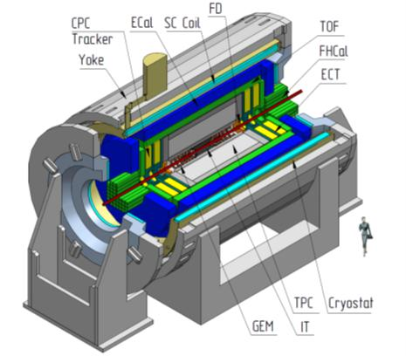

Rice. 3.1 MPD facility scheme, full version.
To power the magnet and the corrective windings, an electric energy of about 300 kW is required. Electrical power of 1.0 MW is planned to power the entire detector.

3.3. Purpose and description of facility detectors

The time-projection chamber (TPC) is optimal as the main tracking system. It should be supplemented by an internal tracking system based on silicon semiconductor detectors (IT) that surround the beam collision region. Both detectors provide an accurate reconstruction of particle tracks and their pulses, as well as the determination of particle decay vertices. The inner detector must have at least 5 layers that surround the beam interaction region to reconstruct the secondary vertices of short-lived particles such as heavy hyperons.
For particle identification, in addition to TPC a precise time-of-flight system (TOF) is needed, it should provide identification of charged particles with pulses up to 2 GeV/s in a wide range of pseudo velocities. The TOF system requires a fast forward detector (FD), which provides the starting signal for the time-of-flight system and the time resolution is not worse than 30 ps.
For identification of electrons and photons and measurement of their energies, an electromagnetic calorimeter (ECAL) is required. High granularity of the calorimeter along with good energy and time resolution will significantly improve the capability to identify particles in the MPD detector.
Optimal in design and price calorimeter is based on a multi-layer absorber-detector assembly of shashlyk type.
Expansion days of phase space of particle registration in the front region (pseudo velocity region |η| < 2, when the TPC track efficiency decreases, EndCap Tracker (ECT) system based on proportional straw tubes, cathode read-out proportional chambers, and GEM-based detectors should be provided. Track systems (ECT) should be placed on both ends of MPD directly behind the TPC reading chambers. To identify particles, in the range of angles |η| > 1,2 time-of-flight system and electromagnetic calorimeters that are similar to those in systems in the cylindrical part of MPD are supposed to be used.
Fast forward detectors (FFD) and forward hadron calorimeters (FHCal) are used to detect particles emitted at very small angles 1,2 < |η| < 2. These detectors are used in the trigger to determine the centrality of the collision and reconstruct the interaction point of the nuclei in the beam.
Thus, in the considered MPD structure it is possible to distinguish three region with a distinctive method and accuracy of measurement: the central region |η| < 1,2, the front region |η| < 2, where the particle momentum is measured quite roughly (dp/P ~ 4 - 10%) and the region 2 < |η| < 3, where the integral parameters of the event are measured.
To optimize the facility construction and start-up time, it is reasonable to establish it in several stages. At the first stage ("Basic configuration of the NICA complex") the following subsystems are established: TPC, TOF cylindrical part, FD, FHCal and ECal cylindrical part. In this configuration, the facility can effectively identify secondary particles and measure their momentum in the pseudo-velocity range | η |< 1,2.
The internal tracking system, the front tracking system including Straw and CPC, as well as the end TOF and ECal are included in the next stage - "Full configuration of the NICA complex".
3.4. MPD data acquisition system
The main function of the data acquisition and processing system (DAQ) is to receive data from the detectors of the facility, their primary processing, event reconstruction and recording events in the intermediate disk storage.
Basic parameters of the DAQ system:
- channel capacity from the detectors is about 4 TB/s;
- channel capacity of the input channels of the processors of the first level is about
  - TB/s;
- channel capacity of the DAQ technology network is 1.6 TB/s;
- number of computing nodes – 50 (1600 computing cores);
- the capacity of the intermediate disk storage for 24 hours is determined by the maximum data acquisition rate (7 kHz) and is about 600 TB.
The data read-out electronics of the MPD facility is connected to the network equipment, which will be installed on a special mobile platform. The mobile platform is connected to the computer cluster DAQ via optical communication lines. The core of technology network providing uninterrupted operation and monitoring of the entire MPD facility will be located in building 1A. The power consumption of the installed equipment will be 100 kW.
3.5. MPD detector control panel

To monitor and control the operation of the MPD detector, it is necessary to have a remote control (hall) of the detector and a control room that provides the functions of the MPD data taking and monitoring system.
The control room has an area of at least 150 square meters, equipped with workstations, necessary computer equipment, and information monitors, associated with the data acquisition system and the local computer cluster of the facility.
To ensure trouble-free operation of the detector control panel, 30 kW of power is required to ensure uninterrupted power supply to all elements.

3.6. MPD test area and test channel
An MPD test channel is developed for R&D and testing of full-scale prototypes of MPD detector subsystems. The test channel uses direct beams of protons, deuterons and carbon nuclei accelerated in Nuclotron to energies in the range of 1-3 GeV/n. To study the response of the detector under study at different conditions for charged particles to pass through it, the test channel must include a trigger system based on scintillation counters, its own track system based on proportional chambers with a two-dimensional restoration of the particle entry point into the chamber. For track reconstruction, it is necessary to have at least three chambers with six detecting planes each. Information reading should be carried out by the DAQ system, which is the prototype of the data readout system of the MPD detector. For positioning of the detector under study, a high precision system of movement in 3 planes with an accuracy of at least 10 micrometer should be provided. The movement range along the axes X and Y - 50 and 20 cm, respectively. For time measurements with an accuracy of 20-30 ps a modern synchronization system on the basis of White Rabbit is needed. For temperature stabilization, all the equipment on the beam is located in closed clean houses installed on the channel of the Nuclotron amplifier in the experimental hall of the building 215. The control room of the facility is located in the experimental house, separated by biological protection from the channels with the extracted beams.

3.7. Technological areas of MPD subsystems assembly
3.7.1. Production areas of TPC manufacture.
The manufacturing site of readout elements based on proportional chambers with pad readout is located in the building 40, VBLHEP. The total area of production premises is about 460 m2. The building is equipped with a common conditioning system. Working areas at the sites are equipped with HEPA filters, providing the 5-6 class of purity.
3.7.2. TPC assembly and test area
For TPC assembly, special conditions are required. The area is established in building 217 and consists of 2 rooms (48 m2 each) and hall (192 m2), where a clean room is mounted with a total area of 80 m². Purity class – 7. The establishment of areas for float glass preparation, painting of glass with a conductive paint, installation and assembly of modules, control of assembled GEM gas supply of a test bench, clean room for assembly of detectors, gas storage and compressor on a total area of 200 m², and storage space on an area of at least 30 m².
3.7.3. MPD time-of-flight system assembly production areas
As the main elements of the time-of-flight system (TOF), multi-gap resistive plate chambers (MRPC) were selected. To develop a system a production room with an area of about 300 m² is required. All areas are equipped with air conditioning to maintain a constant temperature and humidity.

3.7.4. ECal assembly site
The assembly area of the electromagnetic calorimeter sectors must be at least 600 m² and equipped with a bridge crane with a capacity of 10 tons. To assemble and test modules (basic elements of the calorimeter), it is necessary to have a production area of about 250 m² and power consumption of about 100 kW.
3.7.5. Technological areas for assembly and testing of wide-aperture silicon detectors for ITS
The manufacturing site of elements of wide-aperture tracking systems is established in building 216, VBLHEP. The total area of production premises is about 173 m2. The premises are equipped with separate air conditioning systems and air filtration with HEPA filters. The required electrical power is 180 kW.
3.7.6. Other production areas
To assemble the setup and place it at the collider interaction point, a room with an area of at least 2000 m2 and a height of at least 18 m, including the assembly area and the area for operating the setup, is required. The room must be equipped with industrial cranes, cryogenic lines, systems of power supply, cooling, water supply, fire detection and fire extinguishing, the system of moving the setup between zones.
Detector assembly is performed in the blind area of the MPD pavilion of the collider complex building, through which Collider beams pass. At the beginning of the assembly procedure, the lodgment moving from the assembly area to the setup position on the beam is installed. On this lodgment, the magnet sections (without both poles) are assembled and all internal detectors are mounted. End caps are assembled on rail guides in the service area.
A summary volume of the MPD technical description is available at: http://mpd.jinr.ru/doc/mpd-tdr

- The BM@N facility

4.1. BM@N facility purpose
The purpose of the BM@N experiment is to study the interactions of relativistic heavy ion beams with fixed targets. The physical program for the study of heavy ion collisions at the BM@N facility includes the following aspects: investigation of the dynamics of reactions and the study of the equation of state of nuclear matter, the study of the modification of the properties of hadrons in nuclear matter, the production of (multi)-strange hyperons near the threshold and the search for hypernuclei.
To interpret experimental data in collision processes of heavy ions and to ensure the normalization of the measured spectra obtained in the interaction of nuclei, it is also planned to study elementary reactions (р + р, р + n(d)).
4.2. Main characteristics of the facility
The Nuclotron accelerator will provide the experiment with beams of particles from protons to gold ions with kinetic energy in the range from 1 to 6 GeV per nucleon. The maximum kinetic energy for ions with a charge-to-relative atomic mass (Z/A) ratio of 1/2 is 6 GeV per nucleon. The maximum kinetic energy for heavy ions with a Z/A ratio of~1/3 is 4.5 GeV per nucleon. The planned intensity of the beam of gold ions accelerated and accumulated in the Booster and Nuclotron and transferred to the BM@N facility will be 10⁷ ions per second. The extracted beam of gold ions is expected in 2020.
The main elements of the facility (see Fig. 4.1) are described below.

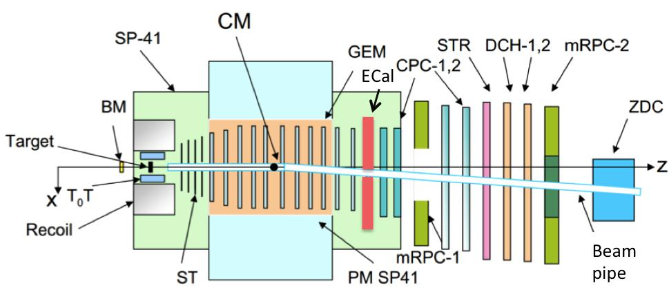

Fig. 4.1. Schematic view of the BM@N facility

Analyzing magnet (PM CP41), which houses the central tracking system of the facility. To achieve the required parameters in the experiments on the facility, the aperture of the magnet is 200x100 cm2, and the magnetic field reaches a maximum value of 1 T.
Central tracking system. It is used to measure the parameters of tracks in nucleus-nucleus collisions. The central tracking system in the basic configuration consists of highly accurate forward silicon microstrip detectors (ST) and charged particle detectors based on large area gas electron multipliers (GEM). In the Starting configuration, this system should provide reconstruction of tracks of charged particles with a resolution of pulse of 3% and half of the full aperture of the facility, which will reliably isolate and investigate the decay of hyperons. In the Full configuration, the сentral tracking system will be supplemented by a system of silicon microstrip large-aperture track detectors to improve the pulse resolution by at least 2 times at twice the aperture, which will ensure the solution of the experimental tasks for the study of hyperons, strange mesons, and hypernuclei.
External tracking system that provides the connection between the tracks measured in the central tracking system and signals in time-of-flight detectors. In the Starting configuration, the external track system includes large drift chambers (DCH-1,2) with a spatial resolution of about 200 µm. For registration of interactions of heavy nuclei in the Basic and Full configurations cathode strip chambers will be used (CPC-1,2), they are able to separate tracks in multiple particle events of the interactions of heavy nuclei up to gold.
A time-of-flight system that serves to separate hadrons (π, K, p) as well as light nuclei with pulses up to several GeV/s in multiple particle events. The time-of-flight system consists of a launch detector (T0) mounted near the target (T) and two planes of multi-channel time detectors located 400 (mRPC-1) and 700 (mRPC-2) centimeters from the target for reliable identification of charged particles with pulses up to 3 GeV/s and 5 GeV/s, respectively.
Detector of hadrons and nuclear fragments at small angles to the beam (ZDC), which serves to measure the centrality of the nucleus-nucleus interactions with an accuracy of about 10%.
Electromagnetic calorimeter (ECal) is designed to study the processes with formation of states decaying into γ, e±. It represents a two-arm detector, which is located between the central and external tracking detectors and temporarily shifts closer to the beam during the data taking.
To register the reactions of different topologies, a trigger system of the facility is used, it can include two or more levels of decision-making to record events.
A data acquisition system is used to synchronize the readout of various detectors, generate and record a single nuclear-nuclear interaction event, and monitor the operation of the facility. This system consists of readout electronics, synchronization systems, computer cluster and computer technological network of the facility.
The facility uses a unified system for monitoring its parameters and recording them into the database.
The experimental zone of the facility includes an analyzing magnet, corrective magnets, a beam tube to the target and along the entire facility from the target, as well as power supply and infrastructure elements.
The technical parameters of the BM@N facility are given in Table 4.1.
Table 4.1.
The technical parameters of the BM@N facility
Facility configuration |  | Starting (2016-2018) | Basic (2020) | Full (2022 and later)
Types of beam ions |  | d(↑), C, Ar, Kr | p - Au | p - Au
Kinetic beam energy (GeV/n) | Z/A~1/2 | 2,3 – 4,6 | 1-6 | 1-6
 | Z/A~1/3 |  | 1-4.5 | 1-4.5
Beam intensity (Hz) |  | 2·10⁵ | up to 10⁶ | up to 5·10⁶
Frequency of data reception (Hz) |  | 5K | 10K | 50K
Configuration of the central tracking system |  | 3 planes of front  silicon detectors  + 6 planes  GEM detectors (1/2  areas) | 3 planes of front  silicon detectors  + 7 full planes  GEM detectors | 3 planes of front silicon detectors +4  Planes of silicon  detectors of large  apertures + 7 planes GEM detectors
Pulse resolution  (%) in pulse interval  0.5-4 GeV/s |  | 3 | 2.5 | 1.5
Pulse area of identified particles  π/k/p (GeV/s) |  | 0.5-2.5 | 0.5-3 | 0.5-3.5
Reconstruction of hyperons |  | Λ | Λ, Ξ⁻ | Λ, Ξ⁻, ³_{Λ}He

The control room of the experiment is located in building 205 in the immediate vicinity of the facility beyond the biological protection. Vacuum, ion beam pipe inside the experimental zone of BM@N maintains a vacuum of at least 10⁻³ T and has a minimum amount of substance from the target to the external tracking detectors. The shape of the ion beam pipe follows the beam trajectory in the magnetic field of the analyzing magnet. Correcting magnets and beam profilometers are used to adjust the beam to the target of the experiment.
At the first stage, ("Starting configuration of the NICA Complex") the structure of the facility consists of the central tracking system ST or GEM detectors), that covers a half of the facility aperture, large drift chambers external tracking system, time-of-flight system, detectors ZDC, ECal, the trigger system and data acquisition system that enables the facility to operate in this configuration. In this configuration, the experimental area of the BM@N facility is surrounded by biohazard of concrete blocks.
At the stage, "Basic configuration of the NICA Complex", the central tracking system will be supplemented by such number of ST and GEM so that to overlap maximum possible facility aperture, and elements of the system of silicon micro-strip large aperture tracking detectors, external tracking system, cathode-strip chambers CPC-1,2. In this configuration, the biological protection of the facility includes an additional concrete ceiling.
At the stage of "Project configuration of the NICA Complex", the design configuration of silicon microstrip large aperture track detectors will be included in the central tracking system; the data acquisition system of the facility for receiving petabyte volumes of experimental data will be significantly expanded and upgraded.
The BM@N facility is located in building 205 of the LHEP site (see Fig. 2). The total area occupied by the facility is 562 m²; the area of production and auxiliary premises is 140 m². The energy consumption of detectors is 165 kW.
A summary volume of the BM@N technical description is available at:
http://bmnshift.jinr.ru/wiki/doku.php?id=bmn_tdr_reports

- The SPD facility
5.1. SPD facility purpose
The SPD facility is designed to study the spin structure of nucleons and other polarization and spin effects. Collisions of polarized (longitudinally and transversely) protons and deuterons with high luminosity (up to 10³² cm⁻²s ⁻¹) at the NICA collider provide an opportunity to study a wide variety of spin and polarization-dependent effects in hadron-hadron collisions, including:
- reactions with the production of Drell-Yan lepton pairs;
- processes with the production of direct photons;
- extraction of unexplored (poorly known) parton distribution functions from reactions with the production of J/ψ;
- spin effects in reactions with the production of baryons, mesons and photons;
- spin-dependent effects in exclusive reactions;
- diffraction processes;
- cross-sections, helicity amplitudes and double spin asymmetries in elastic reactions;
- quarkonium spectroscopy.
5.2. Main characteristics of the facility
The above mentioned physical tasks require measurements other than cross-sections of different reactions, asymmetries and cross-section relations. This requires detecting charged and neutral particles with high efficiency (over 99%) to minimize systematic uncertainties and background effects (especially for asymmetries), and the measurement of pulses of these particles with relative accuracy of at least 3-5%. For the maximum value of pulses of colliding protons and/or deuterons, which is equal to 13.5 GeV/s, the range of measured pulses of secondary particles is 0.05-10 GeV/s, the speed up to 2,7, with the angular acceptance close to 4π.
Based on the design aspects of the experimental hall and the collider, the SPD can have a length of up to 9.2 m and a diameter of up to 6.8 m. A general layout of the SPD facility is shown in Fig. 5.1.
The SPD facility consists of three parts: two end and a central one. This design provides convenient access to its elements, makes it relatively easy to upgrade and modernize the facility for future tasks.
Each part of the facility has an individual magnetic system: the ends are solenoid coils, the сentral part is a toroidal magnet. This type of magnetic system is chosen in order to minimize the influence of the magnetic fields on collider beams near the colliding point. In this case, it will not affect the spins of colliding protons (deuterons) and the reconstruction of direct tracks of charged particles in the vertex detector will be the most accurate.
The vertex detector (VD) is based on the most advanced silicon detectors at the time of selection. The required spatial resolution of the track should be at least 50 microns.
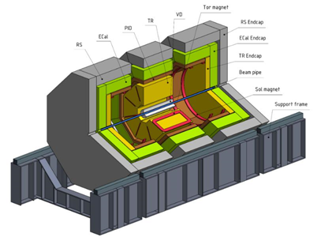
Fig. 5.1. General layout of SPD facility
The tracker (TR) is planned to be based on straw tubes with a diameter of 10 mm, which will be laid in overlapping layers in order to get the maximum efficiency of registration of charged particle tracks. The required track resolution of the tracker is 100 microns. The efficiency of registration of charged particle tracks is close to 100%.
The basic requirements for the particle identification system (PID) consist in reliable separation of π/K and p / K in the pulse range up to 10 GeV. Detectors should work with loads of up to several kHz/cm². Based on the experience of ALICE, HARP, STAR, PHENIX experiments, multi-gap resistive plate chambers (mRPC) can be used in this system. For identification of high-energy particles (with momentum higher 5 GeV/s) other types of detectors, such as aerogel Cherenkov counters will be required.
The electromagnetic calorimeter (ECal) is designed to measure the energy and identify photons and electrons (positrons) in the energy range from 50 MeV to 10 GeV, with an energy resolution not worse than 10 %/√E, with a transverse module size of about 5 cm, a time resolution not worse than 0.5 ns. It should operate in the magnetic field and with the long-term stability of the main parameters of the order of ±5%. The prototype of such a calorimeter module can be a calorimeter module KOPIO, which consists of alternating layers of lead and scintillator of small thickness, for example, of 220 layers of scintillator (1.5 mm) and lead (0.3 mm). Such modules are packed in groups of 4 into a "tower" that has a transverse size of 11×11 cm².
The range (muon) system (RS) of SPD is designed for:
- identification of muons in the pulse range 0.5-10 GeV/s with the efficiency not less than 95%;
- hadron energy measurements (coarse hadron calorimetry) with a resolution of about 100%/√E;
- identification of neutrons with an efficiency of at least 90%.
The identification of muons is performed via pattern recognition and matching of the track segments in the RS to the tracks in the tracker of the facility detectors. Mini-drift tubes and layers of metal (iron) are used as the main components of this system. Layers of iron + mini drift tubes of different sizes for the barrel and end parts of the facility should be 4-4.5 nuclear interaction lengths. In this case, the muon makes a signal in almost all layers of the system, and the hadron-only in the first 2-3 layers. This system is created by analogy with the same system of the PANDA experiment.
The necessary technical elements and subsystems for the facility are listed below:
- magnetic systems with power supplies and cryogenic subsystem;
- vertex detector with high voltage and low voltage power supply, cooling subsystem of silicone detectors and electronics;
- tracker with high-voltage and low-voltage power supply and gas system;
- particle identification system with high-voltage and low-voltage power supply and gas system;
- electromagnetic calorimeter with high-voltage and low-voltage power supply, gas system, system of thermal stabilization system of laser calibration/monitoring of module status;
- range system with high-voltage and low-voltage power supply and gas system;
- tagging system with high-voltage and low-voltage power supply,
- the system of local polarimetry with high voltage and low voltage power supply;
- data acquisition system with low-voltage power supply and cooling system; this system provides the synchronization of data readout from different detectors, formation and recording of a single event in case of interaction and monitoring of the facility operation ; it includes readout electronics, synchronization system, computer cluster and computer technological network of the facility; for the latter, a special mode of "communication" with external computer networks is implemented;
- computer cluster, which will run the data acquisition system, the system of on-line monitoring of all facility systems, and the system of their slow control.
The SPD facility is located in the SPD room of the LHEP site (see Fig. 2), which must meet the above mentioned requirements.
To assemble the facility and place it at the collider interaction point, a room with an area of at least 2000 m² and a height of at least 18 m, including the assembly area and the area for operating the setup, is required.
The room must be equipped with industrial cranes, cryogenic lines, power supply systems, cooling, water supply, fire detection and fire extinguishing, facility displacement system between zones.
The weight of the facility – no more than 2000 tons. The power consumption of the facility is 1.1 MW.
5.3. Testing zone
To test prototypes of SPD detectors in beams of different particles, it is necessary to establish a testing zone in building 205 for extracted Nuclotron beams (Fig. 5.2)
The low-energy channel (MARUSYA facility) should provide beams of particles with the momentum up to 1 GeV, and high-energy one up to 10 GeV. Both spectrometric channels are located in the area of one of the focuses of the beams extracted from Nuclotron. In each channel, spatial registration, identification, and tagging of each particle passing through the test detector is assumed, provided that the data acquisition system (DAQ) of the facility and the test detector or element of the data acquisition system are coupled.
The starting configuration of the test zone includes the target part and the low-energy channel based on the upgraded MARUSYA facility and a high-energy channel is added to its Full configuration.
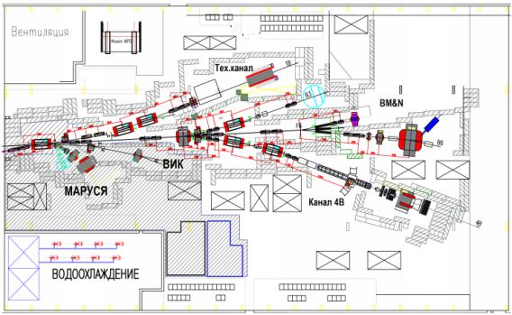
Fig. 5.2. The test zone will include the upgraded and modernized magnetic spectrometer MARUSYA and a high momentum channel (HMC).
The SPD facility will be put into operation at the stage of "Full configuration of the NICA complex".

The summary volume of the terms of reference for the development of the SPD facility and the test zone is given at: http://spd.jinr.ru/doku.php?id=documents.

6. Innovation unit
6.1. Innovation unit of the NICA complex project
The innovation unit of the Complex includes an experimental zone for conducting applied research in three areas that are in great demand for the development of modern technologies.
The first direction is to conduct research and tests of promising products of semiconductor micro- and nanoelectronics, solid state microwave electronics and micromechanical systems on radiation resistance under the influence of heavy charged particles. For this purpose, a Long-range Ion Irradiation Station Technical (LRIIST) is being developed in the Measuring pavilion of building 1 of LHEP, designed to test products of the electronic component base and modules of electronic equipment for resistance to the effects of heavy charged particles of outer space a to single radiation effects. Also, in building 1 of LHEP at the output of the HILAс linear accelerator, a Short-range Ion Irradiation Station Technical (SRIIST) is being developed. This station is designed to test the chips under the irradiation of ions with an energy of 3.2 MeV/n during the decapsulation of their bodies.
The second direction is related to research in the field of space radiobiology and modeling of the impact of heavy charged particles of Galactic cosmic radiation on biological objects, including cognitive functions of the brain, and disorders of the central nervous system during long-term interplanetary space flights. The planned experiments are also aimed at studying the effects of heavy charged high energies (hundreds of MeV/n) on biological objects at the cellular level, leading to gene and structural mutations. For this purpose, in the Measuring pavilion a Long-range Ion Irradiation Station Biological (LRIISB) is being developed.
The third direction is focused on applied research in the field of relativistic nuclear power and nuclear waste disposal. First of all, these studies are aimed at obtaining nuclear physics data at interactions of relativistic beams of protons, deuterons and light ions with the energy of 1-4.5 GeV/n for modeling and design of active subcritical uranium assemblies and targets, for pre-industrial prototypes of radioactive waste disposal facilities. For research in the field of relativistic nuclear power, a specialized station is being developed in the 205 building.
The above mentioned applied research will be carried out on the extracted Nuclotron beams. To support the programme of these studies, extracted ion beams with a pulse duration of 1-10 sec and a high time homogenity are required (Fig. 6.1). For this purpose, the resonance-stochastic method of slow ion beam extraction is implemented at Nuclotron.
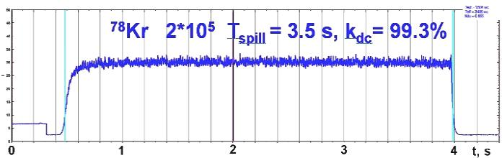
Fig. 6.1. Time structure of the krypton ion beam 78Kr+26 s with the intensity of 2·ּ10⁵ particles per pulse.

6.2. Transport Channels for Applied Research
To transfer of ion beams from Nuclotron to the three stations listed above, two of which are located in the Measuring pavilion and one in the 205 building, two new specialized channels have been developed and the transport channel to the 205 building has been upgraded (Fig. 6.2) based on the existing transport channel from the Nuclotron to the 205 building. The existing transport channel from the Nuclotron to the 205 building will be significantly upgraded. The beam will be transported under fore-vacuum conditions along the entire length from Nuclotron to all stations. Beam diagnostics equipment will be replaced in the existing transport channel in the 205 building. Diagnostic equipment in the beam transport channel for the relativistic nuclear power station should provide the measurement of the time structure of the extracted beam, its intensity, horizontal and vertical beam profile. Two new ion transport channels of 0.25-0.8 GeV/n will be developed for the irradiation of microchips and radiobiological studies.
The specific character of new transport channels is the need for uniform irradiation of target surfaces with transverse dimensions up to 100 ×100 mm for radiobiological research and 200 ×200 mm for irradiation of electronic equipment intended for space research. For uniform irradiation of the targets of LRIIST and LRIISB stations, it is proposed to use" scanning " of the target surface by an ion beam in each cycle. For this purpose, the spot of the focused beam within each recharge is shifted along the target surface along the selected trajectory due to small (about 20 mrad) deviations of the beam from the main direction. These deviations are created using a scan of the dipole magnets with the transverse magnetic field controlled by the magnitude. Scanning magnets are located at such a distance from the target to provide its specified irradiation field.
Diagnostic equipment in the newly established channels should provide measurement of the following beam parameters, horizontal and vertical beam profiles, charged particle flux, the collected integral charged particle flux during the measurements, the time structure of the extracted beam.
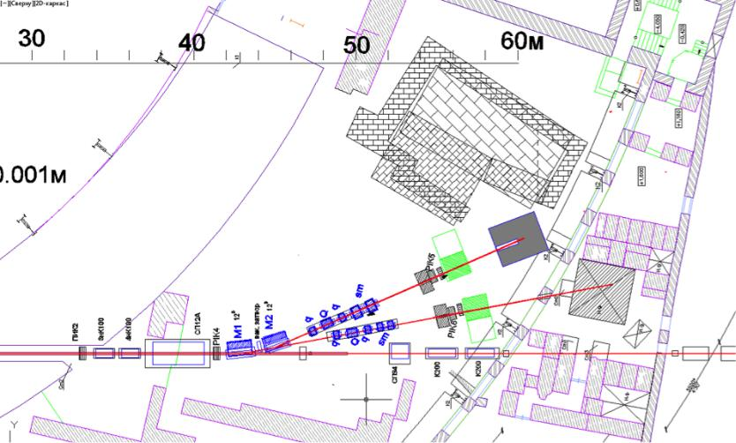

Fig.6.2. Layout of three channels for applied research: 1-beam transport channel and microchip irradiation station, 2-beam transport channel and radiobiological research station, 3-beam transport channel in building 205 for relativistic nuclear energy station.
6.3 Station of irradiation of radio-electronic systems, LRIIST
Modern radio-electronic systems as part of onboard spacecraft and aviation systems must operate in harsh operating conditions being exposed to various types of radiation effects including the effects of space ions. In many cases, failures of on-board control, navigation, telemetry, communication and information processing systems in real operating conditions of space craft are determined by the radiation effects in the electronic component basis microelectronics products, semiconductor and solid state microwave electronics.
Traditional methods of forecasting, evaluating and controlling the durability of products of microelectronics, semiconductor and solid-state microwave electronics to the effects of ions is based on the testing of products on accelerators of such ions. To obtain reliable information on the test results, it is necessary to conduct a series of experiments for different values of linear energy losses (LEL) of ions in the sensitive volume of the semiconductor structure.
The range of changes in the linear energy loss of ions should lie in the range of units of MeV .cm2/mg up to 65 MeV.cm2/mg. Maximum LEL values are provided by irradiation with ions with a charge Z≈80 and ion energies inhibited to a value of about 10 MeV/n, at which a Bragg peak occurs.
In this case, the ions must have the initial energy of 100 -200 MeV/n so that the lengthof ions paths in the body of the chip is a bit more than its thickness; and ions would reach sensitive areas of the chip with energies close to the Bragg peak. With this purpose, beams in the injection complex consisting of three accelerators will be formed: HILAс linear accelerator, the Booster and Nuclotron, a fully stripped nuclei of C, Ar, Fe, Kr, Xe and Au with an energy 250-800 MeV/n at the output of Nuclotron. The peculiarity of the tests of radio-electronic equipment on this facility arises from high initial energies of ions 250-800 MeV/n extracted from Nuclotron, which are necessary to slow down to the energy of 100 -200 MeV/n. For these purposes’ degraders, allowing to smoothly change its thickness are used, so that the ions pass through the body and slow down in the sensitive layer of the chip. Ion beam parameters and requirements to the LRIIST equipment are given in Table 6.1. The LRIIST includes the following equipment: diagnostic system of high energy ion beams 100-800 MeV/n, primary ion energy degrader, system ion beams diagnostics, slowing down to the energy of 10-50 MeV/n, sample positioning system; temperature setting system; vacuum equipment, measuring equipment; means of communication for remote access.
Table 6.1.
Ion beam parameters and requirements for LRIIST
Parameter | Value
Ion types | p, ¹²C⁶⁺, ⁴⁰Ar¹⁸⁺, ⁵⁶Fe²⁶⁺, ⁸⁴Kr³⁶⁺, ¹³¹Xe⁵⁴⁺, ¹⁹⁷Au⁷⁹⁺
Energy of ions extracted from Nuclotron, MeV/n | 250 - 800
Braking length in silicon, mm | 10
Ion energy after slowing down in a degrader, MeV/n | 10-200
Ion energy in the sensitive region of the chip MeV/n | 10-50
Ion flux, ion/(cm²×s) | 10²-3·10⁵
Pulse duration of the extracted beam, s | 2 - 20
Maximum fluence per session ion/(cm²) | 10⁷
Run duration, min | 30 - 40
Beam emittance at the input to the stand, (2σ) ε_{x}/ε_{y}π⋅mm⋅mrad | 3/8
Beam diameter on the target, mm (width at half height) | 10 - 40
Homogenity of the flux under irradiation of size 30×30 mm | ±10%
The maximum area of irradiation of the target, mm | 200x200
Homogenity of the flow at the maximum field of irradiation | ±15%
Frequency of beam scanning at the maximum field of radiation, Hz | 1-2
LEL in Si, MeV×cm²/mg (on the surface of the sensitive area of the chip) | 1-65
Chamber pressure | 10⁻² - 10³Torr, 760 mmHg
Target temperature during irradiation, ⁰C (chip size 20×20 mm) | -65⁰С-1+125⁰С

6.4 Station of irradiation of radio-electronic systems SRIIST
To test electronic equipment with ions with an energy of 3.2 MeV/n, accelerated in HILAc, an irradiation station for decorpuscled SRIIST chips is developed. The specificity of this station is associated with low energy ions that can not pass through the body of the chip with a thickness of several mm, therefore, before its irradiation, decapsulation of the body takes place. Another peculiarity is related to the time structure of the ion beam current, the current pulse duration is 10 ms, and the repetition rate is 10 Hz. In this case, three current pulses are formed, which are repeated at a frequency of 0.25 Hz.
The parameters of ion beams are given in Table 6.2. The SRIIST includes the following equipment: diagnostic system for low-energy ion beams 0.3-3.2 MeV/n, sample positioning system; temperature setting system; vacuum equipment, measuring equipment; means of communication for remote access.
Table 6.2

Ion beam parameters and requirements for SRIIST
Parameter | Value
Types of ions for the specialized irradiation of chips* | p, ¹²C⁶⁺, ⁴⁰Ar¹⁶⁺, ⁵⁶Fe²⁴⁺, ⁸⁴Kr²⁶⁺,  ¹³¹Xe⁴²⁺, ¹⁶⁹TM⁴¹⁺, ¹⁹⁷Au⁵¹
Types of ions for the collider operation mode and associated session of chips irradiation | p, ¹²C⁴⁺, ⁴⁰Ar⁸⁺, ⁸⁴Kr¹⁴⁺  ¹³¹Xe²²⁺,¹⁹⁷Au³¹⁺
Energy of ions extracted from HILAc, MeV/n | 0.3, 2, 3.2
Energy spread (half width at half height) % | 3
Average ion flux, ion/(cm2×s) | 10² - 3·10⁵
Pulse duration of the extracted beam, mcs | 10
Repetition frequency of current pulses, Hz | 10
Number of pulses | 3
Repetition frequency of macropulse current, Hz | 0.25
Maximum fluence per session ion/(cm²) | 10⁷
Run duration, min | 30 – 40
RMS emittance, π⋅mm⋅mrad | 10
RMS diameter of the beam at the HILAc output, mm | 0.8
Homogenity of the flux under irradiation of size 30×30 | ±10%
LEL in Si, MeV×cm2/mg (on the surface of the sensitive area of the chip) for a specialized session of irradiation of chips | - 38*
LEL in Si, MeV×cm2/mg for Collider operation mode and associated microchip irradiation session | 1 – 15
Chamber pressure, Torr | 10⁻⁸
Target temperature during irradiation, ⁰C (chip size 20×20 mm) | -65⁰ С-1+125⁰ С

6.5 Irradiation station for radiobiological studies LRIISB
The experiments planned at the LRIISB facility are aimed at studying the effect of ions with energies of 0.5-0.8 GeV/n on biological objects at the cellular and organismal level. The mechanisms of gene and structural mutations formation in mammalian cells under the influence of high energy ions on them are studied on the cellular level. Morphological changes as a result of such influence in tissues and organs of mice and rats are investigated at the organismal level, and also, changes in behavioral and cognitive functions of small laboratory animals and lower primates during irradiation of their brain structures with ion beams (disorders of the central nervous system of astronauts during long interplanetary space flights are simulated). The most probable energies of galactic nuclei lie in the region of 0.5 - 0.8 GeV/n, causing severe cluster damage at the cellular level and inhibiting the functions of the central nervous system under chronic irradiation, even in small doses, so a specialized station LRIISB for radiobiological objects will be set up in the Measuring pavilion to study the impact of galactic cosmic ray nuclei outside the Earth's magnetosphere on astronauts. Various ion beams extracted from Nuclotron can be used to provide a dose of 1 Gy at a biological object parameters given in Table 6.3. The parameters of ion beams during brain irradiation of lower primates are given in Table 6.4.

Table 6.3
Parameters of ion beams extracted from Nuclotron for radiobiological research
Nuclei energy (MeV) | LEL per input (Kev/µm) | Nuclei path in tissues, cm | Nuclei flow for creation of dose of 1 Gy (nuclei/cm²)
¹²C, 500 MeV/n | 9.7 | 39.7 | 6,45·10⁷
¹²C, 800 MeV/n | 8.2 | 80.6 | 7,61·10⁷
²⁰Ne, 500 MeV/n | 27.2 | 23.6 | 2,30·10⁷
²⁰Ne, 800 MeV/n | 23.1 | 46.8 | 2,70·10⁷
⁴⁰Ar, 500 MeV/n | 92.2 | 13.9 | 6,77·10⁶
⁴⁰Ar, 800 MeV/n | 78.3 | 28.2 | 7,97·10⁶
⁵⁶Fe, 500 MeV/n | 182.5 | 9.9 | 3,47·10⁶
⁵⁶Fe, 800 MeV/n | 155.0 | 20.0 | 4,03·10⁶
⁸⁴Kr, 500 MeV/n | 358.7 | 7.6 | 1,74·10⁶
⁸⁴Kr, 800 MeV/n | 305.1 | 15.3 | 2,05·10⁶
6.6 Station for Relativistic Nuclear Power
The idea of using accelerator beams for the electro-nuclear method of energy production (Accelerator Driven Systems-ADS) involves the formation of neutron fluxes during the interaction of the beam extracted from the accelerator and the production of energy based on the fission reaction of natural and depleted uranium ²³⁸U, thorium 232Th and other heavy elements. called electro-nuclear method of energy production or ADS-systems.
Table 6.4
Parameters of ion beams at brain irradiation of lower primates
Ion types | ¹²C⁶⁺, ⁴⁰Ar^{18+, 56}Fe ²⁶⁺,  ⁸⁴Kr ³⁶⁺
Ion energy, GeV/n | 0.5 - 0.8
Ions intensity
Admixture of nuclei with non-target Z not more than % | 5
Irradiation field, cm | ∅ 10
Non-circularity of the irradiation field on the flow  nuclei on the target 10cm x 10 cm², % | ±5
The maximum absorbed dose on  the irradiated body part, Gy | 3
Absorbed dose to the body of a monkey – no more % of dose in the irradiated body part | 5
Time of irradiation of the object by the dose of 1 Gy

The opportunities for the development of ADS-systems are interesting due to a number of advantages: solution of safety problems of operation of such systems, possibility of afterburning (transmutation) of radioactive wastes (minor actinides), shorter than at fast neutron reactors, cycle of operating time of fission materials, etc. Usually considered concept of electro-nuclear power production assumes that the energy of high-current proton beam with energy ~1 GeV and target station of heavy elements (natural uranium, thorium) provides an energy multiplication factor of 30-40.
The possibility of using light ion beams instead of protons is also discussed. Accelerated low energy ions have short paths in the target and this significantly reduces the probability of nuclear inelastic interactions and, accordingly, reduces the effect of increasing power of the system.
Fig. 6.3 shows the dependence of the relative contribution due to uranium fission on the energy for protons and several light nuclei.
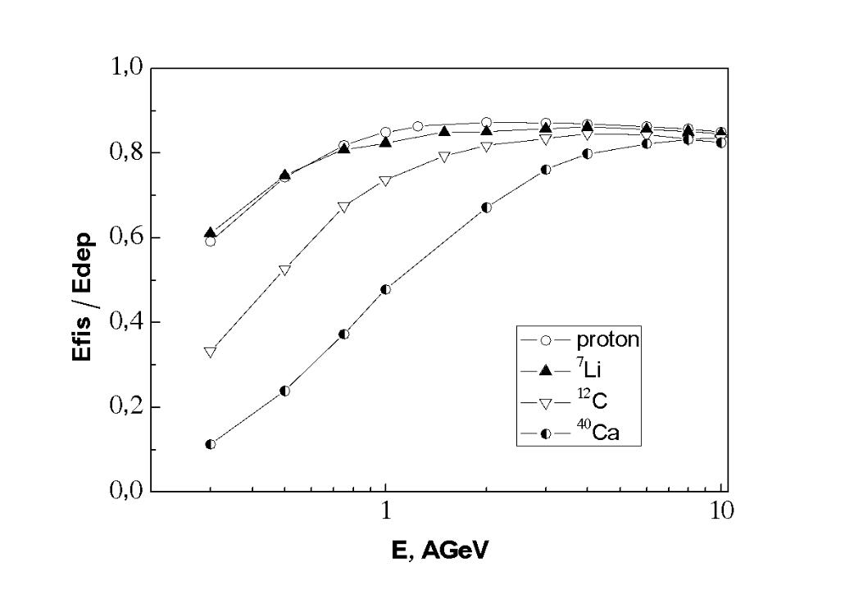
Fig. 6.3. Relative energy contribution released into the target from uranium fission reactions as a function of the kinetic energy per nucleon of incoming ions.
Analysis of the simulation results shows that the beam 7 Li with an energy of 0, 5 GeV/n is equivalent to the beam of protons with an energy of 3 GeV. For a proton beam, energy deposit in the target is almost independent of the target type. For light ions, however, the Be or C Converter significantly increases the energy deposit in the target. Thus, for 0.3 GeV/n⁷Li the energy deposit is 2 times higher than for Be Converter and 1, 4 times higher than for C Converter.
To experimentally verify the use of light nuclei in ADS-systems instead of proton beams, it is planned to reconstruct a specialized channel (Fig. 6.4) of an extracted beam from Nuclotron. It is expected to perform the following works: the reconstruction of the "Technical channel", the development of the required radiobiological protection at the studied targets, as well as further improvement of the diagnostics and monitoring system of the beam on the targets, as well as special detectors for measuring the temperature fields of heating, the spatial distribution of neutron fluxes inside and outside of the studied targets. The parameters of ion beams for relativistic nuclear power stations are given in Table 6.5.
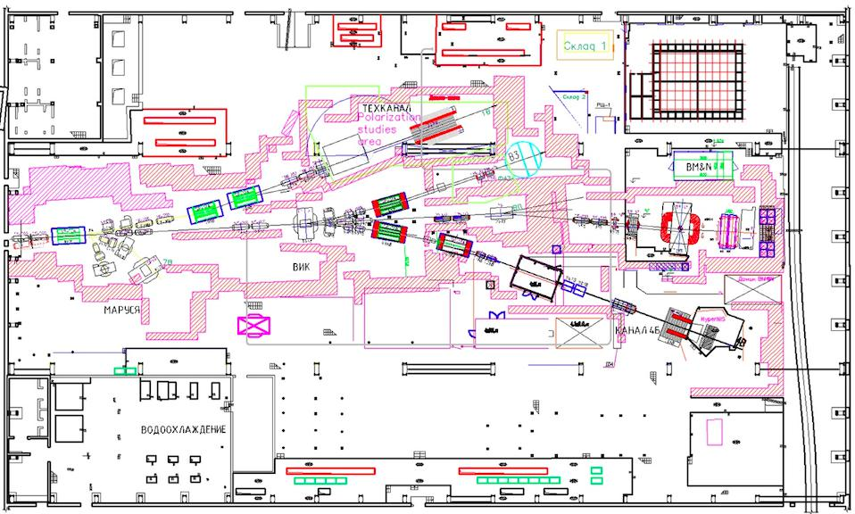
Fig.6.4 Technical layout of the channel for the station of relativistic nuclear energy.

Table 6.5

Parameters of the required beams for irradiation of ADS targets
Types of ions | 12_{C}6+, 40_{Ar}18+  7_{Li}3+,1_{P}1+, 2_{D}1
Ion energy, GeV/n | 0.3-0.4
Ion intensity 1/s | 1_{P}1+, 2_{D}1+ ₋ ₁₀10  12_{C}6+, 7_{Li}3+ ₋ ₁₀9
Admixture of nuclei with non-target Z not more than % | 5
Irradiation field, mm | ∅ 20-50
Time structure of the extracted beam | Homogenious  Impulsive  <1mks/cycle
Duration of one object irradiation | Accumulated  integral >10¹⁴

At the stage "basic configuration of the NICA Complex" a technical project will be prepared, equipment for all applied channels and stations will be manufactured, equipment installation will be completed and commissioning will be carried out.

- Network and computing infrastructure for the NICA complex
7.1. General description of the computing infrastructure
The computing infrastructure of the NICA complex is developed as part of the JINR general information and computing infrastructure. It is aimed at the accumulation, transmission, and storage of physic data obtained from the main nodes of the NICA complex - accelerators, BM@N, MPD and SPD detectors, computing equipment of experimental facilities for innovative and applied research, as well as their processing, analysis, monitoring and modeling of studied processes and systems used. It also includes the local data transmission network and elements of its interaction with the technological networks and computers of the complex, as well as with the JINR local computer network and networks of other organizations involved in the implementation of the NICA complex project.
The computing cluster of the NICA complex at JINR is geographically and functionally distributed. Its main technological elements are located in four specialized rooms, three of them are located on the Laboratory of High Energy Physics (VBLHEP) site, one - at the Laboratory of Information Technologies (LIT) on the LNP site. On the LHEP site, the on-line cluster is located in the building 14, its prototype is located in the building 201; the off-line cluster is located in the building 216, room 115; the off-line cluster of the NICA center will be located in a new building of the NICA center. On the LNP site, an autonomous off-line cluster is located in the building 134 (LIT) as part of JINR Multifunctional Information and Computing Complex (MICC).
The computing resources of the cluster and the network are based on modern and affordable technical solutions, scalable and open for connecting various computer and network elements located both at JINR and outside it. In the Basic configuration of the complex, these resources should be sufficient to work at JINR with a data volume of 3-10 petabytes per year in 20-2021, and in the Project configuration (starting from 2022) - 30-70 petabytes per year.
7.2. NICA distributed computer cluster
7.2.1. NICA computing network
One of the most important components of the computing infrastructure of the NICA complex is a computer network that combines clusters and servers within clusters into common computing infrastructure of the complex, as well as a computer network in buildings №1, 1A, 1B, 2, 4, 14, 17, 32, 42, 201, 202, 203A, 203B, 205, 215, 216, 217. Its on-line and off-line components use 100 GB/s local network. To balance the load, the entire Ethernet segment of the computer unit is structured according to access speeds.
When organizing the network computer infrastructure, the on-line cluster provides the channel capacity up to 320 Gbit/s, reliability and fault tolerance of the local network. All network computer elements of the on-line cluster are connected by interfaces with data transmission rates over N x 100 Gbit/s and are connected to each other via several lines.
Intel servers, Mellanox 100GbE network equipment, ОС CentOS 7.X. are used in the off-line VBLHEP cluster.
Equipment of the Central Telecommunication Node – the core of the switching and routing system of the LIT off-line cluster is implemented on four multifunction switches of the Cisco Nexus 9504 product family with connectivity over full-mesh topologies for maximum reliability and performance.
Network infrastructure for computer clusters of the NICA complex is a part of the Basic configuration. Estimated cost of its development 4.0 M$.
An additional 1.0 M$ for Project configuration is required to establish a computer network of the NICA Center and equip its offices and halls with computer and presentation equipment.
7.2.2. The structure of the NICA distributed computer complex
The general view of the distributed computer cluster of the NICA Complex project is shown in Fig. 7.1.
On-line cluster performs several basic and auxiliary functions. Its main functions are: receiving data from data acquisition systems from the NICA complex facilities with a total volume up to 500 TB / 24 hours in 2020 -2021 in the Basic configuration, and in the Full configuration (starting from 2022) - up to 1000 TB/24 hours; sorting and packing of raw data; express data processing (no more than 5~10% of the total); temporary storage of "packed" data (no more than 24 hours); data transfer to off-line clusters for further storage and processing with data volume from 500 TB to 1000 TB per day and data transfer rate up to 100 GB/s.
The estimated size of events and raw data from the main subsystems of the NICA complex used to calculate the main characteristics of the NICA computing unit.

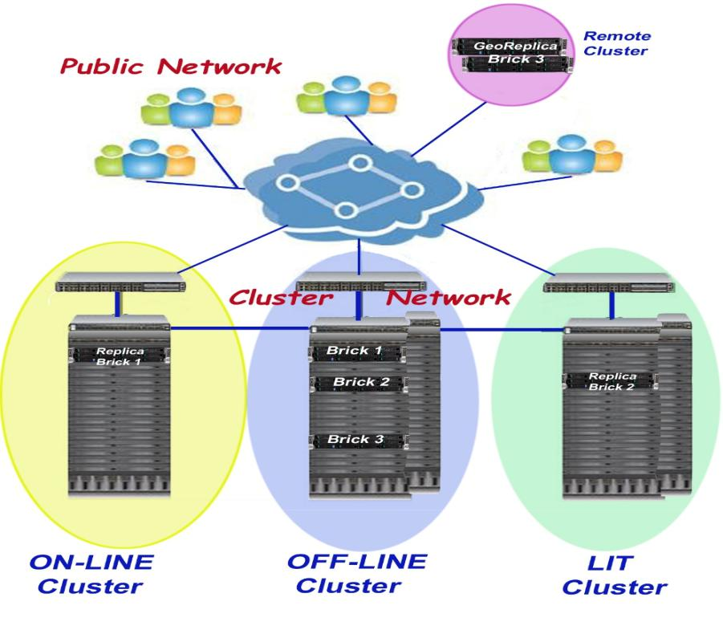

Fig. 7.1. Diagram of the distributed recourses usage at the NICA cluster.

 |  |  |  |  |  |  |  |  |  |  | Table 7.1
 |  | Information on the main subsystems of the NICA complex
NICA |  | Technical |  | Event |  | Event |  | Full |  | Mean |  | Data
subsystem of |  | data |  | rate |  | (kHz) |  | Event |  | data |  | volume
the NICA |  | rate (GB/s) |  | size |  | (MB) |  | size |  | transfer |  | per day
complex |  | (GB/s) |  | (kHz) |  |  |  | per second |  | rate |  | (TB/24 hours)
 |  |  |  |  |  |  |  | (GB/s) |  | (GB/s)
Accelerators
2019 - 2020 | 0.5 |  |  |  |  |  |  |  | 0.1 |  | 4
>2020 | 1.5 |  |  |  |  |  |  |  | 0.3 |  | 10
carried out
2019-2020 |  |  | 30 |  | 0.5 |  | 15 |  | 20 |  | 100
>2020 |  |  | 50 |  | 0.7 |  | 35 |  | 100 |  | 300
MPD
2021-2022 |  |  | 0.1 |  | 1 |  | 0.1 |  | 10 |  | 200
>2022 |  |  | 6 |  | 2 |  | 12 |  | 100 |  | 600

SPD

>2023 | 50 | 0.5 |  | 25 | 100 | 1000

Auxiliary functions of the cluster include receiving and displaying data of monitoring and diagnostics of physics facilities, support of services (DHCP, DNS, etc.).
Table 7.2 presents basic elements of the on-line cluster of the NICA complex.

Table 7.2

Basic elements of the NICA complex on-line cluster

Name |  | Quantity
Servers of Super Micro 2U TwinPro type |  | 10
Servers of Super Micro 2028R-DN2R24L type |  | 22
NVME type disk servers for fast data reception |  | 22

The on-line cluster shall be equipped with technological systems of uninterrupted power supply with the automatic transition to the autonomous electric generator, cooling and ventilation, fire extinguishing.
The on-line VBLHEP cluster refers to the Basic configuration of the NICA complex.
Estimated cost of its establishment– 3.8 M$. Additional 1.1 М$ is required to increase its performance after 2022 in The Full configuration of the complex.
The off-line computer cluster of the NICA complex, as well as all major centers of processing and storing data from large physics facilities, is geographically distributed and combines all components located both on the VBLHEP site and on the LNP site into a single local computer network N x 100 GB/s.
The off-line LHEP cluster has the characteristics listed in Table 7.3 to be achieved by the end of 2017 and the end of 2019. The off-line LHEP cluster should be equipped with technological systems of uninterrupted power supply with automatic transition to an autonomous generator, cooling and ventilation, fire extinguishing.
The LHEP off-line cluster refers to the Basic configuration of the NICA complex. The estimated cost of its establishment - 3.4 M$.
The off-line cluster of the NICA Center is located in the premises of the new building of the center and innovative developments of the NICA complex project (hereinafter – the NICA Center). In addition, the newly created cluster will be associated with a working prototype located in the building 215, on-line cluster (building 14), the off-line LHEP cluster and the off-line MIVC cluster. The off-line cluster design takes into account the experience of the establishing of a large JINR MIVC center, the results of modeling and the experience gained in the development of the prototype and the off-line LHEP cluster.

 |  |  |  | Table 7.3.
 | Basic parameters of the off-line cluster-216
Term |  | Required parameters |  | Required server
 |  |  |  | equipment
The end of 2017 |  |  |  | 14 INTEL servers
 |  |  |  | R2000WT
 |  | 0.5 PB disks (with replication), |  | 18x2x2x14=1008 cores
 |  | 1K CPU cores |  | CPU
 |  |  |  | 12x8x14=1344 TB
 |  |  |  | of disks
The end of 2019. |  |  |  | 60 INTEL servers
 |  |  |  | R2312WFTZS

4-5PB disks (with replication), |  | 20x2x2x60=4800 cores
 |  | CPU
4K CPU cores |  | 12x16x60=11520 TB
 |  | of disks

Table 7.4 shows the planned basic parameters of the NICA center off-line cluster; its commissioning is scheduled for 2021. The hardware required to achieve these parameters is specified under the assumption that in 2020, 3.5” hard drives with a capacity of 32 TB will already be available, and 2.5” SSD drives will have a capacity of 16 TB. The number of CPU cores in 2019 is 20, in 2020 - 22, in 2021-24, in 2023 – 26. The data are given for two variants of equipment of the NICA center cluster: variant 1 - based on 2-processors Intel-type servers R2312WFTZS and 8-processors of R2312LR3 type (High Density – four 2-processors modules in the server with the 2U height), variant 2 – based on the architecture of mini-RSC DCMINI. In the full cluster configuration, it is planned to increase the amount of disk space to 50 PB.
Computer cluster is supplemented by a block of auxiliary premises: control room for 2 workplaces of operators of twenty-four-hour shift, amenity rooms for staff. The necessary technological equipment for climate control in the computer room, operation of power supply, cooling, fire detection, and fire extinguishing systems are located on the technical floor and, partially, on the roof of the NICA center and outside the main building of the center.
Configuration of the NICA center off-line cluster with parameters achieved at the end of 2022 is part of the Basic configuration of the NICA complex. The estimated cost of its establishment – 7.34 M$. An additional 2.65 M$ is required to achieve the Full configuration parameters.
Table 7.4.

Basic parameters of the NICA off-line cluster
Stages of implementation | Required parameters | The required server hardware (air cooling  of servers) | The necessary back-end equipment (water cooling of servers, RSC)
Stage I | 8-10PB disks (with replication),  5K CPU cores | 60 servers of INTEL R2312WFTZS type  22x2x2x60=5280 CPU cores  12x32x60=23040 TB of disks | 64 modules (4 units)  22x2x2x64=5632 CPU cores  Data storage system  ClusterStor L300N:  4 SSU:  82x32x4=10496TB disks
Stage II | 12-15PB discs (with  replication),  10K CPU cores | 30 INTEL r2312lr3 type servers  (HD: 4 х 2CPU в 2U)  24x4x30x4=11520 CPU cores  12x32x30=11520 TB disks | 48 modules (3 units)  24x2x2x48=4608 CPU cores  Data storage system  ClusterStor L300N:  2 SSU:  82x32x2=5248TB disks
Stage III | 20PB disks (with replication),  20K CPU cores | 30 INTEL r2312lr3 type servers  (HD: 4 х 2CPU в 2U)  26х4х30х4=11520  CPU cores  12x32x30=11520 TB  of disks | 48 modules (3 units)  26x2x2x48=4992 CPU cores  Data storage system  ClusterStor L300N:  2 SSU:  82x32x2=5248 TB  of disks

The main task of the LIT off-line cluster is the development of two-level (disk-tape) data storage system for NICA experiments, as after the first stage of these experiments, significant storage volumes will be required (from 2.5 PB to 70 PB per year). The list of equipment additional to the existing JINR resources is given in Table 7.5.
Table 7.5.
 | Additional hardware for the LIT cluster
Product |  |  | Description |  |  |  | Quantity
3584-S54 |  |  | TS3500 HD Frames for LTO |  |  |  | 2
 |  |  | Drives
1646 |  |  | HD COD for S54/S55 |  |  |  | 2
3589-550 |  |  | 2.5TBUltriumTape |  |  |  | 1
 |  |  | Cartridge Labeled
5500 |  |  | 2.5 TB Labeled 20-pack |  |  |  | 66

The initial configuration of the LIT off-line cluster refers to the Basic configuration of the NICA complex. Estimated cost of its establishment – 1,3 M$. An additional 0.6 M$ is required to extend the configuration to the full one.
7.2.3. File system of the distributed computer complex
One of the main components of the computer unit of the NICA complex project is a cluster file system. Currently multiple cluster file systems are used in this function: GPFS, Lustre, dCache, Ceph, EOS, GlusterFS, etc. For on-line and off-line clusters, the EOS file system is best suited. EOS is a distributed, parallel, linearly scalable file system with the ability to protect it from failures.
7.2.4. Engineering infrastructure of clusters
Engineering infrastructure of each cluster of the distributed computer complex of the NICA complex project includes systems of power supply, cooling, fire detection and firefighting.
Computer rooms are equipped with false floors. These systems are designed and installed by specialized design organizations.
Power consumption for each cluster of the complex are shown in Table 7.6.
Table 7.6
Power consumption by computer clusters of the NICA complex

Cluster

On-line
VBLHEP off-line cluster
Off-line NICA Center

Off-line LIT cluster

Energy consumption

- kW

- kW

- kW

- kW

A set of these systems refers to the Basic configuration of the NICA complex. The estimated cost of the systems is 3 M$.
7.3. NICA complex software
Software for modeling, reconstruction, and analysis of experimental data in the field of high energy physics is an integral part of every experiment. A new generation of experiments using polarized beams of heavy ions starts at the NICA complex. Experiment on the study of baryonic matter at Nuclotron (BM@N) is the first of them, it is carried out on extracted ion beams at the fixed target. The experiment will start in 2017. Experiments with the multi-purpose detector (MPD) at the Collider of the accelerator complex of the NICA project will start in 2022.
Experiments with polarized particle beams at the collider using the SPD setup will start in 2025.
Software frameworks are developed for all the above mentioned experiments: MpdRoot is designed for experiments at MPD, BmnRoot - for experiments at BM@N, SpdRoot - for experiments at SPD.
The computer system of the NICA computer complex is aimed at: simulation of primary particles and heavy ion interactions and resulting detector response; reconstruction, and analysis of data from simulated and real interactions. During the construction of the detectors, optimization of hardware design and code preparation and computing infrastructure requires a robust modeling and reconstruction chain implemented by a distributed computing environment.
All developed Root-packages are used to perform the description of the technical design of all subdetectors of experimental facilities and further modeling of the processes registered in them in order to optimize their design and determine the necessary parameters of detectors and subsystems. Packages are also used for research of implemented physics problems at the complex facilities, determination of their capabilities, analysis of events and physics characteristics in studied processes.
The software is based on open systems and elaborations used at JINR on the basis of bilateral and multilateral agreements with relevant institutions and organizations.
During the "Starting NICA project configuration" stage the following basic parameters of the computer cluster are achieved
- number of CPU (cores) | - at least 1 | 000;
- amount of disk space for data storage | - at least 1 | PB;
- local network channel capacity | - at least 100 GB/s.
At the "Basic configuration of the NICA project" stage -
- number of CPU (cores) | - at least 10 |  | 000;
- amount of disk space for data storage | - at least 6 | PB;
- local network channel capacity | - at least 200 GB/s;
- amount of disk tape space for data storage | - at least 10 |  | PB.
At the "Full configuration of the NICA project" stage» -
- number of CPU (cores) | - at least 25 |  | 000;
- amount of memory to store data of Data Lake type | - at least 40 |  | PB;
- local network channel capacity | - at least 400 GB/s.

Technical project of computer network of general type and the NICA project computer cluster is posted on the website:
http://mpd.jinr.ru/wp-content/uploads/2018/06/NICA_computing_TDR_1.03.pdf

8. Building, Research and Engineering Infrastructure of the NICA Complex
8.1 Building Infrastructure of the Complex
The building infrastructure of the NICA complex comprises reconstructed buildings and facilities and those under construction. Among the new buildings under construction are the buildings and facilities of the Collider complex with the halls for the MPD and SPD experimental setups (Fig. 2), the buildings of the cryogenic-compressor complex and NICA Center. The buildings to be reconstructed include Building 1, which houses the Booster and Nuclotron, as well as part of the equipment for the beam transfer channels; Building 205 for the BM@N setup and beam transfer channels; Building 217 with the process line for assembly, testing and certification of superconducting magnets for all elements of the accelerator complex; Building 42 with process sections for assembling the MPD electromagnetic calorimeter; Building 14 for housing an on-line computer cluster; Building 32 for express workshops; Building 208 for the Collider electric power substation and the Building 205 equipment; Buildings 216, 22, 217 for process sections of detector assembly and the LHEP off-line computer cluster; Building 1A for housing power supply sources and the MPD control center; Building 1B for housing the cryogenic equipment, Building 4 for a thermal shield assembly section to be set up and Building 203A for a complex for preparing accelerator parts for the final assembly to be set up.
8.1.1. Complex of the Collider Buildings and Facilities with the Halls for the MPD and SPD Experimental Setups
The main building for housing the Collider and technological equipment (lenses, magnets, etc.), Building 17, is a biologically protected one-storey tunnel of elongated elliptic shape with an internal perimeter of about 503 meters (to be specified in the design). Beams of heavy ions and polarized nuclei are transported to this building through biologically protected tunnels that are being constructed and connected to Building 1 to transfer beams from the Nuclotron. To house the electron beam cooling system in the Collider, a special biologically protected hall is being constructed. A special auxiliary construction around the Collider building is also being created - one- and/or two-storey parts of the building with a standard column grid of 6x6 or 9x9 to accommodate engineering equipment, providing the necessary conditions for the operation of the Collider.
The NICA complex accelerator ring and beam extraction channels have both straight and radius sections in the project plan. To mount the magnet system of the complex and other related facilities, each section of the tunnel is equipped with its own overhead crane.
The project of ZAO “Kometa” includes 18 overhead cranes of various lifting capacities and required length. Initially, the technical design specification for overhead cranes supposed manual drive for both lifting the load and for moving it along the rails by analogy with the Booster overhead cranes. Such a solution greatly reduces the design requirements and simplifies further operation. Under the Federal rules and regulations in the field of atomic energy use “Rules for Design and Safe Operation of Cargo Cranes for Nuclear Facilities” NP-043-18 (Paragraph 3), any manually operated overhead cranes belong to cranes of general industrial use. For the purpose of standardization, all overhead cranes are designed to work with a load weight of up to 5 tons. To lift the load, a manual hoist is put in the design of the overhead cranes. Cranes of general industrial use are also installed in the buildings adjacent to the tunnels of the accelerator complex and extraction channels. The stroke of the cranes corresponds to the height of the room.
The halls for placing the MPD and SPD setups in the Collider beam collision zones located in the tunnel breaks are integrated into the Collider building in such a way as to ensure that the setups are placed in position in the beam collision zone with high accuracy. In the halls, a special area is provided for assembly and upgrading of the setups as well as the possibility of transporting the setups with an estimated weight of at least 1200 tons each from the assembly area to the operating position and back. The area of ​​the halls should be sufficient to accommodate technological equipment, including cryogenics, located in the immediate vicinity of the setups and necessary for their maintenance.
The MPD and SPD halls are equipped with crane facilities, as there it is supposed to assemble complex detectors that have both large-sized heavy components and lightweight, but fragile, long parts, such as vacuum tubes of ion guides located in the axial parts of the detectors. The SPD hall is designed to mirror the MPD hall while maintaining the overall dimensions of the halls, following the geometric profile of the building in height and depth of the areaways, the load-carrying structure of the footing and crane equipment. The cranes are for general industrial use.
The lifting capacity of the crane in the MPD hall is 80 tons. The maximum lifting height of the main crane hook is +12 m from the floor zero mark, the length of the ropes makes it possible to operate the crane in the pit of the hall at a mark of -3.19 m.
In order to move-in large-dimensioned objects, the entrance gates of the halls are 8 m x 8 m in size.
To move the detectors from one technological location to another and to move the poles on their lead-out supports of their parking position to the position for their installation in the support ring, rail tracks and transporter trucks are provided. The detectors are moved by a movement system with electromechanical rods.
To reduce local loads on the concrete base of the pit as well as to obtain the lowest possible non-flatness of the rail position, foundation plates are laid under the rail plates with the possibility of adjusting them in height during the installation with a non-flatness of 0.4 mm over a length of 19 m in the area of the rails installation for moving the detector.
Special traverses are developed for lifting, tilting and installing individual elements of the detectors.
The main units with electronics will be installed floor-by-floor on a special platform, which moves with the setups during the operation. An additional horizontal platform is being constructed to accommodate the elements of the cryogenic system of each setup.
The whole complex of buildings is classified as a hazardous production facility.
The total area of the complex of buildings and facilities excluding tunnels is at least 25,000 m² (to be specified in the design).
The energy consumption is 10,100 MW. The heat consumption is 5.93 Gcal/h. The water cooling system is closed. The fire water consumption is 17 l/s. Pure water consumption - 11 m³/day.
The whole complex of facilities belongs to the Basic configuration of the NICA complex.
8.1.2. Building of the Cryogenic-Compressor Complex
The existing building infrastructure of the Laboratory is insufficient to place in it all the necessary cryogenic equipment to ensure the regular operation of the accelerator complex and experimental setups. In this regard, the new building of the cryogenic compressor station has been included into the NICA complex. The following technological equipment is located in the building of the cryogenic-compressor station: Cascade 110/30 helical rotary compressor - 2 pcs; Aerkom-179 nitrogen turbocharger - 1 pc; SM5000 nitrogen turbocharger - 2 pcs; instrument air compressor with drying - 1 pc; a compressed nitrogen receiver unit; an autonomous water supply system consisting of mechanical-draft cooling towers, a block of water pumps; make-up plant. Site utility lines (utility bridges).
The building is classified as a hazardous production facility. The building services of the facility must comply with the technical specifications for connection to the on-site utility lines in accordance with the Construction standards and regulations.
The energy consumption is 7.680 MW. The heat consumption is 0.693 Gcal/h. The fire water consumption is 45 l/s. The pure water consumption is 20 m³/day.
The building belongs to the Basic configuration of the NICA complex.
8.1.3. Building of the NICA Center
An innovation center, the NICA Center, is created to ensure the conditions for the effective work of specialists involved in research at the NICA accelerator-experimental complex, including participants in the international MPD, BM@N and SPD collaborations, providing them with the necessary information and computing services as well as to accommodate the Basic element of the distributed computer cluster of the NICA complex. A preliminary sketch of the NICA Center building is shown in Fig. 8.1.1.
It is an office building round in shape with a diameter of 100 meters and a total area of 12,000 square meters (to be specified in the design), while the natural landscape is preserved in the inner yard. The building will accommodate: the lobby of the main entrance, office spaces for LHEP employees and other participants in the experiments, executive offices, rooms for working meetings, a computer cluster room, a transformable hall for conferences, presentations, etc. with the total capacity of up to 750 people, a cafeteria and utility space. The construction of the building involves the provision of related infrastructure, as follows: renovation of the adjacent roads and walkways, development of parking areas, landscape design. The building is planned to be constructed on the territory of the LHEP site in the immediate vicinity of the NICA accelerator complex. The estimated area of the development land is 1.8 ha. The number of storeys: office building - 3 to 5 storeys, engineering storey and basement. The height of the object is 27.45 m (excluding engineering equipment). The technical and economic indices are specified in the construction project and should not exceed the parameters of the land plot development plan.

Fig. 8.1.1 Scheme design of the NICA Center building
The building is classified as a research and production facility. The building services of the facility must comply with the technical specifications for connection to the on-site utility lines in accordance with the Construction standards and regulations.
The energy consumption is 1.924 MW. The heat consumption is 2.3 Gcal/h. The fire water consumption is 43.2 l/s. The pure water consumption is 29 m³/day.
The building belongs to the Basic configuration of the NICA complex.
8.1.4. Building 1
It is an existing building, a part of the accelerator complex under construction, requiring technological reconstruction. Building 1 is a permanent structure, a rounded industrial building with a diameter of 87.3 meters, a height of 30 meters in the crestal area and a total area of ​​23931 square meters with two extensions. The building accommodates the Synchrophasotron, an accelerator built in Dubna in 1957, which became the largest and most powerful for its time. Its magnet weighs 36,000 tons and is listed in the Guinness Book of World Records as the heaviest in the world. The accelerator had worked until 2002, and now its basement houses the Nuclotron constructed in 1992. It is a superconducting accelerator, on the basis of which the accelerator complex of the NICA project is being built. The building accommodates: a magnet-cryostat system of the ring with a perimeter of 251.5 m, which is located in the tunnel around the foundation of the Synchrophasotron electromagnet; a system of beam diagnostics, monitoring and control; a vacuum ring system; an HF system for accelerating beams in the Nuclotron; a system for slow resonance extraction of accelerated beams in the direction of the main experimental hall (Building 205) with the initial section of the beam transfer from the exit window of the Nuclotron cryostat to the “Focus F3” point; channels of extracted beam transfer from the F3 point to the experimental setups in Building 205.
In the steel channel of the yoke of the Synchrophasotron magnet, one of the accelerators of the NICA complex, the Booster, will be located. The Synchrophasotron channel contains 4 radius parts with the radii of curvature of 25.85 m on the inner radius and 30.15 m on the outer radius and 4 straight 8-m long sections between the radius parts. The cross section of the Booster channel is 4.3 m wide and 2.3 m high. A standard crane with a lifting capacity of 50 tons is used to install elements of the Booster into straight sections, and 4 identical overhead cranes with a lifting capacity of 2 tons are used to install elements of the Booster in the closed radius parts of the Synchrophasotron channel, one for each section. The rail tracks of the overhead cranes are fixed with rods directly to the ceiling and go towards an open, straight section, which allows one to attach a load on the hook of the crane hoist. For mounting heavy lower joint casings connecting two adjacent elements of the Booster magnet system, the overhead crane has an additional hoist with a lifting capacity of 1 ton, which allows one to capture the casing on both sides of the beam channel.
The beam injection channels from HILAc to the Booster and from the Booster to the Nuclotron are also located in the building.
In order to implement the planned works, it is necessary to carry out the following reconstruction activities: study, design and reconstruction of the engineering systems, construction works on building the necessary building structures and replanning the premises, replacement of the reflective structures, provision of openings in the concrete ceiling, restoration of the facades, replacement of the roofing pie, construction of a concrete circuit of biological protection, construction works on connecting Building 1 with Building 17, equipping the entrance groups, reconstruction of the loading-unloading area with the replacement of the gates, landscaping the adjacent area.
The building is classified as a hazardous production facility. The building services of the facility must comply with the technical specifications for connection to the on-site utility lines in accordance with the Construction standards and regulations.
The energy consumption is 1,750 MW. The heat consumption is 3,503 Gcal/h. The process water consumption (water cooling) from the intake at the Dubna river is 160 m³/h. The fire water consumption is 10 l/s.
The building belongs to the Basic configuration of the NICA complex.
8.1.5. Building 1A
It is an existing building, a part of the accelerator complex, which requires technological reconstruction. Building 1A is a permanent structure, an industrial four-story separate rectangular-shaped building equipped with a supported two-beam electric crane with a lifting capacity of 30.0/5.0 tons. Its main purpose is housing power supplies for the magnets, lenses of the Nuclotron ring, beam transfer channels and power cable runs.
The reconstruction of the building involves the replacement of the technological equipment (the power supply sources). It is necessary to accommodate in the building the following: the MPD control room, power supply control room, MPD computing cluster, staff offices. To accomplish these tasks, the following measures should be carried out: study, design and reconstruction of the engineering systems, replacement of the reflective structures, construction works on building the necessary building structures and replanning the premises, replacement of the roofing pie, reconstruction of the entrance group, necessary works on replacing the technological equipment, landscaping the adjacent area.
The building is classified as a hazardous production facility. The building services of the facility must comply with the technical specifications for connection to the on-site utility lines in accordance with the Construction standards and regulations.
The energy consumption is 9.000 MW. The heat consumption is 2.632 Gcal/h. The closed water cooling system is 2x70 kW. The fire water consumption is 10 l/s. The pure water consumption is 5 m³/day.
The building belongs to the Basic configuration of the NICA complex.
8.1.6. Building 1B
It is an existing building, a part of the accelerator complex, which requires technological reconstruction.
Building 1B is a permanent structure, an industrial building adjacent directly to Building 1, and serves to accommodate the Nuclotron cryogenic system. The building houses helium refrigerators with related infrastructure for liquefaction and circulation of helium gas, as well as vats for storing liquid nitrogen and its transportation lines.
The reconstruction is carried out in order to install additional cryogenic equipment on the newly constructed platform. The added equipment will increase the cooling capacity of the cryogenic system. As part of the reconstruction, it is necessary to carry out the following activities: study, design and reconstruction of the engineering systems, construction works on building a platform for cryogenic equipment and other necessary building structures, replanning and renovation of the utility spaces, necessary works on replacing the technological equipment with the involvement of industrial designers.
The building is classified as a hazardous production facility. The building services of the facility must comply with the technical specifications for connection to the on-site utility lines in accordance with the Construction standards and regulations.
The energy consumption is 5.0 MW. The heat consumption is 1.07 Gcal/h. The process water consumption (water cooling) from the intake at the Dubna river is 15 m³/h. The fire water consumption is 5 l/s. The pure water consumption is 3 m³/day.
The building belongs to the Basic configuration of the NICA complex.
8.1.7. Building 4
It is an existing building, a part of the accelerator complex, which requires technological reconstruction.
Building No. 4 is a permanent structure, an industrial one-two-storey separate building where the Experimental Workshops (EW) is located. On the basis of the factory, it is necessary to set up an area for heat shield assembly. To do this, it is necessary to reconstruct the left wing of the building. The following reconstruction activities are required: study, design, reconstruction of the engineering systems, restoration of the facades, replacement of the roofing pie, construction works on the preparation of the premises for the installation of technological equipment - ultrasonic baths, a drying oven, etc., development of an industrial supply-and-exhaust ventilation system, setting up an external vestibule, widening the existing window opening for the installation of metal gates, landscaping the adjacent area.
The building is classified as a production facility of hazard class B2. The building services of the facility must comply with the technical specifications for connection to the on-site utility lines in accordance with the Construction standards and regulations.
The energy consumption is 245 kW. The heat consumption is 0.396 Gcal/h. The fire water consumption is 5 l/s. The pure water consumption is 3 m³/day.
The building belongs to the Basic configuration of the NICA complex.
8.1.8. Building 14
It is an existing building, a part of the accelerator complex, which requires technological reconstruction. Building 14 is a permanent structure, an industrial two-storey separate building, where the engineering infrastructure of the on-line computer farm of the NICA complex will be arranged. The building is designed to accommodate telecommunications equipment, server hardware and a data storage and transfer system, and the engineering infrastructure of the building is to provide the conditions for the continuous and uninterrupted operation of the computer equipment. The engineering infrastructure should provide a round-the-clock mode of operation of the farm in the 7x24x365 mode. The following activities are required for the reconstruction of the building: study, design, reconstruction of the engineering systems, reconstruction of the bearing and enclosing structures of the building, replacement of the roofing pie, construction works on the preparation of the premises for the installation of technological and computer equipment, landscaping the adjacent area.
The building is classified as a production facility. The building services of the facility must comply with the technical specifications for connection to the on-site utility lines in accordance with the Construction standards and regulations.
The energy consumption is 300 kW. The heat consumption is 0.042 Gcal/h. The fire water consumption is 5 l/s. The pure water consumption is 3 m³/day.
The building belongs to the Basic configuration of the NICA complex.
8.1.9. Building 32
It is an existing building, a part of the accelerator complex, which requires reconstruction. Building 32 is a permanent structure, an industrial three-storey separate building, in which it is planned to set up an express section of EW with the installation of CNC machines and upgrading of an overhead crane (increasing the lifting capacity from 3 to 5 tons) for the production of necessary parts of various materials (metals, laminated fabric, polycarbonate, etc.) needed for the physics and technological equipment of the NICA complex under construction. As part of the reconstruction, the following activities are to be carried out: study, design, reconstruction of the engineering systems, construction works on the crane tracks upgrading, building a platform for CNC machines and other necessary technological structures, replanning and renovation of the utility and office spaces, works on replacing the technological equipment, replacement of the reflective structures, restoration of the facades, replacement of the roofing pie, equipping the entrance groups, landscaping the adjacent area.
The building is classified as a production facility of hazard class B2. The building services of the facility must comply with the technical specifications for connection to the on-site utility lines in accordance with the Construction standards and regulations.
The energy consumption is 900 kW. The heat consumption is 0.59 Gcal/h. The fire water consumption is 5 l/s. The pure water consumption is 3 m³/day.
The building belongs to the Basic configuration of the NICA complex.
8.1.10. Building 42
It is an existing building, a part of the accelerator complex, requiring reconstruction. Building 42 is a permanent structure, an industrial two-storey separate building which will accommodate the following: an area for assembling time-of-flight detectors for MPD and BM@N, an area for assembling the electromagnetic calorimeter, an area for testing accelerator elements, as well as spaces prepared for superconducting magnets storage As part of the reconstruction, the following activities are planned: study, design, reconstruction of the engineering systems, construction works on the upgrading of the crane tracks and other necessary technological structures, replanning and renovation of the utility and office spaces, works on the technological equipment installation, replacement of the reflective structures, works on thermal insulation of the external walls and mounting ventilated facades, the replacement of the roofing pie, equipping the entrance groups, reconstruction of the loading-unloading area with the replacement of the gates, landscaping the adjacent area.
The building is classified as a production facility of hazard class B2. The building services of the facility must comply with the technical specifications for connection to the on-site utility lines in accordance with the Construction standards and regulations.
The energy consumption is 788 kW. The heat consumption is 0.087 Gcal/h. The fire water consumption is 5 l/s. The pure water consumption is 3 m³/day.
The building belongs to the Basic configuration of the NICA complex.
8.1.11. Building 203A
It is an existing building, a part of the future accelerator complex, requiring reconstruction.
Building 203A is a permanent structure, an industrial one-storey separate building, which will accommodate a complex for preparing accelerator parts for the final assembly consisting of an ultrasonic bath, a vacuum heating furnace and a “clean room”. The reconstruction measures should include: study, design, reconstruction of the engineering systems, construction works on the setting-up of crane tracks and other necessary technological structures, replanning and renovation of the utility and office premises, necessary measures for the installation of technological equipment, replacement of the reflective structures, replacement of the roofing pie, equipping the entrance groups, reconstruction of the equipment movement area with replacing the gates, landscaping the adjacent area.
The building is classified as a production facility of hazard class B2. The building services of the facility must comply with the technical specifications for connection to the on-site utility lines in accordance with the Construction standards and regulations.
The energy consumption is 317 kW. The heat consumption is 1.721 Gcal/h. A closed-loop 60 chiller system. The fire water consumption is 5 l/s. The pure water consumption is 6 m³/day.
The building belongs to the Basic configuration of the NICA complex.
8.1.12. Building 205
It is an existing building, a part of the future accelerator complex, requiring reconstruction.
Building 205 is a permanent structure, an industrial building for physics experiments, consisting of a one-storey industrial part for housing setups involved in the experiments, two additional buildings, east and west, for housing offices and power supply components of the Collider. In Building 205, it is planned to construct, with further development, the BM@N setup, an MPD/SPD test area, an area for the improvement of the ROC technology for the MPD TPCs, the upgrading of the radiobiological protection area, the arrangement of power supply systems. The reconstruction involves the following activities: study, design, reconstruction of the engineering systems, construction works on the setting-up of crane tracks and other necessary technological structures, replanning and renovation of the utility and office premises, replacement of the lifting equipment (elevators), necessary measures for the installation of technological equipment, replacement of the reflective structures, replacement of the roofing pie, works on thermal insulation of the external walls and mounting ventilated facades, reconstruction of the loading-unloading area with the replacement of the gates, landscaping the adjacent area.
The building is classified as a hazardous production facility. The building services of the facility must comply with the technical specifications for connection to the on-site utility lines in accordance with the Construction standards and regulations.
The energy consumption is 7.8 MW. The heat consumption is 1.705 Gcal/h. The process water consumption (water cooling) from the intake at the Dubna river is 100 m³/h. The fire water consumption is 10 l/s. The pure water consumption is 10 m³/day.
The building belongs to the Basic configuration of the NICA complex.
8.1.12. Building 216
It is an existing building, a part of the future accelerator complex, requiring reconstruction.
Building 216 is a permanent structure, an industrial two-storey building connected to Building 215 with a walkway, in which several “clean rooms” should be located to house the following: a section for assembling modules of silicon tracking systems for the BM@N and MPD experiments; a section for assembling and certification of the tracking systems; a section for joining and machine processing of structural elements of the tracking systems. It is also planned to set up a computer cluster in the premises of the building - an LHEP off-line farm. As part of the reconstruction, the following activities are planned: study, design, reconstruction of the engineering systems, construction works on the upgrading of the necessary technological structures, measures on strengthening the floors and constructing the foundations for equipment to be installed, replanning and renovation of the utility and office premises, necessary activities for the installation of technological equipment, replacement of the reflective structures, works on thermal insulation of the external walls and mounting ventilated facades, replacement of the roofing pie, equipping the entrance groups, reconstruction of the loading-unloading areas, landscaping the adjacent area.
The building is classified as a production facility of hazard class B2. The building services of the facility must comply with the technical specifications for connection to the on-site utility lines in accordance with the Construction standards and regulations.
The energy consumption is 630 kW. The heat consumption is 1.332 Gcal/h. Process water is supplied from the cooling tower of Buildings 218-219. The fire water consumption is 10 l/s. The pure water consumption is 7 m³/day.
The building belongs to the Basic configuration of the NICA complex.
8.1.14. Building 217
It is an existing building, a part of the future accelerator complex infrastructure, requiring reconstruction.
Building 217 is a permanent structure, an industrial two-storey separate building. In the building, it is planned to set up with further development a high-tech line for assembly, testing and certification of superconducting magnets and custom-made elements of the magnet-cryostat system of the NICA accelerator complex, as well as to accommodate a “clean room” for assembling the MPD time-projection chamber. The reconstruction activities include: study, design, reconstruction of the engineering systems, arrangement of an industrial supply-and-exhaust ventilation system, construction works on the setting-up of crane tracks and other necessary technological structures, replanning and renovation of the utility and office premises, necessary activities for the installation of technological equipment, replacement of the reflective structures, replacement of the roofing pie, equipping the entrance groups, reconstruction of the loading-unloading area with the gates replacement, landscaping the adjacent area.
The building is classified as a production facility of hazard class B2. The building services of the facility must comply with the technical specifications for connection to the on-site utility lines in accordance with the Construction standards and regulations.
The energy consumption is 500 kW. The heat consumption is 0.217 Gcal/h. The fire water consumption is 5 l/s. The pure water consumption is 3 m³/day.
The building belongs to the Basic configuration of the NICA complex.
8.1.15. Summary table of the resource intensity of the NICA project buildings
The estimates of the resource consumption and cost with a breakdown into existing and being constructed buildings of the NICA complex are presented in Table 8.1.1.

Table 8.1.1.
Resources consumption of the NICA project buildings

NICA Facilities | Area Size, m² | Energy Consumption, MW | Heat consumption, Gcal/h | Process water, m³/h | Fire water, l/s | Pure water, m³/day
Building 17 with the halls | 30 800 | 9.200 | 5.930 |  | 17.0 | 11.0
Building of the cryogenic-compressor station | 1 730 | 7.680 | 0.693 |  | 45.0 | 20.0
NICA Center building | 12 000 | 1.924 | 2.300 |  | 43.2 | 29.0
Building 1 | 23 900 | 1.750 | 3.503 | 160 | 10.0
Building 1A | 240 | 2.000 | 2.632 |  | 10.0 | 5.0
Building 1B | 3 450 | 1.500 | 1.070 | 15 | 5.0 | 3.0
Building 4 | 300 | 0.245 | 0.396 |  | 5.0 | 3.0
Building 14 | 960 | 0.300 | 0.042 |  | 5.0 | 3.0
Building 32 | 2 500 | 0.900 | 0.590 |  | 5.0 | 3.0
Building 42 | 2 500 | 0.788 | 0.870 |  | 5.0 | 3.0
Building 203A | 300 | 0.317 | 1.721 |  | 5.0 | 6.0
Building 205 | 8 900 | 7.000 | 1.705 | 100 | 10.0 | 10.0
Building 216 | 350 | 0.630 | 1.332 |  | 10.0 | 7.0
Building 217 | 2 200 | 0.500 | 0.217 |  | 5.0 | 3.0
Total | 90 130 | 34.734 | 23.001 | 275 | 180.2 | 106.0
8.2 Cryogenic Infrastructure
8.2.1 Purpose of the cryogenic complex
The NICA Collider cryogenic complex is designed to cool the accelerator rings of the Nuclotron, Booster and Collider to a temperature of 4.5 K. Superconducting magnets operate at this temperature. In addition, it provides liquid helium to the line for assembly and testing of superconducting magnets, the MPD magnet, ion sources, and helium consumers of the Laboratory.
8.2.2. Cryostat facilities for the accelerator complex.
The cryogenic system of the NICA project accelerator complex is being developed on the basis of two upgraded KGU-1600/4,5 helium plants started in the early 90s for cooling the superconducting synchrotron - the Nuclotron. In order to provide cooling for two more accelerators – the Booster and Collider, it is necessary to increase the cooling capacity of the existing cryogenic system from 4000 W to 10000 W. The solution is to put into operation an additional helium liquefier OG-1000 with a capacity of 1000 l/h and three satellite refrigerators RSG-2000/4,5 with excess back flow. Cryogenic plants of this type operate in conjunction with a large central liquefier on the liquid helium obtained from it. Two of the satellite refrigerators are located next to the Collider accelerator ring, and the third is located on the platform of the cryogenic plants in Building 1B. The OG-1000 liquefier is also located there.
8.2.3. Main parameters of the cryogenic complex equipment.
The basic parameters of the cryogenic complex equipment are presented in Table 8.2.1.
Table 8.2.1
Basic parameters of the equipment of the cryogenic complex
No. | Parameter | Value
1 | Cooling capacity at a temperature level of 4.5 K | 10000 W
2 | Total mass of the equipment cooled to 4.5K | 290 t
3 | Installed capacity of the compressor facilities | 11.4 MW
4 | Power consumption in the peak mode | 7 MW
5 | Helium storage volume | 34932 mn³
6 | Nitrogen liquefaction capacity | 2300 kg/h
7 | Nitrogen storage volume | 61676 mn³
8 | Total area occupied by the equipment of the cryogenic complex | 4000 m²
9 | Total length of the nitrogen and helium pipelines | ~ 4 km

8.2.4. Configuration of the technological equipment of the cryogenic complex.
The location of the main elements of the cryogenic complex at the LHEP site is shown in Fig. 8.2.1. Their brief description and the list of the equipment being installed in the respective premises are presented in Table 8.2.2.
Fig. 8.2.1. Location of the main elements of the cryogenic complex at the LHEP site
Table 8.2.2
Equipment to be installed in the cryogenic complex premises
No. | Item | Quantity
1 | Central platform of the cryogenic station in Building 1B. Comprises the following equipment:
 | Cryogenic helium plant KGU-1600/4,5 | 2
 | Helium liquefier OG-1000 | 1
 | Helium satellite refrigerator RSG-2000/4,5 for the Booster | 1
 | Nitrogen recondenser RA-0,5 | 1
 | Nitrogen liquefier OA-1.3 | 1
 | Compressed helium draining and oil-purification units MO-800 | 4
2 | Machine room of the cryogenic complex. Comprises the following equipment:
 | Helium screw compressor KASKAD-80/25 | 2
 | Helium piston compressor 305GP-20/31 | 3
 | Helium piston compressor 2GM4-12/31 | 2
 | Helium piston compressor 6GSH1.6/1.1-200-1 | 3
3 | Atmospheric cooling towers of the machine room | 2
4 | Constant volume helium gasholder | 1
5 | Reservoirs for helium gas storage | 10
6 | Liquid nitrogen tank | 2
7 | Tank container for liquid helium storage | 1
8 | Extensive helium pipeline system
9 | Extensive nitrogen pipeline system
10 | Cryogenic-compressor station. Comprises the following equipment:
 | Helium screw compressor KASKAD-110/30 | 2
 | Nitrogen turbo compressor AEROKOM-178/18 | 1
 | Nitrogen turbo compressor SAMSUNG SM5000 | 2
11 | Constant volume nitrogen gasholder | 1
12 | Reservoirs for nitrogen gas storage | 5
13 | Helium satellite refrigerator RSG-2000/4.5 for the Collider | 2
14 | Nitrogen recondenser RA-0.5 | 1
15 | Liquid nitrogen tank | 1
The cryogenic infrastructure belongs to the Basic configuration of the NICA complex.
A detailed description and characteristics of the equipment listed above are presented in Volume 4, Ch. 11 of the technical design report of the NICA accelerator complex (http://nucloweb.jinr.ru/nica/TDR/2015/TDR_Volume_4.pdf) and in the 8.2-TS: Technical specifications of the cryogenic complex of the NICA complex project.
8.3. Infrastructure of the energy-supplying and energy-saving engineering systems
8.3.1. General characteristics of the systems
The NICA complex is a high technology and energy-intensive facility. Directly for the Collider facilities with internal infrastructure, up to 10 MW of free capacity is required according to the second category of reliability and continuous supply. In addition, the arrangement of additional connection points for scientific research equipment, power supplies, measuring equipment and related equipment for experimental setups is required.
In order to fully supply the object with electricity, it will be necessary to carry out a series of preparatory works on the reconstruction of the existing networks and the main supply substation GPP 110/6 kV Substation Dubna with an increase in the transformer capacity of the electric grid facility to two 110/6 kV transformers with a unit capacity of 40 MVA. Currently, executive documentation is being prepared for the comprehensive reconstruction of the main supply substation GPP-110/6kV, taking into account the future development of the research capacity of the site. In parallel with the development of the executive documentation for the reconstruction of the supply substation, an analysis of the existing electrical facilities of the site is carried out in order to determine the need to strengthen the on-site lines to arrange the required number of connection points for new consumers and ensure reliable and uninterrupted power supply to the existing facilities.
According to the approved preliminary technical solutions for the reconstruction of the GPP 110/6kV Dubna relating to the arrangement of distribution mains on the 6kV side, a scheme of the on-site supply lines has been developed taking into account the future development of the electrical facilities for the next 15 years. According to the proposed scheme, on the 6kV side, 4 main and 4 reactivated busbar sections are provided, to which all existing and new users of the LHEP site are connected according to a radial-ring scheme ensuring compliance with the requirements of the second category of reliability and continuous supply to users.
8.3.2. Key power grid elements of the NICA complex facilities and their characteristics
The layout of electric grid facilities at the LHEP site is shown in Fig. 8.3.1.
In connection with the construction of new experimental setups in Building 1 of the site, it is necessary to reconstruct the supply centers of this building, PS-11 and PS-12, with an increase in their transformer capacity for connecting new technological equipment, as well as improving the reliability of power supply to the existing research equipment, infrastructure, laboratory setups in the experimental hall.

Fig. 8.3.1. Layout plan of the arrangement of the electric grid facilities of the voltage class 6kV at the LHEP site
Due to the accommodation of a number of new facilities in the area adjacent to Building 2 at the site, a comprehensive reconstruction is required with an increase in the capacity of Substation 21 located in this building. As part of the reconstruction, it is necessary to set up points for technological connection to the site electric grid of the new cryogenic compressor station and the IT cluster of the Online farm located in Building 14, as well as to improve the reliability of power supply to the facilities of the existing infrastructure of Building 2, existing compressor units of the cryogenic complex and Water Intake Substation 91. As part of the reconstruction of the substation, it is proposed to divide the consumers according to the nature of the loads into the infrastructure facilities and the electrically driven compressor part, which will be equipped with a soft shock-free start system. This solution will ensure reliable operation of the electricity supply system of the infrastructure facilities and cryogenic system by eliminating the negative impact of the starting processes of high-voltage motors on the electric grid of the LHEP site.
In order to upgrade the electricity supply system of the magnetic elements of the experimental hall of Building 205, as well as to set up technological connection points for the building 17 under construction of the NICA complex, the reconstruction of Substation 15 located in this building is required. The nature of the loads of the consumers of the substation is changing, instead of previously used silicon rectifiers of the voltage class 6kV, modern converter equipment of the voltage class up to 1kV is used. For the period of the electricity supply system reconstruction, the electricity supply of the existing power sources of the magnetic elements will being maintained.
The LHEP off-line computer farm of the NICA complex is located in Building 216, and the reconstruction of Substation 216 is needed for its supply with the replacement of a failed power transformer.
The designed distribution points and substations of the NICA complex will provide the electricity supply to the technological and research equipment of the complex in full measure in the second category of reliability after the reconstruction of the main supply substation GPP-1 110/6kV Substation 134 Dubna. The connection points for the facilities of the electricity supply system of the NICA complex are the upgraded Substation 13 of Building 1A and Substation 15 of Building 205, which requires reconstruction.
In addition, it is necessary to provide points of connection to the on-site utility lines of the buildings being designed of the NICA Center Innovation Complex. For the electricity supply of the buildings, the project provides for two substations with a total capacity of up to 2000 kVA.
In order to automate the control and monitoring of the electric networks of the LHEP site, it is necessary to install and integrate an automated process control system based on microprocessor control systems.
8.3.3. 3 MJ inductive energy storage unit made of high-temperature superconductor
To develop ultra-precision highly dynamic electricity power supply systems for high-power SC magnetic structures, it is reasonable to have a buffer energy storage unit. The use of an energy storage unit in the power supply system of the NICA project SC accelerators is caused by:
- the need to unload the power network infrastructure as putting megawatt capacities through it leads to energy losses in the network lines and the reduced quality of power supply to other consumers;
- the requirement to remove the network harmonics in the energy source to create better conditions for obtaining ultra-precision current parameters in the SP magnets of the accelerators;
- the need to optimize the amount of required energy in the storage unit during locked anti-phase operation of the Booster and Nuclotron;
- the task of simplifying the technology of the energy regeneration process.
Table 8.3.1 shows the basic parameters of the magnetic systems of the Booster and Nuclotron, which determine the characteristics of the NICA energy storage unit.
Table 8.3.1
Parameters | Values
 | Booster | Nuclotron
Cumulative inductance of the superconducting magnets, L [mH] | 31 | 120
Maximum operating current (field), Imax [A] (Bmax [T]) | 10 (1.8) | 6.0 (2.0)
Voltage of the current sources [V] | 260 | 450
Relative current accuracy:  - at dI/dt ≠ 0  - at dI/dt = 0 | 2*10⁻⁴  2*10⁻⁵ | 2*10⁻⁴  2*10⁻⁵
Cycle shape, duration and frequency, [s] | See Fig. 9.3.1 a), repeats constantly, without duty ratio | See Fig. 9.3.1 b), repeats constantly, without duty ratio
Maximum linear rate of the current change, dI/dt [kA/s] | 6.7 | 3.0
Energy stored per each half-cycle (with the rising current), [MJ] | 1.6 | 2.16
Peak output power of the current source required to create the cycles outlined above, P [MW] | 2.16 | 2.7
Figure 8.3.1 shows the cycle correlation of the magnetic fields of the Booster and Nuclotron. Figure 8.3.2 shows the time change of the accumulated energy cycle in the Booster, Nuclotron and their energy in total.
Fig. 8.3.1. Cycle correlation of the magnetic fields of the Booster (top) and Nuclotron (bottom).

Fig. 8.3.2. Time change of the accumulated energy cycle in the Booster (top), Nuclotron (in the middle) and total energy (bottom).
Features of the current source cycle operation when fields are formed in SC magnets:
- maximum energy consumption when the current rises, while the voltage at the source has a peak value,
- minimum energy consumption on a plateau current, while the voltage at the source has a minimum value,
- energy regeneration during current output, while the voltage at the source has a negative peak value.
Figure 8.3.2 shows that the energy stored in the NICA storage unit should be about 3 MJ.
The infrastructure of the energy-supplying and energy-saving engineering systems belongs to the Basic configuration of the NICA complex, except for the SC energy storage unit, which is part of the Project configuration of the Complex.
A program has been developed for the technical re-equipment and development of the on-site 6 kV electricity networks of the LHEP site. The corresponding document, which contains the detailed description of the electricity network facilities and systems, priority schedules of their construction, reconstruction and commissioning, as well as the description of the SC energy storage unit, is at the Office of the JINR LHEP Chief Engineer.
8.4. High-tech line for SC magnet assembly and testing.
8.4.1 Purpose of the line
The line is designed for the manufacture of SC windings of various configurations, assembly of a winding with a yoke, electrical, vacuum, magnetic and cryogenic tests of magnets for the NICA and FAIR projects. Within the NICA Complex project, the dipole, quadrupole and correcting SC magnets of the Booster synchrotron and Collider should be manufactured and tested, as well as the SC magnet of the 3 MJ inductive energy storage unit.
8.4.2. Process sections and their equipment
The line for SC magnet assembly and testing includes the following process sections (Fig. 8.4.1, left):
- manufacturing of a superconducting cable with an operating current of up to 11 kA;
- precision winding and baking of superconducting windings;
- precision input control of magnet components;
- high-precision assembly of a winding with a yoke;
- measurement of the magnetic field quality with a relative accuracy of at least 1 • 10⁻⁴;
- tests for vacuum tightness of channels with liquid helium and nitrogen with a sensitivity of 1*10⁻⁹ Pa*m³/s and higher;
- mounting a magnet in the cryostat;
- comprehensive cryogenic tests of magnets with the use of three helium satellite refrigerators with a cooling capacity of 100 W at a level of 4.5 K each (Fig. 8.4.1, right);
- low-noise sources of pulsed electrical power supply up to 15 kA.
The required SC magnets for the Booster and Collider of the NICA complex are presented in Table 8.4.1.
Table 8.4.1
Item | Quantity
Booster synchrotron
Dipole magnet | 40+1
Quadrupole magnet | 48+1
Dipole corrector | 24
Multipole corrector | 8
Collider
Dipole magnet | 80+1
Quadrupole magnet | 86+1
Final focus quadrupole magnet | 12
Beam convergence/divergence magnet | 8
Multipole corrector | 136
The flow rate of liquid helium and liquid nitrogen for testing one NICA Booster dipole magnet will be 800 l and 3400 l, respectively. The flow rate of liquid helium and liquid nitrogen for testing one NICA Collider dipole magnet will be 1,500 l and 4,700 l, respectively. The planned pace of cryogenic tests at a temperature of 4.5 K is from 4 to 9 magnets per month, depending on the type of magnet, its mass and the hydraulic resistance of the cooling channels.
Fig. 8.4.1 Layout plan for the sections of the high-tech line for superconducting magnet assembly and testing (left) and the flow diagram of a satellite helium refrigerator (right). Indications in the figure: 1 - SC cable manufacturing; 2 - SC winding manufacturing; 3 - assembly of a winding with a yoke; 4 - magnetic measurements; 5 - vacuum tests; 6 - mounting a magnet in the cryostat; 7 - cryogenic tests with the use of the helium satellite refrigerators; 8 - power supplies.
The basic equipment of the line for SC magnet assembly and testing is presented in Table 8.4.1.
Table 8.4.1
Basic equipment of the line for assembly and testing of SC magnets
No. | Item | Parameter | Quantity
1 | Cabling machine for SC cable production | 30 m/h | 1
2 | SC winding machine | from 0.5 m to 3 m | 4
3 | Winding heat treatment furnace | 3.5 m and 6.5 m | 2
4 | System for precision control of the product geometrical dimensions | 15 µm | 2
5 | Table for magnet assembly, welding and brazing the helium cooling channels | 3 m | 4
6 | High vacuum volume for the leak check | 6 m, DN 800 | 1
7 | System for measuring the magnetic field quality along the length | from 0.5 to 3 m | 8
8 | Satellite helium refrigerator | 100 W/4.5 K | 3
9 | Bath for liquid nitrogen storage | 10 m³ | 2
10 | Liquid helium dewar | 1000 l | 3
11 | Cryostat for the supply of cryogenc liquids | DN 800 | 6
12 | Current leads made of high-temperature superconductor | 12 kA DC | 12
13 | Cryogenic parameter monitoring and control system | TANGO | 3
14 | System of the normal zone detection and energy evacuation from the SC magnet | up to 200 ms | 3
15 | Electricity power supply source for regular magnets | 15 kA/20 V | 2
16 | Electricity power supply source for correctors | 260 A/90 V | 2

The high-tech line is set up in three stages:
1. Start-up configuration: two arms for the cryogenic tests of magnets - 2014.
2. Basic configuration: 6 arms for parallel cryogenic tests of magnets - 2016.
3. Project configuration - 2019.
The high-tech line for SC magnet assembly and testing belongs to the Start-up configuration of the NICA complex. The area of the line for SC magnet assembly and testing is about 2200 m². It is located in Building 217 of the LHEP site.

9. Plan for the construction of the NICA complex facilities
(Indications: S – Start-up configuration, B – Basic configuration, P – Project configuration)
Passport section | Facility | Date of readiness, year
 |  | 2016 | 2017 | 2018 | 2019 | 2020 | 2021 | 2022 | 2023 | 2024 | 2025
1 | Scientific programme
2 | Accelerator complex |  |  |  |  |  | B |  | P
2.2 | Injection complex for light ions |  | S |  | B |  |  |  |  | P
2.3 | Injection complex for light ions |  | S |  |  | B | P
2.3.1 | KRION-6T heavy ion source | S |  | B |  | P
2.3.2 | HILAc | S |  |  | B |  | P
2.3.3 | Beam transfer channels |  |  |  | S | B | P
2.4 | Booster |  |  |  | S | B | P
2.5 | Nuclotron | C |  |  | B |  | P
2.5 | Collider |  |  |  |  | S |  | B | P
3 | MPD setup |  |  |  |  | S |  | B |  | P
3.6 | MPD test area and test channel | S | B |  |  |  |  | P
4 | BM@N setup | S |  |  | B | P
5 | SPD setup |  |  |  |  |  |  |  |  |  | S
5.3 | Test area |  |  |  | S | P
6 | Innovation complex |  |  |  |  |  | S | B | P
6.2 | Beam transfer channels |  |  |  |  |  | S | B | P
6.3 | LRIIST station |  |  |  |  |  | S | B | P
6.4 | SRIIST station |  |  |  |  | S |  | B | P
6.5 | LRIISB station |  |  |  |  |  | S | B | P
6.6 | Relativistic nuclear energy station |  |  |  |  |  | S | B | P
7 | Computer complex and networks
7.1 | On-line cluster | S |  |  |  | B |  |  | P
7.2 | LHEP off-line cluster | S |  |  | B |  |  |  | P
7.3 | NICA Center off-line cluster |  |  |  |  | S |  | B |  | P
7.4 | LIT off-line cluster |  |  | S |  |  | B |  |  | P
8 | Infrastructure
8.1 | Building infrastructure
8.1.1 | Building 17 with the halls | S |  |  | B |  | P
8.1.2 | CCS building |  |  | S |  | B | P
8.1.3 | NICA Center building |  |  |  | S |  | B | P
8.1.4 | Building 1 |  |  |  | B |  |  | P
8.1.5 | Building 1A
8.1.6 | Building 1B
8.1.7 | Building 4
8.1.8 | Building 14 |  |  |  | S | B |  |  | P
8.1.9 | Building 32 |  | S |  | B | P
8.1.10 | Building 42 |  | S | B | P
8.1.11 | Building 203A
8.1.12 | Building 205 | S | B |  |  | P
8.1.13 | Building 216 |  |  | S | B |  |  |  | P
8.1.14 | Building 217 | P
8.2 | Cryogenic infrastructure | B |  |  |  |  | P
8.3 | Infrastructure of energy systems | S |  |  |  | B |  | P
8.4 | Line for SC magnet assembly and testing | B |  |  | P

Appendix 1
To the section «Technical Specification
(passport) of. the “NICA Complex” Object

Estimation of the material costs for the construction of basic NICA complex objects
Passport section | Object name | Year (M $)
 |  | 2013-2016 | 2017 | 2018 | 2019 | 2020 | 2021 | 2022 | 2023 | 2024 | 2025 | Total
1 | Scientific Programme
2. | Accelerator block (with engineering and technological systems)): | 25,3 | 23,2 | 27,6 | 48,3 | 34,4 | 19,5 | 8,5 | 3,4 | 0,0 | 0,0 | 190,3
2.2. | Injection block for light ions | 1,5 | 1,4 | 2,0 | 3,5 | 3,0 | 1,3 | 0,6 | 0,0 | 0,0 | 0,0 | 13,3
2.3. | Injection block for heavy ions | 9,3 | 0,4 | 0,4 | 3,5 | 0,1 | 0,0 | 0,0 | 0,0 | 0,0 | 0,0 | 13,7
2.3.1 | Heavy ion source KRION-6T | 0,5 | 0,2 | 0,1 | 0,2 | 0,1 | 0,0 | 0,0 | 0,0 | 0,0 | 0,0 | 1,0
2.3.2 | HILAc | 6,9 | 0,1 | 0,1 | 0,3 | 0,0 | 0,0 | 0,0 | 0,0 | 0,0 | 0,0 | 7,4
2.3.3 | Beam transport channels | 2,0 | 0,1 | 0,3 | 3,0 | 0,0 | 0,0 | 0,0 | 0,0 | 0,0 | 0,0 | 5,4
2.4 | Booster | 9,1 | 4,6 | 4,4 | 4,2 | 0,7 | 0,2 | 0,2 | 0,1 | 0,0 | 0,0 | 23,5
2.5 | Nuclotron | 1,1 | 0,7 | 0,4 | 2,2 | 1,0 | 2,6 | 2,5 | 1,7 | 0,0 | 0,0 | 12,1
2.6 | Collider | 4,3 | 16,1 | 20,4 | 34,9 | 29,7 | 15,5 | 5,3 | 1,6 | 0,0 | 0,0 | 127,7
3 | MPD, including: | 14,3 | 8,3 | 11,7 | 25,6 | 13,9 | 4,3 | 7,4 | 6,7 | 0,0 | 0,0 | 92,2
4 | BM@N | 4,5 | 2,26 | 1,6 | 4,8 | 2,7 | 0,7 | 0,4 | 0,3 | 0,0 | 0,0 | 15,0
5 | SPD, including: | 0,0 | 0,0 | 0,5 | 1,7 | 1,8 | 10,9 | 8,1 | 2,6 | 0,0 | 0,0 | 25,6
5.1 | Test area | 0,0 | 0,0 | 0,0 | 0,6 | 0,2 | 0,1 | 0,0 | 0,0 | 0,0 | 0,0 | 0,9
6. | Innovation block, including: | 0,0 | 0,0 | 0,0 | 3,4 | 10,4 | 8,5 | 1,4 | 0,6 | 0,0 | 0,0 | 24,3
6.1. | Beam transport channel | 0,0 | 0,0 | 0,0 | 1,5 | 4,6 | 4,0 | 0,0 | 0,0 | 0,0 | 0,0 | 10,0
6.2. | LRIIST station | 0,0 | 0,0 | 0,0 | 0,7 | 1,4 | 1,3 | 0,0 | 0,0 | 0,0 | 0,0 | 3,4
6.3. | SRIIST station | 0,0 | 0,0 | 0,0 | 0,4 | 1,2 | 0,6 | 1,4 | 0,6 | 0,0 | 0,0 | 4,2
6.4. | LRIISB station | 0,0 | 0,0 | 0,0 | 0,4 | 1,3 | 1,1 | 0,0 | 0,0 | 0,0 | 0,0 | 2,8
6.5. | Station for Relativistic Nuclear Power | 0,0 | 0,0 | 0,0 | 0,4 | 1,9 | 1,6 | 0,0 | 0,0 | 0,0 | 0,0 | 3,9
7 | Computing and Network | 0,7 | 1,0 | 6,8 | 5,8 | 10,2 | 1,9 | 1,6 | 1,1 | 0,0 | 0,0 | 28,9
7.1. | On-line cluster | 0,0 | 0,0 | 2,6 | 0,8 | 1,1 | 0,0 | 0,0 | 0,0 | 0,0 | 0,0 | 4,6
7.2. | LHEP off-line cluster | 0,2 | 0,3 | 2,1 | 0,7 | 0,0 | 0,0 | 0,0 | 0,0 | 0,0 | 0,0 | 3,3
7.3. | NICA Centre off-line cluster | 0,0 | 0,0 | 0,0 | 0,8 | 6,7 | 1,8 | 1,6 | 1,1 | 0,0 | 0,0 | 12,0
7.4. | LIT off-line | 0,0 | 0,3 | 0,0 | 1,0 | 0,0 | 0,0 | 0,0 | 0,0 | 0,0 | 0,0 | 1,2
7.5. | Computer network and other services | 0,5 | 0,4 | 2,0 | 2,6 | 2,4 | 0,0 | 0,0 | 0,0 | 0,0 | 0,0 | 7,9
8 | Infrastructure | 41,3 | 27,5 | 22,0 | 60,3 | 29,1 | 4,3 | 0,2 | 0,0 | 0,0 | 0,0 | 184,6
8.1. | Civil construction, including: | 18,9 | 16,4 | 10,9 | 35,2 | 24,3 | 3,3 | 0,0 | 0,0 | 0,0 | 0,0 | 108,9
8.1.1. | Building 17 with pavilions | 17,9 | 15,1 | 9,1 | 22,4 | 11,4 | 0,0 | 0,0 | 0,0 | 0,0 | 0,0 | 76,0
8.1.2. | CCS building | 0,6 | 1,0 | 0,6 | 4,7 | 0,6 | 0,0 | 0,0 | 0,0 | 0,0 | 0,0 | 7,5
8.1.3. | Building of the NICA center | 0,0 | 0,0 | 0,2 | 4,8 | 9,4 | 3,3 | 0,0 | 0,0 | 0,0 | 0,0 | 17,6
8.1.4. | Other object of the NICA civil construction (b.1, b.1А, b.1B, b.4., b.14, b. 32, b.42, b.203А, b.205, b.216, b.217) | 0,4 | 0,2 | 0,9 | 3,4 | 2,9 | 0,0 | 0,0 | 0,0 | 0,0 | 0,0 | 7,8
8.2. | Cryogenic infrastructure | 14,2 | 9,3 | 6,2 | 6,4 | 0,0 | 0,0 | 0,0 | 0,0 | 0,0 | 0,0 | 36,0
8.3. | Power system infrastructure | 1,2 | 1,0 | 3,6 | 15,8 | 4,5 | 1,1 | 0,2 | 0,0 | 0,0 | 0,0 | 27,5
8.4. | High-tech assembly and testing line of SP magnets | 7,0 | 0,9 | 1,3 | 2,8 | 0,2 | 0,0 | 0,0 | 0,0 | 0,0 | 0,0 | 12,2
Total costs for the NICA complex |  | 86,2 | 59,9 | 70,2 | 149,8 | 102,5 | 50,1 | 27,5 | 14,8 | 0,0 | 0,0 | 560,9

