Study of deep subcritical electronuclear systems and possibilities of their application for energy production, transmutation of radioactive waste and research in the field of radiation material science

Part III

QUASI-INFINITE TARGET

TOPIC NUMBER 02-1-1107/2020–2021

AUTHORS

J.Adam, A.Baldin, A.Berlev, E.Levterova, Yu.Kovalev, I.Kriachko, A. Makan'kin, I.Mar'in, M.Paraipan, V.Pronskikh, V.Shaliapin, V.Slepnev, A.Solnyshkin, V.Stegailov, E.Strekalovskaya, S.Tyutyunnikov, A. Vishnevsky, V.Wagner, I.Yudin, B.Yuldashev, N.Zamyatin, Chan Ngoc Toan (Joint Institute for Nuclear Research, Dubna), Djavadova V.K.

Project Leader: S.TYUTYUNNIKOV

Deputy Project Leader: A.A.SOLNYSHKIN

Form № 24
PROJECT FULL NAME
Study of deep subcritical electronuclear systems and possibilities of their application for energy production, transmutation of radioactive waste and research in the field of radiation material science

Part III

QUASI-INFINITE TARGET

CONVENTIONAL NAME OF THE PROJECT OR COLLABORATION

E&T&RM (Energy & Transmutation & Radiation Material
TOPIC NUMBER
02-1-1107/2020–2021
LIST OF AUTHORS IN ALPHABETIC ORDER BY INSTITUTIONS,
ALPHABETLY LOCATED BY CITIES

J.Adam, A. Baldin, A. Berlev, Chan Ngok Toan, Djavadova V.K. Yu. Kovalev, I. Kriachko, E. Levterova, A. Makankin, I. Mariin, M. Paraipan, V. Pronskikh, V. Shaliapin, V. Slepnev, A. Solnyshkin, V. Stegailov, E. Strekalovskaia, S. Tyutyunnikov, V. Vagner, A. Vishnevsky, I. Yudin, B. Yuldashev, N. Zamyatin (Joint Institute for Nuclear Research, Dubna)

Project Leader: S.TYUTYUNNIKOV

Deputy Project Leader: A.A.SOLNYSHKIN

DATE OF SUBMISSION OF THE PROJECT IN THE SOD _________
DATE of STC LABORATORY ___________
DOCUMENT NUMBER _________
DATE OF SUBMISSION OF PHYSICAL SUBSTANCES AT THE SEMINAR OF THE LABORATORY ______

Form № 25

PROJECT APPROVAL SHEET
PROJECT FULL NAME
Study of deep subcritical electronuclear systems and possibilities of their application for energy production, transmutation of radioactive waste and research in the field of radiation material science

Part III

QUASI-INFINITE TARGET

CONVENTIONAL NAME OF THE PROJECT OR COLLABORATION

E&T&RM (Energy & Transmutation & Radiation Material
TOPIC NUMBER
02-1-1107/2020–2021

APPROVED BY JINR DIRECTOR | SIGNATURE | DATA
AGREED
JINR VICE-DIRECTOR
CHIEF SCIENTIFIC SECRETARY
DEPUTY DIRECTOR ON FINANCE AND ECONOMICS

CHIEF ENGINEER
HEAD OF SOD
DIRECTOR OF THE LABORATORY
CHIEF ENGINEER OF THE LABORATORY
PROJECT LEADER
DEPUTY PROJECT LEADER
APPROVED BY THE PAC
FOR
Preface
The problem of effective spent nuclear fuel (SNF) recycling has recently got great importance in discussions on the future of the global energetics. The world powers have started considering application of electronuclear systems (international term - Accelerator Driven Systems – ADS) as an alternative and promising method of solving the problem. This is confirmed by the beginning of practical realization of the large-scale European project MYRRHA, as well as by active work on elaboration of corresponding national programmes in the US, China, India, Japan and South Korea.

It should be noted that all the programmes and projects are focused on classic electronuclear (ADS) scheme, which is, in fact, a subcritical fast reactor with an external (electronuclear) source of neutrons.

A lead or lead-bismuth neutron-producing target of limited size (usually, in calculations and experiments Ø20×60 cm targets are considered), placed in the center of subcritical active zone, in which narrow proton beam with an energy of ~1 GeV is delivered from the accelerator, serves as an external source of neutrons.
The start subcriticality of active zone is in the range of k_{eff} ~ 0,97÷0,98 and provided by “primer” uranium-235 [1].

As a result, neutron spectrum in core of ADS setups is mainly formed by neutrons of fission spectrum.

Thus, classic electronuclear scheme – ADS – in fact is realization of the same chain reaction, which is the first, well-known and mastered in the industrial scale way of neutron production. Electronuclear method of neutron production in ADS scheme contributes only several percents in its (neutron) production.

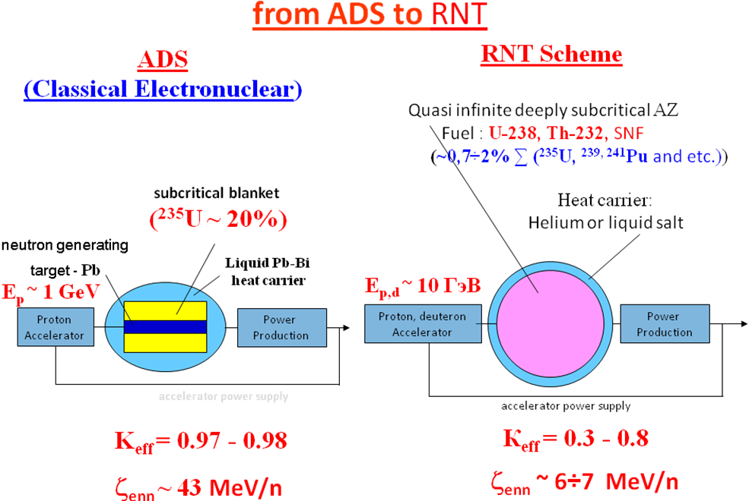
Fig.1 Scheme of obtaining nuclear energy with the use of charged particles beams.

In the basis of the RNT (relativistic nuclear technology) scheme lies an idea of using the extremely hard neutron spectrum formed by beams of relativistic particles inside deeply subcritical, quasi infinite (at negligible leakage of neutrons) active zone (AZ) of natural (depleted) uranium and thorium for disposal of SNF of nuclear power plants with simultaneous energy production [4, 5]. To implement the idea in the NRT scheme there is provided, in particular, increase in energy of relativistic particle beam from traditional value of ~ 1 GeV to ~ 10 GeV.

In the RNT scheme the emphasis is made on the complete utilization of the energy of primary relativistic particle in quasi infinite target (AZ) and its maximal conversion to production of accelerator driven neutrons (fig.1).

It is proposed that significant tightening neutron spectrum comparatively to durable one will allow effective using complex of multi-stage cascade reactions, high-energetic fission by protons, mesons and neutron, as well as threshold reactions of (n,xn) type for neutron production, besides traditional for nuclear reactors (n,f) and (n,γ) reactions.
Such neutron spectrum makes it possible to “burn” effectively threshold minor actinides and to transmute long-living fission fragments while loading SNF in AZ.
The “Energy and Transmutation of RAW” project is aimed at solving the following main tasks:

- Development and testing methods and systems for measuring parameters of nuclear-physical processes, taking place in an extensive uranium target under exposure of relativistic particle beam in order to prepare full-scale experiments at the Big URANium target (BURAN), available at JINR.

- Limited modeling central part of BURAN target setup, which is realistic prototype of quasi infinite AZ in the NRT scheme.

3. Fundamental and applied research in the field of relativistic particle interactions with massive multiplying targets, aimed at test and modification of the existing models and transport codes.

1. Calculated evaluation of radiation fields in experiments with the target assembly of the Large Uranium Target at the Phazotron of DLNP, JINR

1.1. Initial data and calculation method

Calculations were carried out on the basis of codes MCNP and FLUKA (basic program used in calculations). The geometry of the computational model of the target assembly (TA) of the Big Uranium Target (BT) is shown in Fig. 2
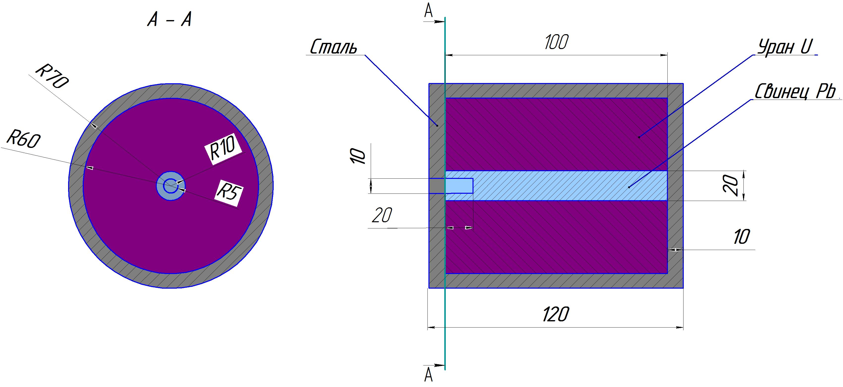
Fig.2 Computational model of target assembly (TA) of the Big Uranium Target (BUT)

Some additional data for the calculation are given below:

- The target is irradiated with 660 MeV protons;
- The intensity of the proton beam is 1·10¹¹ p/s;
- Irradiation time up to 60 h/year;
- Isotopic composition of uranium: Depleted uranium: 99.7% uranium-238, 0.3% uranium-235,
- Mass of uranium in the installation (19.2 g/cm³) = 21.563889 tons (in the calculation model),
- Target - lead (11.3 g/cm³), weight ~ 285 kg,
- Container - iron (7.8 g/cm³), weight ~ 5.5625 tons.

1.2. Nuclear safety. Calculations of TA of BUT for the multiplication factor

The main calculated data obtained from the evaluation (assessment) of the nuclear safety of the MS of BM are as follows:
• Effective multiplication factor Keff = 0.34218 +/- 0.00014,
• Multiplication 1 / (1-Kef) = ~ 1.52,
• Prompt (instant) neutron lifetime = 2.8E-8 s
• Average energy of neutrons causing fission = 2.66 MeV,
• Percentage of fission caused by neutrons in the thermal, intermediate and fast energy ranges: (<0.625 eV) - 0.00%, (0.625 eV - 100 keV) - 6.04%, (> 100keV) - 93.96%,
• Average number of neutrons produced per absorbed neutron = 0.41,
• Average number of neutrons released per fission = 2.739.
• Filling the installation with water does not lead to a noticeable change in the multiplication factor (Kef = 0.34343 +/- 0.00017).

Conclusions on the nuclear safety of TA of BUT: the system is deeply subcritical with Kef = 0.34218 with a small multiplication of no more than two. In the case of the maximum design basis accident caused by the flooding of the installation with water, the multiplication factor is maintained practically at the same level and is significantly less than the permissible one (permissible K_{eff} = 0.95 as for a spent nuclear fuel storage facility).

1.3. Some data on the energy release in the TA of BUT and the spectral composition of neutrons and gamma quanta emitted from the installation.

Fig. 3 shows the energy release density distribution in the TA of BUT from one initiating proton and Fig. 4 shows the spectral composition of neutrons (n/cm²) and gamma quanta (γ/cm²) emitted from the TA of BUT from one proton of the accelerator.

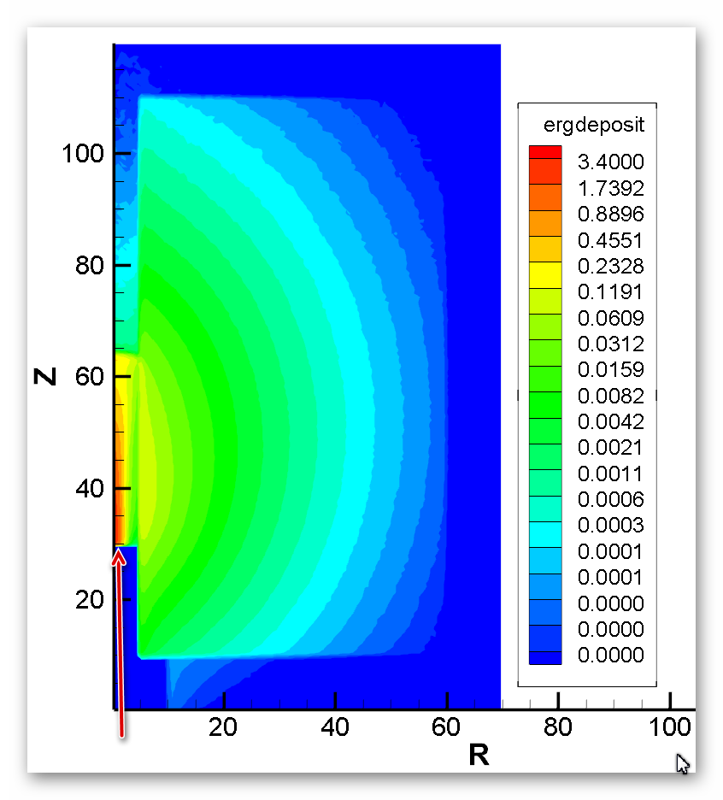
Fig. 3. The density of energy release (MeV/cm³) in the TA of BUT from 1 proton of the accelerator.

Fig. 4. Spectrum of neutrons (n/cm²) and gamma-quanta (γ/cm²) emitted from the TA of BUT from 1 proton of the accelerator.

1.4. Calculation of dose distribution inside and outside the TA of BUT.

Operating conditions of the TA of BUT: irradiation, subsequent (following) exposure, irradiation period and some other parameters were set in accordance with the requirements of the experiment during the irradiation of the installation.
Dose loads inside and outside the TA of BUT were calculated in several types of irradiation:
Option 1. Continuous irradiation with a proton beam for 5 hours, then exposure; the intensity of the proton beam is 1 · 10¹¹ p/s;
Option 2. 10 periods of irradiation with a proton beam with an intensity of 1·10¹¹p/s for 5 hours, followed by exposure for 30 days.

Option 1. Continuous (unbroken) irradiation with a proton beam with an intensity of 1·10¹¹p/s for 5 hours, then exposure

The spatial distribution of the decay of the effective dose rate inside and around the TA of BUT after irradiation for 5 hours at a proton beam intensity of 1·10¹¹p/s is shown in Fig. 5, and in Fig. 6 - decline in the activity of the TA of BUT itself (Bq/cm³).
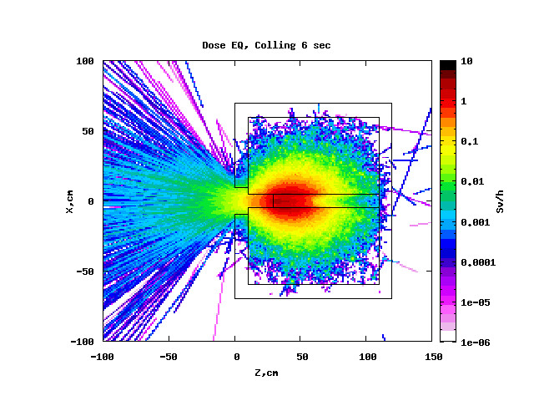  1) | 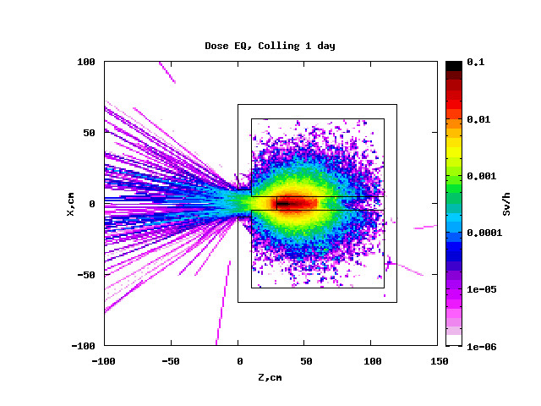  2)
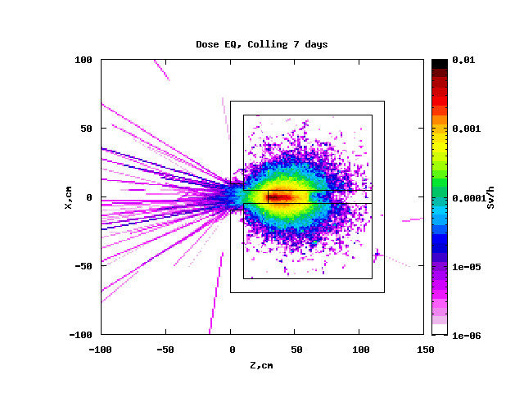  3) | 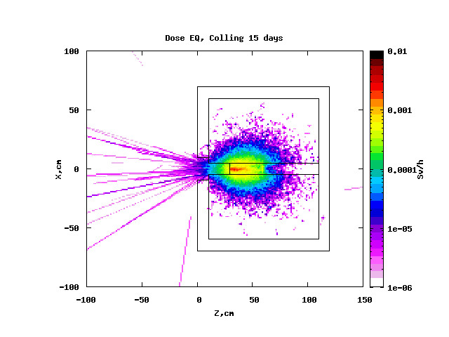  4)
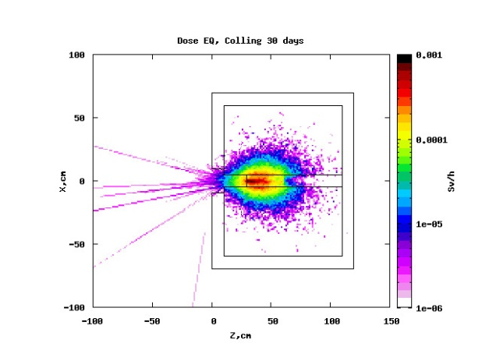
5)
Fig.5. The spatial distribution of the decay of the effective dose rate inside and around the TA of BUT after irradiation for 5 hours at a proton beam intensity of 1·10¹¹p/s

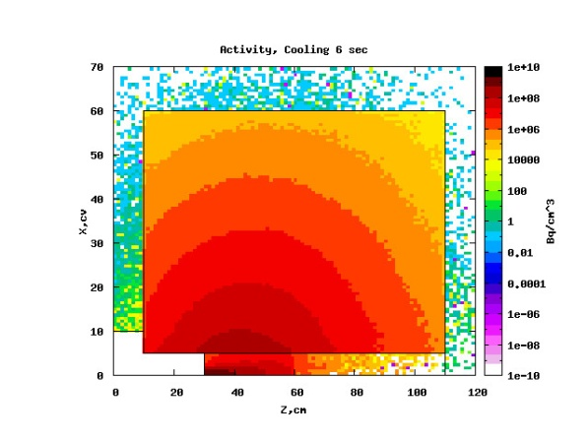  1) | 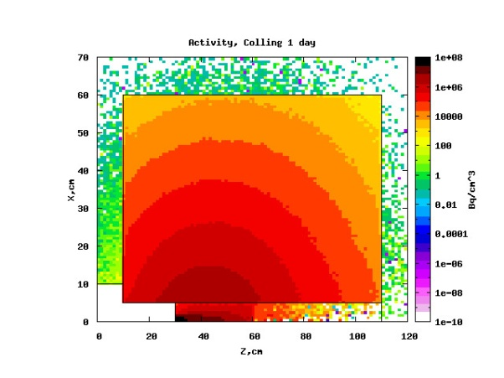  2)
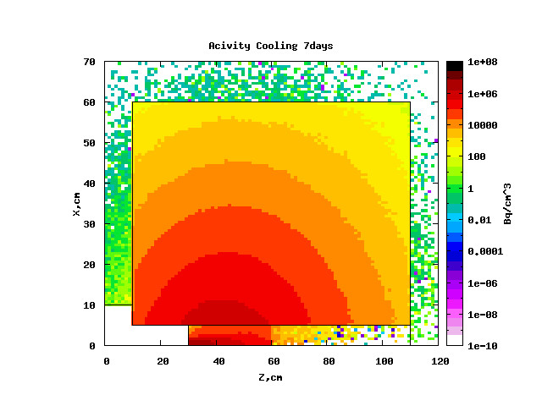  3) | 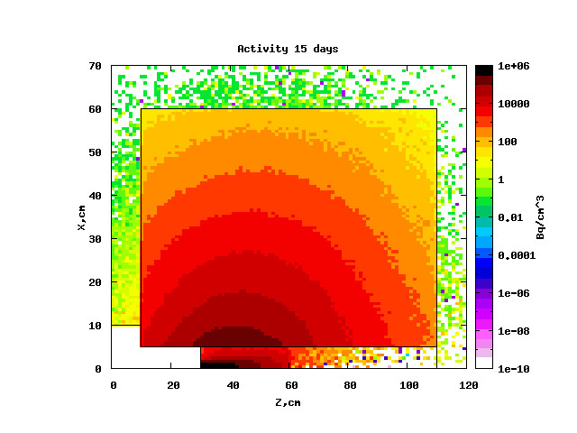  4)
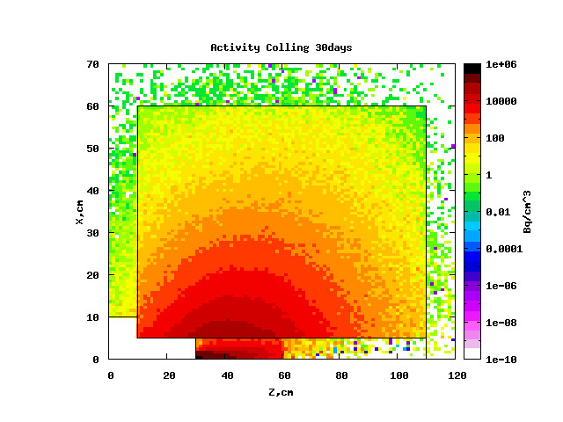
5

Fig.6. Decline in the activity of structural elements of the TA of BUT (Bq/cm³) after irradiation of the installation for 5 hours at a proton beam intensity of 1×10¹¹ p/s at different exposures: 1 - 6 sec., 2 - 1 day, 3 - 7 days, 4 - 15 days, 5 - 30 days

Option 2. 10 periods of irradiation with a proton beam with an intensity of 1·10¹¹p/s for 5 hours, followed by exposure for 30 days, then a final exposure

The spatial distribution of the decay of the effective dose rate inside and around the TA of BUT after irradiation of the TA of BUT for 10 cycles with 5-hour exposure and 30-day exposure in each cycle with subsequent final exposure up to one year is shown in Fig. 7, and in Fig. 8 - decline in the activity of the TA of BUT itself (Bq/cm³).
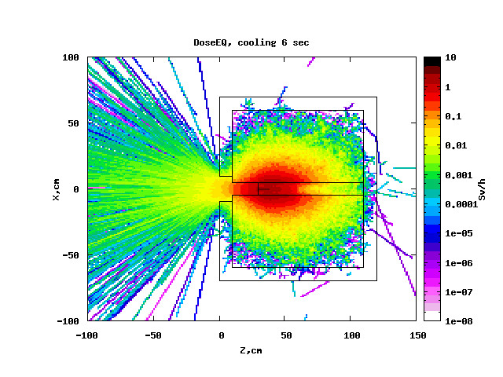  1) | 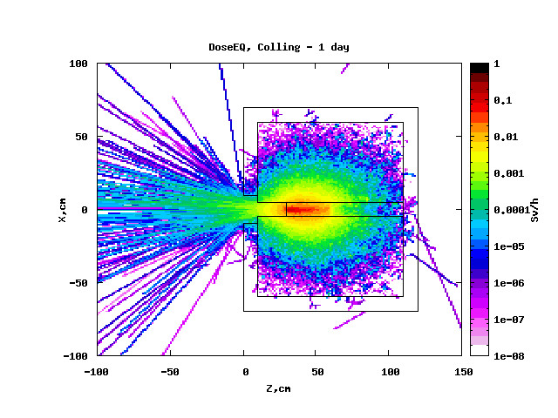  2)
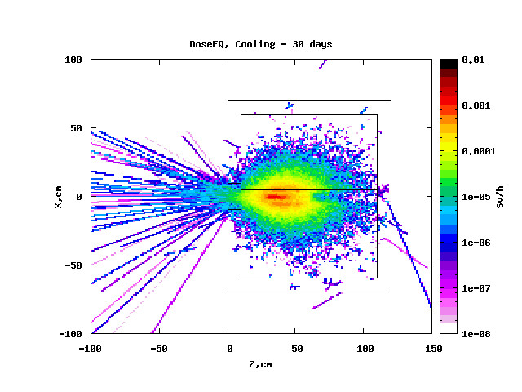  3) | 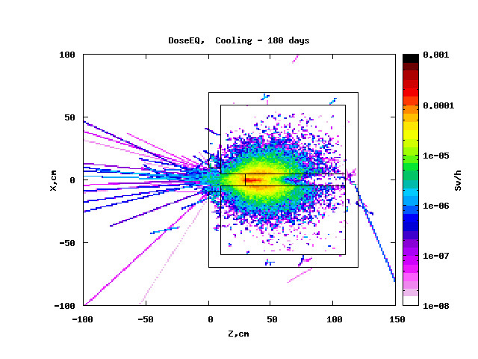  4)
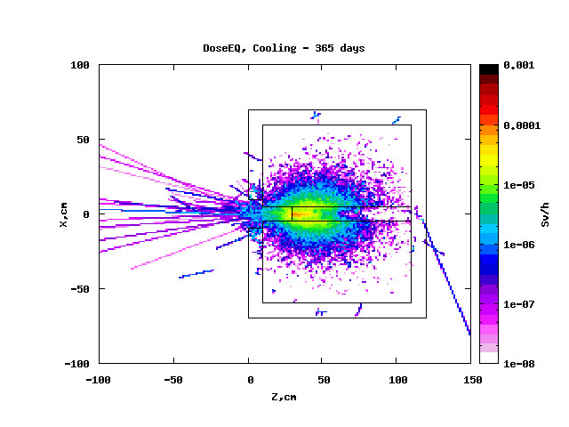
5)
Fig. 7. Spatial distribution of the decay of the effective dose rate inside and around the TA of BUT after its irradiation for 10 cycles (5 hours of irradiation at a proton beam intensity of 1×10¹¹ p/s, followed by a hold of 30 days) with different final exposure.

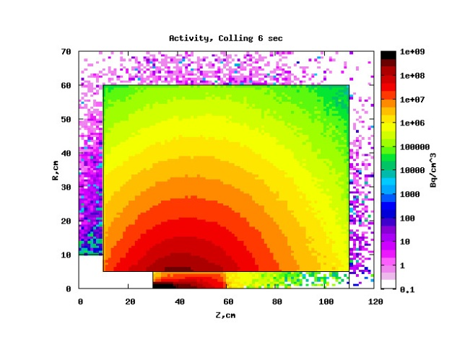  1) | 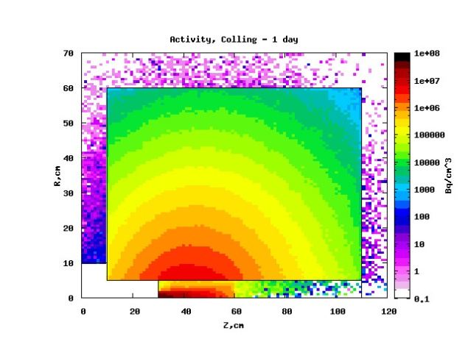  2)
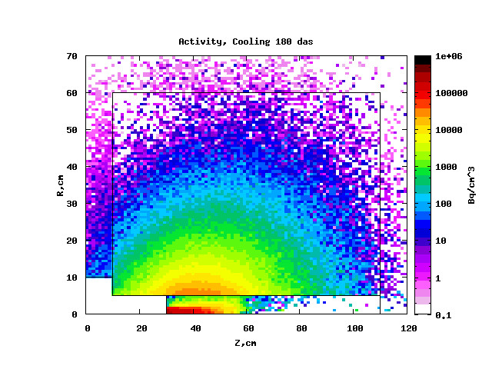  3) | 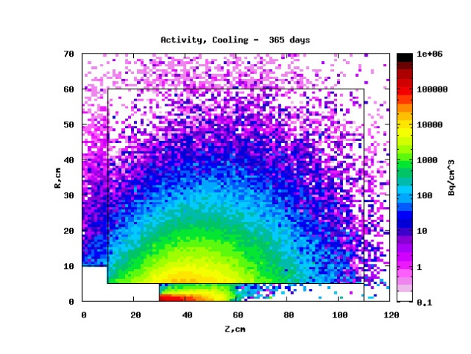  4)
Figure: 8. Decline in the activity of structural elements of the TA of BUT (Bq/cm³) after irradiation of the installation for 10 cycles (5 hours of irradiation with a proton beam intensity of 1·10¹¹ p/s, followed by exposure of 30 days) at different exposure times: 1-6 sec., 2 - 1 days, 3 - 180 days, 4 - 365 days.

1.5. Discussion of calculation results

Some features of radiation field distribution arising inside and around of the TA of BUT (when it is) irradiated with protons of the DLNP Phasotron are as follows:

• The main effective dose rate is released in the center of the installation near the entrance end surface of the lead target and is distributed deep into the target at about ten cm from its edge;
• The radiation field inside the facility is a slightly elongated ellipse centered in the inner part of the lead target;
• Outside the installation, the radiation field spreads to a greater extent along the axis of the proton beam. Characteristically that the main distribution of the dose rate is observed in the opposite (albedo) direction of the proton beam. The dose rate in the opposite direction from the front end of the setup is formed mainly due to conversion neutrons and gamma quanta. Distribution area of the radiation field in the reverse (opposite) direction of the proton beam is 2-3 times larger than distribution area (the zone of propagation) of radiation damage in the forward direction of the beam.

Calculations show that irradiation of the TA of BUT for 5 hours at a beam intensity of 1·10¹¹ p/s (option 1) lead to a completely safe radiation load (about less than 1mSv/h) at the rear end of the TA of BUT almost immediately after turning off the proton beam. Moreover, the dose after one day of exposure drops to a level of 10μsv/hour.
The dose rate after exposure to the TA of BUT for 10 cycles (5 hours of exposure at 1·10¹¹ p/s followed by exposure for 30 days, option 2) varies slightly with exposure and remains (holds, keeps) sufficiently high even after exposure for 1 year. The maximum dose is localized on the lead target, and at exposure, for example, equal to 30 days, it is equal to 1.38 · 10⁻³ Sv/h. At the same time, the dose load around the installation at a distance of up to 1 meter from the surface of the installation, even with exposure for 1 day, is small and (equal to) amounts to 1.0·10⁻⁶Sv/h.

2. Preliminary conclusion on the possibility of carrying out the planned experiments with the TA of BUT installation at the Phazotron of DLNP, JINR

Considering (in respect that) the planned order of execution of experiments with MS BM proton beam with an energy of 660 MeV, presented in Appendix 1 (in the draft “Instructions on radiation safety in an experiment to study the transmutation characteristics of long-lived radioactive waste of nuclear power plants under the action of secondary neutrons 660 MeV from the LNP PHASOTRON using the Big Target (BT)") and the results of the study of the spatial and energy distributions of secondary neutrons inside and on the surface of the TA of BUT, which corresponds to the irradiation modes in options 1 and 2, indicated above, we can make a preliminary conclusion about the nuclear and radiation safety of proposed experiments.

Preliminary control of radiation conditions on the surface and around the BURAN facility is required during an irradiation session when installing and removing activation, track and semiconductor detectors.

3. Discussion of the power amplification factors of the bombarding beam and the transition to a quasi-infinite active zone (core).

From the viewpoint of the practical applicability of any Electronuclear system power gain factor of the beam of bombarding particles is of decisive importance.
For deeply subcritical active zones studied in this project, the value of the coefficient of energy gain (C_{eg}), along with the maximally hard neutron spectrum, determines the real possibilities of NRT for disposal of spent nuclear fuel with simultaneous energy production. It is necessary to distinguish between the so-called starting the coefficient of energy gain (C_{eg}) (0) and the corresponding the coefficient of energy gain (C_{eg}) (equal), which is set in the core when the equilibrium concentration of ²³⁹Pu is reached after a certain operating time of the given electronuclear system.
In this project, the dependence of the value of the the coefficient of energy gain (C_{eg}) (0) on the configuration of the core (active zone) (TA "Quinta" or the TA of BUT), as well as on the energy and type of bombarding particles is experimentally investigated.
The experimental values of the coefficient of energy gain (C_{eg}) (0) ≈ 2 obtained for the TA "Quinta" are satisfactorily reproduced by calculation, although the latter value indicates a 20% decrease in the value of the coefficient of energy gain (C_{eg}) (0) with increasing deuteron energy Ed from 1 to 8 GeV. This result is obtained in a high neutron leakage from the TA "Quinta" in entire investigated range of energies Ed.

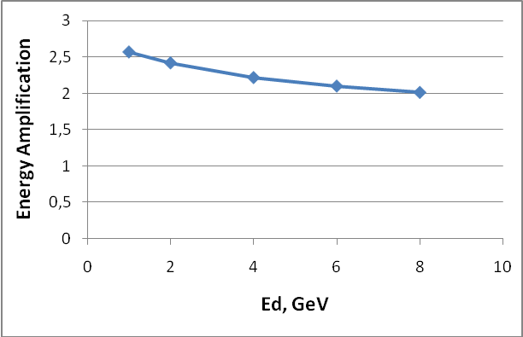
Fig: 9. The results of calculating of the coefficient of energy gain (C_{eg}) of the deuteron beam in the TA "Quinta" depending on the value of its energy Ed. (using the MARS15 code)

The decrease in the calculated coefficient of energy gain (C_{eg})) (0) with increasing, Ed is due to the calculated decrease in the number of fissions per unit of deuteron energy. With an increase in the radial size of a sufficiently long cylindrical core (Active Zone) (in which at least five path lengths for inelastic interactions of initiating particles fit), the coefficient of energy gain (C_{eg}) (0) should increase significantly due to the complete utilization of leakage neutrons and, especially, their high-energy component.

However, as noted above, the existing computational codes strongly underestimate the part of the neutron spectrum with energies En> 20 MeV. This, apparently, explains the strong underestimation of the calculated values of the coefficient of energy gain (C_{eg}) (0), compared with the values of ≈ 7.4 and ≈ 6.0 obtained from the data of experiments [11] with quasi-infinite targets from natural and depleted uranium, respectively. In [11], the measurements were carried out at the incident proton energy Ep = 0.66 GeV, the targets had an equivalent mass of ≈ 6 tons due to the asymmetric injection of the beam into it.

Extrapolation of the results of [11] to a quasi-infinite target with a mass of ≈20 t gives the coefficient of energy gain (C_{eg}) ≈ 7.3 for depleted uranium and C_{eg} ≈ 9.0 - for natural uranium at a proton energy of 0.66 GeV (Fig. 9).

In [12], the SHIELD code was used to calculate, in particular, the coefficient of energy gain (C_{eg}) for a quasi-infinite depleted uranium target with a mass of 30 tons, irradiated by protons with energies Ep from 1 to 10 GeV. The values obtained in [12] for the coefficient of energy gain (C_{eg}) ≈ (3 ÷ 3.3), as well as the number of fissions per 1 GeV of the beam energy, turned out to be approximately two times less than those estimated from the experimental data [11] and presented above, for a target with a mass ~ 5 times smaller. This is a direct consequence of a significant underestimation of the calculated value of the high-energy (En> 20 MeV) component of the neutron spectra.

Fig: 10. Radial distributions of uranium fission numbers measured in [11] and integrated to radius R at distances from the beam entrance to the target Z = 245 mm (blue curve) and Z = 655 mm (purple curve).

4. Proposals for the “E&T&RM” project for 2020 – 2021

  - The main tasks for the activities of the “E&T&RM” project with the target setup BURAN for 2020÷2021

The experiments carried out during the 1st stage of the project in 2011-2013 on the base of the target setup Quinta of the limited size allowed us to develop and test the main methods of measuring and data processing. As result of analysis of the experimental results described above the scientific and methodical programmes for measurements of the 2nd stage of the “E&T-SNF” project with the quasi infinite target setup BURAN were refined. It also gave an opportunity to estimate real terms and resources required for accomplishment of the programmes.
Consequently, the main tasks of the project aimed at experiments with the TS Buran “Big Uranium target” for 2020-2021 are the following:
- Study of spatial distribution of neutron fields and their energy spectra inside and on the surface of the TS.
- Defining spatial distribution of densities of uranium nuclei fission inside the TS.
- The study of the spatial distribution of developments dynamics and destruction dynamics (fission) of ²³⁹Pu and determination of the equilibrium concentration for a given configuration of the active zone.
- Investigation of dependence of beam power gain coefficient C_{eg} on energy of bombarding particles (protons and deuterons) in order to find its optimal value for the given type of particle.
- Evaluation of velocity of recycling reactions of long-living isotopes composing RAW.
- Obtaining full set of experimental data required for verification and modification of existing theoretical models and transport codes, which can reliably describe and predict the properties of accelerator driven systems.
- Research of radiation damage in structural materials used in superconducting magnets complex "NIKA"

  - Conditions required for “E&T&RM” project implementation

The project scientific programme implementation is possible due to availability of the unique target setup BURAN from depleted uranium (see Fig. 11 and 12) at JINR. The uranium target cased in solid steel 10 cm thick frame has a mass of about 21 tons, a diameter of 1.2 m and a length of 1 m in relation to uranium.
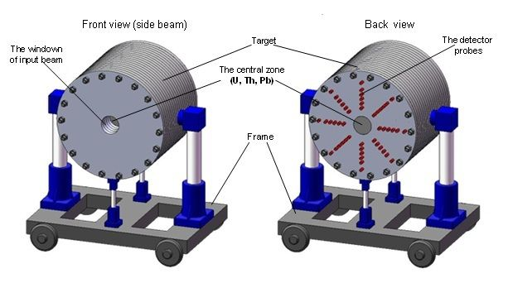

Figure 11. General view of the target setup BURAN at the transport-fixing platform.

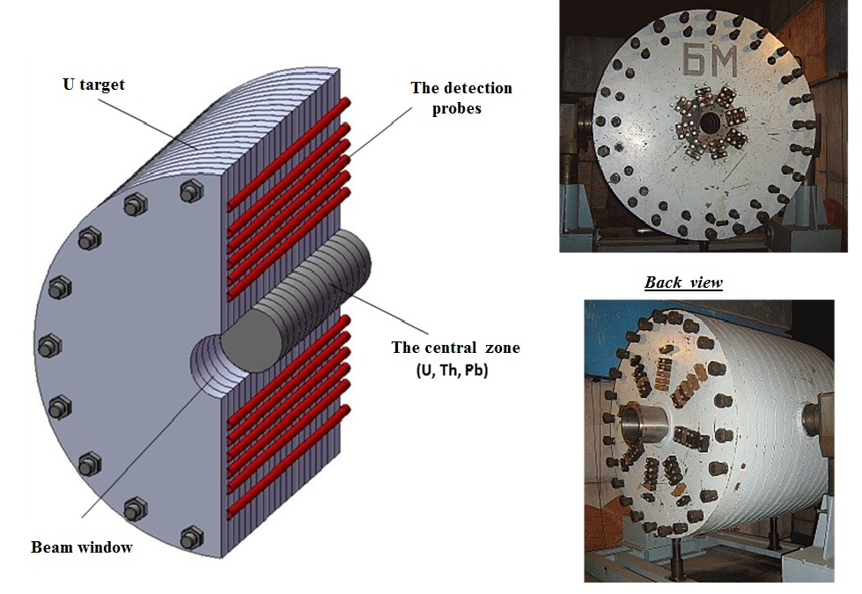
Figure 12. The scheme of longitudinal section of the TS BURAN with the mounted central zone (left) and general view photo (right).

As the TA BURAN was designed, produced and delivered to JINR for experiments at the Synchrophasotron more than 20 years ago its adjustment to carrying out experiments at the measurement hall in the Nuclotron F3 focus requires holding huge amount of designing and building and assembly works. Besides, elaboration of the TA central zones of different type made from uranium and lead is a complicated task.
Development of optimal set (in respect to costs and time required for the result obtaining) of measuring systems of different type tested in experiments at the TA Quinta is a resource-demanding and large-scale task.
An important condition of the scientific programme implementation is to carry out R&D on upgrading systems of injection and extraction of proton and deuteron beams from the Nuclotron with the purpose of providing low-background extraction of accelerated particles with the intensity less than ~ 1∙10¹¹ particles per cycle and of achieving proton energy of 12 GeV and of 6 GeV/nucleon for deuteron.
At last, the determining condition of the tasks fulfillment is presence of qualified and capable team of the project initiators and implementers, which has already been formed of interested specialists of the JINR laboratories and organizations from JINR member and non-member states.

  - Preliminary estimates of the main parameters of the TS BURAN bombarded by protons and deuterons with energies of 1÷12 GeV.

In course of preparing the scientific and methodical programme for experiments at the TA BURAN there was held a set of calculations of parameters of neutron fields and basic nuclear reactions going under influence of bombarding relativistic particles. The spots for which the calculations were made are shown in Figure 13.

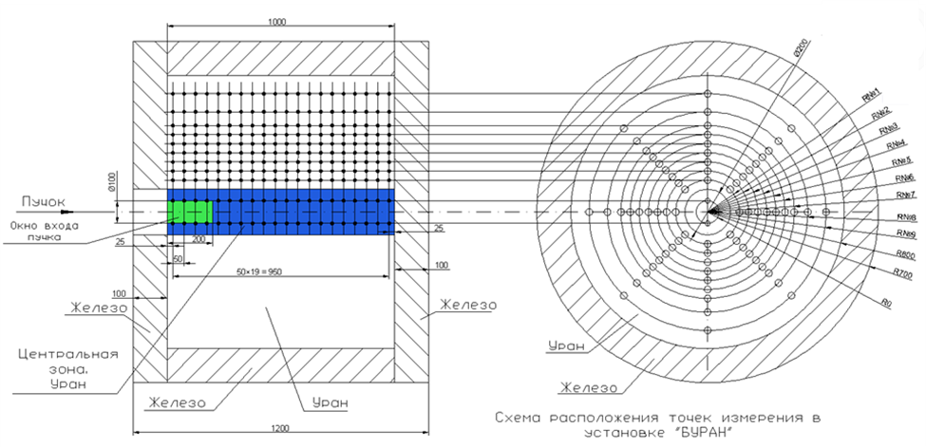

Figure 13. The calculation scheme of the TA BURAN and calculation geometry.

Some results of integral parameter calculations for the TS BURAN under irradiation by protons and deuterons, normalized per 1 incident particle are shown in the Table 1. At transition from the limited TA QUINTA to the quasi-infinite TA BURAN total neutron multiplicity increased almost, keeping linear growth at decreasing incident-particle energy. At this number of produced ²³⁹Pu nuclei increased in 7 times, and number of uranium nuclei fission increased in 1.5 times only.
Thus, beam coefficient of energy gain (C_{eg}) increased less than twice and appeared to be almost constant for the studied range of bombarding particle energy.

Table 1. Integral characteristics of the target setup BURAN bombarded with proton and deuteron beams calculated per 1 incident particle.

 | Protons |  |  | Deuterons
Е_{р(d)}, GeV | 1 | 6 | 12 | 1 | 6 | 12
Total multiplicity of neutrons | 126 | 770 | 1450 | 125 | 794 | 1455
Reactions number (n,γ) | 70 | 440 | 826 | 70 | 452 | 837
Reactions number (n,f) | 16 | 100 | 183 | 15 | 100 | 183
C_{AP} = Е_{total}/E_{p(d)} | 3.82 | 3.75 | 3.5 | 3.82 | 3.85 | 3.55

Neutron leakage from the surface of the target setup BURAN was calculated in the spots, shown in Figure 14.

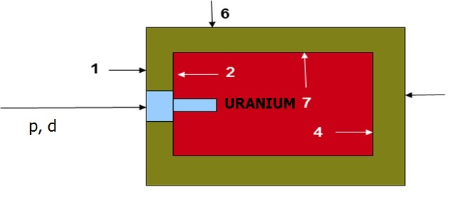

Figure 14. The layout of spots for calculation of neutron leakage from the TS BURAN surface.

Table 2 shows that the expected total neutron leakage from the surface of the TS BURAN is almost 3 times lower than the respective value for the TS Quinta. At that, the maximal number of neutrons escapes from the end of the TS BURAN turned to the beam window. Massive steel case of the TS significantly reduces neutron leakage thereby improving radioactive background in the experimental area.

Table 2. Neutron leakage from the surface of the target setup BURAN per 1 incident particle.

 | PROTONS |  |  | DEUTERONS
Е_{р(d)}, GeV | 1 | 6 | 12 | 1 | 6 | 12
Coordinates
Fe-1 | 3.2 | 10 | 21 | 3.2 | 11 | 17
U-2 | 8 | 30 | 55 | 8.1 | 29 | 48
Fe-3 | 0.03 | 1 | 1.8 | 0.03 | 0.95 | 2.4
U-4 | 0.22 | 6 | 11 | 0.2 | 6 | 15
Fe-6 | 0.16 | 1.2 | 2 | 0.16 | 1.8 | 2.1
U-7 | 1 | 7.5 | 13 | 1.2 | 7.5 | 14
Total | 3.34 | 13 | 24 | 3.34 | 13 | 22

As it was mentioned above in section 2.3.4, C_{AP} values calculated by means of existing transport codes are significantly underrated, however neutron flows inside the target (see [8]) and neutron leakage from the target surface are reconstructed reliably in calculations. This allows planning time of measurements in different detector channels and optimization of set of detectors and systems of data taking and processing, required for the project research programme implementation in announced time (see Annex 1).

Realization of the proposed project with use of the TA BURAN requires considerably greater financial, material and labor resources totalized in Annex 2 in comparison with the already fulfilled research programme. Yet the results obtained by now, its reliability and reproducibility level prove the reasonableness of allotment of the required resources necessary for realization of the project research programme.

Obviously, in the framework of the project it is impossible to get answers on all the questions determining the real applicability of nuclear relativistic technology scheme to large-scale RAW utilization and energy production. The cause of it is, firstly, that the competence of specialists of JINR and other participating organizations is not enough in regard to a range of scientific and technological areas, in particular, to reactor technology, fuel cycle and core heat-and-mass exchange, as well as to designing and construction of megawatt accelerators.
Secondly, the scale and scope of tasks determining solving the issue of the NRT practical realization requires organization and financing of the work of fundamentally different level. Yet realization of the research programme will allow us to form a more grounded opinion about validity of the main nuclear-physical principles and expediency and scale of further work in this direction.

References

- Y. Kadi. Examples of ADS design II: The Energy Amplifier DEMO. ICTP, Triest, Italy, 20 Оctober 2005.
- W. J.Adam et al. (“E&T – RAW” Collaboration) Study of Deep Subcritical Electronuclear Systems and Feasibility of Their Application for Energy Production and Radioactive Waste Transmutation. Preprint JINR E1-2010-61, Dubna, 2010.
- Problems of development of large-scale nuclear energetics and nuclear relativistic technologies (NRT). http://www.cftp-aem.ru/Data/RADS02.pdf.
- A.A. Baldin, E.M. Belov, M.V. Galanin et al., Nuclear relativistic technologies (NRT) and radioactive waste utilization use in energy production and spent nuclear fuel (SNF) utilization. The results of the first experiments on development of physical backgrounds of NRT. Letters to PEPAN v.8, No.6, p. 1007-1023 (2011).
- V.V. Chilap et al., Nuclear relativistic energetics – physical and technical basis and the first experiments results. Vestnik NNC RK, №4 (48), 2011, p. 68-76.
- W. Furman et al, Recent results of the study of ADS with 500 kg natural uranium target assembly QUINTA irradiated by deuterons with energies from 1 to 8 GeV at JINR NUCLOTRON In Proceedings of XXI IHEP PoS(MC2000)086
- L. Zavorka, J. Adam, W. Furman et al., A summary of experimental results on the reactions in uranium samples irradiated with a deuteron beam of energies up to 8 GeV at the QUINTA target, PoS(Baldin ISHEPP XXI)089
- M. Suchopar, V. Wagner, J. Vrzalova et al., MonteCarlo simulation of natural uranium setups irradiated with relativistic deuterons by means of MCNPX code, PoS (Baldin ISHEPP XXI) 091
- M.Yu. Artyushenko, V.A. Voronko, K.V. Gusak and “E&T-RAW”collaboration, Research of spatial distributions of reactions of neutron radiation capture and fission in massive uranium targets irradiated with 1-8 GeV deuterons (the “QUINTA-M” setup), Preprint JINR Р1-2012-147, Dubna, 2012. Submitted to European Physical Journal A.
- V.Yu. Yurevich, R.M. Yakovlev, V.A. Nikolaev, V.G. Lyapin, N.S., Investigation of neutron emission in interactions of relativistic protons and deuterons with lead targets. Letters to PEPAN, 2006, v.3, p.49.
- V.F. Bataev, M.A. Butko et al, Analysis of the main nuclear-physical characteristics of proton beams interaction with heavy metal targets. Atomic energy, v.104, No.4, 2008.
- R.G. Vasil’kov, V.I. Gol’dansky, B.A. Pimenov, Yu.N. Pokotilovsky, L.V. Chistyakov. Neutron multiplying in uranium bombarded with 300-600 MeV protons. Atomic Energy, v.44, No.4, 1978, p. 329.
- Tiziana Spina “Proton irradiation effects on Nb₃Sn wires and thin platelets in view of high luminosity LHC upgrade” These. CERN Thesis – 2015-086 11/07/2015

Form N 26

LIST OF ACTIVITIES WITHIN THE PROJECT

Study of deep subcritical electronuclear systems and possibilities of their application for energy production, transmutation of radioactive waste and research in the field of radiation material science

Stages of the project | 2020 |  |  |  | 2021
Stages of the project | I | II | III | IV | I | II | III | IV
- Planning and design.
Development of the project to install a uranium target on DLNP Phasotron
Development of diagnostic system specifications for a big uranium target
Mounting of pilot setup of large uranium target at the DLNP Phasotron
Selection, preparation and testing of experimental systems and instrumentation modules
Development of schemes of experimental studies on the "Quinta" installations "Big uranium target"
- Production, mounting and debugging of experimental equipment and measurement systems.
Production of experimental equipment and systems for installation on "Big uranium target"
Installation and debugging of experimental equipment and systems to installation "Big uranium target"
Installation and testing of experimental systems and measuring equipment
Debugging of methodologies and systems of experimental and measuring equipment.
- Design-theoretical activities aimed at prediction and improvement
- Experimental data processing. Refinement and development of new algorithms, models and programs in order to achieve the project goals.

LHEP Director V.D. Kekelidze

Project Leader S.I. Tyutyunnikov

Form N 29

Project estimate expenditure

Study of deep subcritical electronuclear systems and possibilities of their application for energy production, transmutation of radioactive waste and research in the field of radiation material science

 |  | Expense item No. | Total costs | 1 year | 2 year
Direct costs on the project
 | Accelerator, reactor (type) |  | hour | 50 | 300
 | Computer (type) |  | hour
 | Networking |  | USD thsnd
 | Design department |  | Standard hour | 100 | 800
 | Workshop |  | Standard hour | 750 | 1500
 | Materials |  | USD thsnd | 25 | 50
 | Equipment |  | USD thsnd | 50 | 75
 | Payment for research and development carried out under contracts |  | USD thsnd | 10 | 50
 | Business trip expenses, including: |  | USD thsnd |  | 20
 | - trips to the non-rouble zone states
 | - trips to rouble-zone states
 | - trips within the protocol
 | Total direct costs: |  | USD thsnd | 85 | 195

LHEP Director V.D. Kekelidze

Project Leader S.I. Tyutyunnikov

LHEP economist G.G. Volkova

