*Appendix 1*

Form No. 24

JINR participation in the Japanese neutrino program: from T2K to Hyper-Kamiokande

Project

**T2K**

DLNP: Baranov V.Yu., Boikov A.V., Brazhnikov A.O., Budagov J.A., Davydov Yu.I., Demin D.L., Glagolev V.V., Khomutov N.V., Kirichkov N.V., Kiseeva V.I., Kolesnikov A.O., Krasnoperov A.V., Limarev K.K., Malyshev V.L., Popov B.A., Shaikovskiy A.V., Sinitsa A.A., Suslov I.A., Tereschenko V.V., Tereschenko S.V., Vasilyev I.I.,

BLTP: Kozlov G.A.

**Joint Institute for Nuclear Research, Dubna, Russia**

Khabibullin M.M., Khotjantsev A.N., Kudenko Yu.G., Mineev O.V.

**Institute for Nuclear Research of the Russian Academy of Sciences**

PROJECT LEADERS V.V. Glagolev, Yu.I. Davydov

SCIENTIFIC PROJECT LEADER Yu.A.Budagov

DATE OF SUBMISSION OF PROPOSAL OF PROJECT TO SOD _________

DATE OF THE LABORATORY STC _________ DOCUMENT NUMBER _________

STARTING DATE OF PROJECT ____2022_____

(FOR EXTENSION OF PROJECT –– DATE OF ITS FIRST APPROVAL) _________

Date of the Lab seminars 17.03.2021

*Appendix 2*

Form No. 25

PROJECT ENDORSEMENT LIST

**T2K**

V.V. Glagolev, Yu.I. Davydov

|  |  |  |
| --- | --- | --- |
| APPROVED BY JINR DIRECTOR |  |  |
|  |  |  |
|  |  |  |
| ENDORSED BY |  |  |
|  |  |  |
| JINR VICE-DIRECTOR |  |  |
|  |  |  |
| CHIEF SCIENTIFIC SECRETARY |  |  |
|  |  |  |
| CHIEF ENGINEER |  |  |
|  |  |  |
| HEAD OF SCIENCE ORGANIZATION DEPARTMENT |  |  |
|  |  |  |
| LABORATORY DIRECTOR |  |  |
|  |  |  |
| LABORATORY CHIEF ENGINEER |  |  |
|  |  |  |
| PROJECT LEADER |  |  |
|  |  |  |
| PROJECT DEPUTY LEADERS |  |  |
|  |  |  |
|  |  |  |
| ENDORSED |  |  |
|  |  |  |
| RESPECTIVE PAC |  |  |

**T2K**

**Table of Contents**

1. Abstract
2. Introduction
3. State-of-the-art of this scientific problem
4. Description of the proposed research
5. Estimation of human resources
6. SWOT Analysis
7. References
8. Estimation of costs and resources
9. Appendixes

**Abstract**

The main goal of this project is to promote the participation of the JINR physicists in the very successful Japanese experimental program on neutrino physics[1][2]: the ongoing T2K experiment and the Hyper-Kamiokande project currently under preparation.

The already approved T2K-II experimental program will allow to extend the T2K running time until 2026 and to collect a statistics of up to 20x1021 protons-on-target (p.o.t.), aiming at initial observation of CP violation with 3σ or higher significance for the case of large CP violation and measurements of neutrino mixing parameters, $θ_{23 }$ and $∆m_{32}^{2}$ , with a precision of ${1.7}^{0}$ or better and 1%, respectively [3]. In order to achieve these goals upgrades of the J-PARC accelerator complex[4] and of the near detector – ND280[5] – are being performed.

Further goals include the group's participation in the new generation Hyper-Kamiokande project which will follow up the T2K-II experiment and will use the same set of near detectors.

The nearest goal of the Project is to build a very unique active target Super Fine Granularity Detector (SuperFGD) consisting of about 2 million scintillation cubes pierced by scintillation fibers in three mutually perpendicular directions. This target is needed for the upgrade of the magnetized ND280 detector. Due to its fine-grained geometry surrounded by TOF detectors and two High Angle Time Projection Chambers (HA-TPCs), the SuperFGD has a unique capability to reconstruct short tracks and to detect fast-neutrons, which is required for the reconstruction of (anti)neutrino energy as well as for improved reconstruction efficiency for outgoing charged particles produced at large angles (almost perpendicular and backward) with respect to the incoming (ani)neutrino direction. This would also allow to lower the momentum threshold for pions and knocked-out nucleons produced in (anti)neutrino interactions.

Methods and technology for creating the new SuperFGD target include studying the properties of individual scintillation elements (cubes) with reflective edges, cross-talks between elements, light output, testing the target prototype and performing data analyses. A system is being developed for calibrating all fiber channels and SiPM using a system of LEDs. It is also necessary to note the structural difficulties of creating such a target - a box, mainly made of fiberglass, all the edges of which must have holes for fibers with a step of 1 cm and devices for such box assembly. A procedure for assembling and further equipping the target with electronic boards for read-out and calibration is being developed.

Project participants have extensive experience in the creation and maintenance of scintillation detectors (CDF muon counters, Mu2e CRV modules and crystal calorimeter elements), electronic board design and programming (OPERA, Mu2e, Comet), data simulation and analysis (CDF, Mu2e), design of various objects.

The requested financing for 3 years is 600 k$.

**Introduction**

The phase II of the T2K experiment is expected to start in 2022 and to last until 2026. It will be followed by the Hyper-Kamiokande (HK) experiment which will use the same neutrino beam produced by the J-PARC accelerator and the same set of near detectors. The physics goals of T2K-II are measurements of the neutrino oscillation parameters $θ_{23 }$ and $∆m_{32}^{2}$ with a precision of 1.7° and 1%, respectively, as well as a confirmation at the level of 3 σ or more of the matter-antimatter asymmetry in the neutrino sector in a wide range of possible true values of $δ_{cp}$ - the parameter responsible for the CP (matter-antimatter) asymmetry. Achievement of these goals requires reduction of the statistical and systematic errors, and thus a significant upgrade of the beamline and the ND280 detector, as well as improvements in the software and analysis methods.

The current design of the near detector ND280 is well optimized for the detection and reconstruction of forward-going particles (mainly charged leptons: muons and electrons), but it also has a number of limitations, like low reconstruction efficiency of particles produced almost perpendicular and backward w.r.t. the direction of the incoming neutrino, as well as too high momentum threshold to reconstruct a large part of produced pions and knocked-out nucleons (protons and neutrons). It is essential to optimize the detector to be sensitive to additional low-momenta particles produced via nuclear effects, reducing the systematic error in the neutrino oscillations analysis associated with models of neutrino interactions.

The SuperFGD is a 2m x 2m x 0.5m detector consisting of approximately 2 million 1 cm3 scintillating polystyrene cubes. The cubes are woven with a series of optical fibres designed to detect the light emitted by the particles produced during the interactions in the target. Unlike the current FGDs, the SuperFGD has a three-fold projective 2D readouts providing a quasi-3D readout. This readout configuration increases the detection of short tracks almost uniformly in all directions. Due to its geometry and coupled with the TOF and the High Angle Time Projection Chambers (HA-TPCs), the SuperFGD has the capability to detect fast-neutrons, which is needed in the reconstruction of the antineutrino energy.

On the strength of a double Nobel prize winning experiment (Super)Kamiokande and an extremely successful long baseline Japanese neutrino programme, the third generation Water Cherenkov detector, Hyper-Kamiokande, is being developed by an international collaboration as a leading worldwide experiment based in Japan. It will address the biggest unsolved questions in physics through a multi-decade physics programme that will start in the middle of the next decade.

The science that will be developed will be able to shape the future theoretical framework and generations of experiments. Hyper-Kamiokande will be able to measure with the highest precision the leptonic CP violation that could explain the baryon asymmetry in the Universe. The experiment also has a demonstrated excellent capability to search for proton decay, providing a significant improvement in discovery sensitivity over current searches for the proton lifetime. The atmospheric neutrinos will allow to determine the neutrino mass ordering and, together with the beam, able to precisely test the three-flavour neutrino oscillation paradigm and search for new phenomena. A strong astrophysical programme will be carried out at the experiment that will also allow to measure precisely solar neutrino oscillation. A set of other main physics searches is planned, like indirect dark matter.

**State-of-the-art of the science case proposed**

T2K [1] is a currently-operating experiment which uses the well-known Super-K as a far detector to measure (anti)neutrinos produced in the J-PARC accelerator. Hyper-K will use much of the existing infrastructure produced for T2K, particularly the beam line and near detectors. Hyper-K will also benefit from any improved data analysis techniques developed for T2K. Several important T2K upgrades and improvements are planned for the coming years, and this will have a direct impact on improved Hyper-K performance.

The T2K experiment uses the ND280 near detector suite. Future analysis improvements in the ND280 detector aim to reduce the (anti)neutrino cross section and flux uncertainties.

In June 2015, the Super-Kamiokande Collaboration approved the SK-Gd project. This project is an upgrade of the detector's capabilities, achieved by dissolving 0.2% gadolinium sulfate into Super-K's water in order to enhance detection efficiency of neutrons from neutrino interactions. Therefore, following the prompt detection of a positron, the accompanying inverse beta decay (IBD) neutron can be identified in SK-Gd by a delayed gamma cascade, the result of the neutron's capture on gadolinium. As a result of this positive identification of true IBD events, a much improved separation between signal and background can be achieved. As Super-K is the first example of gadolinium loading in a large-scale water Cherenkov detector, this will be a template for any future possibility of loading gadolinium into Hyper-K.

it is possible to determine the neutrino mass hierarchy by comparing the absolute values of the effective mass squared differences determined by reactor ( $\overline{ν_{e}}$ disappearance) and accelerator ( $ν_{µ}$ disappearance) with high precision [1],[7]. It is expected, around the year 2025, the mass hierarchy could be determined at ~(3-4)σ or more by combining the future data coming from the ongoing experiments such as NOvA, T2K and reactor experiments, Daya Bay [8], RENO [9], Double Chooz [10], and proposed future experiments such as JUNO[11], RENO-50 [12], ICAL [13], PINGU [14], and ORCA [15] where the last three projects will use atmospheric neutrinos to determine the mass hierarchy.

The magnitude of the charge-parity (CP) violation in neutrino oscillation can be characterized by the difference of neutrino oscillation probabilities between neutrino and anti-neutrino channels [16,17 ]. The current data coming from T2K [18] and NOvA [19], when combined with the result of the reactor $θ_{13}$ measurement, prefer the value around $δ_{cp}\sim -π/2$ (or equivalently, $δ_{cp}\sim 3π/2$) for both mass hierarchies though the statistical significance is still small. Interestingly, the Super-K atmospheric neutrino data also prefers similar $δ_{cp}$ values with a similar statistical significance [20].

If CP is maximally violated ($|sinδ_{cp}|\sim 1$), CP violation ($sinδ_{cp}≠0$) could be established at ~(2-3)σ CL by combining the future data coming from T2K and NOvA as well as with data coming from the reactor $θ_{13}$ measurements.

One of the main T2K goals also is a search for sterile components in $ν_{μ}$ disappearance by observation of neutral-current events (as neutral-current events are produced by all flavours of active neutrinos, a deficit would indicate an oscillation into sterile neutrinos).

In Hyper-K the neutrino oscillation parameters will be measured using two neutrino sources which can provide complementary information. Both atmospheric neutrinos, where neutrino oscillations were first confirmed by Super-K, and a long baseline neutrino beam, where electron neutrino appearance was first observed by T2K, will be employed.

With a total exposure of 1.3 MW × 108 sec integrated proton beam power (corresponding to 2.7×1022 protons on target with a 30 GeV proton beam) to a 2.5-degree off-axis neutrino beam, it is expected that the leptonic CP phase $δ_{cp}$ can be determined to better than 23 degrees for all possible values of $δ_{cp}$, and CP violation can be established with a statistical significance of more than 3σ(5σ) for 76% (57%) of the $δ_{cp}$ parameter space.

Hyper-K will be a multipurpose neutrino detector with a rich physics program that aims to address some of the most significant questions facing particle physicists today. Oscillation studies from accelerator, atmospheric and solar neutrinos will refine the neutrino mixing angles and mass squared difference parameters and will aim to make the first observation of asymmetries in neutrino and antineutrino oscillations arising from a CP-violating phase, shedding light on one of the most promising explanations for the matter-antimatter asymmetry in the Universe. The search for proton decays will probe one of the key tenets of Grand Unified Theories. In the case of a nearby supernova, Hyper-K will observe an unprecedented number of neutrino events, providing much needed experimental results to researchers seeking to understand the mechanism of the explosion. Finally, the detection of astrophysical neutrinos from sources such as dark matter annihilation, gamma ray burst jets, and pulsar winds could further improve our understanding of some of the most spectacular, and least understood, phenomena in the Universe.

The Deep Underground Neutrino Experiment (DUNE), formerly LBNE [21], is a 40 kilotonne liquid argon neutrino experiment that is projected to begin taking data around the same time as Hyper-K. Because DUNE will use a different target material than Hyper-K (liquid argon rather than water), many complementary measurements can be made, including nucleon decay measurements and supernova neutrino detection. Information about the neutrino signature from supernovae is much sought after, and Hyper-K and DUNE will each add to the overall picture. The primary reaction channel for these neutrinos in Hyper-K is the inverse beta decay channel, in which only electron antineutrinos will take part. In DUNE, the reaction channel will be the charged-current reaction on 40Ar, which measures electron neutrinos. Taken together, these measurements will be able to determine the relative abundance of neutrinos to antineutrinos. Furthermore, DUNE will be able to better determine some features of the neutrino spectrum which are dominated by the electron neutrino signal, such as the neutronization burst that occurs during early times, while Hyper-K will better measure features where there is an antineutrino signal, such as the accretion and cooling phases that occur at late times. Due to the fact that the baseline between the accelerator facility and Hyper-K will be shorter than the proposed baseline for the DUNE experiment, the two experiments will have some complementarity in the information they can extract from their accelerator programs. The longer baseline in the DUNE experiment means their measurement will be more affected by matter effects, which will give them more sensitivity to the mass hierarchy. The shorter baseline of Hyper-K experiment means less sensitivity to matter effects, which should lead to an increased sensitivity to the measurement of the CP-violation phase.

**Description of the proposed research**

In order to achieve a precision of the order of 4-5% in the prediction of neutrino and antineutrino fluxes for the future accelerator neutrino experiments (such as T2K-II, DUNE, T2HK and others) it is necessary to measure the yields of hadrons in proton-nucleus and pion-nucleus interactions using (CERN) hadron beams. This study [22] is being successfully performed for the first stage of the T2K long-baseline neutrino experiment with an active participation of a group of physicists from DLNP JINR.

Using the existing NA61/SHINE spectrometer at the H2 beamline at the CERN SPS we plan to perform a new data-taking with the exact replica of the T2K long carbon target. These measurements are crucial for further reduction of (anti)neutrino flux uncertainties in T2K-II/HK.

The group of phycisists from DLNP (N.Atanov, A.Krasnoperov, V.Lyubushkin, B.Popov, S.Tereshchenko, V.Tereshchenko) plans to participate in

- data-taking and analysis of experimental data using CERN hadron beams;

- software development for data processing and analysis;

- preparation of scientific publications.

The nearest plans are :

- 2021/2022: collection of new data with the T2K replica target

- 2022/2023: calibration and analysis of these data; extraction of precise hadron yields from the surface of the T2K replica target

- 2023/2024: usage of these new hadron production measurements for improved predictions of (anti)neutrino fluxes in T2K/HK; better-precision measurements of neutrino oscillation parameters in T2K-II.

We plan to join the T2K collaboration efforts on oscillation analysis that has the aim to define the neutrino oscillation parameters such as *sin2θ23*, *sin2θ13*, Δ*m*232 and δ*CP* (although T2K sensitivity to *sin2θ13* is much smaller than that of reactor experiments). Currently, constraints exist for the *θ*12 and *θ*13 angles, as well as for the two mass differences Δ*m*221 and Δ*m*232. The *θ*23 angle still has a large uncertainty and it is not yet known whether it has a value of π/4 (corresponding to maximal mixing), or above (below) this value. One more outstanding oscillation parameter is the complex phase δ*CP*. Any value of δ*CP* different from 0 or π would lead to CP violation in the leptonic sector, with ±π/2 representing maximal CP violation. One remaining task is the determination of the neutrino mass hierarchy (MH), which can either be normal (NH) or inverted (IH). In addition to these measurements, the consistency of the Pontecorvo–Maki–Nakagawa–Sakata (PMNS) framework is also probed.

The oscillation parameters are extracted from a fit of the predicted event rate to the oscillated data at Super-Kamiokande (SK) while the data at ND280 is used to provide precise predictions for the far detector spectrum. There are three sets of systematic uncertainties that are parameterized to define “nuisance parameters” in the fit:

1) Flux uncertainties. The neutrino flux is simulated with the FLUKA simulation package, and then tuned with external data constraints from the NA61/SHINE hadron production experiment at CERN, to account for mis-modelled hadron interactions in the graphite target.

2) Detector systematic uncertainties which are parameterized according to each detector (ND280 or SK).

3) Neutrino cross-section uncertainties. The neutrino interaction model is tuned to world cross-section data and our understanding of neutrino-nucleus interaction theory.

Data and simulated samples at ND280 are classified according to their final state pion multiplicity, beam mode, and the target in which the interaction occurred. The SK data is categorized in a similar way to that of ND280. Samples are defined according to the Cherenkov ring multiplicity and type. T2K tests the fitting framework and systematic error model through simulated data studies. Alternative models or tunes are used to create mock data sets and are passed through the oscillation analysis procedure. The results are compared to the nominal simulation fit. These studies allow to identify biases and motivate model improvements. In case of a significant deviation this effect is included in the oscillation parameter errors.

We plan to participate in T2K oscillation analysis, which involves analyzing new data obtained with the upgraded ND280 detector, developing event selection methods, and performing studies on various types of systematic uncertainties to better understand and reduce them. On the first stage (year 2022) we expect to join to the ongoing T2K analyses and focus on adapting and developing their methods with respect of the upgraded ND280 detector. This activity implies performing MC studies and developing software tools for analysis. Here close cooperation with the INR group is expected. As soon as the new data from the upgraded T2K arrives and is available (years 2023 and 2024), we are going to participate in their analysis and in obtaining physical results. Also this activity implies the participation in the T2K publication preparation process and in the scientific conferences. To be included in the author list for regular physics publications by the T2K collaboration we have to take part in shifts with respect to the institution shift quota.

People involved are Igor Suslov (FTE=100%), Konstantin Limarev (PhD student, FTE=100%) and Viktoria Kiseeva (young researcher, FTE=100%) . Some expenses are required to purchase the data server and computers.

The near detector ND-280 of the T2K experiment includes a SuperFGD measuring about 2x2x0.6 m, composed of about 2 million polystyrene scintillators measuring 1x1x1 cm2. Each cube is made by injection molding. The cubes have three through holes with which wavelength shifting fibers are passed to pick up signals. Optical isolation of the cubes is ensured by a surface layer formed by chemical etching. However, such a surface does not provide complete light isolation of the cubes, therefore it is important to control the transmission of light through the surface layer and its effect on the reconstruction of tracks in the detector.

The transmission of light through the walls of the cubes and its penetration into neighboring cubes was tested by our colleagues using accelerator beams. We have developed a way to investigate optical light leakage between cubes using LEDs, which provides a fast and reliable way to control light leakage through the cubes' surfaces. For this, a flash from a led diode through an optical fiber was transmitted into one cube through one of three holes. The LED wavelength is 375 nm, which overlaps with the absorption region of the scintillator. The absorbed light is re-emitted by the scintillator at longer wavelengths with a peak at about 425 nm. The light re-emitted in the cube is picked up by an optical wavelength-shifting fiber and recorded using a SiPM. At the same time, the signal is read out from the adjacent cube to measure the light portion that has passed into it through the light insulated walls of two cubes, as shown in Fig. 1.

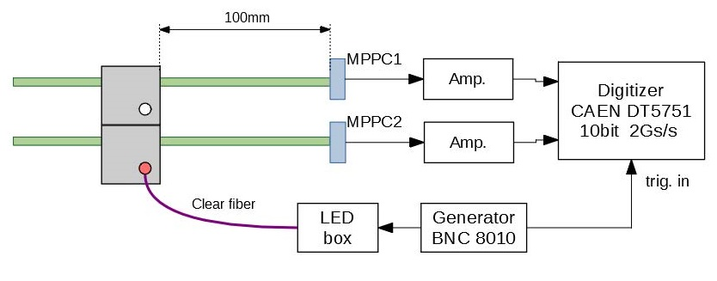

**Fig.1** Read-out scheme

We have made comparisons of light leaks at different geometries. Two options are shown in Fig. 2. Here, in one case, light was transmitted into cube "0" and the light leakage into cube "1" (left figure) was measured, in the other - cube "1" was illuminated and light leakage into cube "0" (right figure) was measured. Figure 3 shows the spectra of signals from the cubes, obtained when the cube "0" is illuminated. The left spectrum shows the signal from the illuminated cube "0", and the right one - the signal from the cube "1" due to the light passing from the cube "0". In this case, the ratio of the average signal in the cube “1” to the average signal in the cube “0” is 0.033. This value of the measured light leakage is consistent with the data obtained by our colleagues in measurements with accelerator beams.



**Fig.2** Scheme of the cube tests



**Fig.3** The spectra of signals from the cubes, obtained when the cube "0" is illuminated. The left spectrum shows the signal from the illuminated cube "0", and the right one - the signal from the cube "1"

Of particular note is the difference between the two geometries shown in Figure 2. In the case of illumination of the "1" cube, the light leakage into the "0" cube is noticeably less and the ratio of the signal in the "0" cube to the signal in the "1" cube is 0.0187. This is due to the different distances from the spot of illumination to the boundaries of the cubes and to the optical wavelength shifting fibers. This effect demonstrates the dependence of light leaks into neighboring cubes on the place of light source and can be used to increase the spatial sensitivity when recоnstructed tracks of charged particles.

Typically, detectors operate under stable conditions and large temperature fluctuations are not expected. Nevertheless, in the conditions of transportation and storage of scintillators, one-time or cyclic temperature changes are possible. To study the effect of elevated temperatures on the light yield and light leakage through the walls of the cubes, we carried out studies of the behavior of cubes with increasing temperature.

We are developing electronics for LED calibration system of the SuperFGD using notched light guide plates (LGP). The calibration system can distribute LED light uniformly to several channels at once and is used for gain calibration and stability monitoring. The module consists of PCB with LEDs’ array, LGP, diffuser, container and electronics unit. Concept of the calibration system is presented on the Fig. 4.

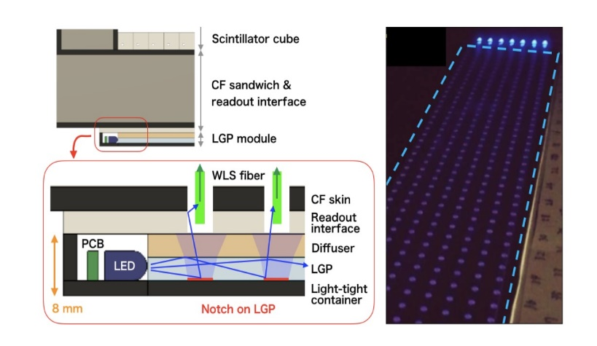

**Fig. 4**

Scheme of LGP (left) and a photo of the LGP prototype (right).

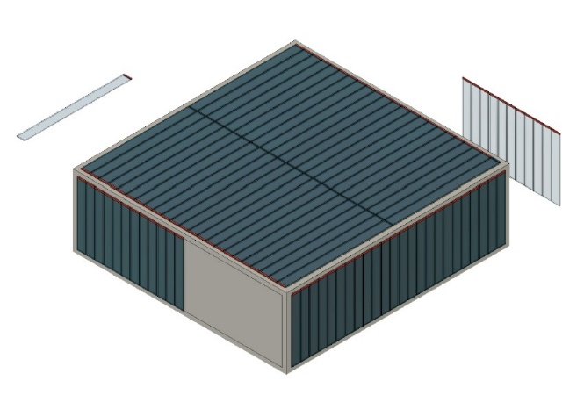

**Fig.5** Common view of the mechanical box and the LGP modules attached to the box surface.

Fig.5 shows a common view of the mechanical box and the LGP modules attached to the box surface. The calibration system will be integrated to the mechanical box (Fig.5) and a single module with 7 LEDs has to cover 96x8 SuperFGD channels. In total, 93 LGP modules are necessary to cover full detector.

A special electronic board was developed to control the LGP modules (Fig. 6).

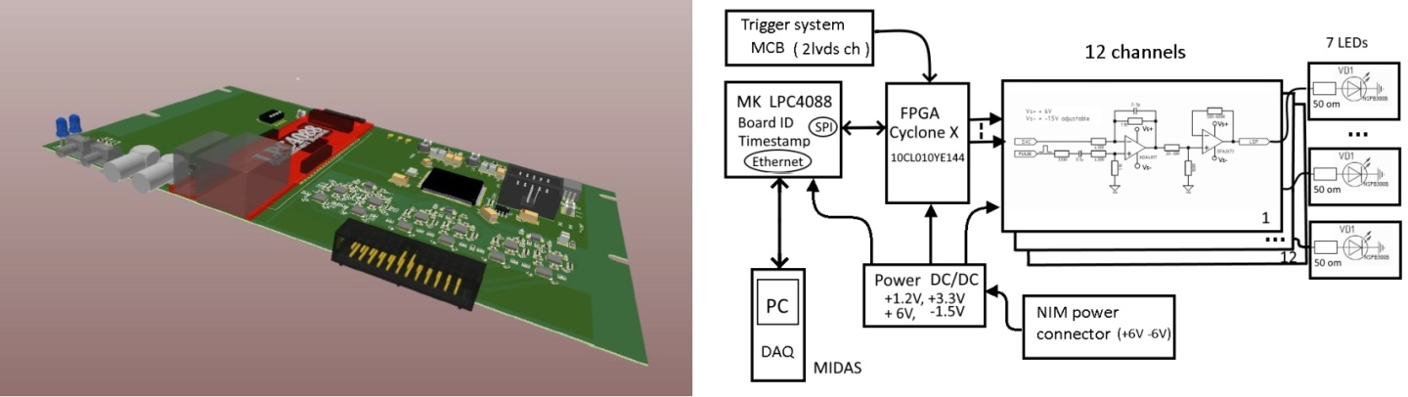

**Fig.6** Special electronic board for LGP modules.

The board consists of LPC4088 microcontroller, FPGA (Cyclone10 LE) and 12 channels of analog drivers. The developed scheme allows us receiving commands via UDP protocol to manage calibration LED pulse duration and amplitude. At the moment, the final debugging of the circuit is being performed before mass production. After that, we will produce the required number of blocks. In early 2022, we need to install and configure a calibration system on the SuperFGD.

One of the areas of responsibility of the JINR group is the design of the platform and equipment for assembling the unique superFGD target. It is very likely that the JINR will eventually be tasked with creating this platform and providing a procedure for assembling the target in the J-PARC before placing the target in its place in the experiment. The assembly of the target on this special platform should take place within 2022.

The SuperFGD platform (Fig. 7) is designed for:

- assembly of the SuperFGD detector on the fishing lines at the first stage, which is an assembly of the detector array, consisting of scintillation cubes 1 cm3 in size arranged in rows, 192x184 cubes in size and 56 cubes high in accordance with the assembly technology (2021-2022) ;

- assembly of the detector at the second stage, which is the installation of optical fibers, MPPC boards, calibration system and flexible cables for connecting the registration system (2022) ;

- calibration of the optical channels of the detector and installation of the detector components (2022);

- maintenance of the detector (2023-2024+)

At each stage of the assembly, the platform structure and its component parts provide unhindered access to the detector from all sides and secure fixation of the detector in its regular spatial position.

In terms of application, the platform refers to special-purpose ground support facilities and is intended for use in industrial-type premises, laboratories, capital residential and other similar premises.

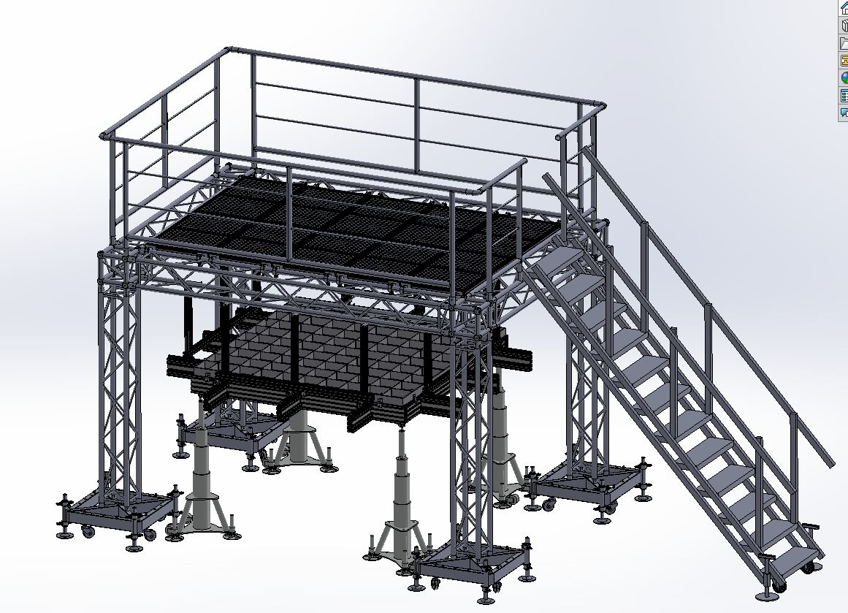

Fig.7 General view of the platform.

The target will be assembled on the bottom grid (Fig.7), starting from the bottom plate and the two side walls forming an angle. All walls of the target (including top and bottom panels) will have holes with 1 cm period for fibers. The platform will ensure the assembled procedure first on the fishing lines and vertical spokes which will be changed to the optical fibers after assembling full matrix of scintillator cubes and installation other two side walls and top panel.

Our design engineers performed calculation of strength and stiffness of the platform and box support system according to construction standards in seismic regions of the Far East (9 points, 0.65 g) and shown that the construction meet seismic requirements. Calculations will be continued in accordance with the spectrum of earthquake frequencies provided by the Japanese colleagues.

From 2022-2023, the JINR participants plan to join the research work on the creation of the Hyper-Kamokande veto detector - Outer detector which is designed to exclude background events caused by cosmic muons. This detector will be equipped with 6,700 ultrasensitive photosensors (PMTs) with a diameter of 20 cm. The JINR group plans to develop a system for mounting PMTs for the Outer detector of the Hyper-Kamokande facility, create shifters for photomultipliers and corresponding electronic equipment

Let us emphasize that our group was invited to participate in the T2K experiment by the leaders of the T2K collaboration and J-PARC (see the letters in the appendix) to carry out a unique assembly and maintenance of a new type of 3D scintillation active target and to participate in data analysis to measure the phase of cp-mixing. We also closely cooperate with INR RAS on the creation of a SuperFGD, about which there is a corresponding protocol on cooperation between JINR and INR RAS.

The project participants, as you know, have extensive experience in working with scintillation detectors, including the creation of a part of the muon system of the CDF experiment, test modules of the e.m. calorimeter and veto system of the Mu2e experiment; measurement of the top quark mass on CDF, simulation for Mu2e, data analysis from NA61/SHINE experiment, creation of the front-end electronics boards for Mu2e calorimeter and electronics for other experiments.

From the point of view of the leading roles of the T2K experiment, we note that Boris Popov is the group leader of for analysis of data for the T2K experiment, obtained on the graphite target at CERN (NA61/SHINE), Yuri Davydov is the SuperFGD target assembly group leader and Vladimir Glagolev is IB representative.

And we have 7 young scientists and engineers working on this Project. Moreover in the next three years we are going to involve 2-3 young PHD students in data analysis of the T2K and further development of the HK project.

# **Estimation of human resources**

|  |  |  |  |
| --- | --- | --- | --- |
| **Name** | **FTE** | **Positon** | **Work (apart common duties like shifts)** |
| V.Yu. Baranov | 1.0 | Junior researcher | SuperFGD cube tests |
| A.V. Boikov | 1.0 | engineer | SuperFGD calibration system |
| A.O. Brazhnikov | 0.3 | design engineer | platform and tooling for SFGD assembly |
| J.A. Budagov | 0.2 | Chief researcher | SuperFGD |
| Yu.I. Davydov | 0.9 | Head of department | SuperFGD assemble group leader |
| D.L. Demin | 0.3 | Head of sector | Tests at DLNP Linak-200 |
| V.V. Glagolev | 0.6 | DLNP Deputy director | SuperFGD |
| N.V. Khomutov | 0.3 | scientist | Firmware development |
| N.V. Kirichkov | 0.3 | head of the design department | platform and tooling for SFGD assembly |
| V.I. Kiseeva | 1.0 | Young researcher | Monte Carlo, data analyses |
| A.O. Kolesnikov | 0.8 | Senior engineer | SuperFGD tests |
| A.V. Krasnoperov | 0.3 | scientist | Software support |
| K.K. Limarev | 1.0 | PhD student | Monte Carlo, data analyses |
| V.L. Malyshev | 0.5 | scientist | SuperFGD tests |
| B.A. Popov | 1.0 | Senior scientist | Data analyses |
| A.V. Shaikovskiy | 0.7 | design engineer category 1 | platform and tooling for SFGD assembly |
| A.A. Sinitsa | 0.4 | design engineer category 2 | platform and tooling for SFGD assembly |
| I.A. Suslov | 1.0 | Senior scientist | Monte Carlo, data analyses |
| V.V. Tereschenko | 0.8 | Head of group | SuperFGD calibration system |
| S.V. Tereschenko | 0.6 | Engineer | SuperFGD calibration system |
| I.I. Vasilyev | 1.0 | Junior researcher | SuperFGD cube tests |
|  |  |  |  |
| **Total FTE** | **14.0** |  |  |

**Justification of estimated costs**

During 2022-2024, it is planned to carry out research work to create an HK Outer detector, in particular, to choose a suitable large-diameter PMT from 3-4 different types. It is also necessary to carry out a RnD and create a shifting plate, fasteners, cable connections and develop PMT fastenings inside the HK volume. In addition, it is planned to participate in the future upgrade of the near detector ND280.

To ensure the procurement of samples of 3-4 different types of photomultiplier tubes with a large-diameter photocathode (from 7 to 20 cm) for R&D, expenses are expected for 2022-2023-2024 years as 20-20-10 K $.

To equip a stand for testing PMT samples, you will need light insulation, mechanical and electronic components, a computer. Expenses are expected for 2022-2023-2024 years as 30-20-30 K $.

Data analysis and Montecarlo require a data server, 2-3 computers with monitors and laptops. Expenses are expected for 2022-2023-2024 years as 10-15-10 K $.

For the creation of shifter plates for the HK Outer detector PMT, R&D is expected with chemical plants for the production of a plastic scintillator with special additives. Expenses are expected for 2022-2023-2024 years as 20-20-15 K $.

**SWOT Analysis**

The **strengths** of the project are undoubtedly its fundamental nature and focus on the missing model parameters of neutrino physics - measuring the neutrino mixing parameter responsible for the cp-parity violation and improved accuracy of neutrino mixing parameters, $θ_{23 }$ and $∆m_{32}^{2}$.

The T2K-II experiment is based on a well-developed relatively simple technique for reconstructing Cherenkov light in water and the optimal parameters of the distance to the far detector and neutrino energy for a successful and hopefully the world's first $δ_{cp}$ measurement result.

Further goals include the group's participation in the new generation Hyper-Kamiokande project which will follow up the T2K-II experiment. Hyper-K apart from studying neutrinos from an accelerator will provide wide program of neutrino physics in particular the detection of astrophysical neutrinos from sources such as dark matter annihilation, gamma ray burst jets, and pulsar winds could further improve our understanding of some of the most spectacular, and least understood, phenomena in the Universe.

It should be noted that in comparison to US experiments (NOvA, LBNE), there is a huge advantage here in the absence of the enormous problem of obtaining US visas and the prohibition of access to US national Laboratories for JINR employees.

The **weaknesses** of the Project is the possible delay in implementation due to the pandemic.

The longer baseline in the DUNE experiment means their measurement will be more affected by matter effects, which will give them more sensitivity to the mass hierarchy.

It is expected that measurement of the mass hierarchy could be determined not at the T2K alone but combining the future data coming from the ongoing experiments such as NOvA, T2K and reactor experiments.

**References**

1. http://www.jinr.ru/posts/68584/
2. Nature 580 (2020) 7803, 339-344
3. K. Abe et al. [T2K Collaboration], arXiv:1607.08004 [hep-ex]
4. J-PARC Neutrino Beamline Upgrade Technical Design Report e-Print: 1908.05141 [physics.ins-det]
5. T2K ND280 Upgrade - Technical Design Report, CERN-SPSC-2019-001 (SPSC-TDR-006), e-Print: 1901.03750 [physics.ins-det]
6. de Gouvea, J. Jenkins, and B. Kayser, Phys. Rev. D71, 113009 (2005), arXiv:hep-ph/0503079 [hep-ph].
7. H. Nunokawa, S. J. Parke, and R. Zukanovich Funchal, Phys. Rev. D72, 013009 (2005), arXiv:hepph/ 0503283 [hep-ph].
8. X. Guo et al. (Daya-Bay), (2007), arXiv:hep-ex/0701029.
9. J. K. Ahn et al. (RENO), (2010), arXiv:1003.1391 [hep-ex].
10. F. Ardellier et al. (Double Chooz), (2006), arXiv:hep-ex/0606025.
11. F. An et al. (JUNO), (2015), arXiv:1507.05613 [physics.ins-det].
12. S.-B. Kim, in Neutrino Oscillation Workshop (NOW 2014) Conca Specchiulla, Otranto, Lecce, Italy, September 7-14, 2014 (2014) arXiv:1412.2199 [hep-ex].
13. S. Ahmed et al. (ICAL), (2015), arXiv:1505.07380 [physics.ins-det].
14. M. G. Aartsen et al. (IceCube PINGU), (2014), arXiv:1401.2046 [physics.ins-det].
15. U. F. Katz (KM3NeT), in Proceedings of the 15th International Workshop on Neutrino Telescopes (Neutel 2013) (2014) arXiv:1402.1022 [astro-ph.IM].
16. V. D. Barger, K. Whisnant, and R. J. N. Phillips, Phys. Rev. Lett. 45, 2084 (1980).
17. S. Pakvasa, Proceedings, 20th International Conference on High-Energy Physics, AIP Conf. Proc. 68, 1164 (1980).
18. K. Abe et al. (T2K), Phys. Rev. D91, 072010 (2015), arXiv:1502.01550 [hep-ex].
19. M. Sanchez, \Results and Prospects from the NOvA Experiment," Talk presented at the XVII International Workshop on Neutrino Factories and Future Neutrino Facilities (NuFact15), Rio de Janeiro, Brazil, August. 2015.
20. R. Wendell (Super-Kamiokande), Proceedings, 26th International Conference on Neutrino Physics and Astrophysics (Neutrino 2014), AIP Conf. Proc. 1666, 100001 (2015), arXiv:1412.5234 [hep-ex].
21. http://lbne.fnal.gov/, LBNE collaboration.
22. N. Abgrall et al. [NA61/SHINE Collaboration],

Measurements of π± , K± and proton double differential yields from the surface of the T2K replica target for incoming 31 GeV/c protons with the NA61/SHINE spectrometer at the CERN SPS Eur. Phys. J. C 79 (2019) 2, 100; e-Print: 1808.04927 [hep-ex]

*Appendix 3*

Form No. 26

**Schedule proposal and resources required for the implementation of the Project**

**___________T2K________________**

(Project title)

|  |  |  |  |  |  |  |
| --- | --- | --- | --- | --- | --- | --- |
| Expenditures, resources, financing sources | | | Costs (k$)  Resource  requirements | Proposals of the  Laboratory on the distribution of finances and resources | | |
| 1st year | 2nd year | 3rd year | |
| Expenditures | | Main units of equipment, work towards its upgrade, adjustment etc. | 165 | 60 | 55 | 50 | |
| Construction/repair of premises |  |  |  |  | |
| Materials | 55 | 20 | 20 | 15 | |
| Required resources | Standard hour | Resources of  – Laboratory design bureau;  – JINR Experimental Workshop;  – Laboratory experimental facilities division;  – accelerator;  – computer.  Operating costs. | 7000h  600h  420h | 3000h  200h  140h | 2000h  200h  140h | 2000h  200h  140h | |
| Financing sources | Budgetary  resources | Budget expenditures including foreign-currency resources. | 600 k$ | 200 | 205 | 195 | |
| External resources | Contributions by collaborators.  Grants.  Contributions by sponsors.  Contracts.  Other financial resources, etc. | 30  10 | 10  5 | 10  5 | 10 | |

PROJECT LEADERS V.V.Glagolev Yu.I.Davydov

*Appendix 4*

Form No. 29

**Estimated expenditures for the Project**  T2K

(full title of Project)

|  |  |  |  |  |  |
| --- | --- | --- | --- | --- | --- |
|  | Expenditure items | Full cost | 1st year | 2nd year | 3rd year… |
|  | Direct expenses for the Project |  |  |  |  |
| 1. | Accelerator, reactor | 420 h | 140 | 140 | 140 |
| 2. | Computers | h |  |  |  |
| 3. | Computer connection | k$ |  |  |  |
| 4. | Design bureau | standard 7000 hour | 3000 | 2000 | 2000 |
| 5. | Experimental Workshop | standard 600 hour | 200 | 200 | 200 |
| 6. | Materials | 55 k$ | 20 | 20 | 15 |
| 7. | Equipment | 165 k$ | 60 | 55 | 50 |
| 8. | Construction/repair of premises | k$ |  |  |  |
| 9. | Payments for agreement-based research (operation fee) | 95 k$ | 25 | 35 | 35 |
| 10. | Travel allowance, including:  a) non-rouble zone countries  b) rouble zone countries  c) protocol-based | k$  255  30 | 85  10 | 85  10 | 85  10 |
|  | Total direct expenses | 600 | 200 | 205 | 195 |

PROJECT LEADER

LABORATORY DIRECTOR

LABORATORY CHIEF ENGINEER-ECONOMIST

Appendix 5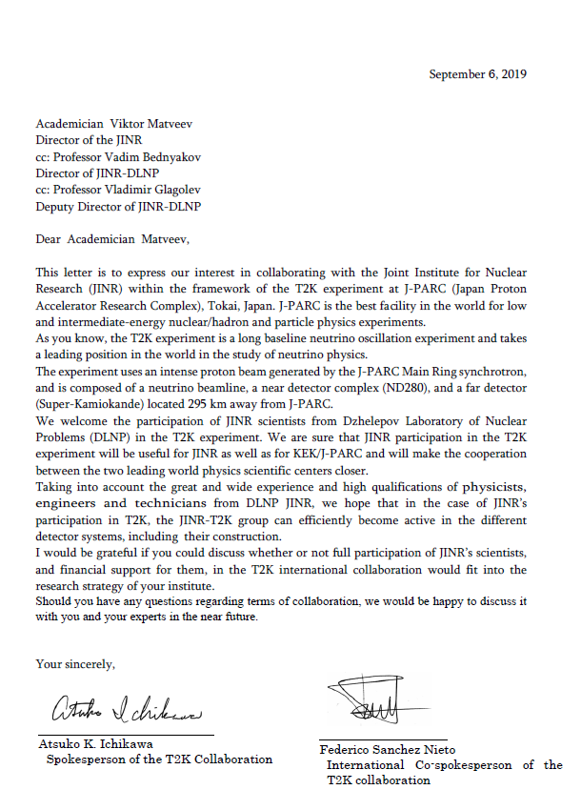

Appendix 6



Appendix 7

­