Educational Programme (06)
№ | Name of the project | Theme | Leader | Terms
12. | Open information and educational environment for supporting fundamental and applied multidisciplinary research at JINR | 1139 | Yu.A. Panebrattsev | 2021-2023

Questionnaire
for the extraordinary session of the PAC for Condensed Matter Physics for the assessment of related JINR projects
Project on development of Open information and educational environment for supporting fundamental and applied multidisciplinary research at JINR continues the work started in 2017 to create new educational and information resources related to the topics of JINR scientific research. The technical solutions of the project are based on the use of modern achievements of information and communication technologies and modern approaches in the field of e-learning (VR, AR, MOOCs, virtual and remote labs). The current stage of the project has been opened since the beginning of 2021, therefore, when preparing this questionnaire, we, in addition to the results obtained in 2021, included the results obtained earlier – in 2017–2020, that is, over the past 5 years. As for 2021, the main result is the launch of the interactive exhibition "JINR Basic Facilities" prepared in the period from September 2020 to March 2021, which is devoted to the 65th anniversary of the Institute and will be exhibited in Dubna up to September 2021 in the JINR Cultural Centre “Mir”. On the basis of this exhibition, mobile exhibition expositions will be prepared for the JINR Member States and Associate Members. From the results of 2021, we also would like to draw your attention to the opening of the JINR Information Center in Egypt, where the exposition includes the virtual laboratory of nuclear physics developed within the framework of this project and the publication of the textbook “Physics. Grade 7 "within the framework of the program of in-depth study of physics " Engineers of the Future ".
PART A: Achievements
1. Contributions of the JINR group:
The initiator of the project is the Department of development of educational programmes of the JINR UC. Therefore, the JINR UC is the main developer of hardware (computer service located in the Laboratory of Information Technologies, computer classes for practical studies and workshops, a hands-on practicum developed at JINR, the hardware and software complex from 7 exhibits – the exposition “JINR Basic Facilities” created in 2021 (https://www.youtube.com/watch?v=8GyWYDnxrqU) is located in the JINR Cultural Centre “Mir”). In terms of software development, the main software products are:
- JINR educational portal (edu.jinr.ru);
- virtual laboratory for study of nuclear physics (edu.jinr.ru/vlabs/);
- website of the exhibition (expo.jinr.ru).
The materials developed by the Dubna group are located on the JINR servers.
The main responsibilities and management are carried out by the JINR group. Bilateral agreements have been concluded with the main project participants from the JINR Member States (Bulgaria, Poland, Mongolia, Slovakia, Russia) and Associate Members (Egypt, South Africa, Serbia), within of which the responsibilities of the parties are determined, and collaboration is in progress.
The main results of the project are presented below.
- Online courses and new educational programs within the subject-matter of JINR projects on the basis of modern educational platforms
This part of the project was realized through the creation of JINR open educational portal (edu.jinr.ru) with online-courses, interactive multimedia educational resources for university and school students. In total, about 10 courses have been developed and published on the edu.jinr.ru platform. And about 50 courses are developed in collaboration with other project participants. These courses are published on the international educational platforms Coursera and edX, for example, the course “Megascience project NICA” and the specialization “Nuclear Legal Frameworks and Databases” (in collaboration with NRNU MEPhI).
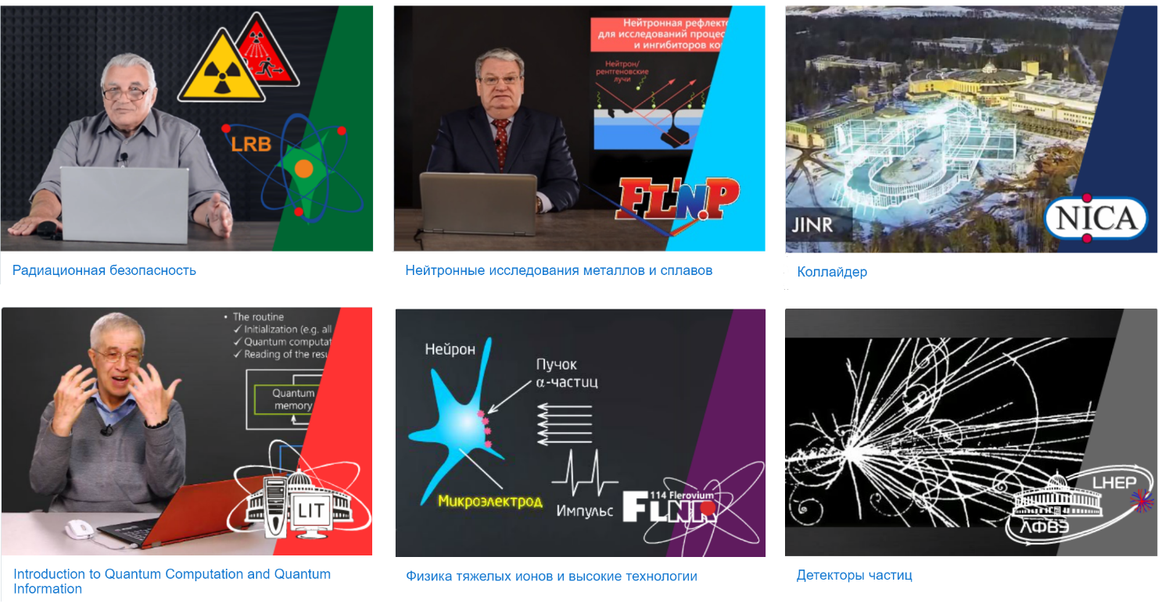
- Multimedia educational resources for websites of JINR laboratories
This part of the project was realized through:
- support of the official web-sites of Frank Laboratory of Neutron Physics and Polish Group in JINR;
- creation of the web-site of IBR-2 User Club;
- creation and support of the official web-site of NICA megaproject,
- renovation of NRV (Nuclear Reaction Video) Open Web Oriented Platform;
- creation of videos about main activities of the Laboratory of Neutron Physics for the basic departments of the FLNP

- Informational and educational support of NICA megaproject
This part of the project was realized through multimedia resources and an online course “Megascience project NICA” (Russian and English versions), that consist of following sections:
- Megascience projects
- Particle accelerators at JINR
- Structure and tasks of NICA complex
- Injection complex
- Superconducting magnets
- Nuclotron
- Collider
- Cryogenic complex

- Multimedia exhibits related to JINR subject-matter

This part of the project was realized through:

- Exhibition dedicated to 65th JINR anniversary. Dubna, Russia. March – September 2021
https://www.youtube.com/watch?v=8GyWYDnxrqU
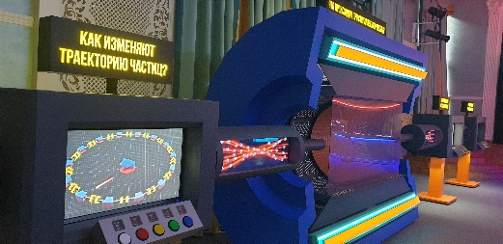 | 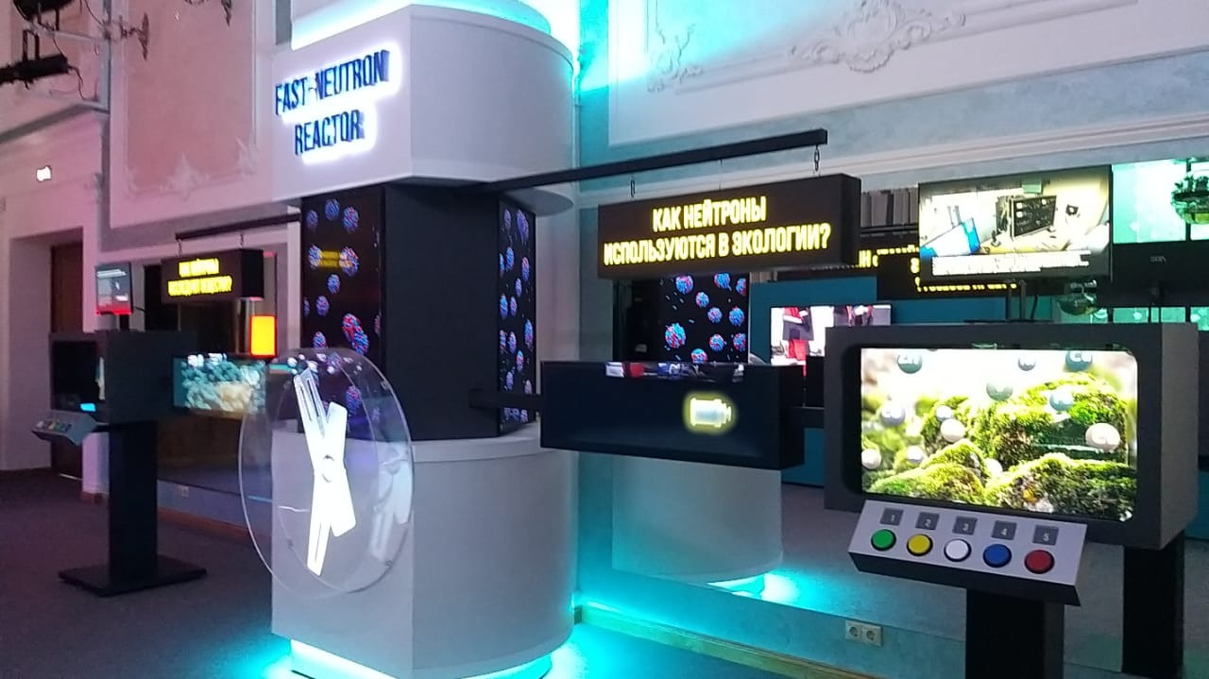
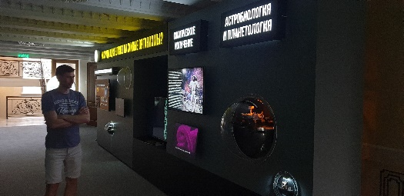 | 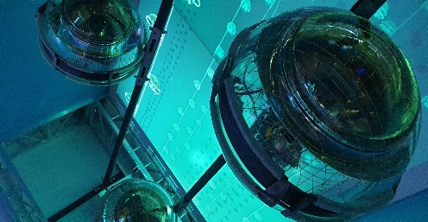
The exhibition includes interactive software and hardware complexes with models of:
- the NICA / MPD detector (VBLHEP),
- experimental complexes for applied and fundamental research at the cyclotron (FLNR),
- the IBR-2 pulsed reactor with examples of experimental facilities (FLNP).
It also includes the stands of:
- the Laboratory of Radiation Biology with information on the results in the field of clinical radiobiology, astrobiology, nuclear planetology, radiation cytogenetics, radiation physiology:
- the Laboratory of Information Technologies ("Big Data");
- the stand of the Laboratory of Nuclear Problems with the real detecting cells, which tells about the underwater neutrino telescope on Lake Baikal.
Each of the exhibits is accompanied by a VR tour.

- Participation in creation of multimedia exposition and practicum on experimental nuclear physics in the JINR Informational Centre in Cairo (Egypt), 2020
- Participation in creation of multimedia exposition in the JINR Informational Centre in the South of Russia (North Ossetian State University, Vladikavkaz), 2019
- Exposition “JINR Main Facilities” at the International Symposium on Exotic Nuclei (EXON) in Kazan (2017), Petrozavodsk (2018), Dubna (2019)
- Multimedia exposition at the International Festival of Science and Education 2018 (Novi Sad, Serbia)
- Interactive JINR expositions during events in Egypt, Serbia, Vietnam, South Africa and Russia
- Exposition “Megascience project: NICA” at XIX World Festival of Youth and Students (Sochi, Russia)
- Creation of multimedia exposition in JINR Science and Technology Museum

- Educational web resource “Virtual Laboratory of Nuclear Physics”
This part of the project was realized through:
- creation of distant course: “Introduction to Experimental Nuclear Physics”;
- creation of 3 new sections:
- “Laboratory of Gamma Spectrometry”,
- “Laboratory of Detectors and Data Processing”,
- “Laboratory of Data Analysis in ROOT”;
- development of the web-site of the project “Virtual Laboratory of Nuclear Fission”;
- development and organization of hands-on practicums on experimental nuclear physics for university and school students;
- development of educational materials for student practices;
- organization of off-site workshops on experimental nuclear physics for university students;
- organization of workshops with project participants from Russia, Bulgaria, Serbia, South Africa.

- Educational materials for teachers and school students
In the framework of the project the following multimedia educational resources have been developed:
1. Video lectures “NICA – the Universe in the Lab” (Russian and English versions). On the base of these materials open lessons for school and university students, workshops for physics teachers were held in schools and universities of Russia.
2. A text-book of nuclear physics was developed and published at the Publishing House “Prosveschenie” for grades 10–11 of Russian schools. When creating the course, along with the traditional text-book, the course includes elements of augmented reality, video lectures, interactive tests, and a virtual laboratory practicum. The course contains the section “In the Laboratories of Scientists” on the JINR scientific topics.
3. A text-book of physics for engineering classes was developed and published at the Publishing House “Prosveschenie” for grade 7 of Russian schools.
2. Publications:
- Инженеры будущего. Физика. 7 класс. В 2 ч. Ч. 1: учеб. Пособие для общеобразоват. организаций: углубл. Уровень / Ю.А. Панебратцев, В.В. Белага, Н.И. Воронцова, И.А. Ломаченков; под ред. Ю.А. Панебратцева. — М.: Просвещение, 2021. — 160 с.: ил. — ISBN 978-5-09-081175-0.
- Инженеры будущего. Физика. 7 класс. В 2 ч. Ч. 2: учеб. Пособие для общеобразоват. организаций: углубл. Уровень / Ю.А. Панебратцев, В.В. Белага, Н.И. Воронцова, И.А. Ломаченков; под ред. Ю.А. Панебратцева. — М.: Просвещение, 2021. — 160 с.: ил. — ISBN 978-5-09-081176-7.
- Ядерная физика. 10–11 классы: учеб. Пособие для общеобразоват. организаций / [Н.И. Воронцова, М.И. Делов, К.В. Клыгина, В.В. Кондаков, Ю.А. Панебратцев, Н.Е. Сидоров, П.Г. Стручалин, Г.В. Тихомиров.]; под ред. Ю.А. Панебратцева, Г.В. Тихомирова. — М.: Просвещение, 2019. — 159 с.: ил. — (Профильная школа). — ISBN 978-5-09-051605-1.
- Основы системного анализа. 10–11 классы: учеб. Пособие для общеобазоват. организаций / В.В. Белага, О.Ю. Тятюшкина. — М.: Просвещение, 2019. — 143 с.: ил. — (Профильная школа). — ISBN 978-5-09-072536-1.
- V.V. Belaga, E.V. Dolgy, K.V. Klygina, P.O. Kochnev, Yu.A. Panebrattsev, N.E. Sidorov and E.B. Vesna. Online courses at international and national platforms and the possibility of creating a digital educational environment for megaprojects. Journal of Physics: Conference Series. 1406 (2019) 012004
3. PhD theses:
In the framework of the project two candidate dissertations are being prepared:
- “Development of hardware and software complex ‘Virtual Laboratory for Study of Nuclear Physics’” (P.O Kochnev)
- “Development of the online education technology with adaptive learning” (E.V. Dolgii)

Also 2 bachelor's and 4 master's theses were prepared.
4. Talks:
In July 2021 we are invited to give a talk “Nuclear Physics and Engineering E-Learning” at the VII European Conference EMOOCs 2021.
4.1. Reports at international conferences
- International Science School for Physics Teachers at JINR, Dubna, 26 June – 1 July 2017.
- the 10th Anniversary International School for Nuclear Physics “JINR Days in Bulgaria”. 16–19 May 2017. “Borovets” mountain complex, Sofia, Bulgaria.
- The 14th annual international Conference on Hands-on Science: Growing with Science, HSCI2017. July 10 – 14, 2017. Braga, Portugal.
- Workshop for VLab collaboration, June 30 – July 10 2017, Stellenbosch, South Africa.
- 26-th International Symposium on Nuclear Electronics & Computing (NEC’2017), 25–29 September 2017. Montenegro, Budva, Becici.
- The 15th annual international conference on Hands-on Science, HSCI2018, The Hands-on Science Network (www.hsci.info), Barcelona, Catalonia, Spain, 16 – 20 July 2018.
- IX International Symposium on EXOtic Nuclei (EXON-2018), 10–15 September 2018, Petrozavodsk, Russia
- South Africa-JINR Workshop “Virtual laboratory on detectors and signal processing” Somerset West, South Africa, 26 October – 04 November, 2018.
- 5th Symposium «Advances and Challenges in Physics by JINR and South Africa», 4–9 November 2018. Somerset West, RSA.
- Science School for Physics Teachers from Czech Republic Slovakia, 1–5 June 2019. JINR, Dubna.
- International Science School for Physics Teachers. JINR, Dubna State University.14–25 July 2019, Dubna.
- XXVII International Symposium on Nuclear Electronics & Computing, Montenegro, Budva, Becici, 30 September – 4 October 2019.
- XII Science School for Physics Teachers from the JINR Member States at CERN, 3–10 November 2019, CERN, Geneva, Switzerland.

4.2. Participation in international events: student practices, International training programs for decision-makers in science and international scientific cooperation “JINR Expertise for Member States and Partner Countries” (JEMS), exhibitions

- IV International Russian–Serbian Industrial Exhibition, 14–18 March 2017, Belgrade, Serbia.
- Student Practice 2017 at JINR (I stage), 28 May – 17 June 2017, JINR, Dubna, Russia.
- September Student Practice 2017 at JINR (III stage), 10–30 September 2017, JINR, Dubna, Russia.
- 2nd Industrial Exhibition “EXPO-RUSSIA VIETNAM 2017”, 13–15 December 2017, Hanoi, Vietnam.
- Practice for high-school students from Israel 2018, 11–13 April 2018, JINR, Dubna, Russia.
- JINR Exposition at 16th Arab Conference on the Peaceful Uses of Atomic Energy, 16–20 December 2018, Sharm El-Sheikh city, Egypt.
- Practice for high-school students from Israel 2019, 11–13 March 2019, JINR, Dubna, Russia.
- Practice for high-school students from Germany 2019, June 2019, JINR, Dubna, Russia.
- Practice for high-school students from Czech Republic 2019, 01 – 04 July 2019, JINR, Dubna, Russia.
- 2nd JINR-RSA School in iThemba LABS. 9–30 January, 2020.
- GeekPicnic 2020 Online Festival. 6–8 August, 2020.
- International training programme for decision-makers in science and international scientific cooperation JEMS – «JINR Expertise for Member States and Partner Countries» – 2017–2021, JINR, Dubna, Russia.
- Exhibition dedicated to 65th JINR anniversary. Dubna, Russia. March – September, 2021. Excursion program.

PART B: Plans and requests
5. Plans
5.1. Project goals
- Use of modern educational technologies for various training methods and courses for students and specialists to work at JINR. Attracting talented youth from the participating countries to work at JINR.
- Integration of the results of fundamental and applied research obtained at JINR into the education process in the JINR Member States and Associate Members.
- Collaboration with leading world scientific centers (CERN, BNL) to create educational resources for physics teachers and high school students.
- Promotion of fundamental and applied multidisciplinary research conducted at JINR and the JINR brand to a wide audience. Development of courses prepared by the leading JINR specialists for international open education platforms.
- Creation of educational and exhibition content on JINR topics at the level of leading research centers.

5.2. The expected results of the project
- Development of the JINR Educational Portal. Creation of online courses for students and post-graduates of the JINR Member States and Associate Members, as well as countries collaborating with JINR on topical problems of modern physics (research on nuclear matter and particle physics at colliders, search for superheavy and exotic nuclei, neutrino physics, condensed matter- and nanostructure research) and multidisciplinary applied research with heavy ions, neutrons and synchrotron radiation in the field of materials science, life sciences and radiation biology.
- The inclusion of online courses created by the specialists of the JINR Member States and Associate Members into the curricula of the universities of the JINR Member States as well as those of the Associate Members. The publishing of these courses on leading open education platforms will also be done in collaboration with the basic departments of JINR.
- Creation of a series of virtual, remote and hands-on practicums, and research based on real experimental data. Creation of an open Internet environment for experiment modeling to study nuclear physics.
- Creation of multimedia courses, organizing of workshops, lectures and practicums with the possibility of remote access to the platform, inclusive of laboratory works on nuclear physics, for teachers and high school students.
- Creation of modern multimedia interactive expositions using virtual (VR) and augmented (AR) reality technologies devoted to the current scientific projects and scientific achievements of JINR. Development of a stationary exhibition in Dubna for the 65th anniversary of JINR and development of mobile exhibitions in countries collaborating with JINR.

6. Group size, composition and budget
6.1. Authors
I. Arsenich¹, S.N. Balalykin², V.V. Belaga², M.H. Brzozowy³, E.I. Golubeva², Z.I. Goryainova², V. Gurev⁴, P. Duda³, M. Hnatich^{2,5}, Sh. Janchiw⁶, D.V. Kamanin², Yu.N. Kasumov⁷, K.V. Klygina², D. Kocheva⁴, A.O. Komarova², O.A. Kreider⁸, M. Krmar¹,M.L. Lekala⁹,E. Labanich¹⁰, V. Malaza¹³, R. Newman¹⁰, M.K. Olszewski³, Yu.D. Orlova², M.P. Osmachko², S.Z. Pakuliak², E.V. Potrebenikova², N.E. Pukhaeva^{2,7}, M. Peryt^{2,3}, Yu.V. Pyatkov¹², G. Rainovski⁴, T.I. Sadyrova⁸, P.D. Semchukov², N.E. Sidorov², O.A. Smirnov², A.O. Strekalovsky², T.G. Stroganova², G.V. Tikhomirov¹², I.V. Tvauri⁷, A. Wyngaardt¹³, Sh. Wyngaardt¹³, I. Vankov¹⁴, E.B. Vesna¹², S. Vokal⁵, N.I. Vorontsova², A.S. Zhemchugov², D.V. Zhuravleva²
¹University of Novi Sad, Novi Sad, Republic of Serbia
²Joint Institute for Nuclear Research, Dubna, Russia (LHEP, FLNR, UC)
³Warsaw University of Technology, Warsaw, Poland
⁴Sofia University “St. Kliment Ohridski”, Sofia, Bulgaria
⁵Pavol Jozef Šafárik University, Košice, Slovakia
⁶Mongolian State University of Education, Ulan Bator, Mongolia
⁷North Ossetian State University, North Ossetia - Alania, Vladikavkaz, Russia
⁸Dubna State University, Dubna, Russia
⁹UNISA, Pretoria, SouthAfrica
¹⁰Slovak Technical Museum, Slovakia
¹¹Laboratory for Accelerator Based Sciences (iThemba LABS), Somerset West, South Africa
¹²National Research Nuclear University MEPhI, Moscow, Russia
¹³Stellenbosch University, Stellenbosch, South Africa
¹⁴Institute for Nuclear Research and Nuclear Energy (INRNE) of the Bulgarian Academy of Sciences, Sofia, Bulgaria

6.2. Human resources are required to solve the tasks of the project
- Creation of online courses for the JINR Educational Portal
Participants:
- UC, JINR (6 FTE)
- LHEP, JINR (6 FTE)
- NRNU MEPhI (2 FTE)
- FLNP, JINR (1 FTE)
- Dubna State University (2 FTE)
- AM-MP, SPbU (1 FTE)
- Institute of Physics, KFU (1 FTE)
- North Ossetia State University (2 FTE)
- Works under R&D contracts (10 FTE)
- Development of the project: Virtual Laboratory of Nuclear Physics
  - Virtual Laboratory of Gamma Spectrometry
  - Virtual Laboratory of Detectors and Signal Processing
  - Practicum on Data Analysis in ROOT
  - Implementation of project results in the educational process at universities in Russia, the JINR Member States and the Republic of South Africa
Participants:
- FLNR, JINR (2 FTE)
- UC, JINR (5 FTE)
- Stellenbosch University, RSA (3 FTE)
- UNISA, RSA (1 FTE)
- NRNU MEPhI (1 FTE)
- Sofia University, Bulgaria (2 FTE)
- INRNE BAS, Bulgaria(1 FTE)
- University of Novi Sad, Serbia (1 FTE)
- Mongolian State University of Education (1 FTE)
- Works under R&D contracts (8 FTE)

- Creation of hands-on practicum on nuclear physics
Participants:
- FLNR, JINR (2 FTE)
- LHEP, JINR (6 FTE)
- UC, JINR (2 FTE)
- Dubna State University (2 FTE)
- NRNU MEPhI (1 FTE)
- Sofia University, Bulgaria (1 FTE)
- INRNE BAS, Bulgaria (1 FTE)
- Works under R&D contracts (3 FTE)
- Development of remote practicum with the opportunity of a project work
Participants:
- Warsaw University of Technology, Poland (3 FTE)
- LHEP,JINR (5 FTE)
- UC,JINR (2 FTE)
- Dubna State University (2 FTE)
- NRNU MEPhI (1 FTE)
- Sofia University, Bulgaria (1 FTE)
- INRNE BAS, Bulgaria (1 FTE)
- Works under R&D contracts (4 FTE)

- Development of the JINR exhibition
  - Exhibits devoted to the main directions of research at JINR laboratories
  - Popular science exhibits based on VR and AR
  - Creation of real models and exhibits
  - Interactive models of the NICA accelerator complex and MPD detector
Participants:
- FLNR, JINR (1 FTE)
- FLNP, JINR (1 FTE)
- LHEP, JINR (3 FTE)
- LRB, JINR (0,5 FTE)
- LTP, JINR (0,5 FTE)
- LIT, JINR (1 FTE)
- UC, JINR (5 FTE)
- Works under R&D contracts (12 FTE)
- Creation of multimedia resources for physics teachers and high school students
Participants:
- LHEP, JINR (3 FTE)
- UC, JINR (5 FTE)
- Dubna State University (3 FTE)
- North Ossetia State University (1 FTE)
- Stellenbosch University, RSA (2 FTE)
- NRNU MEPhI (2 FTE)
- Works under R&D contracts (5 FTE)

6.3. Project budget 2021–2023
Estimation of the total budget of the project, budget per year and expenses for each of the following categories:
(a) Construction of experimental equipment for students’ practicum in Dubna:
15 000 × 3 years = 45 000 $

(b) Creation of JINR exhibition (materials and equipment):
30 000 × 3 years= 90 000 $

(c) Consumables and overheads:
5 000 × 3 years = 15 000 $

(d) Costs of the salary for the project/theme participants:
9 750 000 × 3 years = 29 250 000RUB

(e) Costs of third-party contractors under the item Research and Development:
9 100 000 × 3 years = 27 300 000 RUB

(f) Financing sources (internal and external resources):
- JINR UC budget theme: 1139
- JINR infrastructure
- RSA–JINR cooperation funds
- Grants of Plenipotentiaries of JINR Member States
It is assumed that the cooperating educational organizations pay their teachers for the work related to the development of training courses and program content.
№ | Expenditure | 2021 | 2022 | 2023 | TOTAL
1 | Materials and equipment | 45 000 $ | 45 000 $ | 45 000 $ | 135 000 $
2 | Consumables and overheads | 5 000 $ | 5 000 $ | 5 000 $ | 15 000 $
3 | International scientific and technical collaboration | 10 000 $ | 10 000 $ | 10 000 $ | 30 000 $
4 | Personnel costs
4.1. | Salary for JINR personnel:  15 FTE (9 – LHEP, 6 – UC) | 150 000 $  (9 750 000 RUB) | 150 000 $  (9 750 000 RUB) | 150 000 $  (9 750 000 RUB) | 450 000 $  (29 250 000 RUB)
4.2. | Income tax charge (Universal Social Charge) | 45 300$ | 45 300$ | 445 300$ | 135 900$
5 | Costs of third-party contractors under the item R&D  2 FTE | 140 000 $ (9 100 000 RUB) | 140 000 $ (9 100 000 RUB) | 140 000 $ (9 100 000 RUB) | 420 000 $ (27 300 000 RUB)
 | TOTAL | 395 300 $ | 395 300 $ | 395 300 $ | 1 185 900 $

