Start on top line, use capital Times New Roman (14 pt) font for the title, which should be in bold and centered

Presenting Author’s First Name and Surname underlinedª and Author’s First Name and Surname^{b}

ª Authors’ affiliation
^{b} Authors’ affiliation

Body of abstract. Single line space should be used in entire document. The document can be submitted in Microsoft Word or equivalent Open Source document file format. The entire abstract can not exceed 1 page in length, including title, authors, references. Leave 2.5cm margins on all sides of the page. Use Times New Roman (12 pt). Put references in the text in brackets [1].

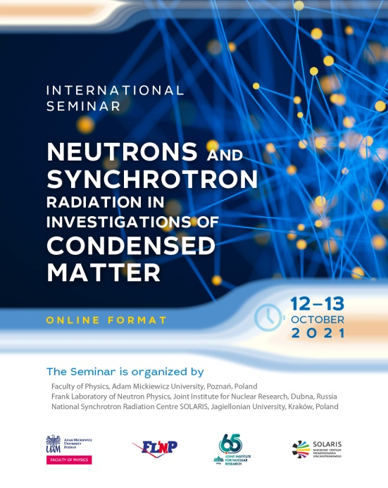

FIGURE 1. Style for FigureCaptions, all text should be 10 pt.

Acknowledgements

References
[1] Should be justified to the left.

