V.V. Korenkov¹, N.A. Kutovskiy¹, V.V. Mitsyn¹, А.А. Moshkin², I.S. Pelevanyuk¹, D.V. Podgainy¹, O.V. Rogachevskiy², V.V. Trofimov¹, A.Yu. Tsaregorodtsev³

¹ Meshcheryakov Laboratory of Information Technologies, JINR
² Veksler and Baldin Laboratory of High Energy Physics, JINR
³Center for Particle Physics of Marseille, Aix-Marseille University, Center for Scientific Research, French National Institute of Nuclear Physics and Particle Physics, Marseille, France

A series of works “Development and implementation of a unified access to the heterogeneous distributed resources of JINR and its Member States on the DIRAC platform” is being submitted to JINR’s competition in the scientific-methodological and scientific-technical research section.

The integration of computing resources based on the DIRAC platform is an important step in the development of distributed data processing at JINR. This integration allows one to include any kind of computing resources into a unified system and provide them to users via a unified web interface, a command line interface or a programming interface. The relevance of the presented research and the elaborated approaches is primarily related to the implementation of the experiments of the NICA megascience project, i.e. BM@N, MPD, SPD. According to the document “TDR MPD: Data Acquisition System” of 2018, the data flow from the MPD detector will amount to at least 6.5 GiB/s. For the SPD experiment, preliminary estimates for the amount of data received are close to 20 GiB/s. Processing, transferring, storing and analyzing such large arrays of data will require a significant amount of computing and storage resources.
JINR has a large number of different computing resources, namely, the Tier1/Tier2 clusters, the “Govorun” supercomputer, the cloud, the NICA cluster. The resources of each of them can be used to achieve the goals of computing for the NICA experiments. The major difficulty in this case is that these resources differ from each other in terms of the architecture, access and authorization procedures, methods of their use. To ensure their efficient use, it is required, on the one hand, to integrate the resources into a unified system, and on the other hand, not to interfere with their current operation and performance of other tasks.
The studies were carried out in compliance with the Topical Plan for JINR Research jointly by the Laboratory of Information Technologies, the Laboratory of High Energy Physics and the Center for Particle Physics of Marseille University (Marseille, France).
To integrate the above heterogeneous resources, it was decided to use the DIRAC Interware platform [1]. DIRAC (Distributed Infrastructure with Remote Agent Control) acts as a middleware between users and different computing resources, ensuring efficient, transparent and reliable use by providing a common interface to heterogeneous resource providers. Initially, the DIRAC platform was developed by the LHCb collaboration to organize computing. In 2008, it began to develop as an open-source product aimed at organizing distributed computing based on heterogeneous computing resources.
The DIRAC platform was deployed at JINR in 2016 in an experimental mode [2]. Typical simulation jobs for the BM@N and MPD experiments, as well as test jobs not related to the experiments, were used to evaluate the platform’s efficiency.
In 2018, work to integrate the cloud infrastructures of JINR and its Member States into the DIRAC-based distributed platform was performed [3]. This entailed the development of a special module that would allow DIRAC to initiate the creation of virtual machines in the OpenNebula system, on the basis of which the JINR computing cloud and the Member States’ clouds were built. The module was developed by specialists of the Laboratory of Information Technologies and added to the source code of DIRAC [4]. At present, the developed module is actively used not only at JINR, but is also included in the infrastructures of the BES-III and JUNO experiments. The integration of the clouds of the JINR Member States’ organizations into the DIRAC-based distributed platform (Fig. 1) opens up new opportunities for the Member States to participate in computing for the experiments of the NICA megascience project [3].
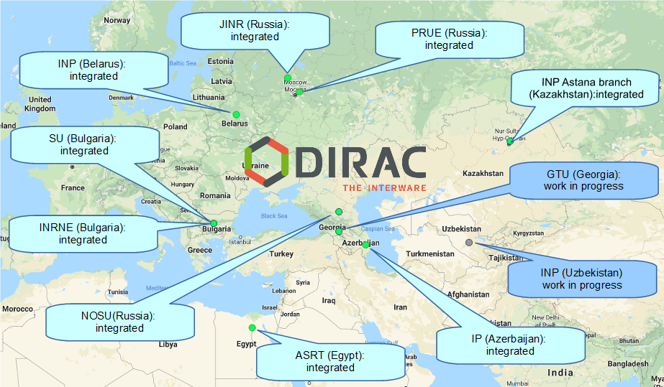
Fig. 1. Clouds of the JINR Member States’ organizations integrated into the distributed information and computing environment based on the DIRAC platform

Simultaneously with the integration of computing clouds, a solution on the integration of heterogeneous computing resources based on DIRAC for the current BM@N experiment, as well as for the future MPD experiment at the NICA collider under construction, was worked out. The bandwidths of storage systems on disk and tape drives were studied, stress testing of all the main resources was conducted, approaches to solving standard tasks of data generation, processing and transfer were elaborated [5,6].
In August 2019, the first set of Monte-Carlo data simulation jobs for the MPD experiment was sent to the resources of the Tier1 and Tier2 grid clusters via DIRAC. Then the “Govorun” supercomputer was integrated into the distributed computing platform (DCP). In the summer of 2020, the NICA cluster and the cluster of the National Autonomous University of Mexico (UNAM) were added. dCache, which manages disk and tape storages, and EOS were integrated as storage systems. It is noteworthy that the UNAM cluster became the first computing resource located outside Europe or Asia and included in the DIRAC infrastructure at JINR. The scheme of the integration of geographically distributed heterogeneous resources based on the DIRAC Interware is shown in Fig. 2.
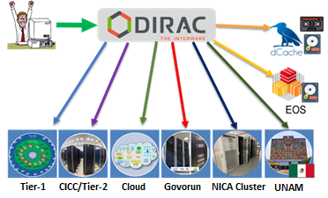
Fig. 2. Scheme of the integration of geographically distributed heterogeneous resources based on the DIRAC Interware

The created distributed computing platform enables load distribution across all the resources involved, thereby accelerating calculations and enhancing the efficiency of using integrated resources [6]. The “Govorun” supercomputer can serve as an example. Depending on its loading by different types of jobs, it became possible to allocate temporarily available resources to solving tasks related to the experiments of the NICA megascience project [7].
The DIRAC-based distributed platform is successfully used by MPD not only for job management, but also for data management [8]. All data are registered in the file directory, and metainformation is assigned to some of them. Owing to it, one can select files by such characteristics as collision energy, beam composition, generator name, etc.
The example of MPD and the experience gained in the process of introducing new approaches made it possible to propose the DIRAC-based distributed computing platform at JINR as a standard solution for the mass launch of jobs. The DCP was used by the Baikal-GVD experiment, one of the key experiments of the JINR neutrino program. The data obtained were used for studies on the observation of muon neutrinos and were reported at a specialized conference [9]. The BM@N experiment tested DIRAC to launch jobs related to the primary processing of data obtained at the detector and successfully completed 13 thousand simulation jobs.
The participation in voluntary computing related to the study of the SARS-CoV-2 virus within the Folding@Home project became another area of using the DIRAC platform at JINR [9]. Cloud resources of both the Institute and its Member States’ organizations that are free from JINR’s major activity are successfully involved in the COVID-2019 research. The contribution of all the cloud infrastructures is taken into account both in the Folding@Home information system within the “Joint Institute for Nuclear Research” group and in the frame of the accounting system of DIRAC itself.
To date, thanks to resource integration using DIRAC, 1.07 million jobs have been completed on the distributed platform. The number of calculations performed is estimated at 5.66 million HEPSPEC2006 days, which is equivalent to 874 years of computing on one core of the central processor. 90% of all calculations were performed on the “Govorun” supercomputer, Tier1 and Tier2, 6% on the JINR cloud infrastructure, 3% on the NICA cluster.
The major user of the distributed platform is the MPD experiment, which accounts for 90%. Using DIRAC, a program of mass data simulation runs within the MPD experiment is performed. More than 750 million events were successfully modeled with the help of the UrQMD, GSM, 3 Fluid Dynamics, vHLLE_UrQMD and other generators, 220 million events were subsequently reconstructed. The total amount of data received exceeds 200 TB. 5% of calculations were performed by the Baikal-GVD experiment, 3% by Folding@Home, 2% by BM@N.
In addition to the ability to perform the mass launch of jobs, the integration of a large number of heterogeneous resources opened up the possibility of their centralized analysis. An approach to evaluate the performance of different computing resources was developed, based on the results of its implementation a method for assessing on top of user jobs, rather than artificial tests, was proposed [10]. Now it is possible to qualitatively evaluate the performance of different resources. In some cases, this made it possible to understand when a resource was being used inefficiently. It was also found that the standard DIRAC Benchmark underestimated performance for some processor models, which we reported to the developers of this benchmark.
With the growing use of the distributed computing platform, it was necessary to create additional services for users. One of the services is related to performance evaluation at the level of a specific user job, which allows the user to better understand the modes of using computing resources, the network and RAM. It also enables the early detection of problems in software packages used for data processing. The second service was specially developed for the MPD experiment. It provides users with a job launching interface designed not in terms of the number of jobs, executable processes, passed arguments, but in physical terms, i.e. the number of events, generator, energy, beam composition [11]. Thus, physicists are provided with an interface that relies on concepts closer to them. This is the first example of creating a problem-oriented interface within the DIRAC infrastructure at JINR. In the future, it is possible to develop similar interfaces for other scientific groups of this distributed resource platform.
The uppermost results are:
- Developed and implemented module for the integration of cloud resources based on the OpenNebula software. Using the developed module, the clouds of JINR and its Member States were combined to perform joint computing. The joint infrastructure of JINR and its Member States was used to participate in the Folding@Home project to study the SARS-CoV-2 virus, as well as to launch simulation jobs for the Baikal-GVD experiment.
- Integration of computing resources into DIRAC: “Govorun” supercomputer, Tier1, Tier2, NICA cluster, JINR cloud, JINR Member States’ clouds, UNAM cluster. Integration of storage resources: EOS disk storage, dCache tape storage. The workflows of mass data simulation within the MPD experiment were adapted to launch jobs and save data using the DIRAC platform. Since 2019, this platform has been used to implement the program of mass data simulation runs of the MPD experiment.
- New approach to analyzing the performance of distributed heterogeneous computing resources. The application of this approach made it possible to define the performance of computing resources integrated into DIRAC.

References:
- V. Korenkov, I. Pelevanyuk, P. Zrelov, and A. Tsaregorodtsev: “Accessing Distributed Computing Resources by Scientific Communities using DIRAC Services”// CEUR workshop proceedings, 2016, Vol. 1752, pp. 110-115
- V. Gergel, V. Korenkov, I. Pelevanyuk, M. Sapunov, A. Tsaregorodtsev, and P. Zrelov: “Hybrid Distributed Computing Service Based on the DIRAC Interware”// Communications in Computer and Information Science, 2017, Vol. 706, pp. 105-118, doi:10.1007/978-3-319-57135-5_8
- N.A. Balashov, N. A. Kutovskiy, A. N. Makhalkin, Y. Mazhitova, I. S. Pelevanyuk, and R. N. Semenov: “Distributed Information and Computing Infrastructure of JINR Member States' Organizations”// AIP Conference Proceedings, 2021, Vol. 2377, 040001, https://doi.org/10.1063/5.0063809
- N.A. Balashov, R. I. Kuchumov, N. A. Kutovskiy, I. S. Pelevanyuk, V. N. Petrunin, and A. Yu Tsaregorodtsev: 2019. “Cloud Integration within the Dirac Interware”// CEUR workshop proceedings, 2019, Vol. 2507, pp. 256-260
- V. Korenkov, I. Pelevanyuk, and A. Tsaregorodtsev: “Dirac System as a Mediator between Hybrid Resources and Data Intensive Domains”// CEUR workshop proceedings, 2019, Vol. 2523, pp. 73-84
- V. Korenkov, I. Pelevanyuk, and A. Tsaregorodtsev: “Integration of the JINR Hybrid Computing Resources with the DIRAC Interware for Data Intensive Applications”// Communications in Computer and Information Science, 2020, Vol. 1223, pp. 31-46, doi:10.1007/978-3-030-51913-1_3
- D.V. Belyakov, A. G. Dolbilov, A. N. Moshkin, I. S. Pelevanyuk, D. V. Podgainy, O. V. Rogachevsky, O. I. Streltsova, and M. I. Zuev: “Using the “Govorun” Supercomputer for the NICA Megaproject”// CEUR workshop proceedings, 2019, Vol. 2507, pp. 316-320
- N. Kutovskiy, V. Mitsyn, A. Moshkin, I. Pelevanyuk, D. Podgayny, O. Rogachevsky, B. Shchinov, V. Trofimov, and A. Tsaregorodtsev. 2021. “Integration of Distributed Heterogeneous Computing Resources for the MPD Experiment with DIRAC Interware”// Physics of Particles and Nuclei, 2021, Vol. 52 (4), pp. 835-841, doi:10.1134/S1063779621040419
- N.A. Kutovskiy, I. S. Pelevanyuk, and D.N. Zaborov: “Using distributed clouds for scientific computing”// Accepted for publication in CEUR workshop proceedings
- I. Pelevanyuk: “Performance Evaluation of Computing Resources with DIRAC Interware”// AIP Conference Proceedings, 2021, Vol. 2377, 040006, https://doi.org/10.1063/5.0064778
- A.A. Moshkin, I. S. Pelevanyuk, and O. V. Rogachevskiy: “Design and development of application software for the MPD distributed computing infrastructure”// Accepted for publication in CEUR workshop proceedings

