The the JINR Scientific Works Competition 2021

PRESENTATION
The work is presented
“Creation of the NICA Booster”
Section: Scientific-Technical works

Authors:
1. Butenko Andrei Valerievich (VBLHEP JINR)
2. Volkov Valery Ivanovich (VBLHEP JINR)
3. Galimov Artem Rafaelevich (VBLHEP JINR)
4. Karpinsky Victor Nikolaevich (VBLHEP JINR)
5. Kostromin Sergei Alexandrovich (VBLHEP JINR)
6. Meshkov Igor Nikolaevich (VBLHEP JINR, scientific leader of the NICA project)
7. Mikhailov Vladimir Afanasievich (VBLHEP JINR)
8. Sidorin Anatoly Olegovich (VBLHEP JINR) sidorin@jinr.ru
9. Trubnikov Grigory Vladimirovich (JINR director)
10. Khodzhibagiyan Нamlet Georgievich (VBLHEP JINR)

The presented series of articles includes 10 publications:
- Н.Н.Агапов, А.В.Бутенко, В.И.Волков, А.В.Елисеев, Г.Г.Ходжибагиян, В.Н.Карпинский, А.Д.Коваленко, О.С.Козлов, И.Н.Мешков, В.А.Михайлов, В.А.Мончинский, Р.В.Пивин, А.О.Сидорин, А.В.Смирнов, Г.В.Трубников, Бустерный синхротрон ускорительного комплекса NICA, Письма в ЭЧАЯ, 7(163), стр 723-730 (2010)
- Andrey Butenko, Nikolay Agapov, Alexey Eliseev, Viktor Karpinsky, Hamlet Khodzhibagiyan, Alexander Kovalenko, Grigory Kuznetsov, Igor Meshkov, Vladimir Mikhaylov, Valery Monchinsky, Anatoly Sidorin, Alexander Smirnov, Grigoriy Trubnikov, Bogdan Vasilishin, DESIGN OF THE NUCLOTRON BOOSTER IN THE NICA PROJECT, The First International Particle Accelerator Conference, IPAC`10, 23 - 28 May, 2010
- A.Sidorin, H.Khodzhibagiyan, V.Mikhailov, I.Meshkov, G.Trubnikov, A.Tuzikov, A.Valkovich, Progress in NICA booster design, XXIII Russian Particle Accelerator Conference (RuPAC 2012), Peterhof, St. Petersburg, Russia, 24-28 September, 2012
- Аверичев А С и др. в сб. “Технический проект ускорительного комплекса NICA” т. 1, 2 (Под ред. Мешкова И Н, Трубникова Г В) (Дубна, Россия: ОИЯИ, 2015).
- A. Tuzikov, O. Brovko, A. Butenko, A. Eliseev, A. Fateev, V. Karpinsky, H. Khodzhibagiyan, S. Kostromin, I. Meshkov, V. Mikhaylov, A. Sidorin, A. Sidorov, A. Smirnov, E. Syresin,G. Trubnikov, V. Volkov, O. Anchugov, V. Kiselev, D. Shvedov, A. Zhuravlev, BOOSTER SYNCHROTRON AT NICA ACCELERATOR COMPLEX, Proc. RuPAC 2016, St. Petersburg, Russia (2016)
- A. M. Bazanov, A. V. Butenko, A. R. Galimov, A. K. Lugovnin, and A. V. Smirnov, Ultra-High Vacuum in Superconducting Accelerator Rings, Письма в ЭЧАЯ, Т. 13, №7 (2016)
- В.В.Борисов, А.В.Бычков, О.М.Голубицкий, А.М.Донягин, С.А.Костромин, Н.А.Морозов, Е.В.Самсонов, Г.Г.Ходжибагиян, А.В.Шемчук, ИЗМЕРЕНИЕ ХАРАКТЕРИСТИК МАГНИТНОГО ПОЛЯ ДИПОЛЬНОГО МАГНИТА БУСТЕРА NICA, Письма в ЭЧАЯ, Т. 13, №7 (2016)
- A.V.Shemchuk, V. Borisov, A. Bychkov, O. Golubitsky, A. Donyagin, S. Kostromin, M. Omelyanenko, H. Khodzhibagiyan, M. Shandov, I. Donguzov, T. Parfilo, D. Zolotykh, M. Kashunin, Serial Magnetic Measurements of Quadrupole Magnets of the NICA Booster Synchrotron, Письма в ЭЧАЯ, Т. 15, №7 845 (2018)
- Butenko A et al. “First experiments with accelerated ion beams in the Booster of the NICA accelerator complex” Proc. IPAC 2021 (Campinas Brazil: 2021).
- A. V. Butenko, A. R. Galimov, I. N. Meshkov, E. M. Syresin, I. Yu. Tolstikhina, A. V. Tuzikov, A. V. Philippov, H. G. Khodzhibagiyan & V. P. Shevel’ko, Vacuum Conditions and the Lifetime of a Single-Charged Helium Ion Beam in the Booster Synchrotron of the NICA (First Run), Письма в ЖЭТФ 113 784 (2021)

The papers, presented for the JINR prize, constitutes the completed cycle of investigations, performed at the VBLHEP JINR during 2010 – 2021 years in the frame of the topic 02-0-1065-2007/2023 “NICA Complex: Design and Construction of the Complex of Accelerators, Collider and Physics Experimental Facilities at Extracted and Colliding Ion Beams Aimed at Studying Dense Baryonic Matter and the Spin Structure of Nucleons and Light Ions, and at Carrying out Applied and Innovation Projects”.

The main results obtained in the framework of the presented series of articles:
1. Concept of the NICA Booster was developed.
2. Technical project was developed and approved.
3. All elements and systems of the Booster were fabricated and tested.
4. Assembly of the Booster was completed.
5. First run of the Booster operation was performed; main design parameters were achieved in experiments with the ion beam.

Superconducting booster synchrotron (Booster) is the heavy ion injector of the Nuclotron. Main goals of the Booster operation are the following:
- beam storage at injection energy (2·10⁹ ions of ¹⁹⁷Au³¹⁺);
- acceleration at minimum loss by achievement of ultra-high vacuum conditions in the beam pipe,
- formation of the required beam phase volume by electron cooling application;
- acceleration of heavy ions to the energy required for effective stripping;
- fast extraction of the beam for injection into the Nuclotron.
For the beam transfer into the Nuclotron the Booster is equipped with corresponding beam transport line.
The Booster with a perimeter of 211 m and a structure of four periods is placed inside the yoke of the Synchrophasotron magnet (Fig. 1). The maximum field of the Booster dipole magnets is 1.8 T (magnetic rigidity is 25 T·m), which corresponds to the ¹⁹⁷Au³¹⁺ion energy of 578 MeV/u.

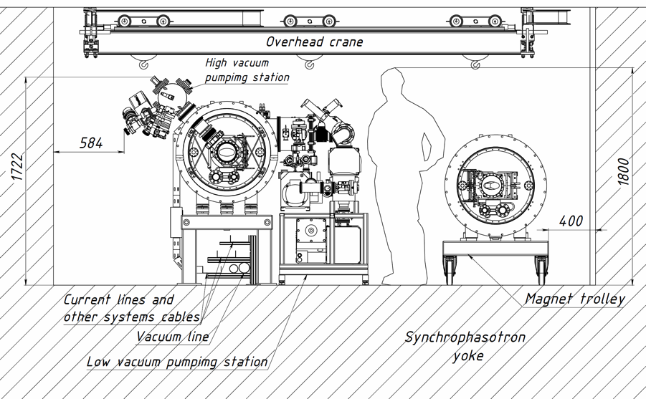
Fig. 1. Location of the Booster magnets inside the yoke of the Synchrophasotron magnet

The Booster (Fig. 2) includes the systems listed below.
Cryo-magnetic system, including dipole magnets, quadrupole lenses, correctors, vacuum chambers, cryostat system. The Booster magnets are similar to the Nuclotron superconducting magnets, but they have a single-layer winding and are bent with a radius of curvature of about 14 m. The doublets of the lens are made as a whole in one setting on the machine. The magnetic lattice of the Booster consists of 4 superperiods, each of them includes 5 regular periods and one period that does not contain dipole magnets. The regular period includes focusing and defocusing quadrupole lenses, 2 dipole magnets, and 4 small free straight sections designed to locate multipole correctors, collimators, and diagnostic equipment. The listed elements of the magnetic system belong to the lattice elements of the Booster. Periods that do not contain dipole magnets are designed to locate inserted elements. The inserted elements are: the beam injection and extraction systems, the accelerating RF system and the electron cooling system.
The electron cooling system (ECS) of the Booster, designed to form the required value of the phase volume of the beam, has maximum electron energy of 60 keV. The electron cooling system is designed and manufactured in the Budker Institute of nuclear physics (BINP, Novosibirsk). ECS includes the following systems: main magnetic structure of ECS, electron gun and collector, magnetic optics, vacuum system and diagnostics of ECS, automated control system of ECS, power supply systems, engineering systems.
Injection and extraction systems, transfer of the beam, beam transport lines, including the following systems: injection System, fast extraction system, beam transport line from the Booster to the Nuclotron, slow extraction system, test benches for injection and extraction systems.
Power supply system of Booster magnets, including the main and two additional power supplies, power supplies for correctors, energy evacuation system, quench detection system.
Radio-frequency system (RF), including accelerating stations and control system. The Booster acceleration stations were designed and manufactured at Budker INP (Novosibirsk), delivered to JINR and tested on a testbench with a magnetic field cycle imitator in 2014.
Diagnostic and control system including the following subsystems and devices: magnetic field ramp dB/dt measurement system, cycle control system, pickups, diagnostics, orbit correction system, thermometry system, Booster ACS, orbit measurement system, ionization monitor. Additionally, the system includes test benches for the diagnostic and ACS elements.
Vacuum system, including a pumping system of the beam pipe, the pumping system of the insulation vacuum volume and control system of the vacuum equipment. The system also includes high-vacuum stands.
The beam transport line from the Booster to the Nuclotron also belongs to the Booster systems and is functionally combined with the beam injection and extraction systems.

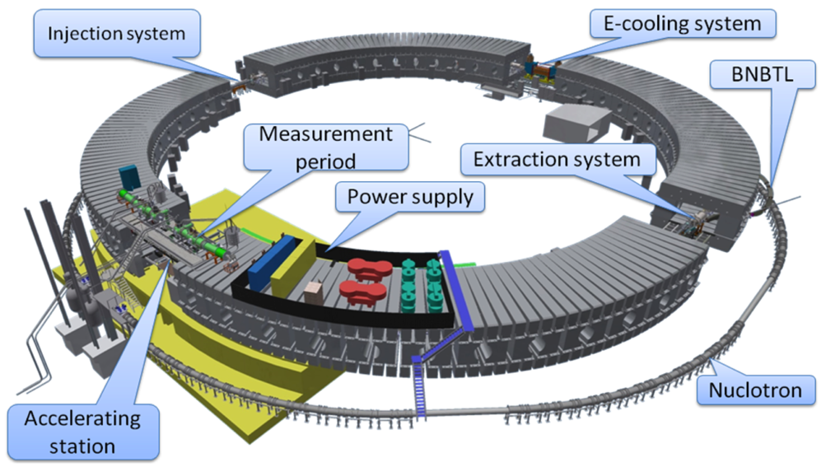
Fig. 2. Location of the main Booster systems

The main parameters of the Booster are listed in the Table 1.

Table 1.
Main parameters of the Booster
1. Common parameters
Ions | ¹⁹⁷Au³¹⁺
Injection energy | 3.2 МeV/u
Maximum energy | 600 МeV/u
Magnetic rigidity at injection | 1.6 Т∙m
Maximum magnetic rigidity | 25 Т∙m
Circumference | 210.96 m
Transition energy | 3.25 GeV/u
2. Optic structure and magnetic elements
Number of super-periods | 4
Number of DFO periods | 24
Number of dipole magnets | 40
Number of quadrupole lenses | 48
Effective length:  Dipole magnets  Quadrupole lenses | 2.2 m  0.47 m
Magnetic field of the bending magnets:  At injection  Maximum | 0.11 Т  1.8 Т
Gradient of the F lenses: at injection, | 1.28 Т/m
maximum | 21.01 Т/m
Gradient of the D lenses: at injection, | –1.31 Т/m
maximum | –21.48 Т/m
Bending radius in the dipole magnets | 14.09 m
Number of long straight sections | 4
Length of the long straight section | 7 m
Lengths of the small straight sections | 0.7/0.85/0.95 m
3. Lattice parameters
Betatron tunes:  Q_{x}  Q_{z} | 4.8  4.85
Chromaticity:  ΔQ_{x}/(Δp/p)  ΔQ_{z}/(Δp/p) | −5.1  −5.5
Orbit compaction factor | 0.05
Acceptance:  Horizontal  Vertical | 150 π∙mm∙mrad  57 π∙ mm∙mrad
Revolution period at injection | 8.5 μs
After acceleration | 0.89 μs
Assembly of the Booster has been started in 2016 with the installation of the electron cooling system in its nominal position. The first elements of the Booster magnetic system were delivered to the accelerator hall in September 2018. The Booster assembly was completed at the end of 2019 (Fig.3).
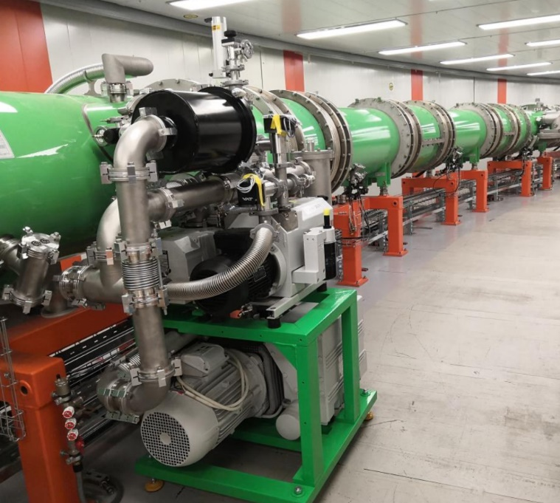
Fig. 3. The Booster cryo-magnetic system in assembly
All elements of the Booster were tested and tuned. The technological run dedicated to the Booster commissioning has been started 12 of November 2020.
During the run, completed on 30 December 2020, the following works were performed consequently:
- assembly and test of the vacuum system was completed,
- the Booster control and thermometry systems were put into operation, cryo-magnetic system was cooled down to 4.5 К,
- the quench detection system was tuned and put into operation, cycle control system and power supply system of Booster magnets were tuned,
- the heavy ion linear accelerator HILAc and the beam transport line from the HILAc to the Booster were tuned, the design parameters of the injection system devices were provided,
- the beam injection into the magnetic field plateau corresponding to the injection energy was performed, circulation beam of He¹⁺ ions was obtained,
- main systems of the circulating beam diagnostics, orbit correction system were tested consequently, the circulating beam intensity closed to the design value was obtained,
- Radio-frequency system was tuned, the regime of the adiabatic beam capture into the acceleration was tested, the beam acceleration up to 100 MeV/u was obtained,
- the electron cooling system was switched on and tested,
- the power supply, cryogenic and cryo-magnetic systems were tested at operation with the magnetic field cycle of the design parameters.

Chairman of the SC VBLHEP E.A. Strokovsky

Scientific Secretary SC VBLHEP S.P. Merts

