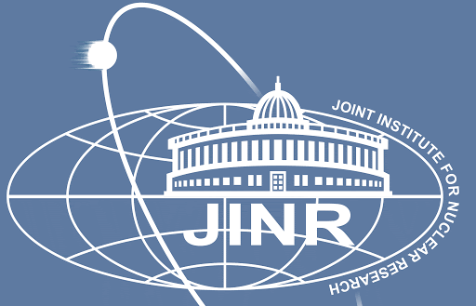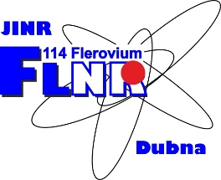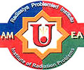
FLEROV LABORATORY OF NUCLEAR REACTIONS AT THE JOINT INSTITUTE FOR NUCLEAR RESEARCH
INSTITUTE OF RADIATION PROBLEMS, AZERBAIJAN NATIONAL ACADEMY OF SCIENCES
CIRRICULUM VITAE and PUBLICATION LIST

Matlab N. Mirzayev  Address: Flerov Laboratory of Nuclear Reactions at the Joint Institute for Nuclear Research, DUBNA, MOSCOW distr., 141980, RUSSIA  Email: matlab@jinr.ru | Telephone: +79197683236 | 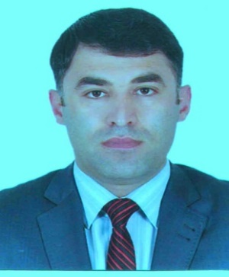
PERSONAL INFORMATION
Name | MATLAB
Surname | Mirzayev
Address | Flerov Laboratory of Nuclear Reactions at the Joint Institute for Nuclear Research, DUBNA, MOSCOW distr., 141980, RUSSIA
e-mails | matlab@jinr.ru
matlabmirzayev@gmail.com
matlab_mirzayev@yahoo.com
Tel | +7 496 216 42 11
Mobile Phone | +7 919 768 32 36
Date of birth | 13.07.1983
Bio link: | https://www.scopus.com/authid/detail.uri?authorId=57201685593 https://www.mendeley.com/profiles/matlab-mirzayev/  https://www.researchgate.net/profile/Matlab_Mirzayev https://scholar.google.com/citations?user=e3UPPTQAAAAJ&hl=en  https://orcid.org/0000-0002-0847-5452
Skype address | mat-lab1983
PERSONAL STATEMENT
My primary research focuses on the experimental nuclear physics such as the investigation of radiation effects and defects and positron annihilation lifetime spectroscopy in solids under different types of radiation conditions. I am particularly interested in understanding behaviors of the substances that are prominent materials for radiation shielding against gamma, neutron, electron and ion irradiations. As an associate professor at Flerov Laboratory of Nuclear Reactions at the Joint Institute for Nuclear Research, I have gained precious experience in the nuclear topics such as shielding materials for nuclear applications, irradiation damage and analysis and studies of ion—radiation stability of microstructure, elemental and phase compositions. The scientific field of my researches connected with structure and phase state investigation of promising nanocomposite materials for nuclear applications. Pure boron compounds and boron-tungsten based composite materials were used in the experimental process that had been irradiated by alfa, neutrons, ions, and electron and flows of high-energy charged particles. My research area mainly focuses boron and tungsten alloys that are prominent materials due to their high melting point, low vapour pressure, very low sputtering erosion yields and high thermal conductivity for armour materials of plasma facing components. On the other hand, its limitations are associated with handling at low temperatures, plasma compatibility including neutron irradiation and radiological issues.
EDUCATION
09/2019
Supreme Attestation Commission under the President of the Republic of Azerbaijan | Baku, Azerbaijan
By the decision dated October 7, 2019 (Protocol 19-K) confers on Matlab N. Mirzayev the academic title of Associate Professor in the Specialty of Radiation Materials Science
01/2010 – 01/2014
Institute of Radiation Problems, Azerbaijan National Academy of Sciences| Baku, АZ1143 Azerbaijan
Ph.D: Radiation material science, application and technology
Thesis Title: INFLUENCE OF INTERNAL AND EXTERNAL IRRADIATION ON ELECTROPHYSICAL PROPERTIES OF URANYL-SILICATE COMPOUNDS
Degree: Ph.D on Physics, Senior Scientist
09/2005 – 07/2007
Baku State University, Faculty of Physics | Baku, АZ1143 Azerbaijan
MSc: Division of Physics Education, Master Program, Faculty Physics of Solid State
09/2001 – 07/2005
Baku State University, Faculty of Physics | Baku, АZ1143 Azerbaijan
BSc: Division of Physics Education, Bachelor Program, Faculty Physics of Solid State
EMPLOYMENT HISTORY
01/09/2017 – Present
Associate Professor | Flerov Laboratory of Nuclear Reactions at the Joint Institute for Nuclear Research.
Scientific and Experimental Physical Department: Ion-implantation nanotechnology and radiation materials science
Head of Department: Vladimir Alexeevich SKURATOV, D.Sc.
Dubna, Russia
01/09/2017 – 18/12/2014
Senior Scientist | National Nuclear Research Center, AZ1073, Inshaatchilar pr. 4, Baku, Azerbaijan
Division: Department of Nanotechnology and Radiation Material Science
Position: Ph.D on Physics, Senior Scientist
In this period, I carried out studies on the following topics:
Determination of microstructure, elemental and phase states of the boron matrix composites under the radiation irradiation conditions. As shown in the below techniques:
- Scanning Electron Microscopy (SEM)
- X-Ray Diffraction (XRD)
- Raman Spectroscopy
- Small-Angle Neutron Scattering (SANS)
- Differential Scanning Calorimetry (DSC)
- Thermogravimetric analysis (TGA)
06/05/2007 – 23/12/2014
Research Fellow | Institute of Radiation Problems, Azerbaijan National Academy of Sciences| Baku, АZ1143 Azerbaijan
Title of department: Physics of radionuclide-containing materials.
Position: Researcher
Supervisor: Ravan N. Mehdiyeva
I studied the topics as shown below during this period:
- Acquaintance with gamma irradiation technique and irradiation of composites by high-energy electrons.
- Electrophysical properties of boron composites irradiated by gamma and ions.
- Analysis and studies of ion—radiation stability of microstructure, elemental and phase compositions.
- Investigation of surface modifications and phase transformation of composite materials under the high gamma irradiation conditions.

ADDITIONAL SKILLS / RESEARCH INTEREST
I have been working as a research assistant at the Flerov Laboratory of Nuclear Reactions at the Joint Institute for Nuclear Research since 2018. In the meantime, I also have some responsibilities to give lectures at the following laboratories.
    - Radiation measurement techniques
    - Positron annihilation lifetime spectroscopy XRF Analyses
    - XRD Analyses
    - SEM Analyses
    - Energy-dispersive X-ray spectroscopy (EDS, EDX)
    - The investigation on behaviour of soil samples against radiation
    - Selection of tracer injection and sampling procedures
    - Raman Spectroscopy
    - Small Angle Neutron Scattering (SANS)
    - Differential Scanning Calorimetry (DSC) Thermal Analysis.
    - Thermogravimetric Analysis (TGA)

