Annotation of work “The vGeN experimental setup for the investigation of reactor’s antineutrino properties” for JINR competition in section of physics instruments and methods.
Authors: V.Belov, I.Zhitnikov, S.Kazartsev, A.Lubashevskiy, D.Medvedev, D.Ponomarev, S.Rozov, K.Shakhov, E.Shevchik, E.Yakushev.

DLNP, JINR group has created the unique experimental νGeN setup at Kalinin nuclear power reactor (Udomlya, Russia). It is aimed to the investigation of the fundamental neutrino properties. The search of coherent elastic neutrino-nucleus scattering (CEvNS), neutrino magnetic moment and other rare processes is performed. The νGeN spectrometer is installed at the close vicinity of reactor core (at about 11 m), where neutrino flux is more than 5x10¹³ neutrino/(cm²⋅s). The setup is located under the reactor, so surrounding materials provide at about 50 m water equivalent shielding from cosmic rays. The custom-designed low-threshold high purity germanium detector is used to detect desired signals. The system of passive and active shielding has been built around the detector to suppress ambient background (see Pic.1).
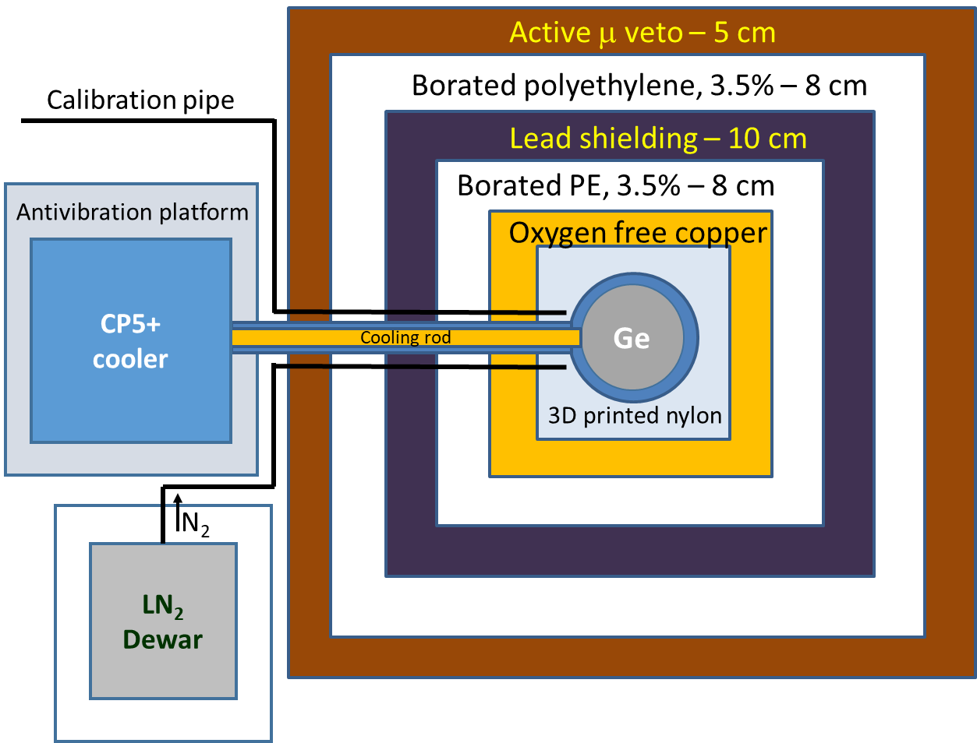
Pic.1. Scheme of the νGeN shielding. Top view [1].
We have been organized acquisition and noise reduction systems to detect low energy signals. It has been demonstrated that the detection efficiency for signals above 250 eV is always higher than 80%. The comparison of the data taken with reactor on and off (94.5 and 47.1 days respectively) does not show any significant difference in taken spectra (see Pic.2).
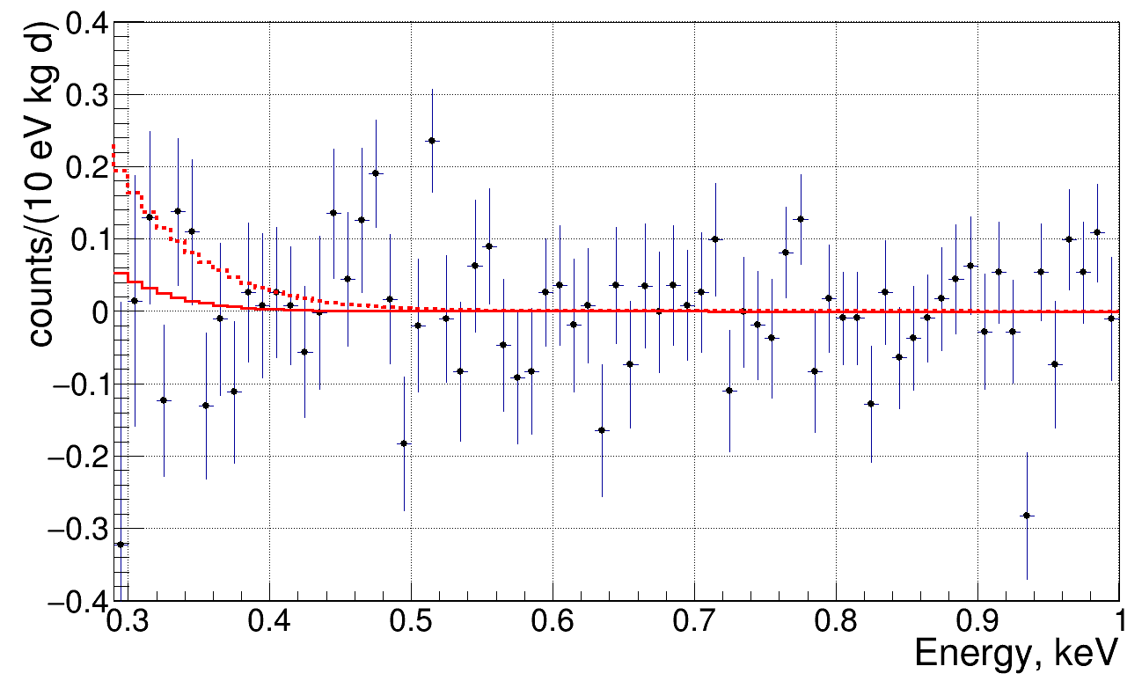
Pic.2. Residual spectrum (on-off). Red solid and dashed lines demonstrate predictions from CEvNS with k = 0.179 and k = 0.26 respectively.
Analysis of the data does not show any indications of signals from CEvNS so far. The data disfavored the important parameter of the ionization losses (quenching) in germanium k > 0.26 with 90% CL. The νGeN experimental setup showed that one of the best sensitivities to search of coherent elastic reactor antineutrino nucleus scattering has been achieved. It is looking towards to the first registration of CEvNS in the full coherent regime.

Publications:
[1] I. Alekseev et al., “First results of the νGeN experiment on coherent elastic neutrino-nucleus scattering”, Phys. Rev. D 106, L051101, (2022)

