**Report for 2015-2023**

**of the topic:**

**02-0-1108-2011/2023**

**“Experiment PANDA at FAIR Accelerator Complex”**

**Abstract**

FAIR complex, which is being constructed at GSI (Darmstadt), will provide unique possibilities for studying physics in a wide domain including atomic and plasma physics, heavy ion collisions and nuclear matter physics, nuclear structure and physics with antiprotons. The PANDA experiment planned at FAIR High Energy Storage Ring (HESR) is devoted to the investigation of possible exotic states (hybrids, glue-balls, etc.) and structure of nucleons performed with antiproton beam of high intensity and homogeneity. The information obtained in this experiment will complement the knowledge from analyses of heavy ion collisions about nuclear matter features and phase transitions, which will be obtained in the fixed target experiment CBM, also at FAIR, and collider experiments MPD and SPD at NICA (JINR, Dubna).

The main JINR contribution to the PANDA experiment now is construction of the Muon System by instrumenting the layers of steel absorber with active detectors (Mini Drift Tubes) and electronics. The JINR is expected to contribute significantly to the construction of the detector and, later – to the physics of the PANDA experiment. This will provide a unique possibility in future for JINR physicists to study in details the antiproton-proton and antiproton-nuclei interactions at PANDA energies, make the measurement of different interaction parameters and test different models. In particular, the structure functions, charm resonances and general behavior of nuclear matter, including new states and phase transitions, are of great interest.

**Contents**

1. Executive summary …………………………………………………… 2
2. Introduction ………………………………………………………………. 3
3. Main results of the project ……………………………………………… 4
   1. Solenoidal magnet ……………………………………………………. . 4
   2. Muon System …………………………………………………………. 10
   3. Software tools and physics ……………………………………………. 15
4. Publications, Presentations and Reports ……………………………………. 17
5. Conclusion ………………………………………………………………….. 19
6. **Executive summary**

The present document describes JINR’s involvement and current contribution to the PANDA experiment.

The basis for the collaboration of the Russian Institutes and JINR in PANDA experiment is the strategic partnership of Russia and Germany in FAIR project. According to the documents signed at the governmental level the significant contribution (~ 17.5 % of the total FAIR project costs) should be provided by Russia. Most of this contribution is expected in form of constructing the accelerator and detector elements.

It is planned and expected that the main financial resources for this work will come to JINR from the Russian contribution to FAIR in form of FAIR-JINR contract on construction of the PANDA Muon System as a whole. At present, absence of this contract is the most challenging issue in the project. We hope that situation will resolve in Germany-Russia negotiations in reasonable time for project. In the case of positive decision, the JINR will have the possibility to contribute significantly to the construction of the detector and physics of the PANDA experiment. This will provide a unique possibility for JINR physicists to study in details the antiproton-proton and antiproton-nuclei interactions at PANDA energies, make the measurement of different interaction parameters and test different models. In particular, the structure functions, charm resonances and general behavior of nuclear matter, including new states and phase transitions, are of great interest.

Very important aspect of JINR participation in PANDA project is the possibility to use the technology of Mini Drift Tube (MDT) detectors and corresponding electronics developed for PANDA Muon System in design work of Spin Physics Detector (SPD) at NICA collider. The whole concept of PANDA Muon System fits well the needs of SPD muon system having very close energy range of projectiles. The degree of synergy between these projects is close to 100 % for detectors, analog electronics, test beam data (calibration) and about 90% for digital electronics.

1. **Introduction**

The PANDA setup (Fig.1) was designed to achieve 4*π* acceptance, high resolution for tracking, particle identification and calorimetry. To obtain a good momentum resolution the detector will comprise two magnetic spectrometers: the Target Spectrometer based on a superconducting solenoid magnet and the Forward Spectrometer based on a dipole magnet.

The detector will make use of excellent HESR design parameters for cooled antiproton beam interacting with internal targets: luminosity ~ 2*1032 - 2*1031 cm-2s-1(*), variable beam momenta in the range 1.5–15 GeV/c, and its high homogeneity ~ 10-4 – 2*10-5 (*), depending on high intensity or high resolution (*) mode of operation. The available center of mass energy is 2.5 – 5.5 GeV. The start of PANDA operation in the year 2025 (commissioning stage) is now planned with proton beam. The PANDA Collaboration comprises more than 420 physicists from 63 institutions in 18 countries.

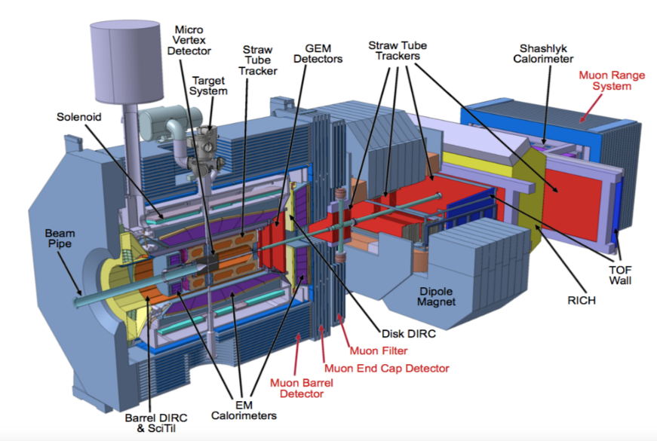

Fig.1 The view of PANDA setup: the Muon System elements (Barrel, End Cap, Filter and Range system) are indicated in red

The steel yoke of the Target Spectrometer serves also as particles absorber. This yoke is manufactured mostly of 30 mm thick plates (for better registration of very low muon momenta), the rest of absorber is made of 60 mm thick plates (for better interception of higher momenta). Such differentiation in sampling is selected due to the features of fixed target kinematics at PANDA energies.

The main JINR contribution to the PANDA experiment (Fig.1) now is construction of the Muon System by instrumenting the layers of steel absorber with active detectors and corresponding front-end analog and digital readout electronics. Mini Drift Tubes were chosen as active detectors for few reasons. First, the JINR group has large experience in equipping of D0/FNAL and COMPASS/CERN muon systems with this type of detectors. Second, the analog front-end electronics for these large systems was also designed and provided by JINR group. Third, MDT detectors may be easily adapted for second coordinate readout made of strip boards positioned on top of MDTs. So, PANDA Collaboration has accepted the proposal of JINR group of this two-coordinate detector for instrumenting its Muon System. The Technical Design Report of the PANDA Muon System was fully approved by FAIR management in 2015. This document, containing all motivations, scientific and technical features, is available at <https://panda.gsi.de/system/files/user_uploads/u.kurilla/RE-TDR-2012-003.pdf>.

Another big part of JINR activity was preparation of the solenoidal magnet design, which was fully developed in JINR. Since the year 2017 the JINR group, on mutual agreement between FAIR, JINR and PANDA collaboration, had delivered the fully prepared magnet project with finalized technical documentation to the Budker Institute of Nuclear Physics (BINP, Novosibirsk) for further construction.

The JINR group also contributes significantly to the development of software and Monte Carlo tools, both for Muon System and PANDA as a whole, and to the physical program.

1. **Main results of the project**

During the execution of this topic the following main activities were developing at JINR:

* Solenoidal Magnet

* Muon System

* Software tools and physics

The details on the main results obtained in 2015-2020 and the plans for 2022-2024 are given below.

**3.1. Solenoidal Magnet**

The solenoidal magnet system of PANDA Target Spectrometer consists of three main parts: superconducting solenoid, its cryostat and the steel yoke. The last one, after been instrumented with detectors, represents part of the Muon System.

**The following main results were obtained during execution of the project by JINR team.**

The strength analysis of the PANDA magnet has been performed by Dubna group, which consisted of several tasks: building a model and coordinating the initial data for calculations (main dimensions, cryostat model, material properties, magnetic and seismic forces, weight loads, rail track parameters, tolerance for cryostat center axis inclination, etc.), choosing options for cryostat fixation, magnet door component arrangement, magnet support, passages for tubing and cabling, developing the naming conventions for magnet parts and many others. The following figures illustrate general parameters of the magnet modeling (Fig. 2).



Fig.2 General parameters of the Magnet FE modeling

As a result of detailed calculations and FE analysis the following conclusions were derived:

* The strength of the main components and fixation units of the iron yoke is on a sufficient level. The yoke is able to bear loads in all assembly, transportation and operative regimes with minimal safety margin 1.4.
* The request of the Muon group for increased passages for cabling has been met.
* It takes some minor design modifications before preparation of the Technical Specification of the yoke.
* Both cryostat support design options meet the demand of the GSI/INFN colleagues. From yoke strength point of view they are virtually identical.
* Rigidity characteristics of the cryostat supports are obtained. They can be implemented for strength analysis of the cryostat with SC winding without yoke modeling.
* Main characteristics of the yoke supports are prepared for Technical Specification of the rail track in GSI.

According to section 3 of the Technical Specification for the contract the goal of this work is development a set of design documentation for the Technical project of the PANDA magnet cryostat. During the development of the contract the following documents and drawings of the Technical Design of the PANDA magnet cryostat have been prepared:

**3NM1004.00.000TO1Technical Description of the PANDA cryostat**

The document is available on the CERN EDMS service and can be found at the following link: <https://edms.cern.ch/file/1710145/1/TechDescr_PANDA_Cryostat.zip>

General view of the PANDA cryostat with the control Dewar is presented on the following picture (Fig. 3).

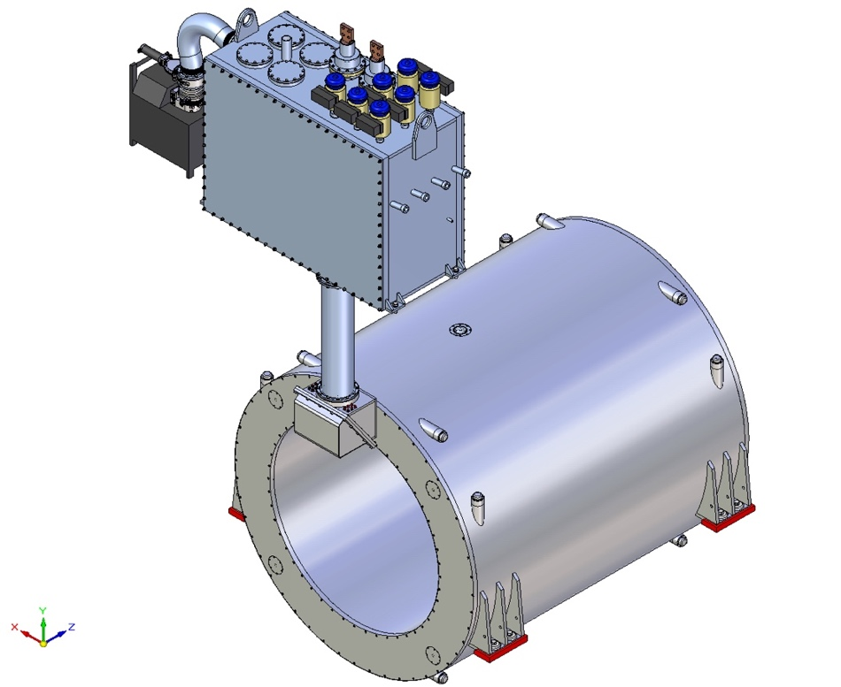

Fig. 3 General view of the PANDA cryostat with the control Dewar

This document contains description of the Cooling System of the magnet including description of the cooling cycle and operating regimes of the PANDA magnet. The parameters of the helium flows of operating regimes and thermal loads of the cryostat and control Dewar of the solenoid are given in the document as well. The document includes detailed description of the cryostat and control Dewar design including description of their vacuum vessels and thermal shields , control and safety valves, vessel for liquid helium, service chimney, interface box, suspension system of the cold mass, vacuum pumping system. Cryostat and cryogenic safety is considered in the document.

Cryostat assembly at producer places and procedure of cryostat insertion into the Iron Yoke in GSI have been considered. Wheeling the fully assembled cryostat into the iron yoke along the mounting beam is shown on the following picture (Fig. 4).

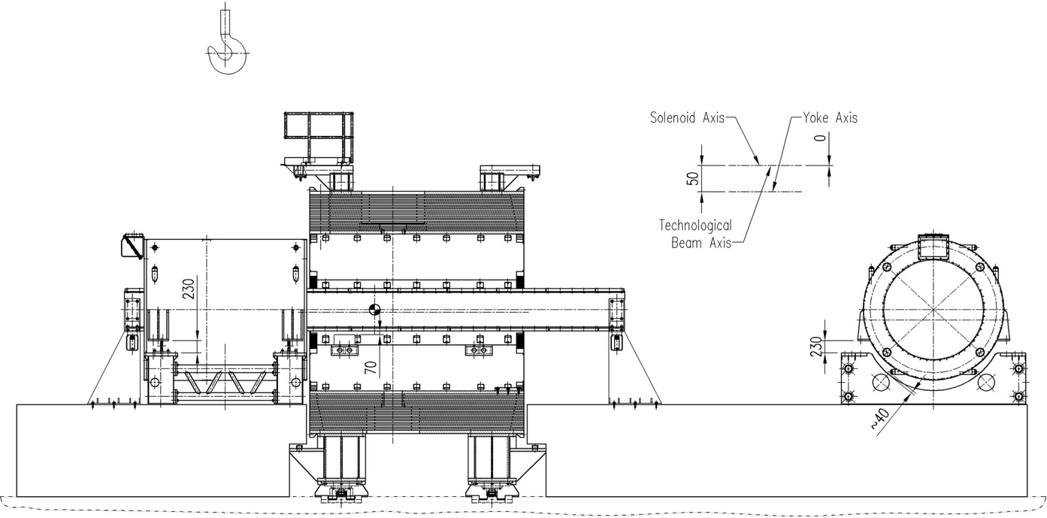

Fig. 4 Wheeling the fully assembled cryostat into the iron yoke along the mounting beam

**3NM1004.00.000TZ2 Technical Specification for supply of the PANDA magnet cryostat**

The document is available on the CERN EDMS service and can be found at the following link:

<https://edms.cern.ch/file/1713167/1/TZ1_PANDA_cryostat_TechSpec_11.08.2016.docx>

In accordance with the section Scope of the delivery of the document the Contractor is obliged

* to make a detailed design of the PANDA cryostat;
* to provide the materials and services, necessary equipment and facilities for manufacturing;
* to produce and to test the cryostat with its components;
* to assemble the cryostat at his place with cold mass and iron yoke;
* to produce the necessary tools for assembly;
* to provide the cryostat transportation toDarmstadt, Germany;
* to make the final assembly of the cryostat with iron yoke at the PANDA experimental building at High Energy Storage Ring (HESR) of the accelerator complex FAIR at GSI;
* totake part in tests of the assembled magnet and its commissioning.

The Contractor shall develop assembly procedure of the cryostat with the cold mass and Control Dewar, installation procedure of the cryostat into the iron yoke and commissioning of the system in the PANDA experimental building.

The solenoid cryostat shall include service chimney, control Dewar, suspension system of the cold mass, control system of the cryogenic and all ancillary instrumentation, safety relief valves, vacuum system etc. as specified.

**Assembly drawings** **of the cryostat with control Dewar:**

The list of the main assembly drawings of the cryostat and control Dewar

3NM1004.00.500 SB Solenoid (Assembly drawing)

3NM1004.00.510 SB Cryostat (Assembly drawing)

3NM1004.00.550 SB Vacuum vessel (Assembly drawing)

3NM1004.00.570 SB Thermal screen (Assembly drawing)

3NM1004.00.630 SB Interface box (Assembly drawing)

3NM1004.00.660 SB Chimney (Assembly drawing)

3NM1004.00.670 SB Control Dewar (Assembly drawing)

3NM1004.00.600 SB Suspension unit (Assembly drawing)

3NM1004.00.610 SB Suspension unit (Assembly drawing)

3NM1004.00.690 SB Vacuum vessel (Assembly drawing)

3NM1004.00.710 SB Thermal screen (Assembly drawing)

The drawings are available on the CERN EDMS service and can be found at the following link:

<https://edms.cern.ch/file/1710492/1/Cryostat_DWG_and_JPG_ENG.ZIP>

<https://edms.cern.ch/file/1710492/1/Cryostat_DWG_and_JPG_RUS.ZIP>

**TOSCA model for 3D computations of the magnetic field (last options of the CERN coil dimensions and iron yoke with reduced number of slots for muon panels)** (Fig. 5)

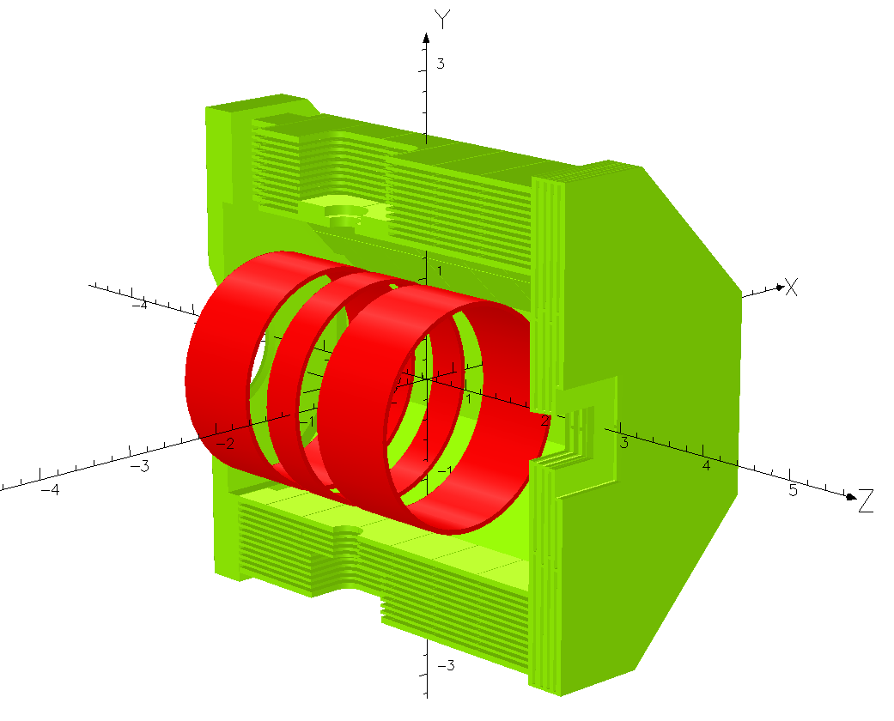

Fig. 5 TOSCA model for 3D computations of the magnetic field (last options of the CERN coil dimensions and iron yoke with reduced number of slots for muon panels)

The file of TOSCA model is available on the CERN EDMS service and can be found at the following link: <https://edms.cern.ch/file/1431368/2/PANDA_TS_3D_coil3x2_new_yoke.opc>

**Two 3D-models of the Iron Yoke with reduced number of the slots for muon panels**

The files of 3D model (one of the models is simplified for use in a large detector 3D model) is available on the CERN EDMS service and can be found at the following links:

<https://edms.cern.ch/file/1064509/2.1/Solenoid12g_3D100_Yoke_Full_Light_Reduced_(12_layers_barrel)_stp.zip>

<https://edms.cern.ch/file/1064509/2.1/Solenoid12g_3D100_Yoke_Full_Light_Reduced_WB_(12_layers_barrel)_stp.zip>

**3D PANDA Cryostat model with cold mass**

The file of the model is available on the CERN EDMS service and can be found at the following link:

<https://edms.cern.ch/file/1458626/1/Solenoid12g_3D100_Cryostat_Full_Update-1_stp.zip>

**3NM1004.00.000R1.3 Calculations of stress-strain state of the suspension system of the PANDA solenoid cold mass taking into account technology deviations of the production process and the cyclic strength of materials**

In this work by the static and cyclic strength of the cold mass suspension rods with increased diameter of the threaded part was determined in addition to the previously performed calculations 3NM1004.00.000R1.1, 3NM1004.00.000R1.2, including assessment of their strength under seismic load, as well as refined permissible field of technological deviations of mutual position of the rod ends during installation of the cold mass into the vacuum envelope of the cryostat.

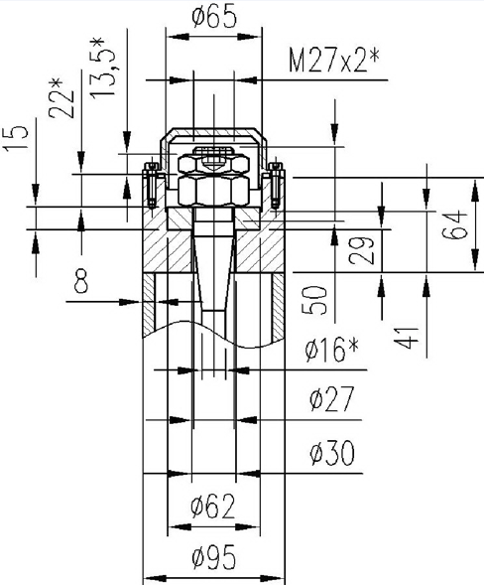

Fig.6 Design of suspension rods

According to calculations the most loaded unthreaded parts of suspension rods are unthreaded parts of the radial horizontal rods. The most loaded threaded parts are threaded parts of the axial rods on the opposite side of the cryogenic input (Fig.6). Least loaded are radial vertical rods. Besides static and cyclic strength of the vessel for liquid helium when it is exposed to an internal overpressure 0.6 MPa was evaluated. According to calculations the static and cyclic strength of the vessel is ensured.

**3NM1004.00.000R2.2Calculation of field and forces for the new design of Flux Return Yoke of the PANDA Target Spectrometer magnet**

The following changes in the yoke design have been considered:

* number of steel layers in the barrel is reduced from 13 to 12;
* interlayer (air) gaps thickness is increased from 30 mm to 35.45 mm both in the barrel and in the downstream end cap;
* thickness of steel layers is changed

Maximal field inhomogeneity and integral of the radial component in the Tracker region are practically the same as in the previous yoke design (within the accuracy of calculations) and are equal to 1.6 % and 2 mm correspondingly. Lorentz force Fz acting on the coil at nominal current is increased from ‑40 kN to -53 kN.

Lorentz force Fz acting on the coil shifted by ΔZ=-20 mm at maximal current increased from   
-154 kN to -168 kN. So, the decentring force ΔFz=168-62=106 kN appears to be smaller than in the previous design ΔFz=108 kN.

Lorentz force Fy acting on the coil (maximal current, coil shifted by ΔY=+15 mm) is 47.5 kN. So, the decentering force ΔFy=47.5+3.2=50.7 kN appears to be practically the same as in the previous design ΔFy=51 kN.

**3NM1004.00.000R2.3 Calculation of magnetic forces acting on the radiation shields of cryogenic chimney and interface box**

The radiation shields of cryogenic chimney and interface box made of conducting materials are affected by magnetic forces due to eddy currents during the transient processes (quench or magnet energizing/de-energizing). The purpose of this work was calculation of the Lorentz force density distribution in the shield and finding the regions with the maximum values of forces. ELEKTRA 3D transient model has been prepared and computations of magnetic induction and time dependence of eddy currents have been performed. The surface force density distributions have been computed and integral forces over selected regions have been calculated.

According to calculations these forces are not too large. For example, the radiation screens of cryogenic chimney and interface box are affected by the following sum forces during the fast discharge of the coil: Fy = -34.55 N, Fz = 31.8 N.

**3NM1004.00.000R3.2Clarification of cryogenic characteristics of the PANDA magnet**

Repeated calculations of the natural convection regime (thermosyphon) and transit regime of the cold mass cooling have been performed due to some changes of the cold mass design.Calculations of the cool-down regime of the cold mass was performed to determine cooling time of the cold mass from 300 K to 4.5 K and the helium flow needed to provide cooling rate of 1 K/h. According to calculations maximal helium flow, which is needed to provide cooling rate of 1 K/h is 32.4 g/sec.

The description given above on solenoidal magnet design demonstrates the amount and quality of conducted works. The full engineering design of the system after been made by JINR group was delivered for construction to Novosibirsk. To the date, construction of the yoke is finished. The manufacture Barrel (8 assembled modules) and full yoke (Barrel and End Cap) are demonstrated on Fig.7. The Mini Drift Tubes with corresponding analog front-end electronics should be later installed in the slots of the yoke modules in Darmstadt before their final assembly in PANDA setup.

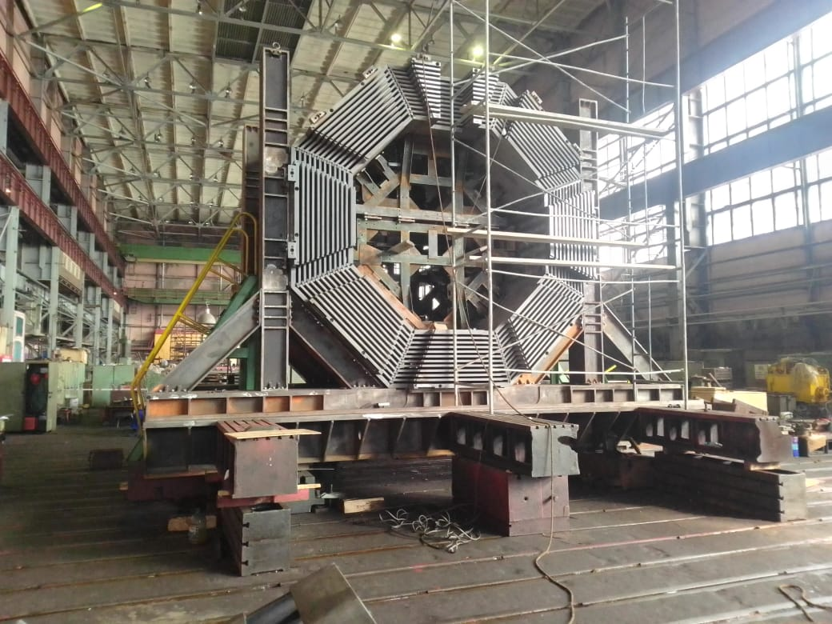 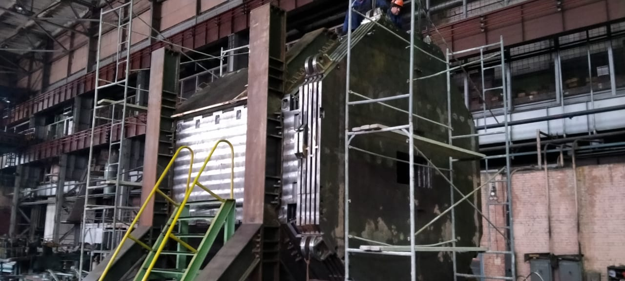

1. (b)

Fig.7 Yoke fabricated at Novosibirsk factory: (a) – Barrel, (b) Barrel with End Cap

**3.2. Muon System**

The R&D work of the JINR Muon group in PANDA was concentrating for the last three years on the following two items:

* Tests of the Muon System Prototype (Range System Prototype, RSP) at the test beam line T9 at PS/CERN, which mostly include calibration of prototype response to the different particles and energies.
* Development of the digital front-end electronics based on FPGA/Artix7 chip.

The RSP is constructed in a way, which represents all main structures of the Muon System: Barrel, End Cap, Forward and Range System. All of them are based on range system technology – steel plates (30mm or 60mm thick, depending on particular structure) interleaved with wire gaseous detectors planes made of Mini Drift Tubes (MDTs). The total thickness of the prototype is about 5 nuclear absorption length (in case of the most thick Forward Range System), and its weight is about 10 ton. The MDT planes carry also the strip boards on them made of 2mm thick G-10 fiberglass with 3cm wide strips scratched on the internal board surface looking to the MDTs. The strips run perpendicular to the wires. So, we have two-coordinate detector with resolution 1 cm and 3 cm for wires and strips, respectively. The prototype has more than 3000 readout channels on total. As the wires readout (due to the features of MDTs) has practically no noise it is used for pattern recognition and rough digital calorimetry. The strip readout has complimentary meaning for the events topology recognition.

**1) The most important result obtained with RSP at T9/PS beam line at CERN is demonstration of its excellent pattern recognition abilities.** On Fig.8 one can see process of the prototype mounting to the beam line, as well as the distinct differences in the patterns related to the muon, proton and neutron responses (wires readout channel). For 5 GeV/c beam momentum (arrows indicate the beam direction at entry to the prototype) three types of response are present: 1) practically ‘straight line’ for muon, 2) ‘shower tree’ for proton with clear point of shower start and 3) ‘shower tree without trunk’ for neutron. Green points represent the hit wires in these events (with resolution 1 cm) in the detecting planes inserted into the absorber structure of the RS. These pictures clearly demonstrate the excellent PID features of the Muon System and its ability to decouple muons and hadrons, which is the main task of this device in PANDA experiment. Moreover, the system serves as ‘2 in 1’ device as it may not only resolve muons and hadrons, but due to its design (sampling structure and reasonable thickness) it may also serve as hadron calorimeter with modest resolution.

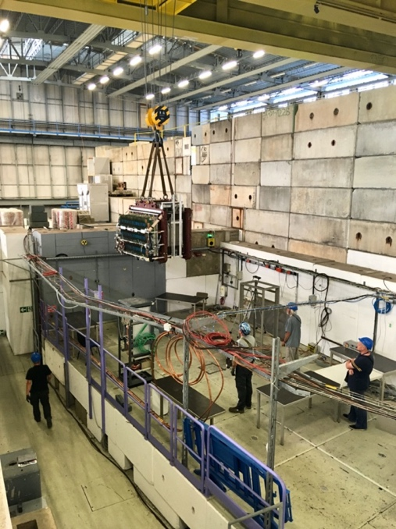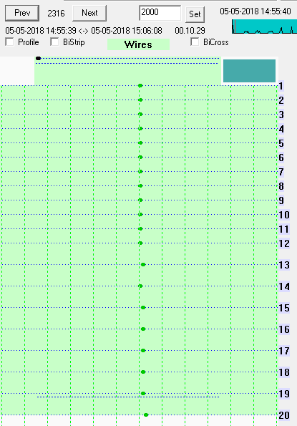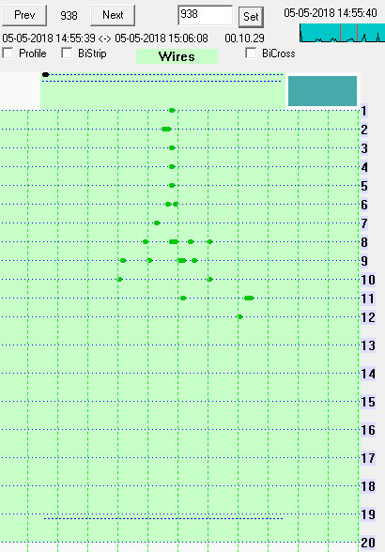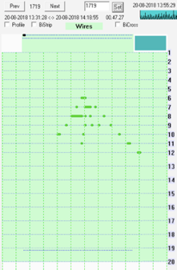

μ

p

n

5 GeV/c

5 GeV/c

5 GeV/c

Fig.8 Mounting of Range System Prototype at beam position and events with muon, proton and neutron at 5 GeV/c beam momentum (arrow indicates the beam direction at entry to the prototype/green volume/)

**Muon System is the only system in PANDA setup capable to register the neutrons** **and even roughly estimate their energy.** This observation was met with big enthusiasm by PANDA community, as it shows increased capability of PANDA experiment to see the neutrons thus improving the registration of hyperons.

**2) Calibration of the prototype (RSP) response to all particles (e+/-, µ+/-, π+/-, p+/-) available at CERN in full energy range of PANDA (0,5 – 10 GeV)** **is another important achievement of JINR group.** Such calibration performed at high enough statistical level permits us to start reliable MC description of data and, most important - to start development of pattern recognition algorithms for muons, pions and protons/antiprotons. For neutrons we have for the moment very initial data which demonstrate possibility to reliably measure their signal in principle.

On Fig.9 below the example of calibration curve (signal versus beam kinetic energy, T) and the energy resolution is given for the protons entering the prototype’s structure representing the Forward Range System. The calorimetric signal per event is measured digitally as total sum of wire hits in a shower. One may see a good linearity of response and energy resolution corresponding to the sampling of 60mm. Such calibrations for protons in other parts of PANDA (Barrel, End Cap and Filter) do also exist. Experimental beam data taken with pions are now being treated.

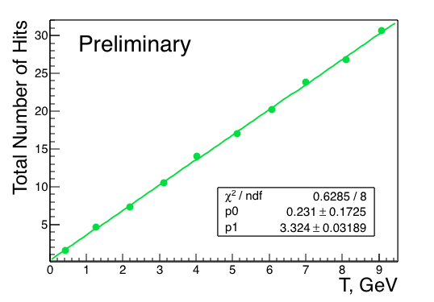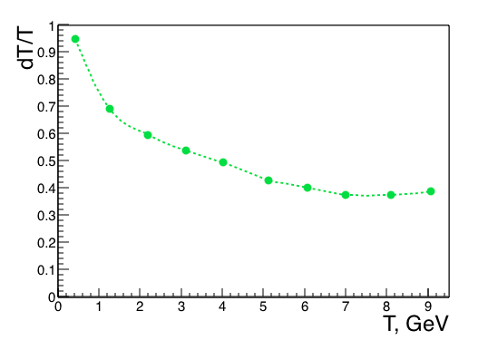

Fig.9 The calorimetric signal versus beam energy T (left) and energy resolution (right) for protons in FRS structure: sampling 60 mm / Fe, total absorber thickness ≈ 5.2 *λI*

**3) Observation of antiproton signal in FRS structure of the Muon System became also a serious result of the last period.** To get the signal with reasonably high statistics the test beam momentum was tuned to 4 GeV/c (corresponding to the maximal antiproton yield) and full data taking day was spent on this task (out of seven days of data taking period granted to the PANDA Muon System prototype on total for the spring 2018 run). The result is shown on Fig.10. The left plot gives superposition of proton and antiproton spectra at equal energies (for that the positive beam was tuned to the same 3.1 GeV energy for a short time). On the right plot one may see the calorimetric point for antiproton superimposed on the calibration curve for protons (that of Fig.9). It is seen that calorimetric response for antiproton is exactly 2 GeV above the response of proton with the same energy, which is due to the annihilation of antiproton in the prototype’s absorber. Thus, this feature may be helpful in PANDA for recognition of antiprotons: track with positive charge and momentum defined by tracker should have much higher calorimetric response.

**Protons vs Antiprotons**

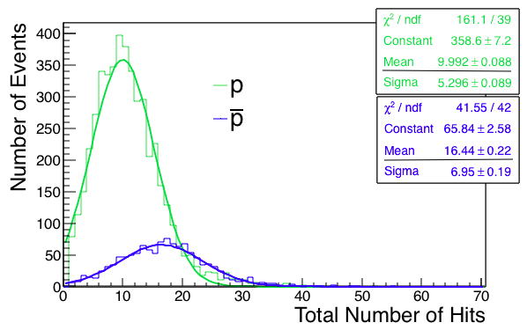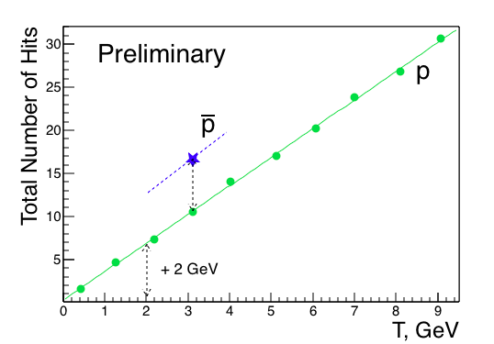

Fig.10 Antiproton signal (preliminary) as seen in FRS structure at beam energy T = 3.1 GeV (4 GeV/c beam momentum)

**4) Separation of muons and pions at low energies (around 0.5-1.0 GeV) is one of the main tasks of Muon System in PANDA setup.** At these energies big portion of pions do not produce hadronic showers but loose the energy in range system via ionization (dE/dx), thus they mimic the behavior of muons. Having the close masses, pions have almost the same path in media as muons. Additional difficulty for pion/muon separation is caused by muons from pions decay. Some of such decay muons may also have a path comparable with original/prompt muons. Direct experimental estimate of pion-to-muon separation achievable with our Muon System was performed at T9/PS test beam at CERN using time-of-flight technique to separate pions and muons at 0.5 GeV/c beam momentum. Separation was estimated by the number of last layer in the prototype reached by the particle. For this study the Barrel structure having more fine sampling of 30mm was used. Fig.11 shows the distribution of maximal depth of particle’s penetration in absorber measured in number of absorber layers (30mm thick each) with straggling peak of muons clear visible. One may see that we have generally rather good agreement between data and MC. Numerically it looks the following: if we select the layer #7 as maximal hit by the pions, than for 93% efficiency for muon registration the contamination of pions is 22% (in data), and 99% efficiency with 27% contamination (in MC).



Fig.11 Comparison of pion-to-muon separation in experimental data (left) and Monte Carlo (right)

We think that observed small discrepancy in data and MC is mostly due to the decay muons in T9/PS beam line. For better estimate of separation at low energies we plan to repeat this important measurement in JINR on SPD/NICA test beam area which is now being constructed at Nuclotron. The beam diagnostic for pions and muons will comprise better time-of-flight resolution and pressurized gas Cherenkov beam counter. This high-pressure counter (up to 60 bar of CO2 gas) is now constructed and will be tested at SPD test beam area at Nuclotron accelerator at JINR in 2021.

**5) Digital front-end electronics is the key element for connecting the Muon System to PANDA DAQ.** The situation with this part of front-end electronics (FEE) till the last year (2019) was rather critical, as the designing of digital FEE readout module was impossible due to the absence of PANDA-like DAQ system. To the contrary, the JINR group did practically finish development and tests of analog FEE with the prototype (suitable for PANDA). Thus, for reading out the information from MDT detectors we used COMPASS-like DAQ and digital FEE developed and produced by our group for COMPASS experiment at CERN (as the group is also responsible for the COMPASS Muon System). With this COMPASS-like DAQ all test beam data were obtained so far, since the year 2012. Now the Technical Design Report of PANDA DAQ is being written and we can start development of our new version for digital FEE. As a stage of preparation to final digital FEE of Muon System we have designed and produced intermediate version of the unit based on FPGA Artix7 chip. This approach (using FPGA chips for digital FEE) accepted by PANDA Collaboration is flexible enough and permits tuning the digital electronics for particular DAQ by proper programming of FPGA.

This intermediate version was realized in VME 6U module shown on Fig.12. The module was successfully tested with the prototype on cosmic at CERN (see Fig.13) in October 2019.

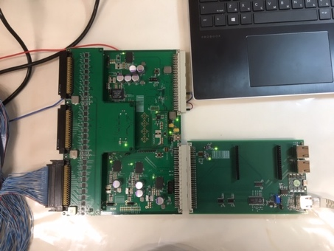

**VME/6U FPGA unit (192 R/O channels) based on ARTIX7 chip**

**DAQ interface card**

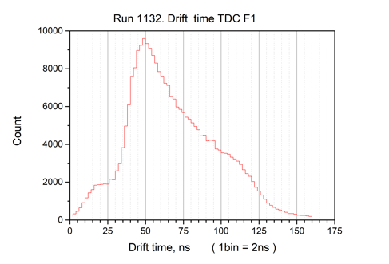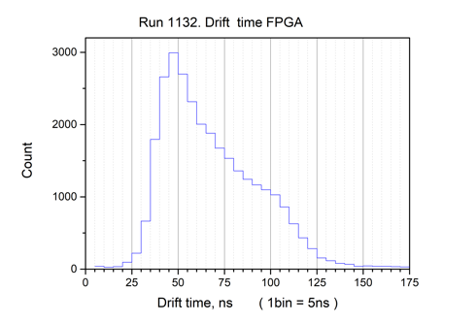

F1/ASIC TDC

FPGA TDC

200 MHz clock

Fig.12 Digital/FPGA FEE intermediate module (left) and drift time spectra of MDT detectors (right) for standard unit (in red) and the intermediate one (in blue)

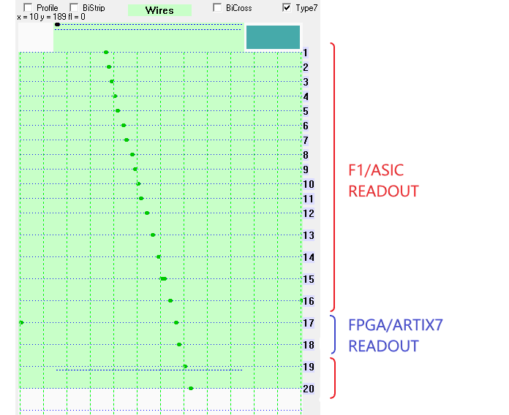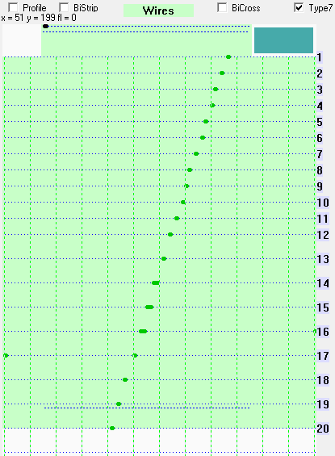

Fig.13 Typical cosmic events read out by common COMPASS DAQ system as combination of standar modules (ASIC chip, in red) and intermediate one (FPGA, in blue)

For this test the following was done: 1) the module was programmed to the COMPASS DAQ protocol, 2) two MDT detecting planes (#17 and #18), out of 20 on total, were connected to readout via this module, whereas the rest of prototype was readout by standard COMPASS units based on ASIC/F1 TDC chip. Both types of digital FEE modules were readout by common COMPASS DAQ system on cosmic event triggers. Equality in drift time spectra (small bump at the beginning of ‘red spectrum’ is due to some peculiarity of ASIC chip), as well as correct position of the hits readout by the FPGA module on the common tracks, prove the proper operation of FPGA based digital FEE module. When PANDA DAQ Technical Design Report will be finished and approved by the Collaboration, we shall design a final version of digital FEE module for the Muon System.

**3.3. Software tools and physics**

1. **The full geometrical description/model of the Muon System was finalized.** It is now ready for implementation into the PANDARoot package. In 2018-2019, the final mechanical design of the Muon System (absorber part) was agreed with colleagues from the BINP (Novosibirsk) who are engaged in the production of the Solenoid Magnet yoke. The Barrel part of the Muon System has undergone significant changes, in particular, the number of detecting layers has decreased (to 12) compared to the previous design, the dimensions of the installation also have changed. As a result, the geometrical model of the Barrel part of the Muon System was modified. Also, the geometrical models of the End Cap, Muon Filter and Forward Range System are now ready for integration into PANDARoot framework (Fig. 14, FRS not shown). The software was rewritten using a geometry package in Root.

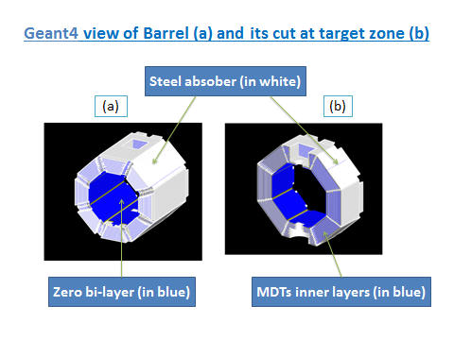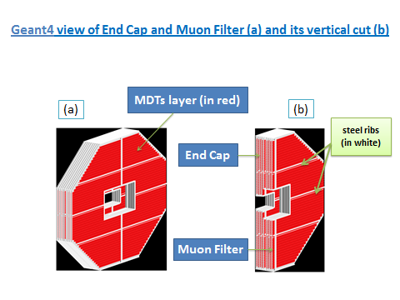

Fig.14 View of Muon System parts in PANDARoot

1. **In 2017-2019, current versions of PANDARoot framework from GIT with corresponding versions of external libraries FAIRSoft and FAIRRoot were installed at heterogeneous cluster “HybriLIT” at LIT JINR.** That gave a possibility to perform full simulations, reconstruction and analysis of Pbar-P and Pbar-A processes in **PANDARoot** at cluster **HybriLIT** for PANDA users from JINR and Russia.
2. **New probabilities of strange quark-antiquark pair and diquark-antidiquark pair productions were proposed and implemented in the FTF model of Geant4.** Kinematical properties of Lambda- hyperons and K- mesons produced in antiproton-proton reactions were calculated in the improved FTF model and compared with the experimental data at various initial momenta. The differential cross sections of the processes Pbar-P -> Lambda - LambdaBar, Pbar-P-> Lambda -SigmaBar, Pbar-P->Pi+Pi- , Pbar-P->K+-K- were also calculated in the FTF model. Good description of the experimental data was obtained in the FTF model with the rotating strings and the new probabilities. Application of the FTF model is demonstrated for the physical program of **PANDA Phase 0 and Phase 1**.
3. **Simulations of elastic P-P and Pbar-P interactions in the frame of the Unified Systematic of Elastic Scattering Data (USESD) are performed** in a wide range of energy– from 100 MeV up to 10 TeV. Calculations of inelastic P-P interactions at various energies are performed in the frame of improved FTF model of Geant4 toolkit. These results can be used for developing of physical program of **PANDA Phase 1.**
4. **Full simulation using PANDARoot at HybriLIT cluster was performed** for reconstruction and analysis of inelastic and elastic proton-proton interactions with 2,4,6 hadrons in the final states with large transverse momentum in the frame of FTF model. The analysis results show that such processes can be studied in the frame of **PANDA Phase 1**.

**6) Simulation of proton interactions with C, Al, Cu and W at 50 GeV/c was done using Geant4 FTF model.** Kinematical properties of cumulative protons, pi-mesons, K-mesons and antiprotons produced at 40 degree angle were studied and compared with experimental data of SPIN experiment. These results can be useful for developing of Pbar-Nucleus physical program of the PANDA experiment.

**7)** **The scaling and asymptotic properties of slow neutrons spectra (produced in interactions of protons with various nuclei in the energy range from 747 MeV up to 8.1 GeV) were implemented in the Geant4 FTF model.** It was obtained that the improved FTF gives reasonable results for neutron production in proton-nucleus interactions at projectile energies more than 1.0 GeV. For neutron production in antiproton-nucleus interactions at 1.2 GeV/c, ‘FTF+Binary’ cascade model calculations are in a good agreement with experimental data of the LEAR collaboration.

**8)**  **For the first time,** **charmed quark production is implemented in the Geant4 hadronic models - FTF and QGS.** Using experimental data on inclusive cross section of charmed meson production, the probability of charmed quark-antiquark pair production is approximated. Using this probability, the differential cross sections of production of various type of D-mesons and Λc- hyperons are calculated.

**9) Drell-Yan process has been studied in details for mu+mu- channel on the basis of PYTHIA6 Monte-Carlo generator.** Calculations of cross sections of this process for the whole spectrum of available at PANDA antiproton energies (3.5 - 15.5 GeV) were done together with estimations of the number of di-muon events that are expected at different accelerator modes. Also detailed kinematical and correlation distributions of the muons for each of studied energies were obtained.

**10) Search for the new kinematical criteria for background suppression to Drell-Yan** process and their parameters optimization with use of PYTHIA6 Monte-Carlo generator. Efficiencies of different criteria were evaluated.

1. **Interface between PYTHIA6, PYTIA8 and new version of PANDARoot** in collaboration with PANDA Computing group was written.
2. **Simulation of background to Drell-Yan process with single DPM generator was performed**. Comparison of obtained spectra and cross sections with PYTHIA ones was carried out.
3. **Participation in preparation of LoI for ‘Phase-C’ of PANDA, which is devoted to high Pt physics studies during commissioning of PANDA.** For example, it includes some items for pp- and pA-interactions: existence of the pentaquarks and tetraquarks in the light quark sector, the properties of the multiquark component of nuclear matter. The possibility to investigate the exclusive reactions with 2-6 prongs was demonstrated using PANDARoot for 5 GeV/c proton beam, and probability to register exclusive reactions was defined by simulation with FTF MC generator.
4. **Publications, Presentations to Conferences and Reports to PANDA Collaboration**

Below the references of last few years are given which either relate directly to results of execution of the works by JINR group within PANDA project or are relevant to SPD/NICA project, which rely on PANDA results.

1. **“Toward simulation of quark and diquark fragmentations in the Quark-Gluon String Model (QGSM)”,** V. Uzhinsky, A. Galoyan, Physics of Particles and Nuclei Letters, 2019, Vol. 16, No. 6, pp. 985–988, arXiv:1806.01534 [hep-ph].
2. **“Precision resonance energy scans with the PANDA experiment at FAIR: Sensitivity study for width and line-shape measurements of the X(3872)”,** PANDA Collaboration (G. Barucca et al.). Eur. Phys. J. A55 (2019) no.3, 42, DOI: 10.1140/epja/i2019-12718-2, arXiv:1812.05132 [hep-ex]
3. **“Simulation of neutron production in hadron-nucleus and nucleus-nucleus interactions in Geant4”,** A. Galoyan, A. Ribon, V. Uzhinsky, EPJ Web Conf. 204 (2019) 03004; DOI: [10.1051/epjconf/201920403004](https://doi.org/10.1051/epjconf/201920403004). arXiv:1811.03896 [hep-ph]
4. **“Simulation of AntiMatter-Matter Interactions in Geant4”,** A.Galoyan, V. Uzhinsky,   
   A. Ribon, EPJ Web Conf. 173 (2018) 06005. DOI: 10.1051/epjconf/201817306005
5. **“Production of strange particles in hadronic interactions”,** A. Galoyan, A. Ribon,   
   V. Uzhinsky. Nuclear Theory V. 37 (2018) 98-108; arXiv:1810.09973 [hep-ph]
6. **“Feasibility study for the measurement of πN transition distribution amplitudes at PANDA in p¯p→J/ψπ0”,** PANDA Collaboration (B. Singh et al.).Phys. Rev. D 95 (2017) no.3, 032003
7. **“Muon System for Spin Physics Detector at NICA”**, V. Abazov et al. New Trends in High-Energy Physics: Proceedings of the Conference. Dubna: JINR, 2019. - 287 p. ISBN 978-5-9530-0509-8, <https://indico.jinr.ru/event/410/attachments/2518/3289/Proceedings_NTiHEP18.pdf>
8. **"Panda Muon System Prototype"**, V. Abazov et al., EPJ Web Conf., Vol. 177 (2018), 04001, <https://doi.org/10.1051/epjconf/201817704001>
9. **“Empirical Parameterization of Nucleon-Nucleon Scattering Amplitude at High Energies for Glauber Calculations and Monte Carlo Simulations”** V. Uzhinsky, A. Galoyan, Q. Hu, J. Ritman, H. Xu, Phys. Rev. C 94, 064003 (2016), arXiv:1603.04731 [hep-ph].
10. **“Recent developments in Geant 4”**, J. Allison et al. Nucl. Instrum. Meth. A835 (2016) 186-225
11. **“Feasibility studies of time-like proton electromagnetic form factors at PANDA at FAIR**”, PANDA Collaboration (B. Singh et al.). Eur. Phys. J. A52 (2016) no. 325, arXiv:1606.01118 [hep-ex]
12. **“Study of doubly strange systems using stored antiproton”,** PANDA Collaboration (B. Singh et al.), Nuclear Physics A954 (2016) 323-340
13. **“Scaling and Asymptotic Properties of Evaporated Neutron Inclusive Cross Sections in High Energy Hadron-Nucleus and Nucleus-Nucleus Interactions”**   
    A. Galoyan, A. Ribon, and V. Uzhinsky, JETP Letters Vol. 102, No. 6, (2015) pp. 324-328
14. **“The effect of uu diquark suppression in proton splitting in Monte Carlo event generators”** V. Uzhinsky, A. Galoyan, Phys. Rev. D91 (2015) 037501; arXiv:1410.6612
15. **“Dynamics of Interactions of Anti-Protons and Anti-Nuclei with Nuclei in Geant4”**   
    A. Galoyan, A. Ribon, V. Uzhinsky, Proc. Baldin ISHEPP XXII, 2015, 049
16. **“Perspectives of Study the Direct Photon Production Process at FAIR Energy”**, A.N.Skachkova, N.B.Skachkov, Phys. Part. Nucl. Lett. 12 (2015) 6, 763-772
17. **"Status of Muon System"**, A. Verkheev, PANDA Collaboration Meeting 19/3, 4-8 November 2019, GSI, Darmstadt, Germany
18. **“The cold super dense baryon component of the nuclear matter (CsDBM)”**, S.Shimanskiy, The II International Workshop on Theory of Hadronic Matter Under Extreme Conditions", September 16 - 19, 2019, Dubna, Russia.
19. **“The fundamental problems and high pT physics in the energy range √sNN < 10 GeV”**, S. Shimanskiy, PANDA Collaboration Meeting 19/2 (24-28 June 2019), GSI, Darmstadt, Germany.
20. **"Status of Muon System"**, A. Verkheev, PANDA Collaboration Meeting 18/3, 5-9 November 2018, GSI, Darmstadt, Germany

1. **“Feasibility study of direct photon production process at FAIR energy”**, A.Skachkova, The XIVth International School-Conference "The Actual Problems of Microworld Physics", 12-24.08.2018, Grodno, Belarus
2. **“Baryons and Nuclei Structure at High pT Processes”**, S. Shimanskiy, Int. Conference “Hadron Structure and QCD” (HSQCD'2018) Dedicated to the Memory of Lev N. Lipatov 6-10 August 2018 NRC KI - PNPI, Gatchina, Russia.
3. **"Preliminary Test Beam Results for the Muon Range System Prototype"**, A. Verkheev SPIN-Praha-2018, 9-13 July 2018, Charles University, Praha, Czech Republic, <https://indico.jinr.ru/event/501/contributions/4508/>
4. **“Open question on Drell-Yan backgrounds in mu+mu- case”**, A. Skachkova, PANDA Collaboration Meeting 18/2, 04 - 08.06.2018, Stockholm University, Stockholm, Sweden
5. **“Muon System Status Report”,** G. Alexeev, PANDA Collaboration Meeting 17/3, 4-8, September 2017, BINP, Novosibirsk, Russia
6. **"Status of Panda Muon System Software"**, A. Verkheev, PANDA Collaboration Meeting 17/3, 4-8, September 2017, BINP, Novosibirsk, Russia
7. **“Muon System Digital Electronics (prototype design)”**, N. Zhuravlev, PANDA Collaboration Meeting 17/3, 4-8, September 2017, BINP, Novosibirsk, Russia
8. **“Cross-section of Drell-Yan at PHASE1 and muon distributions”**, A. Skachkova, PANDA Collaboration Meeting 17/3, 4-8 September 2017, BINP, Novosibirsk, Russia
9. **“Status of background study for Drell-Yan process in e+e- mode”**, A. Skachkova, Joint BMBF-JINR PANDA Physics Meeting, 01.02.2017, JINR, Dubna, Russia
10. **“The studies of exotic hadronic states and nuclear matter as part of the physics program for PANDA”**, S. Shimanskiy, Joint BMBF-JINR PANDA Physics Meeting, 01.02.2017, JINR, Dubna, Russia
11. **"Exotic multiquarks states at PANDA”**, Shimanskiy S.S., PANDA Collaboration Meeting 17/3, 4-8 September 2017 BINP, Novosibirsk, Russia.
12. **"Exotic quark states and Cold Superdense Baryonic Matter at PANDA (FAIR)"**, S.Shimanskiy, 51-th Annual Winter School St.Petersburg Nuclear Physics Institute NRC KI, 27 February – 4 March 2017.

33. **"Wire Tension Test Bench for Wire Chambers"**, V. Abazov et al., Physics of Elementary Particles and Atomic Nuclei, Letters, 2022, Т. 19, № 5(244), P. 398–404.

34. **“SPD Range (Muon) System”**, V. M. Abazov et al, Physics of Particles and Nuclei, 2021, Vol. 52, No. 4, pp. 797–800.

1. **Conclusion**

The assumed JINR contribution to PANDA experiment comprises the construction of the Muon System, conducting the corresponding R&D works, development of software tools and physical program. The results achieved by JINR team so far demonstrate feasibility of these tasks.

It was expected that the main financial resources for this work should come from the Russian contribution to FAIR in form of FAIR-JINR contract on construction of the Muon System. At present, absence of this contract due to the external ‘force major’ obstacles is the most challenging issue in the project which prevents further work.

Very important aspect of JINR participation in PANDA project and already conducted works - is the possibility to use the technology of MDT detectors and corresponding electronics (both, analog and digital), as well as design of superconducting solenoid which were developed for PANDA, for the design of Spin Physics Detector (SPD) at NICA collider. The whole concept of PANDA Muon System fits well the needs of SPD muon system having very close energy range of projectiles. Synergy between these projects is close to 100 %.