APPROVED
JINR Vice-Director
/ /
“ “ ___202_ y.

REPORT ON THE THEME / MAJOR INFRASTRUCTURE PROJECT
ON THE DIRECTION OF RESEARCH IN THE
THEMATIC PLAN OF JINR

1. General information on the research project of the theme
1.1. Theme code
02-2-1125-2011/2023
1.2. Laboratory
DLNP
1.3. Scientific field
Particle physics
1.4. Title of the project
Astrophysical research in the TAIGA experiment
1.5. Project leader
A. Borodin
1.6. Deputy project leader
L. Tkachev

2. Scientific report on the performance of project

2.1. Annotation
Multi-information astronomy is a new direction in modern astrophysics, an important part of which is high-energy gamma-ray astronomy. Gamma rays represent the highest energy part of the electromagnetic spectrum and are a unique tool for studying the most energetic and most extreme processes in the universe. There are a number of fundamental questions for ultra-high-energy (UHE) gamma-ray astronomy that are currently unanswered, and above all, the question of the sources of galactic CRs with energies ~ PeV.
Until now, most of the gamma-ray astronomy data in the TeV and sub-TeV energy ranges have been obtained using the Imaging Atmospheric Cherenkov Telescopes (IACT), in particular, with the stereo systems of several such telescopes. The prototype gamma-ray observatory TAIGA (Tunka advanced instrument or space and gamma-ray astronomy), which is being built in the Tunka Valley, is aimed at energies above 30 TeV. The observatory combines several IACT with a set of relatively cheap Hi-SCORE wide-angle detectors without imaging method (High Sensitivity Cosmic Origin Explorer). This makes it possible to increase the area of the device to several square kilometers and to significantly suppress the background from charged CRs. The combination of two complementary methods of gamma-ray research makes it possible to build a device with a large area at a relatively low cost. TAIGA is the first detector of its kind.
The full scale of the TAIGA observatory is planned to cover an area of 10 km² and include a network of ~1000 wide-angle (0.6 sr) synchronized Hi-SCORE Cherenkov light detectors, up to 16 IACT with shower image analysis (FOV 10×10 degrees) and muon detectors with a total sensitive area of 2000 m² distributed over an area of 1 km². The prototype of the observatory is located in the Tunkinskaya valley - 50 km from Lake Baikal. JINR bears full responsibility for the manufacture of the mechanics of Cherenkov telescopes and composite "faceted" mirrors. In addition, the JINR team participates in shifts during data collection in the Tunka region, MC modeling and physical data analysis.
Over the previous years, the TAIGA-HiSCORE area has increased to 1 km², deployed three
more IACTs and 200m² new muon detectors. With such a prototype, you can carry out a scientific
program:
1. Studying the high-energy edge of the spectrum of the brightest galactic and extragalactic sources of gamma radiation
2. Search for galactic PeVatrons.
3. Apply a new hybrid approach to study the mass composition of CR in range 10¹⁴-10¹⁷ eV.
4. Study of CR anisotropy in the energy range 100 - 3000 TeV.

2.2. Extended scientific report

Introduction
Progress in understanding the nature of high-energy CR sources in our Galaxy and in the Metagalaxy is proceeding along the path of detecting 3 types of astroparticles in experiments: charged CRs, gamma quanta, and neutrinos. For the energy range of gamma rays above 30 TeV, there are a number of fundamental questions that are currently unanswered. First of all, we are talking about sources of Galactic cosmic rays with energies of about 1 PeV, the energy region approximately adjacent to the classical break in the all particle energy spectrum. The study of secondary gamma quanta generated by CRs in the vicinity of the source where particles are accelerated makes it possible to elucidate the mechanism of acceleration of galactic CRs. In the HESS experiments [1. F.Aharonian (HESS Collaboration)//Astroparticle Physics 34(2011) 738-747], VERITAS [2. V.Acciari (VERITAS
Collaboration) Ap. J Letters 730 (2011) L20], MAGIC [3. Albert et al (MAGIC)// Astrophys.J.639:761-765,2006], MILAGRO [4. Abdo AA et al., (Milagro) 2007, ApJ 664, L91], HAWC [5. A. Abdo et al. (Milagro)//arxiV: 1403.0161] sources with gamma-ray spectra extending up to several tens of TeV were discovered. In addition, several measurements of high-energy neutrinos using the IceCube detector point to sources of UHE gamma radiation available for experimental research.
High-energy gamma radiation entering the atmosphere triggers an electromagnetic cascade of secondary e⁻ ,e⁺ and photons, the Extensive Atmospheric Shower (EAS). Two separate indirect methods measure such EAS. Surface detector arrays measure secondary particles that reach ground level. Such an instrument has a duty cycle close to 100%, as well as a large field of view (FoV). However, their operating parameters, such as energy threshold and resolution, are quite low. On the contrary, IACT measure Cherenkov light produced by secondary charged particles in EAS. IACT observations are mostly limited to good weather and dark nights, resulting in a low ~10% duty cycle. In addition, the IACT field of view is typically only a few degrees across. However, their operating parameters, such as energy and angular resolution and energy threshold, allow for in-depth studies of individual sources.
So far, most of the TeV and sub-TeV gamma-ray astronomy data have been obtained using the IACT, in particular with the stereo systems of several such telescopes. The prototype of the TAIGA observatory [6, N. Budnev et al. (TAIGA Collaboration), Jour.Phys: Conf. Series 718 052006 (2016), 7. Budnev N. et al., (TAIGA Collaboration), NIMA 845, 384 (2017)], which is being built in the Tunka Valley, is aimed at the energy range of gamma rays above 30 TeV. The observatory combines several Cherenkov telescopes with a network of relatively cheap wide-angle (~0.6 sr) TAIGA-HiSCORE non-imaging optical detectors [8 Tluczykont, D. Hampf, D. Horns, L. Kuzmichev et al. Astropart. Phys., 56:42, 2014]. This makes it possible to increase the installation area to several square kilometers and significantly suppress the background from charged CRs due to good gamma-hadron separation of IACT (~100 at energies above 100 TeV). The combination of two complementary gamma separation techniques allows a large area device to be built at a relatively low cost. TAIGA is the first detector of its kind.
The TAIGA observatory's full scale will cover an area of 10 km according to the preliminary plan and include ~1000 TAIGA-HiSCORE detectors, up to 16 Cherenkov telescopes with EAS image analysis (FOV ~10 degrees) and muon detectors with a total sensitive area of 2000 m², distributed over an area of 1 km². The advantage of IACT telescopes in combination with the Hi-SCORE array is the ability to use image information about EAS characteristics (axis position, direction, energy) to better separate gamma hadron events. This makes it possible to maintain a suppression level of ~0.01 hadron showers at an energy of 100 TeV even at a distance between telescopes of up to 600 m. Sensitivity of detection of local sources of an observatory with an area of 10 km² in the energy range of 30–200 TeV, it is expected at the level of 10^{–13} erg cm^{–2} s^{–1} for 500 hours of observation or 10 recorded events, which is comparable to the planned sensitivity of gamma ray astronomy projects (LHAASO [9. G.Di.Sciascio (LHAASO collaboration) //arXiv: 1602.07600], CTA [10. BSAcharya et al. (CTA collaboration) Astroparticle Physics 43 (2013) 3-18;]) in this energy range.
In 2019, the prototype of the TAIGA observatory consisted of 85 HiSCORE stations on an
area of 0.7 km² and two IACT. During 2020, 30 more HiSCORE stations and a Cherenkov telescope
with an SST-1M camera based on SiPM detectors developed within the CTA project [11 Schioppa EJ et al. [CTA SST-1M Project Collaboration] // arXiv:1508.06453]. This work was not implemented (the
delivery of the camera did not take place). Another IACT was produced and installed in 2021.

TAIGA is the first facility in which telescopes are spaced 300 m or more apart, while retaining the benefits of observing high-energy gamma rays in stereo mode.

With such a TAIGA prototype, it is possible not only to demonstrate the advantages of the hybrid and stereo approach for separating gamma-hadron EAS in the many TeV energy range, but also to obtain new interesting results when studying the high-energy edge of the spectrum of galactic and extragalactic sources. The participation of the JINR group in the TAIGA project was supported by the Russian Science Foundation (RSF) grant No. 19-72-20173 "Small-sized telescopes as part of the experimental complex of the TAIGA gamma-ray observatory" for 2019-2022.

2.2.3. Results obtained over the past three years
During the period from 2019 to 2022, during the deployment of the installation, the observation and search for high-energy gamma-ray quanta from 6 sources was carried out: 2 extragalactic ones: Markarian 501 (Mrk501), Mrk421, 2 pulsar nebulae: Crab Nebula, DragonFly Nebula and the remnant the Boomerang G106.3+2.7 supernova, which also contains a pulsar nebula, thought to have originated from the same supernova explosion as the G106.3+2.7 remnant. In all these sources, it was expected to detect high-energy radiation in the region of 100 TeV (except for Mrk421). To date, it has been possible to study the hybrid method (IACT + HiS-CORE) only the Crab Nebula source, since the cones of the HiSCORE stations are directed precisely at this source.
Energy spectrum of gamma rays from the Crab Nebula according to the first
Atmospheric Cherenkov Telescope (ACT)
The gamma-ray source in the Crab Nebula was observed by the first atmospheric Cherenkov telescope for 150 hours during two seasons (2019-2020 and 2020-2021), 618 events were identified from gamma rays in the energy range of 5-100 TeV. The significance level of such a number of events against the background of charged cosmic rays is 12 sigma (Fig. 1). A technique has been developed for restoring the energy of gamma rays from the data of only one atmospheric telescope. When restoring the particle energy, we used a procedure tuned according to the MC calculations, which leads to energy determination accuracy of about 30%, and allowing to restore the energy spectrum of events (Fig. 2). The resulting spectrum of particles agrees quite well with world data in the region from 5 to 100 TeV.

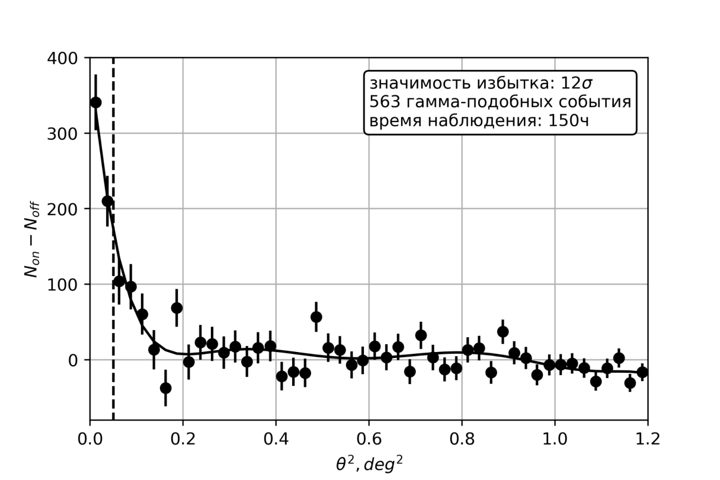
Fig. 1 Distribution by parameter ϴ² (ϴ- angle between the direction to the source and the direction of arrival of this event)
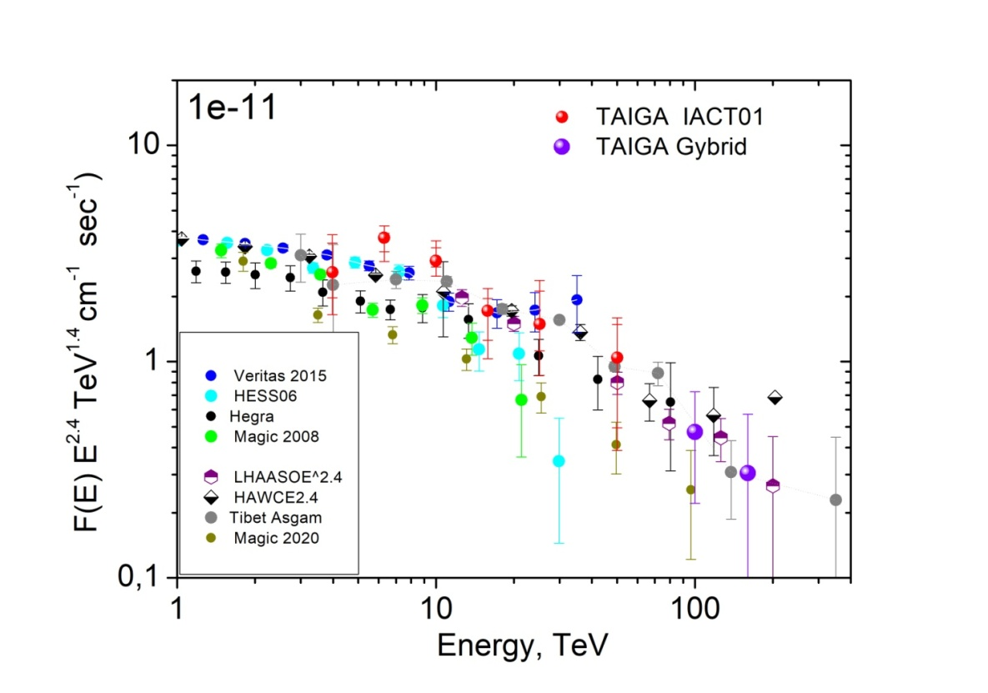
Fig.2. The reconstructed gamma-ray spectrum from the Crab Nebula according to the data of
the first telescope of the TAIGA experiment in comparison with the results of measurements by other observatories over 150 hours of observation. The last two points are based on hybrid events (IACT01+HiSCORE).

Hybrid events in the observation of the Crab Nebula.
The total statistics of the selected hybrid events for two seasons of observing the "Crab" is
~150,000 (AFT01 + HiSCORE ) for ~ 150 hours. For each event, the Hillas parameters were determined, calculated as two sets of parameters "On" and "Off" for source tracking and background
tracking, and the excess is found after suppression of the hadron background as the difference between these two samples, and the spectra of gamma-like showers are plotted as the difference spectra "On" and "Off.
The analysis of hybrid events additionally includes such parameters as the distance to the
shower axis (Rtel), the angle between the reconstructed EAS direction and the direction to the source, and the energy reconstructed according to the TAIGA-HISCORE setup. Background suppression criteria in hybrid events make it possible to collect events from very large distances - up to 400 m. Therefore, in hybrid events, the effective area turns out to be orders of magnitude larger than when using 1 telescope, the threshold energy for gamma rays turns out to be very high - about 60-80 TeV due to the high energy threshold of registration of TAIGA-HiSCORE stations. The analysis used data from only a quarter of the installation, with an area of 0.25 km². For 150 hours, 6 gamma quanta were emitted with energies above 100 TeV (Fig. 2). Thus, according to the data of the entire TAIGA-HiSCORE facility and 3 telescopes, 20-30 events with energies above 100 TeV can be expected from the Crab Nebula in 150 hours of observation.

Spectrum of gamma rays from the Crab Nebula in stereo
Stereo observations of the Crab Nebula were carried out by the first two telescopes of the TAIGA-IACT installation from October to February of the 2020-21 season. The analysis implies the standard calculation of the Hillas parameters for each event (relative to 7 background positions and one source), as well as the calculation of additional parameters required for stereoscopic reconstruction of the EAS geometry. For 36 hours of observation, a signal with a significance at the level of 5σ was obtained and the energy spectrum (Fig. 3), which is in good agreement with the data from the HAWC and TIBET AS+MD high mountain arrays.
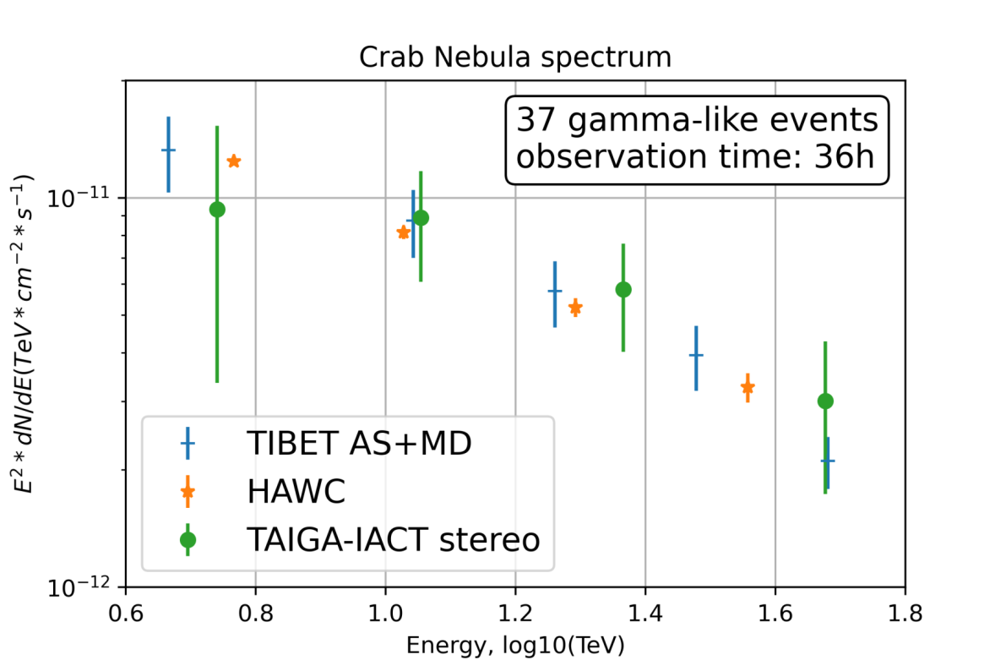
Fig. 3. The energy spectrum of gamma quanta, reconstructed by the stereo method.

Gamma rays from blazars Mrk421 and Mrk501
The first extragalactic source Mrk421, from which a signal was detected in the TAIGA experiment, is a blazar located near the Earth (redshift z~0.03) with variable intensity, well measured in TeV radiation, but high-energy events over 20 TeV were not expected. The exposition of Mrk421 in the Tunka Valley in the 2019-2020 season was 62 hours from November to the end of February with good weather. On Fig. 1 shows the alpha distribution for 'On' events and for 'Off' events with step 4º selected according to optimal criteria

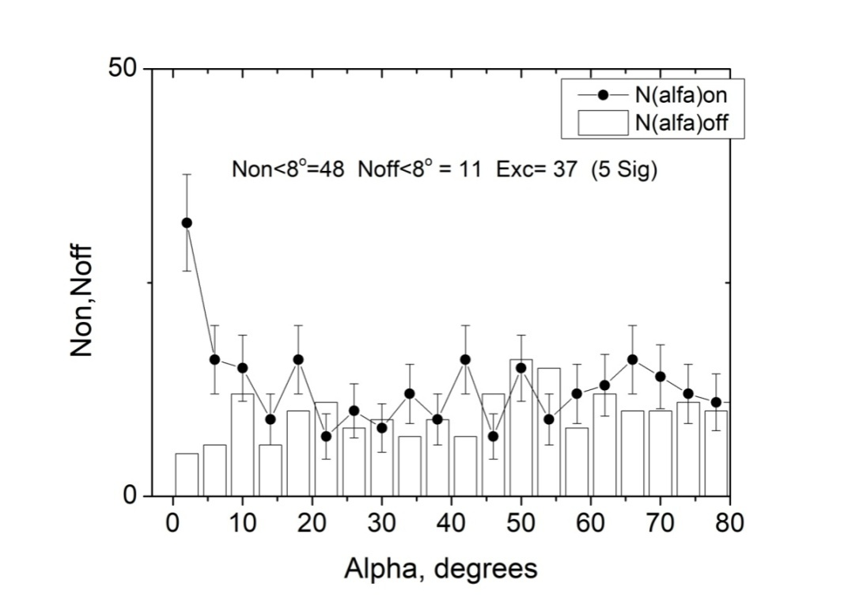
Fig. 4 Distribbution by parameter α ‘On’ and for ‘Off’ events from blazar Мrk421, отобранных selected according to the following criteria: Size>172 ph. e.; dist= 0.5º -1.25º, 0.024º<Width<0.068º× lgSize-0.045º, Length<0.31º,Con2>0.44.

In the region α<10, 37 showers with a significance of 5.77σ were registered, and in the region α<6ºExc=141 events with a significance of about 5σ, at a threshold energy of about 3 TeV. The observation was carried out according to the IACT01 work.
The Blazar Mrk 501 is located at a distance from the Earth with a redshift of z=0.034. To date, the data for 2019-2020 from March to May have been processed and analyzed. The total observation time during this period was ~ 27 hours. To identify gamma-like showers, we used an approach tested on the registration of radiation from the Crab Nebula. The excess is about 30 events. But the significance is not high - about 2.5 sigma.

Pulsar Dragonfly Nebula
This is a pulsar nebula in the region of the well-known constellation Cygnus, in which the process of star formation is underway. The nebula was created and is fueled by the rotational energy of the pulsar PSR J2021+3651. It is characterized by high-energy TeV radiation, previously detected by VERITAS and HAWC: in the 10 TeV region, the radiation intensity is comparable to the Crab radiation, but decreases exponentially at energies above 37 TeV, although events in the 100 TeV region are also observed. Therefore, this source is considered as one of the most promising. The processing of the data from this source was carried out in stereo mode. Total observation hours 40. In total, 144 ON-events and 100 OFF-events were registered for two samples with different angles, the excess was 44 events, and taking into account the choice of 5 background points, this corresponds to a significance of 3.37sigma.

Search for high-energy gamma-rays from the Boomerang source
During the 3 observation seasons of 2019-2022, about 140 hours of observation of the source for IACT01 and about 100 hours for IACT02 were collected. From an astrophysical point of view, this is a very interesting source. The pulsar nebula associated with pulsar J2229+6114 and the supernova remnant (SNR) G106.3+2.7 are thought to be the result of the same supernova explosion, since the whole structure is located on the edge of a bubble with extended regions of molecular gas inside and about 800 ps, and the supernova explosion occurred in the region of active star formation. From an experimental point of view, its spectrum, measured in the Milagro and HAWC experiments, is of interest; the measured intensity in the region of 100 TeV is comparable to the intensity from the Crab Nebula. However, in the region of about 5-10 TeV it is an order of magnitude lower.

Monte-Carlo calculations of the telescope response and their experimental calibration
In the TAIGA experiment, EAS modeling is performed using the CORSIKA version 7.35 package with the QGSJET-II-04 model for high-energy interactions and GHEISHA-2002d for low-energy interactions. Details and references can be found in reference [16]. A set of image parameters was determined that made it possible to most effectively suppress the background and register gamma quanta. One of the most important parameters for reconstructing the EAS energy is the coefficient of transition from the number of photoelectrons in the image size to the photon flux I(phot/m2) falling on the telescope mirrors, R= size/I. In Monte Carlo calculations, estimates of this coefficient (RMK) are associated with a number of uncertainties (reflection of light from mirrors, allowance for the passage of light through the entrance window of the camera, reflection of light from Winston cones, quantum sensitivity of photomultipliers, etc.), therefore, an independent estimate of this value is required. In the TAIGA experiment, the ratio of size to the photon flux (Rexp) was obtained from hybrid events recorded by the telescope and HiSCORE stations. For such events, the energy E, reconstructed from the photon density at a distance of 200 m from the EAS axis, and the photon spatial distribution function (PDF) reconstructed from the data of the HiSCORE stations are known with an accuracy of about 10% [17].
Using the PDF, one can obtain the number of photons at the telescope position I, compare with the number of photoelectrons in the image recorded by the telescope, and obtain the value of the ratio Rexp= size/ I. The coefficient obtained from the event bank turned out to be equal to Rexp= 0.56 ±0.03 + 0.07syst. In Monte Carlo calculations R_{M-K}=0.63 pe +/- 0.03, which agrees with the experimental value within the error and confirms the correctness of the performed simulation. An example of a hybrid event is shown in fig. 5 A. Black dots are the experimentally measured PDFs for the Hi-SCORE stations, the solid line is an approximation of this PDF, a square is the light flux at the point where the telescope is located. R distribution_{exp} shown in fig. 5 B.
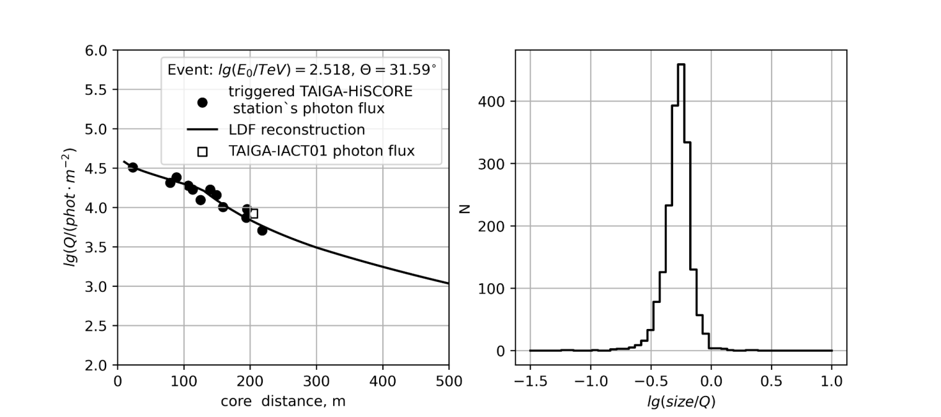
А | Б
Fig. 5. A: An example of a hybrid event. The black circles are the experimental points of the
PDF for the HiSCORE stations, the solid curve is an approximation of this PDF, the black square is the light flux at the telescope location, recalculated from the event recorded by the telescope with the coefficient R_{m-k}=0.63. B Distribution by coefficient R_{exp}

3. Program for the development of the astrophysical complex
The immediate development of the TAIGA astronomical complex is associated with the creation of two more atmospheric Cherenkov telescopes and a significant increase in the area of muon
detectors (TAIGA-MUON facility). One of the shortcomings of the hybrid approach in the existing version of the astrophysical complex is the significant difference between the angular aperture of the Cherenkov telescopes and the aperture of the TAIGA-HiSCORE facility, leading to the possibility of observing only one source at a given time. To correct this situation, it is planned to create small imaging Cherenkov telescopes (SIT) with an angular aperture of 25-30 degrees and an energy threshold of 80-100 TeV. The joint operation of such telescopes and the TAIGA-HiSCORE facility will increase the number of hybrid events by almost 10 times, for which gamma rays can be extracted against the background of cosmic ray events. Further development of the astrophysical complex, most likely elsewhere, is associated with the expansion of the TAIGA Hi-SCORE facility to an area 10 times larger and supplemented by small imaging Cherenkov telescopes.

Cherenkov telescopes
The mechanical part of the fourth Cherenkov telescope was manufactured at JINR, shipped and assembled at the test site (Fig. 6). Three telescopes are operating as planned. Planned work is underway to manufacture the upgraded fifth telescope.

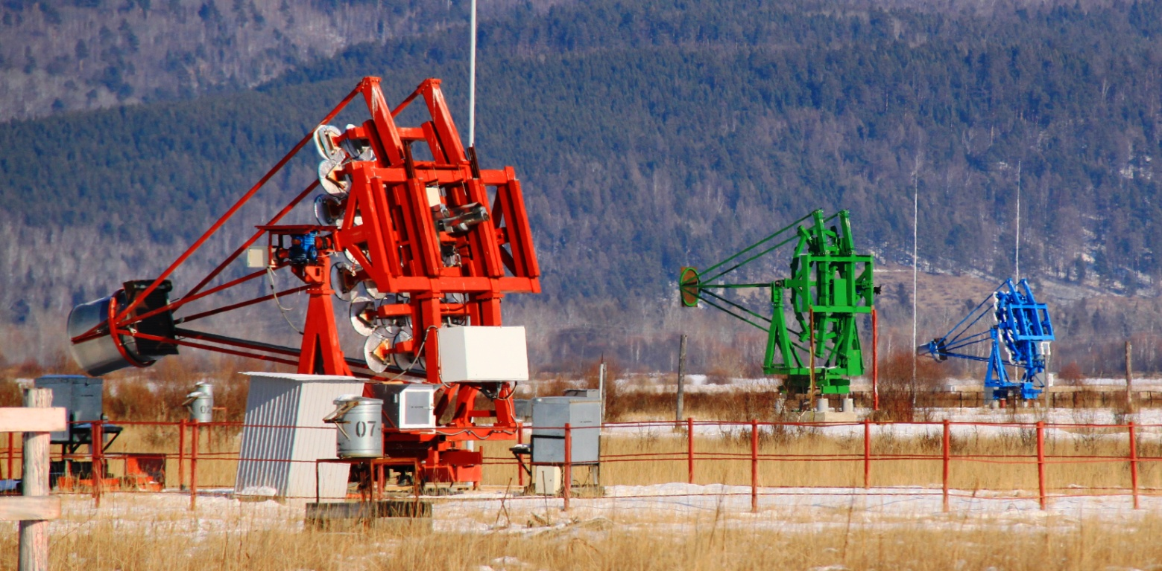

Fig. 6 The first, fourth and third telescopes at the test site in the Tunka Valley.

Wide-angle telescope
As part of the work on promising areas to expand the TAIGA project, JINR participated in the discussion of modeling and manufacturing a prototype of a wide-field Cherenkov telescope. The use of such telescopes in conjunction with distributed detectors will make it possible to obtain large statistics of joint events in the high-energy region due to the large field of view of the telescope. The parameters of the telescope prototype are presented in Table 1.
Table 1.
 | Value
Lens
Lens diameter, mm | 820
Focal length, mm | 3666±100
Maximum field of view, degrees | ±7,5
Maximum field of view, mm | 940
The siz of the field of view used, mm | 600
Telescope positions, ° from vertical (telescope oriented to the South) | 0, 35, 90
Camera
FOV of one pixel | ~ 0.4 °
Number of pixels | 1000 - 1200

It can be noted that such a telescope will work together with HiSCORE stations, the energy threshold of which is about 70 TeV. Thus, it can be seen that in the region of joint work energies, the effective area covers dozens of stations and can help the EAS analysis by having a spatial pattern in several pixels.
A prototype of a wide-angle lens Cherenkov telescope has been successfully manufactured and installed at the test site. At present, the camera is expected to be manufactured and the telescope can start working.

Bibliography

1. F.Aharonian (HESS Collaboration)//Astroparticle Physics 34(2011) 738-747
2. V.Acciari (VERITAS Collaboaration) Ap.J Letters 730 (2011) L20
3. Albert et al (MAGIC)// Astrophys.J.639:761-765,2006
4. Abdo A.A. et al.,(Milagro) 2007, ApJ 664, L91
5. A.Abdo et al. (Milagro)//arxiV: 1403.0161
6. N. Budnev et al. (TAIGA Collaboration), Jour.Phys: Conf. Series 718 052006 (2016)
7. Budnev N. et al., (TAIGA Collaboration), NIMA 845, 384 (2017)
8. Tluczykont, D. Hampf, D. Horns, L.Kuzmichev et al. Astropart. Phys., 56:42, 2014.
9. G.Di.Sciascio (LHAASO collaboration) //arXiv: 1602.07600
10. B.S.Acharya et al. (CTA collaboration) Astroparticle Physics 43 (2013) 3-18;
11. Schioppa E.J. et al. [CTA SST-1M Project Collaboration] // arXiv:1508.06453.
12. G.Sinnis. Nucl.Instrum.Meth.A623:410-412,2010
13. Home pager of HAWC: www.hawc-observatory.org
14. HAWC collaboration. Astroparticle Physics 50-52(2013) 26-32
15. Tibet ASγ (the Tibet air-shower array) [15]
16. M. Peresano, R. Mirzoyan, I. Vovk, P. Temnikov et al. for the MAGIC Collaboration, PoS(ICRC2019)759
17. K. Malone for the HAWC Collaboration PoS(ICRC2019)734
18. K. Kawata for Tibet AS gamma Collaboration, PoS(ICRC2019)712
19. Q.An et al et// Nucl.Instrum.Meth.A644:11-17,2011
20. G.Di.Sciascio (LHAASO collaboration) //arXiv: 1602.07600
21. R. Mirzoyan et al., Nuclear Instr. And methods A351 (1994) 513-526. DOI: 10.1016/0168-9002(94)91381-1.
22. I.I. Yashin et al. (TAIGA Coll.), Journal of Physics: Conference Series 675 (2016) 032037.
23. I.I. Yashin et al. (TAIGA Coll.), PoS(ICRC2015)986.
24. H. Anderhub et al., JINST 8 (2013) P06008 [arXiv:1304.1710].
25. A. Nepomuk Otte, D. Garcia, T. Nguyen and D. Purushotham, Nucl. Instrum. Meth. A846 (2017) 106 [arXiv:1606.05186].
26. M. Heller et al., PoS(ICRC2019)694 (2019) .
27. J. A. Aguilar et al., Nucl. Instrum. Meth. A830 (2016) 219.
28. P. Rajda et al., PoS(ICRC2015)931 (2015) [arXiv:1508.06082].
29. V.Prosin et al. (Tunka Collaboration) NIM A 756, 94 (2014)
30. N.Lubsandorzhiev et al., PoS(ICRC2019)729.
31. Y. Sagan et al., PoS(ICRC2019)776
32. E.B. Postnikov et al. Bulletin of the Russian Academy of Sciences: Physics, 2017, Vol. 81, No. 4, pp. 428-430
33. E.B. Postnikov, A.A,Grinyuk et al. Proceedings of ISVHECRI-2016
34. Heck D., Knapp J., et al. // Report FZKA 6019. Forschungszent. Karlsruhe. 1998.
35. Hillas A.M. // Proc. 19nd ICRC. La Jolla. NASA Conf. Publ., 1985. V. 3. P. 445.
36. Li, T.-P., & Ma, Y.-Q. 1983, ApJ, 272, L317.
37. L.Kuzmichev et al., NIM A 952 (2020 ) 161830.
38. M.Heller, A.N.Borodin et al. PEPAN Letters (2020 г.)

REPORT on the activity of "Experiment OLVE-HERO"

The lead organization in the preparation of the OLVE-HERO experiment is SINP MSU. Within the list of the Federal Space Program (FSP) for 2016-2025. R&D of OLVE-HERO is being carried out. Proposals have been formulated for the creation of a complex of scientific equipment (SPA) with a total mass of up to 16 tons, subject to launch into low Earth orbit using a heavy launch vehicle (Proton or Angara). This project, as R&D, has been included in the FKP since 2021, with a launch in the period up to 2030.
In preparation for this experiment at JINR, prototypes of boron calorimeters were developed, manufactured and tested on SPS beams at CERN. The results obtained on measuring the yield of alpha particles arising in the absorption of thermal neutrons by boron-10 nuclei were reported at various conferences, including the international conference ICRC-2019 in Madison, USA.
Due to the impossibility of carrying out the planned test of the OLHE-HERO prototype on the heavy ion beam at the SPS at CERN, the DLNP Directorate asked the VBLHEP Directorate to give permission to test the prototype on the xenon beam with an energy of 3-4 GeV/nucleon at the NUCLOTRON in November-December 2022 in the amount of 30-40 hours of beam time. Unfortunately, it was not possible to allocate a suitable place on the beam and we were offered the only hard-to-reach place at a distance of ~1.5 meters from the beam axis at the end of the setup BM@N . As shown in Fig. 7, the data set was carried out in different ways.

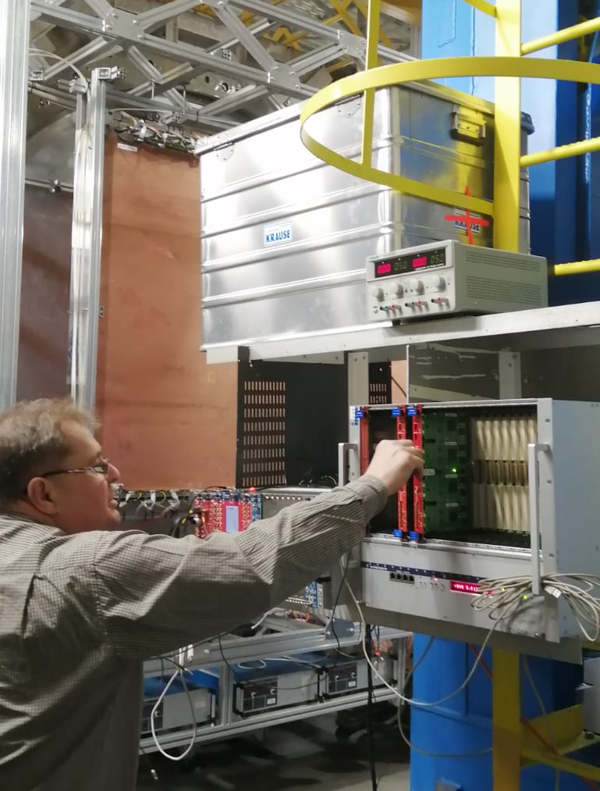
Fig. 7. OLVE-HERO prototype on a beam in the installation BM@N

Fig. 8. shows the results on the yield of alpha particles as a function of time in the range up to 4096 * 4 ns ~ 16 μs in borated scintillators of the OLHE-HERO prototype, obtained with a 13 GeV/nucleon heavy ion beam at SPS at CERN. The charge measurement system (SIS) consists of 4 silicon detectors and measures the charges Z of incident nuclear fragments in the range from 200 to 2000 arbitrary units. Figure 9 shows the measured yields of alpha particles, divided using PPE into light (Z < 750 a.u. - green), medium (750 < Z < 1500 a.u. - red) and heavy (Z > 1500 c.u. - blue color). Like it was to be expected that the yield of alpha particles increases with an increase in the charge of the incident nucleus at the level of tens of percent, which is inconsistent with the results of the MS simulation presented in Fig. 9, where this growth is at the level of 10-50 times.
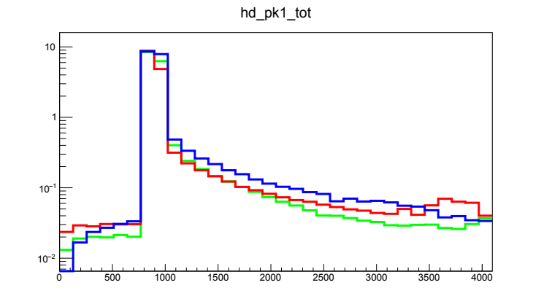

Fig.8. Yield of alpha particles for light, medium and heavy nuclei with an energy of 13 GeV/n

For a more detailed analysis of the charge dependence of the yield of alpha particles, it was supposed to conduct an additional test of the prototype on a heavy ion beam at SPS in 2022, which was not performed due to a ban on exporting the prototype to CERN. The test on the extracted beam of xenon nuclei at the NUCLOTRON with an energy of 3.5 GeV/nucleon also turned out to be impossible due to the lack of space on the beam.
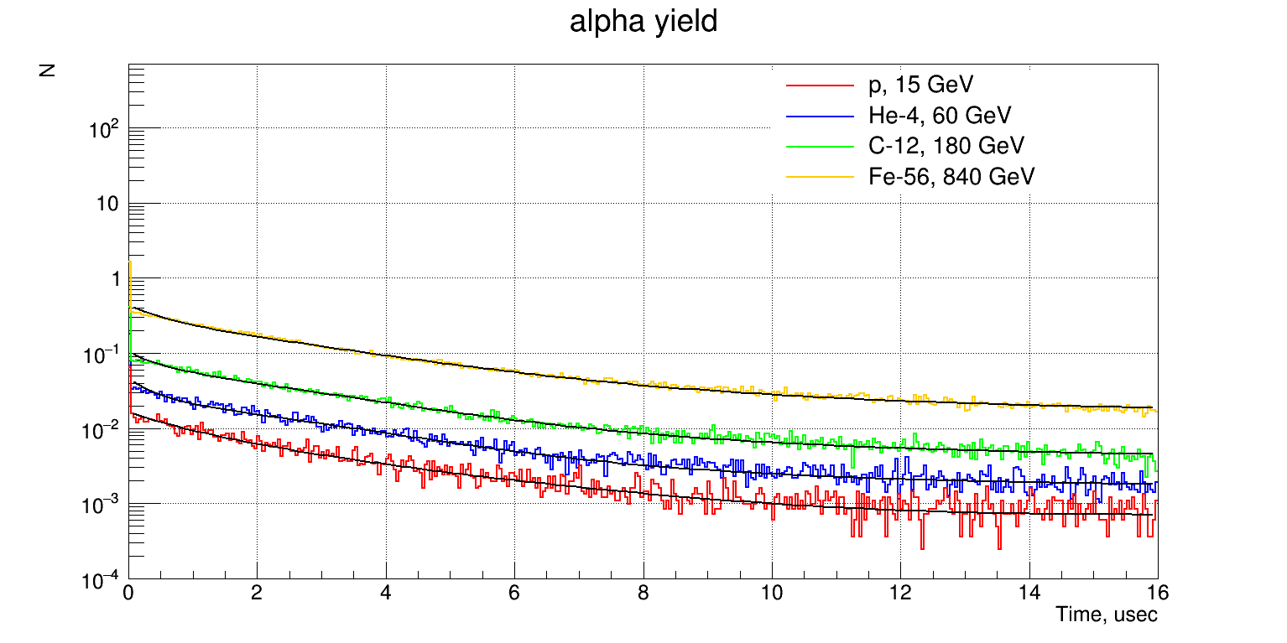

Fig.9. MC simulation of the yield of alpha particles with a nucleus energy of 13 GeV/n

At present, JINR has the first prototype of a detector with a borated scintillator, which has been tested on the SPS test beams at CERN. In the next 2-3 years, it is planned to design, manufacture and test more advanced prototypes of the OLVE-NERO calorimeter on extracted beams of protons and nuclei in order to select the final design of the apparatus.

Publications for the activity "Experiment OLVE-HERO"
1. The HERO project for the study of high-energy primary cosmic radiation
D.M. Podorozhnyi(Moscow State U.), E.V. Atkin(Moscow Phys. Eng. Inst.), L.S. Burylov(Watervliet Arsenal), A.G. Voronin(Moscow State U.), N.V. Kuznetsov(Moscow State U.) et al. (May 1, 2009)
Published in: Bull.Russ.Acad.Sci.Phys. 73 (2009) 5, 593-596, Izv.Ross.Akad.Nauk Ser.Fiz. 73 (2009) 5, 632-635 • Contribution to: 30th Russian Cosmic Ray Conference, 593-596
DOI reference search0 citations
2. New High-Energy cosmic-Ray Observatory (HERO) project for studying the high-energy primary cosmic-ray radiation
E.V. Atkin(Moscow Phys. Eng. Inst.), L.S. Burylov(Unlisted), A.P. Chubenko(Lebedev Inst.), N.V. Kuznetsov(SINP, Moscow), M.M. Merkin(SINP, Moscow) et al. (2009)
Published in: Nucl.Phys.B Proc.Suppl. 196 (2009) 450-453 • Contribution to: ISVHECRI 2008
3. Ya. Sagan et al., The OLVE-HERO calorimeter prototype beam test at CERN SPS
36th International Cosmic Ray Conference -ICRC2019-July 24th - August 1st, 2019
Madison, WI, U.S.A.
PoS(ICRC2019)141
4. I.Satyshev, A.Pan and L.G.Tkachev. Toy Monte-Carlo simulation of the OLVE-HERO detector
37th International Cosmic Ray Conference (ICRC 2021) July 12th – 23rd, 2021
Online – Berlin, Germany
PoS(ICRC2021)078
5. Pan A., Grebenyuk V., Karmanov D., et al. The OLVE-HERO Calorimeter Prototype Beam Test at CERN SPS. Physics of Particles and Nuclei Letters (2020) 17(1), стр. 13-18
6. Pan A., Grebenyuk V., Karmanov D., et al.Tests of the OLVE-HERO Calorimeter Prototype at Heavy-Ion Beams at SPS CERN. Physics of Atomic Nuclei (2019) 82(6), стр. 788-794
8. Grebenyuk V., Krasnoperov A., Lavrova M., et al.The OLVE-HERO Calorimeter Prototype Tests at Heavy Ion Beams of CERN SPS. Physics of Particles and Nuclei Letters (2019) no.2, 85-92
9. Sagan, Ya., Grebenyk, V.M., Krasnoperov, A.V., ...Karmanov, D.M., Podorozhny, D.M.The OLVE-HERO calorimeter prototype beam test at CERN SPS
Proceedings of Science, 2021, 358, 141

Activity report «TUS experiment»
The main goal of the TUS space experiment is to search for of ultra high energies cosmic rays (E > 70 EeV) by measuring the fluorescent and Cherenkov radiation of extensive air showers (EASs) in the Earth's atmosphere. The TUS detector registered more than 40 events, the origin of which is unclear. In contrast to the standard events, in the observed events, the same signals appeared in all pixels of the photodetector, which is the criterion for their anomalousness. The probable nature of such atmospheric events is out-of- aperture lightning discharges, the diffuse reflection of light from which from the solar panels of the satellite hits the photodetector matrix.
In anomalous events, a group of several “hybrid” events is distinguished (Fig. 10): narrow, several time cycles wide, peaks at the beginning of the event, accompanied by wide distributions. It is possible that the narrow peak is due to Cherenkov and fluorescent radiation from the ascending EAS, which originated outside the field of view of the detector optics, which then initiated a lightning discharge, the reflection of which is also visible as a wide subsequent distribution.
This work has been reported on:
1. 31stJEM-EUSOInternationalCollaborationMeeting,
2. RCRC-2022 (will be published in the proceedings of the conference),
3. 6thInternationalConferenceonParticlePhysicsandAstrophysics.

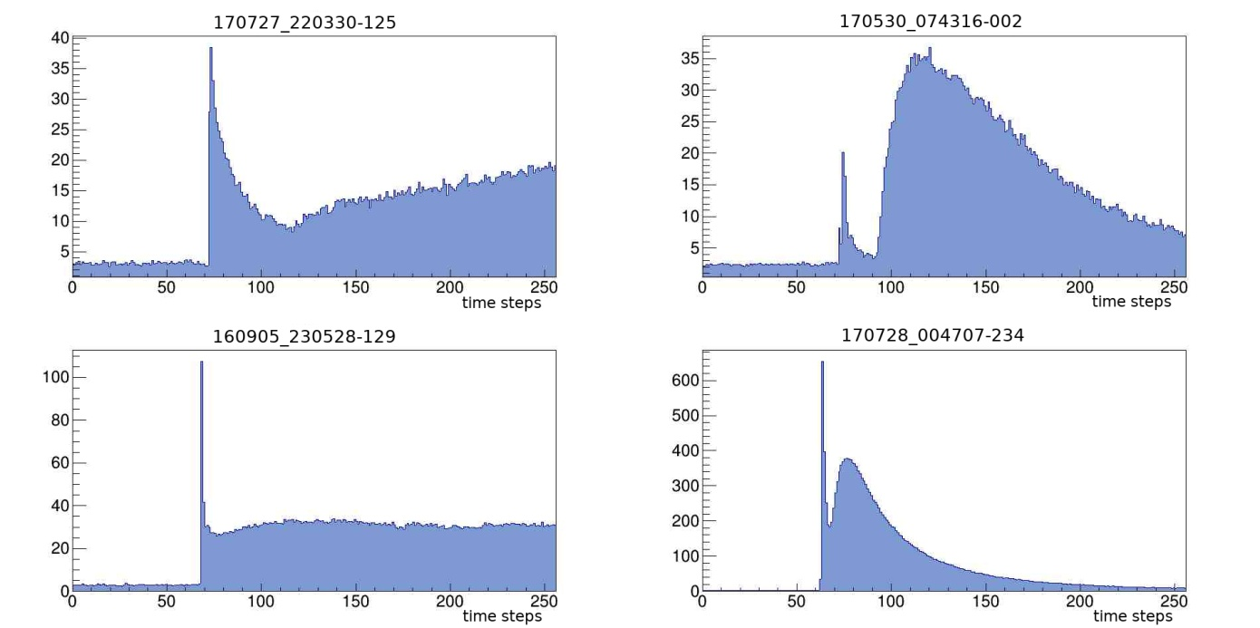
Fig. 10. Examples of "hybrid" anomalous events.

Relative calibration of the photodetector.

Based on the assumption of diffuse reflection of light from out-of-aperture lightning flashes from solar panels as the cause of anomalous events, it is natural to expect that the same reflected signal is measured in all pixels of the TUS photodetector, which can be used to calibrate the photodetector. If the photon flux density is sufficiently high and spatially uniform, then the difference in signal amplitudes in pixels will be due to the difference in their sensitivity and gain factors. In principle, such a calibration can be done using each of the events. The coincidence of calibrations from different events would be a confirmation of the external nature of the events and the legitimacy of the calibration method itself. However, this is true only in the ideal case, when all channels of the photodetector have characteristics that are stable over time. In fact, this is not the case due to changes in the physical characteristics of the photodetector channels during the flight (aging), as well as changes in the temperature of the electronics when entering the night part of the orbit, since thermal stabilization of the photodetector was not provided. Such an analysis is currently in progress.
Figure 11 shows the relative calibration of the photodetector pixels. First, about 40 events were selected in which there is no signal saturation in the pixels of the photodetector, by means of which the relative calibration coefficients were measured by averaging. It can be seen that the relative calibration of the photodetector by anomalous events is qualitatively consistent compared to the previously performed calibration by analyzing background fluctuations by colleagues from SINP MSU [6].
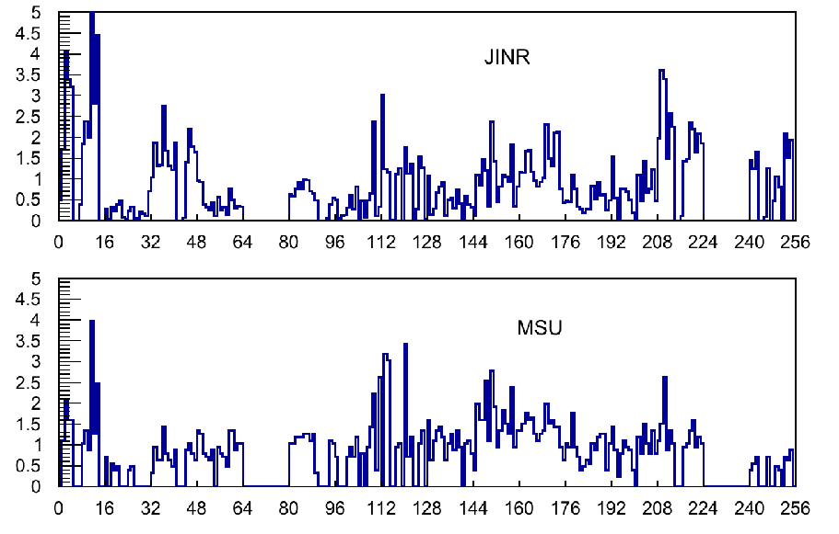

Fig. 12. Photodetector calibration measurements. Above - calibration by anomalous events, below - by analysis of amplitude fluctuations in background events.

Published (or already accepted for publication) works for TUS activity
1. M. Lavrova et. al. Russian Cosmic Rays Conference, Moscow, Russia (RCRC-2022)
2. A.Blinov et al., 6thInternational Conference on Particle Physics and Astrophysics. Moscow, 29 Nov. 2022 to 2 Dec. 2022

2.2.4. List of main publications of the JINR authors, including associate personnel based on the results of work on the project(list of bibliographic references)
More than 100 works have been published in the collaboration

1. N. M. Budnev, I. I. Astapov, P. A. Bezyazeekovetal., NuclearInstrum. andMethods, A 958, 162113 (2020).
2. L. A. Kuzmichev, I. I. Astapov, P. A. Bezyazeekov et al., Physics of Atomic Nuclei, 81, 4, 497 (2018)
3 L. Kuzmichev, I. Astapov, P. Bezyazeekov et al., Nucl. Instrum. Meth.A 952,161830 (2020)
4. S.Berezhnev et al.,( ( TAIGA Coll.) Nucl.Instrum. Meth. A, {\bf 692}, 98 (2012)
5.O. Gress, I. Astapov, N. Budnev et al., Nucl. Instrum. Methods, A 845, 367 (2017)
6. R. Monkhoev, N. Budnev, A. Gafarov et al., Bull. of the RAS, Phys., 83, 8, 959 (2019).
7.A. Ivanova, N. Budnev, A. Chiavassa et al., JINST 15, C06057 (2020)
8. I.Astapov et al ( TAIGA Coll.) Journal of Experimental and Theoretical Physics, 134, № 4, с. 469-478 DOI (2022)
9. М.Tluczykont, D.Hampf , D.Horns et al., Astroparticle Physics, 56, 42 (2014)
10. I.Astapov et al., ( TAIGA Coll.) Bull. of the RAS, Phys, 81, 4, 460 (2017)
11. L.Kuzmichev, I. Astapov, P. Bezyazeekov et al., EPJ Web of Conferences, 145, 01001 (2017)
12. A.D. Panov et al., (TAIGA Coll.) arXiv: 2109.09637
13. N. Budnev et al., (TAIGA Coll.) JINST 15, C09031 (2020)
14. A.Grinyuk et al., (TAIGA Coll.) PoS, 395 (ICRC2021), 713 (2021)
15. N. Budnevet al.,( TAIGA Coll.) Astroparticle Physics, 117, 102406, (2020)
16. V.Prosin et. al.( TAIGAColl.). Report on RCRC-2022(Moscow, june 2022). Accepted for publication in Bulletin of the RAS:Physics.
17. R. Monhoev et. al. ( TAIGAColl.). Report on RCRC-2022(Moscow, june 2022). Accepted for publication in Bulletin of the RAS:Physics.
18. W.Apel, J.ArteagaVelázquez, K. Bekketal., AstroparticlePhysics36, 183 (2012)
19.M. G. Aartsen, R. Abbasi, Y.Abdou et al., Phys. Rev. D. 88, 042004. (2013)
20. R.Abbasi, M. Abe, T. Abu-Zayyad et al., Astrophys. J., 858, 76 (2018)
21.А.Yushkov, A. Aab, P.~Abreu, et al., PoS (ICRC2019) 482; arXiv: 1909.09073 (2019)
22. R. Abbasi, M. Abe, T.Abu-Zayyad et al., Astrophys.J., 909 2, 178 (2021)
23 W.D. Apel et al., KASCADE-Grande Collaboration Phys. Rev. Lett. 107 (2011) 171104
24. D.Kang et al (KASCADE-Grande Coll.) arXiv :2208.10229
25. P.Voljugov et al . This conference proceedings
26. Fomin V P, Stepanian A A, Lambet R C et al. 1994 Astr. Phys. 2 137

Published (or already accepted for publication) works for the reporting period
1. GAMMA/HADRON SEPARATION FOR A GROUND BASED IACT IN EXPERIMENT TAIGA USING RANDOM FOREST MACHINE LEARNING METHODS
Vasyutina M., Sveshnikova L., Bonvech E.A., Bulan A.V., Chernov D.V., Kalmykov N.N., Korosteleva E.E., Kozhin V.A., Kryukov A.P., Kuzmichev L.A., Lubsandorzhiev N.B., Mirzoyan R., Osipova E.A., Panov A.D., Podgrudkov D.A., Popova E.G., Postnikov E.B., Prosin V.V., Razumov, Silaev A.A. et al.
In the collection: Proceedings of Science. 5. Сер. "5th International Workshop on Deep Learning in Computational Physics, DLCP 2021" 2022.
2. ASTROCLIMATE OF THE PLAIN HIGH-MOUNTAIN ZONES OF THE GREATER ALTAI REMOTE SENSING SATELLITE DATA: THE CAPACITY FOR HOUSING FULL SCALE GAMMA ASTRONOMIC EXPERIMENT
Mordvin E.Yu., Volkov N.V., Revyakin A.I., Togoo R., Astapov I.I., Bezyazikov P.A., Blank M., Bonvech E.A., Borodin A.N., Brukner M., Budnev N.M., Bulan A., Vaidyanatan A., Vishnevsky R.,
Volchugov P.A., Voronin D.M., Garmash A.Yu., Gafarov A.R., Grebenyuk V.M. ., Gress O.A. and etc.
Bulletin of the Russian Academy of Sciences:Physics. 2022. V. 86. No. 3. S. 452-456. 3.
3. TAIGA—A hybrid array for high energy gamma-ray astronomy and cosmic-ray physics
N. Budnev(Irkutsk State U.), I. Astapov(Moscow Phys. Eng. Inst.), P. Bezyazeekov(Irkutsk State U.), E. Bonvech(SINP, Moscow), A. Borodin(Dubna, JINR) et al. (Sep 11, 2022)
Published in: Nucl.Instrum.Meth.A 1039 (2022) 167047 • Contribution to: VCI2022
4. TAIGA - an advanced hybrid detector complex for astroparticle physics and high energy gamma-ray astronomy
N. Budnev(Irkutsk State U.), I. Astapov(Moscow Phys. Eng. Inst.), P. Bezyazeekov(Irkutsk State U.), E. Bonvech(SINP, Moscow), A. Borodin(Dubna, JINR) et al. (Aug 29, 2022)
Contribution to: ISVHECRI 2022 • e-Print: 2208.13757 [astro-ph.IM]
5. Primary Cosmic Rays Energy Spectrum and Mean Mass Composition by the Data of the TAIGA Astrophysical Complex
V. Prosin, I. Astapov, P. Bezyazeekov, E. Bonvech, A. Borodin et al. (Aug 2, 2022)
Contribution to: ISVHECRI 2022 • e-Print: 2208.01689 [astro-ph.HE]
6. Optimisation studies of the TAIGA-Muon scintillation detector array
TAIGA Collaboration : I. Astapov(Moscow Phys. Eng. Inst.) et al. (Jun 17, 2022)
Published in: JINST 17 (2022) 06, P06022
7. Identification of electromagnetic and hadronic EASs using neural network for TAIGA scintillation detector array
TAIGA Collaboration : I. Astapov(Moscow Phys. Eng. Inst.) et al. (May 16, 2022)
Published in: JINST 17 (2022) 05, P05023

Theme Leader
/ ___________/
“ “ 202_г.

Project Leader / LRIP Leader
/ ___________/
“ “ 202_г.

Project Leader / LRIP Leader(in case of
multiple projects)
/ ___________/
“ “ 202_г.

Laboratory Economist
/ ___________/
“ “ 202_ г.

