**Annex 3.**

***Form of opening (renewal) for Project /***

***Sub-project of LRIP***

**APPROVED**

**JINR DIRECTOR**

**/**

**" " 202 г.**

**PROJECT PROPOSAL FORM**

Opening/renewal of a research project/subproject of the large research infrastructure project within the Topical plan of JINR

**1. General information on the research project of the theme/subproject of the large research infrastructure project (hereinafter LRIP subproject)**

* 1. **Theme code / LRIP** (for extended projects) - *the theme code includes the opening date, the closing date is not given, as it is determined by the completion dates of the projects in the topic.*

**02-1-1107-2024**

**1.2 Project/LRIP subproject code** (for extended projects) **—.**

**1.3 Laboratory**: VBLHEP

**1.4 Scientific field**

**1.5 Title of the project/LRIP subproject:** ADSR

**1.6 Project/LRIP subproject leader(s):** Tyutyunnikov S. I.

**1.7 Project/LRIP subproject deputy leader(s) (scientific supervisor(s)):** Paraipan M.

1. **Scientific case and project organization**
   1. **Annotation**

Nuclear fuel represents clean source of energy, with high energy capacity, free of carbon dioxide emissions and cheaper than other green sources, being a proper candidate for the main source of energy in the future.

Both fission and fusion reaction can be used for energy production. The first accessible from technological point of view was the fission of uranium and plutonium. The critical nuclear reactors confront with two major disadvantages. The first is the risk of radiation release during severe accidents, which periodically happened in spite of the efforts to improve the safety of the power plants. The second disadvantage is generated by the accumulation of the nuclear waste which has as principal source of long term radiotoxicity the unfissioned actinides. In thermal critical reactors only 3% from the actinides fissioned in one cycle. Better results are obtained in fast reactors because the harder neutron spectrum realized allows to burn until 6-7% of actinides in one cycle [1,2].

A possibility to realize a safer nuclear power plant with increased burning capabilities is to use an accelerator driven subcritical reactor (ADSR). It consists of a particle accelerator coupled with a nuclear reactor.

The particle beam striking a converter placed in the central part of the reactor realizes a supplementary source of neutrons which allows the functioning of the reactor in subcritical regime (with criticality coefficient keff below 0.99), ensuring a safer exploitation of nuclear plants. The harder neutron spectrum obtained ensures a better incineration of the actinides.

The idea to use a particle accelerator for transmutation appeared in the middle of the last century. The first attempts to use accelerators as neutron sources were made in the late 1940’s by E.O. Lawrence in the United States, and W.N. Semenov in the former Soviet Union. Research about the fertile to fissile conversion in uranium and thorium were performed in USA at Livermore Research Laboratory [3], in Canada by the group of Lewis at Chalk Rivers [4], and the group of Goldanski and Vassylkov in Dubna [5]. However, the beam intensity that could be achieved in particle accelerators at that time was by many orders of magnitude lower than the beam intensity estimated as necessary for a self-sustainable functioning of ADS, and the research on this field was abandoned for a while. The progress achieved in the technology of particle accelerators created the possibility to obtain beam intensities of 1016 and revived the interest for ADSR.

The first scheme of ADSR was described by the team of Bowman in the early 90’s [6]. The facility presented under the name “The Accelerator Transmutation of Waste” (ATW) was dedicated to the transmutation of the nuclear waste. The beam conditions for a self-sustainable ATW were analyzed. Initial ADSR was seen mainly as a possibility to transmute the nuclear waste.

Two years later, the team of Rubbia show that a subcritical reactor based on U-Th cycle, driven by an intense proton beam can realize high energy gain, working as source of energy and transmuter in the same time [7]. They introduced the concept of “Energy Amplifier” (EA).

**2.2 Scientific case** (aim, relevance and scientific novelty, methods and approaches, techniques, expected results, risks)

The principle of EA was verified in the FEAT experiment [8]. A subcritical core of 3.5 tones natural uranium, immersed in water was irradiated with proton beams with energies from 0.6 GeV to 2.75 GeV. The experiment was dedicated to the study of the influence of the beam energy on the energy efficiency of the system. The spatial distribution of fissions and the temperature distribution inside the target were measured and used to calculate the power released in each case. The authors estimated the energy efficiency of a given beam using the energy gain calculated as the ratio of the power released to the beam power. The dependence of the energy gain G on the beam energy obtained in [8] is presented here in the figure 1. The curve from the figure reaches a plateau for energies above 1 GeV and lead to the conclusion that the optimal energy of proton beam for ADS is around 1 GeV. This manner of calculating the energy gain was taken over by other authors. Still, we have to underline that this method is not correct. The correct way to calculate G for any power plant is as the ratio of the power produced to the power spent to maintain the functioning of the plant. We proposed another method for the calculation of G as the ratio of the gross electrical power produced to the electrical power spent to maintain the functioning of ADSR. The method used in [8] reproduces qualitatively the dependence of G on the proton beam energy in the case of beam acceleration in a linear accelerator, but not in a cyclotron, and does not allow a correct comparison between different ion beams. However, the results of the FEAT experiment invalidate the hope that the increase of the beam energy above 1-1.5 AGeV leads to an increase of G.



Fig. 1 The energy gain as function on proton kinetic energy (FEAT experiment).

A similar conclusion as in FEAT experiment was reached by the experiments carried out at LHEP JINR, Dubna with the extended natU target “Quinta” [9]. The target “Quinta” has a modular structure with five hexagonal sections and gaps between them for the placement of the plates with detectors. Each section is an assembly of fuel rods with length 104 mm, radius 17 mm, Al cladding with thickness 1 mm and pitch 36 mm, realizing a total radius of ~ 140 mm. The rods are placed in hexagonal Al containers with thickness 5 mm, 61 rods for each section, except the first. In the first section 7 central rods are removed to create a beam window with diameter 80 mm. The uranium mass is ~ 512 kg. Each section is sealed front and back with Al plates with dimensions 350 mm × 350 mm × 5 mm. The total length of a section is 114 mm. The plates are mounted onto a single Al slab with a gap of 17 mm between two adjacent sections.

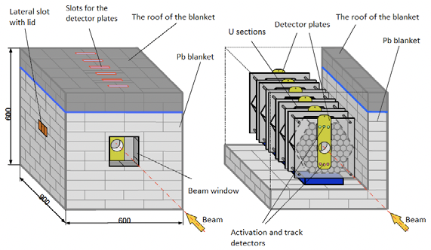 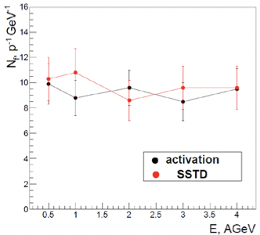

1. b)

Fig. 2 The scheme of the target “Quinta” (a) and the dependence of the number of fissions on the deuteron beam energy (b).

The target is surrounded by a lead blanket with thickness 10 cm. The front side of the Pb blanket has a beam window with dimensions 150 mm × 150 mm. The roof of the blanket presents 6 slots that allow inserting and removing the detector plates. A schematic representation of the target is given in the figure 2a. The target was irradiated with deuteron beams with energies between 0.5 and 4 AGeV. The number of fissions normalized to the projectile energy measured with two methods: solid state track detectors (SSTD) and activation technique is presented in figure 2b. The agreement between the two methods is good, in the limit of the experimental errors. The results demonstrate that one cannot achieve the increase of the energy efficiency by increasing the beam energy even in the case of deuteron beam.

A difficulty in the development of ADSR was generated by the necessity to use high intensity beams. The progress attained in the particle accelerators field makes now to obtain beam intensities of 1016 in linear accelerators [10] or cyclotrons [11] (1.5‧1016 at ESS project, 3.12‧1016 at CiAD project, 3.75‧1016 at MYRRHA project), which are enough to ensure energy gain on the order 8-10 for 1-1.5 GeV proton beams. Starting with 1990 many programs and projects around the world are dedicated to ADSR subject (the program EUROTRANS and the projects MYRRHA and ESS in European Union, the OMEGA program in Japan, CIADS in China). All of them plan to use proton beams with energy in the range 0.6-1.5 GeV.

In spite of the almost generalized opinion that the optimal beam for ADS is a proton beam with energy around 1–1.5 GeV [12-14] we have shown in a series of works that ion beams have a superior energetic efficiency than protons [15-17]. Our studies are oriented towards researching the conditions which maximize the energy efficiency of ADSR and ensure high burnup. In fact, these two goals of ADSR are linked. For a needed reactor power, the design of the core aimed to maximize the cycle length entails the improvement of the transmutation capability. Aspects related with the core geometry, the material used for the converter, the fuel composition, the working value of keff, the enrichment and power density distribution were investigated. The influence of the beam characteristics (particle type, energy, beam intensity), and of the accelerator type were also investigated. The main conclusions obtained constitute the bases for the present project proposal.

Experiments and simulations in extended and quasi-infinite natU targets

The comparative study on the efficiency of proton and ions as source of spallation neutrons for a subcritical reactor started with simulations realized in quasi-infinite natU target [17, 18]. The information about particle fluence, fission distribution and energy released is obtained from simulations realized with the toolkit GEANT4 [19]. The electromagnetic interaction was modeled with standard electromagnetic models. All ionization losses for all charged particles, including primary beam particles and all secondary particles from successive nuclear reactions inside the target were summed for calculating the energy deposited in the target Edep. For the inelastic interaction of hadrons intranuclear cascade models were used (Bertini cascade for barions and mesons, binary cascade for ions). In the case of neutrons with energy below 20 MeV the interactions were modeled with the high precision neutron package based on a detailed implementation of the experimental data from ENDF library [20]. The capability of GEANT4 to predict the experimental data of the neutron yield from thin and thick metallic targets irradiated with protons and light ions, the isotopes production and the distribution of fission fragments was checked in various works. The good agreement between the experimental data and the predictions of the Geant4 with respect to the interaction of beams with intermediate energies (from hundreds MeV to several GeV) with various heavy metal targets was demonstrated in [21]. The comparative analysis of calculations using different codes, namely GEANT4, MCNPX, SHIELD and MARS15 [22, 23], also demonstrated satisfactory agreement on a level of 30% for the simulation of ion-beam interaction with thick targets. Experimental data on the isotopes production and the distribution of fission fragments were compared with the predictions of GEANT4 in [24]. The conclusion was that for integral values as the neutron yield, the number of fissions or the energy released one can count on the results of the simulations in the limits of 25–30%.

A crucial aspect of our analysis is to find the correct manner to compare the energy efficiency of various ion beams. The energy gain G is used as measure for the energy efficiency. An often made mistake is to define the energy gain as the ratio of the power produced in the target Pprod to the power transmitted to the beam Pbeam. The correct definition of G is the ratio of the power produced in the target Pprod to the power spent to accelerate the beam Pspent:

(1)

The power produced depends on the energy released in the target per incident projectile Edep, beam intensity Ibeam, and conversion coefficient from thermal to electrical power ηel:

For the power spent Pspent we proposed a method to calculate it by scaling from the data about the accelerator efficiency η0 for a reference particle with atomic number Z0, mass number A0 and final energy per nucleon E0 (momentum per nucleon p0). The power spent Pspent to accelerate a given beam depends on both the characteristics of the beam and the accelerator type and it is seen as a sum of two components: the power transmitted to the beam, and the power necessary to maintain the functioning of the accelerator Pacc. In linacs Pacc is proportional with the accelerator length and scales with the ratio A‧E/Z, and in cyclotron it is proportional with the area of the accelerator and scales as (A‧p/Z)2. Here A is the mass number, Z the atomic number, E is the energy per nucleon and p the momentum per nucleon.

The formula for Pspent in a linac is:

$P_{spent}=A∙E∙I_{b}\left[1+\left(\frac{1}{η_{0}}-1\right)\frac{Z_{0}}{Z}\frac{I_{b0}}{I_{b}}\right]$ (3)

and in a cyclotron:

$P_{spent}=A∙E∙I_{b}\left[1+\left(\frac{1}{η_{0}}-1\right)\frac{E_{0}}{E}\frac{A}{A_{0}}{\frac{I_{b0}}{I_{b}}\left(\frac{Z_{0}}{Z}\frac{p}{p_{0}}\right)}^{2}\right]$ (4)

In formulas (3) and (4) Ib0 represents the beam intensity for the reference particle, and Ib is the beam intensity for the analyzed particle.

In the first set of simulations we covered a large range in ion mass and energy, from proton to Ba and energies from 0.3 AGeV to 10 AGeV. Some interesting results were obtained. It was shown that the optimal proton energy is ~1–1.5 GeV when the beam is accelerated in a linear accelerator and ~1 GeV when is accelerated in a cyclotron. The use of the deuteron beam does not provide much advantage when compared to protons except the acceleration in linac at energies below 1 AGeV, when the gain of deuteron is higher than proton. Ions with high mass can realize efficiency significantly higher than protons (from 2.5 times for 7Li to 6 times for 40Ca), but the fact that the optimum is reached at high ion energies represents an important disadvantage because their acceleration necessitates larger dimensions of the accelerator (for a linac it would involve lengths of few km). From this point of view light ions at energies below 1 AGeV seem to be more interesting because they are equivalent with protons as performance but need accelerators with lower dimensions.

These first results of the simulations in quasi-infinite natU target determined the E&T collaboration to experimentally check the effect of ions with higher mass. In addition to 0.5-4 AGeV deuteron beams, the target “Quinta” was irradiated also with carbon beams with energy 2 AGeV and 4 AGeV. The comparative analysis of the neutron spectra at different positions inside the target reveals the hardening of the spectra obtained during irradiation with carbon beams with respect to the spectra realized by irradiation with deuteron beams for the same energy per nucleon. The analysis of the neutron spectra was realized measuring the accumulation rates of the isotopes with different threshold energies in samples of Co and the results were presented in [24]. But the most relevant results are offered by the measurements of the fission distribution in natU samples. Uranium foils with diameter 9 mm and thickness 1 mm were placed at radii from 0 to 12 cm on the Al plates positioned in front, end and in the gaps between sections. The accumulation rates of the fission products 97Zr, 131I, 133I, and 143Ce were measured through gamma spectrometry. The measured accumulation rates together with the information about the cumulative yield of the isotopes were used to calculate the averaged value of the fission rate for each sample. Details about the technique and the results obtained can be found in [25-27]. An example for the distribution of fissions along the target, at radii 4, 8 and 12 cm, measured in the case of irradiation with deuteron and carbon beams with energy 2 AGeV is presented in figure 3. Besides the experimental data, the results obtained by simulation with Geant4 are also shown.

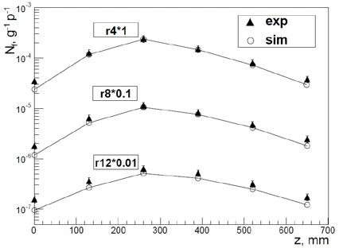 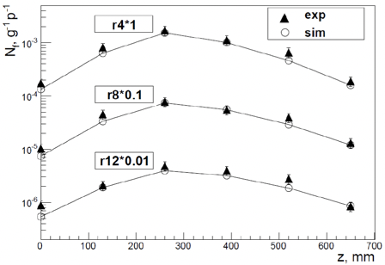

1. b)

Fig. 3 The fission distributions along the target “Quinta” irradiated with deuteron 2 AGeV (a) and carbon 2 AGeV (b) at radii 4,8 and 12 cm (experimental data and simulation).

The integrated number of fissions per projectile was used to calculate the experimental value of the energy gain G under the assumption that the fission fragments are the only source of the energy released, taking a value of 200 MeV/fission. The simulation shows that the energy released is calculated in this manner with 20-25 % lower than the total energy released. The values of G correspond to the beam acceleration in a linac (eq. 3), assuming proton as reference particle with the accelerator efficiency η0 of 0.2 and a beam intensity of 1.5‧1016 p/s. The experimental results are compared with the predictions of Geant4. The simulations allow us to calculate both the number of fissions and the total energy released Edep, the last being used to obtain the simulated G values. The results are presented in table 1. Here we also give the values obtained through simulations in quasi-infinite natU target.

The experimental data confirm the expectations of the simulations. The experimental number of fissions per projectile registered with carbon beam is 4.7-4.9 times higher than the number obtained with deuteron beam at the same beam energy per nucleon, ensuring G 2.4 higher for carbon. One remarks that the simulation predicts the same fission values as the measured ones (in the limit of the experimental errors) for all beams. In the case of the target Quinta the low value of the criticality coefficient (0.26) does not allow to realize a real energy gain, the calculated G values being below 1. Even a quasi-infinite U target (keff 0.43) cannot ensure a real energy gain. If one intends to realize ADSR with G>10 one must use enriched fuel.

Table 1. The number of fissions Nf per incident projectile, the estimated energy gain G in “Quinta” and in a quasi-infinite natU target with keff 0.43.

|  |  |  |  |  |  |  |  |  |  |
| --- | --- | --- | --- | --- | --- | --- | --- | --- | --- |
| Part. | Ebeam, AGeV | Quinta - exp | | Quinta - sim | | | quasi-infinite natU - sim | | |
| Nf, p-1 | G | Nf,  p-1 | Edep,  MeV p-1 | G | Nf,  p-1 | Edep,  MeV p-1 | G |
| D | 0.5 | 9.9±1.6 | 0.16 | 10.5 | 2631 | 0.2 | 20 | 4.456·103 | 0.36 |
| 1 | 17.6±2.8 | 0.14 | 20.5 | 5057 | 0.19 | 42.9 | 9.383·103 | 0.37 |
| 2 | 38.4±5.6 | 0.15 | 37.1 | 9336 | 0.17 | 93.6 | 2.055·104 | 0.41 |
| 4 | 76±12.8 | 0.15 | 66.4 | 17195 | 0.16 | 178.5 | 3.956·104 | 0.4 |
| 12C | 2 | 180±19.2 | 0.36 | 175.8 | 49146 | 0.46 | 436.3 | 1.011·105 | 1.01 |
| 4 | 369.6±38.4 | 0.37 | 352.4 | 97049 | 0.43 | 966.2 | 2.191·105 | 1.1 |

Simulations in cores with enriched fuel rods cooled with metals

Simulations in cores with a realistic structure were meant to analyze the possibility of energy production in ADSR on industrial scale. Aspects related with the core structure and composition, the optimal value of keff, the cooling possibilities, the particle beams and energies and the accelerator type were analyzed. The purpose was to identify the conditions which optimize the functioning of ADSR with respect to the electrical power produced, the energy gain, the mass of the actinides burned during a cycle, ensuring in the same time a safe operation. With respect to the particle beam, the study was focused on the comparative analysis between protons with energies until 2 GeV and ions with masses until 20Ne and energies until 1 AGeV.

The reactor core was modeled as an assembly of fuel pins surrounding the converter and immersed into the coolant. The fuel pin has in center the fuel rod, followed by a helium filled gap and the steel cladding. The coolant is simulated as a large cylinder with the core placed in the center. The converter is positioned on the central axis, displaced inside the active zone to realize a beam window of 20-30 cm in order to diminish the neutron losses. A schematic representation is given in figure 4.

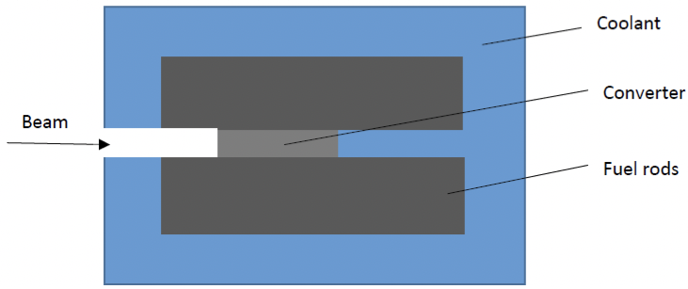

Fig.4 The scheme of the reactor core.

The coolant

The cooling with metals was considered taking into account the experience with fast reactors (FR). The cooling with lead, LBE, and sodium was analyzed in the same geometry and we concluded that the metallic coolant does not modify the shape of the neutron spectrum and does not change the ratio of the energy released realized by different beams. It should be pointed out that Pb or LBE act as better reflectors for neutrons in comparison with Na and allow a less compact packing of the fuel pins, with a pitch to diameter ratio ~2 or higher. Lead and LBE do not react with water or air and due to their high boiling temperature (2016 K for Pb, 1943 K for LBE) the coolant does not reach the boiling point during transients and the pin failure is limited to a small group of fuel pins. Both Pb and LBE have corrosive action on the cladding which limits the velocity of the coolant at 2-3 m/s. The neutronic properties of lead and LBE are similar. Pb has the advantage of a reduced production of volatile 210Po which can become a radiological hazard in case of coolant leakage, but has the drawback of its high melting temperature (601 K) with the risk of freezing. From this point of view, LBE (melting temperature 396 K) is preferable because it can be operated at lower temperature than Pb, which improves the compatibility with structural materials and reduces coolant freezing risks. For this reason, the ADSR projects under development have chosen LBE as coolant.

Core geometry and composition

Cores with different composition and structure were studied, the coolant being LBE. It was shown in [29] that changes in rod dimensions, number and pitch, or the use of various types of fuel (metal, oxide, carbide, nitride) do not influence the shape of the neutron spectrum and consequently, it preserves the ratio of the energy deposited by different ions. The factor that has a significant influence on the neutron spectrum and on the energy released is the material used for the converter. Usually, for proton beams with energy around 1 GeV converters from heavy metals (W, Pb, LBE, U) are considered the best option [30-32]. Pb and LBE are preferred for the possibility to use them as converter and coolant in the same time [33, 34]. But in the case of ion beams especially at low energy converters from low Z materials are preferable. Two actions contribute to the total effect. One is the increase in ion range in low Z materials. More inelastic interaction took place at higher ion energy and the spectra of the secondary neutrons become harder. The hardening of the neutron spectrum is maximum in very low Z materials as Li and Be.

The other contribution to the increase of the Edep is due to the neutron moderator action of light materials that determines the appearance of a tail towards low energies in the neutron spectrum. Converters of C and Be demonstrate important moderator effect. The influence of the dimensions of the converter on the energy released was studied in detail in [29, 35]. The increase of the dimensions has reduced effect on the Edep when one uses converters from C or Li, but it produces a significant rise of the energy released if a Be converter is chosen (fig. 5a). In the case of Be converter the rise of the dimensions produces an increase of the fluence of low energy neutrons (fig. 5b).

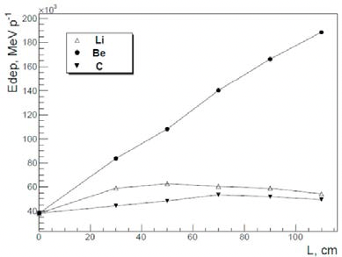 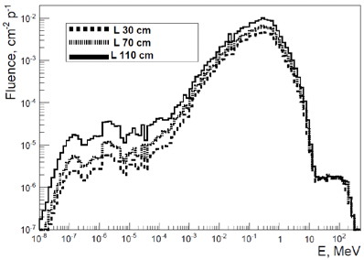

1. b)

Fig. 5 The dependence of the energy released on the converter length in target with 8.9% Pu239, irradiated with 7Li 0.3 AGeV beam (a) and the neutron spectra in cores with Be converter with different lengths (b).

The use of a long Be converter has three major advantages. The main advantage is the amplification of Edep for ion beams in comparison with protons. The ratio EdepL / Edep0 is higher at low ion energy, as can be seen in table 4, where the energy deposited in core with U-Pu-10%wtZr fuel (8.9 % 239Pu), irradiated with 1.5 GeV proton and 7Li beams with energy 0.25 AGeV and 0.4 AGeV is compared. The values of Edep corresponding to LBE and Be converter with radius 10 cm and length 110 cm are given. The use of such converter makes a 7Li with energy 0.25 AGeV equivalent with 1.5 GeV proton from the point of view of the energy produced, and that allows the reduction of the accelerator length 2.6 times.

Table 4. The energy released in cores with converters from LBE and Be

|  |  |  |  |
| --- | --- | --- | --- |
| Particle | E, AGeV | Edep, MeV/p | |
| Converter LBE | Converter Be |
| proton | 1.5 | 7.433‧104 | 1.681‧105 |
| 7Li | 0.25 | 2.523‧104 | 1.606‧105 |
| 7Li | 0.4 | 6.713‧104 | 3.155‧105 |

The other two advantages are related with the appearance of a tail towards the thermal energy in neutron spectrum. Such shape of the neutron spectrum improves the breeding capability of the core. In a critical fast reactor, the use of moderator materials must be avoided in order to maintain the fission neutron spectrum hard enough to produce the fission of fertile actinides, but in ADS, the yield of neutrons with energy above 1-2 MeV produced in spallation reactions is significant and one can moderate part of them still maintaining an increase rate of actinides incineration. The analysis of the isotopes evolution in cores with the same geometry and enrichment but with different converters (LBE and Be) shows that the breeder capabilities are different, conducing to different cycle lengths and different mass of the actinides burned at the end of the cycle [29]. The concentration of 239Pu presents a period of build-up when the keff rises, followed by a slower decrease. Such target needs the use of the control rods during operation. With a proper adjustment of the position of the control rods the keff and the energy released can be kept constant at a wanted level during operation. As criterion for refueling the moment when the produced power falls down with 30 % was chosen. At the moment of refueling the initial mass of actinides is reduced with 10.2 % in the case of the target with LBE converter, and with 14.8 % in the target with Be converter.

The softening of the neutron spectrum in the presence of Be converter offers the possibility to diminish the enrichment necessary to realize the needed keff in a given geometry. Consequently, longer cycles and a deeper burning of the actinides in one cycle can be realized. It was shown in [35] that with low enrichment (6-8% 239Pu) one can incinerate in one cycle until 20-25 % from the initial mass of the actinides. Taking into account that in a fast reactor 6 -7 % from the actinides can be incinerated in one cycle, one concludes that in ADSR 3-3.5 times more actinide can be burned, which represents a major advantage of ADSR.

At the end of the cycle the fuel is reprocessed by extracting the fission fragments, some fresh fertile material is added, and a new cycle can start. In principle, ADSR can incinerate any mixture of actinides, but the initial composition influences the length of the cycle. The composition of the fresh fuel added at the beginning of the cycle must be adjusted in order to maximize the cycle length. In this way, ADSR can be seen not only as a means to incinerate uranium free fuel, but also, as an alternative to critical reactors. The supplementary costs generated by the necessity to build a particle accelerator are compensated by the increased safety, the high values of the energy gain, and the lowering of the overall cost of a closed fuel cycle due to the deeper actinides incineration in each cycle. Both uranium and thorium based fuels can be used in ADSR. In a core with a given keff the energy produced with different beams is the same, independently of the use of uranium or thorium fuels. However, thorium reactors need higher enrichment, as compared to uranium cores with the same geometry and the same keff, and the cycle length is shorter for Th based cores [17].

Regarding the core, besides the material used for the converter and the fuel enrichment, another key factor for the efficiency of ADSR is the optimal working value of keff. Various values for keff are recommended in the literature. The group of Rubbia planned for their energy amplifier keff 0.98 [7]. In the project MYRHHA a value of keff 0.97 was considered for the ADSR prototype [34]. The authors in [Ref. 36] recommended a value of 0.985 for keff in ADS with MOX fuel.

The value of keff must be low enough to ensure a safe operation, but as high as possible to maximize the energy gain. For a safe operation it is necessary on one hand to obtain a quick decrease of the power to a safe level when the beam is stopped, equivalent with the insertion of the shutdown rods, and on the other hand to avoid reaching the criticality during unprotected transients. Part of the transients that can appear in ADSR are common with fast reactors. Besides these, there are also transients specific to ADSR generated by the variations of the beam intensity. In the first group, the transient with positive reactivity insertion are relevant for the choice of keff. The insertion of positive reactivity can appear in the case of the accidental withdrawal of the control rods, in core compaction, and in the case of pin failure.

The analysis of the transients possible to produce an insertion of positive reactivity conduces to the conclusion that one can expect in an ADS cooled with LBE an increase of the reactivity less than 400 pcm. The influence of the reactor keff on the evolution of a transient overpower transient (UTOP) was studied assuming the insertion of +400 pcm during 10 s. The results obtained in reactor core with keff 0.98, 0.99 and 0.996 and metallic fuel are presented in the figure 6a. The power evolution obtained by simulation with GEANT4 was corrected for the effect of the reactivity feedback generated by the changes of the temperature of the fuel and coolant. The corrected power *P(t)* at time *t* is:

$P\left(t\right)=P_{0}(t)\frac{ρ_{0}}{ρ(t)}$ (4)

where *P0(t)* is the uncorrected power, *ρo* is the reactivity in steady-state, and *ρ(t)* is the corrected reactivity taking into account the Doppler reactivity coefficient of the fuel $α_{D}$, the reactivity coefficient of the coolant $α_{c}$, the radial reactivity coefficient $α_{R}$, the axial reactivity coefficient $α_{A}$, and the difference between the mean temperature of the fuel (coolant) *Tf* (*Tc*) at time *t* and the mean temperature in steady-state *Tf0*(*Tc0*):

(5)

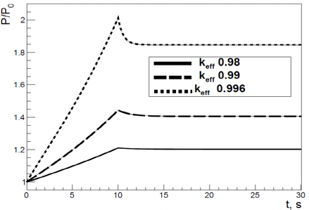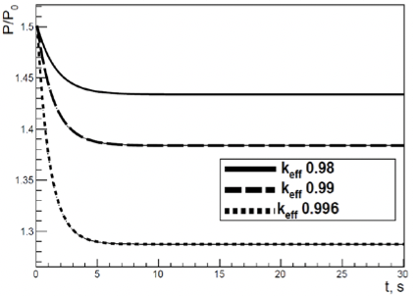

1. b)

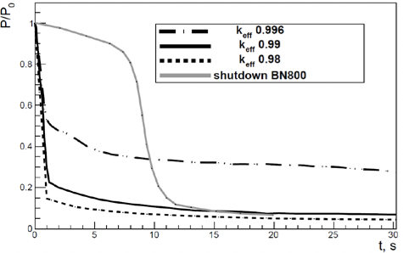

c)

Fig. 6. The power evolution in UTOP (a), in UBOP (b) transients and after the beam turn off (c) in ADS with U-Pu-10%Zr fuel and keff 0.98, 0.99, 0.996.

The closer the value of keff to the criticality the higher the maximum power reached during UTOP and in the new steady-state is. The analysis of the power and temperature evolution conduces to the conclusion that values of keff below 0.99 are advantageous from the point of view of the evolution of UTOP transient.

Two situations are relevant from the point of view of variations of the beam intensity. The first is an unprotected beam overpower transient (UBOP) and the second is the power evolution after the beam shutdown. The power evolution when the beam intensity suddenly increases with 50% calculated in the cores with keff 0.98, 0.99 and 0.996 is illustrated in fig. 6b. After an initial jump, the power stabilizes at a lower value through the intervention of the reactivity feedback mechanisms. The new equilibrium level depends on the value of keff. In the case of UBOP transient a higher initial value of keff is favorable because conduces to a new steady state at a power level closer to the initial one.

The power variation after the beam shut-off for three values of keff (0.98, 0.99 and 0.996) is presented in fig. 6c. For comparison, the power evolution experimentally measured during the passive shutdown of BN800 reactor is shown, also [37]. In ADS the power falls sharply in the first second after the beam stopping. The lower is the value of keff, the deeper is the falling down of the power: with 85% for keff 0.98, 80% for keff 0.99 and 56% for keff 0.996. One remarks that with a keff 0.99 the power evolution is similar with the one measured in BN800 reactor, so one concludes that from this point of view a value of 0.99 forkeff is safe enough. Even a target with keff 0.996 ensures a safe shutdown when the beam is turned off.

The conclusion is that a value of 0.988-0.99 for keff could be recommended, ensuring a quick and safe reactor and enough safety margin to avoid criticality during various transients.

Optimal beam

Initially, a large range of ion mass and energy were investigated, but as we clarified aspects related with the core optimization it became clear that the domain must be restricted. The restriction in ion mass and energy is imposed by the capacity of the system to remove the heat. If one considers the maximum thermal power in ADS at approximately 3 GW, the conclusion is that for cores with keff 0.985-0.988 and beam intensities of 1‧1016-1.5‧1016 one can use ions with masses until 20Ne and energies below 0.75 AGeV. The dependence of the thermal power produced Pth on the particle mass and energy, in a core with keff 0.985 and Be converter is presented in the fig. 7. The simulations were realized in a core at industrial scale. Fuel pins with the length of the active zone 160 cm and the length of gas plenum 2 m, surrounding the Be converter, with a pitch to diameter ratio of 2 are immersed in the LBE coolant. The coolant is a cylinder with radius 2.5 m and length 8 m. The structure of the fuel pin is the following: fuel pellets with diameter 9 mm, helium filled gap with thickness 0.15 mm, and ferritic martensitic steel T91 cladding with thickness 0.6 mm. The internal reactor vessel has an inner radius of 160 cm and thickness 5 cm. The assumed beam intensity was 1.5‧1016. The limit of 3 GW for the Pth is shown with dashed line in the figure. One can see that in our conditions one can accelerate 7Li and 9Be until ~ 1 AGeV, while ions with higher mass at energies below 0.75 AGeV.

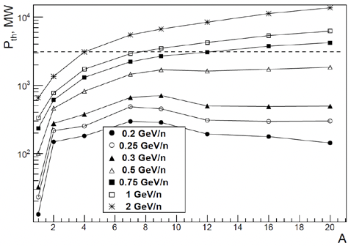

Fig. 7. The thermal power as a function of projectile mass number and energy.

The energy efficiency and Pnet were analyzed for to situations: when the beams are accelerated in a linac, and in a cyclotron. In both cases the beam intensity was the same and as reference particle was considered proton, assuming an accelerator efficiency 0.18 for the reference particle. In present, proton and ion beam intensities necessary for ADSR can be obtained only in linear accelerators. Regarding the possibility to accelerate 7Li ions, a beam with intensity until 7‧1016 was reported recently in [38]. Cyclotrons can accelerate until now only protons at energies below 1 GeV. Still, there are hopes that fixed field alternating gradient accelerators will be able to produce high intensity ion beams at energies of few AGeV [11]. A problem of the linear accelerators is related with their length. From this point of view, the construction and the maintenance of compact circular accelerators would be more advantageous.

The efficiency of different beams is illustrated in figure 8, where the dependence of the energy gain G and the net power produced Pnet on the particle energy and mass are given in the case of a linac (a,b) and a cyclotron (c,d). The beam intensity was 1.5‧1016 p/s. The gross electrical power produced was calculated from Pth using a value of 0.4 for the conversion coefficient from thermal to electrical power. The curves for G are slightly different in linac and cyclotron. In the case of protons accelerated in a linac G varies slowly in the energy range 1-2 GeV, with a maximum around 1.5 GeV (G ≈ 14). The energy gain of deuteron is higher than of proton for energies until 1 AGeV, and approaches the proton value at 2 AGeV. The ions 4He, 7Li and 9Be have values of G higher than proton 1.5 GeV in the entire energy range. In this case G rises until the ion energy ~0.5 AGeV when reaches a plateau at values 35-40. In the case of ions with higher mass G exceeds the proton value after some threshold energy (0.25 AGeV for C, 0.3 AGeV for O and Ne) and the plateau is reached at higher energies. All ions need some threshold energy to equalize the Pnet value of proton 1.5 GeV (0.6 AGeV for D, 0.35 AGeV for 4He, 0.25 AGeV for 7Li and 9Be, 0.3 AGeV for 12C, 16O, 20Ne).

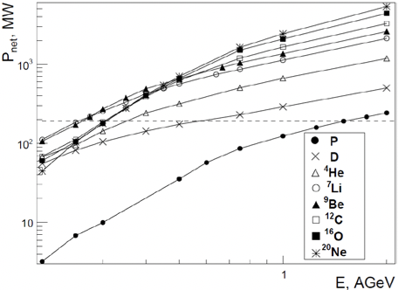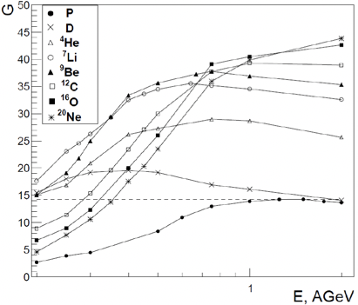

1. b)

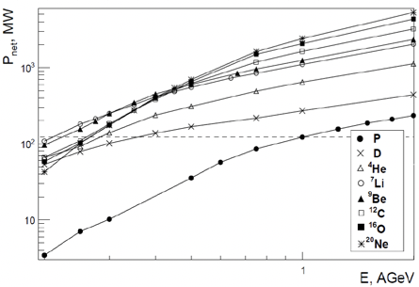

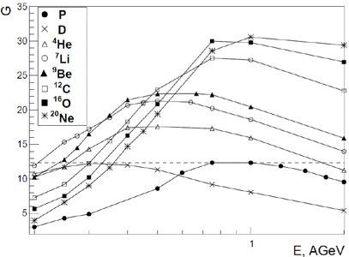

1. d)

Fig. 16 G and Pnet as a function of projectile energy for particles accelerated in a linac (a,b), and a cyclotron (c,d) in core with keff 0.985.

When accelerated in a cyclotron, the curves of G don’t reach a plateau as in the case of a linac but present a broad maximum. The maximum is in the range 0.75-1 GeV for proton and ions with higher mass (12C, 16O, 20Ne). For lighter ions the maximum is reached at lower energies. The optimal energy of proton beam is ~ 1 GeV with a G value of ~ 12. A beam of 7Li with energy 0.2 AGeV is equivalent with 1 GeV proton beam with respect to the energy gain and the net power produced. Ion beams starting with 7Li and energy above 0.3 AGeV can realize 2-3 times higher gain than 1 GeV proton. The values of G are slightly lower in comparison with a linear accelerator (from 15 to 35 for ions with energy above 0.25 AGeV), but they are high enough to make insignificant the differences in Pnet obtained in cyclotron and linac with the same beam.

A problem for linacs is the accelerator length. For 1.5 GeV proton a length of approximately 300 m is expected. From this point of view, it is preferable to the search for a beam that produces the same Pnet but with minimal accelerator length.

The results presented in this section show the range in mass and energy for an efficient utilization of ions in ADS. The increase of ion mass number above 20 displaces the maximum of G to energies above 1 AGeV. But at such energies the thermal power becomes too high, and the dimensions of the accelerator must be larger. The idea to compensate the increase in mass and energy by diminishing the beam intensity (or, in another words that the increase of ion mass and energy allows to diminish the beam intensity) is not a good one because, in this way the energy efficiency of ADS decreases.

Table 6. The dependence of G and Pnet on the beam intensity

|  |  |  |  |
| --- | --- | --- | --- |
| Particle/Energy, AGeV | Beam intensity, s-1 | G | Pnet,MW |
| 12C/0.75 | 1.5‧1016 | 37.8 | 1191 |
| P/1.5 | 9‧1016 | 38 | 1199 |
| 7Li/0.25 | 9.5‧1016 | 39.8 | 1195 |

If one is interested to produce high net power (~1 GW) one has two possibilities: to increase the beam intensity or to accelerate ions with higher mass as 12C at energy 0.75 AGeV (using an accelerator with the same length as for 1.5 GeV proton). A comparison between the efficiency of these approaches is presented in table 6. The same Pnet and G as those realized with a beam of 0.75 AGeV 12C and intensity 1.5‧1016 can be obtained with beams of 1.5 GeV proton or 0.25 AGeV 7Li and intensity ~ 6 times higher. If such high intensities can be achieved, one remarks again, that it is advantageous to accelerate a beam of 0.25 AGeV 7Li in a shorter accelerator. We also underline that the increase of the beam intensity improves the efficiency of the accelerator.

We underline that ADSR with a proper configuration (long Be converter, keff 0.985-0.988) represents an efficient source of energy, with high energy, explained by the fact that the energy necessary to maintain the functioning of ADSR represent only few percent from the energy produced. This is another major advantage of ADSR. The G values in ADSR are 8-10 times higher than the values that can be achieved in fusion reactors. Seen as alternative to the critical fission reactors, prototype projects for fusion reactors based on magnetic or inertial plasma confinement started at the end of last century. The estimated safety risks for a fusion power plant are lower in comparison with a fission plant, but the G estimated to be realized in fusion plants is quite reduced (below 4) because a fusion power plant requires a big amount of energy to ensure the functioning of the plant. For example, in the case of magnetic plasma confinement in a tokamak (ITER project) the estimation of the power produced and of the entire corresponding power consumption realized in [39] concluded that a plant with gross electrical power 1660 MW produces 953 MW net electrical power resulting a value of 2.3 for G.In the case of a laser inertial fusion plant (LIFE project) the analysis presented in [40] estimates for a plant with 1217 MW gross electrical power a net electrical power of 905 MW with G 3.9.

Planning of new experiments

The planned research will be oriented in two directions. The first involves the comparative study of the fission distribution and the energy released in enriched fuel blanket, irradiated with proton beams with energy 0.2-2 GeV and ion beams with masses until 20Ne and energies in the interval 0.2 -1 AGeV. The second consists in measurements of the neutron yield from various converters, irradiated with proton and ion beams.

The most relevant data about the efficiency of proton and ion beams are obtained in experiments with fuel blanket. The design of the experimental target must reproduce at a small scale the situation in a real ADS with LBE coolant. It should allow also to check the effect of converters with various lengths and to ensure a correct comparison between proton and ion beams in the entire interval of energies. That requests a minimum length of the target and the use of a combined converter (Be and Pb) in such way to ensure the interaction of more than 98% from the beam inside the target. For example, a proton beam with energy 2 GeV and Be converter 60 cm length needs a supplementary part of Pb converter with length 40 cm in order to fulfill this condition. As first choice for the role of the coolant is a block of lead (cylinder or parallelepiped) with holes disposed in concentric layers for the fuel rods, and empty in the center (to create place for different converters). The minimal length of the fuel rods is determined by the maximal length of the converter that we intend to use (110 cm for Be converter) and the length of the beam window (10 cm), resulting a minimum length of 120 cm. We consider rods from metallic U enriched with 10% 235U, with radius 1 cm. The interest is to determine the minimal dimensions and minimal amount of fuel necessary for a correct reproduction of the ratio of the energy released (amount of fissions) produced with proton and ion beams. We show in table 7 that a lead cylinder with radius 70 cm, length 150 cm, 5 layers of fuel rods with length 120 cm reproduces correctly the ratio.

Table 7. The energy released by 0.25 AGeV 7Li and 1.5 GeV proton in lead target with Be converter

|  |  |  |  |
| --- | --- | --- | --- |
| Particle/ Energy, AGeV | Edep, MeV/p | | |
| L 0 cm | L 30 cm | L 110 cm |
| 7Li 0.25 | 3.67·103 | 8.65·103 | 1.29·104 |
| P 1.5 | 8.86·103 | 1.17·104 | 1.31·104 |

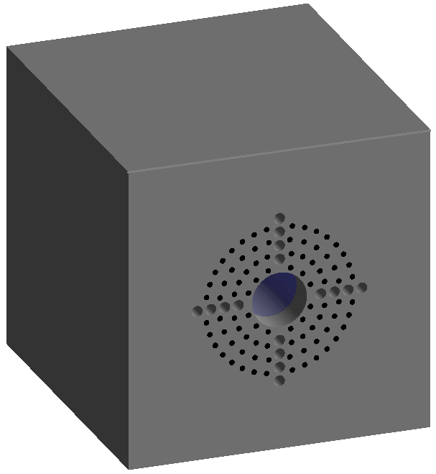

Fig. 17 The scheme of the target “GAMMA 4”.

The second option is a graphite target with reduced dimensions, a parallelepiped with dimensions 110cm×110cm×120cm. The scheme of the target is presented in figure 17. Such target is cheaper, easier to realize and to manipulate due to its reduced weight. The neutron spectrum is softer than the spectrum in lead target. That allows to reduce the enrichment and the number of fuel rods. Metallic fuel rods with diameter 19 mm, steel cladding with thickness 1 mm, length 120 cm, enrichment 6 % 235U are disposed in 4 layers with pitch ~ 5 cm. In this way we implement a target with keff ~0.9. As drawback of the softer spectrum, the increase of the energy released with the increase of the dimensions of the Be converter is less pronounced than in the case of lead target. The predictions of the simulations for some beams are exemplified in table 8. The total energy released and the number of fissions for three variants of the converter are given. One remarks that for beams with higher energy the maximum energy released is realized at intermediate length of Be converter (due to the reduced length of the target). In the last column of the table 8 we give also the values of G corresponding to the maximum energy released for each particle, assuming a beam intensity of 1.5‧1016p/s and the acceleration in a linear accelerator.

Table 8. The energy released, the number of fissions and the energy gain in the target “GAMMA4”

|  |  |  |  |  |  |  |  |
| --- | --- | --- | --- | --- | --- | --- | --- |
| Particle/  Energy,  AGeV | 110 cm Pb | | 40 cm Be +70 cm Pb | | 110 cm Be | | G |
| Edep, MeV p-1 | Nf, p-1 | Edep, MeV p-1 | Nf, p-1 | Edep, MeV p-1 | Nf, p-1 |
| P 1 | 6.506‧103 | 32.3 | 7.897‧103 | 39.7 | 5.509‧103 | 26.9 | 0.68 |
| P 1.5 | 1.069‧104 | 53.9 | 1.268‧104 | 64.7 | 7.247‧103 | 35.3 | 0.72 |
| 7Li 0.25 | 4.121‧103 | 14.1 | 8.68‧103 | 39.9 | 1.053‧104 | 47 | 1.03 |
| 7Li 0.3 | 5.781‧103 | 21.8 | 1.183‧104 | 56.5 | 1.366‧104 | 66.5 | 1.11 |
| 20Ne 1 | 6.093‧104 | 242.3 | 1.368‧105 | 675.5 | 1.004‧105 | 478.9 | 1.43 |

On horizontal and vertical direction there are holes with radius 2 cm for the detectors. The fission distribution inside the target will be measured through activation of U samples and with fission ionization chambers. One can see that even a value of keff 0.9 is not enough to obtain a real energy gain. However, the graphite target “GAMMA4” is suitable for a comparative study on the efficiency of various beams.

***References***

1. Orlov V. V., et al., The closed on-site fuel cycle of the BREST reactors, Progr. Nucl. En. 47 1-4 (2005) p. 171-177

2. Hashim M., Cao L., Zhou S., Ma R., Shao Y., Chen R., SPARK-NC: A Lead-Bismuth-Cooled Small Modular Fast Reactor with Natural Circulation and Load Following Capabilities, Energies 13 (2020) 5410; doi:10.3390/en13205410

3. C.M. Van Atta, “A brief History of the MTA Project”, ERDA Information Meeting on Accelerator Breeding, January 19-29 (1977).

4. G.A. Bartholomew and P.R. Tunnicliffe, Eds, “The AECL Study for an Intense Neutron Generator”, Atomic Energy of Canada Limited, Report No. AECL-2600 (1966).

5. R.G. Vassylkov, Vi.L. Goldanskii et al., Atomnaya Energiya 48, 329(1978).

6. C.D. Bowman et al., “Nuclear energy generation and waste transmutation using accelerator driven intense thermal neutron source”, LA-UR-91-2601.

7. C. Rubbia et al., “An energy amplifier for cleaner and inexhaustible nuclear energy production driven by a particle beam accelerator,” CERN/AT/93-47 (1993).

8. J. Calero et al., Experimental temperature measurements for the energy amplifier test, Nucl. Instr. Meth. Phys. Res. A, 376 (1996) p. 89-103

9. Furman W. et al., Recent results of the study of ADS with 500 kg natural uranium target assembly QUINTA irradiated by deuterons with energies from 1 to 8 GeV at JINR NUCLOTRON, PoS Baldin ISHEPP XXI (2012) 086

10. ESS Technical Design Report April 23, ESS-doc-274, (2013).

11. [Craddock](https://www.worldscientific.com/doi/abs/10.1142/S1793626808000058) M. K., Symon K. R., Cyclotrons and Fixed-Field Alternating-Gradient Accelerators, [Reviews of Accelerator Science and Technology](https://www.worldscientific.com/worldscinet/rast) 1 (2008) p. 65-97.

12. Beller, D.E., et al., The US accelerator transmutation of waste program. Nucl. Instrum. Methods Phys. Res. A 463 (2001) p. 468–486.

13. Oigawa, H., et al., R&D Activities on Accelerator-Driven Transmutation System in JAERI, (2004) [https://pdfs.semanticscholar.org/8831/31a7756c250df7a9ebb8caf11183 ee282ce3.pdf](https://pdfs.semanticscholar.org/8831/31a7756c250df7a9ebb8caf11183%20ee282ce3.pdf).

14. Zhao, Z., Chen, Z., Chen, H., Preliminary optimization of proton energy and target for Lead- Bismuth Eutectic target of a demonstration ADS. Prog. Nucl. Energy 71 (2014).

15. Paraipan M., Javadova V. M., Tyutyunnikov S. I., Influence of Particle Beam and Accelerator Type on ADS Efficiency, Nuclear Science and Engineering (2023) DOI: 10.1080/00295639.2023.2175582

16. Paraipan M., Baldin A.A., Baldina E.G., Tyutyunikov S.I., Light ion beams for energy production in ADS, EPJ proceedings MMCP2017 (2017) 173; Ann. Nucl. Energy 110 (2017), 04011, 973.

17. Paraipan M., Baldin A.A., Baldina E.G., Tyutyunnikov S.I., Beam and target optimization for energy production in accelerator driven systems. In: Baldin ISHEPP XXIV EPJ Web of Conferences, vol. 204 (2019), https://doi.org/10.1051/epjconf/ 201920404001.

18. Baldin A. A., Berlev A. I., Paraipan M., Tyutyunnikov S. I.,Optimization of accelerated charged particle beam for ADS energy production, Phys. Part. Nucl. Lett., 14, 1 (2017) p. 113-119.

19. Agostinelli, S., et al., GEANT4 A a simulation toolkit. Nucl. Instrum. Methods A 506 (2003) p. 250–303.

20. Chadwick, M.B., et al., 2011. ENDF/B-VII.1: nuclear data for science and technology: cross sections, covariances, fission product yields and decay data. Nucl. Data Sheets 112, 2887.

21. Baldin A. A., Berlev A. I., Kudashkin I. V., Mogildea G., Mogildea M., Paraipan M., and Tyutyunnikov S. I., Simulation of neutron production in heavy metal targets using Geant4

software, Phys. Part. Nucl. Lett. 32, (2016) p. 391–402.

22. A. Krylov, M. Paraipan, N. Sobolevsky, G. Timoshenko, V. Tretyakov, “GEANT4, MCNPX, and SHIELD code comparison concerning relativistic heavy ion interaction with matter,” Phys. Part. Nucl. Lett. 11 (2014) p. 549.

23. Baznat M. et al., Cascade models in simulation of extended heavy targets irradiated by accelerated proton and deuteron beams, Phys. Part. Nucl. 53, 5 (2022) p. 1000-1020.

24. Paraipan M. (E&T Collab.), Study of neutron spectra in extended U target. New experimental data, EPJ Web of Conf. 138 (2017) 10005; J. Adam et al., Secondary particle distributions in an extended uranium target under irradiation by proton, deuteron, and carbon beams, Nucl. Instrum. Methods Phys. Res., Sect. A 872 (2017) p. 87–92.

25. Adam J., et al., The Study of Spatial Distributions of Neutron Capture and Fission Reactions in Massive Uranium Target Irradiated by Deuterons with Energies of 1…8 GeV (“Quinta” Setup), Preprint JINR. 2012, P1-2012-147.

26. Artiushenko M. Yu. et al., Investigation of the spatial and energy distributions of neutrons in the massive uranium target irradiated by deuterons with energy of 1…8 GeV**,** Prob. Atomic Sci.Technol. 6, 88 (2013) p. 170-174

27. Artiushenko M. Yu. et al., Comparison of Neutron-physical Characteristics of Uranium Target of Assembly"quinta" Irradiated by Relativistic Deuterons and 12C Nuclei**,** Prob. Atomic Sci.Technol. 3, 103 (2016) p. 74-78

28. Suzuki T., Chen X. N., Rineiski A., Maschek W., Transient analyses for accelerator driven system PDS-XADS using the extended SIMMER-III code, Nucl. Eng. Des. 235 (2005) 2594–2611

29. Paraipan M., Javadova V. M., Tyutyunnikov S. I., Aspects of target optimization for ADS with light ion beams at energies below 0.5 AGeV, Progr. Nucl. En. 120 (2020) 103221

30. Kadi Y., Transmutation capabilities of the CERN Energy Amplifier System, Progr. Nucl. En. 49 (2007) p. 606-616

31. De Paula Barros G., Pereira C., Veloso M. A. F., and Costa A. L., Study of an ADS Loaded with Thorium and Reprocessed Fuel, Science and Technology of Nuclear Installations (2012) 934105, doi:10.1155/2012/934105

32. Hashemi-Nezhad S.R., Westmeier W., Zamani-Valasiadou M., Thomauske B., Brandt R., Optimal ion beam, target type and size for accelerator driven systems: Implications to the associated accelerator power, Annals of Nuclear Energy 38 (2011) p. 1144–1155

33. Accelerator driven systems: Energy generation and transmutation of nuclear waste, Status report, IAEA-TECDOC-985 1997

34. Abderrahim H. A. et al., MYRRHA: A multipurpose accelerator driven system for research &development, Nucl. Instr. Meth. Phys. Res. A 463 (2001) p. 487–494

35. Paraipan M., Kryachko I. A., Javadova V. M., Levterova E. A., Tyutyunnikov S. I., Main Results of Neutronical Study about ADS with Ion Beams and Implications on Experiments Planning, Phys. Part. Nucl. Lett. 19 2 (2022) p. 129-144

36. Ahmad A., Lindley B. A., Parks G. T., Accelerator-induced transients in Accelerator Driven Subcritical Reactors, Nucl. Instrum. Meth. Phys. Res. A 696 (2012) p. 55-65

37. Yu. K. Alexandrov, V.A. Rogov, A.S. Shabalin, “Main features of the BN-800 passive

shutdown rods”, *Proceeding of a Technical Committee meeting*, Obninsk, Russian Federation, 3-7 July 1995, IAEA-TECDOC-884, 107 (1995).

38. M. Okamura et al., “Demonstration of an intense lithium beam for forward‑directed pulsed neutron generation”, Scientific Reports 12, 14016 (2022) https://doi.org/10.1038/s41598-022-18270-0.

39. Entler S. et al., Approximation of the economy of fusion energy, Energy 152 (2018) 489-497

40. Meier W.R. et al., Fusion technology aspects of laser inertial fusion energy (LIFE), Fusion Engineering and Design 89 (2014) 2489-2492

**2.3 Estimated completion date:** 2024-2027

**2.4 Participating JINR laboratories:** VBLHEP, DLNP, FLNP

**2.4.1** **MICC resource requirements**

|  |  |  |  |  |  |
| --- | --- | --- | --- | --- | --- |
| **Computing resources** | **Distribution by year** | | | | |
| 1st year | 2nd year | 3rd year | 4th year | 5th year |
| Data storage (TB)  - EOS  - Tapes | 0 | 0 | 0 | 0 | — |
| Tier 1 (CPU core hours) | 0 | 0 | 0 | 0 | — |
| Tier 2 (CPU core hours) | 0 | 0 | 0 | 0 | — |
| SC Govorun (CPU core hours)  - CPU  - GPU | 0 | 0 | 0 | 0 | — |
| Clouds (CPU cores) | 0 | 0 | 0 | 0 | — |

**2.5. Participating countries, scientific and educational organizations**

|  |  |  |  |  |
| --- | --- | --- | --- | --- |
| **Organization** | **Country** | **City** | **Participants** | **Type**  **of agreement** |
| ISEI BSU | Republic of Belarus | Minsk | Kievitskaya A.I. | Cooperation Agreement |
| NRC «Kurchatov Institute» - ITEP | Russian Federation | Moscow | Kulevoy T.V., Titarenko Yu.E. | Cooperation Agreement |
| «JIPNR – Sosny» of the NASB | Republic of Belarus | Sosny | Gusak K. | Cooperation Agreement |
| BSU | Republic of Belarus | Minsk | Svito I.,  Fedotov A. K. | Cooperation Agreement |
| IFTP | Russian Federation | Dubna | Smirnov +4 persons | Cooperation Agreement |

**2.6. Key partners** *(those collaborators whose financial, infrastructural participation is substantial for the implementation of the research program. An example is JINR's participation in the LHC experiments at CERN).*

**3. Manpower**

**3.1. Manpower needs in the first year of implementation**

|  |  |  |  |
| --- | --- | --- | --- |
| **№№**  **n/a** | **Category of personnel** | **JINR staff,**  **amount of FTE** | **JINR Associated**  **Personnel,**  **amount of FTE** |
| 1. | research scientists | 6,1 | 8,5 |
| 2. | engineers | 2 | 2 |
| 3. | specialists | 0,5 | 0 |
| 4. | office workers | 0 | 0 |
| 5. | technicians | 0 | 0 |
|  | **Total:** | **8,6** | **10,5** |

**3.2. Available manpower**

**3.2.1. JINR staff**

|  |  |  |  |  |  |
| --- | --- | --- | --- | --- | --- |
| **No.** | **Category of personnel** | **Full name** | **Division** | **Position** | **Amount**  **of FTE** |
| 1. | research scientists | Tyutyunnikov S.I. | VBLHEP Department № 5 | Head of the Department | 1 |
| 2. |  | Paraipan M. | VBLHEP Department № 5 | Senior researcher | 1 |
| 3. |  | Baldin A. A. | VBLHEP Department № 4 | Head of the VBLHEP Sector | 0,5 |
| 4. |  | Stegailov V.I. | SEDNSR DLNP | Researcher | 0,8 |
| 5. |  | Khushvaktov  J. K. | SEDNSR DLNP | Senior researcher | 0,3 |
| 6. |  | Kryachko I. A. | VBLHEP Department № 5 | Researcher | 1 |
| 7. |  | Phan Luong T. | SINFP FLNP | Researcher | 0,5 |
| 8. |  | Sushkova M. P. | VBLHEP Department № 5 | Research assistant | 1 |
| 9. | engineers | Dzhavadova V. | VBLHEP Department № 5 | Senior engineer | 1 |
| 10. |  | Penkin V. A. | VBLHEP Department № 5 | Engineer | 1 |
| 11. | specialists | Maryin I. I. | VBLHEP Department № 2 | Technician of control and measuring devices and automation | 0,5 |
|  | **Total:** | **11** | **-** | **-** | **8,6** |

**3.2.2. JINR associated personnel**

|  |  |  |  |
| --- | --- | --- | --- |
| **No.** | **Category of personnel** | **Partner organization** | **Amount of FTE** |
| 1. | research scientists | ISEI BSU | 1,5 |
|  |  | NRC «Kurchatov Institute» - ITEP | 2 |
|  |  | «JIPNR – Sosny» of the NASB | 2 |
|  |  | BSU | 2 |
|  |  | IFTP | 1,5 |
| 14. | engineers | IFTP | 2 |
|  | **Total:** | **—** | **10,5** |

**4. Financing**

**4.1 Total estimated cost of the project/LRIP subproject**

The total cost estimate of the project (for the whole period, excluding salary).

The details are given in a separate table below.

780 000,00 USD

**4.2 Extra funding sources**

Expected funding from partners/customers – a total estimate.

0 USD

**Project (****LRIP subproject) Leader** __________/Tyutyunnikov S.I./

Date of submission of the project (LRIP subproject) to the Chief Scientific Secretary: _________

Date of decision of the laboratory's STC: _________ document number: _________

Year of the project (LRIP subproject) start: 2024

(for extended projects) – Project start year: _______

**Proposed schedule and resource request for the Project / LRIP subproject**

|  |  |  |  |  |  |  |  |  |
| --- | --- | --- | --- | --- | --- | --- | --- | --- |
| **Expenditures, resources,**  **funding sources** | | | **Cost (thousands**  **of US dollars)/**  **Resource requirements** | **Cost/Resources,**  **distribution by years** | | | | |
| 1st year | 2nd year | 3rd year | 4th year | 5th year |
|  | | International cooperation | 40 | 10 | 10 | 10 | 10 | — |
| Materials | 60 | 20 | 20 | 10 | 10 | — |
| Equipment, Third-party company services | 600 | 200 | 200 | 100 | 100 | — |
| Commissioning | 40 | 10 | 10 | 10 | 10 | — |
| R&D contracts with other research organizations | 40 | 15 | 15 | 5 | 5 | — |
| Software purchasing | 0 | 0 | 0 | 0 | 0 | — |
| Design/construction | 0 | 0 | 0 | 0 | 0 | — |
| Service costs (*planned in case of direct project affiliation)* | 0 | 0 | 0 | 0 | 0 | — |
| **Resources required** | **Standard hours** | Resources |  |  |  |  |  | — |
| * the amount of FTE, | 83,7 | 19,1 | 20,5 | 21,1 | 23,0 | — |
| * accelerator/installation, | 100 h. | 25 h. | 25 h. | 25 h. | 25 h. | — |
| * reactor,… |  |  |  |  |  | — |
| **Sources of funding** | **JINR Budget** | JINR budget *(budget items)* | 780 | 255 | 255 | 135 | 135 | — |
| **Extra fudning (supplementary estimates)** | Contributions by  partners  Funds under contracts with customers  Other sources of funding | 0 | 0 | 0 | 0 | 0 | — |
| 0 | 0 | 0 | 0 | 0 |
| 0 | 0 | 0 | 0 | 0 |

Project (LRIP subproject) Leader _________/________________/

Laboratory Economist _________/________________/

**APPROVAL SHEET FOR PROJECT / LRIP SUBPROJECT**

ADSR

02-1-1107-2024

PROJECT LEADER: Tyutyunnikov S. I.

DEPUTY PROJECT LEADER: Paraipan M.

|  |  |  |  |  |
| --- | --- | --- | --- | --- |
|  |  |  |  | |
| AGREED |  |  |  | |
| JINR VICE-DIRECTOR | ___________  SIGNATURE | _________  NAME | _________  DATE |  |
| CHIEF SCIENTIFIC SECRETARY | ___________  SIGNATURE | _________  NAME | _________  DATE |  |
| CHIEF ENGINEER | ___________  SIGNATURE | _________  NAME | _________  DATE |  |
| LABORATORY DIRECTOR | ___________  SIGNATURE | _________  NAME | _________  DATE |  |
| CHIEF LABORATORY ENGINEER | ___________  SIGNATURE | _________  NAME | _________  DATE |  |
| LABORATORY SCIENTIFIC SECRETARY  THEME / LRIP LEADER | ___________  SIGNATURE | _________  NAME | _______  DATE |  |
| PROJECT / LRIP SUBPROJECT LEADER | __________  SIGNATURE | _________  NAME | _________  DATE |  |
|  |  |  |  |  |
| APPROVED BY THE PAC | ___________  SIGNATURE | _________  NAME | _________  DATE | |