Annex 4.
Project (LRIP subproject) report form

PROJECT REPORT
1. General information on the project / LRIP subproject
1.1. Scientific field: Elementary particle physics and relativistic nuclear physics

1.2. Title of the project / LRIP subproject: E&TМ report
1.3. Project (LRIP subproject) code
—
1.4. Theme / LRIP code
02-1-1107-2011/2023

1.5. Actual duration of the project/ LRIP subproject: 2022-2023

1.6. Project / LRIP subproject Leader(s): S.I. Tyutyunnikov

2. Scientific report
Experimental data obtained at the QUINTA setup showed that the experimental number of divisions per incident particle registered on a carbon beam is 4.7-4.9 times higher than the number obtained on a deuteron beam at the same beam energy per nucleon. This provides an energy gain of 2.4 G higher for carbon. In the case of the QUINTA target the low value of the criticality coefficient (0.26) does not allow for a real increase in energy, the calculated value of G is less than 1. Even a quasi-infinite U-target (ke_{eff} 0.43) cannot provide G>1. If it is intended to implement ADSR with G>10, it is necessary to use enriched fuel.
Simulation of reactor cores with a more realistic structure was implemented. The simulation was intended to analyze the possibility of energy production in ADSR on an industrial scale. Aspects related to the structure and composition of the core, the optimal value of the kk_{eff} criticality coefficient, cooling capabilities, particle beams, their energies and the type of accelerator were analyzed. The goal was to determine the conditions that optimize the ADSR operation for the generated electricity, increasing the mass of actinides burned per cycle, while ensuring safe operation. As for the particle beam, the study focused on a comparative analysis between protons with energies up to 2 GeV and ions with masses up to ²⁰Ne and energies up to 1 Gev.
The reactor core was modeled as an assembly of fuel rods surrounding the converter and immersed in a coolant. The fuel cell has a fuel rod in the center, followed by a gap filled with helium and a steel shell. The coolant is modeled as a large cylinder with a hole located in the center. The converter is located on the central axis, shifted inside the core to realize a beam window of 20-30 cm to reduce neutron losses. A schematic representation is shown in Figure 1.
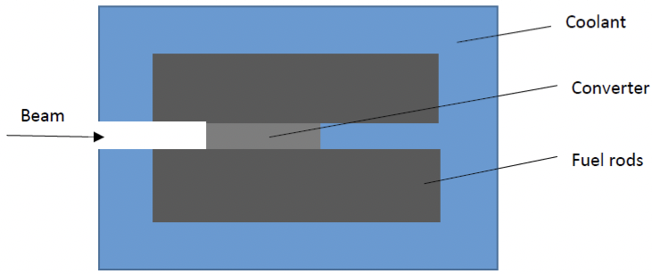
Fig. 1. Diagram of the reactor core.
Metal cooling was considered taking into account the experience of fast neutron reactors (FNR). Cooling with lead, LBE and sodium was analyzed in the same geometry and we came to the conclusion that the metal coolant does not change the shape of the neutron spectrum and does not change the ratio of the released energy realized by different beams. It should be noted that Pb or LBE act as better neutron reflectors compared to Na and allow less compact stacking of fuel rods with a pitch-to-diameter ratio of ~2 and higher. Both Pb and LBE have a corrosive effect on the steel shell which limits the speed of the coolant at the level of 2-3 m/s.
Active zones of different composition and structure were studied. LBE was the coolant was LBE. It was shown in [Paraipan et al., 2023] that changing the size, number and pitch of rods or using different types of fuel (metal, oxide, carbide, nitride) does not affect the shape of the neutron spectrum and, therefore, preserves the ratio of energy released by different ions. The material used for the converter is a factor that has a significant impact on the neutron spectrum and the energy released. Usually, for proton beams with an energy of about 1 GeV, a converter made of heavy metals (W, Pb, LBE, U) is considered the best option. But in the case of ion beams especially at low energy converters made of materials with low Z are preferred. An increase in the size of the converter has little effect on E_{dep} when using a converter from C or Li, but leads to a significant increase in the energy released when choosing a converter from Be. The use of a Be converter with a radius of 10 cm and a length of 110 cm makes a ⁷Li with an energy of 0.25 AGeV equivalent to a proton with an energy of 1.5 GeV in terms of energy generated which reduces the length of the accelerator by 2.6 times.
The k_{eff} should be low enough to ensure safe operation but as high as possible to maximize the energy gain. For safe operation it is necessary, on the one hand, to obtain a rapid reduction in power to a safe level when the beam is stopped, and on the other hand, to avoid reaching criticality with unprotected transients. The power evolution obtained by modeling with GEANT4 has been adjusted to take into account the feedback effect on reactivity caused by changes in fuel and coolant temperature. The conclusion is that we can recommend a value of 0.988-0.99 for k_{eff} which provides a sufficient margin of safety to avoid the occurrence of criticality during various transients.
As the aspects were clarified in connection with the optimization of the reactor it became clear that the range of ion masses and energies should be limited. The limitation on the mass and energy of ions is determined by the ability of the system to remove heat. If we take into account the maximum thermal power in the ADSR of the order of 3 GW, we can conclude that for reactors with a k_{eff} of 0.985-0.988 and a beam intensity of 1×10¹⁶-1.5×10¹⁶, ions with masses up to ²⁰Ne and energies below 0.75 AGeV can be used. The simulation was implemented in the reactor on an industrial scale. Fuel rods with a core length of 160 cm and a gas chamber length of 2 m surrounding the converter with a pitch-to-diameter ratio of 2 are immersed in the LBE coolant. The coolant is a cylinder with a radius of 2.5 m and a length of 8 m. The design of the fuel rod is as follows: fuel rods with a diameter of 9 mm, a gap filled with helium, a thickness of 0.15 mm, shell made of T91 steel 0.6 mm thick. The inner reactor vessel has a radius of 160 cm and a thickness of 5 cm. The estimated beam intensity was 1.5-10¹⁶ G and P_{net} are analyzed for situations: when beams are accelerated in the linear accelerator and in the cyclotron. The results are shown in Figure 2.
a) b)
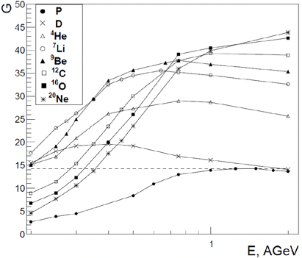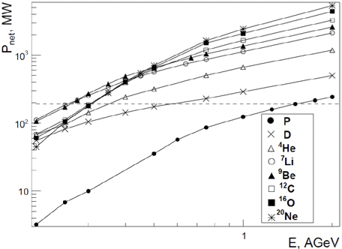

c) d)

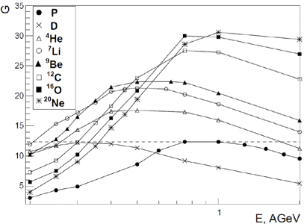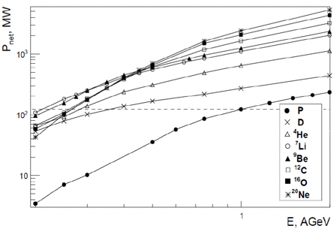

Fig. 2. G and Pnet depending on the energy of incident particles accelerated in the linear accelerator (a, b) and the cyclotron (c, d) in the reactor with a k_{eff} of 0.985.

We emphasize that the ADSR with the correct configuration (a long converter Be, k_{eff} 0.985-0.988) is an efficient energy source. The ADSR implements a high G (12-14 for protons, and higher for ions), which is explained by the fact that the energy required to maintain the functioning of the ADSR is only a few percent of the energy produced. This is another important advantage of ADSR. The G values in the ADSR are 8-10 times higher than the values that can be achieved in thermonuclear reactors.

References
- Paraipan M., Javadova V. M., Tyutyunnikov S. I., The influence of the particle beam and accelerator type on ADS efficiency, Nucl. Sci. Eng. (2023), DOI: https://doi.org/10.1080/00295639.2023.217558

- Paraipan M., Javadova V. M., Tyutyunnikov S. I., Aspects of target optimization for ADS with light ion beams at energies below 0.5 AGeV, Progr. Nucl. En. 120 (2020) 103221

- Paraipan M., Kryachko I. A., Javadova V. M., Levterova E. A., Tyutyunnikov S. I., Main Results of Neutronical Study about ADS with Ion Beams and Implications on Experiments Planning, Phys. Part. Nucl. Lett. 19 2 (2022) p. 129-144

- Baznat M. et al., Cascade models in simulation of extended heavy targets irradiated by accelerated proton and deuteron beams, Phys. Part. Nucl. 53, 5 (2022), p. 1000-1020.

- A.Baldin et al., Using TFBC for the neutron field characterization in experiments on “QUINTA” setup, Phys. Part. Nucl. 52, 6 (2022), p. 1033-1043.

- Paraipan M., Javadova V. M., Tyutyunnikov S. I., High efficiency ADS, International Conference “Modern Problems of Nuclear Energetics and Nuclear Technologies”, Institute of Nuclear Physics of Uzbekistan Academy of Sciences, Tashkent, Uzbekistan (2021)

- Paraipan M., Javadova V. M., Tyutyunnikov S. I, Target design for experimental investigation of ADS with proton and light ion beams, LXXII International conference "Nucleus-2022", Lomonosov Moscow State University, Moscow, Russia (2022)

- Paraipan M., Javadova V. M., Tyutyunnikov S. I, Perspectives of ADS with protons and light ion beams, IV International Scientific Forum “NUCLEAR SCIENCE AND TECHNOLOGIES” dedicated to the 65th anniversary of the Institute of Nuclear Physics, Алматы, Казахстан (2022)

- Paraipan M., Javadova V. M., Tyutyunnikov S. I, The influence of the particle beam and accelerator type on ADS efficiency, 14th International Topical Meeting on Nuclear Applications of Accelerator AccApp`21, Washington DC, USA (2021)

3. International cooperation
Actually participating countries, institutions and organizations

Organization | Country | City | Участники | Type of Agreement
YSU | Armenia | Yerevan | A.P. Balabekyan + 2 persons | Protocol
RI PCP BSU | Republic of Belarus | Minsk | Yu. A. Fedotova  V. G. Baev + 4 persons  K.G. Batrakov + 4 persons | Joint work  Exchange of visits
«JIPNR – Sosny» of the NASB | Republic of Belarus | Minsk | I. V. Zhuk + 4 persons | Joint work  Exchange of visits
INRNE BAS | Bulgaria | Sofia | Ch. Stoyanov + 4 persons | Protocol
IAP MAS | Moldova | Kishinev | M. Baznat + 1 person | Protocol
IPT MAS | Mongolia | Ulan Bator | R. Togoo + 2 persons | Joint work
NCBJ | Poland | Otvotsk-Sverk | M. Shuta + 4 persons  M. Zelchinsky | Protocol
IPI “Omega” | Russian Federation | Dubna | V.A. Luzanov | Joint work
SINP MSU | Russian Federation | Moscow | T. V. Tetereva | Joint work
IFTP | Russian Federation | Dubna | A.A.Smirnov  I.M. Gazizov  A.G. Letov | Protocol
"Diamant" LLC | Russian Federation | Moscow | M.G. Sapozhnikov  P. P. Reunov  Yu. S. Rogov | Protocol
JIHT RAS | Russian Federation | Moscow | V. P. Efremov + 4 persons | Joint work
"Marathon" LLC | Russian Federation | Moscow | A. S. Chepurnov + 3 persons | Joint work
ITEF SIC "Kurchatov Institute" | Russian Federation | Moscow | T. V. Kulevoy,  Yu. E. Titarenko + 4 persons | Joint work
RI | Russian Federation | Saint-Petersburg | S. G. Yavshits  A. N. Smirnov + 1 person | Protocol
TPU | Russian Federation | Tomsk | Yu. L. Pivovarov+4 persons | Joint work
ISS | Romania | Bucharest | M. Khayduk + 4 persons | Protocol
UMF | Romania | Bucharest | N. Verga + 2 persons | Joint work
IFIN-HH | Romania | Bucharest | A. K. Dragolich | Protocol
TUCN-NUCBM | Romania | Baia Mare | D. Rakolta | Protocol
UVT | Romania | Timisoara | M. Bunoyu | Protocol
UAIC | Romania | Lasi | D. Mikhalesku + 3 persons | Protocol
NSC KhPTI | Ukraine | Kharkov | V. A. Voronko + 1 person  V. V. Sotnikov + 1 person | Protocol
CTU | Czech Republic | Prague | L. Zavorka + 2 persons | Joint work
NPI CAS | Czech Republic | Rzhezh | V. Vagner + 4 persons  F. Spurny + 2 persons  K. Turek + 2 persons  A. Kugler | Protocol
BUT | Czech Republic | Brno | K. Katovsky + 3 persons | Joint work
University | Australia | Sydney | S. R. Khashemi-Nezhad + 1 person | Joint work
INP | Uzbekistan  Uzbekistan | Tashkent | B. Yuldashev + 3 persons | Protocol

4. Analysis of planed vs actually used resources: manpower (including associated personnel), financial, IT, infrastructure

4.1 Manpower (actual at the time of reporting)

No. | Personnel category | JINR staff,  amount of FTE | JINR associated personnel,  amount of FTE
1. | research scientists | 10 | 0
2. | engineers | 3 | 0
3. | specialists | 0 | 0
 | Total: | 10 | 0

4.2 The actual estimated cost of the project/ LRIP subproject

Names of costs, resources, funding sources |  |  | Cost (thousands  of US dollars) / Resource request | Proposal from  the laboratory for allocation of funding and resources
 |  |  |  | 1  year | 2  year | 3  year | 4  year | 5 year
 |  | International cooperation | 40 | 20 | 20 | — | — | —
 |  | Materials | 0 | 0 | 0 | — | — | —
 |  | Equipment, Third-party company services | 100 | 50 | 50 | — | — | —
 |  | Commissioning | 0 | 0 | 0 | — | — | —
 |  | R&D contracts with other research organizations | 0 | 0 | 0 | — | — | —
 |  | Software purchasing | 0 | 0 | 0 | — | — | —
 |  | Design/construction | 0 |  |  | — | — | —
 |  | Service costs (planned in case of direct project affiliation) | 0 | 0 | 0 | — | — | —
Resources required | Standard hours | Resources |  |  |  | — | — | —
 |  | - the amount of FTE, | 10 | 10 | 10 | — | — | —
 |  | - accelerator/installation, | 0 | 0 | 0 | — | — | —
 |  | - reactor,… | 0 | 0 | 0 | — | — | —
Sources of funding | JINR Budget | JINR budget (budget items) | 140 | 70 | 70 | — | — | —
 | Extra fudning (supplementary estimates) | Contributions by  partners  Funds under contracts with customers  Other sources of funding | 0 | 0 | 0 | — | — | —

4.3 Other resources
Computer resources consumed  MICC | Distribution by years
 | 1st year | 2nd year | 3rd year | 4th year | 5th year
Data storage (TB)  - EOS  - Tapes | 0 | 0 | 0 | 0 | 0
Tier 1 (CPU core hours) | 0 | 0 | 0 | 0 | 0
Tier 2 (CPU core hours) | 0 | 0 | 0 | 0 | 0
SC Govorun (CPU core hours)  - CPU  - GPU | 0 | 0 | 0 | 0 | 0
Clouds (CPU cores) | 0 | 0 | 0 | 0 | 0

5. Conclusion
The main tasks of the project envisaged within the proposed timeframe have been completed. The project had the adequate human and material support as well as other resources for implementation.

6. Proposed reviewers

Yu. E. Titarenko — ITEF SIC "Kurchatov Institute", Moscow, Russia.
Ivan Svito — Belarusian State University, Minsk, Republic of Belarus.

Theme / LRIP Leader
/______________/
" " 202_г.

Project leader (project code) / LRIP subproject
/____ /
" " 202_г.

Laboratory Economist
/_______ /
" " 202_ г.

