In total the completed form should not exceed 20 pages (together with tables).
Annex 3.
Form of opening (renewal) for Project /
Sub-project of LRIP

APPROVED
JINR DIRECTOR
/
" " 202 г.

PROJECT PROPOSAL FORM
Opening/renewal of a research project/subproject of the large research infrastructure project within the Topical plan of JINR
1. General information on the research project of the theme/subproject of the large research infrastructure project (hereinafter LRIP subproject)
  - Theme code / LRIP (for extended projects) - the theme code includes the opening date, the closing date is not given, as it is determined by the completion dates of the projects in the topic.

1.2 Project/LRIP subproject code (for extended projects) 04-2-1126-2015
1.3 Laboratory of Nuclear Problems

1.4 Scientific field: Condensed Matter Physics, Radiation and Radiobiological Research

1.5 Title of the project/LRIP subproject:
Study of the Nucleon Spin Structure in Strong and Electromagnetic Interactions
Project "GDH & SPASCHARM & NN"

1.6 Project/LRIP subproject leader(s) Yu.A. Usov

1.7 Project/LRIP subproject deputy leader(s) I.S. Gorodnov, Yu.A. Plis

2 Scientific case and project organization
2.1 Annotation
Dubna-Protvino-Prague-Moscow-Mainz-Glasgow Basel-Lund-Zagreb-Pavia-Kharkov-Bochum
Bonn–Giessen–Kent–Regina–Sackville Washingtion–York

Dubna, Dzhelepov Laboratory of Nuclear Problems, JINR
N.A. Bazhanov, D.V. Belov, N.S. Borisov, V.P. Volnykh, A.S. Dolzhikov, A.N. Fedorov, I.V. Gapienko, I.S. Gorodnov, G.M. Gurevich, V.L. Kashevarov, A. Kovalik, E.S. Kuzmin, A.B. Neganov, Yu.A. Plis, A.A. Priladyshev, A.B. Sadovski, Yu.A. Usov, Yu.N. Uzikov

Dubna, N.N. Bogoliubov Laboratory of Theoretical Physics, JINR
S.B. Gerasimov
Dubna, V.I. Veksler and A.M. Baldin Laboratory of High Energy Physics, JINR
V.V. Fimushkin, L.V. Kutuzova, M.V. Kulikov

Introduction
The subject of research on polarization phenomena has a great tradition and arose at DLNP JINR as a result of the successful implementation of a new method for obtaining ultralow temperatures (1966) and the proposal of the Laboratory employee B.S. Neganov (International Conference on Electromagnetic Interactions at Low and Medium Energies, Dubna, 1967 ) on the possibility of creating a new type of Polarized Target. Here we mean a “frozen” type target, in which the effect of cooling the working substance of the target to ultralow temperatures ~ 20–50 mK is fully used. Already in 1975, on the first polarized "frozen" target created at DLNP OTJI, the first studies were carried out at the synchrocyclotron: Yu. M. Kazarinov, et al. “Measurement of the polarization correlation coefficient Cnn of elastic pp scattering at energies of 550 and 630 MeV,, Zh. Exp. Teor. Fiz. 73, 1679-1683 (November 1977). Moreover, later the priority of this target was also recognized in the world (C. Keith, PSTP-2017).
As a result, several “frozen” type polarized targets were created at DLNP, which have been successfully used and are being used at various accelerators (DLNP, VBLHEP, Gatchina, Protvino, Prague, Mainz and Bonn). The study of polarization phenomena in our Laboratory has always been of particular importance. On the other hand, the statements of well-known theorists are characteristic, for example, the Englishman Elliot Leader: “Experiments with spin have killed more theories than any other physical parameter"» (Elliot Leader. Spin in Particle Physics, Cambridge U. Press (2001)) or the American James Bjorken: "Polarization data has often been the graveyard of fashionable theories. If theorists had their way they might well ban such measurements altogether out of self-protection" (J.D.Bjorken. Proc. Adv. Workshop on QCD Hadronic Processes, St. Croix, Virgin Islands, 1987).
This Project presents four main "activities" in which the authors are engaged: "SPASCHARM", "GDH", "NN" and "MESA".
- Experimental study of single-spin asymmetries in the production of miscellaneous light particles with the use of 28 GeV π⁻-beam at first stage and the study of single-spin and double-spin asymmetries in dozens of reactions including charmonium production with the use of polarized proton beam (SPASCHARM project).
The ultimate goal of the SPASCHARM project is to study spin structure of the proton, starting with determination of gluon contribution into the proton spin at large values of the Bjorken variable x through a study of spin effects in charmonium production. This will allow to understand charmonium hadronic production mechanism and to extract gluon polarization at large x.

- Experiments with a real photon beam: meson photoproduction on nucleons and nuclei and Compton scattering on nucleons. The main goals: experimental verification of the Gerasimov-Drell-Hearn (GDH) sum rule, investigation the helicity structure of partial reaction channels, resolve the excitation spectrum of light-quark baryons, search for missing baryon resonances and exotic states (dibaryons, narrow nucleon resonances), studying the structure of hadrons.

- Measurement of ∆σ_{T} and ∆σ_{L} in the nd transmission experiment at neutron energies < 16 MeV where limited experimental data exist and where the theory predicts the essential effect of the 3NF. This part of the project NN is the continuation of the same quantities measurements in neutron-proton scattering being performed previously.

- Research and development for polarization equipment for MESA.
The Mainz Energy Recovering Superconducting Accelerator (MESA) is located in Mainz. At MESA was explored the physics opportunities offered by using the recently established Energy-Recovery-Linac (ERL) accelerator technology, which enables very high electron-beam luminosity on internal targets at low energies. One of aims for this new electron accelerator MESA is to measure the weak mixing angle in electron-proton scattering with a precision of 0.13%. The beam polarization significantly contributes to this measurement. The Möller polarimeter proposed by V.Luppov and E.Chudakov opens the way to reach a sufficiently accurate determination of the polarization. Research and development for MESA polarization equipment is already started. At the moment the polarized atomic hydrogen target is under construction by Mainz-JINR team. The important part of this target is Dilution Refrigerator where JINR have a long-term experience.

Technically, three parts of the project are unified by the use of the frozen-spin polarized proton and deuteron targets.

2.2 Scientific case (aim, relevance and scientific novelty, methods and approaches, techniques, expected results, risks)

To date, there is no theory that gives a complete and consistent description of all the observed polarization effects in the hadronic sector. Therefore, a systematic experimental study of polarization effects in a wide variety of reactions using polarized beams and polarized targets is of great importance for the development of a theory that consistently describes all the observed spin phenomena.

The observed polarizations are the paramount characteristics of the interactions of elementary particles and nuclear reactions. Formally, the measurement of spin-dependent parameters imposes additional restrictions on the proposed reaction mechanism, the structure of the microobject under study, and the very nature of the fundamental interaction. It should be noted that modern experiments aimed at searching for the effects of CP violation and T invariance violation outside the Standard Model, as well as CPT violation, are based on polarization measurements.

Due to the complexity of polarization experiments, this area began to develop dynamically relatively recently, in accordance with the progress of experimental technology. At present, almost all modern accelerators of protons, deuterons and electrons produce polarized beams and have programs of polarization experiments. Targets made of polarized protons, deuterons, 3He, and heavier nuclei are being actively developed. High-density polarized gas targets (storage cells) used on storage rings are being developed. Modern tracking devices have been developed that make it possible to build efficient and fast polarimeters. This technological advance makes increasingly sophisticated polarization measurements available.

It is planned to perform the following works:
Plans for 2024-2028:

• Development and creation of a new cryostat for the polarized "frozen" target of the SPASCHARM setup - 2024-2026.

• Development and creation of the main components of a powerful 3He/4He dissolution refrigerator for the “MESA” facility – 2024-2025.

• Completion of work on the creation of a cryostat for a polarized target at the University of Bonn. – 2024.

• Return transportation and full launch of the polarized target in Mainz for the GDH project - 2024-2025.
Carrying out polarization studies using a polarized “frozen” target at the MAMI C accelerator,
- 2026-2028.

• Carrying out polarization studies on a new polarized target at the accelerator of the University of Bonn, “ELSA” - 2025-2028.

• Assembly, installation and testing of a powerful 3He/4He dissolution refrigerator on the beam channel of the MESA facility. – 2026-2027.

• Launch of the modified polarized target of the “SPASCHARM” installation and the beginning of the collection of physical statistics at the U-70 accelerator, - 2027-2028.

• According to the NN-interaction program, channeling experiments will be carried out at the stand of a source of polarized deuterons, - 2024-2025.

• An accurate measurement of the vector and tensor polarizations of deuterons will be carried out, at the VdG- 2025-2026.

• Preparation of a special device for using a new target material based on trityl-doped butanol, - 2025.

• Manufacture and installation of equipment for measuring neutron polarization using scattering on a 4He target, - 2026-2027
.• Carrying out the depreservation of the polarized deuteron target and the beginning of measuring the difference between the cross sections ΔσΤ and ΔσL in the experiment on transmission nd at neutron energies <16 MeV, - 2027-2028.

2.3 Estimated completion date 2028

2.4 Participating JINR laboratories
LTP S.B. Gerasimov
LHEP V.V, Fimushkin, L.V. Kutuzova, M.V. Kulikov

2.4.1 MICC resource requirements
Computing resources | Distribution by year
 | 1st year | 2nd year | 3rd year | 4th year | 5th year
Data storage (TB)
- EOS
- Tapes
Tier 1 (CPU core hours)
Tier 2 (CPU core hours)
SC Govorun (CPU core hours)
- CPU
- GPU
Clouds (CPU cores)

2.5. Participating countries, scientific and educational organizations

Organization | Country | City | Participants | Type  of agreement
Czech Technical University | CR | Prague | M. Solar | Agreement on cooperation
University, Mainz  University, Bonn | Germany  Germany | Mainz | А2 Collaboration at MAMI.  Collaboration P2 MESA  Collaboration  “Crystal Barrel” | Contract
Institute of High Energy Physics | RF | Protvino | V.V. Abramov, A.N. Vasiliev, V.V. Mochalov | Treaty
MePhI | RF | Moscow | M.V. Nurusheva, V.A. Okorokov, V.L. Rykov
ИЯИ РАН | РФ | Moscow | G.M. Gurevich

2.6. Key partners (those collaborators whose financial, infrastructural participation is substantial for the implementation of the research program. An example is JINR's participation in the LHC experiments at CERN).

3. Manpower
3.1. Manpower needs in the first year of implementation

№№  n/a | Category of personnel | JINR staff,  amount of FTE | JINR Associated  Personnel,  amount of FTE
1. | research scientists | 8
2. | engineers | 7
3. | specialists | 1
4. | office workers
5. | technicians
 | Total: | 16

3.2. Available manpower
3.2.1. JINR staff

No. | Category of personnel | Full name | Division |  | Position | Amount  of FTE
1. | research scientists | Bazhanov N.A.  Borisov N.S.  Gapienko I.V.  Dolzhikov A.S.  Neganov A.B.  Plis Yu.A.  Usov Yu.A..  Kashevarov V.L. | lnp snt  lnp snt  lnp snt  lnp snt  lnp snt  lnp snt  lnp snt  lnp snt |  | researcher  sen. res.  jun. res.  researcher  researcher  sen. res.  head of sector  sen. res.
2. | engineers | Belov D.V.  Gorodnov I.S.  Ivanova L.V.  Kolomiets V.G.  Fedorov A.N.  Priladyshev A.A.  Usov D.Yu. |  | lnp snt  lnp snt  lnp snt  lnp snt  lnp snt  lnp snt  lnp snt | engineer lead eng.  engineer engineer  lead eng.  engineer engineer
3. | specialists | Titenkova L.V. | lnp snt |  | specialist on documents
4. | technicians
 | Total: |  |  |  |  | 16

3.2.2. JINR associated personnel

No. | Category of personnel | Partner organization | Amount of FTE
1. | research scientists
2. | engineers
3. | specialists
4. | technicians
 | Total:

4. Financing
4.1 Total estimated cost of the project/LRIP subproject 387 thousands of US dollars
The total cost estimate of the project (for the whole period, excluding salary).
The details are given in a separate table below.

4.2 Extra funding sources
Expected funding from partners/customers – a total estimate.

Project (LRIP subproject) Leader _Yu.A. Usov_________/___________/

Date of submission of the project (LRIP subproject) to the Chief Scientific Secretary: _________
Date of decision of the laboratory's STC: _________ document number: _________
Year of the project (LRIP subproject) start: ________________
(for extended projects) – Project start year: _______

Proposed schedule and resource request for the Project / LRIP subproject
Expenditures, resources,  funding sources |  |  | Cost (thousands  of US dollars)/  Resource requirements | Cost/Resources,  distribution by years
 |  |  |  | 1st year | 2nd year | 3rd year | 4th year | 5th year
 |  | International cooperation | 220.0 | 50.0 | 50.0 | 50.0 | 35.0 | 35.0
 |  | Materials | 42.0 | 10.0 | 8.0 | 8.0 | 8.0 | 8.0
 |  | Equipment, Third-party company services | 96.0 | 22.0 | 22.0 | 22.0 | 15.0 | 15.0
 |  | Commissioning | 15.0 | 9.0 | 4.0 | 2.0
 |  | R&D contracts with other research organizations | 9.0 | 4.0 | 1.0 | 1.0 | 3.0
 |  | Software purchasing | 5.0 | 2.0 | 2.0 | 1.0
 |  | Design/construction
 |  | Service costs (planned in case of direct project affiliation)
Resources required | Standard hours | Resources
 |  | - the amount of FTE,
 |  | - accelerator/installation,
 |  | - reactor,…
Sources of funding | JINR Budget | JINR budget (budget items) | 387.0 | 97.0 | 87.0 | 84.0 | 61.0 | 58.0
 | Extra fudning (supplementary estimates) | Contributions by  partners  Funds under contracts with customers  Other sources of funding

Project (LRIP subproject) Leader____Yu.A. Usov_____/________________/

Laboratory Economist G.A. Usova _________/________________/

APPROVAL SHEET FOR PROJECT / LRIP SUBPROJECT

TITLE OF THE PROJECT/LRIP SUBPROJECT
SHORT DESIGNATION OF THE PROJECT / SUBPROJECT OF THE LRIP
PROJECT/LRIP SUBPROJECT CODE
THEME / LRIP CODE
NAME OF THE PROJECT/ LRIP SUBPROJECT LEADER
AGREED
JINR VICE-DIRECTOR | ___________  SIGNATURE | _________  NAME | _________  DATE
CHIEF SCIENTIFIC SECRETARY | ___________  SIGNATURE | _________  NAME | _________  DATE
CHIEF ENGINEER | ___________  SIGNATURE | _________  NAME | _________  DATE
LABORATORY DIRECTOR | ___________  SIGNATURE | _________  NAME | _________  DATE
CHIEF LABORATORY ENGINEER | ___________  SIGNATURE | _________  NAME | _________  DATE
LABORATORY SCIENTIFIC SECRETARY  THEME / LRIP LEADER | ___________  SIGNATURE | _________  NAME | _______  DATE
PROJECT / LRIP SUBPROJECT LEADER | __________  SIGNATURE | _________  NAME | _________  DATE
APPROVED BY THE PAC | ___________  SIGNATURE | _________  NAME | _________  DATE
Annex 4.
Project (LRIP subproject) report form

PROJECT REPORT
1. General information on the project / LRIP subproject
1.1. Scientific field: Condensed Matter Physics, Radiation and Radiobiological Research

1.2. Title of the project / LRIP subproject:
Study of the Nucleon Spin Structure in Strong and Electromagnetic Interactions
Project "GDH & SPASCHARM & NN"

1.3. Project (LRIP subproject) code: 04-2-1126-2015/
Example (04-4-1140-1-2024/2027)

1.4. Theme / LRIP code
Example (theme 04-4-1140-2024, MIP 04-4-1140-2024)

1.5. Actual duration of the project/ LRIP subproject: 2022-2023

1.6. Project / LRIP subproject Leader(s): A. Kovalik, Yu.A. Usov

2. Scientific report

  - Annotation

In December 2022, a methodical session was conducted on a polarized target at IHEP (Protvino) in order to determine the state of the equipment for subsequent operation on the beam.

During the reporting period, remote cooperation was carried out on the operation of a polarized target in Mainz, instructions were drawn up for launching a dilution cryostat for this polarized target.

The results of experiments at the installation of a source of polarized deuterons at the Czech Technical University in Prague were processed. A corresponding publication has been prepared.

2.2. A detailed scientific report

Report:
(05.2022-03.2023)
.In December 2022, a methodical session was conducted on a polarized target at IHEP (Protvino) in order to determine the state of the equipment for subsequent operation on the beam. Based on the results of the launch of the facility, the SPASCHARM collaboration decided to develop and manufacture a new Cryostat for a polarized target.

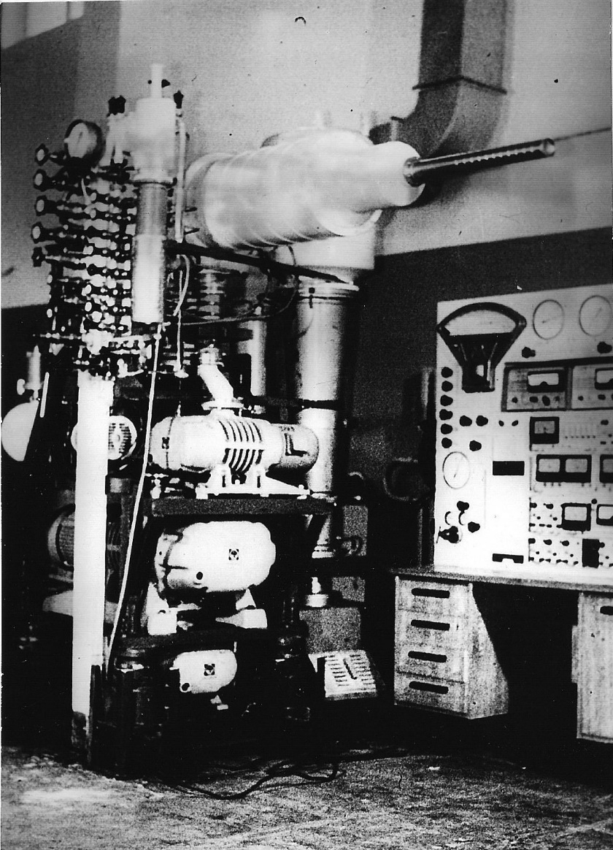
.

Fig.1 Polarized frozen target before sending to IHEP (Protvino) - 1978.
During the reporting period, cooperation was also carried out in a remote format on the operation of a polarized target in Bonn, instructions were drawn up for launching a dilution cryostat of this polarized target. Work was carried out to process the obtained physical data on the accelerators "MAMI C" and "ELSA"
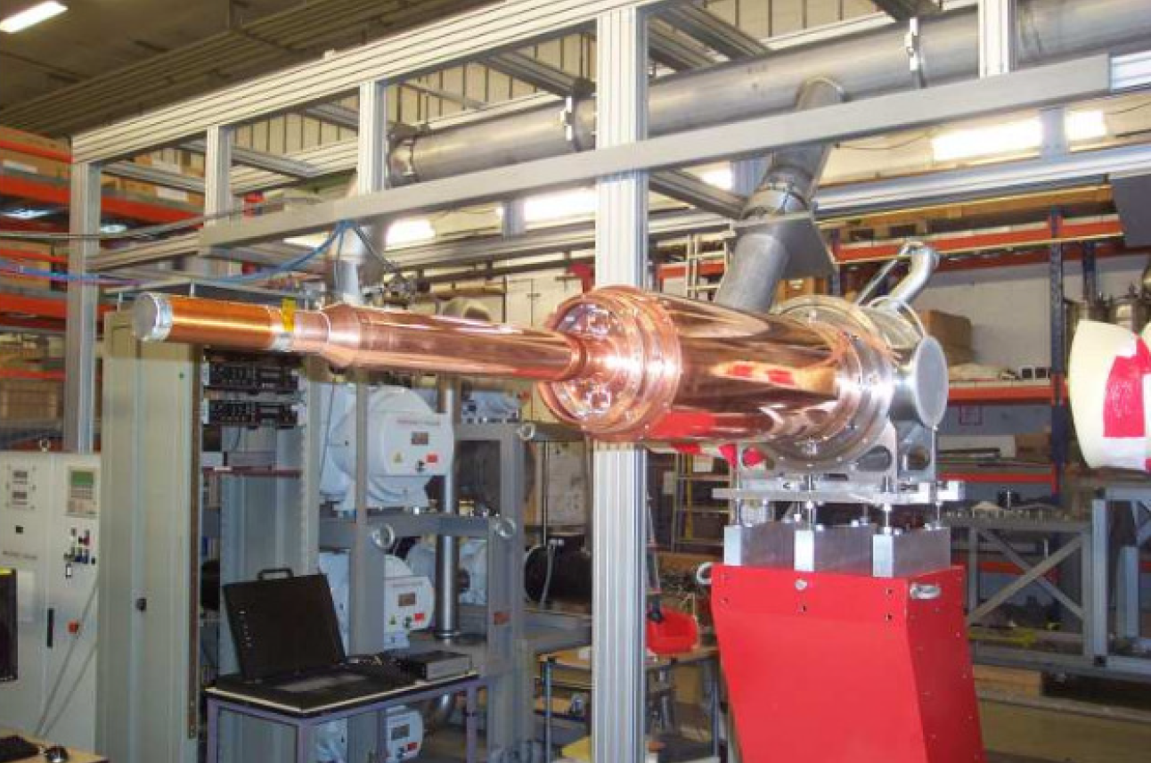
Fig.2 Cryostat of polarized target cryostat created at DLNP JINR (Mainz).

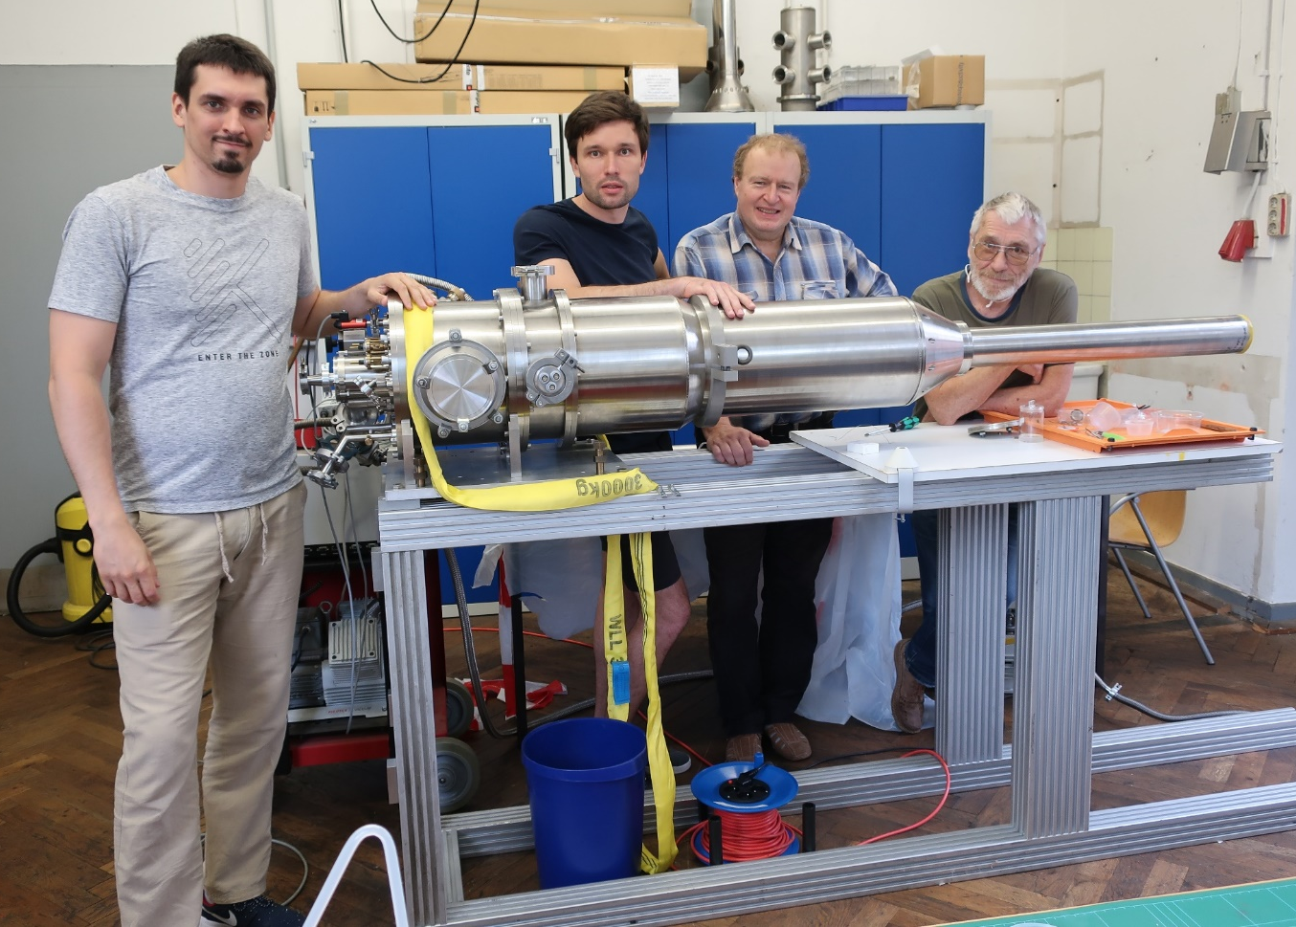
Рис.3 Новый криостат, созданный в ЛЯП, ОИЯИ (Бонн).
Проведена обработка результатов экспериментов на установке источника поляризованных дейтронов в Чешском техническом университете в Праге. Подготовлена соответствующая публикация и запланирован доклад на семинаре 6 апреля 2023 г.
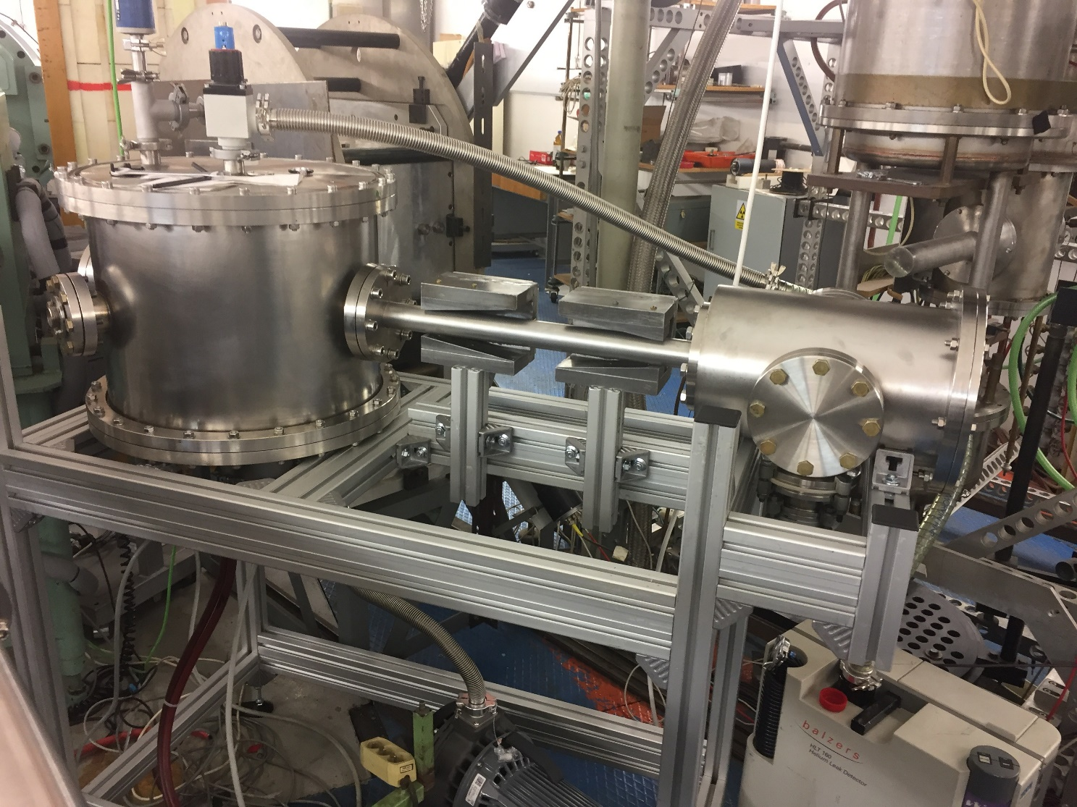
Рис.4 Установка для повышения поляризации пучка нейтронов ускорителя VdG, изготовленная в ЛЯП ОИЯИ (Прага).
Publications 2022-2023 г. Germany
№ | Publication title | Journal, DOI | Reference to journals | Ref. to arxiv.org
1 | Measurement of Compton scattering at MAMI for the extraction of the electric and magnetic polarizabilities of the proton. | Physical Review Letters 128, 132503.  DOI: 10.1103/PhysRevLett.128.132503.  01.04.2022.  Q1, Scopus. | https://journals.aps.org/prl/abstract/10.1103/PhysRevLett.128.132503  Received 5 November 2021, Revised 31 January 2022,  Accepted 25 February 2022, Published 1 April 2022. | https://arxiv.org/abs/2110.15691
2 | Measurement of the helicity dependence for single π0 photoproduction from the deuteron. | European Physical Journal A 58, 113 (2022).  DOI:10.1140/epja/s10050-022-00760-4.  Submitted 03.03.2022  Q1, Scopus. | https://link.springer.com/article/10.1140/epja/s10050-022-00760-4  Received 01 March 2022. Accepted 02 June 2022.  Published 30 June 2022. | https://arxiv.org/abs/2203.00535
3 | Target and beam-target asymmetries for the γp→π0π0p reaction. | 27 Sep 2022 |  | https://arxiv.org/abs/2207.14079
4 | First measurement of polarisation transfer C^{n}_{x′} in deuteron photodisintegration and the signatures of the d∗(2380) hexaquark | Preprint submitted to EPJ |  | https://arxiv.org/abs/2206.12299
5 | Neutron polarisation transfer, Cx′, in π+ photoproduction off the proton | Preprint submitted to Physics Letters B |  | https://arxiv.org/abs/2211.09688

Protvino, IHEP
1 | Conceptual project of the experiment SPASCHARM | PEPAN 2023. v.54, iss.1. pp.6–189 | http://www1.jinr.ru/Pepan/v-54-1/02_abramov.pdf

4.1 Manpower (actual at the time of reporting)

No. | Personnel category | JINR staff,  amount of FTE | JINR associated personnel,  amount of FTE
1. | research scientists | 8
2. | engineers | 7
3. | specialists | 1
 | Total: | 16

4.2 The actual estimated cost of the project/ LRIP subproject

Names of costs, resources, funding sources |  |  | Cost (thousands  of US dollars) / Resource request | Proposal from  the laboratory for allocation of funding and resources
 |  |  |  | 1  year | 2  year | 3  year | 4  year | 5 year
 |  | International cooperation
 |  | Materials | 8 | 8
 |  | Equipment, Third-party company services | 26 | 26
 |  | Commissioning
 |  | R&D contracts with other research organizations
 |  | Software purchasing
 |  | Design/construction
 |  | Service costs (planned in case of direct project affiliation)
Resources required | Standard hours | Resources
 |  | - the amount of FTE,
 |  | - accelerator/installation,
 |  | - reactor,…
Sources of funding | JINR Budget | JINR budget (budget items) | 34 | 34
 | Extra fudning (supplementary estimates) | Contributions by  partners  Funds under contracts with customers  Other sources of funding

4.3 Other resources
Computer resources consumed  MICC | Distribution by years
 | 1st year | 2nd year | 3rd year | 4th year | 5th year
Data storage (TB)
- EOS
- Tapes
Tier 1 (CPU core hours)
Tier 2 (CPU core hours)
SC Govorun (CPU core hours)
- CPU
- GPU
Clouds (CPU cores)

Theme / LRIP Leader
V.V. Glagolev /______________/
" " 202_г.

Project leader (project code) / LRIP subproject
Yu.A. Usov /____ /
" " 202_г.

Laboratory Economist
G.A. Usova /_______ /
" " 202_ г.

