APPROVED
JINR DIRECTOR
/
" " 2023

SCIENTIFIC AND TECHNICAL REASONING FOR THE OPENING
SUB-PROJECT OF LARGE RESEARCH INFRASTRUCTURE PROJECT
IN RESEARCH AREA WITHIN THE TOPICAL PLAN FOR JINR RESEARCH
- General information on the subproject of the large research infrastructure project (hereinafter LRIP subproject)

  - LRIP: 03-0-1129-2017

1.2 LRIP subproject code --
1.3 Laboratory: Flerov Laboratory of Nuclear Reactions

1.4 Scientific field: Heavy-ion physics

1.5 Title of the LRIP subproject: The U-400R Accelerator Complex

1.6 LRIP subproject leaders: Kalagin I.V., Popeko A.G.

  - LRIP subproject deputy leaders: Yeremin A.V., Semin V.A.

- Scientific case and project organization
2.1 Annotation
Scientific program of the Flerov Laboratory assumes focusing research at the U-400 accelerator complex on the synthesis and the study of properties of transfermium nuclides, mechanisms of nuclear reactions, nuclear spectroscopy and mass spectrometry, as well as the search of perspective experimental approaches to the synthesis of superheavy nuclides. The project falls into three subprojects: i) upgrade of the U400 cyclotron (U400R after the upgrade); ii) extension of experimental areas through the construction of a new building; iii) development of new experimental facilities to be placed in a new building.
2.2 Scientific case (aim, relevance and scientific novelty, methods and approaches, techniques, expected results, risks)
The goal of the project is the creation of the U400R accelerator complex focused on the synthesis and the study of properties of transfermium nuclides, mechanisms of nuclear reactions, nuclear spectroscopy and mass spectrometry, as well as the search of perspective experimental approaches to the synthesis of superheavy nuclides. Reactions with heavy ions are characterized by a strong overlap of several competing reaction channels: quasi-elastic scattering, deep-inelastic collisions, quasi-fission, fusion-fission, and fusion-survival. Experiments planned to be performed at the modernized U400R cyclotron will be aimed at the study of reaction mechanisms as well as at the use of different reaction channels as a method for production and study of new nuclei. In reaction studies we will mainly concentrate on studying competition of fusion-fission and quasifission processes as well as on studying multinucleon transfer (MNT) reactions, such as U+U, U+Cm, which are being considered as a promising way of the production of new (especially neutron-rich) nuclei. In the latter case, the key characteristics of reactions are angular and energy distributions, cross-sections etc.
In was clearly shown both experimentally (Fig. 1) and theoretically (Figs. 2 and 3) that the MNT reactions with actinides may lead to formation of neutron-enriched reaction products in transuranium region. They, however, can be hardly identified because they are mainly β-emitters and/or have very large half-lives. This motivates development of new identification methods, independent of the decay properties of the nuclei, which is mandatory to access the upper region of the nuclear chart.
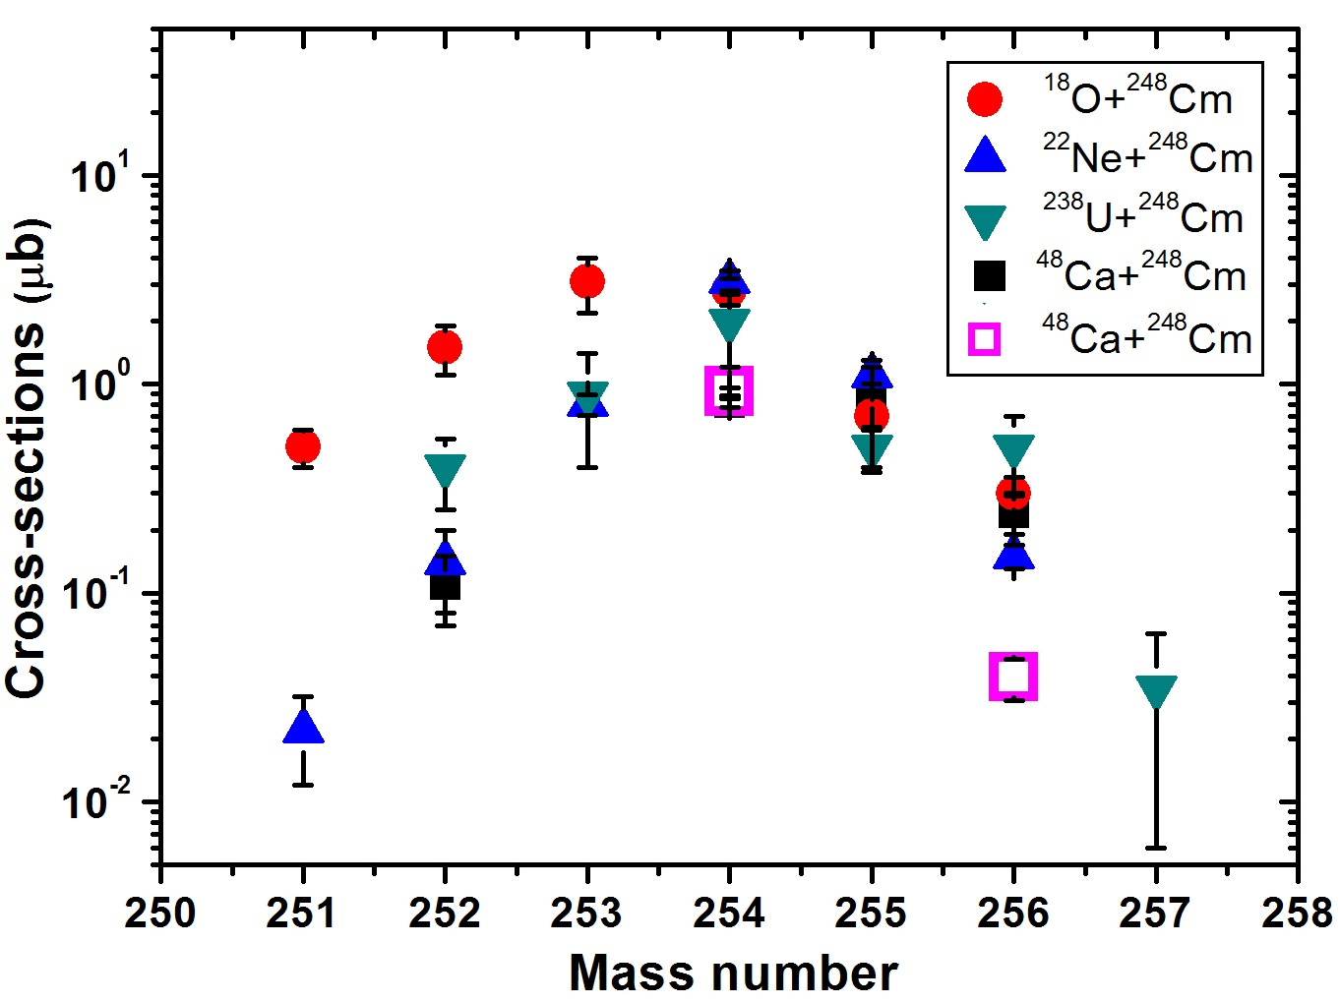
Fig. 1. Measured cross sections of Fm (Z =100) isotopes populated in multinucleon transfer reactions with ²⁴⁸Cm targets (ﬁlled symbols). The respective projectiles are indicated in the inset.
Fermium is so far the heaviest element for which a broad variety of diﬀerent isotopes was observed in MNT reactions. The open squares denote the results from our recent experiment with ⁴⁸Ca+²⁴⁸Cm at the kinematic separators - velocity ﬁlters, located at zero degrees in the beam direction.
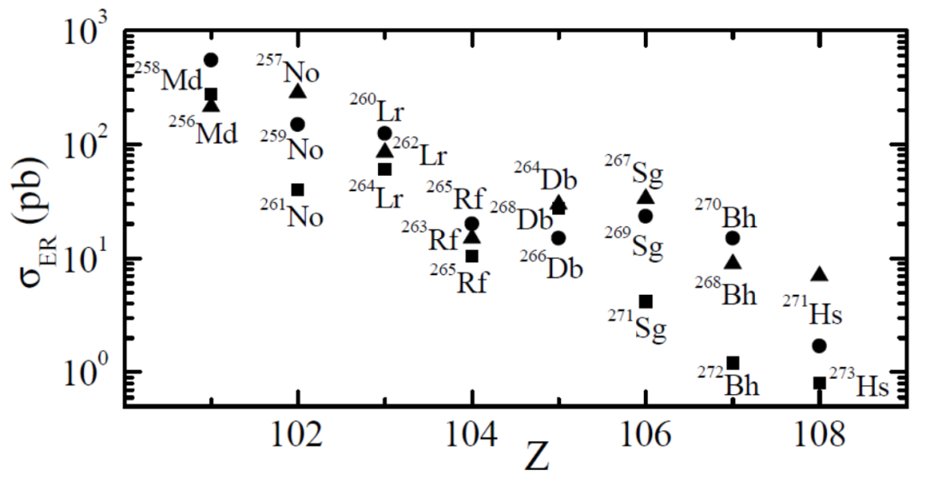
Fig. 2. Calculations of cross sections for neutron- rich nuclei with Z = (101 − 108) produced in MNT reactions of ⁴⁸Ca projectiles on targets of ²⁴⁴Cm (Ec.m. = 207 MeV, triangles), ²⁴⁶Cm (Ec.m. = 205.5 MeV, circles) and ²⁴⁸Cm (Ec.m. = 204 MeV, squares). The beam energies were close to the respective Coulomb barrier. The denoted reaction products result after evaporation of one neutron from the excited primary transfer products.
There is also a predicted possibility to apply MNT reactions for production of nuclei around Z=104. Most of the known nuclei located in this region of the nuclear chart have been produced indirectly as the α-decay products of superheavy nuclei synthesized in the ⁴⁸Ca-indiced hot fusion reactions.
Despite still existing uncertainties, diﬀerent theoretical approaches and available experimental data leave a common picture. The calculated cross sections for new neutron-rich superheavy MNT products are in the sub-microbarn cross section region. If we assume that cross sections in the range 1 pb to 1 nb are accessible, MNT reactions can be an option to reach new isotopes with Z ≤108.
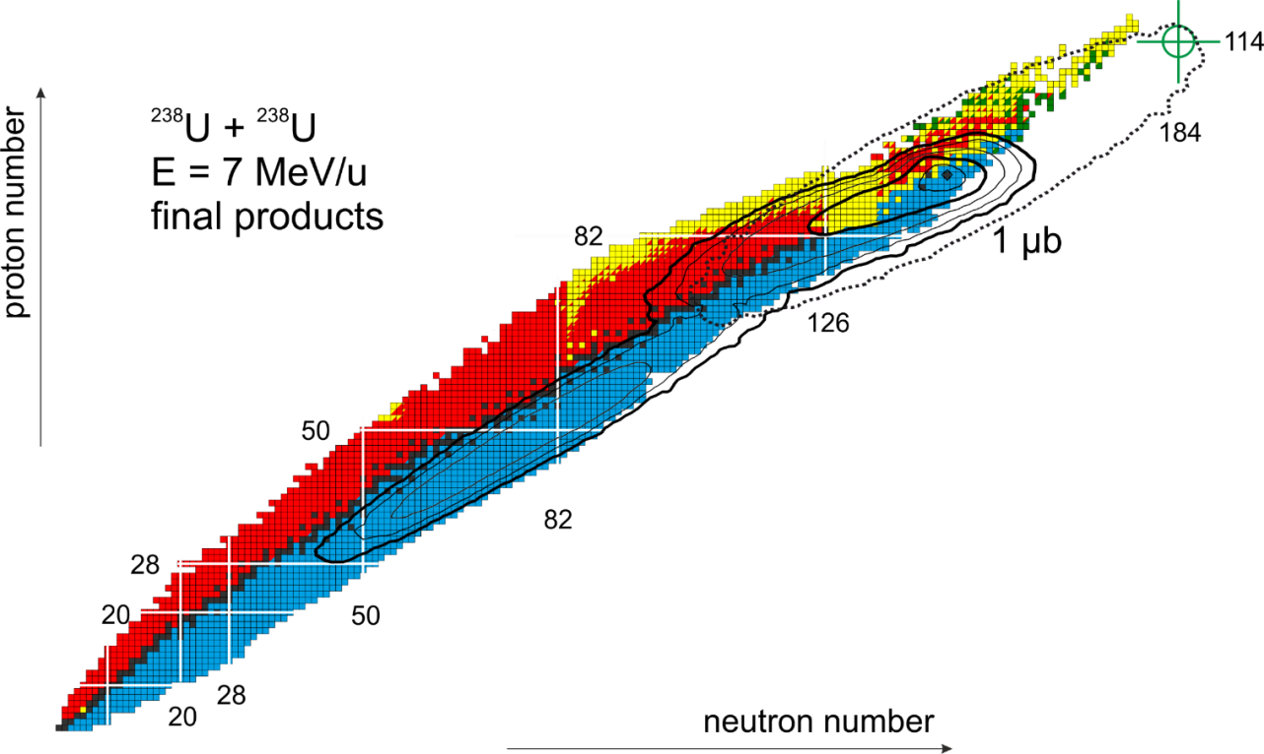
Fig. 3. Calculated cross sections for different nuclei produced in ²³⁸U+²³⁸U collisions at 7 MeV/u beam energy down to 1 ub. The dashed curve show the 1ub cross section level for primary (excited) products, while the solid ones correspond to final (survived) reaction products.

Another important requirement to be fulfilled is a possibility to measure binary and triple (sequential fission of one of the fragments) exit channels. As a next step, decay properties (decay spectroscopy) of new nuclei produced in MNT reactions can be studied. The study of the competition between the processes of complete fusion and quasi-fission is an important task of nuclear physics allowing in particular to estimate the fusion cross section for synthesis of superheavy elements. Since quasi-fission can probably be observed already for fairly light systems with Z1⋅Z2 ≈ 700, it is extremely important to measure all possible channels, both for the reactions leading to the formation of heavy and superheavy systems and for the reactions with light and medium nuclei. There are great difficulties in distinguishing these processes. For estimation of the cross section of the fusion-fission process and more accurate distinguishing of fission fragments of the compound nucleus, it is necessary to measure the cross section of evaporation residues. Measurements of the cross sections of the evaporation residue, fusion-fission, and quasi-fission will make it possible to determine this dependence and conduct a deeper theoretical analysis of the dynamics of a reaction under study. It is extremely important to carry out these measurements in a single experiment at the same values of the interaction energy.
Within the project we propose the upgrade of the U400 cyclotron, the expansion of experimental areas by constructing a new building and development of new specialized separators. The complex is aimed at the detailed study of production mechanisms of heavy and superheavy nuclides, as well as to the search for new approaches to the synthesis of superheavy elements. These studies do not imply the use of radioactive target materials in amounts exceeding activity more than 10⁵ Bq.
Subproject I. Upgrade of the U400 cyclotron.
The project also implies an essential upgrade of the U400 cyclotron, endorsed by the PAC at the 54th PAC session in 2021 (see Fig. 4). The principal goals of the upgrade are:
- increase in the intensity of accelerated beams of ⁴⁸Са ions up to 2-2.5 рμА;
- upgrade of a beam extraction system. The upgraded system will provide beam extraction both with a recharging foil and an electrostatic deflector, which will improve beam quality;
- smooth variation of the beam energy in a wide range of ion mass-to-charge ratios A/Z, which is important for experiments on the dynamics of fusion-fission reactions, MNT reactions, and experiments on nuclear spectroscopy;
- decrease of the energy spread of the beam to 3·10⁻³;
- decrease of the maximum level of the magnetic field in the center of the cyclotron from 2.1 T to 1.8 T, which will significantly reduce the power consumption of the cyclotron and reduce the level of the scattered magnetic field.
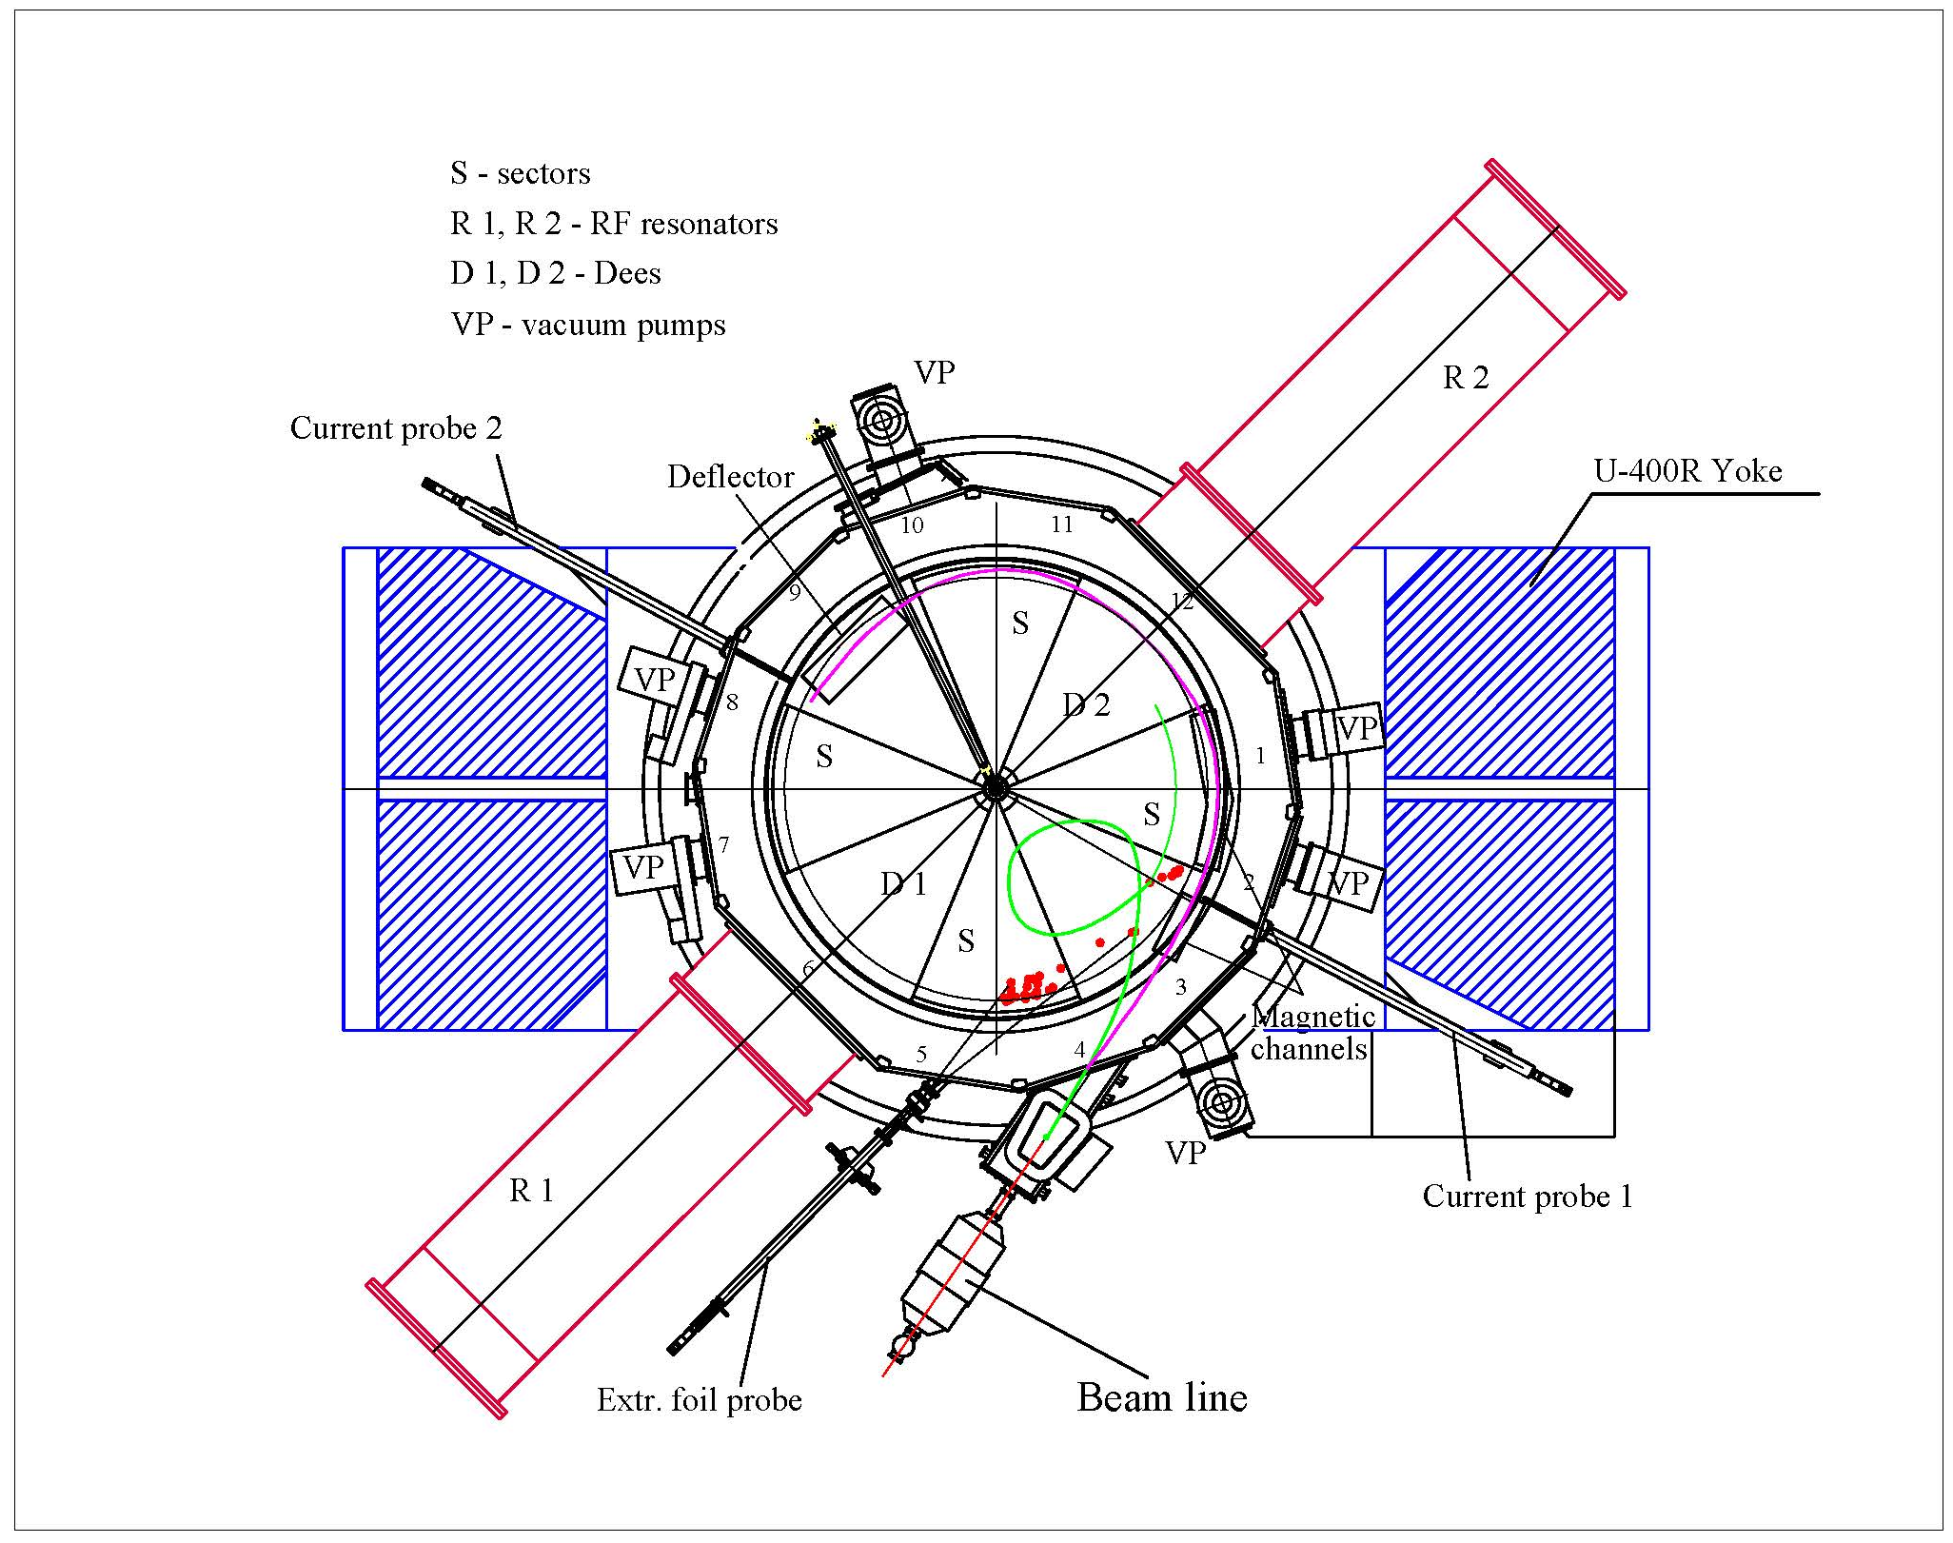
Fig. 4. Scheme of the U-400R accelerator

Comparative characteristics of U-400 and U-400R ion beams are given in the Table 1.
Table 1. Comparative characteristics of U-400 and U-400R ion beams
 | U400  A/Z=5÷12, E=3÷29 MeV/u |  | U400R  A/Z=4÷12, E=0.8÷27 MeV/u
beam | E/A (MeV) | intensity | E/A (MeV) | intensity | Physics
6<A<40  ⁷Li  ¹⁸O  ⁴⁰Ar | 17  19  5 | 6×10¹³  2×10¹³  9×10¹² | 17  19  5 | 1×10¹⁴  1×10¹⁴  3×10¹³ | production of light RIB, fragmentation, transfer, structure of light exotic nuclei
A ~ 60  ⁴⁸Ca  ⁵⁴Cr  ⁵⁸Fe | 5  5  5 | 7.5×10¹²  4×10¹² 4.4×10¹² | 5  5  5 | 2×10¹³  6×10¹²  6×10¹² | superheavy elements,  spectroscopy of SHE,  fusion-fission,  quasi-fission, etc.
A ~ 150  ¹²⁴Sn  ¹³⁶Xe | 5  5 | 3×10¹¹  5×10¹¹ | 5  5 | 2×10¹²  3×10¹² | DIP, multi-nucleon transfer, new neutron rich nuclei, shell effects
A ~ 240  ²³⁸U | 7 | 3×10¹⁰ | 7 | 10¹¹ | neutron-rich SHE,  new heavy isotopes,  ternary fission,  super strong electric fields, e⁺ e⁻ formation

Subproject II. Extension of experimental areas through the construction of a new building.
Civil construction of additional experimental area
Nowadays the total area intended for placing experimental facilities at the U-400 cyclotron in the building 131 makes about 200 m²; the physical facilities located on two levels of the bulilding occupy almost the entire available area. New facilities require additional space. Besides, the radiation shielding of the existing hall does not allow preparation for one experiment while another is underway. To provide conditions for further development, a project of a new experimental hall was proposed. The proposal was appreciated by PAC at the 54th PAC session in 2021. The project assumes the construction of experimental building of a total area of about 1200 m² intended for placing experimental facilities (Figs. 5,6).
U-400R
Building 131
Experimental Hall of U-400
New Experimental Hall of U-400R
Fig. 5. Plan of the U-400R accelerator complex
The building of the new experimental hall located on the area of about 2000 m², and consists of 4 floors. The 1st floor is designed for technological systems: water cooling, ventilation, gas cleaning, fore-vacuum. There are also rooms for the temporary storage and release of solid and liquid radioactive waste. The 2nd floor contains the physical cabins and two galleries connecting the building to the cyclotron building. The 3rd floor is designed Control rooms are located on the 3rd floor. The 4th floor is intended for accommodation of electric boards and power supplies of physical setups.

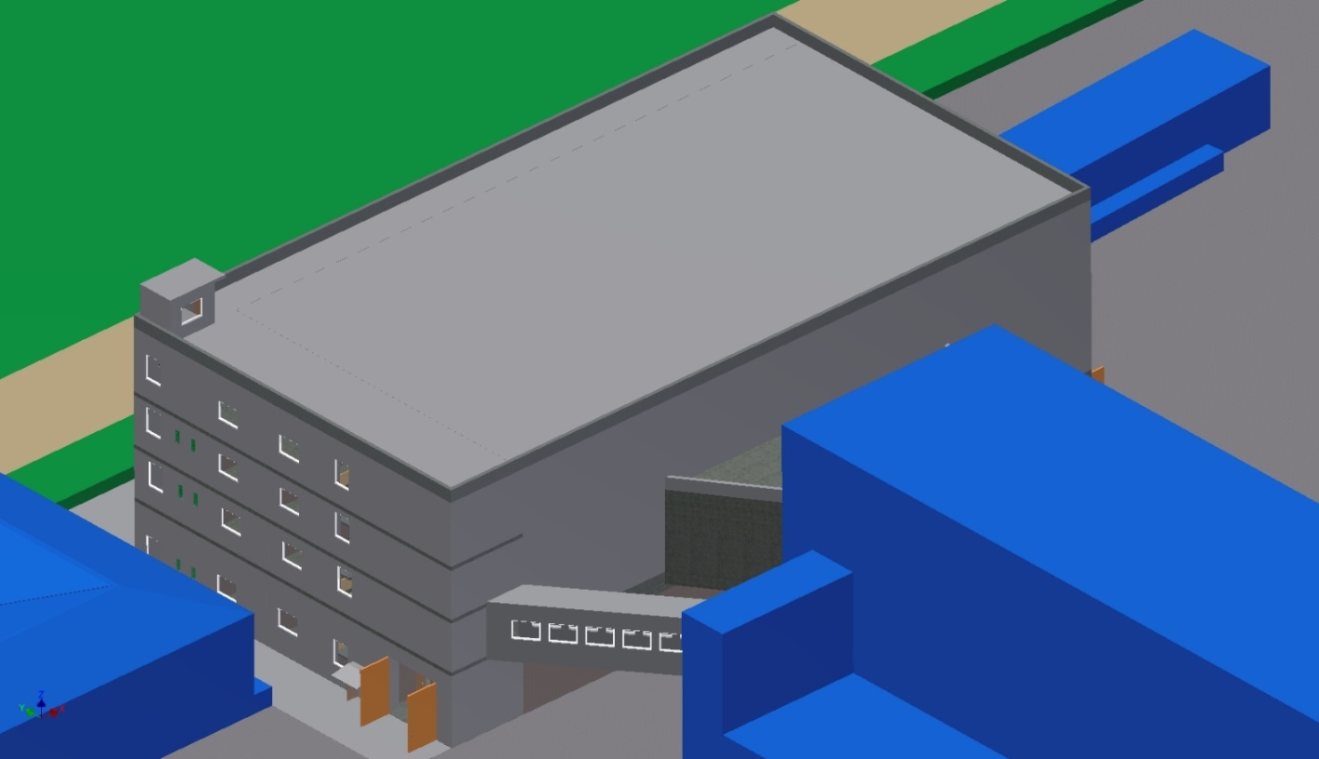
Storehouse
Storehouse
Building of U-400R cyclotron
New Experimental Hall of U-400R
Fig. 6. Sketch of the U400R accelerator complex
Floors are interconnected by two stairs located in opposite corners of building and passenger elevator with carrying capacity of 1600 kg. To move equipment between the first and second floors, a scissor-type cargo platform with a carrying capacity of 1000 kg is provided. A track passage was designed below the galleries.
The design concept of the main part of the building and the gallery of beam lines is a monolithic frame. The ceiling height in physical cabins is 12.9 m, the area of ​every physical cabin makes about 400 m², the average floor bearing capacity is 10 t/m². The large thickness (more than 1 m) of reinforced concrete walls of physical cabins, floors of physical cabins and rooms on the 1st floor is due to the need to protect against ionizing radiation.

Subproject III. Construction of new experimental facilities to be placed in a new building.
Accelerated ion beams will be transported from the U400R cyclotron to the operating experimental facilities placed in the existing building as well as in the new experimental hall. The experimental facilities in the new experimental hall will be separated by protective walls, which make it possible to work in one cave while the beam of accelerated ions is brought out into another. At the current stage we propose to include in the project construction of a kinematic separator for studying the characteristics of MNT reactions and properties of radioactive decay of neutron-rich isotopes of heavy elements formed in MNT reactions. The separator is intended for operation with high beam intensity to provide reliable separation of heavy and superheavy nuclei at high background suppression. The separator has to provide high efficiency of the transmission of fusion and transfer reaction products. The proposal was appreciated by PAC at the 51th PAC session in 2020.
The facility should provide rotation with respect to the beam axis for the study of MNT reaction dynamics, resulting in a wide angular distribution of reaction products. For this purpose it is planned to use pneumatic platform, which could provide rotation of the separator from +10º to +60º in respect to the beam axe. As an example, Fig. 7 shows calculated angular distribution for the ¹³⁶Xe+¹⁹⁸Pt reaction. It is seen that the angular distributions are predicted to be very sensitive both to the exit channel of interest as well as to the collision energy.
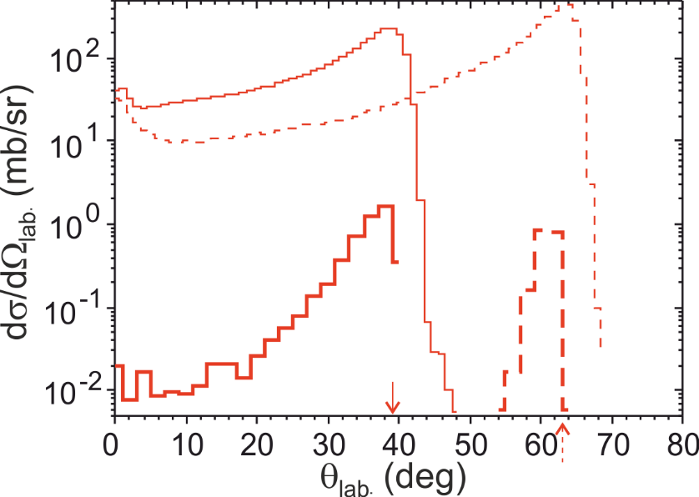
Fig. 7. Predicted angular distributions of iridium isotopes produced in the ¹³⁶Xe+¹⁹⁸Pt reaction at two collision energies: E_{c.m.}=450 (solid) and 643 (dashed) MeV. The thick histograms correspond to ²⁰³Ir₁₂₆, while the thin ones show calculations for all produced iridium isotopes.
Study of MNT reactions with the goal to produce neutron-rich nuclei along the N = 126 shell, below Pb is of great interest in particular for astrophysics in view of the problem of the modelling of the r-process of production of heavy nuclei. The nuclei in this region are β-emitters will be identified by γ spectroscopy. For this, the efficient clover detector system GABRIELA will provide significant advantages over our previous experiments. Results will be compared with fragmentation reactions and shall give further input to answer the question if finally fragmentation reactions or indeed MNT reactions are better to synthesize neutron-rich nuclei along N = 126.
A compact scheme based on the combination of electric deflector, magnetic sector followed by the detector station was proposed for the new separator (see the scheme in Fig. 8).

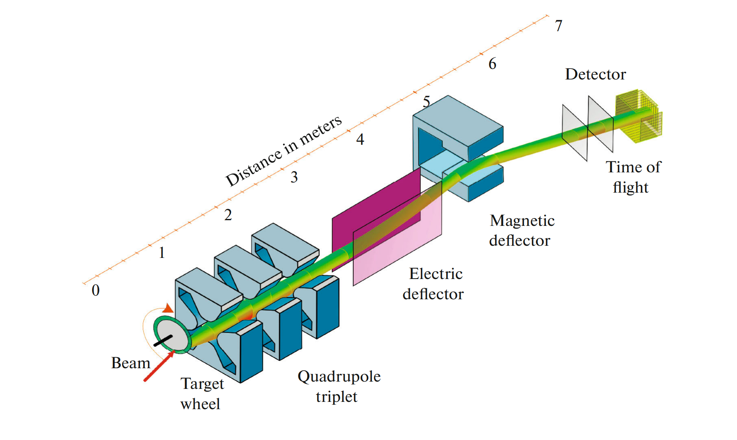

Fig. 8. Conceptual design of the new separator.

The calculated beam envelopes for reference particle with A = 200, ionic charge state Q = 26⁺ and energy about 100 MeV are shown at the Figure 9.

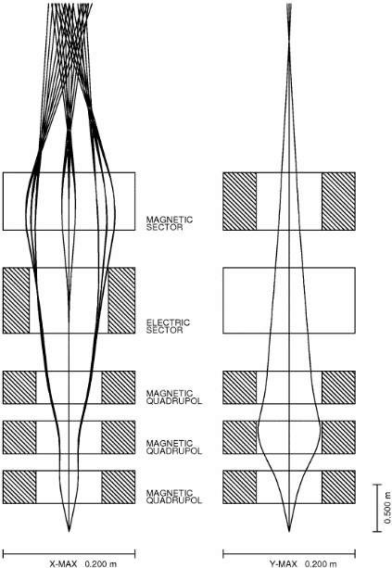
Fig. 9. The beam envelopes for the new separator.

Ion optical calculations showed that it is possible to achieve dispersion at the focal plane of the separator about 6.0 mm/%, and first order resolving power about 300 (with a 2 mm m beam spot). To obtain declared mass resolving power Time of Flight measurements at the focal plane are needed.
In Table 2 the technical information about the possible ion optical elements used in the separator is listed.
Table 2. Key Parameters of a new separator.
Quadrupole lenses Q1,Q2,Q3 |  | Magnetic dipole |  | Electrostatic dipole
Bore diameter | 0.15 m | Bending angle | 35º | Bending angle | 10º
Effective length | 0.45 m | Bending radius | 2.6 m | Effective length | 1.5 m
Maximum field gradient | 13 T/m | Maximum field strength | 1.8 T | Bending radius | 4 m
Weight | 3 t | Pole gap | 0.12 m | Distance between plates | 0.1 m
 |  | Weight | 7 t | High voltage | 2 × 150 kV

Risks.
The main risks are linked to restrictions on the purchase of a number of equipment manufactured in the EU and the USA (vacuum equipment, high-voltage power supplies, detectors and electronic equipment), which may cause delays in the implementation of the project. In addition, the risk of construction delay due to the fault of the contractor is not excluded.
2.3 Estimated completion date
2024 – 2028

2.4 Participating JINR laboratories
FLNR
2.4.1 MICC resource requirements
Computing resources | Distribution by year
 | 1st year | 2nd year | 3rd year | 4th year | 5th year
Data storage (TB)
- EOS
- Tapes
Tier 1 (CPU core hours)
Tier 2 (CPU core hours)
SC Govorun (CPU core hours)
- CPU
- GPU
Clouds (CPU cores)

2.5. Participating countries, scientific and educational organizations

Organization | Country | City | Participants | Type  of agreement

2.6. Key partners (those collaborators whose financial, infrastructural participation is substantial for the implementation of the research program. An example is JINR's participation in the LHC experiments at CERN).

3. Manpower
3.1. Manpower needs in the first year of implementation

№№  n/a | Category of personnel | JINR staff,  amount of FTE | JINR Associated  Personnel,  amount of FTE
1. | research scientists | 6.4
2. | engineers | 10.0
3. | specialists | 1.5
4. | office workers | 0
5. | technicians | 1.8
 | Total: | 19.7

3.2. Available manpower
3.2.1. JINR staff

No. | Category of personnel | Full name | Division | Position | Amount  of FTE
1. | research scientists |  |  |  | 6.4
1.1 |  | Kazarinov N.Y. | FLNR STAD SAPh | Head of Sector | 0.4
1.2 |  | Ivanenko I.A. | FLNR STAD SAPh | Team Leader | 0.4
1.3 |  | Tikhamirov A.V. | FLNR STAD SAPh | Senior Research Associate | 0.4
1.4 |  | Franko Y. | FLNR STAD SAPh | Senior Research Associate | 0.4
1.5 |  | Kozulin E.M. | FLNR Sector N5 | Head of Sector | 0.8
1.6 |  | Knyazheva G.N. | FLNR Sector N5 | Senior Research Associate | 0.8
1.7 |  | Itkis Y.M. | FLNR Sector N5 | Research Associate | 0.8
1.8 |  | Kirakossian V.V. | FLNR Sector N5 | Research Associate | 0.8
1.9 |  | Novikov K.V. | FLNR Sector N5 | Junior researcher | 0.8
1.10 |  | Bogachev A.A. | FLNR Sector N5 | Junior researcher | 0.8
2. | engineers |  |  |  | 10.0
2.1 |  | Kostyrev V.A. | FLNR CES | Deputy chief engineer | 0.3
2.2 |  | Gikal K.B. | FLNR STAD | Deputy Head of Department | 0.3
2.3 |  | Osipov N.F. | FLNR CTD | Head of department | 0.3
2.4 |  | Ivanov G.N. | FLNR CTD CB | Head of Bureau | 0.4
2.5 |  | Verevochkin V.A. | FLNR TDESPhS | Head of department | 0.4
2.6 |  | Pashcenko S.V. | FLNR TDSEAPhS | Head of department | 0.4
2.7 |  | Klenov E.A. | FLNR DTSAPhS | Head of department | 0.3
2.8 |  | Vaganov R.E. | FLNR STAD U-400 | Head of setup | 0.5
2.9 |  | Chernyshev O.A. | FLNR STAD SVT | Head of Service | 0.3
2.10 |  | Lisov V.I. | FLNR STAD SAPh | engineer | 0.4
2.11 |  | Zabanov A.S. | FLNR STAD SAPh | engineer | 0.4
2.12 |  | Bass V. | FLNR STAD SAPh | engineer | 0.4
2.13 |  | Kozulina N.I. | FLNR Sector N5 | Senior engineer | 0.8
2.14 |  | Pchelintsev I.I. | FLNR Sector N5 | Senior engineer | 0.8
2.15 |  | Vorobev I.V. | FLNR Sector N5 | Senior engineer | 0.8
2.16 |  | Tikhomirov R.S. | FLNR Sector N5 | Senior engineer | 0.8
2.17 |  | Saveleva E.O. | FLNR Sector N5 | engineer | 0.8
2.18 |  | Zhukova A.O. | FLNR Sector N5 | engineer | 0.8
2.19 |  | Ostroukhov A.A. | FLNR Sector N5 | Senior lab assistant | 0.4
2.20 |  | Kulkov K.A. | FLNR Sector N5 | Senior lab assistant | 0.4
3. | specialists |  |  |  | 1.5
3.1 |  | Zinchenko S.Y. | FLNR CES | Safety senior engineer | 0.3
3.2 |  | Belyakova E.V. | FLNR CES | Document Specialist | 0.3
3.3 |  | Zagrebaeva S.I. | FLNR CES | Document Specialist | 0.3
3.4 |  | Suslov A.A. | FLNR CES | Lead engineer | 0.3
3.5 |  | Barbashev M.B. | FLNR CES | Lead engineer | 0.3
4. | technicians |  |  |  | 1.8
4.1 |  | Sidorov A.A. | FLNR STAD | mechanic | 0.5
4.2 |  | Makarov M.I. | FLNR STAD | mechanic | 0.4
4.3 |  | Romanov A.S. | FLNR STAD | mechanic | 0.3
4.4 |  | Bykov A.N. | FLNR STAD | mechanic | 0.3
4.5 |  | Kulikov A.V. | FLNR STAD | mechanic | 0.3
 | Total: |  |  |  | 19.7

3.2.2. JINR associated personnel

No. | Category of personnel | Partner organization | Amount of FTE
1. | research scientists
2. | engineers
3. | specialists
 | Total:

4. Financing
4.1 Total estimated cost of the LRIP subproject
The total cost estimate of the project (for the whole period, excluding salary).
The details are given in a separate table below.
International cooperation: 250 k$
Construction: 18.0 М$
U400R modernization, beam lines: 2.0 М$
Experimental set ups: 6.7 М$
Software purchasing: 100 k$

4.2 Extra funding sources
Expected funding from partners/customers – a total estimate.

LRIP subproject Leaders _________/I.V. Kalagin/
_________/A.G. Popeko/

Date of submission of the LRIP subproject to the Chief Scientific Secretary: _________
Date of decision of the laboratory's STC: _________ document number: _________
Year of the LRIP subproject start: ________________
(for extended projects) – Project start year: _______
Proposed schedule and resource request for the LRIP subproject
Expenditures, resources,  funding sources |  |  | Cost (thousands  of US dollars)/  Resource requirements | Cost/Resources,  distribution by years
 |  |  |  | 1st year | 2nd year | 3rd year | 4th year | 5th year
 |  | International cooperation | 250 | 50 | 50 | 50 | 50 | 50
 |  | Materials | 2 650 | 500 | 700 | 450 | 500 | 500
 |  | Equipment, Third-party company services | 5 850 | 1560 | 1660 | 1000 | 765 | 865
 |  | Commissioning | 80 | 10 | 10 | 20 | 20 | 20
 |  | R&D contracts with other research organizations | 120 | 30 | 30 | 30 | 15 | 15
 |  | Software purchasing | 100 | 20 | 20 | 20 | 20 | 20
 |  | Design/construction | 18000 | 9000 | 8000 | 1000 | - | -
 |  | Service costs (planned in case of direct project affiliation)
Resources required | Standard hours | Resources
 |  | - the amount of FTE,
 |  | - accelerator/installation,
 |  | - reactor,…
Sources of funding | JINR Budget | JINR budget (budget items) | It. 4 - 250  It. 5,6 – 8500  It. 9 – 80  It. 10 – 120  It. 11 - 100  It. 18,19- 18000
 | Extra fudning (supplementary estimates) | Contributions by  partners  Funds under contracts with customers  Other sources of funding

LRIP subproject Leaders _________/I.V. Kalagin/
_________/A.G. Popeko/
Laboratory Economist _________/T.V. Mamonova/
APPROVAL SHEET FOR LRIP SUBPROJECT
TITLE OF THE LRIP SUBPROJECT
SHORT DESIGNATION OF THE SUBPROJECT OF THE LRIP
LRIP SUBPROJECT CODE
LRIP CODE
NAME OF THE LRIP SUBPROJECT LEADER
AGREED
JINR VICE-DIRECTOR | ___________  SIGNATURE | Dmitriev S.N.  NAME | _________  DATE
CHIEF SCIENTIFIC SECRETARY | ___________  SIGNATURE | Nedelko S.N.  NAME | _________  DATE
CHIEF ENGINEER | ___________  SIGNATURE | Gikal B.N.  NAME | _________  DATE
LABORATORY DIRECTOR | ___________  SIGNATURE | Sidorchuk S.N.  NAME | _________  DATE
CHIEF LABORATORY ENGINEER | ___________  SIGNATURE | Kalagin I.V.  NAME | _________  DATE
LABORATORY SCIENTIFIC SECRETARY | ___________  SIGNATURE | Karpov A.V.  NAME | _______  DATE
LRIP LEADERS | ___________  SIGNATURE  ___________  SIGNATURE | Kalagin I.V.  NAME  Sidorchuk S.N.  NAME | _________  DATE  _________  DATE
LRIP SUBPROJECT LEADERS | __________  SIGNATURE | Kalagin I.V.  NAME | _________  DATE
 | __________  SIGNATURE | Popeko A.G.  NAME | _________  DATE
APPROVED BY THE PAC

