APPROVED
JINR DIRECTOR
/
" " 2023

SCIENTIFIC AND TECHNICAL REASONING FOR THE OPENING
SUB-PROJECT OF LARGE RESEARCH INFRASTRUCTURE PROJECT
IN RESEARCH AREA WITHIN THE TOPICAL PLAN FOR JINR RESEARCH
- General information on the research project of the theme/subproject of the large research infrastructure project (hereinafter LRIP subproject)

  - LRIP: 03-0-1129-2017

1.2 LRIP subproject code --
1.3 Laboratory: Flerov Laboratory of Nuclear Reactions

  - Scientific field: Heavy-ion physics

1.5 Title of the LRIP subproject: Development of the experimental setups to study the chemical and physical properties of superheavy elements

1.6 LRIP subproject leader: A.V. Yeremin

1.7 LRIP subproject deputy leader: A.M. Rodin

- Scientific case and project organization
2.1 Annotation
The project is aimed at the development of new modern experimental facilities. The experimental set ups to be installed at the DC280 cyclotron will be used for synthesis and study of the physical and chemical properties of the isotopes of heavy and superheavy elements, study of the mechanisms of nuclear reactions, nuclear spectroscopy and mass spectrometry. The project falls into two subprojects:
Subproject I. Superconducting gas filled separator GASSOL.
Magnetic gas-filled separator (GASSOL) is intended for the study of atomic properties and chemical behavior of short-lived (T_{1/2}< 0.5 s) isotopes of superheavy elements including their short-lived (T_{1/2}< 0.5 s) isotopes that opens access to the elements heavier than Fl. The design of the setup is based on the use of a superconducting solenoidal magnet. The main task of the separator, apart from effective separation of reaction products, is focusing nuclei of interest into the spot of the diameter less than1 cm.
Subproject II. Multi-reflection TOF mass spectrometer.
A dedicated high resolution mass spectrometer is intended for the measurement of the masses of superheavy elements with Z=104-118 and A=266-294 and their radioactive decay products with the accuracy <100 keV. Operating principle of the spectrometer is based on the use of multi-reflection time of flight (MR TOF) technique.
2.2 Scientific case (aim, relevance and scientific novelty, methods and approaches, techniques, expected results, risks)
Nowadays the acceleration of high-intensity beams at the DC280 cyclotron (SHE Factory) provides sufficiently large statistics in experiments on the synthesis of SH nuclei in the vicinity of the so-called stability island (Z=114, N=184), which opens new experimental horizons in these studies. Among new opportunities provided by the SHE Factory, first of all, one should mention the study of chemical properties of short-lived (T_{1/2}< 0.5 s) isotopes of superheavy elements and the precise measurement of masses of these isotopes.
Superconducting gas filled separator GASSOL.
Experiments aimed at the study of chemistry of SHE are complicated, first of all, due to the small production rates of the nuclides of interest, which should be picked out both from an ion beam flow of extremely high intensity and unwanted reaction products. Separated nuclei are stopped in the recoil “stop|” chamber, filled with He at pressure of 760 torr, and transported by helium flow through a capillary to the detection system. The detection system is a set of Si detectors coated with gold and kept at temperatures varying in a wide range. The principal requirement is that the time of transport of an atom from a target to the detector should not exceed life-time of its nucleus varying from 0.05 to 0.5 s for SH nuclei of interest. This imposes an upper limit on the volume of the stop chamber < 2.5 cm³ and, consequently, on the diameter of the spot the reaction product must be focused on (D < 1 cm). Separators operating nowadays provide much larger beam size.
Thus, a separator intended for the study of chemical properties of SH nuclei must provide a high transmission efficiency for the nuclei of interest (>40%) as well as an effective suppression of rescattered beam ions and unwanted reaction products. Ion-optical calculations predict the attainability of all required parameters of the facility, except for the degree of background suppression, which can only be established experimentally. Thus, in our expectations we rely on the available experimental data for analogous operation facilities, which allow us to count on obtaining a background suppression factor for the facility of the kind more than 10⁶.
SH nuclei with atomic numbers 112-118 produced in the fusion reaction ⁴⁸Ca + actinide nucleus (U, Pu, Am, Cm, Cf) fly out of the target within the angular range Θ = 0⁰ ± 6⁰ with an energy of about 0.1A MeV. Due to a higher, as compared with the beam ions, magnetic rigidity, products of the fusion reaction, moving along the spiral-like trajectory, are focused farther along the solenoid axis, which makes it possible to separate them from beam nuclei. The chamber placed inside the solenoid magnet is filled with He or H₂ at the pressure of about 1 Torr. Gas provides for: (i) effective collection of the reaction products by reducing the charge spread of reaction products; (ii) effective removal of heat from a target. Calculated trajectories of ions of SH nuclei in the magnetic field of the GASSOL separator are shown in the Fig. 1.
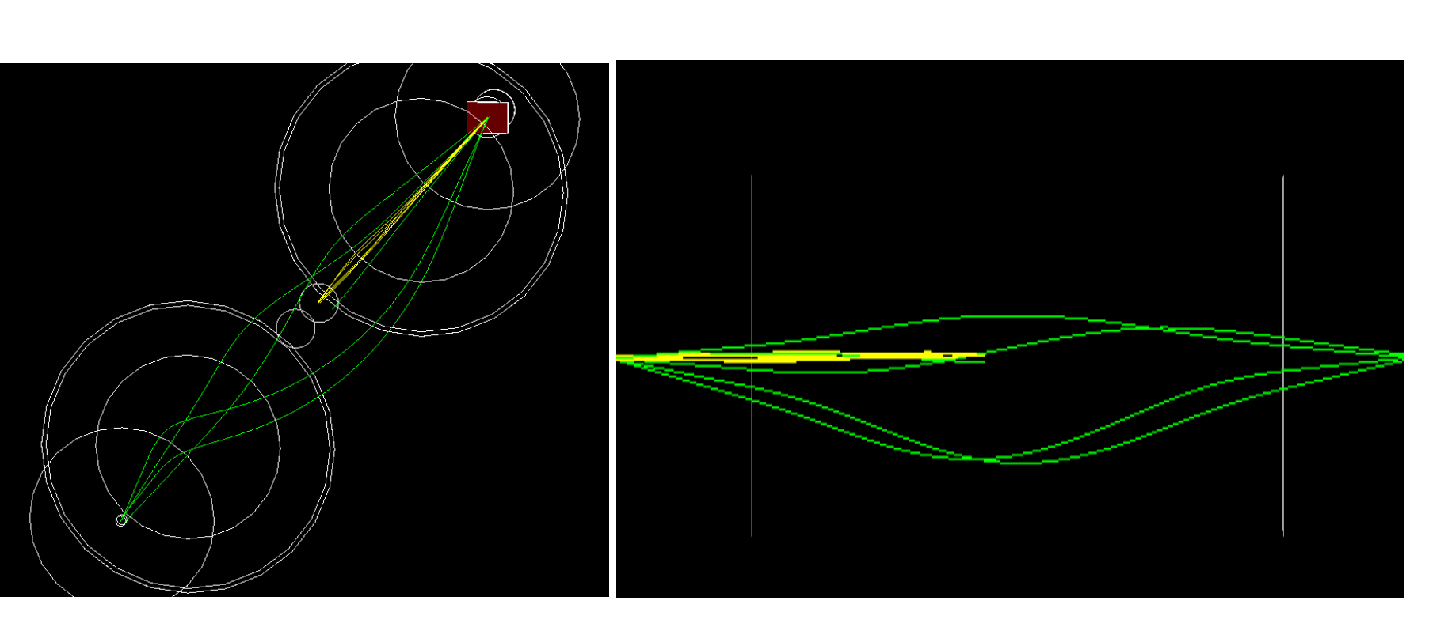
Fig. 1. Trajectories of ions in the magnetic field of the separator for products of fusion reaction (green lines) and for ⁴⁸Ca ions (yellow lines). The target is shown with the red square.

Schematic views of the setup are shown in Figs 2 and 3. The target (source) and the recoil “stop” chamber are located on the axis of the solenoid outside the magnetic field of superconducting solenoid at a distance of about 350 mm from the entrance and exit of the solenoid, respectively. A beam of ⁴⁸Ca (in our calculations we take the beam size d₀ = 10 mm on the target) is focused at the distance of about 1 m from the target into a spot of d ≈ 2 mm. Here the beam stopper is located. The products of complete fusion of interest escape the target within the angular range 1 to 6 degrees and are focused at the distance of 3.5 m from the target.
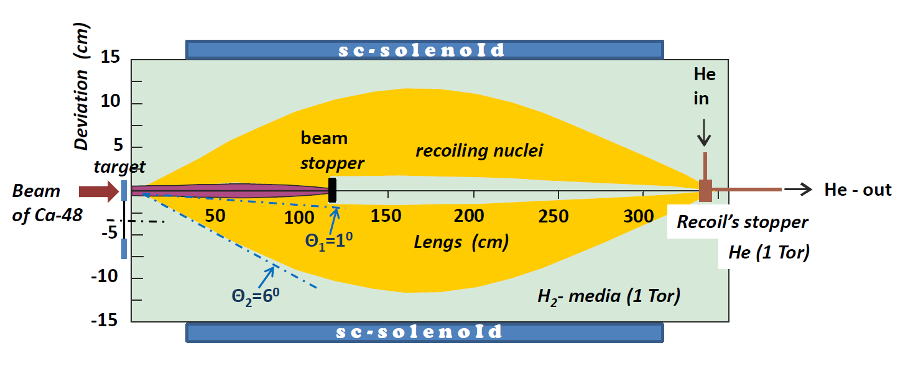
Fig. 2. Schematic view of the GASSOL magnetic separator.
Magnetic field providing a small-sized image of SHE ERs in the focal plane can be formed with a superconducting solenoid housed inside a flux-returning iron yoke. The iron yoke makes it possible to increase the magnetic field in the area of its interaction with the passing ions and to weaken it outside the yoke in the areas of the target and detector allocation.
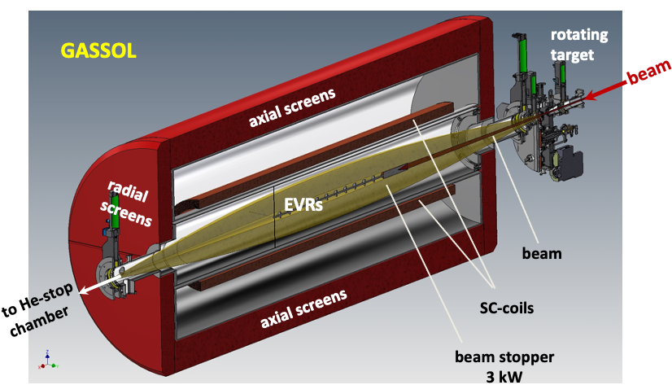
Fig. 3. The concept of the magnetic separator GASSOL.

MR TOF spectrometer
Precise measurement of the masses of superheavy nuclei is a key tool for verifying and refining the theory of the structure of the nucleus and intranuclear interactions. The currently available theoretical knowledge makes it possible to predict the masses of superheavy elements with an accuracy of about 300 keV [1], i.e., with a relative accuracy of 10⁻⁶ for a mass of 300 a.m.u. (a mass of 1 amu corresponds to an energy of about 931 MeV). It should be noted that these are only theoretical predictions, so the value of the mass is not known even with such accuracy. At the same time, to refine the theory of the structure of nuclei of superheavy elements, an accuracy of mass determination of the order of 50 keV is required, i.e., a relative accuracy of about 10⁻⁷.
The relative accuracy of mass measurements during the separation of ions in a mass spectrometer is determined by two factors: the resolution of the mass spectrometer and available statistics, i.e., the number of measurements. Due to the extremely rare occurrence of events for the production of superheavy atoms even at the most modern “superheavy factory” at the Joint Institute for Nuclear Research (JINR, Dubna), in which each such event is expected about once a day, it is necessary to use a mass spectrometer that provides a mass resolution greater than 10⁶. Currently, the only method that meets these demands is a multi-reflection time-of-flight mass spectrometer (MR-TOF).
The ions under study are the products of fusion reactions of target nuclei with heavy ions of a high-intensity beam bombarding the target. After separation in a gas-filled separator (GRAND or GASSOL), evaporation residues are stopped in a cryogenic gas catcher and then are injected into the sample channel of the mass spectrometer. The entire scheme of the facility including the MR-ToF spectrometer, the gas filled separator and a gas catcher system is presented in Fig. 4.
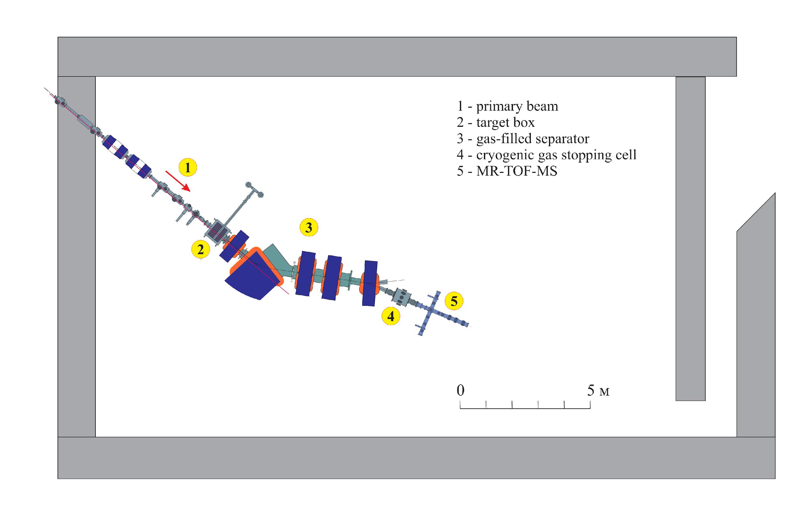
Fig. 4. The scheme of the installation for studying the properties of the isotopes of heavy and superelements: 1 - heavy ion beam, 2 - target box, 3 – gas filled separator (pre-separator), 4 - cryogenic gas ion trap, 5 - MR-ToF spectrometer.
The cryogenic gas catcher (CGC) is already under construction in the Flerov Laboratory. The general view of the catcher is shown in Fig. 5.
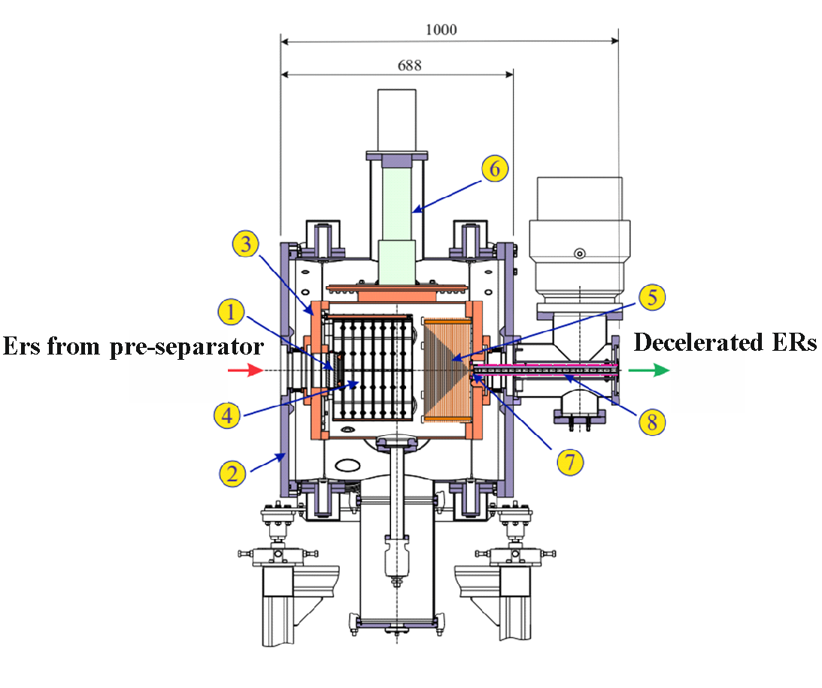
Fig. 5. General view of cryogenic gas catcher: 1 - entrance window; 2 - external warm vacuum shell; 3 - internal cold chamber; 4 - cylindrical electrodes of constant electric field; 5 - radio-frequency multielectrode cone; 6 - head of cryo-refrigerator; 7 - supersonic nozzle; 8 - transport radio frequency quadrupole.
The block diagram of the mass spectrometer is shown in Fig. 6. Ions are transported from the CGC to the spectrometer via a quadrupole RF channel filled with helium at a pressure of 20 mTorr. A collisional dissociation cell with ion acceleration by a potential difference of 30–60 V is placed in the gap between the vacuum gate separating the CGC and the mass spectrometer. The spectrometer has a cruciform configuration and consists of four channels: a calibrant channel from the calibrant source to the switch, a time-of-flight analyzer channel, and a detector channel for monitoring the mass composition of ions extracted from the CGC and from the calibrant source, as well as for detecting isotope alpha decays. The ion motion direction switch allows either to separate the sample and calibrant ion flows, directing one of them to the time-of-flight analyzer and the other to the detector channel, or to mix these flows.

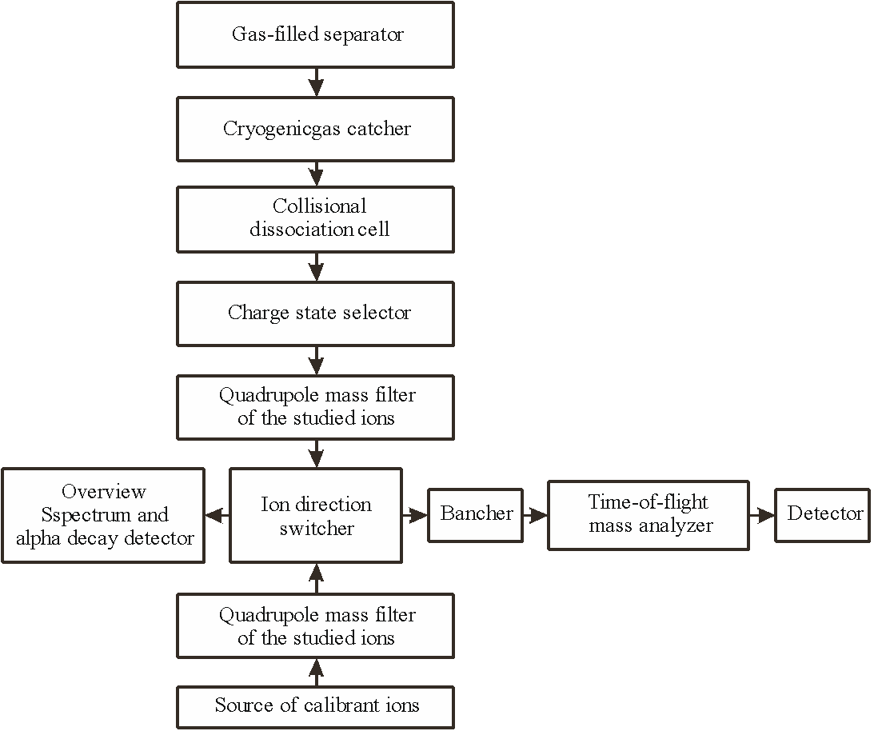
Fig. 6. Block diagram of the mass spectrometer. The ion source for the spectrometer is a gas-filled ion stopping cell at the outlet of the gas filled recoil separator.

A design of a multi-reflection time-of-flight mass spectrometer was developed in collaboration with the Institute of Analytical Instrumentation (St. Petersburg). The layout of the mass spectrometer is shown in Fig. 7.
A resolution of over 1,000,000 can be achieved in several hundred ion turns in the spectrometer. It takes time of the order of tens milliseconds. In this case, the mass range of ions that could provide the appearance of superimposed spectra on the detector as a result of leaving the analyzer after a different number of revolutions is determined by the formula (Δm/q)/(m/q) < 1/(2N), where N is the number of ion revolutions in the analyzer. At N = 200, the mass acceptance of the analyzer is less than 1%. Taking into account the small number of ions under study compared to “parasitic” ions penetrating into the spectrometer from the GSC and from the calibration source, it is highly desirable to get rid of such ions before they enter the time-of-flight analyzer. Optimally, all ions outside the TOF mass acceptance window should be removed. On the other hand, it is desirable to minimize the losses of the studied ions. If the sample contains the studied ions with different charge states, the filtering of ions inside the narrow mass window is possible only when ions with different charge states are sequentially introduced into the analyzer. Such a mode can be implemented using a multiplexed radio frequency (RF) linear quadrupole trap. Ions of one of the charge states are extracted from the trap into the analyzer using dipole resonant excitation, while ions with other charge states remain in the trap without loss. After being extracted from the charge state selector, the ions pass through a quadrupole mass filter tuned to pass a narrow range of mass-to-charge ratios on the order of 1–3 amu/u.

- 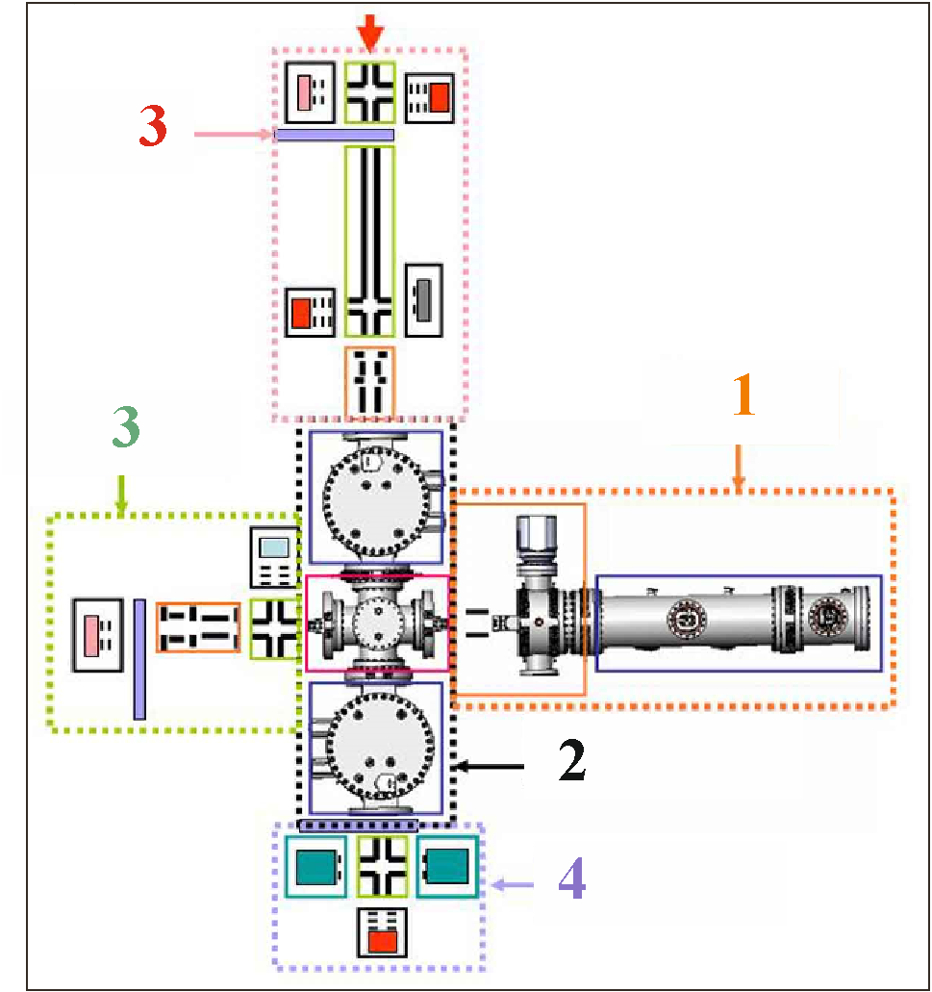
Fig. 7. The division of the mass spectrometer into its main structural units. 1 - node of the multi-turn time-of-flight mass analyzer; 2 – node of quadrupole mass filters; 3 - node of the channel for introducing sample ions; 4 - node of the channel for introducing calibrant ions; 5 - node of detectors.

The ion-transporting channels of the spectrometer are gas-filled RF channels, which ensures stability over a long period of operation of the mass spectrometer. The local acceleration of ions in a gas-filled channel initiates the collisional dissociation of parasitic molecular ions, and low-mass fragments are removed from the channel according to the RF instability condition. Collisional cooling of ions minimizes the ion beam emittance at the entrance to the quadrupole mass filter, ensuring its almost 100% transmission.
Main characteristics of the spectrometer.
The main characteristics of the developed spectrometer:
- The length of the time-of-flight base of the mass analyzer is 1000 mm.
- The maximum number of revolutions in the analyzer is 500.
- Required vacuum in the analyzer chamber < 10⁻⁸ Torr.
- Range of measured masses А=12÷500.
- Mass resolution М/ΔМ=1.5∙10⁶.
- Accuracy of mass determination with event statistics >100 δM/M=10⁻⁷.
- Minimum lifetime of analyzed nuclides τ>50 ms.
- Sensitivity of statistically significant measurement ~10 ions;
- Measurement frequency up to 400 Hz;
- Transmission efficiency up to 95%;
- Measurement dynamic range >10⁴.
- Availability of the ability to analyze single and doubly charged ions without loss of efficiency.

The high accuracy of measurements over a long period of time (several weeks) also requires constant monitoring of fluctuations in the ion travel time in the mass analyzer caused by voltage drift of power supplies and temperature fluctuations in the length of the analyzer. Therefore, the mass spectrometer must provide periodic (of the order of once per minute) calibration, for which molecular calibrant ions created by an additional source are introduced into the analyzer. Since the superimposition of the signal of the calibrant and the ions under study is highly undesirable, the calibrant and the ions under study must be introduced into the mass analyzer separately. Therefore, the design of the mass spectrometer should provide a separate calibrant channel and a switch for supplying ions into the analyzer alternately from the sample channel and from the calibrant channel.
References
[1] Colloquium: Superheavy elements: Oganesson and beyond. S. A. Giuliani, Z. Matheson, W. Nazarewicz, E. Olsen, P.-G. Reinhard, J. Sadhukhan, B. Schuetrumpf, N. Schunck, and P. Schwerdtfeger. Rev. Mod. Phys. 91, 011001 – Published 22 January 2019.
Risks.
The main risks are linked to restrictions on the purchase of a number of equipment manufactured in the EU and the USA (vacuum equipment, high-voltage power supplies, detectors and electronic equipment), which may cause delays in the implementation of the project.

2.3 Estimated completion date
2024 – 2028

2.4 Participating JINR laboratories: FLNR

2.4.1 MICC resource requirements
Computing resources | Distribution by year
 | 1st year | 2nd year | 3rd year | 4th year | 5th year
Data storage (TB)
- EOS
- Tapes
Tier 1 (CPU core hours)
Tier 2 (CPU core hours)
SC Govorun (CPU core hours)
- CPU
- GPU
Clouds (CPU cores)

2.5. Participating countries, scientific and educational organizations

Organization | Country | City | Participants | Type  of agreement
IAI RAS |  | St. Petersburg | Yavor M.I. + 2 pers. | Collaboration
NIIEFA |  | St. Petersburg | Sychevsky S.E.  Strokach A.P. + 12 pers. | Collaboration
INP | Kazakhstan | Almaty | Batyrbekov E.G. + 3 pers. | Collaboration
BA INP |  | Astana | Zdorovets M.V. + 3 pers.  Koloberdin M.V. | Collaboration
ENU |  | Astana | Kuterbekov K.A. | Collaboration
INS "VINCA" | Serbia | Belgrade | Belicev P.  Vujovic V.  Petrovic S. | Collaboration
IMP CAS | China | Lanzhou | Gan Z. + 6 pers. | Contract
iThemba LABS | South Africa | Somerset West | Bark R.  Makhathini L.  Mira J.  Mlungisi Nkosi+ 3 pers.  Rudolph Nchodu  Le Roux Strydom +3 pers. | Collaboration
IUAC | India | New Dehli | M. Madhavan + 3 pers. | Collaboration

2.6. Key partners (those collaborators whose financial, infrastructural participation is substantial for the implementation of the research program. An example is JINR's participation in the LHC experiments at CERN).

3. Manpower
3.1. Manpower needs in the first year of implementation

№№  n/a | Category of personnel | JINR staff,  amount of FTE | JINR Associated  Personnel,  amount of FTE
1. | research scientists | 9.2
2. | engineers | 5.2
3. | specialists | 0
4. | office workers | 0
5. | technicians | 1.2
 | Total: | 15.6

3.2. Available manpower
3.2.1. JINR staff

No. | Category of personnel | Full name | Division | Position | Amount  of FTE
1. | research scientists |  |  |  | 9.2
1.1 |  | Rodin A.V. | FLNR Sector N4 | Head of Sector | 0.8
1.2 |  | Salamatin V.S. | FLNR Sector N4 | Научный сотр. | 0.8
1.3 |  | Chernyshova E.V. | FLNR Sector N4 | Научный сотр. | 0.8
1.4 |  | Vedeneev V.Y. | FLNR Sector N4 | Junior researcher | 0.8
1.5 |  | Novoselov A.S. | FLNR Sector N4 | Junior researcher | 0.8
1.6 |  | Krupa L. | FLNR Sector N4 | Senior Research Associate | 0.8
1.7 |  | Kogout P. | FLNR Sector N4 | Research Associate | 0.8
1.8 |  | Kogoutova A. | FLNR Sector N4 | Junior researcher | 0.8
1.9 |  | Opichal A. | FLNR Sector N4 | Junior researcher | 0.8
1.10 |  | Shumeyko M.V. | FLNR Sector N1 | Junior researcher | 0.5
1.11 |  | Kovrizhnykh N.D. | FLNR Sector N1 | Junior researcher | 0.5
1.12 |  | Solovev D.I. | FLNR Sector N1 | Junior researcher | 0.5
1.13 |  | Ibadullayev D. | FLNR Sector N1 | Junior researcher | 0.5
 | engineers |  |  |  | 5.2
2.1 |  | Podshibyakin A.V. | FLNR Sector N4 | Lead engineer | 0.8
2.2 |  | Gulyaev A.V. | FLNR Sector N4 | Senior engineer | 0.8
2.3 |  | Yukhimchuk S.A. | FLNR Sector N4 | Senior engineer | 0.8
2.4. |  | Komarov A.B. | FLNR Sector N4 | Senior engineer | 0.8
2.5. |  | Gulyaeva A.V. | FLNR Sector N4 | engineer | 0.8
2.6 |  | Kulik V.D. | FLNR Sector N1 | Ст.техник | 0.4
2.7 |  | Petrushkin O.V. | FLNR Sector N1 | Lead engineer | 0.4
2.8 |  | Kuznetsov D.A. | FLNR Sector N1 | engineer | 0.4
 | specialists
 | technicians |  |  |  | 1.2
4.1 |  | Shubin V.D. | FLNR Sector N1 | technician | 0.4
4.2 |  | Kulik V.D. | FLNR Sector N4 | Senior technician | 0.8
 | Total: |  |  |  | 15.6

3.2.2. JINR associated personnel

No. | Category of personnel | Partner organization | Amount of FTE
1. | research scientists
2. | engineers
3. | specialists
4. | technicians
 | Total:

4. Financing
4.1 Total estimated cost of the LRIP subproject
The total cost estimate of the project (for the whole period, excluding salary).
The details are given in a separate table below.
International cooperation: 100 k$
Experimental set ups: 10.0 М$
Software purchasing: 100 k$
4.2 Extra funding sources
Expected funding from partners/customers – a total estimate.

LRIP subproject Leader __________/___________/

Date of submission of the LRIP subproject to the Chief Scientific Secretary: _________
Date of decision of the laboratory's STC: _________ document number: _________
Year of the LRIP subproject start: ________________
(for extended projects) – Project start year: _______
Proposed schedule and resource request for the LRIP subproject
Expenditures, resources,  funding sources |  |  | Cost (thousands  of US dollars)/  Resource requirements | Cost/Resources,  distribution by years
 |  |  |  | 1st year | 2nd year | 3rd year | 4th year | 5th year
 |  | International cooperation | 100 | 20 | 20 | 20 | 20 | 20
 |  | Materials | 2500 | 500 | 500 | 500 | 500 | 500
 |  | Equipment, Third-party company services | 7300 | 1450 | 1450 | 1450 | 1475 | 1475
 |  | Commissioning | 80 | 20 | 20 | 20 | 10 | 10
 |  | R&D contracts with other research organizations | 120 | 30 | 30 | 30 | 15 | 15
 |  | Software purchasing | 100 | 20 | 20 | 20 | 20 | 20
 |  | Design/construction
 |  | Service costs (planned in case of direct project affiliation)
Resources required | Standard hours | Resources
 |  | - the amount of FTE,
 |  | - accelerator/installation,
 |  | - reactor,…
Sources of funding | JINR Budget | JINR budget (budget items) | It. 4 - 100  It. 5,6 – 9800  It. 9 – 80  It. 10 – 120  It. 11 - 100
 | Extra fudning (supplementary estimates) | Contributions by  partners  Funds under contracts with customers  Other sources of funding

LRIP subproject Leader_________/A.V. Yeremin/
Laboratory Economist _________/T.V. Mamonova/

APPROVAL SHEET FOR LRIP SUBPROJECT
TITLE OF THE LRIP SUBPROJECT
SHORT DESIGNATION OF THE SUBPROJECT OF THE LRIP
LRIP SUBPROJECT CODE
LRIP CODE
NAME OF THE LRIP SUBPROJECT LEADER
AGREED
JINR VICE-DIRECTOR | ___________  SIGNATURE | Dmitriev S.N.  NAME | _________  DATE
CHIEF SCIENTIFIC SECRETARY | ___________  SIGNATURE | Nedelko S.N.  NAME | _________  DATE
CHIEF ENGINEER | ___________  SIGNATURE | Gikal B.N.  NAME | _________  DATE
LABORATORY DIRECTOR | ___________  SIGNATURE | Sidorchuk S.N.  NAME | _________  DATE
CHIEF LABORATORY ENGINEER | ___________  SIGNATURE | Kalagin I.V.  NAME | _________  DATE
LABORATORY SCIENTIFIC SECRETARY | ___________  SIGNATURE | Karpov A.V.  NAME | _______  DATE
LRIP LEADERS | ___________  SIGNATURE  ___________  SIGNATURE | Sidorchuk S.I.  NAME  Kalagin I.V.  NAME | _______  DATE  _______  DATE
LRIP SUBPROJECT LEADER | __________  SIGNATURE | Yeremin A.V.  NAME | _________  DATE
APPROVED BY THE PAC

