**REPORT**

**on a research project**

**"Emission of Neutrons and Gamma-quanta in Reactions Induced by Neutrons (ENGRIN)"**

**for 2022-2023**

**Theme:** "Investigations of the interaction of neutrons with nuclei and properties of the neutron"

**Theme code:** 03-4-1128-2017/2022

**Project leader:** Zeynalov Sh.S.

In the current year, studies were carried out on variations in the average number of prompt fission neutrons (PFN) in the resonance region of neutrons. In experiments carried out on IREN channel 2 using a double ionization chamber with Frisch grids in combination with a fast neutron detector, new data were obtained. These results were presented at international conferences in Montenegro[1] and Moscow [2].

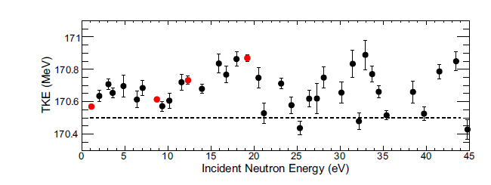

Figure 1. Total kinetic energy (TKE) variations in the 235U(nres,f) reaction as a function of energy of resonance neutrons, obtained in the laboratory in comparison with the results obtained with the participation of the author at the GELINA source (left) and IREN (right). The data were obtained using a double ionization chamber with Frisch grids and one neutron detector located along the axis of symmetry of the chamber.



Figure 2. Results of the study of the dependences of the average number of PFN in the reaction 235U(n,f) in the thermal energy range of incoming neutrons. These data were included in the EXFOR database and make it possible to increase the resolution in the spectrometry of fission fragments using an ionization chamber.

A measuring module has been created in the laboratory to study correlations between the properties of fission fragments from resonance neutron induced fission and PFN emission. The setup consists of 32 PFN scintillation detectors with a BC501 liquid scintillator and a double ionization chamber. To organize the experiment, CAEN electronic modules were used. The developed measuring module is located on channel 2 of the IREN source and is used to study the properties of PFN emission (with 32 neutron detector modules) in reactions induced by resonance neutrons. The created spectrometer makes it possible to carry out studies using N6730 pulse digitizers (16 bit 500 MHz, CAEN) connected in a Daisy chain for communication with a data acquisition PC. As a result, it was possible to start data collection for studying the correlations between the properties of fission fragments and the PFN emission in the beam of resonance neutrons of the 2nd IREN channel using the developed equipment.

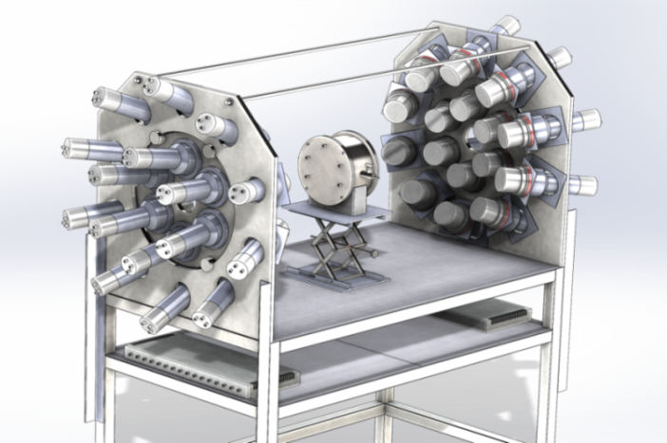

Figure 3. A new facility for studying PFN emission in fission induced by resonance neutrons at the IREN source was put into operation in 2022.

A new facility for studying the properties of PFN is installed on the second channel of IREN and is ready to measure the properties of fission with PFN emission on a beam of resonance neutrons. To study the properties of PFN with an updated setup with 32 neutron detectors, it became necessary to determine the angle between the axis of fragment emission and the direction to the neutron detector modules. For this, a new chamber with strip anodes was designed and created. This chamber allows not only the measurement of the masses and kinetic energies of fission fragments, but also the orientation of the fission axis in three dimensions.

[References]

1. International Conference on Radiation in Various Fields of Research- Spring Edition) from 25.07.-29.07.2022 Herceg Novi, Montenegro
2. LXXII International Conference Nucleus 2022, Moscow, July 11-16 https://events.sinp.msu.ru/event/8/

Project leader /Zeinalov Sh. S. /