Annex 4.
Project (LRIP subproject) report form
PROJECT REPORT
1. General information on the project / LRIP subproject
1.1. Scientific field:Nuclear physics;
1.2. Title of the project / LRIP subproject: «Modernization of the EG-5 accelerator and its experimental infrastructure»;
1.3. Project (LRIP subproject) code
1.4. Theme / LRIP code
(theme 03-4-1128-2017/2023)
1.5. Actual duration of the project/ LRIP subproject: 2022-2023
1.6. Project / LRIP subproject Leader(s):
Doroshkevich A.S., Shvetsov V.N., Lychagin E.V.
2. Scientific and technical report
2.1. Abstract
During the project implementation in 2022-2023, a set of organizational and technical measures aimed at solving the key tasks of the project, in particular, the formation of a group (task 3), replacement of faulty nodes (task 1), modernization of the experimental base of the complex (task 2) was carried out. As part of the project, preparations were made for the replacement of the accelerator tube: the rooms of the accelerator hall were brought into compliance with the standards (ISO-9), calculations of the new accelerator tube were carried out. Negotiations were held and an agreement was prepared on the development and supply of a modern microwave ion source with a fiber-optic control system to the FLNP JINR. Currently, a package of documents is being prepared for obtaining a sanitary and epidemiological conclusion (SEC) and preparation for the commissioning of ESA. Work is being done to improve the level of professional skills of the group staff.
2.2. A detailed scientific report
2.2.1. Description of the mode of operation and functioning of the main systems and equipment
(for the LRIP subproject).
2.2.2. A description of the conducted experiments (for experimental projects).
2.2.3. A description of the research undertaken and the results obtained.
2.2.4. A list of the main publications of the JINR authors, including associated personnel on the results of the project (list of bibliographical references).
2.2.5. A complete list of publications (electronic annex, for journal publications with journal impact factor).
2.2.6 List of talks given at international conferences and meetings (electronic annex).
2.2.7. Patent activity (if any)
Task 1. Improving technical parameters of ESA.
- During the project implementation in 2022-2023, a set of organizational measures was carried out at the level of directors of institutes with the personal participation of the FLNP Directorate (V.N. Shvetsov, E.V. Lychagin) aimed at ensuring the possibility of solving the problem of replacing the high voltage tube and the HF-source using the resources of the Novosibirsk nuclear power plant.
- Preparation for the replacement of the accelerator tube was carried out: the premises of the accelerator hall were brought into compliance with the standards (ISO-9), calculations of the new accelerator tube were carried out by the staff of the Budker Institute of Nuclear Physics (Novosibirsk) within the framework of the corresponding research and development project with JINR.
- Consultations and negotiations were held with the management of the Budker Institute of Nuclear Physics, employees of the Budker Institute of Nuclear Physics (S.Yu. Taskaev, S.G. Konstantinov), an expert assessment of the possibility of replacing the RF source of the ESA EG-5 was given, Agreement No. 157 of the 16.02.2023 on the development and supply of a modern microwave source of ions with an optical fiber to the FLNP JINR was prepared control system.
- New oil-free vacuum equipment has been purchased and is under installation. Fast-acting pneumatic vacuum valves were purchased, the protection system of the ESA vacuum system and the high voltage tube are installed.

Task 2. Modernization of experimental and process equipment located on ESA channels.

- Agreements have been reached with the staff of the Budker Institute of Nuclear Physics on the manufacture of a solid-state target.
- A project of a new laboratory has been prepared for the preparation of research objects by ion-beam spectrometry methods by the company "SPETSATOMSERVICE LLC";
- The laboratory of temporary placement in the building 120 is being prepared for operation;
- Negotiations were held with IREN FLNP technical group on automation issues EG-5.
- Cosmetic repairs were carried out in the premises of the Left Experimental Hall, a vibration-resistant foundation was prepared for the installation of the ion-beam spectrometer/nuclear microcondensor module.
- A new module of ion-beam spectrometers has been developed (Chepurchenko I.A., fig.P4.1.).
- A complex of complementary methods for studying surface layers of materials was purchased and put into operation, consisting of an ellipsometric complex of the ELIPS-1991 type, potentiostats R30, R-45x and an impedance meter Z1500.
- Calculations, modeling of processes in electrical circuits, mock-up were carried out, the necessary parts of the positioning system and stabilization of the position of the ion beam were made (Semyonov V.N., Rikhvitskiy V.S., P.4.2.),
- A system for scanning the ion beam into a raster was developed and manufactured for combining with the Dnipro ion implantation chamber (Micron JSC).
- "Carousel-type" doors in the Left Experimental Hall were repaired.

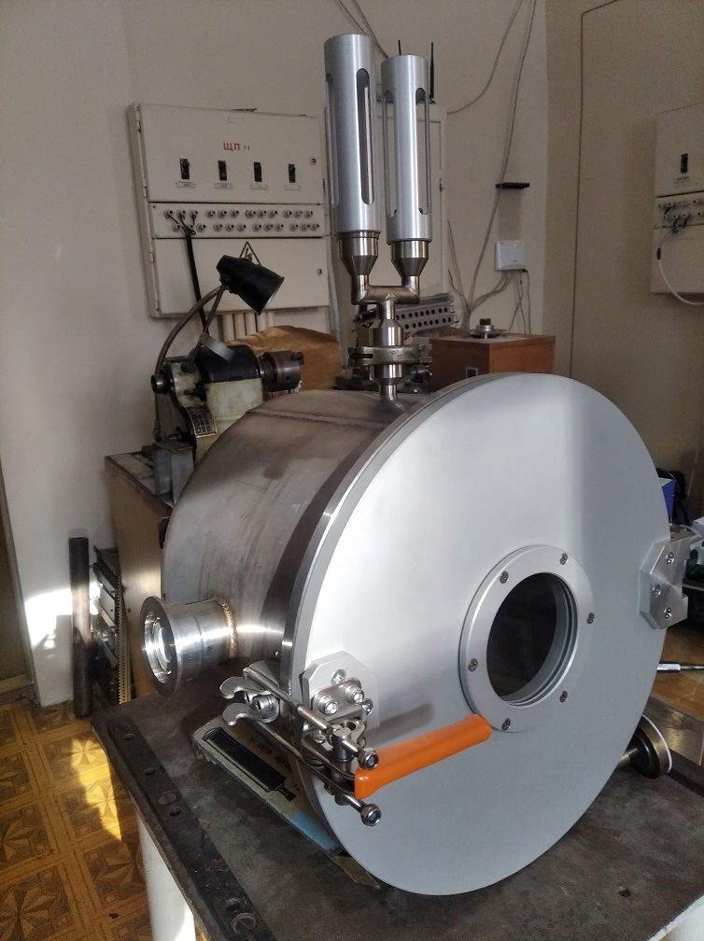
Fig. P4.1. New Ion Beam Spectrometer Module Working Chamber: exterior.

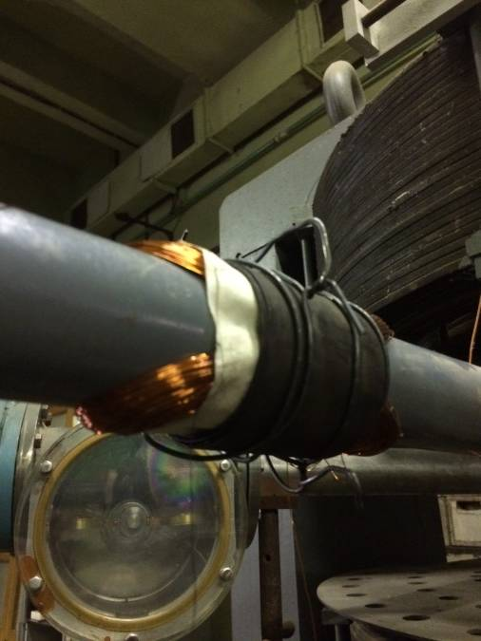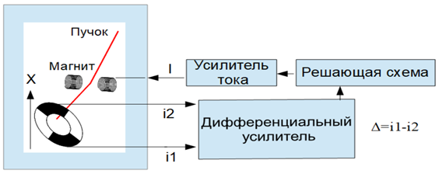
Fig. P4.2. Ion beam positioning and stabilization system: layout coil appearance and working block-diagram.
Task 3. Staff. During the reporting period, the formation of a group capable of ensuring full-fledged work for a scientific experiment and the integration of the EG-5 accelerator into the scientific and technological infrastructure of the FLNP and JINR was almost completed. Group staff: 23 employees, 5 – direction staff, 15 – technical and engineering employees (6 – ESA operators), 6 researchers and leading researchers, 2 PhDs, 3 PhDs in Physical and Mathematical Sciences, 3 students (bachelors/masters), 1 graduate student, 3 applicants. Mean age of the group – 43year. Freelance employees: 2 second year students of Dubna State University.
Improving the professional skills of the group's employees. During the reporting period, employees were trained in the method of RBS, PIXE, NR (Zelenyak T.Yu., Kruglyak A.I., Zakharova A.S., Tatarinova A.A., Alexandrov V.A.), the technical competencies of the slinger and crane operator (Studnev K.E.) required for the safe operation of the accelerator were restored in the group, as well asSanitary and Epidemiological Service certification; competencies in the field of ellipsometry were acquired (Fan Lyong Tuan, Zelenyak T.Yu., Krieger V.N.); advanced training of the designer I.A. Chepurchenko (correspondence training in the magistracy of Moscow Polytechnic University (specialty 15.04.01 "Mechanical Engineering"), required for the modernization of the accelerator; training and certification for work on lathe milling machines were completed by Studnev K.E., an employee of FLNP JINR; individual employees of the group undergo postgraduate training at National Research Nuclear University MEPhI (IsaevR.Sh.). During the reporting period, 2 PhD theses were defended in the group (Yu.V. Aleksiayenak and Chan Van Fuk), students from Dubna State University with high academic performance were involved in the group. Students (Zakharova A.S. and Didenko E.) became winners of the prestigious youth scientific event "Lomonosov 2022," held by Moscow State University. For the period from 2019 to 2020, the number of publications in rating (quartile Q1 - Q2) journals and the level of the journals themselves selected for publication of the obtained results increased linearly (at the time of mid-2022 IF - at least 4).

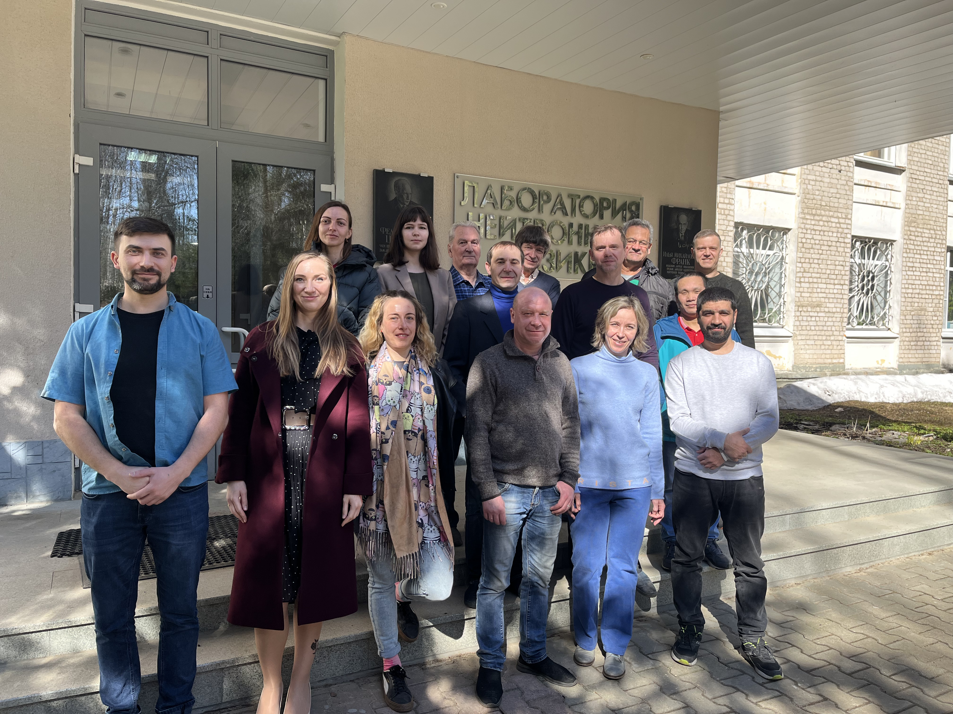
Fig. P4.3. Group «EG-5» in April, 2023.
During the reporting period, the number of international projects and cooperation relations with JINR member countries and external partners (Spain, Portugal) doubled (compared to 2020).
Organizational activities.
1. Negotiations were held with Micron JSC, Angstrom JSC, ROSATOM State Corporation on joint technological work. Relevant agreements have been prepared with JSC Micron, JSC Angstrom, and the transfer of the Dnipro camera for ion implantation of silicon plates with hydrogen is being prepared.
Names of costs, resources, funding sources |  |  | Cost (thousands  of US dollars) / Resource request | Proposal from  the laboratory for allocation of funding and resources
 |  |  |  | 1  year | 2  year | 3  year | 4  year | 5 year
 |  | Internationalcooperation
 |  | Materials | 18 | 18
 |  | Equipment, Third-party company services | 126,6 | 126,6
 |  | Commissioning
 |  | R&D contracts with other research organizations | 32.4 | 17.2 | 15,2
 |  | Softwarepurchasing
 |  | Design/construction
 |  | Service costs (planned in case of direct project affiliation)
Resourcesrequired | Standardhours | Resources
 |  | - theamountofFTE, | 40872 | 20436 | 20436
 |  | - accelerator/facility,
 |  | - reactor,…
Sourcesoffunding | JINR Budget | JINR budget(budgetitems) | 177  (theme 1128)
 | Extrafudning (supplementaryestimates) | Contributions by  partners  Funds under contracts with customers  Othersourcesoffunding | 66 (Grants Authorized representatives of the JINR Member States)

2.ESA lighting and ventilation systems have been audited;
3.Currently, technical measures are being carried out (revision of technological systems) preparation of a package of documents for obtaining sanitary and epidemiological conclusion (SEC) and for the commissioning of ESA.
2.3. Status and stage (TDR, CDR, ongoing project) of the project (subproject) (including percentage of implementation of the declared milestones of the project (LRIP subproject) (if applicable)– 30%
2.4. Results of related activities
2.4.1. Research and education activities. List of defended dissertations.
2.4.2. JINR grants (scholarships) received.
2.4.3. Awards and prizes.
2.4.4. Other results (expert investigation, organizational, outreach activities).
3. International cooperation
Actually participating countries, institutions and organizations

Organization | Country | City | Participants | Type  ofagreement

4. Analysis of planed vs actually used resources: manpower (including associated personnel), financial, IT, infrastructure
4.1 Manpower (actual at the time of reporting)

No. | Personnelcategory | JINR staff,  amount of FTE | JINR associated personnel,  amount of FTE
1. | researchscientists | 1,9
2. | engineers | 5,5
3. | specialists | 3
 | Total: | 10,4

4.2 The actual estimated cost of the project/ LRIP subproject

4.3 Otherresources
Computerresourcesconsumed  MICC | Distributionbyyears
 | 1styear | 2nd year | 3rdyear | 4th year | 5th year
Data storage (TB)
- EOS
- Tapes
Tier 1 (CPU corehours)
Tier 2 (CPU corehours)
SC Govorun (CPU core hours)
- CPU
- GPU
Clouds (CPU cores)
5. Conclusion
As a result of the project implementation, a unique within JINR electrostatic accelerator will be modernized and put into operation, which will allow solving a number of problems in the field of nuclear and neutron physics, radiation materials science.
6. Proposedreviewers
- Lagov Petr Borisovich, Dr., Professor, Department of Semiconductor Electronics and Semiconductor Physics, National University of Science and Technology (MISiS), Moscow, Russia, E-mail: lagov2000@mail.ru,
- Furman Walter Ilyich, PhD, leading researcher, FLNP JINR, Dubna, Moscow region, Russia, E-mail: furman@nf.jinr.ru,
- NesvizhevskyValeriyVictorovich, PhD, Institut Laue-Langevin, Grenoble, E-mail: nesvizhevsky@ill.fr, nesvizhevsky@ill.eu

Project leader (project code) / LRIP subproject

/Doroshkevich A.S. /
" " 202_г.

