**REPORT**

**on a research project**

**TANGRA (TAgged Neutrons And Gamma rays )**

**"Development of the tagged neutron method for determining the elemental structure of matter and studying nuclear reactions"**

**for 2022-2023**

**Topic:** "Investigations of the interaction of neutrons with nuclei and neutron properties"

**Subject code:** 03-4-1128-2017/2022

**Project leader:** Kopach Yu.N.

**Coordinator:** Ruskov I.N.

In 2022 and early 2023, the main efforts of the TANGRA collaboration were focused on the preparing and execution of an experiment to study neutron scattering at origin centers. Analysis of the data of previous experiment showed that measuring the angular distributions of elasticity and inelastic neutron scattering with a standard setup used project is possible.

Other areas of work were:

1) development of a method for soil carbon concentration measurements

2) Analysis of previously acquired data on the yields and angular distributions of the γ-quanta emitted in neutron-nuclear reactions

3) development of the TalysLib library to simplify access to experimental and evaluated data, as well as the results of theoretical calculations.

The source of neutrons used in the experiments of the TANGRA collaboration is the ING-27 continuous-cycle neutron generator, produced by N.L. Dukhov All-Russian Research Institute of Automation. ("VNIIA"). The main objective of the design of a neutron generator is a sealed off maintenance-free neutron tube, which is a compact deuteron accelerator, a target consisting of titanium hydride enriched with tritium and an α-detector, combined in one solid metal-glass or metal-ceramic housing. The neutrons are produced in the fusion reaction of deuterons and tritons, which causes the emission of neutrons and α-particles. The registration of α-particles by a position-sensitive detector makes it possible to estimate the direction of the neutron, to obtain a time reference to the moment of its emission, that is, to “tag” it.

***1. Measurement of the angular distributions of scattered neutrons on carbon.***

In 2021, within the framework of the TANGRA project, an experiment was conducted to measure the angular distributions of elastically and inelastically scattered neutrons. The scheme of the experimental setup is shown in Fig. 1. A stack of graphite plates 44 × 44 × 2 cm in size was used as a target. The duration of the experiment was 22.6 hours. An accompanying measurement without samples with 8 hours duration was also performed.

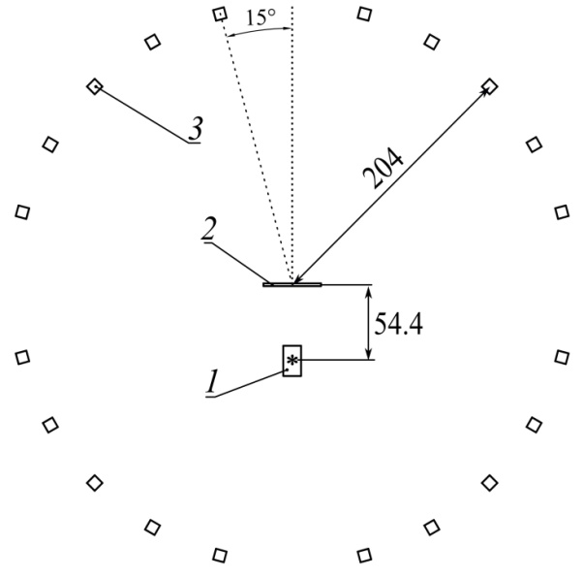

*Fig. 1. Scheme of the TANGRA setup for measuring the angular distribution of neutrons. 1 – ING-27 neutron generator (a tritium target is marked with an asterisk), 2 – carbon sample, 3 – neutron detector. Distances are in cm.*

Obtained time-of-flight histograms shows dependence of events Nt on the difference in the detection times between neutron detector td and the X-strip of the α-detector tx for each combination of a pixel of the α- and the neutron detector. For the time calibration, a peak generated by the γ-radiation emitted from reactions in the generator’s housing. Because each combination “α-pixel – n-detector” corresponds to individual scattering angle θ, each obtained TOF-spectrum was used to determine a point on the angular distribution. The angle band in the center-of-momentum system was 9º ≤ θ ≤ 171º.

To take into account effects which are not related to the reactions in the sample, the data obtained in the measurement without a sample was subtracted after renormalization. Examples of the final time-of-flight histograms are shown in fig. 2. For the peaks of elastic scattering and scattering on the first excited state, areas were determined which are proportional to the number of neutrons, scattered at a certain angle. Although there are peaks corresponding to higher 12C excited states, an accurate determination of their areas cannot be performed for all available angles, due to the insufficient number of events.

To overcome disadvantages of this experiment, we are currently performing the next measurement. The main features of the new experiment are:

1) A more powerful neutron generator with a neutron flux of about 10 8 n/s and an α-detector with 256 pixels.

2) Measurements with and without sample have the same duration

3) It is planned to accumulate ~50 times more events.

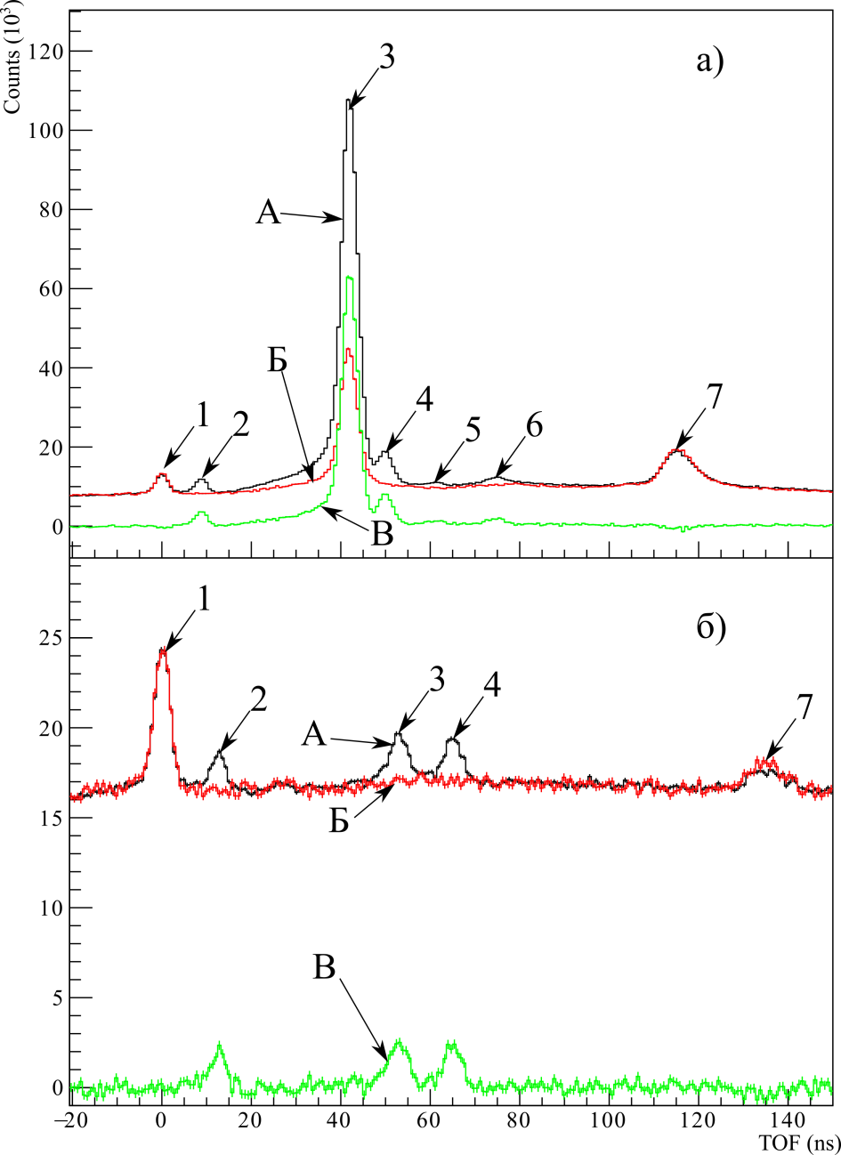

*a)*

C

B

B

C

*Fig. 2. Time-of-flight spectra obtained for θ = 36 a), θ = 170 b). 1 - peak of γ-quanta from the case of the neutron generator, 2 - peak of γ-quanta from the sample, 3 - peak of elastically scattered neutrons, 4, 5, 6 - peaks of neutrons scattered to the first, second and third excited state of 12C, respectively, 7 - peak of γ-quanta from the rear wall. A - measurement with a sample ( 12 C), B - measurement without a sample, and C - difference.*

***2. Determination of the yields and angular distributions of the of γ-quanta emitted in nuclear reactions with 14.1 MeV neutrons.***

To study the characteristics of the γ-quanta emitted in neutron-nuclear reactions, several configurations of the experimental setup were created within the framework of the TANGRA project. Various detection system options include a range of different types of detectors with the possibility of including them in a ring geometry ("Romashka", "Romasha") for angular distribution measurements, an HPGe-based detection system for high-resolution γ-spectrometry and a data acquisition and analysis (DAQ) system. In the work carried out in 2020-2022, the Romasha and HPGe systems were used.

As a source of tagged neutrons, a portable neutron generator ING-27 was used. It has a built-in 64-channel silicon α-detector, divided into 8 strips both horizontally and vertically, which made it possible to obtain 64 beams of tagged neutrons with an amplitude of 14.1 MeV. The total neutron flux in 4π solid angle could be up to 5 × 107 s−1.

The used Romasha spectrometer system (Fig. 3) consists of 18 scintillation γ-detectors based on BGO crystals with a diameter of 76 mm and a thickness of 65 mm. Detectors of γ-quanta are located in a horizontal plane along a circle with a radius of 750 mm with and angular step of 14°. In this case, there is no additional passive collimation of the neutron beam, which reduces the distance from the neutron source to the initial sample to 125 mm.

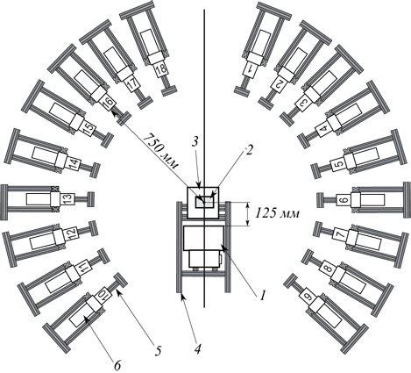

*Fig. 3. Scheme of the Romasha experimental setup: 1 - ING-27 neutron generator, 2 - target, 3 - target holder, 4 - aluminum frame of the setup, 5 – supports for γ-radiation detectors, 6 - γ-radiation detectors, numbered from 1 to 18.*

The "HPGe" setup (Fig. 4) is based on a high-purity germanium (HPGe) detector. The diameter of the crystal was 57.5 mm and a thickness 66.6 mm. The detector was placed at minimal possible distance from the sample, which excludes hits of the detector by direct neutrons. A lead collimator is used to decrease the background generated by neutron-induced reactions in the sensitive volume and reduce radiation damage of the detector.

The targets were placed in a rectangular aluminum container with 14 cm high. The horizontal dimensions of the container are selected to reduce the impact of the absorption and scattering of γ-quanta and neutrons in the target to the γ-quanta angular anisotropy. The distortion should not exceed 20%. To calculate the absorption and scattering coefficients in the sample, the experiment was simulated using the GEANT4 (GEometry And Tracking) package.

The sample was mounted on a light aluminum support. To determine the background impact in the γ-spectra associated with the interaction of neutrons with a support and other structural materials, a separate measurement was carried out without a sample.

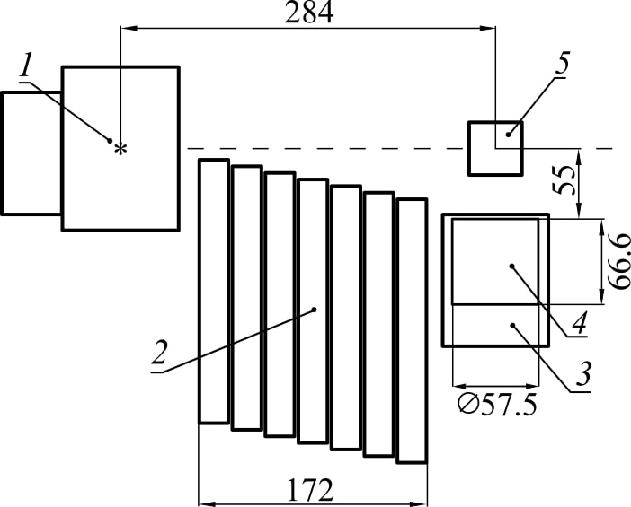

*Fig. 4. Scheme of the experimental setup with HPGe : 1 – ING-27 neutron generator, 2 – lead shielding, 3 – HPGe γ-detector , 4 – sample.*

All detectors were calibrated using standard sources of γ-radiation. Light output and energetic calibration for BGO detectors are not very stable and change with temperature, load and other factors, so a real-time re-calibration was performed using the background γ-lines.

A computer with an ADCM-32 digitizer based on two 16-channel ADCM-16 boards is used to acquire and pre-process data in experiments with the Romasha system. In experiments with HPGe a CRS-32 system was used.

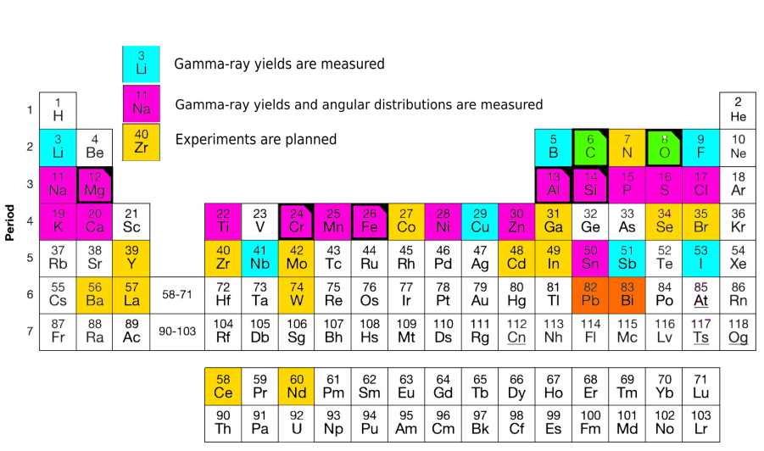

*Fig.5. Samples with measured yields and angular distributions.*

On Fig. 5 selected elements for which the yields of γ-quanta were measured marked in blue, the yields and angular distributions of γ-quanta-in purple, available elements for which subsequent experiments are planned are marked with yellow.

As an example, we would like to present our results for reactions on phosphorus. This element is necessary for the plants growth, and the task of determination of its concentration in minerals, which are used for the production of fertilizers, is quite relevant. The results of our experiment in comparison with the data from [1] and the model calculations obtained by TALYS code are presented in Table 1.

|  |  |  |  |  |  |  |
| --- | --- | --- | --- | --- | --- | --- |
| E γ ( keV ) | Reaction | *JPi*­,  (*Ei*, keV) | *JPf_*  (*Ef*, keV) _ | Yγ, % | | |
| This work | TALYS | [1] |
| **752.2** | **31P n,p)31Si** |  |  | **5.7 (2.3)** | **4.6** |  |
| **983.0** | **31P(n,α)28Al** |  |  | **4.6 (1.0)** | **6.4** |  |
| **1136.2** | **31P (n,n')31P** |  |  | **7.7 (1.4)** | **2.2** |  |
| 1263.3*  1266.1* | 31P(n,d)30Si  31P(n,n')31P |  |  | 72.8 (11.6) | 5.0  53.7 | 43.8 (10.6) |
| **1694.9** | **31P(n,p)31 Si** |  |  | **12.4 (2.5)** | **8.6** |  |
| **1928.3** | **31P(n,n')31P** |  |  | **6.1 (1.9)** | **3.9** |  |
| 2148.5 | 31P(n,n')31 P |  |  | 17.6(3.5) | 16.3 | 14.6(3.3) |
| 2197.6 | 31P(n,n')31 P |  |  | 6.0 (1.2) | 2.9 |  |
| 2233.6*  2235.3*  2240.0* | 31P(n,n') 31P  31P(n,d)30 Si  31P(n,n')31P |  |  | 100 | 24.3  100  3.8 | 100 |
| **3658.3** | **31P(n,n')31P** |  |  | **13.8 (3.3)** | **1.6** |  |

*Table 1. Parameters of the measured γ-transitions for phosphorus. An asterisk “*” marks unresolved γ-transitions. Energy of the γ-quanta Eγ obtained from ENSDF. The measured yields Yγ are compared with the results of calculations in TALYS 1.9 and compilation [1]*.

In the table, data showing large discrepancies with compilation [1] marked with blue, with TALYS model calculations – with red, γ-transitions measured for the first time are showed in bold type.

We also measured the angular distributions of γ-quanta emitted by products of neutron-nuclear reactions on phosphorus for the most intense transitions for the first time. Their graphics are shown in Fig. 6, the coefficients of their approximation by a series of Legendre polynomials are in Table 2.

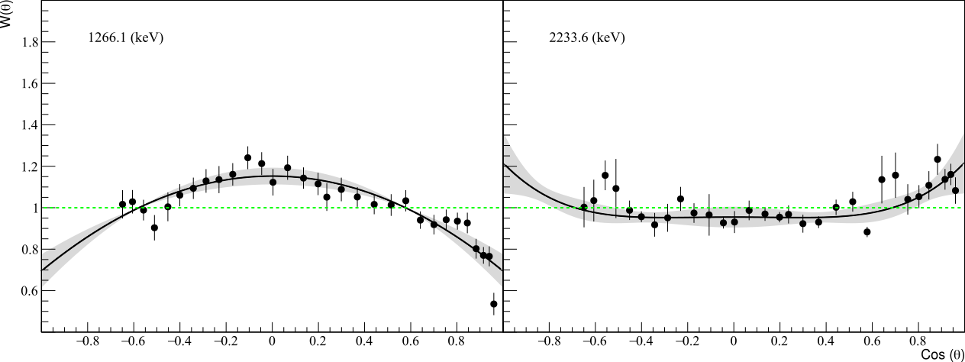

*Fig.6. Angular distributions of γ-quanta from inelastic neutron scattering with the calculation of 14.1 MeV per 31 P. The gray band shows the confidence interval 2σ.*

The parameters of angular distributions obtained by us are presented in Table 2

|  |  |  |  |  |  |
| --- | --- | --- | --- | --- | --- |
| *Eγ* (keV) | Reaction | *JPi­,*  (*Ei*, keV) | *JPf*_  (*Ef* , keV) _ | *a2* | *a4* |
| 1263.3  1266.1 | 31P(n,d)30Si  31P(n,n')31P |  |  | -0.31 ± 0.02 | * |
| 2233.6  2235.3  2240.0 | 31P(n,n')31P  31P(n,d)30Si  31P(n,n')31P |  |  | 0.14 ± 0.02 | 0.07 ± 0.03 |

*Table 2. Angular anisotropy parameters for the most intense γ-transitions in the product nuclei of 31 P (n,xγ) reactions.*

Despite the significant number of studies and the large number of works performed by us, and other teams, research of the properties of the γ-quanta, the available data on the cross sections for the production of characteristic γ-quanta are not enough to create a promising technique for elemental analysis on fast neutrons. In 2022, a project was formed by the TANGRA collaboration team, which purpose is the development of a database of the cross sections of γ-quanta emission in neutron-nuclear reactions for use in fundamental and applied research. The planned studies received positive feedback from the Russian Science Foundation, the project was supported by the Foundation (grant No. 23-12-00239)

1. *Isakov S.P., Pavlik A., Vonakh H. et al. State of experimental and evaluated production of discrete gamma radiation at En=14.5 MeV/ International Atomic Energy Agency, Vienna, Austria. 1998.*
2. ***Measurement of carbon concentration in soil using the tagged neutron method (TNM)***

Soils are the most significant reservoirs of carbon and other biogenic elements, monitoring their content, intra-soil migration and spatial distribution is prospective for environmental studies.

The need to increase monitoring coverage in combination with an improvement of its sensitivity and spatial resolution in description of the carbon distribution in soil, forms a request for the development of instrumentation, which could simplify sample preparation, and creation of field/mobile versions of instruments, and automation of analysis.

The inelastic neutron scattering, as well as the methods of infrared spectroscopy and laser breakdown spectroscopy, is one of prospective methods for proximal non-invasive soil analysis. To test its capabilities, in particular, to determine the limits of sensitivity and accuracy of the method, test measurements were carried out with a prototype AGP-S setup for determining the elemental composition of the soil. It includes a portable neutron generator ING-27, with built-in 9-pixel α-detector, a system of 6 γ-detectors based on BGO crystals, a data acquisition system and a power supply for detectors and a neutron generator.

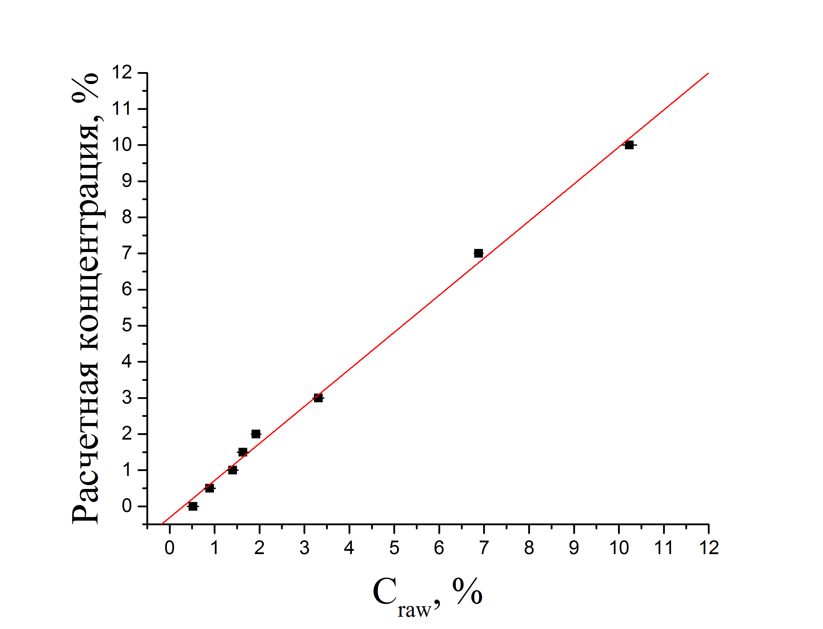

Reference concentration, %

*Fig. 7. Results of measurements of calibration samples. The graph shows AGP-S results versus reference values. The red line shows the calibration characteristic. The marker size is greater than the measurement error value.*

Measurements were made using samples composed of silicate sand which simulates parent material, and sugar which represents organic part of the soil, in various proportions. The mass of each sample was 30 kg, the content of sugar was selected to achieve carbon mass fraction in the sample varied from 0 to 10%. Measurements were made in 3x30 min mode. The average of results of 3 measurements was used as a final value for each sample. Thus, a calibration curve was obtained, which on a mass scale characterizes the accuracy and sensitivity of the method.

Fig. 7. demonstrates the results of measurements of calibration samples, as well as the calibration dependence (red line). The results were approximated by a simple linear function with parameters:

Y = (1.03±0.03) × C ref – (0.31±0.12) (3)

where C raw are the results of measurements of the AGP-S setup, Y are the calculated values of the carbon concentration.

Scatter of calibration data (convergence with calculated values) by standard deviation (RMS):

|  |  |
| --- | --- |
| $$σ_{r}=\sqrt{\frac{\sum_{i}{{\left(X_{i}-Y_{i}\right)}^{2}}}{n}}=0,2\text{\%}$$ | (4) |

where n is the number of calibration samples, X is the element concentration value measured by AGP-S for the i-th sample, Y is the value of the calculated concentration of the element for the i-th sample.

To determine the capabilities of the setup, the accuracy of the repeatability measurement was determined. The absolute error of repetitive measurements for the carbon concentration in range of 1-3% was 0.14%, for silicon - 0.46%, for oxygen - 0.55%. Convergence with the calculated values is estimated σ r =0.2%.

To check the possibility of the carbon concentration profiling we have made a Monte-Carlo modeling. The general view of the model setup is shown in Fig 8, *a)*, the model time spectrum of α-γ coincidences corresponding to the observed inelastic neutron scattering at 12C that occurred at different depths is shown in Fig 8, *b)*. The decomposition of the total time spectra to the depth components allows one to perform a depth carbon profiling, which is demonstrated in Fig. 9 for the case with constant (a) and variable (b) carbon concentration.

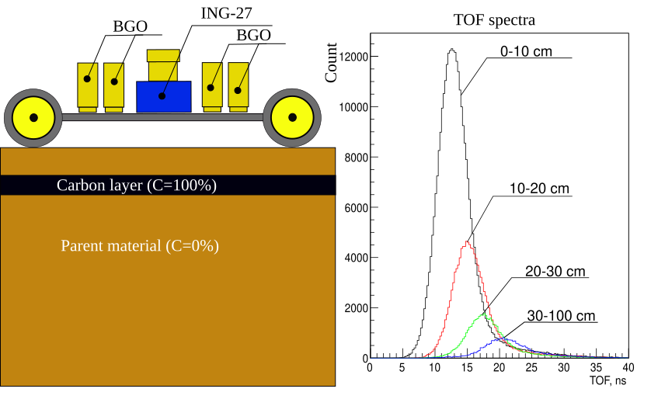

*а)*

*b)*

*Fig. 8. General view of the setup model (a), time spectra components corresponding to the reactions on different depths (b).*

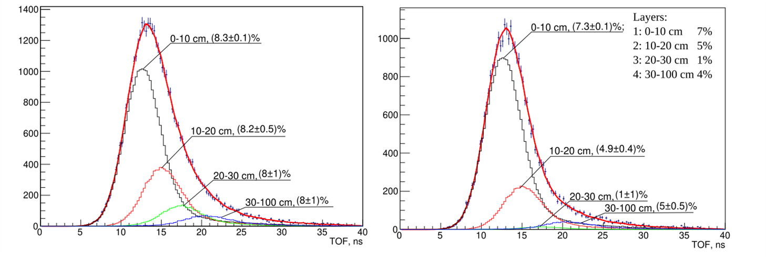

*b)*

*Fig. 9. Decomposition of the TOF spectrum into components corresponding to reactions on different depths for cases with a constant (a) and variable (b) carbon concentration.*

The results obtained by us were presented at the “Nucleus-2022” conference, the experience gained by the team was useful for preparing an application for the RSF grant No. 23-62-10027, which was highly appreciated by the expert council.

1. **Development of the TalysLib library**

The searching and usage of experimental and evaluated nuclear data is a significant part of the job of a nuclear physicist. The main sources of this information are experimental (EXFOR) and evaluated (ENDF, BROND, ROSFOND, etc.) databases which are containing most of the currently available data of the characteristics of nuclear reactions. They were developed quite a long ago and have several disadvantages:

1) Outdated data formats make their reading and interpretation is complicated using modern programming languages. This problem attracts a lot of attention: several variants of processed tabulated (C4, EXFORTABLES) or formatted (JSON) data formats were created. Thus, one of the problems of the data format - the difficulty of reading is partially eliminated. At the same time, the problem of the data interpretation still exists mainly due to the diversity of the same type data description. The solution of these problems, on the one hand, will significantly reduce the labor costs of scientists in the search and use of experimental and evaluated data, and on the other hand, it opens up the possibility of performing a large-scale analysis of experimental information accumulated for over more than eighty years.

2) The information contained in tabulated files is not always correctly interpreted by the software converter.

3) Information about data sources is incomplete. For a large number of records in the EXFOR database (NSR), there is only a bibliographic reference, while there is no information about the digital identifier (DOI) of the paper, from which the data is taken.

4) The existing web interface for accessing the evaluated database [https://www-nds.iaea.org/exfor/endf.htm] is not suitable: the case when researchers failed to obtain needed data is not a rarity.

To simplify development of programs that use calculation results and TALYS databases, the TalysLib library was created, and now it can do the following actions:

1. Generation of TALYS input files,
2. Reading database of nuclei from TALYS data,
3. Data transformation for convenient use in other programs,
4. Executing TALYS with the given parameters,
5. Selection of model parameters using the MINUIT minimizer ,
6. Visualization and data storage using the ROOT software environment.

For the first time TalysLib was created for the automatic peak identification and approximation of γ-spectra acquired in the neutron-nuclear reactions research. Usually, data from ENSDF are used to solve this problem, but this approach is not ideal because, firstly, the ENSDF files have complex format, and, secondly, it is not possible to estimate the relative intensity of the γ-transitions due to absence of this information in ENSDF, which could lead to errors in peak identification. An example of peak identification on the γ-spectrum is shown in Figure 10.

Another area of application of TalysLib is the model parameters adjustment in TALYS to check the results of calculations and experimental data. This procedure requires a lot of calculations to calculate the gradients of the minimized function, so the library can run multiple copies of TALYS at the same time to analyze the results. The TalysLib structure allows one to tune almost any numerical parameter of the model for any set of experimental data. An example of the optimized parameters set of the optical model with TalysLib application is shown in the Fig. 11. A feature of the performed work is the inclusion of the γ-ray yields measured in the TANGRA experiment in the reference data set.

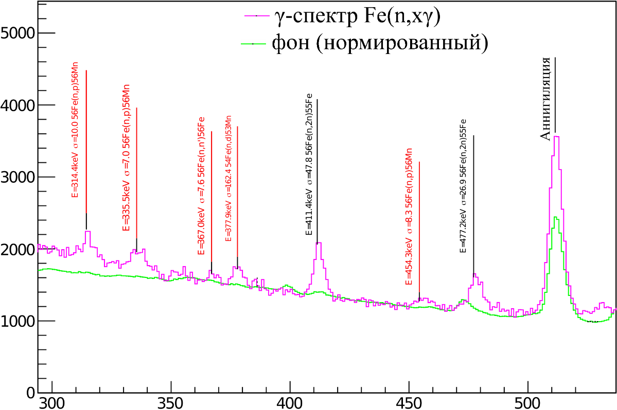

annihilation

γ- spectrum Fe(*n,x γ*)

background (normalized)

*Fig. 10. An example of identification of γ-peaks obtained in the experiment with iron sample using TalysLib . The γ-transitions, which have not been observed before, are highlighted in red.*

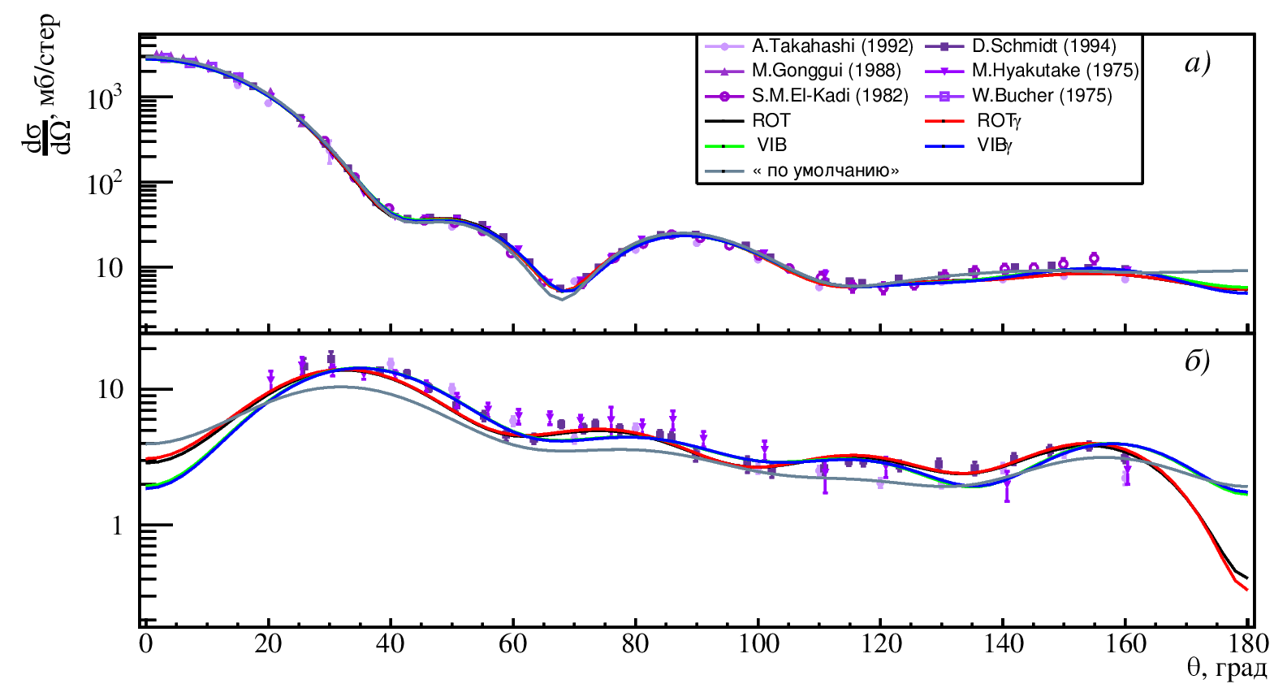

*Fig. 11. An example of fitting the parameters of optical model for elastic a) and inelastic with excitation of the first state b) scattering of 14 MeV neutrons on 56Fe nuclei using TalysLib . The curves of different colors were obtained with different approaches to describing the nature of the excited state.*

TalysLib partially implements the nuclear database access functionality based on reading C4 format (for EXFOR) and ENDF-6 format for evaluated data. An example of extraction a set of experimental data for the angular distribution of inelastically scattered neutrons on 12С is shown in Fig 12.

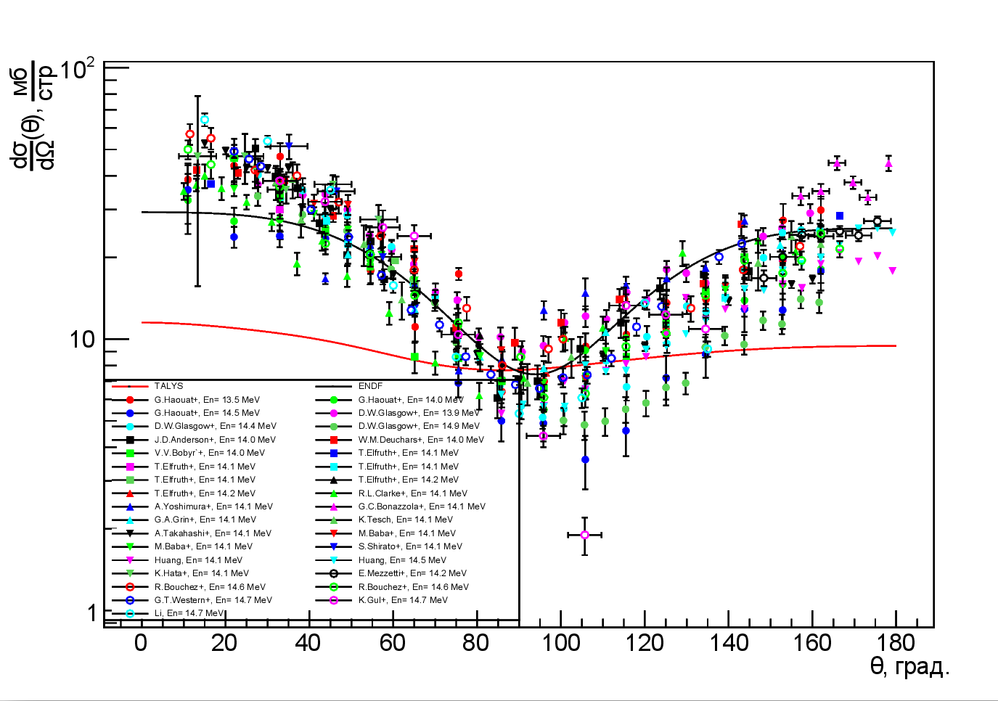

mb/str

θ, deg

*Fig. 12. A set of experimental data on neutron inelastic scattering on 12C with energies in band 13-15 MeV, collected using TalysLib. Result of calculations in TALYS and evaluated data from ENDF – B.VIII are shown with red and black lines.*

Our TalysLib developments were presented at the conferences "Alushta-2022", "Nucleus-2022", "Concentrated energy flows in space technology, electronics, ecology and medicine". An application has been submitted for the RSF grant No. 23-72-01111 “Development of the TalysLib information system for simple and quick access to nuclear data”.

**Publications**

1. N. Yu. Milovanov, I. D. Dashkov, N. A. Fedorov, et al. UZFF, 4 (2022) 2240301

2. I. D. Dashkov, N. A. Fedorov, D. N. Grozdanov , et al., Izv . RAS, ser. Phys. 86 (2022) 1081

3. Aleksakhin V.Yu., Razinkov E.A., Rogov Yu.V. H. et al., PEPAN Letters, 19(6), 699–705.

**FLNP Prizes**

III-d award: Series of works "Measurement of the angular distribution of neutrons with a frequency of 14.1 MeV, scattered on the nuclei of diseases."

Authors from FLNP: I.D. Dashkov, N.A. Fedorov , D.N. Grozdanov , Yu.N. Kopach, T.Yu. Tretyakova, V.R.Skoy

**Dissertations**

D.N. Grozdanov , "Development and use of the 14 MeV tagged neutron method for nuclear determinations and determination of the elemental structure for emissions containing carbon, oxygen or chromium". Dissertation for the degree of Ph.D.

**Applications for RSF grants**

1. 22-62-00035 "Development of a methodology for determining concentration of carbon and other elements in the soils using the tagged neutrons method."
2. 23-42-00086 " Study on high energy gamma-ray position sensitive elemental analysis technology and fast neutron coded imaging diagnostic method based on energy resolution."
3. **23-12-00239 "Development of a technique for position-sensitive neutron-gamma element analysis". -- supported.**
4. 23-62-10027 Development of a methodology and creation of a prototype of a mobile unit for determining the carbon content in soil using the tagged neutron method."
5. 23-22-00362 "Study of the possibility of using a neutron source based on the EG-5 accelerator for the purposes of elemental analysis."
6. 23-72-01111 "Development of the TalysLib informational system for simplification of the nuclear data access"