**APPLYING DATABASES FOR DATA VISUALIZATION IN ENHANCED FOLLOW-UP REGIME OF BAIKAL-GVD NEUTRINO TELESCOPE**

**ПРИМЕНЕНИЕ БАЗ ДАННЫХ ДЛЯ ВИЗУАЛИЗАЦИИ ДАННЫХ В РАСШИРЕННОМ РЕЖИМЕ НАБЛЮДЕНИЯ НЕЙТРИНО BAIKAL-GVD**

A.A. Kulikova, V.Y. Dikb,c, T.V.Elzhovb, I.A. Perevalovaa, A.A. Semeniuka, O.V.Suvorovad for Baikal-GVD collaboration

А.А. Куликовa, В.Я. Дикb,c, Т.В. Елжовb, И.А. Переваловаa, А.А. Семенюкa, О.В. Сувороваd от коллаборации Байкал-ГВД

e-mail: [aleksey.kulikov.2002@mail.ru](mailto:aleksey.kulikov.2002@mail.ru)

aIrkutsk State University, Irkutsk, 664003, Russia

aИркутский Государственный Университет, Иркутск, 664003, Россия

bJoint Institute for Nuclear Research, Dubna, 141980, Russia

bОбъединённый Институт Ядерных Исследований, Дубна, 141980, Россия

cInstitute of Nuclear Physics of the Ministry of Energy of the Republic of Kazakhstan, Almaty, 050032, Kazakhstan

cИнститут Ядерной Физики Министерства Энергетики Республики Казахстан, Алматы, 050032, Казахстан

dInstitute for Nuclear Research, Russian Academy of Sciences, Moscow, 117312, Russia,

dИнститут Ядерных Исследований, Российская Академия Наук, Москва, 117312, Россия,

Received November 12, 2023

**Abstract –** This contribution describes improvements to the Baikal-GVD alert system related to alert visualization which could clarify the alert data and its possible relation to astrophysical phenomena.The Baikal-GVD online data processing and alert system was launched at the beginning of 2021. It is designed for fast online neutrino event reconstruction and, when a potential signal from an astrophysical source is detected, sending an alert message to collaboration members. It also searches for coincidences between internal alerts and other astrophysical experiment alerts. The databases schema used to store the alert data (MariaDB, InfluxDB, MongoDB) is described. Automation of data analysis and visualization processes occurs using specialized Python libraries (Matplotlib, Astropy, etc.), which provide an API for that. The capabilities of the Grafana software system for storing visualized data with the ability to share are also explored.One of the main tasks of our alert system is switch to real-time mode with a low latency mode in signal reception both by the Baikal-GVD trigger and in receiving and responding to an external alert.

**Аннотация –** В этом вкладе описаны улучшения системы оповещений Baikal-GVD, связанные с визуализацией оповещений, которые могли бы уточнить данные оповещений и их возможную связь с астрофизическими явлениями. Система оповещений и онлайн-обработки Baikal-GVD была запущена в начале 2021 года. Она предназначена для быстрой онлайн-реконструкции нейтринных событий и, при обнаружении потенциального сигнала от астрофизического источника, отправки предупреждающего сообщения участникам коллаборации. Она также ищет совпадения между внутренними оповещениями и оповещениями от других астрофизических экспериментов. Описана схема баз данных, используемых для хранения данных оповещений (MariaDB, InfluxDB, MongoDB). Автоматизация процессов анализа и визуализации данных происходит с помощью специализированных библиотек Python (Matplotlib, Astropy и др.), предоставляющих для этого API. Также исследованы возможности программного комплекса Grafana по хранению визуализированных данных с возможностью обмена. Одной из основных задач системы оповещений Baikal-GVD является переход в режим реального времени с малой задержкой при приеме сигнала как по триггеру Baikal-GVD, так и при приеме и реагировании на внешние оповещения.

1. **Introduction**

The Baikal-GVD (Gigaton Volume Detector) operates as an innovative astrophysical observatory situated in Lake Baikal, Russia. It functions using a design consisting of optical modules attached to strings, which, in turn, are composed into clusters. The Baikal-GVD alert system was launched in 2021, geared specifically to promptly disseminate pre-processed data to collaboration members upon the potential identification of signals from astrophysical sources.

Additionally, it actively pursues associations between Baikal-GVD events and external alerts from major astrophysical experiments. The search involves several space angles between events and time windows. Fig. 1 illustrates the first 25 neutrino candidates of astrophysical origin identified through cascade reconstruction within the observation period of 2018-2022 [1], and example how one of real-time IC astrotrack alerts in 2023 aligns with the angular resolution region Baikal-GVD event. The process of identifying and correlating events detected by Baikal-GVD with alerts from other leading astrophysical observatories stands as a pivotal endeavor in validating and cross-referencing the observations. This analytical approach not only fortifies the credibility of detected signals but also fosters collaboration among observatories, contributing to a more comprehensive comprehension of astrophysical events. These goals highlight the importance of organizing alerts in the databases discussed in this article.

The article's primary focus will revolve around exploring the methods of visualizing alerts, elucidating the storage structure of alerts, and their overall configuration.

**2. Basic visualization tools**

The primary programming language adopted for this project is Python, known for its versatility and expansive capabilities, providing a robust foundation for achieving the project's objectives.

The «matplotlib» Python package is a fundamental tool, offering a flexible and strongly framework to generate a variety of plots and visual representations. Specifically, this package is instrumental in crafting the Aitoff projection sky map, aiding in the comprehension of celestial phenomena origins and their relative spatial positioning, as displayed in Fig.2.

Additionally, the «astropy» package, recognized for its diverse and beneficial functionalities, is employed in the project. Specifically, it is utilized in Fig.2 to superimpose the galactic plane onto the sky map, contributing to a more comprehensive visual representation of the celestial sphere.

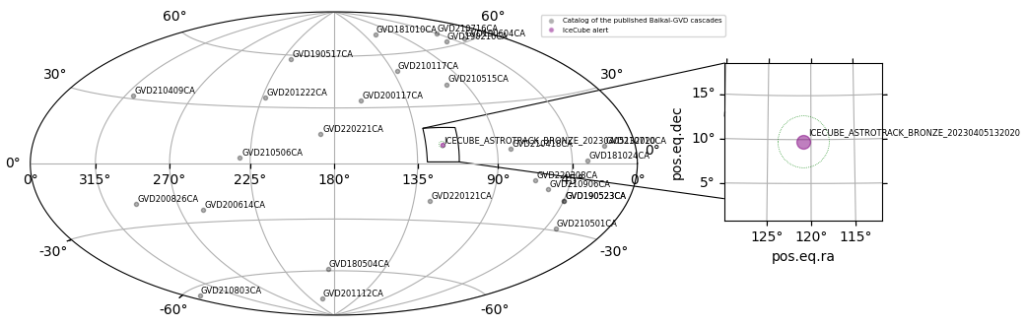 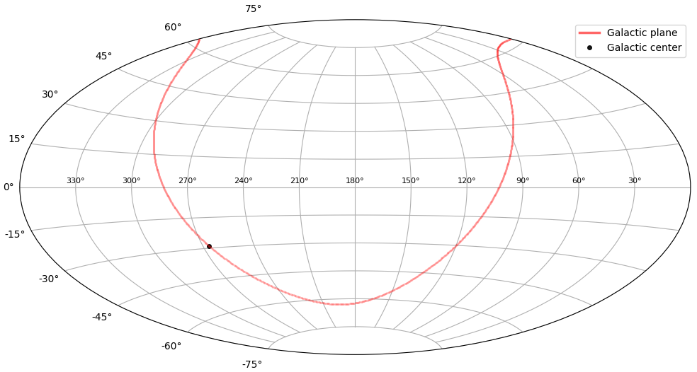

Figure 1: first 25 Baikal-GVD neutrino alerts Figure 2: Sky map in the Aitoff projection

and zoom for IC bronze astrotrack in containment

circle of one of the Baikal-GVD event

**3. Database management systems used in the project**

**3.1 InfluxDB[2]**

InfluxDB, a time series database tailored for managing time-related data like metrics, logs, and events. It is specifically designed to optimize the storage, query, and analysis of time series data, ensuring fast access and high performance in handling such information. Furthermore, it boasts support for a SQL-like query language, simplifying data analysis for users. Additionally, it seamlessly integrates with various tools intended for monitoring and visualizing time-based data.

It is used to store alerts from GCN. These alerts comprise events recorded by other large experiments, like IceCube Observatory (neutrinos) and Gravitation Observatories (IGWN (LIGO, Virgo, KAGRA)) and as well gamma-rays telescope Fermi (GRB). The database stores alerts starting in 2022, its full contents are presented in Fig.3. A catalog of potential neutrino sources is also visually represented on the sky map below (catalog), where IGWN events are depicted by points with the most probable coordinates of these events.

**3.2 MariaDB[3]**

MariaDB is an open source relational database that is a fork of MySQL. As a reliable and extensively used database management system, it offers support for SQL, facilitating complex queries and report generation. MariaDB is characterized by high performance and scalability, critical for efficiently processing vast amounts of data. Furthermore, it benefits from a community of developers and rich documentation that supports the ongoing development of the project.

This database is specifically employed to store Baikal-GVD events. MariaDB also stores catalogs collected during this work, for example a catalog of potential astrophysical sources, which contains 25 objects [4], which is presented in Fig.5.

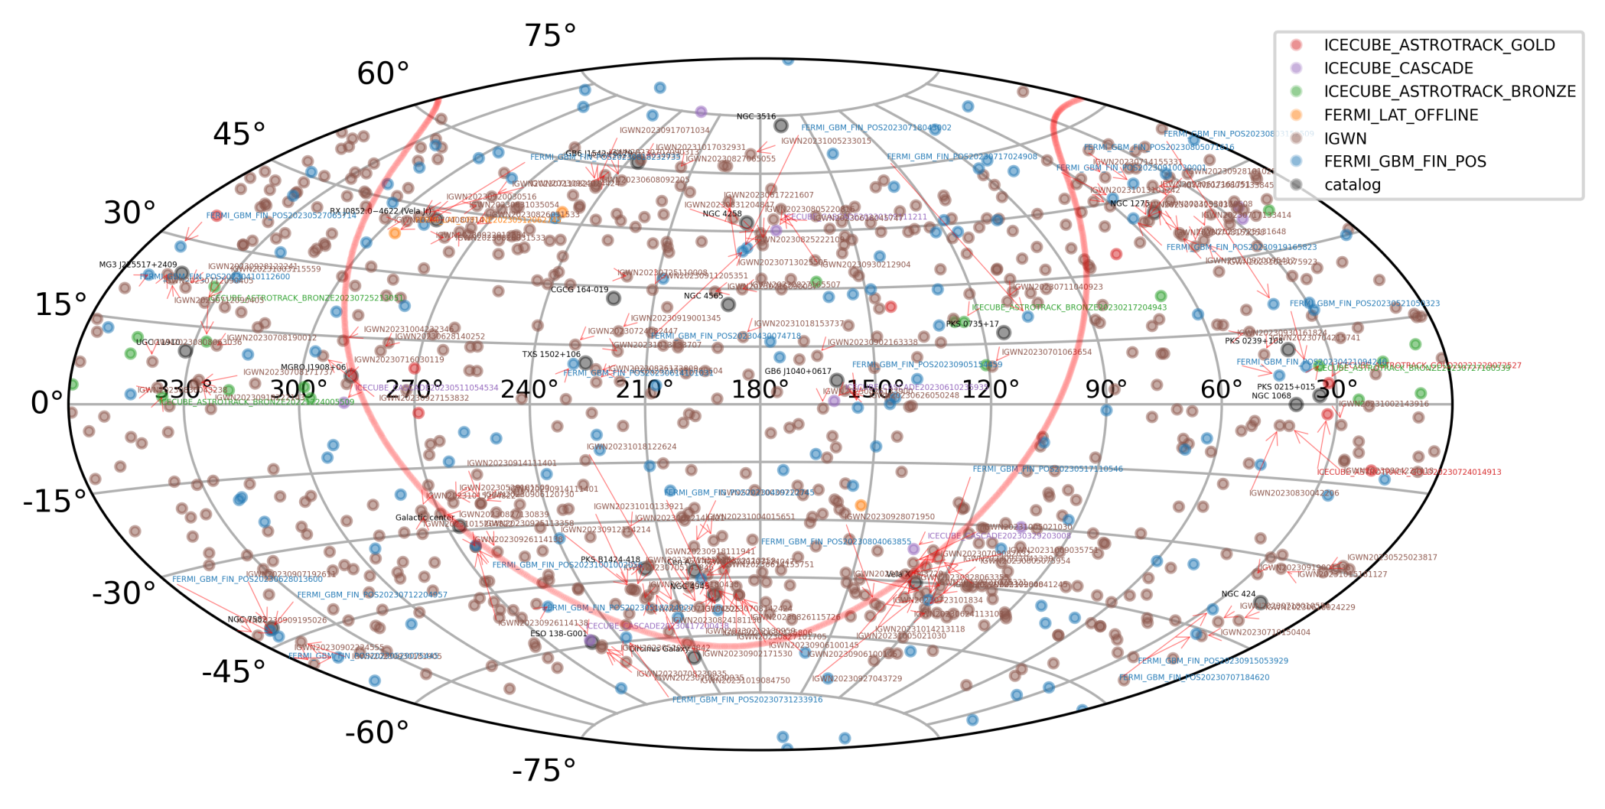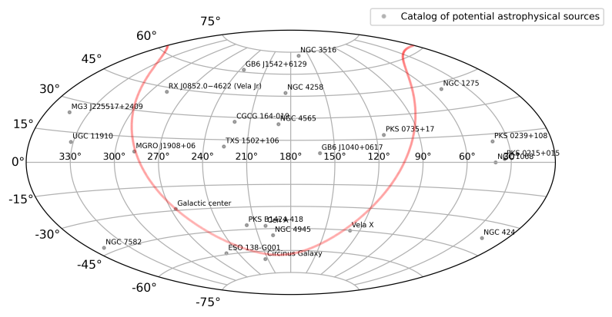

Figure 3: All alerts from InfluxDB Figure 4: Sky map with a catalog of potential

astrophysical sources, which contains 25 objects

**3.3 MongoDB[4]**

MongoDB is a document-centric NoSQL database. Its design allows for the convenient addition of JSON files directly into the database, offering flexibility in managing data of varying types. Moreover, MongoDB showcases high performance, especially when handling substantial volumes of data. It also comes with built-in support for horizontal scaling to manage expanding workloads efficiently. Additionally, MongoDB boasts rich indexing and query capabilities, ensuring swift and efficient access to stored data.

This database is specifically utilized to store JSON alerts from IGWN (LIGO, Virgo, KAGRA).

Notably, IGWN alerts require special consideration as the coordinates of the sources of these events are reconstructed based on specific probabilities. An example of a gravitational event is shown in Fig.5.

Most of the important information about the event in the alert is placed in the «skymap» object and encoded in Base64. Base64 is a binary-to-text encoding scheme that represents binary data in an ASCII string format, commonly used for encoding and transmitting data over text-based protocols such as email attachments or storing complex data in XML or JSON. To decode the «skymap», the «base64» python library is used, and for further reference to the necessary elements of this object («PROBDENSITY», the most probable RA and Dec) the «astropy_healpix» library.

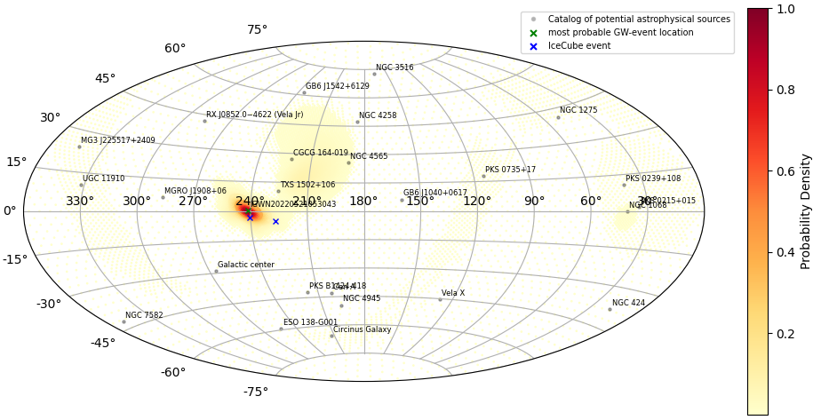 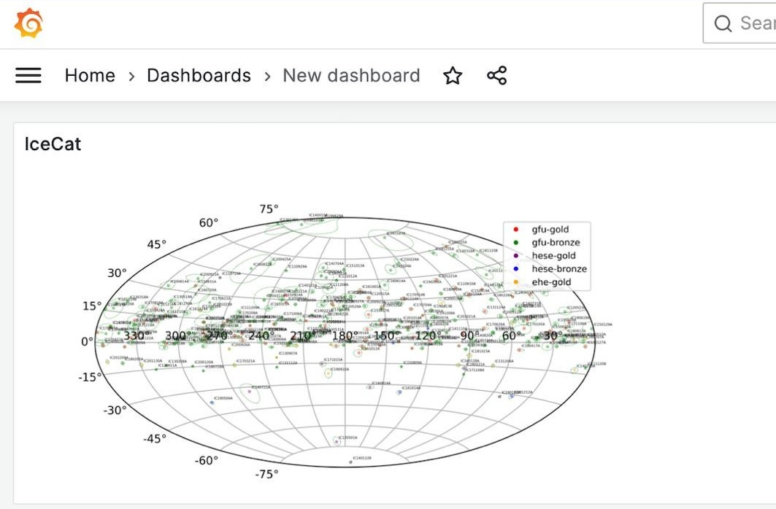

Figure 5: IGWN alert Figure 6: example of using Grafana

**4. Summary and Outlook**

In this article, the visualization techniques and database structures developed in the Baikal-GVD alert system were presented, emphasizing Python as the core programming language. Additionally, specialized Python libraries were imported into the system. The study also scrutinized the utilized databases - MariaDB, InfluxDB, and MongoDB - highlighting their respective advantages in handling and storing specific types of alerts. Additionally, the visualization techniques for search for matches were improved for convenience, particularly, a zoom function was added using the Python library «ligo.skymap». Overall, this exploration enhanced the operational insights into the Baikal-GVD alert system, shedding light on its functionalities and the collaborative endeavors in astrophysical observations.

There are also some improvements planned. Grafana, a widely used data visualization and monitoring tool, allows the creation of diverse dashboards containing histograms, graphs, and other data representations. Supporting multiple data sources, including InfluxDB, MariaDB, MongoDB, and more, Grafana is under consideration for storing data visualized on a sky map. Its primary advantage lies in its user-friendly, adaptable interface, providing uninterrupted access to essential data without requiring re-visualization through scripts. As depicted in Fig.6, an illustration showcases the use of Grafana, exhibiting a sky map integrated with the ICECAT-1 catalog on the dashboard [5]. Additionally, plans are in place to enhance the Baikal-GVD alert message, potentially incorporating a sky map display or a Grafana link housing the sky map.

**5. Acknowledgements**

This work is supported by the Russian Federation Ministry of Science and High Education (projects FZZE-2022-0001, FZZE-2023-0004, FZZE-2020-0024)

**References**

1. *V.A. Allakhverdyan* et al. [Baikal-GVD Collaboration]. Diffuse neutrino  
flux measurements with the Baikal-GVD neutrino telescope // Phys. Rev. D.  
2023. V.107. N.4. P.2005

2. InfluxDB documentation // InfluxData, Inc. 2024. URL: https://docs.influxdata.com/

3. MariaDB Server Documentation // MariaDB. 2024. URL: https://mariadb.com/kb/en/documentation/

4. MongoDB Documentation // MongoDB, Inc. 2023. URL: https://www.mongodb.com/docs/

5. *R. Abbasi* et al. [IceCube Collaboration]. IceCat-1: The IceCube Event  
Catalog of Alert Tracks // ApJS. 2023. V.269. N.1. P.25

6. *V.M. Aynutdinov* et al. [Baikal-GVD Collaboration]. Baikal-GVD real-time  
data processing and follow-up analysis of GCN notices // Proc. of Sci.  
2023. PoS ICRC2023. P. 1458.

**Baikal-GVD collaboration members list:**

**V.M. Aynutdinova, V.A.Allakhverdyanb, A.D. Avrorina, A.V.Avrorina, Z.Bardačovác,d, I.A.Belolaptikovb, E.A.Bondareva, I.V.Borinab, N.M.Budneve, V.A.Chadymovl, A.S.Chepurnovf, V. Y. Dikb,g, G.V.Domogatskya, A.A.Doroshenkoa, R.Dvornickýc, A.N.Dyachoke, Zh.-A.M.Dzhilkibaeva, E.Eckerovác,d, T.V.Elzhovb, L.Fajtd, V.N. Fominl, A.R.Gafarove, K.V.Golubkova, N.S.Gorshkovb, T.I.Gresse, K.G.Kebkalh, I.V.Kharuka, E.V.Khramovb, M.M.Kolbinb, S.O.Koligaevi, K.V.Konischevb, A.V.Korobchenkob, A.P.Koshechkina, V.A.Kozhinf, M.V.Kruglovb, V.F.Kulepovj, Y.E.Lemeshevj, M.B.Milenina†, R.R.Mirgazove, D.V.Naumovb, A.S.Nikolaevf, D.P.Petukhova, E.N.Pliskovskyb, M.I.Rozanovk, E.V.Ryabove, G.B.Safronova, D.Seitovab,g, B.A.Shaybonovb, M.D.Shelepova, S.D.Shilkina, E.V.Shirokovf, F.Šimkovicc,d, A.E.Sirenkob, A.V.Skurikhinf, A.G.Solovjevb, M.N.Sorokovikovb, I. Štekld, A.P.Stromakova, O.V.Suvorovaa, V.A.Tabolenkoe, B.B.Ulzutuevb, Y.V.Yablokovab, D.N.Zaborova, S.I.Zavyalovb, D.Y.Zvezdovb**

*aInstitute for Nuclear Research, Russian Academy of Sciences, Moscow, 117312, Russia,*

*bJoint Institute for Nuclear Research, Dubna, 141980, Russia*

*cComenius University, 81499 Bratislava, Slovakia*

*dCzech Technical University in Prague, Institute of Experimental and Applied Physics, 11000 Prague, Czech Republic*

*eIrkutsk State University, Irkutsk, 664003, Russia*

*fSkobeltsyn Institute of Nuclear Physics, Moscow State University, Moscow, 119991, Russia*

*fInstitute of Nuclear Physics of the Ministry of Energy of the Republic of Kazakhstan, Almaty, 050032, Kazakhstan*

*gLATENA, St. Petersburg, 199106, Russia*

*iINFRAD, Dubna, 141981, Russia*

*jNizhny Novgorod State Technical University, Nizhny Novgorod, 603950, Russia*

*kSt.- Petersburg State Marine Technical University, St.-Petersburg, 190008, Russia*

lFree researcher, Moscow, Russia