DSpace software platform for digital repository of JINR publications
I. Filozova, G. Shestakova, A. Kondratyev, A. Bondyakov, T. Zaikina*, I. Nekrasova
Meshcheryakov Laboratory of Information Technologies, Joint Institute
for Nuclear Research, Dubna, 141980, Russia
e-mail: ztanya@jinr.ru

Abstract — The Dspace software platform was specifically designed to create modern open repositories in academic and educational environments. It is an open-source platform with rich functionality, making it an attractive tool for academic, non-profit and commercial organizations creating open digital repositories. DSpace is supported by a large community of developers and users from around the world, allowing researchers and scientists to publish their papers and data. In our work we consider the use of DSpace software for the JINR repository, which contains articles, preprints and other materials reflecting and facilitating to JINR research activities. A test prototype of the repository, the usage of entities and collections, support for English and Russian languages, schemes for obtaining metadata from external resources such as INSPIREHEP, eLIBRARY are presented. The setup of the DSpace platform and its adaptation to the tasks of the JINR institutional repository are also briefly described.
PACS: 07.05.Bx, 01.90.+g

INTRODUCTION
Joint Institute for Nuclear Research is a world-famous scientific center with a large number of employees creating publications and materials about the process, progress and results of their research. It is extremely necessary for such organization to have an institutional repository as service that allows storing and providing access to scientific output of employees. The institutional repository containing articles, preprints and other materials reflecting and facilitating JINR research activities, store and provide effective access to JINR information resources, make scientific results available to all scientific and educational community, helps to estimate the efficiency of the JINR scientific activity and is also part of scientific communication.
DSpace is the world's most widely used software system for working with open archives, libraries and repositories in general. OpenDOAR shows that DSpace is the most popular and adopted software for institutional open access repositories at a significant rate, approximately 39 percent, among other similar software solutions for several years in a row [1, 2, 3].
The DSpace 7 software platform, as a powerful modern full-featured platform, was chosen as the basis of the JINR Institutional Repository. The platform was deployed at the JINR cloud infrastructure which is represented by the OpenNebula platform. The virtual machine for testing DSpace 7 as JINR institutional repository was created with the following parameters: 100 GB of disk space, 16 GB of RAM, 4 CPU cores, operating system: Oracle Linux 8x.
The DSpace main advantages include the following:
• open source;
• cross-platform;
• the ability to customize according to the specific needs of the user;
• multilingual interface (the Russian language was set by our team for our test installation);
• using Apache SOLR as a search engine for metadata and full text. This allows to quickly and efficiently search for information in the repository, even if it contains a large number of documents;
• the ability to configure access rights to content;
• support for importing metadata through third-party APIs such as ORCID, PubMed, Sherpa and others;
• integration with services that provide persistent identifiers, such as DOI. This allows to enrich digital content while importing from new sources, including CrossRef, Scopus, Web of Science, PubMed, etc.
The disadvantages include a rather complex backup scheme, as well as a mechanism for updating the system.

The concept of the JINR Repository on DSpace 7 platform
The JINR institutional repository is an information system representing an Open Access institutional repository of scientific output of JINR employees. The goals of the repository are to store JINR scientific information resources and provide effective access to them [4, 5].

The technology stack
The DSpace 7 technology stack consist of two part: "backend" (Server, API) and "frontend" (User Interface). For our Server API installation we use: java-17-openjdk, postgresql11, server postgresql11, pgcryptokey11.x86_64, apache-ant-1.10.13, apache-maven-3.9.0, apache-tomcat-9.0.72, apache solr-8.11.2.
To install and build the DSpace 7.x (Angular) package, the following tools were used:
• Node.js-16 — JavaScript runtime environment based on Google's V8 engine;
• Yarn — package manager and tool for managing dependencies in applications written in JavaScript;
• PM2 is a process manager for Node.js applications that ensures stability, scalability and ease of use of applications. It allows you to control the startup, restart, reboot and termination of processes, as well as monitor the status of applications and process signals.

Communities, Collections and item types
One of the main advantages of DSpace 7 are entities, items that can be linked with each other with relationship. At our point, this opportunity is very important for the JINR institutional repository to make links between publications, authors (JINR employees), organizational units and JINR projects.
The contents of JINR institutional repository based on DSpace 7 are presented into four main sections-communities: Famous JINR scientists, Persons with two collections of JINR employees (archive and current staff), JINR departments, JINR Publications divided in two collections — a collection of publications from external sources and reviewed by editors, as well as a collection of publications uploaded by users.
At the first step, the repository supports the following publication types: Article, Preprint, Book, Book section, Presentation, Theses/Abstracts, Dissertation, Patent/Registration of a Computer Program, Report.
Authentication at JINR repository is carried out through the JINR Single Sign On service (SSO). The collections of JINR publications, Famous JINR scientists and JINR departments are open to all Internet users without authorization. SSO users additionally have access to the “Persons” communitie with information about JINR employees, as well as the ability to add their publications to the repository.

Upload the data
Keeping track of all publications of JINR employees is a significant challenge. There is an urgent need for a systematic approach to collect and preserve publications in a standardized way, to avoid multiple inputs of information. [5].
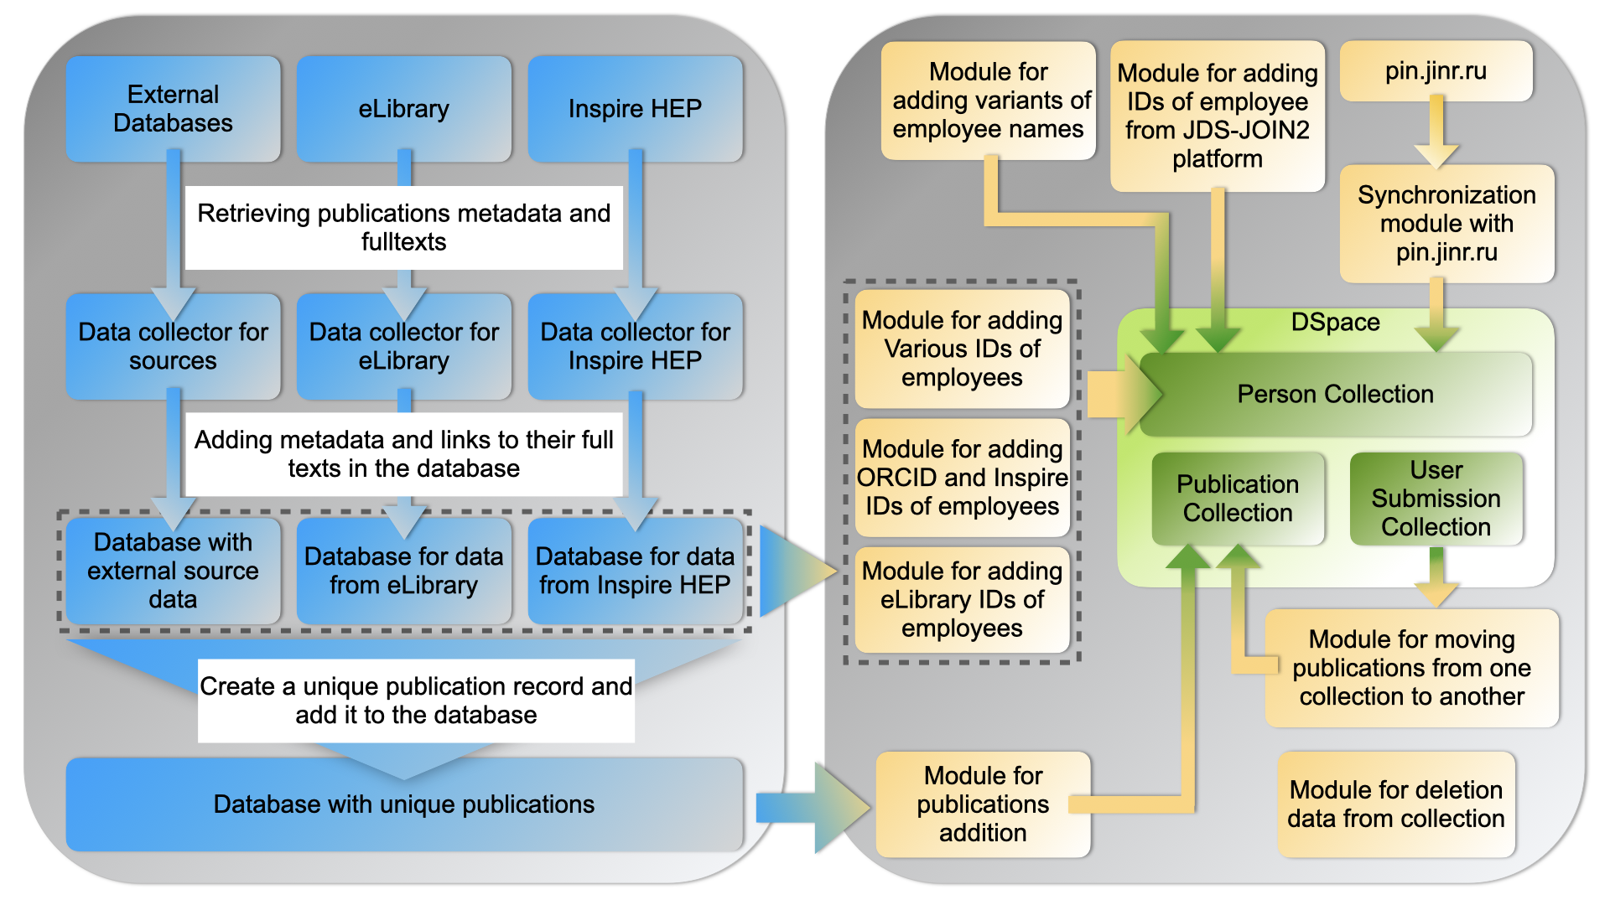
- The general scheme of data uploads to JINR Institutional repository on DSpace 7
We use two approaches to upload the data to the repository — 1) harvesting metadata from the external sources, for the firsts test we use INSPIREHEP API and eLIBRARY API; 2) data can be uploaded by users themselves through the web interface (using DSpace import functions or manually via submission forms). JINR staff metadata uploaded by special addition modules from the JINR Personal Information system (PIN). The general scheme of data uploads presented at the figure 1.

Conclusion
DSpace 7 looks promising enough to be used as the basis for the JINR institutional repository. Work on adapting and configuring the platform, as well as loading data through import from external sources, continues and is being improved. The institutional repository based on DSpace 7 is capable of providing users and the scientific community with a wide range of opportunities for storing, searching and accessing the scientific results of the institute's staff.

References
- Formanek M. DSpace 7 Benefits: Is It Worth Upgrading? Information Technology and Libraries, 42(3), 2023. https://doi.org/10.5860/ital.v42i3.16209.
- Balutkina N.A., Stukalova A.A. Institutional Repositories in Russia and Abroad: Review of Publications. Bibliotekovedenie [Russian Journal of Library Science]. 2022;71(2):193-206. (In Russ.) https://doi.org/10.25281/0869-608X-2022-71-2-193-206
- Fedotova O.A., Fedotov A.N., Zhizhimov O.L., Sambetbayeva M.A. DIGITAL REPOSITORY FOR RESEARCH AND EDUCATION INFORMATION SYSTEMS. Proceedings of SPSTL SB RAS. 2019;(3):23-28. (In Russ.) https://doi.org/10.20913/2618-7515-2019-3-23-28
- Zaikina, T., Filozova, I., Shestakova, G. Semenov R. & Kunyaev S. JDS-JOIN2 Repository as a Workspace for Scientific Output. Phys. Part. Nuclei Lett. 19, 583–585 (2022). https://doi.org/10.1134/S1547477122050454
- Filozova I., Zaikina, T., Shestakova G., Semenov R., Köhler M., Wagner A., Baracchi L. JINR Open Access Repository based on the JOIN² Platform // Proceedings of the XXII International Conference on Data Analytics and Management in Data Intensive Domains, DAMDID/RCDL 2020. Voronezh, Russia, 2020. CEUR workshop proceedings. 2020. V. 2790. PP. 142-155. doi: 10.3204/PUBDB-2021-00818.

ПРОГРАММНАЯ ПЛАТФОРМА DSPACE ДЛЯ ЦИФРОВОГО РЕПОЗИТОРИЯ ПУБЛИКАЦИЙ ОИЯИ
И. Филозова, Г. Шестакова, А. Кондратьев, А. Бондяков,
Т. Заикина*, И. Некрасова
Лаборатория информационных технологий им. М.Г.Мещерякова, Объединенный институт ядерных исследований, Дубна, 141980, Россия
e-mail: ztanya@jinr.ru

Аннотация — Программная платформа Dspace была специально разработана для создания современных открытых репозиториев в академической и образовательной среде. Является платформой с открытым исходным кодом и богатыми функциональными возможностями, что делает её привлекательным инструментом для академических, некоммерческих и коммерческих организаций, создающих открытые цифровые репозитории. DSpace поддерживается большим сообществом разработчиков и пользователей со всего мира, позволяя исследователям и ученым публиковать свои статьи и данные. В нашей работе мы рассматриваем использование программного обеспечения DSpace для репозитория ОИЯИ, содержащего статьи, препринты и другие материалы, отражающие и сопутствующие исследовательской деятельности ОИЯИ. Представлены тестовый прототип репозитория, использование сущностей и коллекций, поддержка английского и русского языков, схемы получения метаданных из внешних ресурсов, таких как INSPIREHEP, eLIBRARY, а также вкратце описаны настройка платформы DSpace и её адаптация к задачам институционального репозитория ОИЯИ.
PACS: 07.05.Bx, 01.90.+g

DSpace web-site — https://dspace.lyrasis.org/
OpenDOAR is the quality-assured, global Directory of Open Access Repositories, which regularly collects and updates data about repositories that provide free, open access to academic outputs and resources — https://v2.sherpa.ac.uk/opendoar/about.html
Installing DSpace — https://wiki.lyrasis.org/display/DSDOC7x/Installing+DSpace
In DSpace, an Entity is a special type of Item which often has Relationships to other Entities — https://wiki.lyrasis.org/display/DSDOC7x/Configurable+Entities
INSPIREHEP web-site — https://inspirehep.net/
Scientific digital library eLIBRARY.RU web-site — https://www.elibrary.ru/defaultx.asp
JINR Personal Information system web-site — https://pin.jinr.ru/pin/pin

