The Budker INSTITUTE OF NUCLEAR PHYSICS SB RAS

**Annex 008**

**Procedures**

**for the PANDA**

**Yoke Doors moving.**

Novosibirsk

2018

*History of Changes*

|  |  |  |  |
| --- | --- | --- | --- |
| *Rev. No.* | *Date* | *Pages* | *Description of Changes* |
| 1. | 2018-05-14 | 1-14 | V1 prepared by E.E.Pyata. |
| 2. | 2018-10-29 | 1-16 | V2 prepared by E.E.Pyata.  Changed articles and items numbering. Described in more detail items 2.2; 2.3; 2.5; 2.6; 3.1; 4.3. Changed items 2.7; 3.6; 4.2; 4.4. The final version should be prepared by BINP after open/closed procedures in the plant site. |
|  |  |  |  |

## Procedure for the PANDA Yoke Doors moving

The procedure determines the order of the PANDA yoke doors moving as for control assembly at the manufacturer areas as for BINP and FAIR sites. The procedure for opening/closing a door wings is described for the downstream door. The procedure is the same for the upstream door.

In the initial position, the door is on the rollers. Then the door is set to the working position and is connected and fixed to the yoke of the magnet. During opening of the door wings, the door is lowered and moved to the rollers. A hydraulic system for moving doors along the rails is installed. The doors are disconnected and moved to the maximal permissible positions. Then the wings are moved by a hydraulic system in the closed position and connected one to the other.

The critical dimensions and control of assembling are given in drawing FPDSSM01000000AS\_C.

During the first control assembly of the PANDA yoke and frame it is possible an additional machining of the barrel beams and door wings.

The quantity procedures open/close the doors are as minimum five during acceptance tests at the manufacturer area.

It is forbidden to lower and then open only one from two door wings.

# Lifting and connection of the downstream door to the yoke.

* 1. Yoke and frame assembly. The door wings rest on their roller skates at the rail tracks (Fig. 1). The wings are connected to each other by bolts.

|  |
| --- |
| **Beam**  Upstream side view. |
| **Beam**  Downstream side view. |

Figure 1. Yoke and frame assembly.

* 1. Install two hydraulic jacks of the downstream door in the position for lifting. Lift door by jacks 2mm above nominal position. Take attention, maximal height of lifting is 4 mm.

|  |  |
| --- | --- |
| **Jacks for lifting of the doors.** | 4 mm |
|  |

Figure 2. Location of the jacks on beam frame.

* 1. Check gaps between ears of the door and octants W3 and W7 of the yoke. Put shim sets on the ears of octants W3 and W7 of the yoke.

|  |
| --- |
| **Gap**  **Shim set** |

Figure 3. Gap and shim set between ears of the door and octant W3.

* 1. Install the rollers for lateral moving (Fig. 4). If it is needed install shims between rollers and frame beam.

|  |
| --- |
| D:\Documents\1Germany\PANDA_GSI_Darmstadt\PANDA documents\QAP\QAP annexis\figuries annex8\Platform_Frame-_Yoke-7a.jpg  **Lateral rollers**  **Gap**  **Gap**  **Gap**  **Gap**  **Gap** |

Figure 4. Location of the lateral rollers

* 1. Put bolts for connection of the door with the yoke according to the drawing and screw the bolts 3-4 mm depth. Bolts should be free in the holes of the doors.

|  |  |
| --- | --- |
| **Bolts for connection of the doors with yoke.** |  |

Figure 5. Installation of the bolts for connection of the door with yoke.

* 1. Install door on the lateral rollers by jacks. Bolts for connection of door with yoke should be free in the holes of the doors. Check gaps between ears of the door and octants W3 and W7 of the yoke. Gaps should be 1±0.5 mm (Fig. 6). The bolts should be free in the holes if no to repeat the steps 2.4-2.5.

|  |  |
| --- | --- |
| **Gap** |  |

Figure 6. Installation of the downstream door on the lateral rollers.

* 1. Check alignment of the door according to assembling drawing. Connect door on the lateral rollers with yoke before touching. Lifting the door by jacks about 1mm to remove the rollers. Lower the door on the yoke’s ears. Take attention, the maximal dimension for the lateral moving is four mm.

Control critical dimensions. Correct position of the door by the jacks. If it is needed to install additional shims between ears of the octants and wings.

|  |
| --- |
| **Gap 4mm** |

Figure 7. Installation of the downstream door on the lateral rollers.

* 1. Fix the door to yoke by bolts. Remove jacks and lateral rollers.

|  |  |
| --- | --- |
|  |  |

Connected points

Figure 8. Connection of the downstream door with barrel part of yoke by 16 bolts M36.

# Lowering the downstream door on the rail track of the frame

* 1. Install of two hydraulic jacks of the downstream door in the position for lifting. Loosen the bolts connecting the doors (Fig. 8). Lift door by jacks 1-3 mm to make it possible to unscrew loose bolts in the holes. Take attention, maximal height of lifting is 4 mm (see 2.2). Check gaps between ears of the door and octants W3 and W7 of the yoke. Gaps should be more than 1 mm (Fig. 8). Remove shims between ears.

|  |  |
| --- | --- |
| **Gap** |  |

Figure 9. Preparation lowering the downstream door. Installation of the jacks and the rollers for lateral moving

* 1. Install the rollers for lateral moving. If it is needed install shims between rollers and door wings (Fig. 9).

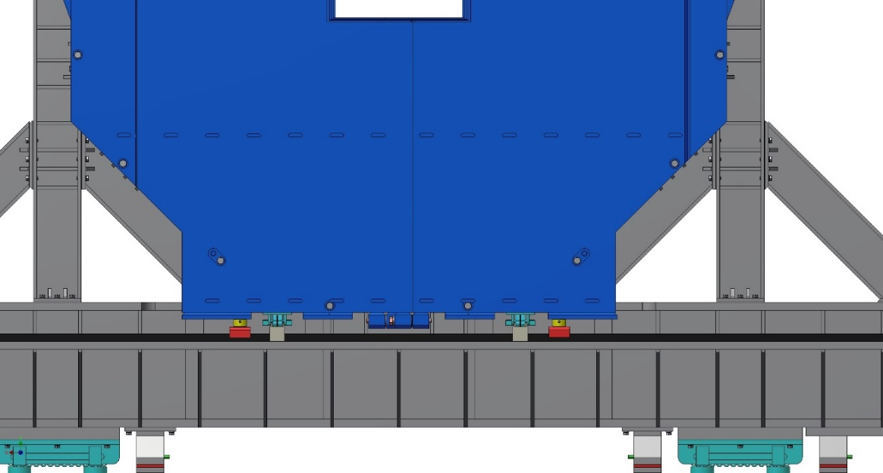

**Lateral rollers**

Figure 10. Location of the lateral rollers

* 1. Remove bolts connecting the doors with the yoke. The springs of the spring-loaded Ball Transfer Units will have to overcome the friction of the rollers for lateral moving, thus separating the door and the yoke surfaces over the distance of about 2mm (fig. 10). If forces of the springs will not be enough then use four squeezer bolts to push the door back. Take attention, maximal length of moving is 4 mm.
  2. Ensure that the movement on the rollers will be smooth, without stopping and jerking. Place the downstream door in position for lowering on the rail track.

|  |
| --- |
| **Gap**  **Squeezer bolt** |

Figure 11. Separation of the door and the yoke surfaces

* 1. Lift the door by the jacks on 1±0.5 mm more than the surface of the rollers for lateral moving. Remove lateral rollers. Loosen the squeezer bolts of the doors. Check that bolts do not disturb to lower the door. Check gaps between ears of the door and octants W3 and W7 of the yoke that ears do not disturb for lowering of the door. Gaps should be about 1±0.5 mm. Remove shim sets between ears of the door and octants W3 and W7 of the yoke.
  2. Check that nothing do not disturb to lower the door on the rollers of the frame rail track. Lower the door on the rollers of the frame rail track by jacks. Ensure that both sides of the door are evenly lowered (Fig. 10). Door is ready for open process.

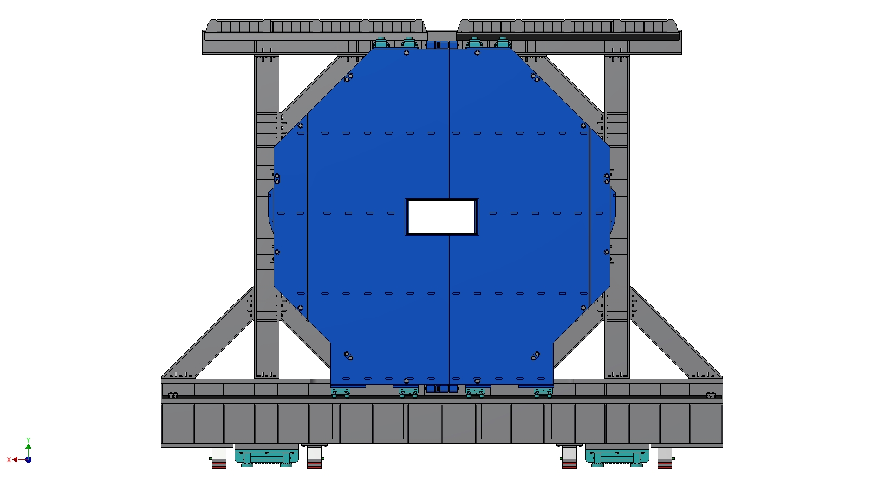

**Frame rail track**

**Rollers**

Figure 12. Preparation lowering the downstream door.

# Opening/closing the wings of the downstream door on the rail track of the frame.

* 1. Unscrew four bolts connecting the wings of the downstream door (Fig. 11).

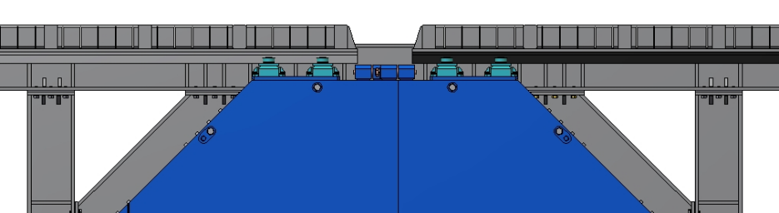

**Places of joints of the wings.**

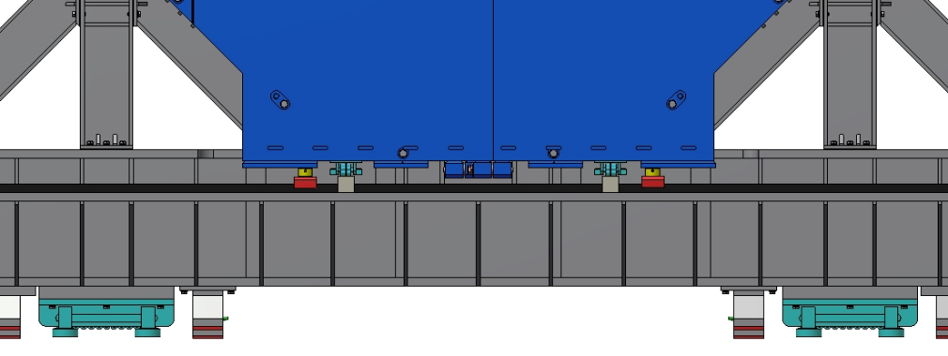

Figure 13. Preparation the door for opening.

* 1. Install the hydraulic jacks for moving the left and right wings of the door (Fig. 12). Check that nothing will not be interfere to move of the wings of the door. Ensure that the movement on the rollers is smooth, without stopping and jerking.

|  |
| --- |
| **Hydraulic jacks.**  a) |
| b) |

Figure 14. a) Installation the hydraulic jacks; b). Open the door.

* 1. Install and fix the doors at the opened position. Move the hydraulic jacks as many times as necessary to open the door. Control critical dimensions (Fig. 13). To avoid opening the wings wider than the restraining line and wing touched the stopper. Watch the movement of the hydraulic cylinders.

|  |  |
| --- | --- |
|  | D:\Documents\1Germany\PANDA_GSI_Darmstadt\PANDA documents\QAP\QAP annexis\figuries annex8\Platform_Frame-_Yoke-3.jpg |
| D:\Documents\1Germany\PANDA_GSI_Darmstadt\PANDA documents\QAP\QAP annexis\figuries annex8\Platform_Frame-_Yoke-3a.jpg |  |

Figure 15. Moving the downstream door in the opened position.

* 1. To move the wings of the downstream door from open position to closed position unlock the wings. Check that nothing will not be interfere for moving of the wings of the door. Start moving by the hydraulic cylinders. Ensure that the movement on the rollers is smooth, without stopping and jerking. Watch the movement of the hydraulic cylinders. Move the hydraulic jacks as many times as necessary to close the door.

|  |  |
| --- | --- |
|  | D:\Documents\1Germany\PANDA_GSI_Darmstadt\PANDA documents\QAP\QAP annexis\figuries annex8\Platform_Frame-_Yoke-3a.jpg |
| D:\Documents\1Germany\PANDA_GSI_Darmstadt\PANDA documents\QAP\QAP annexis\figuries annex8\Platform_Frame-_Yoke-3.jpg |  |
|  |  |

Figure 16. Moving the downstream door in a closed position.

* 1. Stop moving in the position for connection of the wings of the downstream door. Check and install four bolts for connection the wings one to other. Screw the bolts. Control critical dimensions. To assemble the door with yoke to see point 1. Lifting and connection of the downstream door to the yoke (see article 2 this procedure).

|  |
| --- |
|  |
|  |

Figure 17. Downstream door in a closed position.