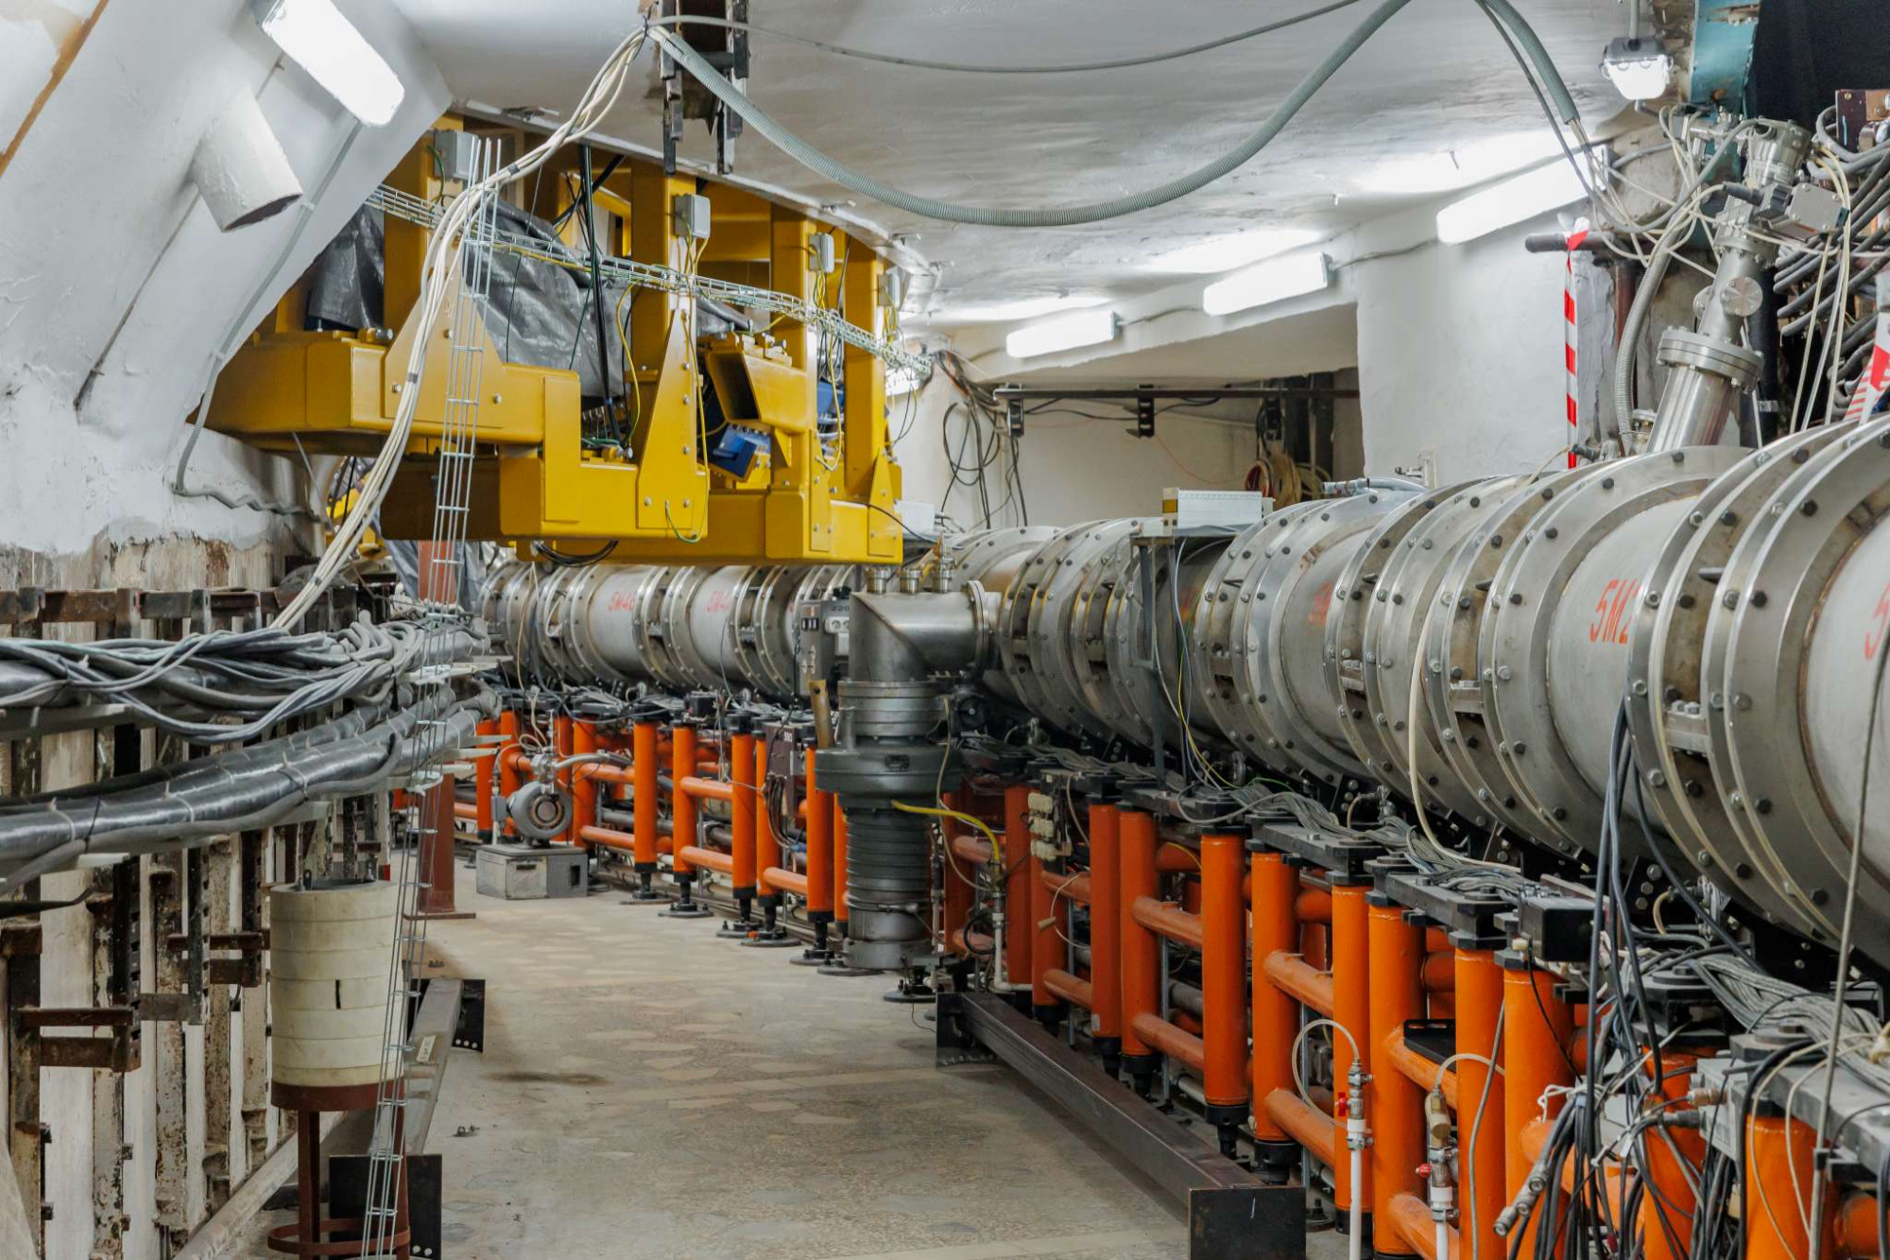

**Transfer Line**

**Nuclotron-to-Collider**

**Valeri Lebedev & Victor Smirnov**

**JINR**

**July 2024**

## Rms Bunch Length and Momentum Spread Coming out from Nuclotron

* Maximal longitudinal beam emittance is determined by longitudinal Booster acceptance at injection

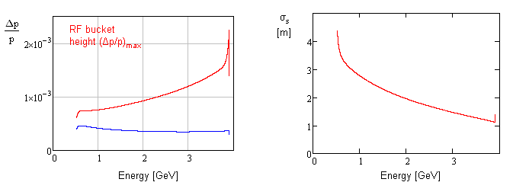

Bunch length and momentum spread in Nuclotron in the course of acceleration

* The maximum rms momentum spread is 4∙10-4 at lowest collider energy of 1 GeV
* Accounting 3s and adding relative energy error of 8∙10-4 we obtain the total required momentum acceptance 2∙10-3
* This momentum spread will be sufficient for operation with p

## Required Transverse Acceptance of Transfer Line

* 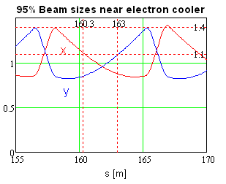The transverse beam emittance was chosen so that 2.5s beam size would be at the boundary of electron beam (14 mm) determined by longitudinal Booster acceptance at injection.
  + That yields en=0.2 mm
    - * 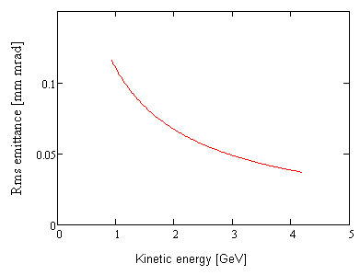e=0.11 mm at 1 GeV
* We require acceptance of 5s
  + - * eaccept ≥ 3 mm
  + Plus 5 mm for the orbit distortion
* Actual acceptance of the line for 1.5 mm thick round chamber is 12 mm

Rms beam emittance in Nuclotron in the course of acceleration

## Beta Functions and Dispersions Through the Line

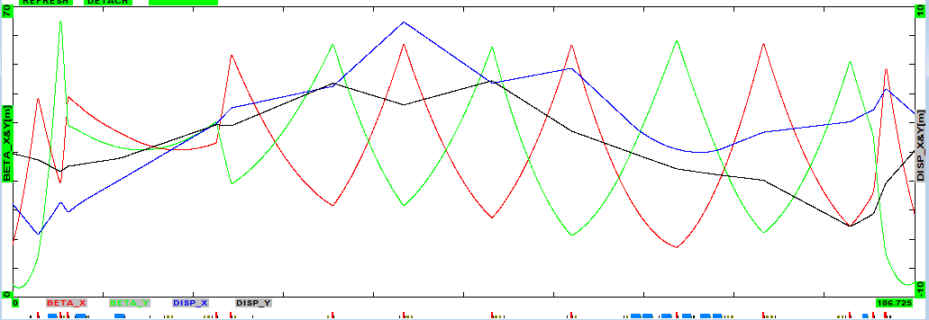

* Peak beta-function 66 m
* Peak dispersions and momentum acceptances
  + Horizontal – 8.8 m (Dp/pmax=2.7 cm/8 m = 3.4∙10-3)
  + Vertical – 5 m (Dp/pmax=2.7 cm/5 m = 5.4∙10-3)
* Separate powering of quads and dipoles gives
  + considerable flexibility in optics choice
  + enables quad centering

## Beam Sizes Through the Line

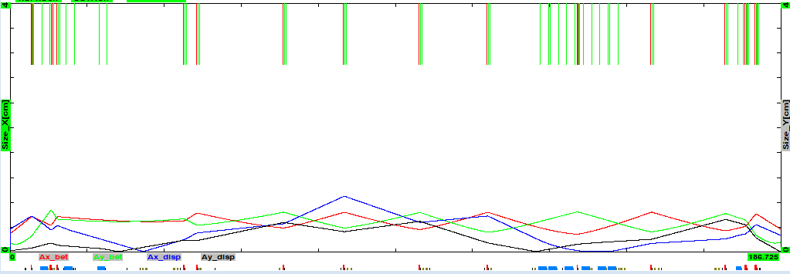

Beam boundaries for 1 GeV beam: e95%=0.66 mm∙mrad, Dp/p=10-3 (2.5s)

* Round vacuum chamber with OD 58 mm and 2 mm wall looks as reasonable choice
* It supports:   
  Transverse acceptance of 12 mm mrad

Momentum acceptance 3.4∙10-3

## Eddy Currents in the Vacuum Chamber walls



* Eddy currents  and, in the first approximation () are equal to zero
* For OD 56 mm and 2 mm vacuum chamber one obtains

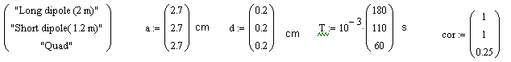

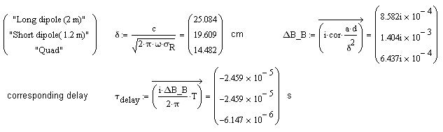

* Thus, the eddy currents do not represent a problem

## Requirements for Correctors

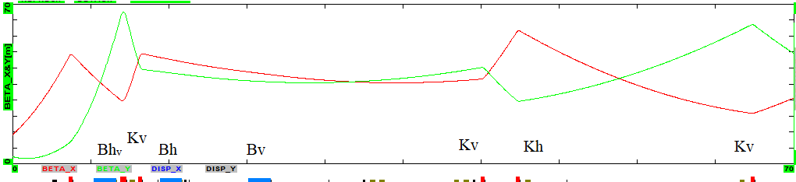

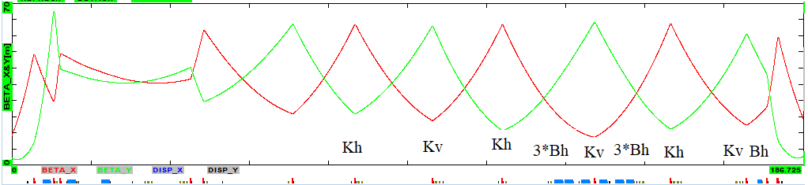

* Since the dipoles have independent power supplies and can be used as correctors we need 10 single plane correctors