ANALYSIS OF HYPERNUCLEI IN SIMULATED DATA OF THE BM@N EXPERIMENT

E. Konstantinovaª, S. Merts^{b}
ª Department of Theoretical Physics, Faculty of Physics, Irkutsk State University, 664022, Irkutsk, Russia
e-mail: Konstantinova-2003@inbox.ru
^{b}VBLHEP, JINR, 141980, Dubna, Russia
Received March 21, 2025

Abstract - This work is devoted to the study of the simplest hypernuclei, namely _{Λ}³H and _{Λ}⁴H, in the BM@N experiment. They may be one of the possible markers of the phase transition from nuclear matter to quark-gluon plasma in high-energy ion collisions. Reconstruction efficiency of two-body decays of these hypernuclei was estimated using simulated data based on DCM-SMM nuclear interaction model and a realistic description of the BM@N spectrometer. A procedure to optimize significance of the observed signal of hypernuclei decays is developed and presented.

INTRODUCTION
The study of hyperons and hypernuclei production in nuclear collisions is of interest because the increased yield of strange particles may be a sign of a phase transition between quark-gluon plasma and nuclear matter, expected at high baryonic densities and energies up to 10 GeV/nucleon in the center-of-mass system.
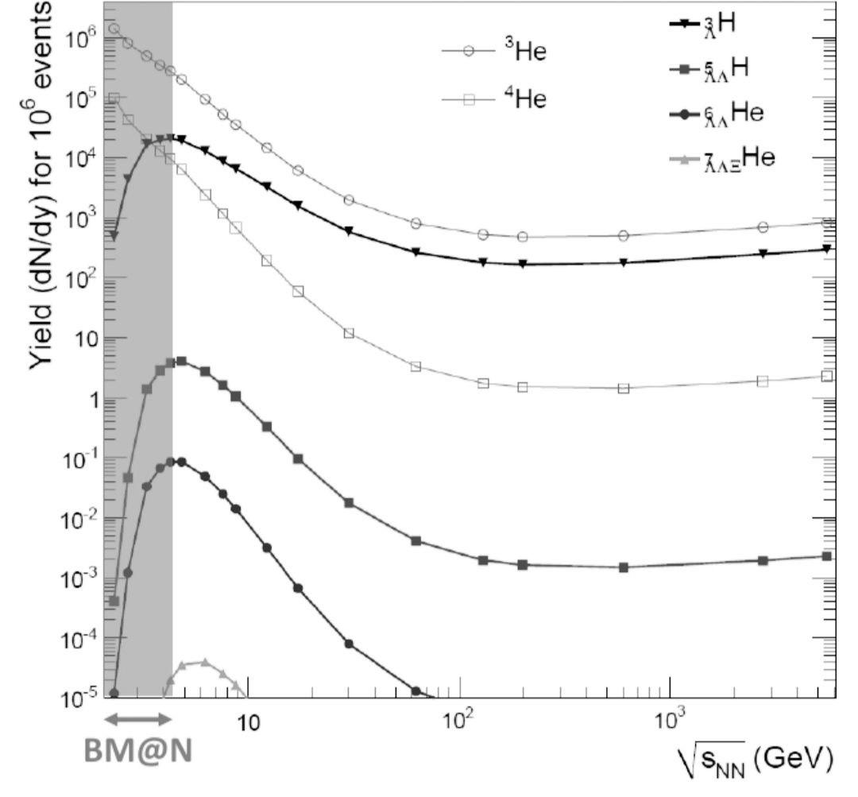
Figure 1 - Yields of different hypernuclei predicted by the thermal model [1]

The Joint Institute for Nuclear Research (Dubna) is finalizing the construction of the NICA (Nuclotron-based Ion Collider fAcility) [2] complex aimed at studying the properties of dense baryonic matter. One of the key experimental facilities, the spectrometer BM@N (Baryonic Matter at Nuclotron), is already operating at the complex. The BM@N is a fixed target experiment designed to study nucleus-nucleus interactions using light (d,C), medium (Ar,Kr) and heavy (Xe,Bi) relativistic ions [3].
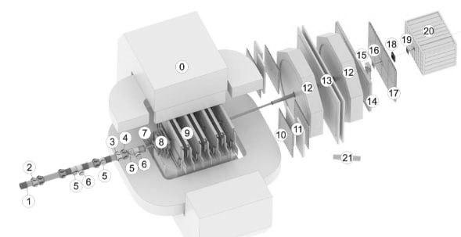
Figure 2 - Scheme of the BM@N setup in the 2023 Xe run

The experiment has had 8 experimental runs at the Nuclotron from 2015 to 2023. The last run was in 2022-2023 using 3.8 GeV/nucleon Xe beam and a CsI target.
The setup used in this 2023 Xe run is presented in Figure 2. In addition to analyzing magnet (0) and the vacuum beam transport line (1), main subsystems of the spectrometer included: beam ion trigger and tracking detectors (2-6,15,18,19); the target station and trigger multiplicity detector (7); the central tracking system, placed inside the analyzing magnet and consisting of silicon (8) and GEM (9) detectors; the outer tracking system which combines two drift chambers (12) and a set of cathode strip chambers (10,14); time-of-flight systems (10,13); and forward scintillation wall (17) and hadron calorimeter (20).
Detector subsystems used for the current hypernuclear studies include the central and outer tracking systems as well as the time-of-flight detectors.

DATA PREPARATION
The simulation, reconstruction, and data analysis work was performed in the BmnRoot environment [4]. A detailed realistic geometry of the experimental setup was used for simulation. At the first stage, the events of a Xe+CsI collision were simulated by the DCM-SMM model [5]. In collisions of heavy ions, hypernuclei are born quite rarely, so it became necessary to model 10⁵ events, each of which has an artificially added hypernucleus.
Tracks were reconstructed using the standard tools of the BmnRoot package based on the Kalman filter [6].
The simplest hypernuclei studied in this work are _{Λ}³H (consisting of one proton, one neutron, and one Λ-hyperon) and _{Λ}⁴H (consisting of one proton, two neutrons, and one Λ-hyperon). For each of these hypernuclei there are several possible decay modes, but in current study for both hypernuclei only two-body π⁻ decays were considered:
_{Λ}³H ³He
_{Λ}⁴H ⁴He
The final step of the data preparation procedure is the creation of candidate pairs of hypernuclear decay products. Among the reconstructed tracks, the macro selects pairs of positive and negative particles, where all negative particles are considered as pions, and helium is identified by mass using the time-of-flight detector system. Selection is then performed by applying cuts on particle momenta, on position of the decay vertex, and on other kinematic parameters of the decay topology (see Figure 3).
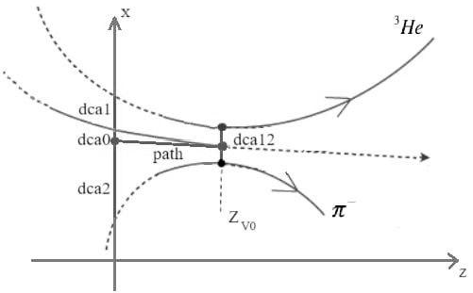
Figure 3- Schematic view of the _{Λ}³H decay with kinematic parameters used for optimization of the reconstruction.

For selected pairs, ³He or ⁴He, invariant mass spectra are obtained in the region of _{Λ}³H or _{Λ}⁴H mass. Entries from decays of hypernuclei can be distinguished in these spectra as peaks apparent above the combinatorial background.

In order to suppress the combinatorial background resulting from the large number of falsely selected pairs, the cuts applied to the following parameters of the decay scheme were optimized:
- dca12 - the minimum distance between the trajectories of two particles from the pair under consideration,
- dca1 - distance from the primary vertex to the trajectory of the positive particle in XY plane (target plane),
- dca2 – distance in the target plane from the primary vertex to the trajectory of the negative particle,
- path - distance from the primary vertex to the decay point V₀,
- dca0 - distance in the target plane from the primary vertex to a fragment trajectory propagated from the decay point to the target assuming fragment momentum equal to the total momentum of the selected pair.
The parameters dca2 and dca12 are considered in χ²-space, i.e. after normalization by the corresponding parameter errors.
Together with these parameters, additional constraints were applied to the mass obtained for the positive particle in the pair, the momenta of positive and negative particles and the ratio of their momenta.

DATA ANALYSIS
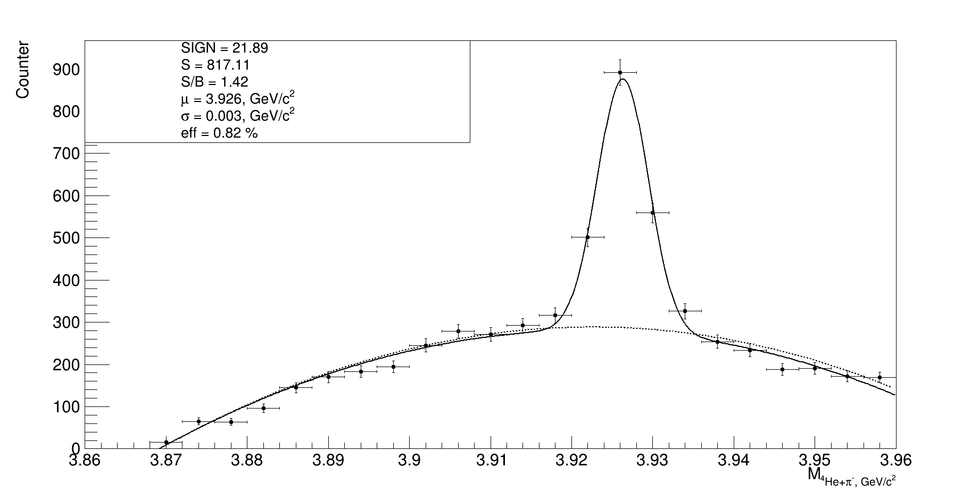
Figure 4 - ⁴He invariant mass distribution. Gaussian function was used to fit signal and polynomial function to fit background
Figures 4 and 5 show the distribution of the invariant mass for ⁴He + and ³He + pairs respectively, with the geometric constraints imposed on them. Cuts were optimized individually for decays of _{Λ}⁴H and _{Λ}³H, and the obtained peak values for the invariant mass, 3.926 GeV/c² and 2.992 GeV/c², respectively, are in good agreement with values of hypernuclei mass. Turning to the assessment of the quality of the obtained peak, first of all, it is necessary to evaluate the background and then to fit the distribution.
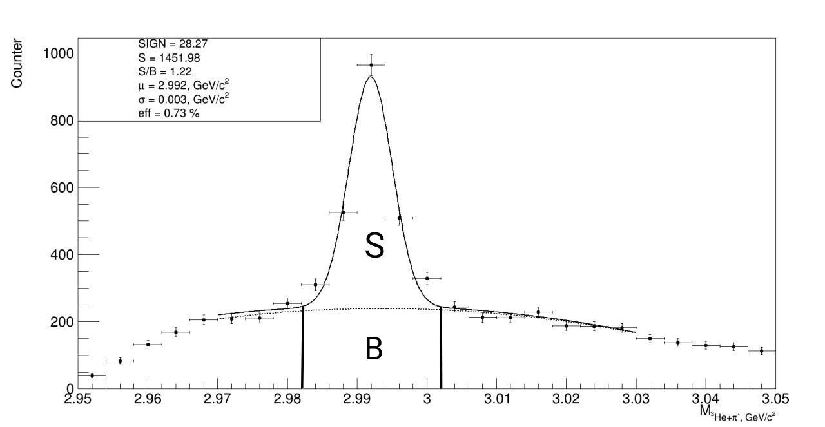
Figure 5 - ³He + invariant mass distribution. Gaussian function was used to fit signal and polynomial function to fit background
Figure 5 shows schematically the main parameters for the analysis: signal (S) corresponds to the area under the plot in range around the center of the peak above the background; background (B) corresponds to the area under the plot in the same range without the signal peak. The algorithm for finding the best geometric constraints was based on combinatorial search in the space of all constraints. Significance maximization (sign) was chosen as a quality criterion: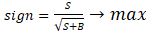

EFFICIENCY
After obtaining a signal, which was stable with respect to variation of cuts, the distribution of the reconstructed hypernuclei in transverse momentum p_{T} and rapidity y space was examined and the hypernuclei decay reconstruction efficiency in (p_{T}, y) space was evaluated (Fig.6).

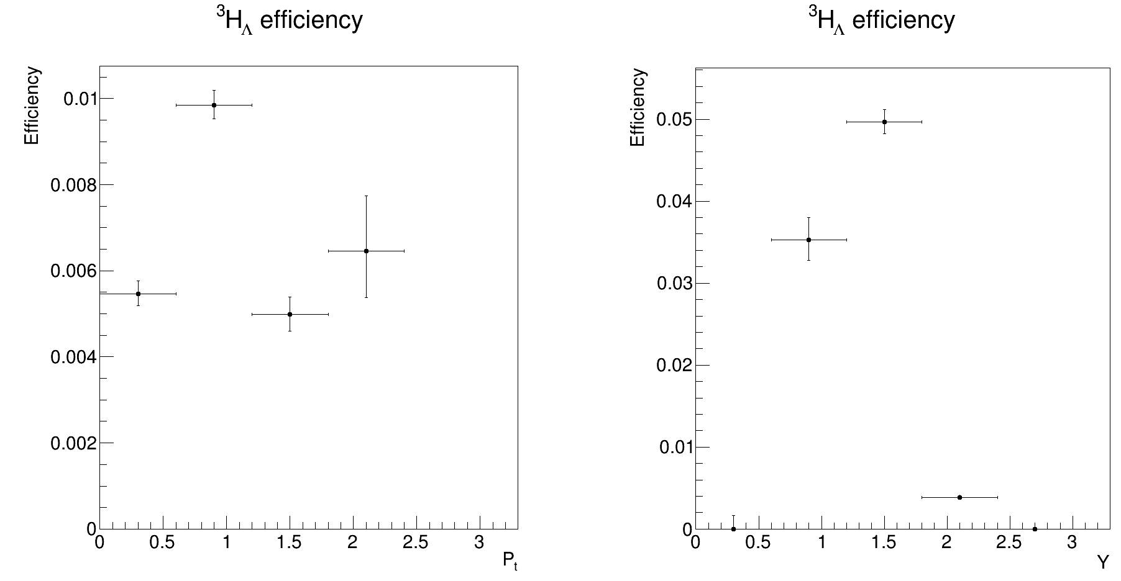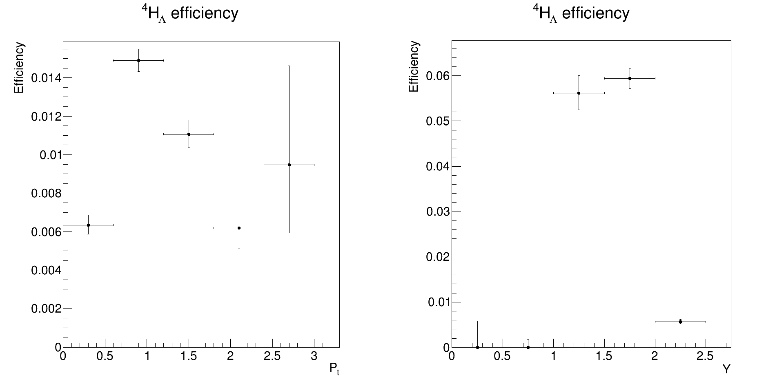
Figure 6 - Efficiency distributions by transverse momentum and rapidity for _{Λ}³H and _{Λ}⁴H

These plots were obtained by dividing the distributions of the reconstructed data by the distribution of the simulated data. The estimation of the hypernuclei reconstruction efficiency is necessary to obtain their production cross-sections in the subsequent processing of experimental data.
eff=S/N_{sim} (S - signal, N_{sim}- number of simulated hypernuclei)

CONCLUSION AND OUTLOOK
Summarizing, an algorithm, which allows suppression of the combinatorial background in the reconstruction of decays of light hypernuclei, was developed and optimized. The efficiency of hypernucleus reconstruction is evaluated. The developed algorithm for reconstruction and efficiency estimation allows us to investigate potential measurement of hypernuclei lifetimes.
In future work, we plan to increase statistics of the simulated data in order to improve estimates of the reconstruction efficiency. In addition, we plan to study precision of lifetime measurements, to analyze three-particle decay channels, and apply the reconstruction procedure and efficiency corrections to the experimental data.

REFERENCES
- A. Andronic et al., Phys. Lett. B 695, 203 (2011)
- V.D. Kekelidze, NICA project at JINR: status and prospects, 2017 JINST 12 C06012
- The BM@N Collaboration, The BM@N spectrometer at the NICA accelerator complex, Nuclear Instruments and Methods in Physics Research Section A: Accelerators, Spectrometers, Detectors and Associated Equipment, Volume 1065, 169532 (2024)
- P.Batyuk et al., The BmnRoot framework for experimental data processing in the BM@N experiment at NICA, EPJ Web of Conferences, 214, 05027 (2019)
- Baznat, M., Botvina, A., Musulmanbekov, G., Toneev, V., & Zhezher, V. (2020). Monte-Carlo Generator of Heavy Ion Collisions DCM-SMM. Physics of Particles and Nuclei Letters, 17(3), 303–324. doi:10.1134/s1547477120030024
- D.Zinchenko et al., Vector Finder — A Toolkit for Track Finding in the MPD Experiment. Phys. Part. Nuclei Lett. 18, 107–114 (2021)

