Correlation analysis of beta/gamma-cytoplasmic actins distribution in functionally active endothelial cells
- S. Shakhov^{a,} *, A. S. Churkinaª, I. B. Alievaª
ªA.N. Belozersky Institute of Physical and Chemical Biology, Lomonosov Moscow State University, 119992 Moscow, Russia
e-mail: antshakhov@gmail.com
Received November 22, 2024
Actin is one of the most abundant proteins, it presents in a living cell in different isoforms depending on the cell type. β-actin (β-Cya) and γ-actin (γ-Cya) are cytoplasmic actin isoforms in non-muscle mammalian cells and their spatial arrangement provides their divers roles in cellular functions. In this work, we used 3D-SIM-microscopy to investigate for the first time β/γ-Cya colocalization in endothelial cells (EC), essential for EC barrier function implementation. We demonstrated β/γ-Cya partial colocalization in certain regions of EC cytoplasm, varies widely between different parts of the marginal regions and near the cell nucleus. In the basal cytoplasm, β-Cya predominates, while the ratio of isoforms evens out as it moves to the apical cytoplasm. Thus, colocalization analysis suggests that β- and γ-Cya are segregated in the endotheliocyte cytoplasm. This segregation is greatly enhanced during EC activation in experiments, modeling endothelial barrier dysfunction in vitro, demonstrating different roles of β/γ-actins in the EC functional activity.

Introduction
Actin structures are found in all cells of a living organism and are involved in maintaining and changing the cell shape, exocytosis and endocytosis, cell adhesion to substratum and cell movement, and signal transduction. Despite minor differences in the amino acid sequence, β- and γ-Cya localize in different cell structures and perform different functions. While cytoplasmic β-Cya is involved in many intracellular processes including cell contraction, γ-Cya is responsible for cell mobility and promotes tumor transformation. Numerous studies demonstrate that β- and γ-Cya are spatially separated in the cytoplasm of fibroblasts and epithelial cells; this separation is functionally determined.
EC line the inner surface of vessels, are form tight contacts with each other thus performing a specific barrier function. The actin skeleton is directly involved in the realization of this function, the interaction and functional activity of actin structures is principle for the normal EC function, as well as for normal and tumor angiogenesis. Some authors suggest that β- and γ-Cya are not spatially separated in EC, i.e., they are colocalized [1]. Other authors suggest that β - and γ-Cya are segregated in the volume of the cell in accordance with their functional differences [2, 3], which, in fact, makes the question more fundamental than it might seem, since the activity of actin cytoskeleton determines normal endothelial barrier function. A possible reason for the authors disagreement may also be purely methodological. Most studies of the cytoskeleton of EC were performed by confocal microscopy, which gives good resolution in XY, but not in the Z-axis. The aim of this work was to analyze the degree of colocalization of the β- and γ-actin systems in various areas of the EC. For the study and analysis of the preparations, we used one of the super resolution microscopy methods - Structured Illumination Microscopy (3D-SIM), which allows us to reconstruct the entire volume of the cell with a high resolution, not only along the XY axis, but also along the Z-axis.

Materials and Methods

Cell Cultures and Treatment
Human pulmonary artery endothelial cells (HPAEC) and vein endothelial cells culture (EA.hy926) obtained from Clonetics BioWhittaker Inc. company (USA) were used for analysis. HPAEC were and were cultivated as described earlier [4,5]. For modeling of endothelial barrier disruption EC were stimulated with 0,01 µM nocodazole (Sigma) [5].

Immunofluorescence
For immunolabeling actin isoforms, cells were grown on glass coverslips and fixed in 1% paraformaldehyde solution (Sigma, United States) in DMEM medium with HEPES buffer for 15 min, then rinsed with PBS and fixed for an additional 5 min with methanol at -20°C. Before fixation, separate coverslips were incubated with nocodazole at a concentration of 0.01 μM for 30 minutes at 37 °C and 5% CO₂. Actin filaments were stained with murine monoclonal antibodies against cytoplasmic β- or γ-actin isoforms [2]. Anti-mouse antibodies conjugated with fluorescent dyes Alexa 488 and Alexa 561 (Molecular Probes, USA) were used as secondary antibodies. The samples were embedded in Moviol and examined using an N-SIM microscopic system (Nikon) with an immersion objective 100x / 1.49 NA, excitation laser wave-lengths of 488 nm and 561 nm. Image stacks (with a z-axis step of 0.12 μm) were ac-quired with an EMCCD camera (iXon 897, Andor, effective pixel size 60 nm) in the 3D-SIM mode. Serial optical sections of the same cell, taken in the wide field mode, were processed using the AutoQuant blind deconvolution algorithm. Image acquisition and SIM reconstruction were performed using the NIS-Elements 4.2 software (Nikon).

Correlation analysis of cytoplasmic actin isoforms distribution
Colocalization analysis of both widefield and SIM images was performed using the Coloc2 plugin of the ImageJ 1.53 software. For the correlation analysis, circular ROIs (regions of interest) of 2 µm diameter were selected in individual optical slices. As a preliminary work, the background was subtracted before ROI was taken. ROIs were located along a line running from the center of the cell to its edge, as well as in the edge areas of the cell. For measurements in the marginal zones of the cell, we selected ROIs located in functionally different areas—in a stable or active edge. For each ROI, colocalization analysis was performed in three consecutive optical sections, where thresholded Manders’ (tM) coefficients were calculated with automatic threshold settings defined by Costes regression approach. For the analysis, an optical section was selected located in the central part of the cell (due to the fact that the EC has a thin lamella of about 0,5 µm in thickness), usually it was 3-4 sections in a series. Then we analyzed two adjacent optical sections, lying above and below it. To find out whether β- and γ-Cya structures are colocalized in a given area, the Coloc2 plugin used the function of calculating the Manders’ coefficients M1 and M2 (i.e., for two channels separately). For the purposes of this work, the modified coefficients tM1 and tM2 (threshold Manders’) were calculated in selected analyzed areas of the cell.

Results and discussion
Analysis of literature sources showed that the most widely used methods of correlation analysis are the Pearson correlation coefficient (PCC) and the Manders’ coefficients – Manders’ overlap coefficient (MOC) and Manders’ correlation coefficient (MCC, we used in our investigation). Both the PCC and Manders’ coefficients are used to quantify the colocalization degree between fluorophores, and the advantages of one over the other are actively debated [6]. Historically, the MOC was introduced to overcome perceived problems with the PCC. The two coefficients are mathematically similar, differing in the use of either the absolute intensities (MOC) or the deviation from the mean (PCC). Both coefficients are independent of gain. We used 3D-SIM images. The analysis was performed discretely - for different sections of the cell within the same optical section, as well as in the volume of the cell - for different optical sections of one section of the cell. The degree of colocalization of-actin β/γ-Cya structures in the analyzed area of the cell was judged on the basis of calculating the MCC [7], which is proportional to the amount of fluorescence of colocalizing pixels in each channel.
For quantification of β/γ-Cya colocalization, we used immunostaining with highly specific monoclonal antibodies [2]. The approach makes it possible to clearly differentiate the distribution of cytoplasmic β/γ-Cya in the cytoplasm of artery and vein EC. When analyzing the whole z-stack, it was found that β-Cya is predominantly present in the basal part of the cell, and both β- and γ-actin structures are present in other parts of the cell, i.e., actin isoforms are unevenly distributed in the cell volume (Figure 1).
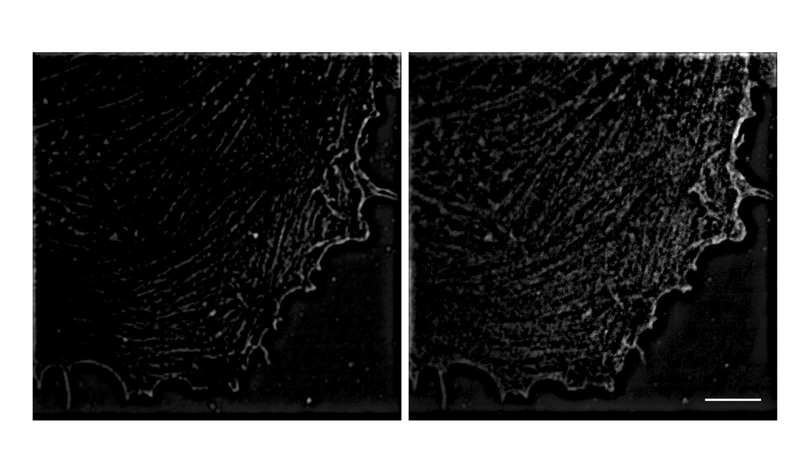
- Immunofluorescent staining of β- (left) and γ-Cya structures (right) in the basal region of HPAEC. Scale bar 10 µm.
In a total (after the addition of the optical layers) colocalization analysis, the β- and γ-Cya structures can look almost completely colocalized in the volume of the entire cell. However, a more thorough, layer-by-layer analysis of the colocalization of β- and γ-Cya structures in specific local areas of the cell showed that this impression does not correspond to reality. It turned out that the colocalization coefficients can differ significantly not only in the neighboring areas of the EC lamella, but also at different depths within the selected area (i.e., on different optical sections). In fact, β/γ-Cya structures spatially separated in the cytoplasm of HPAEC cells. In order to evaluate statistical differences, we performed calculations of the average colocalization coefficients in the region of the cell lamella and in the region adjacent to the cell nucleus. We compared two groups of ROI in these different cell areas. The average Manders’ (tM1=0,551±0,045) coefficient in ROI that are located close to the nucleus was statistically higher (P=0,003) than in ROI of the free lamella (tM1=0,319±0,041) (Figure 2A). We also analyzed the system of actin filaments in EA.hy926 cell lines. The analysis covered the marginal regions of the cell: the free lamella and the area of contact with the neighboring cell. In EA.hy926 cells, the MCC varied in a wide range. The highest values were observed in border areas, in places of contact with a neighboring cell, but located near areas with a free edge. In the free edge of the cell the isoform colocalization coefficient varied significantly: in some regions of interest, the MCC changed dramatically depending on the optical layer. This may be explained by the presence of cellular protrusions in these areas. In the areas of contact, the result was more constant for a specific area, but varied significantly from one region of interest to another, which may indicate the maturity of cellular contact in a certain area.
Since the coefficient of colocalization of actin isoforms varied most significantly at the free edge of the cell, we investigated whether the β/γ-Cya structure localization in this cytoplasm region of ECs may be changed under conditions other than normal, the depolymerization of EC peripheral microtubules is a trigger for the development of barrier dysfunction. We previously developed the in vitro models with nocodazole-compromised endothelium [5], so in the present work we used nocodazole at minimal concentration that causes the development of reversible barrier dysfunction in EA.hy926 cells monolayer. In EA.hy926 cells treated by nocodazole (0,01 µM), the average colocalization coefficient of the two isoforms was lower than in control (intact) cells (Figure 2B). We compared two groups of ROIs in cells marginal region. The average MCC (tM1=0,241±0,030) coefficient in ROIs of cells, which undergo nocodazole treatment, was lower than in intact cells (tM1=0,505±0,034). The difference in the median values between the two groups was greater than would be expected by chance (statistically significant difference, P = <0,001).
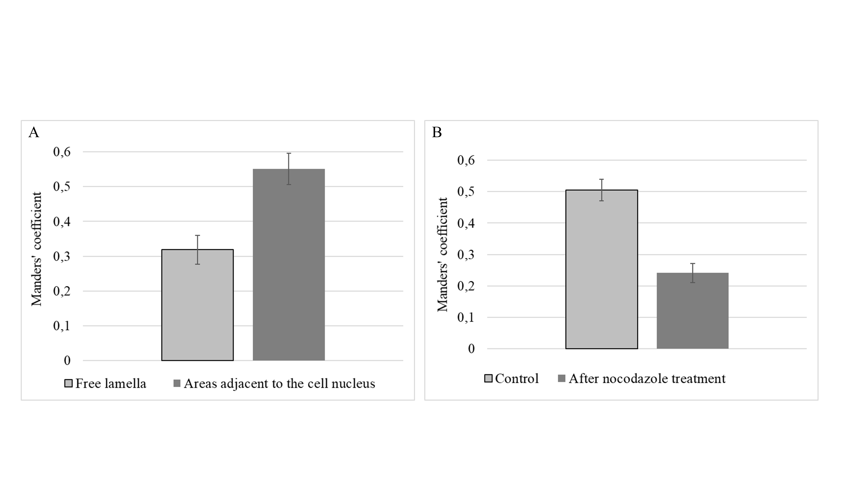
- A. MCCs were calculated for β/γ-Cya structures colocalization analysis in the zone of free lamellae and areas adjacent to the cell nucleus of HPAEC. B. MCCs were calculated for β-/γ-Cya structures colocalization analysis in EA.hy926 cells without and after nocodazole treatment.

Conclusions
The results of this work have convincingly demonstrated that β- and γ-Cya structures are colocalized in EC only partially, in certain areas of the endothelial cytoplasm. The degree of β/γ-Cya colocalization varies depending on the selected area of the cell—there are areas with both a low degree of colocalization and a high one.
Disturbances in EC barrier regulation are critically dependent upon rearrangements of EC actin cytoskeleton. The functional assay we under-took using the experimentally-induced EC barrier dysfunction allowed to demonstrate significant growth of β/γ-Сya segregation accompanying cell lamella activation.
CONFLICT OF INTEREST
The authors of this work declare that they have no conflicts of interest.

ETHICS APPROVAL AND CONSENT TO PARTICIPATE
This work does not contain any studies involving human and animal subjects.
AUTHOR CONTRIBUTIONS
Conceptualization, I.A.; methodology, I.A. and A.S.; software, A.S.; validation, I.A. and A.S.; formal analysis, A.S.; investigation, A.S., A.C. and I.A.; resources, I.A.; data curation, A.S. and A.C.; writing—original draft preparation, A.S. and I.A.; writing—review and editing, I.A., A.S and A.C.; visualization, A.S.; supervision, I.A.; project administration, I.A.; funding acquisition, I.A.
ACKNOWLEDGMENTS
The study was conducted under the state assignment of Lomonosov Moscow State University. The authors thank the Moscow University Development Program (MSU Development Program PNR 5.13) and Nikon Center of Excellence at A.N. Belozersky Institute of Physical and Chemical Biology for providing research infrastructure.

REFERENCES
- Pasquier, E., Tuset, M.-P., Sinnappan, S., Carnell, M., Macmillan, A., Kavallaris, M. γ-Actin plays a key role in endothelial cell motility and neovessel maintenance// Vasc. Cell 2015. V. 7. P.2.
- Dugina, V., Zwaenepoel, I., Gabbiani, G., Clement, S., Chaponnier, C. β- and γ-cytoplasmic actins display distinct distribution and functional diversity// J. Cell Sci. 2009, V.122. P. 2980–2988.
- Latham, S.L., Chaponnier, C., Dugina, V., Couraud, P.-O., Grau, G.E.R., Combes, V. Cooperation between β- and γ-cytoplasmic actins in the mechanical regulation of endothelial microparticle formation //FASEB J. 2013. V. 27. P. 672–83.
- Shakhov, A.S., Dugina, V.B. and Alieva, I.B. Reorganization of actin and microtubule systems in human vein endothelial cells during intercellular contact formation // Cell Tissue Biol. 2015, V.9. P. 299–309.
- Alieva, I.B., Zemskov, E.A., Smurova, K.M., Kaverina, I.N., Verin, A.D. The leading role of microtubules in endothelial barrier dysfunction: Disassembly of peripheral microtubules leaves behind the cytoskeletal reorganization// J. Cell. Biochem. 2013, V. 114. P. 2258–2272.
- Adler, J. and Parmryd, I. Quantifying colocalization by correlation: The pearson correlation coefficient is superior to the Mander’s overlap coefficient // Cytom. Part A. 2010, V. 77, P. 733–742.
- Manders, E.M.M., Verbeek, F.J. and Aten, J.A. Measurement of co-localization of objects in dual-colour confocal images// J. Microsc. 1993. V. 169. P. 375–382.

