**SAXS CURVES PREDICTION FOR HUMAN TRANSGLUTAMINASES**

A.V. Alexandrova1, S.D. Ivashchenko1,2, A.V. Vlasov*1,2,3

1Research Center for Molecular Mechanisms of Aging and Age-Related Diseases, Moscow Institute of Physics and Technology, 141701 Dolgoprudny, Russia

2Laboratory of Microbiology, BIOTECH University, 125080 Moscow, Russia

3Joint institute for nuclear research, 141980 Dubna, Russia

e-mail: vavplanet@mail.ru

**Abstract** - Transglutaminases (TGs) are a unique group of enzymes that facilitate the post-translational modification of proteins by forming isopeptide bonds. Understanding that diverse processes such as normal and cancerous cell growth, reproduction, and cell death rely on sufficient levels of transglutaminases and that these enzymes can influence the differentiation and proliferation of various cell types has led many researchers to explore these intriguing molecules. Additionally, transglutaminases play a role in several diseases, including celiac disease and neurological disorders. In mammals, nine distinct isoenzymes of TGs have been identified at the genomic level. However, only a limited number of proteins possess reliable structures for future studies, while most have only partial structures.

We have predicted open and closed conformations of TG1, TG3, TG4, TG5, TG6, TG7 using AlphaFold and have calculated theoretical SAXS curves for each model using CRYSOL software. Moreover, we demonstrated the ability to distinguish open and closed conformation of TG1 using SAXS.

**INTRODUCTION**

Transglutaminases (TGs) are found across the phyla including microorganisms, plants, invertebrates, and vertebrates. In mammals, nine genes constitute the TG enzyme family, of which eight encode for active enzymes: TG1 to TG7 and Factor XIII-A (FXIII-A). TGases are widely distributed, and each isozyme is involved in multiple biological processes (Table 1). The active enzymes of the TGase family are responsible for the formation of Nε-(γ-glutamyl)-lysine crosslinking between glutamine and lysine residues in Ca2+-dependent posttranslational modification [1]. Besides the crosslinking activity, TGases catalyze the polyamidation and deamidation of γ-carboxamide groups of a protein/polypeptide glutaminyl residue (Fig.1).

The protein structure of TGs includes an N-terminal β-sandwich domain, catalytic and regulatory core domain, and two C-terminal β-barrels.[2,3] Upon activation, TGs undergo conformational change where the two β-barrels extend out opening the structure. This change is triggered by stimuli such as Ca2+-ion binding to the enzyme and redox conditions [4]. In the case of TG2, GTP binding to its structure maintains the enzyme in closed conformation and is thus inactive [5,6]. For other proteins of the TGase family, it is known that they obtain several conformations, which alter the functions of each protein; however, there is no structural data on the topic.

Transglutaminases play a role in several diseases, including celiac disease, renal fibrosis and neurological disorders such as Alzheimer’s disease. For the proper selection and development of substrates-based peptide drugs, it is essential to know the exact structures of each type of transglutaminase. Understanding the differences in the structure of active sites and the characteristics of TGs will enable the production of highly specific substrates for each type of protein from the TG family. Currently, there are no fully resolved structures of the active open and inactive closed conformations of all TGs. According to Ivashchenko S. et al. [7], a fully resolved open conformation of TG2 has been obtained using the AlphaFold-based structure prediction. For other types of TGs, there are no such predicted structures, and ProteinDataBank contains only partially resolved structures which have been obtained using X-ray diffraction.

**Figure 1**. A: Calcium ions activate TGs, facilitate the transition between closed and open conformations. B: Catalytic reactions of TGs’ open conformations. TGs can modify specific glutamine residues of proteins in 3 different ways; 1) glutamine residues can be cross linked to lysine residues to form γ-glutamyl-ε-lysine isopeptide bonds. This reaction creates protein polymers and networks. 2) glutamine residues can be cross linked to primary amines. This is frequently used as an approach to identify substrates, i.e., primary amine is labeled with biotin, and 3) when reaction occurs in the absence of lysine in aqueous environment, glutamine residue can be deaminated to a glutamic acid.

In the current research, we have obtained fully resolved models for TG1, TG3, TG4, TG5, TG6, TG7 for the first time using AlphaFold predictions. To understand whether it is possible to distinguish between different conformations and TGs, we calculated theoretical SAXS curves for each model using CRYSOL.

**Table 1**. Catalytically active members of the mammalian TGase family

|  |  |  |
| --- | --- | --- |
| TGs | Tissue distribution | Biological function |
| TG1 | Epithelia | Barrier function in epithelia |
| TG2 | Ubiquitous | Cell death, survival signal, cell adhesion, fibrosis |
| TG3 | Epidermis, hair follicle | Terminal differentiation of keratinocytes, hair follicles |
| TG4 | Prostate gland | Semen coagulation (rodents) |
| TG5 | Foreskin keratinocytes, female reproductive tissues, skeletal muscle | Epidermal differentiation |
| TG6 | Epidermis, testis, brain | Formation of epidermis and hear follicle, neuronal development |
| TG7 | Testis, kidney | Unknown |
| FXIII | Plasma, brain, bone | Blood clotting, bone growth |

**RESULTS**

To understand whether we can distinguish between open and closed conformations of each transglutaminase, we applied CRYSOL modeling and Alphafold software. CRYSOL is a program for evaluating the solution scattering from macromolecules with known atomic structure and possibly fitting it to experimental scattering curves from Small-Angle X-ray Scattering (SAXS) and Alphafold was used to predict models of the proteins. According to the data obtained, we are able to distinguish between open and closed conformations for TG1 (Fig.2A). For other types of TGs, it will be quite challenging to predict differences between open and closed states (Fig.2B, C). We also verified whether TGases’ open and closed conformations are distinguishable within the group of proteins. The comparison of open conformations of TG1 and TG4 is shown in Fig. 2G. According to charts (Fig.2D-2I), we concluded that it is difficult to distinguish the open conformation of TG1 from that of TG4, as well as for all other TGs. The results highlight the high conservativity of domains among different representatives of the transglutaminase family.

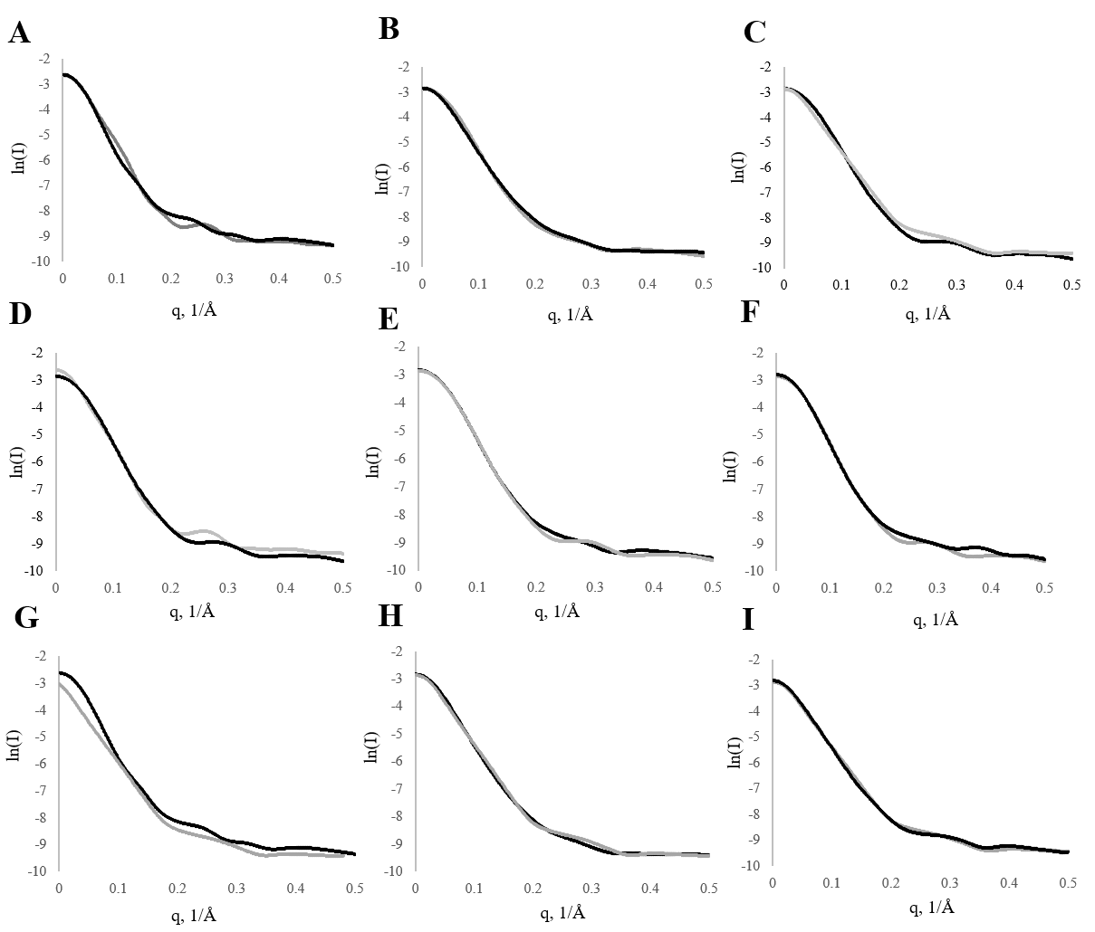**Figure 2.** Theoretical SAXS curves (CRYSOL). A - comparison of the open (black) and closed (grey) conformations of TG1, B - comparison of the open conformation of TG3 (black) and the closed conformation of TG3 (grey), C –TG6 closed (black) and TG6 open (grey), D - TG4 closed (black) and TG1 closed (grey), E - TG3 closed (black) and TG4 closed (grey), F - TG5 closed (black) and TG4 closed (grey), G - TG1 open (black) and TG4 open (grey), H – TG4 open (black) and TG6 open (grey), I – TG4 open (black) and TG5 open (grey).

The X-axis represents the scattering angle vector - q, and the Y-axis represents the natural logarithm of the scattering intensity.

**CONCLUSION**

We constructed theoretical SAXS curves for each model of TGs using CRYSOL and Alphafold software. According to the obtained data, TG1 conformations can be distinguished using SAXS; however, for other transglutaminases the conformations are indistinguishable by SAXS technique. Therefore, SAXS method could be used for the validation of TG1-selective inhibitors, underlying the importance of the study for drug development. Moreover, a combination of the native PAGE protein separation and SAXS could be used to distinguish between TGase proteins and conformations in the future studies.

# **Funding**

The study was supported by the Ministry of Science and Higher Education of the RF, project FSMF-2023-0010.

**REFERENCES**

1. *Kiyotaka Hitomi , Soichi Kojima Laszlo Fesus Editors* Transglutaminases Multiple Functional Modifi Ers and Targets for New Drug Discovery;

2. *Tatsukawa H., Takeuchi T., Shinoda Y., Hitomi K*., Identification and Characterization of Substrates Crosslinked by Transglutaminases in Liver and Kidney Fibrosis. Anal Biochem 2020, 604.

3. *Soltani F., Kaartinen M.T*., Transglutaminases in Fibrosis-Overview and Recent Advances. Am J Physiol Cell Physiol 2023, 325, C885–C894.

4. *Sottrup-Jensen L., Hansen H.F., Pedersen H.S., Kristensen L*., Localization of Epsilon-Lysyl-Gamma-Glutamyl Cross-Links in Five Human Alpha 2-Macroglobulin-Proteinase Complexes. Nature of the High Molecular Weight Cross-Linked Products. Journal of Biological Chemistry 1990, 265, 17727–17737, doi:10.1016/S0021-9258(18)38224-3.

5. *Gupta S., Biswas A., Akhter M.S., Krettler C., Reinhart C., Dodt J., Reuter A., Philippou H., Ivaskevicius V., Oldenburg J.,* Revisiting the Mechanism of Coagulation Factor XIII Activation and Regulation from a Structure/Functional Perspective. Sci Rep 2016, 6.

6. *Steinert P.M., Chung S.-I., Kim S.-Y*., Inactive Zymogen and Highly Active Proteolytically Processed Membrane-Bound Forms of the Transglutaminase 1 Enzyme in Human Epidermal Keratinocytes; 1996;

7. *Ivashchenko S.D., Shulga D.A., Ivashchenko V.D., Zinovev E. V., Vlasov A. V.* In Silico Studies of the Open Form of Human Tissue Transglutaminase. Sci Rep **2024**, 14.