Rules for submission of manuscripts

Правила подачи рукописей

I. Ivanova,b, P. Petrovb,[1], S. Sidorova

И.И. Ивановa,b, П.П. Петровb,1 , С.С. Сидоровa

*a* Joint Institute for Nuclear Research, Dubna, Russia

*a* Объединенный институт ядерных исследований, Дубна, Россия

*b* Georgian Technical University, Tbilisi, Georgia

*b* Грузинский технический университет, Тбилиси, Грузия

This is an English-language abstract. The abstract should contain the description of the topic considered in the paper, the aim of the work and its main results. The abstract is recommended not to exceed 8 lines.

Аннотация на русском языке. Аннотация включает характеристику основной темы, цели работы и ее результаты. Аннотация должна быть краткой, 5–8 строк.

INTRODUCTION

The “PEPAN Letters” journal accepts and publishes manuscripts submitted in Russian or English. All papers are subject to refereeing. Authors should make a careful survey of the literature to ensure that papers do not duplicate previous work and that relevant existing knowledge has been taken into account. By submitting a paper for publication in PEPAN Letters the authors imply that the material has not been published previously nor has been submitted for publication elsewhere.

Authors should provide the following documents in zipped directory.

1. Files of manuscript LaTex-2e + PDF or Word + PDF formats (personal macro-commands are not allowed).
2. Figures as separate files.
3. The copyright agreement.

PAPER PREPARATION

A manuscript should contain the text in the LaTeX or Word formats and files of figures. All pages should be numbered, and the manuscript must include all necessary elements of the paper. The first page of the manuscript should include the title of the paper, the initials, surnames and affiliations of all the authors followed by the short abstract. At least one of the authors should provide an e-mail address for correspondence. The pages, equations, figures and tables of the paper should be sequentially enumerated.

In formulas, all roman letters denoting physical quantities should be italicized (*E*, *V*, *m*, etc.). Vectors must be in bold type without arrows over the letters (**a**, **b**, **c**). Similarity numbers (Ar, Re), functions (sin, arcsin, sinh), conventional mathematical abbreviations (max, min, opt, const, idem, lim, log, ln, det, exp), chemical elements (Cl, Fe) should be in roman type. With the exception of abbreviations including those of surnames, which must be in roman type, letters in sub- and superscripts should be in lowercase italics (*fabc*). Example of formula:

${\left(x+a\right)}^{n}=\sum_{k=0}^{n}{\left({n \atop k}\right)x^{k}a^{n-k}}$. (1)

This is binomial where x and a are numbers.

Figures (see Fig. 1–2) must be clearly readable and of good quality. It is desirable to submit each figure in the form of an individual file in the Encapsulated PostScript format (*.eps) or in the Portable Document Format (*.pdf). Raster artwork should be at least 300 dpi at 100% (Full print size). If a color figure is submitted, please, make sure to upload in addition a usable black and white version required to correctly reproduce the artwork in print. All figures should be of the same size. The maximal width is 11,5 cm, the maximal height is 17,5 cm (including the caption). The width of small figures should not be less than 6 cm (see Fig. 3). All legends are recommended to be noted by Arabic numerals or Latin letters on the figure and be explained in detail in the caption.

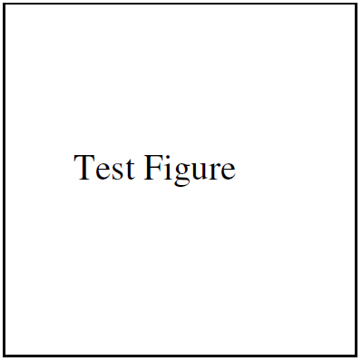

Fig. 1. Figure caption

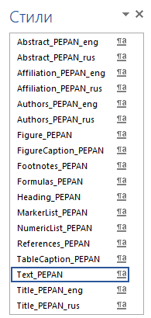

Fig. 2. Figure caption



Fig. 3. Figure caption

Figures and tables should be numbered, and the text of the paper should contain corresponding references to them (see Table 1). Figures and tables should have informative captions which allow one to understand their meaning without referencing the main text of the paper.

Table 1. Table caption

|  |  |  |  |
| --- | --- | --- | --- |
| **ColumnName1** | **ColumnName1** | **ColumnName1** | **ColumnName1** |
| Raw1-value1 | Raw1-value2 | Raw1-value3 | Raw1-value4 |
| Raw2-value1 | Raw2-value2 | Raw2-value3 | Raw2-value4 |

Cited references must be given in a general list at the end of a manuscript and should be numbered by the consecutive numerals as they are mentioned in the main text. The list of references must have the heading REFERENCES. All references should include full list of authors with only exception being collaboration papers. It is not permissible to cite unpublished works. Examples of references [1–8] are as follows. Examples of references to an electronic resource [9] are as follows.

CONCLUSIONS

Use the following styles for formatting the paper in Word and the file ‘PetternPEPAN_word’ (see Fig. 3):

* Title_PEPAN_eng and Title_PEPAN_rus for paper title in English and Russian language accordingly;
* Authors_PEPAN_eng and Authors_PEPAN_rus for last names and initials of all authors in English and Russian language accordingly;
* Affiliation_PEPAN_eng and Affiliation _PEPAN_rus for full names of institutes indicating affiliations of all authors in English and Russian language accordingly;
* Abstract_PEPAN_eng and Abstract_PEPAN_rus for the abstract in English and Russian language accordingly;
* Heading_PEPAN for section titles;
* Text_PEPAN for main text;
* Footnotes_PEPAN for footnotes;
* Formulas_PEPAN for formulas (formulae should be inserted in the form of Microsoft Office formulae);
* Figure_PEPAN for figures;
* FigureCaptpion_PEPAN for names of figures;
* TableCaptpion_PEPAN for names of tables;
* MarkerList_PEPAN and NumericList_PEPAN for lists;
* References_PEPAN for section REFERENCES.

REFERENCES

1. Silenko A.J. Electric and magnetic polarizabilities of pointlike spin-1/2 particles // Phys. Part. Nucl. Lett. — 2014. — V. 11, no. 6. — P. 720–721. — arXiv:1411.5911 [hep-th].
2. Bogolyubov N.N., Shirkov D.V. Quantum Fields. — Benjamin-Cummings Pub. Co, 1982.
3. Hanson C.W. Subject inquiries and literature searching // Handbook of special librarianship and information work / Ed. by W. Ashworth. — 1967. — P. 414–452.
4. Wright R.C. Report Literature // Special Materials in the Library / Ed. by J. Burkett, T. S. Morgan. — 1963. — P. 46–59.
5. Update on transversity and Collins functions from SIDIS and e+ e- data / M. Anselmino, M. Boglione, U. D’Alesio, A. Kotzinian, F. Murgia, Prokudin, S. Melis // Proceedings, Ringberg Workshop on New Trends in HERA Physics 2008. — V. 191. — 2009. — P. 98–107. — arXiv:0812.4366 [hep-ph].
6. Aad G. et al. [ATLAS Collaboration] Observation of a new particle in the search for the Standard Model Higgs boson with the ATLAS detector at the LHC // Phys. Lett.B. — 2012. — V. 716. — P. 1–29. — arXiv:1207.7214 [hep-ex].
7. Beda A.G. et al. [Gemma Collaboration] GEMMA experiment: Three years of the search for the neutrino magnetic moment // Phys. Part. Nucl. Lett. — 2010. — V. 7. — P. 406–409. — arXiv:0906.1926 [hep-ex].
8. Franceschini R., Giudice G.F., Kamenik J.F., McCullough M., Pomarol A., Rattazzi R., Redi M., Riva F., Strumia A., Torre R. What is the gamma gamma resonance at 750 GeV? — 2015. — arXiv:1512.04933.
9. Report on the World Health 2007 [Electronic resource] (In Russ.). Available at: http://www.who.int/whr/2007/whr07_ru.pdf (accessed 22.10.2014).

1. E-mail: second.author@email.ru