***Form of renewal for Project***

**APPROVED**

**JINR DIRECTOR**

**/**

**" " 202 г.**

**PROJECT PROPOSAL FORM**

**1. General information on the research project of the theme**

* 1. **Theme code** (for extended projects)

02-0-1066-2007/2029

* 1. **Project code** (for extended projects)

02-0-1066-2007/2029-1

* 1. **Laboratory**

Laboratory of High Energy Physics

* 1. **Scientific field**

Elementary Particle Physics and Relativistic Nuclear Physics

* 1. **Title of the project**

STAR experiment (JINR participation)

**1.6 Project leaders**

R. Lednický

Yu.A. Panebratsev

* 1. **Project deputy leader(s)**

A.A. Aparin

**2. Scientific case and project organization**

**2.1 Annotation**

The goal of the STAR project (JINR participation) is to study the properties of nuclear matter at extreme densities and temperatures, to search for signatures of quark deconfinement and possible phase transitions in heavy ion collisions over a wide energy range at the Relativistic Heavy Ion Collider (RHIC). The research program also includes the study of the structure functions of quarks and gluons in collisions of transversely and longitudinally polarized protons.

The STAR experiment is unique in its capabilities:

* the energy range in the collider mode $\sqrt{s_{NN}}$ = 7.7–200 GeV, and in the fixed target mode $\sqrt{s_{NN}}$ = 3.0–7.7 GeV;
* RHIC is an amazingly versatile machine, colliding *p*+*p*, *p*+Al, *p*+Au, *d*+Au, 3He+Au, O+O, Cu+Cu, Cu+Au, Zr+Zr, Ru+Ru, Au+Au, U+U;
* the possibility to perform experiments with longitudinally and transversely polarized protons at a maximum energy of 510 GeV;
* the possibility of particle reconstruction with light (*u*, *d*, *s*) and heavy (*c*, *b*) quarks, photons, leptons, lepton pairs, jets, light nuclei, antinuclei, hypernuclei and antihypernuclei as probes.

The main scientific tasks at this stage of the project and during its further implementation in 2025–2029 are:

* RHIC/STAR data analysis using the energy scan program in experiments in the collider mode and on a fixed target in the energy range from 3 to 200 GeV and obtaining statistically significant conclusions on the problem of searching for nuclear matter phase transitions of the first and second order and the possible existence of a QCD critical point for further research at the NICA/MPD accelerator complex.
* Performing the experimental program with transversely polarized protons at the energy of 510 GeV under the Cold QCD program. The new capabilities of the STAR facility after upgrade made possible to carry out measurements in the pseudo-rapidity range of –1.5 < ƞ <1.5 (mid-rapidity) and 2.8 < ƞ < 4.2 (forward rapidity). It corresponds to the range of the Bjorken variable 0.005 < *x* < 0.5. This gives the possibility to study the Sievers distributions, transversity, Collins fragmentation functions in previously inaccessible regions and expand the program for the analysis of the asymmetries of the production of *W*± and *Z*0 bosons.
* Implementation of an experimental program with heavy nuclei using the Hot QCD Physics program in the extended acceptance of the STAR facility in the region of high rapidity and increased luminosity of the RHIC collider.
* Investigation, within the framework of the Hot QCD Physics program, the microstructure of QGP in gold-gold collisions at the energy of 200 GeV to refine the QCD phase diagram and determine the properties of QGP at small scales.
* Further development and application for data analysis of the methods of correlation femtoscopy, developed at JINR for the systematic study of the space-temporal parameters of the production processes, using correlations of identical and non-identical particles, including hyperons, considering the interaction in the final state and spin correlations, to clarify the equation of state of dense and super dense nuclear matter similar to that in neutron stars.

**2.2 Scientific case** (aim, relevance and scientific novelty, methods and approaches, techniques, expected results, risks)

This document is a renewal of the Project 02-0-1066-2007/2024-1 “JINR Participation in the STAR Experiment at RHIC” for the period 2025–2029. This time interval relates to the fact that in the end of 2024 the previous stage of the Project ends. One of the main tasks of the Project is data processing related to the BES-II energy scanning program. It is important to present BES-II results for further planning of the experimental program at STAR facility as well as for the application of the new knowledge about relativistic heavy ion collisions in the energy interval of the NICA collider for the determination of research area, where it is necessary to make high statistics precise measurements at the MPD setup at NICA collider. The end date of 2029 is connected with the fact that for 2022–2026 the STAR collaboration presents a program that is sometimes called STAR after BES-II. In this program, it is planned to extend the acceptance of the STAR facility in the region of forward angles (Mid-rapidity –1.5 < η < 1.5 and Forward Rapidity 2.8 < η < 4.2) and in 2022 and 2024 to conduct experiments on the Hot QCD Physics program with beams of gold nuclei at the maximum energy of the RHIC collider. In 2023 and 2025, experiments are planned under the Cold QCD Physics program, studying collisions of transversely polarized protons with protons at an energy of 500 GeV and with nuclei at an energy of 200 GeV. Additional three years, 2027–2029, are needed for the analysis of data accumulated in Runs 2022–2026.

* + 1. **Present status of BES II measurements and data analysis**

The most important scientific priority of the STAR collaboration at present time is the energy scan program – Beam Energy Scan-II. The goal of the program is to search for signatures of phase transitions and a critical point of the nuclear matter. The expected result is a significant improvement in our understanding of the phase diagram of nuclear matter. The STAR Collaboration has performed the planned measurements at five collider energies ( $\sqrt{s_{NN}}$ = 7.7, 9.1, 11.5, 14.6, and 19.6 GeV). In 2021 STAR collaboration has run at minimal RHIC collider beam energy 7.7 GeV (3.85 + 3.85).

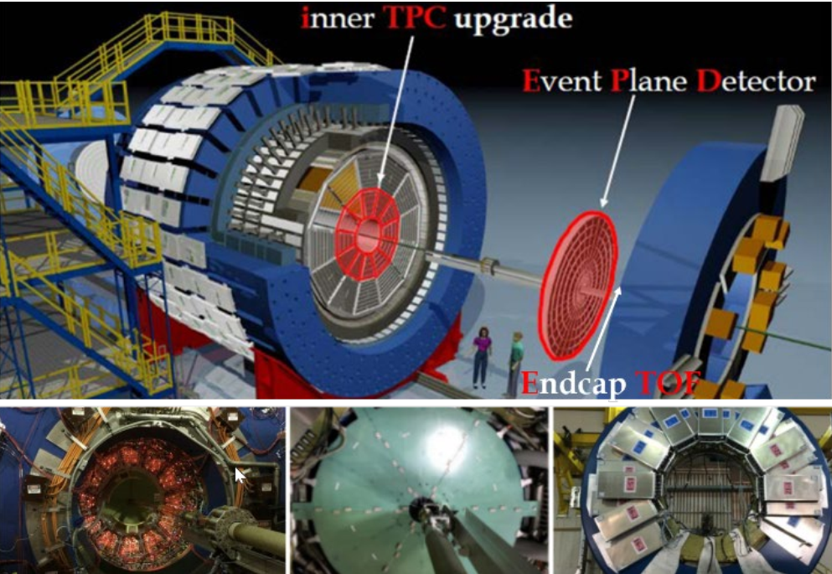

Figure 1. BES II experiments. STAR detector configuration with 3 new detectors (inner TPC, Event Plane Detector, Endcap TOF)

Within the framework of the BES-II research program, a series of experiments on a fixed target was performed. Measurements with a fixed target were also performed, which extend the range of energy scanning to lower energies ( $\sqrt{s_{NN}}$ = 7.7, 6.2, 5.2, 4.5, 3.94, 3.5 GeV).

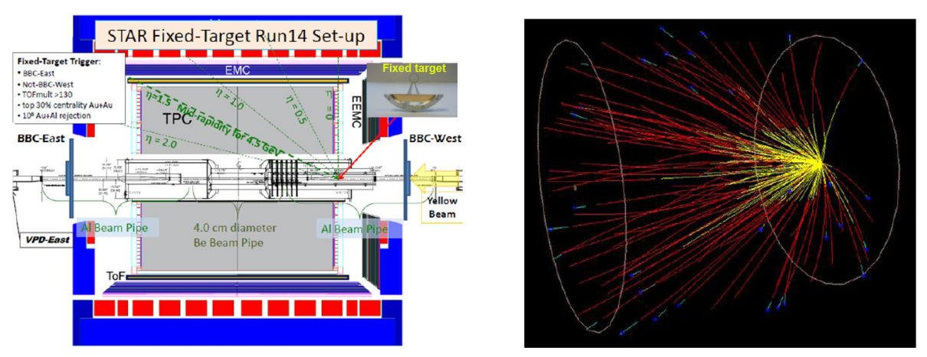

Figure 2. STAR detector configuration for experiments with fixed target

Finally, in BES-I and BES-II program, the energy range in the collider mode was $\sqrt{s_{NN}}$ = 7.7–200 GeV, and in the fixed target mode – $\sqrt{s_{NN}}$ = 3.0–7.7 GeV. For the first time in world practice, within the framework of the same experiment, a program of energy scanning in the energy range of 3–200 GeV was carried out. It gives possibility to study the phase diagram of nuclear matter over a wide range of temperatures (*T*ch = 60–160 MeV) and baryon densities (µB = 25–720 MeV).

The contribution of JINR group for BES-II run preparation, data taking, and data analysis were:

* event plane detector assembling and testing;
* distant participation in runs shifts as a shift crew and QA shifters;
* simulation of global polarization and vorticity;
* development of new particle identification algorithms for net baryon fluctuation study;
* JINR GRID Computing.

The 7.7 GeV colliding system provides the essential bridge between the collider and fixed-target energy scans. Although in later sections we detail a request to acquire fixed-target data at higher overlap energies, there is the largest region of common coverage at this energy. This will provide critical crosschecks between the different modes.

At such a high- $µ_{B}$ region and moderate temperatures, baryon dynamics become important or even dominant in understanding the QCD matter properties. Strange quarks, due to their heavier masses, play an important role in study the high net-baryon density QCD matter. The combination of increased role of strange quarks with the existing high baryon density in low energy heavy-ion collisions offers a unique condition to create various light hypernuclei, which enables us to study e.g. the hyperon-nucleon (Y–N) interactions, which have potential implications for the inner structure of compact stars in nuclear astrophysics.

* + 1. **Results on BES analysis in Dubna in 2022–2024**

1. The analysis of the experimental data obtained at the STAR facility in the BES-I and BES-II energy scanning programs was performed. The fluctuations of net-protons at the energy $\sqrt{s_{NN}}$ = 3 GeV in Au+Au collisions are studied to search for the critical point. High-order proton cumulants have been measured (*Phys. Rev. Lett. 128 (2022) 202303*). The resulting ratio *C*2/*C*4 at the energy $\sqrt{s_{NN}}$ = 3 GeV is reproduced by the hadron transport model (UrQMD). This indicates a dominance of hadronic interactions at this energy and, consequently, the region of possible existence of a critical point at higher energies.

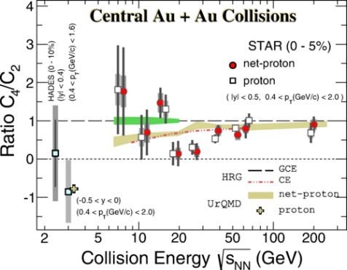

Figure 3. Fluctuations of net-protons at energy $\sqrt{s_{NN}}$ = 3 GeV in Au+Au collisions

2. Determining the phase diagram of nuclear matter in heavy ion collisions is the main goal of experiments carried out at RHIC. Femtoscopic radii and elliptical flow are considered as sensitive characteristics for searching for signatures of phase transitions and the critical point. It is assumed that in the energy region $\sqrt{s_{NN}}$ = 3–7.7 GeV, in which violation of NCQ scaling is observed, these quantities can exhibit anomalous behavior depending on the energy, collision centrality and rapidity. Experimental data in this energy range were obtained in the BES-II Program in collider mode and in experiments with a fixed target and cover a wide range of kinematic variables. The results of data analysis are of interest for determining the equation of state of nuclear matter and testing theoretical models.

It has been established that the number constituent quark (NCQ) scaling observed at high energies in Au+Au collisions at RHIC in the central rapidity region is not observed at low energy of 3 GeV. The magnitude of the elliptical flow is found to be negative for all hadrons (π, *K*, *p*). The positive slope of the forward flow *υ*1 means that the medium in such collisions is most likely characterized by baryon interactions (*Phys. Lett. B 827 (2022) 137003*).

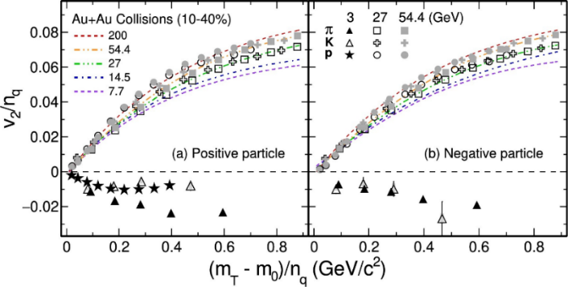

Figure 4. Verification of NCQ-scaling at energy $\sqrt{s_{NN}}$ = 3 GeV in Au+Au collisions

3. The analysis of femtoscopic correlations of identical pions produced in Au+Au collisions at energies $\sqrt{s_{NN}}$ = 3.0 and 3.2 GeV/nucleon was carried out within the “Fixed-Target (FXT)” program.

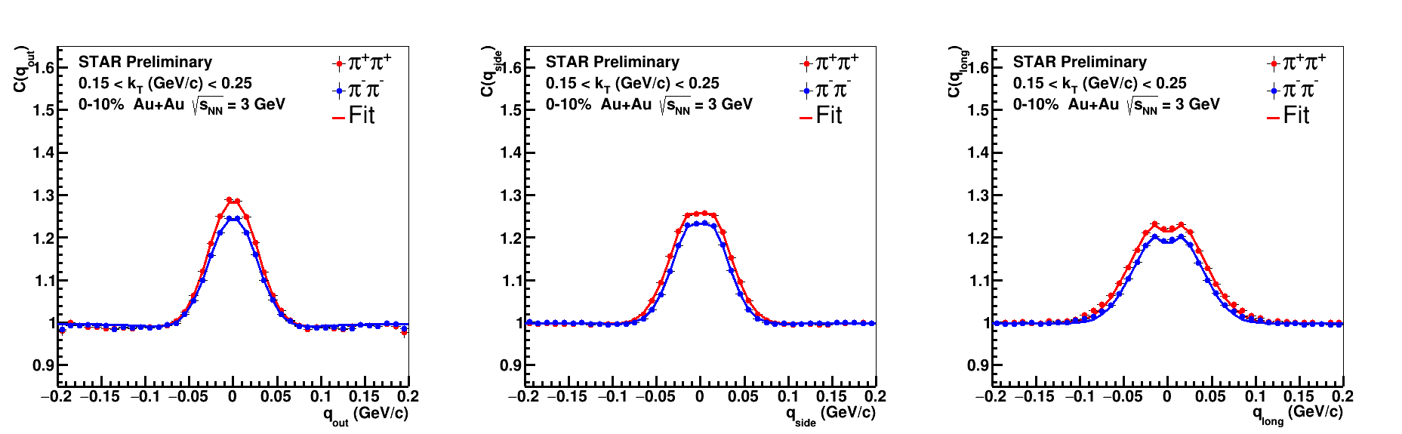

Figure 5. Correlation functions for pairs of charged pions produced in Au-Au collisions at 3 GeV in projection on the side, out and long axes

Figure 5 shows correlation functions and their fit for charged pions with pair transverse momenta 0.15 < $k_{T}$  < 0.25 GeV/*c* from 0–10% most central Au+Au collisions at $\sqrt{s_{NN}}$ = 3 GeV. Red and blue circles correspond to projections of 3-dimensional correlation functions onto “out”, “side”, “long” axes for π+π+ and π−π−, respectively. ﻿For each projection ($q_{out}, q_{side}, q_{long}$), the other components of relative momentum are integrated over the range ± 50 MeV/*c*.

The correlation functions are constructed and fitted for 5 pair rapidity windows: [0, 0.2], [–0.2, 0], [–0.4, –0.2], [–0.6, –0.4], [–0.8, –0.6]. The rapidity-dependence of the extracted femtoscopic parameters is plotted in Figure 6.

Figure 6. Pair rapidity dependence of $R_{out}$ (a), $R_{side}$ (b), $R_{long}$ (c), λ (d), $R_{out-long}^{2}$ (e) in center-of-mass frame of Au+Au collisions at $\sqrt{s_{NN}}$ = 3 GeV for 3 centrality classes: 0–10% (circles), 10–30% (triangles), 30–50% (squares). Open and closed markers correspond to π+π+ and π−π−, respectively. Shaded bands denote theoretical predictions using UrQMD model.

The extracted $R_{out}$, λ, and $R_{out-long}^{2}$ agree within uncertainties between π+π+ and π−π−. of π−π− are systematically larger than one of π+π+ for all rapidity ranges and centrality classes. $R_{side}$ reflects the geometrical size of the emitting source. Hence, π−π− pairs are emitted from homogeneity region of larger size in comparison with π+π+ pairs. Extracted $R_{out-long}^{2}$ is observed to be an odd function w.r.t. pair rapidity in collision center-of-mass frame with a positive slope. (*Phys. Atom. Nucl. 86, no.5, 854-858 (2023)*; *Phys. Atom. Nucl. 86, 988-991 (2023)*; *Report for the STAR Collaboration “Two-pion Bose-Einstein correlations in Au+Au collisions at $\sqrt{s_{NN}}$) = 3 in the STAR experiment”, ISMD-2023, Hungary*)

4. Preliminary results on femtoscopic correlations of identical pions in Au+Au collisions at energies $\sqrt{s_{NN}}$ = 3.0, 3.2, 3.5 and 3.9 GeV were obtained in the STAR experiment at the RHIC collider. Femtoscopic parameters were obtained for 3 classes of centrality (0–10 %, 10–30 %, 30–50 %) depending on energy, transverse momentum ($k_{T}$) and pair rapidity ($y_{pair}$) (Figure 7). The dependence of femtoscopic parameters on collision energy is shown in Figure 7. For comparison with other experiments, pions with medium rapidity (−0.5 < $y_{single}$ < 0) and transverse momentum 0.15 < $k_{T}$ < 0.25 GeV/*c* in 0–10 % central Au+Au collisions were selected. The extracted femtoscopic radii of the current analysis confirm the global trend shown in Figure 7, established by HADES and confirmed by STAR at higher energies. A slight decrease in $R_{side}$ and an increase in $R_{long}$ with increasing collision energy are observed at the energies of this analysis. Figure 7 shows the $R_{out}^{2}-R_{side}^{2}$ and $R_{out}$ */ $R_{side}$* ratios, which are sensitive to the time of particle emission. Measurements of $R_{out}^{2}-R_{side}^{2}$ and $R_{out}$ */ $R_{side}$* ratio at energies of this analysis $\sqrt{s_{NN}}$ =3 – 3.9 GeV are of interest for determining the equation of state of nuclear matter and possible phase transition signatures.

|  |  |
| --- | --- |
|  |  |

Figure 7. Energy dependence of femtoscopic parameters (λ, $R_{out}$, $R_{side}$, $R_{long}$) and $R_{out}^{2}-R_{side}^{2}$, $R_{out}$/ $R_{side}$ ratios extracted from the correlation functions of identical pions with average rapidity (−0.5 < $y_{single}$ < 0) and transverse momentum $k_{T}$ ≈ 0.2 GeV/c in central Au+Au, Pb+Pb and Pb+Au collisions.

Based on obtained results it was established:

* the rapidity dependence in the center of mass system of the collision of the extracted femtoscopic parameters of pion pairs at energies $\sqrt{s_{NN}}$ = 3.0–3.9 GeV
* the dependence of the value of $R_{out-long}^{2}$ on the rapidity of the pair is weakly sensitive to the centrality of the collision and the charge of the pairs.
* the decrease in $R_{side}$ radius with increasing rapidity is most pronounced in central collisions at an energy $\sqrt{s_{NN}}$ = 3 GeV and is associated with a violation of the boost invariance of the source of particle emission.
* a difference between the measured radii $R_{side}$ and $R_{long}$ for π−π− and π+π+ pairs. This effect is assumed to be due to the Coulomb interaction between the source of particle emission and the fireball formed when two nuclei collide. (*Particles 6 (1), 17 (2023); V. Luong (for the STAR collaboration), ISMD-2023, Gyongyos, Hungary, Recent Flow Results from STAR Experiment at RHIC*)

5. Nuclear modification factor of inclusive charged particles in Au+Au collisions at $\sqrt{s_{NN}}$ = 27 GeV. The Beam Energy Scan (BES) program at RHIC aims to explore the QCD phase diagram, including the search for the evidence of the 1st order phase transition from hadronic matter to Quark-Gluon Plasma (QGP) and the location of the QCD critical point. One of the features previously observed in the study of QGP is the effect of suppression of particle production with high transverse momenta $p_{T}$ (> 2 GeV/*c*) at energies $\sqrt{s_{NN}}$ = 62.4–200 GeV, which was deduced from the charged-particle nuclear modification factor ($R_{CP}$) measured using the data from Beam Energy Scan Program Phase I (BES-I) of STAR experiment. Particles lose energy when passing through the nuclear medium formed in collisions of heavy ions. The magnitude of these losses depends on the state of the medium, which is determined by the energy and centrality of the collision, and the type of particles. The nuclear modification factor, defined as the ratio of particle yields in nucleus-nucleus and proton-proton collisions as a function of collision energy and transverse momentum of the particle, was measured by the STAR collaboration in the BES‑I program (Figure 8).

The BES-II data analysis on the spectra of unidentified hadrons and nuclear modification factor $R_{CP}$ was continued. Preliminary results on the dependence of the particle spectrum on the transverse momentum at energies of 14.5, 19.6, and 27 GeV and different centralities are obtained. In 2018, STAR has collected over 500 million events from Au+Au collisions at $\sqrt{s_{NN}}$ = 27 GeV as a part of the STAR BES-II program, which is about a factor of 10 higher than BES-I 27 GeV data size. The new measurements extend the previous BES-I results to higher transverse momentum range, which allows better exploration of the jet quenching effects at low RHIC energies, and may help to understand the effects of the formation and properties of QGP at these energies.

Figure 8. Unidentified charged hadron $R_{CP}$ as a function of transverse momentum for RHIC BES-I and high energy data

The statistics of events collected by the STAR collaboration in the phase II of the BES program (BES-II) at RHIC (Fig. 2) exceeds those collected previously by more than 10 times within the collision energy $\sqrt{s_{NN}}$ = 7.7 – 19.6 GeV in collider mode and makes it possible to determine the RAA value in a wider range and with better accuracy.

Figure 9 demonstrates the transverse momentum spectra and nuclear modification factor $R_{CP}$ for charge hadron production in Au+Au collisions at a collision energy of 27 GeV, for the pseudorapidity range of |η| < 1.

|  |  |
| --- | --- |
|  |  |

Figure 9. Transverse momentum distribution and nuclear modification factor $R_{CP}$ of inclusive charged particles for collision energy of 27 GeV for different centralities

The vertical lines and horizontal lines in Figure 9 represent the statistical errors and bin widths, respectively and the colored boxes the systematic uncertainties, while the error band at unity on the right side of the plot corresponds to the $p_{T}$ independent uncertainty on $N_{bin}$ scaling. The $R_{CP}$ was calculated as:

$$R_{CP}=\frac{{〈N_{Coll}〉}_{Peripheral}}{{〈N_{Coll}〉}_{Central}} \frac{d^{2}N/dp_{T}dη_{0-5\%}}{d^{2}N/dp_{T}dη_{60-80\%}}$$

The growth of $R_{CP}$ is seen at low values of $p_{T}$ (up to $p_{T}$ ≈ 2 GeV/*c*), which is affected by effects such as Cronin enhancement, radial flow, and the relative dominance of coalescence over fragmentation during hadronization. However, as $p_{T}$ increases, $R_{CP}$ reaches a plateau and then demonstrates suppression of hadrons produced in central collisions with respect to peripheral collisions. A significant extension to higher $p_{T}$ values has been achieved. This advancement has enabled a more accurate characterization of the behavior of the nuclear modification in medium. Notably, suppression of particle production at high $p_{T}$ is observed. However, the data is not sufficient to claim the formation of QGP based on this observable, and further study and investigation of the behavior of the nuclear modification factor dependence on energy on the data from STAR BES-II program are necessary. Future comparisons with different theoretical models may help interpret the presented data (*Universe 2024, 10(3), 139*; *A. Aitbayev (for the STAR collaboration), ISMD-2023, Gyongyos, Hungary, Nuclear modification factor in Au+Au collisions at energy $\sqrt{s_{NN}}$ = 27 GeV in the STAR Beam Energy Scan-II program at RHIC*).

6. Strange particles (mesons and baryons) are sensitive probes of the state of nuclear matter, so the study of their spectra is of significant interest for searching for signatures of phase transitions, the position of the critical point, and searching for kaon condensate.

The data obtained by the STAR collaboration under the BES-II program have been processed and the momentum spectra of $K_{S}^{0}$ mesons in Au+Au collisions at the energy of 19.6 GeV and 7 centralities from 0–5 % to 60–80 % have been obtained on statistics ~ 600 million events. Unique results for spectra of $K_{S}^{0}$ mesons produced in Au+Au collisions at the energy of 19.6 GeV and different centralities were obtained in the region of ultra-small transverse momenta (0–200) MeV/*c*. The BES-II data processing on the reconstruction of the spectra of Λ0 and anti-Λ0 hyperons has been begun.

|  |  |
| --- | --- |
|  |  |

Figure 10. Multiplicity distribution and spectra of $K_{S}^{0}$ mesons produced in Au+Au collisions at energy 19.6 GeV , different centralities and rapidity range |y| < 0.5.

After upgrade of the STAR detector – iTPC (improved tracking, extended acceptance, better *dE*/*dx* and momentum resolution), eToF(extended PID resolution), EPD (improve EP resolution, independent centrality detector), reconstruction of $K_{S}^{0}$ mesons with a transverse momentum very close to zero (< 20 MeV/*c*), even in peripheral collisions with low multiplicity with a centrality of 60–80 %, became possible.

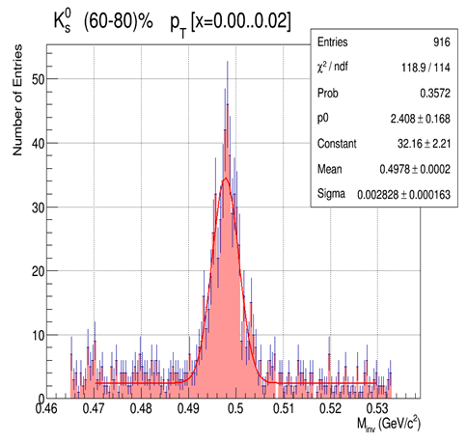

Figure 11. Distribution of $π^{+}π^{-}$ pairs produced in Au+Au collisions at energy 19.6 GeV and 60–80 % centrality at low transvers momentum range 0.00–0.02 MeV/c

7. Search for signatures of phase transition of nuclear matter in *z*-scaling approach. The behavior of the dynamic characteristics of a many-particle system during phase transitions and near the critical point exhibits the property of self-similarity. Therefore, the search and study of scaling patterns of hadron production are of significant interest for studying the phase diagram of nuclear matter formed in collisions of heavy ions at different energies and collision centralities and types of probes. The choice of strange particles as a probe of the state of nuclear matter is due to significantly lower losses. “Scaling” and “Universality” are concepts developed to understanding critical phenomena. Scaling means that systems near the critical points exhibiting self-similar properties are invariant under transformation of a scale. According to universality, quite different systems behave in a remarkably similar fashion near the respective critical points. Critical exponents are defined only by symmetry of interactions and dimension of the space.

New results of analysis of $K_{S}^{0}$ meson spectra measured over a wide range of energy $\sqrt{s_{NN}}$ = 7.7–200 GeV and centrality in Au+Au collisions by the STAR Collaboration at RHIC using the *z*-scaling approach are presented. Indication on self-similarity of fractal structure of nuclei and fragmentation processes with $K_{S}^{0}$ probe is demonstrated. The energy loss as a function of the collision energy, centrality and transverse momentum of the inclusive strange meson is estimated (*“Self-similarity of $K_{S}^{0}$ meson production in Au +Au collisions from BES-I at STAR and anomaly of “specific heat” and entropy” Nuclear Physics A 1025 (2022) 122492).*

Figure 12. Scaling function ψ, nucleus fractal dimension δA, specific heat cAuAu and entropy Sδ,ε of $K_{S}^{0}$ meson production in the most central Au+Au collisions at energies $\sqrt{s_{NN}}$ = 7,7–200 GeV

Based on the results of the analysis of experimental data obtained by the STAR collaboration at RHIC on the production of a strange meson in Au+Au collisions at energies $\sqrt{s_{NN}}$ = 7.7, 11.5, 19.6, 27, 39, 62.4, 130 and 200 GeV in the rapidity region |*y*| <0.5 and six centralities, from 0–5 % to 60–80 %, in the range of transverse momenta from 0.2 to 8 GeV/*c*, the theory of *z*-scaling has been developed:

* The basic principles about the structure of particles on small scales are formulated: each physical particle is a structural object, the constituent particles have a fractal-like structure, fragmentation is a fractal-like process, the compactness of fractal structures is determined by the Heisenberg uncertainty relation.
* The concept of fractal entropy was introduced, and its statistical properties were established in terms of quantization of structural and fragmentation fractal dimensions and crossing symmetry in terms of quantum numbers of fractal dimensions.
* The law of conservation of fractal cumulativeness has been established as a consequence of the principle of maximum fractal entropy.
* A justification is presented for the anomalous behavior of the specific heat of the system accompanying the birth of mesons in the region $\sqrt{s_{NN}}$ = 11–39 GeV, with an increase in collision energy, as a possible signature of a phase transition.
* The justification for the anomalous behavior of the fractal entropy from the transverse momentum of the meson in the region $\sqrt{s_{NN}}$ = 27–39 GeV is presented, as an indication of a phase transition in nuclear matter.

Publications:

* *Nuclear Physics A 1025 (2022) 122492*
* *Moscow University Physics Bulletin, 2022, Vol. 77, No. 2, pp. 190–192*
* *SciPost Phys. Proc. 10, 035 (2022)*
* *Physics of Atomic Nuclei, 2022, Vol. 85, No. 6, pp. 1045–1052*
* *Physics of Atomic Nuclei, 2022, Vol. 85, No. 6, pp. 981–987*
* *Physics 2023, v.5(2), pp.537–546*
* *Physics of Particles and Nuclei, 2023, v.54, №4, pp.640-646*

8. Cooperative phenomena in many-particle systems are manifested in the existence of phase transitions and anomalous behavior of the thermodynamic characteristics of the system near the critical point. Event-by-event analysis of particle production in collisions of heavy ions at high multiplicities depending on energy and centrality is of interest for searching and studying the fractal structure of events. This requires the presence of events with high multiplicity obtained by the STAR collaboration and fractal analysis algorithms developed in the JINR group. Studying the influence of particle formation mechanisms embedded in Monte Carlo generators on the structure of an event is important for suppressing the background and isolating pure effects. Let us note the following results:

* A fractal analysis was carried out using the SePaC Monte Carlo (MC) method for Au–Au events obtained using the AMPT (A Multi-Phase Transport model) generator, MC fractals and events with randomly distributed particles.
* The dependence of the portion of the studied events, defined as fractals, on the method parameter Pmax was studied. It has been established that the hypotheses of independent and dependent formation of fractals correspond to different regions of the behavior of this parameter for AMPT Au-Au events.
* It is shown that the SePaC method with the independent division hypothesis and the optimal value of the Dev parameter makes it possible to divide events into fractal and non-fractal for all centrality classes.
* It has been established that fractal events have several narrow peaks in the distribution of fractal dimension (Figure 13, a) and a distinct group of leading particles in transverse momentum. Such a group of particles is observed in the two-dimensional distribution {$P_{t_{max}}$, $p_{t}$} (Figure 13, b) in the form of points lying near the diagonal, separated by a rarefied gap from the rest. The value $P_{t_{max}}$ is the maximum transverse momentum of particles in the event. It has been established that non-fractal events have an exponential $p_{t}$ spectrum (Figure 13, c).

|  |  |  |
| --- | --- | --- |
|  |  |  |

Figure 13. The result of the SePaC analysis by the method with the hypothesis of independent division of AMPT Au-Au events at an energy of 200 GeV: spectrum of fractal dimensions (a), two-dimensional distribution {$P_{t_{max}}$, $p_{t}$} for particles in the event (b), $p_{t}$ spectrum for fractal and non-fractal events (c).

Based on obtained results it has been established that:

* Fractal events identified by the dependent division hypothesis have a wide peak in the distribution of fractal dimensions. This distribution is not typical for MC fractals.
* Background suppression criteria have been formulated to describe the statistical characteristics of structures at different levels.
* Using these criteria, a significant part of the events identified by the independent fission hypothesis have the same structures and can be interpreted as fractals.
* Events identified by the dependent division hypothesis are suppressed by the criteria and are not considered as fractals. (*Physics of atomic nuclei, 85, 6, 2022, pp. 708–720*; *Physics of Particles and Nuclei Letters, 2023, v. 20, no. 4, pp. 675–682*)

9. Description of charged particle dependence on transverse momentum with Tsallis-like distribution.Recently, a large amount of experimental data has been collected in high energy physics for studying the properties of matter formed in ultrarelativistic heavy-ion collisions. The main interest is to study the phase diagram and localize phase transitions. In this work we study the thermodynamic properties of the system produced in such collisions using the parameters obtained from the transverse momentum distributions of produced hadrons. The hydrodynamic Blast-Wave approach based on Boltzmann statistics was used for analysis.

A new approach based on q-dual statistics, which can provide more information about the system, in particular its chemical potential and measure the difference of the produced system from the classical equilibrium was used. We observe that the kinetic freeze-out parameters depend on collision centrality and energy. Results obtained for Blast-Wave model are in agreement with previously published results. For q-dual statistics we can see that in peripheral collisions the system is less equilibrated leading to an increased deviation from the classical distribution.

Figure 14. Blast-Wave model fits of $K^{±}$, $π^{±}$, $p$, $\overline{p}$ at $\sqrt{s_{NN}}$ = 7.7 GeV and centrality classes from 0–5 % to 70–80 %

Figure 15. Energy dependence of Blast-Wave model fit parameters of $K^{±}$, $π^{±}$, $p$, $\overline{p}$ from $\sqrt{s_{NN}}$ = 7.7 GeV to $\sqrt{s_{NN}}$ = 39 GeV and centrality classes from 0–5 % to 70–80 %

There are different approaches to the description of particle momentum distributions produced in ultrarelativistic heavy-ion collisions. The first approach we considered in this analysis is the hydrodynamic Blast-Wave model based on classical Boltzmann-Gibbs statistics, which describes the collective behavior of particles, taking into account the fireball expansion. This model can give us information about the radial flow and the kinetic freeze-out temperature. A new approach is a statistical model that uses q-dual statistics, which is a generalization of Tsallis statistics with different parametrization. This model can give us information about the degree of deviation of the system from the classical equilibrium state but requires separate accounting for the contribution of mesons and baryons. The combined use of these models allows us to look at the processes occurring in heavy ion collisions from different perspectives:

* for the Blast-Wave model we can see that the kinetic freeze-out temperature *Tkin* monotonically decreases with increasing centrality, which may indicate that the collision fireball in peripheral collisions does not live as long as that in central ones and has less time to build up the radial flow and to reach the equilibrium, while the average expansion velocity ⟨β⟩ increases, which may indicate a more intense expansion in central collisions.
* for the q-dual model we can see that the Tsallis temperature parameter *T* grows with increasing centrality, which may indicate that the central collisions have a higher excitation than the peripheral ones, while the parameter *q* is large in peripheral collisions, which can be explained by the fact that in peripheral collisions the system is less equilibrated leading to an increased deviation from the classical distribution. Radius of the system increases with increasing centrality, indicating that in central collisions, the system size is larger than in peripheral collisions. (*PEPAN, Vol. 55, 4*, *2024* ;*E. Nedorezov, ISHEPP-2023, Dubna, Description of charged particle dependence of transverse momentum with Tsallis-like distribution*)

10. Topic of our interest is anisotropies and chiral magnetic effect in collisions from the STAR experiment. Chiral anomaly creates differences in the number of left-handed and right-handed quarks and leads to charge separation along the magnetic field lines. Chirality imbalance coupled with strong magnetic field induces a charge separation along the B field direction, which violates local P and CP Symmetry in strong interaction. Looking for parity violation in heavy-ion collisions and study the phenomena is of interest for our understanding phase of nuclear matter. The STAR Collaboration has measured at RHIC a signal that may indicate parity violation occurs in metastable regions of the superdense matter.

Parity-odd domains, corresponding to nontrivial topological solutions of the QCD vacuum, might be created during relativistic heavy-ion collisions. These domains are predicted to lead to charge separation of quarks along the system’s orbital momentum axis. A three-particle azimuthal correlator which is a P‑even observable, but directly sensitive to the charge separation effect was used for STAR analysis. The results of measurements of charged hadrons near center-of-mass rapidity with this observable in Au+Au and Cu+Cu collisions at $\sqrt{s_{NN}}$ = 200  GeV using the STAR detector is shown in Figure 16. (*“Azimuthal Charged-Particle Correlations and Possible Local Strong Parity Violation”, B. I. Abelev et al. STAR Collaboration Phys. Rev. Lett. 103, 251601 – Published 14 December 2009*)

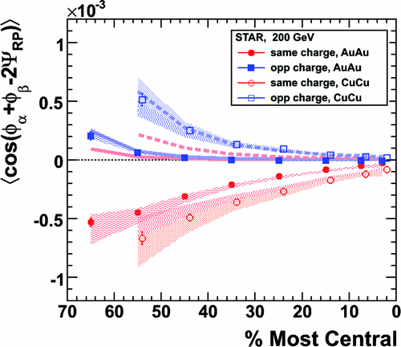

Figure 16. $〈cos⁡(ϕ_{α}+ϕ_{β}-2Ψ_{RP})〉$ in Au+Au and Cu+Cu collisions at $\sqrt{s_{NN}}$ = 200  GeV. The thick solid Au+Au and dashed Cu+Cu lines represent HIJING calculations of the contributions from three-particle correlations. Shaded bands represent uncertainty from the measurement of $υ_{2}$. Collision centrality increases from left to right

Based on the obtained results it was proposed:

* To study the chiral magnetic effect (CME) in AuAu collisions at the top RHIC energies using the direction of the magnetic field where a maximal CME magnitude is observed. This magnitude will be larger with respect to the one determined using the direction of the magnetic field that is perpendicular with respect to the event plane.
* To reproduce the results based on the event plane method that are published in *Phys. Rev. Lett. 103 (2009) 251601*.
* To apply new proposed method for analysis of STAR AuAu data.
  + 1. **Development of machine learning methods**

The developed approach made it possible to solve the problem of particle trajectory classification using machine learning methods: an array of primary track properties, together with information about their type, was used to adjust the parameters of various classifiers. Based on the analysis of the obtained ROC-curves for these classifiers, it is shown that the use of any of them can significantly increase the efficiency of particle identification in comparison with the currently used standard identification algorithm, as well as carry out reliable identification of particle types along tracks that go beyond the limits of applicability of the standard method. At the same time, the best results were achieved when classifying using the Multi-Layer Perceptron multiclassifier (Multi-Level Perceptron) and the CatBoost gradient boosting algorithm. Both methods demonstrated the stability of the identification process depending on the change in the initial conditions of the data set in the simulation, simulating various operating conditions of the accelerator complex and the MPD detector. The project participants (A.A. Aparin, A.A. Korobitsyn) participated and took first place in the hackathon on the application of machine learning methods in particle identification problems. The hackathon was held as a part of the 2nd AI4EIC-exp Workshop on Artificial Intelligence for the Electron-Ion Collider (BNL, USA). (*Phys.Atom.Nucl. 86 (2023) 5, 845-849; Phys.Atom.Nucl. 86 (2023) 5, 869-873*)

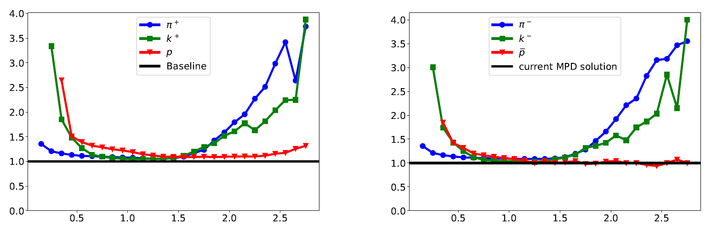

Figure 17. Efficiency ratio for the CatBoost and n-sigma classification for particle identification. Diagrams show the following types of particles: π+, *K*+, *p* and π−, *K*−, .

* + 1. **Plans on continuation of data analysis**
* To continue the work on the construction of differential yields of light particles and particles with strangeness on the data of the energy scan program at various collision energies. The results of the analysis at low energies will be used for comparison with model data from the MPD experiment in preparation for the first data set at the MPD facility.
* To perform analysis of the experimental data of the STAR collaboration, obtained by the energy scan program for Au + Au collisions at the energy of 7.7, 11.5, 14.5, 27 GeV, and create a femto-DST.
* To obtain momentum spectra of $K_{S}^{0}$ mesons, Λ0 and anti-Λ0 hyperons in Au+Au collisions at 7.7, 11.5, 14.5, 27 GeV and seven centralities from 0–5 % to 60–80 % in a wide range of transverse momenta (from 0.025 to 7 GeV/*c*) with all corrections considered.
* To determine the nuclear modification factor for $K_{S}^{0}$ mesons, Λ0 and anti-Λ0 hyperons at energies 7.7, 11.5, 14.5, 19.6, 27 GeV and, for $K_{S}^{0}$ mesons, in the super-low momentum range.
* To determine the dependence of the ratio of the yields of $K_{S}^{0}$ mesons, $Λ^{0}$ and anti- $Λ^{0}$ hyperons at energies of 7.7, 11.5, 14.5, 19.6, 27 GeV GeV on the interaction centrality and momentum of the produced particle.
* To study and compare femtoscopic correlations of identical pions and elliptical flow for hadrons π, *K*, *p* formed in overlapping (acceptance) regions in the collider mode and the mode with a fixed target in the region in Au+Au collisions at energy $\sqrt{s_{NN}}$ = 7.7 GeV.
* To analyze the experimental data obtained at the STAR facility to calculate the ΛΛ-correlations. To perform analysis of the data on collisions of gold nuclei at the energy of 200 GeV on full statistics.
* To improve the developed particle identification algorithms based on machine learning methods, evaluate the effectiveness of using machine learning methods for processing experimental data to identify charged particles in comparison with traditional method.
* To continue research into the measurement of energy losses of charged particles in the TPC to reduce the measurement *dE*/*dx* error. Further improvement of the identity method for calculating the moments of distribution of net proton multiplicity and evaluation of fluctuations of baryonic matter in the BES-II energy range to determine the type of phase transition of hadronic matter to the quark-gluon phase and the exact parameters of this transition.
* To present the results of the research at the workshops of STAR, MPD and other scientific events in the form of publications in the proceedings of conferences and articles in Russian and international journals.
  + 1. **STAR experimental program for 2023–2026**

At RHIC it is possible to build detectors that can span from mid-rapidity to beam rapidity – with the two recent upgrades STAR is able to achieve this unique capability. STAR’s BES-II upgrade sub-systems comprised of the inner Time Projection Chamber (iTPC, 1.0 < η < 1.5), endcap Time-Of-Flight (eTOF, 1 < η < 1.5) and Event Plane Detector (EPDs, 2.1 < η < 5.1), that are all commissioned and fully operational since the beginning of 2019. The STAR collaboration is constructing a forward rapidity (2.5 < η < 4) upgrade that will include charged particle tracking and electromagnetic/hadronic calorimetry. For charge particle tracking the aim is to construct a combination of silicon detectors and small strip thin gap chamber detectors. The combination of these two tracking detectors will be referred to as the forward tracking system (FTS). The FTS will be capable of discriminating the hadron charge sign. It should be able to measure transverse momentum of charged particles in the range of 0.2 < $p_{T}$ < 2 GeV/*c* with 20–30 % momentum resolution. In what follows, we will refer to the combination of the existing TPC (η < 1) and the iTPC upgrade as iTPC (η < 1.5) for simplicity.

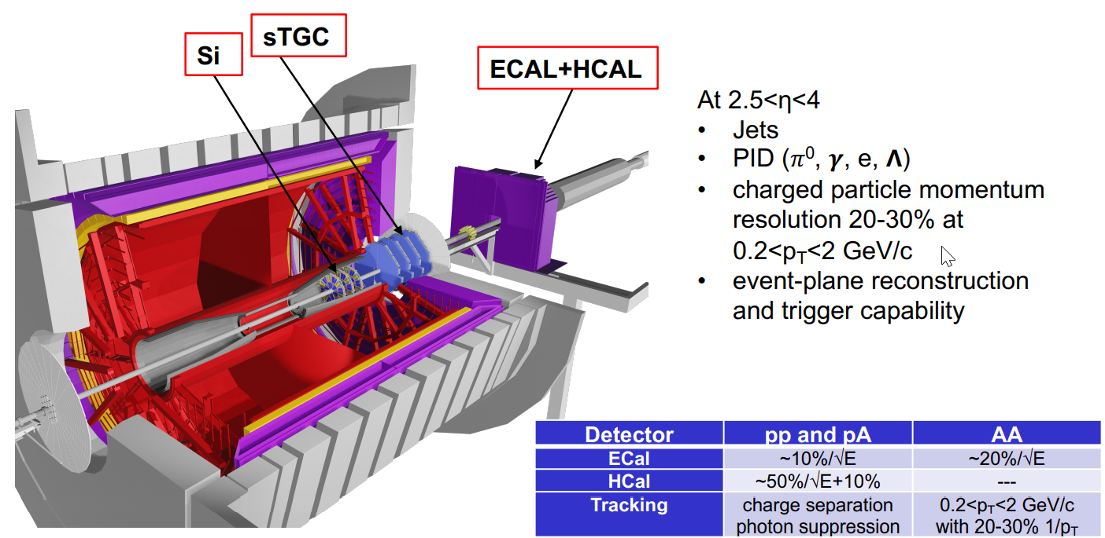

Figure 18. STAR setup further upgrades for experiments after BES II period

Run-22 with 510 GeV was very successful. This run has taken the full advantage of STAR’s new forward detection capabilities and further capitalize on the recent BES-II detector upgrades. We motivate a program that RHIC’s unique ability will be used to provide transverse and longitudinally polarized proton beams to exploit both an increased statistical power and kinematic reach from recent and planned detector upgrades. During the run the integral luminosity 400 pb–1 was recorded. We have practically doubled our statistics.

Table 1. Integrated luminosities at different runs

It means that, in 2022, the first run with transversely polarized protons at energy of 510 GeV took place under the Cold QCD program. New capabilities of the STAR facility after its modernization made it possible to carry out measurements in the pseudo-rapidity range of –1.5 < ƞ <1.5 (mid-rapidity) and 2.8 < ƞ < 4.2 (forward rapidity), corresponding to the range of Bjorken variable 0.005 < *x* < 0.5. This allowed us to study the distributions of Sievers, transversity, Collins fragmentation functions in previously inaccessible regions and expand the program for the analysis of asymmetries of the production of *W*± and *Z*0 bosons.

The JINR group took part in Run-22 shifts totally 26 manweeks as shift crew and QA shifts. At present time the preparation for Run-24 with *p*+*p* and *p*+Au at 200 GeV is taking place.

Figure 19. Preparation for Run-24 for proton-proton experiment with iTPC, EPD and Forward upgrades

Table 2. Beam Use Request for Run-24

|  |  |  |  |
| --- | --- | --- | --- |
| $$\sqrt{s_{NN}}$$ (GeV) | Species | Number of Events/  Sampled Luminosity | Year |
| 200 | *p*+*p* | 142 pb–1 / 12w | 2024 |
| 200 | *p*+Au | 0.69 pb–1 / 10.5w | 2024 |

**2.2.5.1 Hot QCD Physics (Run-23 & Run-25)**

The completion of the RHIC’s scientific mission involves the two central goals:

* mapping out the phase diagram of the QCD,
* probing the inner workings of the QGP by resolving its properties at short length scales.

The STAR collaboration has identified a number of topics that together make a compelling case to take data during Runs 23–25 alongside sPHENIX, and successfully complete RHIC’s scientific mission. In this section, we present a selection of those topics that will take full advantage of both STAR and RHIC’s unique capabilities and address the following important questions about the inner workings of the QGP:

* What is the precise temperature dependence of the shear η/*s*, and bulk ζ/*s* viscosity?
* What is the nature of the 3-dimensional initial state at RHIC energies? How does a twist of the event shape break longitudinal boost invariance and decorrelate the direction of an event plane?
* How is global vorticity transferred to the spin angular momentum of particles on such short time scales? And how can the global polarization of hyperons be reconciled with the spin alignment of vector mesons?
* What is the precise nature of the transition near µB = 0, and where does the sign-change of the susceptibility ratio $χ_{6}^{B}/χ_{2}^{B}$ take place?
* What is the electrical conductivity, and what are the chiral properties of the medium?
* What can we learn about confinement and thermalization in a QGP from charmonium measurements?
* What are the underlying mechanisms of jet quenching at RHIC energies?
* What do jet probes tell us about the microscopic structure of the QGP as a function of resolution scale?

The event statistics projections that are used in this section will rely on the CAD’s recently update 2023 and 2025 Au + Au luminosities. For each year we presume 24 weeks of RHIC operations and based on past run operations an overall average of 85 % × 60 % (STAR × RHIC) uptime, respectively. The minimum-bias rates assume a conservative 1.5 kHz DAQ rates which will allow sufficient bandwidth for specialized triggers which are listed as integral luminosities. To achieve the projected luminosities, the collaboration will look into optimizing the interaction rates at STAR by allocating low and high luminosities periods within fills.

Table 3. STAR minimum bias event statistics and high-*pT* luminosity projections for the 2023 and 2025 Au+Au runs. For comparison the 2014/2016 event statistics and luminosities are listed as well

|  |  |  |  |  |
| --- | --- | --- | --- | --- |
| Year | Minimum bias  [× 109 events] | High- $p_{T}$ int. luminosity [nb–1] | | |
| all vz | |vz| < 70 cm | |vz| < 30 cm |
| 2014  2016 | 2 | 26.5 | 19.1 | 15.7 |
| 2023  2025 | 10  10 | 43  58 | 38  52 | 32  43 |

Table 4. Beam Use Request for Run-24 and Run-25

|  |  |  |  |
| --- | --- | --- | --- |
| $$\sqrt{s_{NN}}$$ (GeV) | Species | Number of Events/  Sampled Luminosity | Year |
| 200 | *p*+*p* | 142 pb–1 / 12w | 2024 |
| 200 | *p*+Au | 0.69 pb–1 / 10.5w | 2024 |
| 200 | Au+Au | 18 B / 32.7 nb–1 / 40w | 2023+2025 |

The impetus for running STAR during the year of 2023–2025 in terms of bulk correlation measurements in Au+Au 200 GeV collisions comes from gains via: extended acceptance and enhanced statistics.

The first run for study of Au+Au collisions at 200 GeV took place in 2023. And thus, measurements began according to the Hot QCD Program. The structure of event from the STAR facility in new configuration is shown at Figure 20. Figure 21 demonstrates the functionality of new forward detector systems. As in Run-22 the JINR Group took part in the Run-23 shifts and our obligation was 25 manweeks.

Figure 20. The gold-gold event at 200 GeV in the new configuration of the STAR detector

Figure 21. Left: The invariant mass distribution from FCS ECal clusters showing the π0 peak. Middle: Multiplicity distribution for the sTGC detector showing an approximately negative binomial distribution as expected for the trigger mix. Right: FST hit map distribution from minimum bias Au+Au collisions

Thanks to a reduced material budget between the beam and the iTPC, STAR will be uniquely positioned to perform di-electron measurements with which we propose to probe degrees of freedom of the medium and its transport properties. For that we will use the high precision dilepton excess yield, i.e. *l*+*l*− invariant mass distribution after subtraction of dilepton sources produced after freeze-out, and contributions from the initial collisions such as Drell-Yan and correlated charm-anticharm pairs. Furthermore, we propose to study the virtuality, Wigner function and final-state magnetic field in the QGP. For the latter photon-photon collisions in ultra-peripheral, peripheral, and midcentral reactions and *p*+A (all centralities) in both channels *e*+*e*−, µ+µ− will be measured with high accuracy.

* ***Pseudorapidity dependence of global hyperon polarization***

One of the key sets of measurements is of interests – pseudorapidity dependence of global hyperon polarization.

The global polarization of hyperons produced in Au+Au collisions has been observed by STAR. The origin of such a phenomenon has hitherto been not fully understood. Several outstanding questions remain: How exactly is the global vorticity dynamically transferred to the fluid-like medium on the rapid time scales of collisions? How does the local thermal vorticity of the fluid get transferred to the spin angular momentum of the produced particles during the process of hadronization and decay? To address these questions, one may consider measurement of the polarization of different particles that are produced in different spatial parts of the system, or at different times. A concrete proposal is to: 1) measure the Λ, anti-Λ polarization as a function of pseudorapidity, 2) measure polarization for different particles such as Ω and Ξ. Both are limited by the current acceptance and statistics available. With the addition of the iTPC and FTS, and with high statistics data from Run-23 it will be possible to perform such measurements with a reasonable significance. Note that iTPC (+ TPC) has excellent PID capability to measure all these hyperons. Although the FTS has no PID capability we can do combinatorial reconstruction of Λ, anti-Λ candidates via displaced vertices. A similar analysis was performed and published by STAR using the previous FTPC. In order to make a conservative projection we assume similar momentum resolution of 10−20 % for single charged tracks, similar overall tracking efficiency, charge state identification capability for the FTS and FTPC (see the forward upgrade section for exact numbers). We also assume the FTS, with its novel-tracking framework, will be able to measure a minimum separation of 20 cm between the all pairs of one positive and one negative track (a possible decay vertex) from the main vertex of the event. This will give rise to about 5 % efficiency of Λ(anti-Λ) reconstruction with about (15–20) % background contribution from $K_{S}^{0}$ → π+ + π−. With this we can make projections for a polarization measurement in Au+Au 200 GeV (40–80) % assuming 10 Billion minimum-bias events. Currently theoretical models predict contradictory trends for the pseudorapidity dependence of Λ polarization. If the initial local orbital angular momentum driven by collision geometry plays a dominant role it will lead to increases of polarization with pseudorapidity. On the other hand, if the local thermal vorticity and hydrodynamic evolution play a dominant role it will predict decreasing trend or weak dependence with pseudorapidity. Such tensions can be easily resolved with the future proposed measurement during Run-23.

**2.2.5.2** **Cold QCD Physics (Run-22 & Run-24)**

The exploration of the fundamental structure of strongly interacting matter has always thrived on the complementarity of lepton scattering and purely hadronic probes. As the community eagerly anticipates the future Electron Ion Collider, an outstanding scientific opportunity remains to complete “must-do” measurements in *p+p* and *p+A* physics during the final years of RHIC. Much of the Run-22 and Run-24 physics program outlined here is, on the one hand, unique to proton-proton and proton-nucleus collisions and offers discovery potential on its own. On the hand, these studies will lay the groundwork for the EIC, both scientifically and in terms of refining the experimental requirements of the physics program, and thus are the natural next steps on the path to the EIC. When combined with data from the EIC these STAR results will provide a broad foundation to a deeper understanding of fundamental QCD.

In Run-22 at 510 GeV and Run-24 at 200 GeV the combination of 510 GeV *p+p* collisions and the STAR Forward Upgrade will provide access to forward jet physics at perturbative scales, thereby enabling measurements at the highest and lowest *x* values. The mid-rapidity measurements at 510 and, especially at 200 GeV will interpolate between the high- and low-*x* values, with significant overlaps to probe evolution effects and provide cross-checks. Together, the two runs will allow STAR to measure fundamental proton properties, such as the Sivers and transversity distributions, over nearly the entire range 0.005 < *x* < 0.5.

Run-24 will also provide outstanding opportunities to probe fundamental questions regarding QCD in cold nuclear matter. The STAR Forward Upgrade will enable an extensive suite of measurements probing the quark-gluon structure of heavy nuclei and the regime of low-*x* non-linear gluon dynamics. STAR will also explore how a nucleus, serving as a color filter, modifies the propagation, attenuation, and gluons.

In Run-24 STAR also requests at least 11 weeks of polarized *p+p* data-taking at $\sqrt{s}=$  200 GeV and 11 weeks of polarized *p*+Au data-taking at $\sqrt{s_{NN}}=$ 200 GeV. All of the running will involve transversely polarized protons, with the choice between vertical or radial polarization to be determined during the coming year. We expect to sample at least 235 pb–1 of *p+p* collisions and 1.3 pb−1 of *p*+Au collisions.

STAR provides a lot of unique data with polarized proton beams. These data can be useful for training young scientists who will then work on NICA polarized program. The JINR participation in the STAR experiment is the unique opportunity to work with real collider data on spin physics.

In experiments with polarized protons, it is supposed to carry out the following measurements:

* ***Inclusive transverse spin asymmetries at forward rapidities***

A transverse single-spin asymmetry *AN* measurement at forward rapidity for hadrons will be studied at highest RHIC energy 510 Gev as a function *xF*. Verification of possible mechanisms of experimental observed TSSA allows to understand the role of transverse-momentum-dependent (TMD) parton distribution and fragmentation functions and independence of the asymmetry on center-of-mass energy. The *AN* data for charged hadrons provide new constraint for evolution and flavor dependence of the twist-3 ETQS distributions.

* ***Transversity, Collins Function and Interference Fragmentation Function***

The *p↑+p*collisions is an ideal tool to explore the fundamental QCD questions of TMD factorization, universality, and evolution. Measurements at $\sqrt{s}$ = 200 and 510 GeV will provide additional experimental constraints on evolution effects and provide insights into the size and nature of TMD observables. Transversity as well as longitudinally distributions of partons in proton are needed for complete understanding nucleon spin structure. The transversity distribution describes the transverse polarization of quarks within a transversely polarized proton. Both distributions for quarks and anti-quarks are connected to nonzero orbital angular momentum components in the wave function of the proton. Transversity distribution can also shed light on the tensor charge distribution – new fundamental quantity of the spin structure of the nucleon. The *kT* integrated quark transversity distribution can be extracted from the single spin asymmetry *AN* of the azimuthal distribution of hadrons in high energy jets. The collinear transversity distribution couples to the TMD Collins function and therefore it is possible to directly probe the Collins fragmentation function. The transversity distribution can also be extracted from the single spin asymmetry of pion pairs through the collinear interference fragmentation function.

The fragmentation of linearly polarized gluons into unpolarized hadrons is an equivalent for the Collins fragmentation function. The linear polarization of gluons is an unexplored phenomenon. The measurement of “Collins-like” asymmetries is an important example to access the distribution of linearly polarized gluons. The best kinematic region to access this distribution is at backward angles with respect to the polarized proton and at small jet *pT*.

* ***Sivers and Efremov-Teryaev-Qiu-Sterman Function***

Both the Sivers and the ETQS functions encapsulate partonic spin correlations within the proton, but they are formally defined in different frameworks. The Sivers function is a TMD quantity that depends explicitly on spin-dependent transverse partonic motion *kT*, the ETQS function is a twist-3 collinear distribution, in which Single Spin Asymmetry are generated through soft collinear gluon radiation.

The Sivers effect manifests itself as a correlation (a triple product) between the transverse momentum of a parton (*T*) with momentum fraction *x,* and the transverse spin ($\vec{S}$) of a polarized proton moving in the longitudinal ($\vec{p}$) direction. Thus, for transversely polarized protons, the Sivers effect probes whether the *kT* of the constituent quarks is preferentially oriented in a direction perpendicular to both the proton momentum and its spin.

Runs with transversally polarized *p*+*p* and *p*+Au collisions at $\sqrt{s_{NN}}$ = 200 GeV (spin/cold QCD run) will provide STAR with the unique opportunity to investigate these collision systems with the Forward Upgrade providing full tracking and calorimetry coverage over the region 2.5 < η < 4 and the iTPC providing enhanced particle identification and expanded pseudorapidity coverage at mid-rapidity. These powerful detection capabilities will enable critical measurements to probe universality and factorization in transverse spin phenomena and nuclear PDFs and fragmentation functions, as well as low-*x* non-linear gluon dynamics characteristic of the onset of saturation. The mid-rapidity *p+p* measurements at 510 and, especially at 200 GeV, will interpolate between the high and low-*x* values, with significant overlaps to probe evolution effects and provide cross-checks. These runs will allow STAR to measure fundamental proton properties, such as the Sivers and transversity distributions, over nearly the entire range 0.005 < *x* < 0.5 and clarify the role of Efremov-Teryaev-Qiu-Sterman function in formation of single spin asymmetry *AN*.

* ***Polarized p↑ + p and p↑ + A collisions at 200 GeV***

Run with transversally polarized *p*+*p* and *p+Au* collisions at $\sqrt{s_{NN}}$ = 200 GeV will provide STAR with the unique opportunity to investigate these 200 GeV collision systems with the Forward Upgrade.

* ***Forward transverse spin asymmetries***

The forward transverse spin asymmetries in *p*+*p*, *p*+Al, and *p*+Au collisions vs. *xF* and *pT* contains information on the dynamics that underlie the large asymmetries both in *p+p* and *p+*Acollisions. The asymmetry is substantially larger for isolated π0 than when it is accompanied by additional nearby photons. The observed nuclear dependence is very weak. The STAR will enable measurements of *AN* for *h*+/−, in addition to π0, with isolation criteria for nearby charged, as well as neutral, fragments. It will enable full jet asymmetry and Collins’s effect measurements.

* ***Sivers effect***

The measurements of dijet production in *p*+*p* are crucial to explore questions regarding factorization of the Sivers function. In Run-24 the data will reduce the uncertainties for |η3 + η4| and will provide a detailed mapping vs. *x* for comparison to results for Sivers functions extracted from SIDIS, Drell-Yan, and vector boson production.

* ***Transversity and related quantities***

Measurements of the Collins asymmetry and IFF in *p*+*p* collisions at RHIC probe fundamental questions regarding TMD factorization, universality, and evolution. The observed asymmetries are functions of jet ($p_{T}$, η), hadron (*z*, *jT*), and *Q*2. Measurements in Run-22 at high-*x* with the Forward Upgrade and at low-*x* with the STAR mid-rapidity detectors will provide a significant overlapping region of *x* coverage. The high statistical precision of the Run-24 data will enable detailed multi-dimensional binning for the Collins asymmetry results and provide a direct probe of the Collins fragmentation function. The asymmetry *AUT* vs. $p_{T}$ provides information about the transversity distribution.

STAR at RHIC has the unique opportunity to extend the Collins effect measurements to nuclei and verify the universality of the Collins effect in hadro-production by dramatically increasing the color flow that can break factorization for TMD PDFs like the Sivers effect. This will also explore the spin dependence of the hadronization process in cold nuclear matter.

* + 1. **JINR contribution**

Based on the tasks formulated in the project, we propose the following schedule for the JINR group (see Table 5).

Table 5. Schedule of the project

|  |  |  |  |  |  |  |
| --- | --- | --- | --- | --- | --- | --- |
| **No.** | **Activity** | **Years** | | | | |
| **2025** | **2026** | **2027** | **2028** | **2029** |
|  | BES II data analysis |  |  |  |  |  |
|  | Joint data analysis of STAR and MPD data in the overlapping energy interval of RHIC and NICA colliders |  |  |  |  |  |
|  | Cold QCD Physics with *p*↑*p*↑ collisions at 510 GeV |  |  |  |  |  |
|  | Cold QCD Physics with *p*↑+A collisions at 200 GeV |  |  |  |  |  |
|  | Hot QCD Physics data taking Runs with Au+Au collisions at 200 GeV |  |  |  |  |  |
|  | Hot QCD Physics data analysis |  |  |  |  |  |
|  | Study of femtoscopy correlation,  event structure, global polarization, high *pT* |  |  |  |  |  |

**Below there is** **a list of tasks** **that are of particular interest to the JINR group**:

1. BES-II data analysis to obtain momentum spectra, rapidity spectra, particle yields, check the self-similarity of particle production, estimate the constituent energy losses, study cumulative particle production and search for phase transition signatures.
2. The event-by-event analysis of Au+Au collisions at energies $\sqrt{s_{NN}}$ = 200 GeV and different centralities obtained by STAR at RHIC, with the aim of searching for fractal structures. The further development of the method for fractal analysis of events of nucleus-nucleus interactions.
3. Participation in the Hot QCD Physics Program with emphasis on the study of pseudo-rapidity dependence of global hyperon polarization.
4. Participation in the Cold QCD Physics Program and study of spin effects in collisions of polarized protons with protons and nuclei.

***Cold QCD Physics with p↑+p↑ сollisions at 510 GeV:***

* inclusive transverse spin asymmetries at forward rapidities;
* transversity, Collins function and interference fragmentation function;
* Sivers and Efremov-Teryaev-Qiu-Sterman function.

***Polarized p↑+p and p↑+A collisions at 200 GeV:***

* forward transverse spin asymmetries;
* Sivers effect;
* transversity and related quantities.

1. Analysis of data from fixed target experiments:

* high moments of proton multiplicity distributions,
* new results on hypernuclei production (${}_{Λ}^{4}H$, ${}_{Λ}^{5}{He}$).

1. There is enhanced interest to the production of light ions, which surprisingly appears to be in agreement with predictions of particle number ratios in both statistical and coalescence models. The first model is unjustified due to a huge difference between the temperature of chemical freeze-out of ~ 160 MeV and the binding energy of a few MeV. A possibility to distinguish these models has been suggested based on the yields of 4Li and 4He.
2. Study of femtoscopic correlations. At the previous stages of the project, the JINR group made a contribution to the study of femtoscopic correlations. Development of studying the space-time picture, the effects of the final state interactions and spin-spin correlations:

* “Spin correlations and consequences of quantum-mechanical coherence”, R. Lednicky and V. L. Lyuboshitz, *Phys. Lett. B 508 (2001) 146;*
* “Correlation femtoscopy of multiparticle processes”, R. Lednicky, *Phys. of Atom.Nucl. 67 (2004)71;*
* “Femtoscopic search for the phase transition”, R. Lednicky, *Nucl.Phys. B(Proc.Suppl.) 198 (2010)43*.

It is planned to pay a special attention to the energy interval close to the energy region expected in the NICA/MPD and BM@N experiments:

* Femtoscopic search for the phase transition and critical point
* Correlation femtoscopy of multiparticle processes
* The measurement of the ΛΛ interaction
* Measurement of interaction between antiprotons
* Spin correlations and consequences of quantum-mechanical coherence

1. Software infrastructure and software development

* ***Machine learning techniques to data analysis***

Given the experience with machine learning, it is planned to develop a convolutional neural network to find objects of interest in the image. It is planned to explore the possibility of machine learning in high energy physics, namely, the identification of charged particles based on machine learning. Particle identification based on trajectory geometry and TOF data analysis using a neural network. The characteristics used for identification are the particle momentum-to-charge ratio and mass-to-charge ratio, which we extract from the particle’s passage through detector data, modeled using the MpdRoot software package. The parameters of the particle momentum-to-charge ratio and the mass-to-charge ratio are fed to the input layer; the output layer consists of six softmax elements, which correspond to the probabilities of identifying a particle as one of six types. For machine learning, we plan to use the open software library TensorFlow. Now there is a process of studying the literature, discussing and developing a neural network.

Given the experience with machine learning, it is planned to develop a convolutional neural network to find objects of interest in the image. It is planned to explore the possibility of machine learning in high energy physics, namely, the identification of charged particles based on machine learning. Particle identification based on trajectory geometry and TOF data analysis using a neural network. The characteristics used for identification are the particle momentum-to-charge ratio and mass-to-charge ratio, which we extract from the particle's passage through detector data, modeled using the MpdRoot software package. The parameters of the particle momentum-to-charge ratio and the mass-to-charge ratio are fed to the input layer; the output layer consists of six softmax elements, which correspond to the probabilities of identifying a particle as one of six types. For machine learning, we plan to use the open software library TensorFlow. Now there is a process of studying the literature, discussing, and developing a neural network.

* ***STAR-JINR end-to-end GRID production***

The large luminosity of RHIC and high-speed data acquisition system at the STAR is allowed to collect more than 50 Petabytes of information about Au+Au collisions. And the amount of information increases every year. STAR’s RHIC computing facility provides over 15K dedicated slots for data reconstruction. This number of slots is not always sufficient to satisfy an ambitious and data-challenging physics program and harvesting resources from outside facilities are paramount to scientific success. However, constrains of remote sites (e.g. CPU time limits) do not always provide the flexibility of a dedicated farm. STAR has a breadth of smaller data sets (both in runtime and size) that can be easily offloaded to remote facilities with many such limits. Scavenged resources can be run with efficiency comparable to that of the local production and contributes additional computing time to an experiment that runs every year and therefore needs fast turnaround.

The use of the distributed data centers of different institutions of the STAR collaboration is one of the possible solutions to this problem. The Laboratory of Information Technologies of the JINR became the world’s leading centers for the processing by the GRID system. Therefore, JINR resources can be used to process the STAR data. The JINR software group together with the STAR software group developed software stack of GRID production framework including dealing with multi-site submission, automated re-submission, job tracking, as well as new challenges and possible improvements.

Our framework has an excellent first pass efficiency of 93.2 %. The efficiency is comparable to, but slightly lower than, local efficiency, which is 98 %, due to the additional complexity of the added software interfaces. STAR has put a lot of thought and iterative refinement into the design of this production system. Extensive preproduction testing and a well-structured finite state system applied to each job, with retries in the event of interruption, applied to each job contributes to this high efficiency. What makes this even more remarkable is that it is running on heterogeneous nodes.

* + 1. **References**

1. R. Lednicky, *Phys. of Atomic Nuclei 67 (2004) 71*.
2. R. Lednicky, Nucl. *Phys. B (Proc. Suppl.) 198 (2010) 43*.
3. P. Batyuk et al., *Phys. Rev. C 96 (2017) 024911*.
4. D. Lonardoni et al., *Phys. Rev. Lett. 114 (2015) 092301*.
5. STAR Collab. (L. Adamczyk et al.), *Phys. Rev. Lett. 114 (2015) 022301*.
6. P. Naidon and S. Endo, *Rept. Prog. Phys. 80 (2017) 056001*.
7. ALICE Collab. (S. Acharya et al.), *Phys. Lett. B 797 (2019) 134822*.
8. R. Lednicky and V. L. Lyuboshitz, *Phys. Lett. B 508 (2001) 146*.
9. R. Lednicky and V.L. Lyuboshitz, *Sov. J. Nucl. Phys. 35 (1982) 770*.
10. R. Lednicky, *Phys. Part. Nuclei 40 (2009) 307*.
11. STAR Collab. (L. Adamczyk et al.), *Nature 527 (2015) 345*.
12. S. Bazak and St. Mrowczynski, *Eur. Phys. J. A 56 (2020) 193*.

**2.3 Estimated completion date**

2025–2029

**2.4 Participating JINR laboratories**

LHEP, LTP, LIT, UC

**2.4.1** **MICC resource requirements**

|  |  |  |  |  |  |
| --- | --- | --- | --- | --- | --- |
| **Computing resources** | **Distribution by year** | | | | |
| 1st year | 2nd year | 3rd year | 4th year | 5th year |
| Data storage (TB)  - EOS  - Tapes | 0 | 0 | 0 | 0 | 0 |
| Tier 1 (CPU core hours) | 0 | 0 | 0 | 0 | 0 |
| Tier 2 (CPU core hours) | 0 | 0 | 0 | 0 | 0 |
| SC Govorun (CPU core hours)  - CPU  - GPU | 0 | 0 | 0 | 0 | 0 |
| Clouds (CPU cores) | 0 | 0 | 0 | 0 | 0 |

**2.5 Participating countries, scientific and educational organizations**

| **Organization** | **Country** | **City** | **Participants** | **Type**  **of agreement** |
| --- | --- | --- | --- | --- |
| IRP ANAS | Azerbaijan | Baku | Shakhaliev E.I. | Joint works |
| INRNE BAS | Bulgaria | Sofia | Bynzarov I.Zh. | Joint works |
| INRNE BAS | Bulgaria | Sofia | Vankov I.D. | Joint works |
| SU | Bulgaria | Sofia | Rainovski G. | Joint works |
| SU | Bulgaria | Sofia | Gurev V. | Joint works |
| ITEP | Russia | Moscow | Stavinski A.V. | Joint works |
| NNRU “MEPhI” | Russia | Moscow | Strikhanov M.N. | Joint works |
| NNRU “MEPhI” | Russia | Moscow | Nigmatkulov G.A. | Joint works |
| IHEP | Russia | Protvino | Vasiliev A.N. | Joint works |
| SPbSU | Russia | St. Petersburg | Braun M.A. | Joint works |
| SPbSU |  | St. Petersburg | Feofilov G.A. | Joint works |
| MIPT | Russia | Dolgoprudny | Rogachev A.V. | Joint works |
| UPJS | Slovakia | Kosice | Vokal S. | Joint works |
| IP SAS | Slovakia | Bratislava | Filip P. | Joint works |
| NPI CAS | Czech Republic | Rez | Zborovski I. | Joint works |
| BNL | USA | Upton | Zhangbu Nu | Agreement |
| BNL | USA | Upton | Li Zhuan Ruan | Agreement |
| BNL | USA | Upton | Arkhipkin D. | Agreement |
| Berkeley Lab | USA | Berkeley | Nu Xu | Joint works |
| IU | USA | Bloomington | Jacobs W. + 2 | Joint works |
| ANL | USA | Lemont | Spinka H. | Joint works |
| Yale Univ. | USA | New Haven | Caines H. | Joint works |
| Yale Univ. | USA | New Haven | Ulrich T. | Joint works |
| SUNY | USA | Stony Brook | Leslie R. | Joint works |
| UIC | USA | Chicago | Evdokimov O. | Joint works |
| Penn State | USA | University Park | Heppelmann S. | Joint works |
| SUBATECH | France | Nantes | Erasmus B. | Joint works |
| American University of Cairo | Egypt | Cairo | Hammed Ahmed + 3 | Agreement |
| Niele University | Egypt | Giza | Abdel Tawfik | Agreement |
| CCNU | China | Wuhan | Xaofeng Luo | Joint works |
| High Intensity Heavy-ion Accelerator Facility (HIAF) | China | Lanzhou | Subhash Singh | Joint works |
| University of the Punjab | India | Punjab | Lokesh Kumar | Joint works |
| University of Jammu | India | Jammu | Bashin Anju | Joint works |
| Indian Institute of Science Education and Research (IISER) Tirupati | India | Tirupati | Chitrasen Jena | Joint works |
| UNAM | Mexico | Mexico City | Alejandro Ayala | Joint works |
| A. Alikhanyan national scientific laboratory (AANL) | Armenia | Yerevan | Tumasyan Armen | Agreement |
| UNS | Serbia | Novi Sad | Krmar M. | Joint works |
| INS | Serbia | Belgrad | Milosevic J. | Joint works |
| MNUE | Mongolia | Ulaanbaatar | Janchiv Shinebayar | Joint works |
| Institute of Nuclear Physics (INP) | Kazakhstan | Almaty | Issadykov Aidos | Agreement |
| Dalat Nuclear Research Institute (DNRI) | Vietnam | Dalat | Vinh Ba Luong | Joint works |
| InSTEC | Cuba | Havana | Guzman F. | Joint works |

**2.6 Key partners** *(those collaborators whose financial, infrastructural participation is substantial for the implementation of the research program. An example is JINR's participation in the LHC experiments at CERN).*

Brookheaven National Laboratory (USA) – Relativistic Heavy Ion Collider (RHIC) and STAR detector.

**3. Manpower**

**3.1 Manpower needs in the first year of implementation**

|  |  |  |  |
| --- | --- | --- | --- |
| **№№**  **n/a** | **Category of personnel** | **JINR staff,**  **amount of FTE** | **JINR Associated**  **Personnel,**  **amount of FTE** |
| 1. | research scientists | 12.5 | 3.25 |
| 2. | engineers | 2.75 | 0 |
| 3. | specialists | 0 | 0 |
| 4. | technicians | 1.5 |  |
|  | **Total:** | **16.75** | **3.25** |

**3.2 Available manpower**

**3.2.1 JINR staff**

|  |  |  |  |  |  |
| --- | --- | --- | --- | --- | --- |
| **No.** | **Category of personnel** | **Full name** | **Division** | **Position** | **Amount**  **of FTE** |
| 1. | research scientists | Lednický R. | LHEP | Chief research scientist | 1 |
|  |  | Panebratsev Yu.A. | LHEP | Head of Department | 1 |
|  |  | Averichev G.S. | LHEP | Deputy Head of Department | 1 |
|  |  | Agakishiev H. | LHEP | Leading research scientist | 1 |
|  |  | Aparin A.A. | LHEP | Senior research scientist | 1 |
|  |  | Dedovich T.G. | LHEP | Senior research scientist | 1 |
|  |  | Dunin V.B. | LHEP | Senior research scientist | 1 |
|  |  | Kechechyan A.O. | LHEP | Leading research scientist | 1 |
|  |  | Korobitsyn A.A. | LHEP | Scientist | 1 |
|  |  | Luong Ba Vinh | LHEP | Junior research scientist | 1 |
|  |  | Lyuboshits V.V. | LHEP | Senior research scientist | 0.5 |
|  |  | Tokarev M.V. | LHEP | Head of sector | 1 |
|  |  | Shakhaliyev E. | LHEP | Leading research scientist | 1 |
| 2. | engineers | Aitbayev A. | LHEP | Engineer | 1 |
|  |  | Krayeva A.Yu. | LHEP | Engineer | 0.75 |
|  |  | Panyushkina S.I. | LHEP | Engineer | 1 |
| 3. | specialists | – |  |  |  |
| 4. | technicians | Nedoresov E.V. | LHEP | Senior assistant | 0.5 |
|  |  | Platonova A.V. | LHEP | Senior inspector | 1 |
|  | **Total:** |  |  |  | **16.75** |

**3.2.2 JINR associated personnel**

|  |  |  |  |
| --- | --- | --- | --- |
| **No.** | **Category of personnel** | **Partner organization** | **Amount of FTE** |
| 1. | research scientists | American University of Cairo (Egypt), Niele University (Egypt), University of the Punjab (India), University of Jammu Indian Institute of Science (India), Education and Research (IISER) Tirupati (India), UNAM (Mexico), Dalat Nuclear Research Institute (DNRI, Vietnam), Institute of Nuclear Physics (INP, Kazakhstan) | 3.25 |
| 2. | engineers | – | 0 |
| 3. | specialists | – | 0 |
| 4. | technicians | – | 0 |
|  | **Total:** |  | **3.25** |

**4. Financing**

**4.1 Total estimated cost of the project**

The total cost estimate of the project (for the whole period, excluding salary).

The details are given in a separate table below.

|  |  |  |  |  |  |  |  |
| --- | --- | --- | --- | --- | --- | --- | --- |
| **No.** | **Items of expenditure** | **Cost** | **Expenditure per year**  **(thousands of the US dollars)** | | | | |
| **2025** | **2026** | **2027** | **2028** | **2029** |
| 1. | International cooperation | 275 | 55 | 55 | 55 | 55 | 55 |
| 2. | Materials | 75 | 15 | 15 | 15 | 15 | 15 |
| 3. | Equipment, Third-party company services | 125 | 25 | 25 | 25 | 25 | 25 |
| 4. | Commissioning | – | – | – | – | – | – |
| 5. | R&D contracts with other research organizations | 125 | 25 | 25 | 25 | 25 | 25 |
| 6. | Software purchasing | – | – | – | – | – | – |
| 7. | Design/construction | – | – | – | – | – | – |
| 8. | Service costs (*planned in case of direct affiliation)* | – | – | – | – | – | – |
| **TOTAL:** | | **600** | **120** | **120** | **120** | **120** | **120** |

**4.2 Extra funding sources**

Expected funding from partners/customers – not expected.

**Project Leader** _____________________/_______________________/

**Project Leader** _____________________/_______________________/

Date of submission of the project to the Chief Scientific Secretary: _________

Date of decision of the laboratory's STC: _________ document number: _________

Year of the project start: ________________

(for extended projects) – Project start year: _______

**Proposed schedule and resource request for the Project / LRIP subproject**

|  |  |  |  |  |  |  |  |  |
| --- | --- | --- | --- | --- | --- | --- | --- | --- |
| **Expenditures, resources,**  **funding sources** | | | **Cost (thousands**  **of US dollars)/**  **Resource requirements** | **Cost/Resources,**  **distribution by years** | | | | |
| 1st year | 2nd year | 3rd year | 4th year | 5th year |
|  | | International cooperation | 275 | 55 | 55 | 55 | 55 | 55 |
| Materials | 75 | 15 | 15 | 15 | 15 | 15 |
| Equipment, Third-party company services | 125 | 25 | 25 | 25 | 25 | 25 |
| Commissioning |  |  |  |  |  |  |
| R&D contracts with other research organizations | 125 | 25 | 25 | 25 | 25 | 25 |
| Software purchasing |  |  |  |  |  |  |
| Design/construction |  |  |  |  |  |  |
| Service costs (*planned in case of direct project affiliation)* |  |  |  |  |  |  |
| **Resources required** | **Standard hours** | Resources |  |  |  |  |  |  |
| - the amount of FTE, |  | 16.75 | 16.75 | 16.75 | 16.75 | 16.75 |
| - accelerator/installation, |  |  |  |  |  |  |
| - reactor,… |  |  |  |  |  |  |
| **Sources of funding** | **JINR Budget** | JINR budget *(budget items)* | 600 | 120 | 120 | 120 | 120 | 120 |
| **Extra fudning (supplementary estimates)** | Contributions by  partners  Funds under contracts with customers  Other sources of funding |  |  |  |  |  |  |

Project Leader___________________/____________________________/

Project Leader___________________/____________________________/

Laboratory Economist _________/________________/

**APPROVAL SHEET FOR PROJECT**

TITLE OF THE PROJECT

**STAR project (JINR participation)**

SHORT DESIGNATION OF THE PROJECT / SUBPROJECT OF THE LRIP

**STAR**

PROJECT CODE: **02-1-1066-1-2010/2024**

THEME CODE: **02-1-1066-2007**

NAMES OF THE PROJECT LEADERS: **R. Lednický, Yu.A. Panebratsev**

|  |  |  |  |  |
| --- | --- | --- | --- | --- |
| AGREED |  |  |  | |
| JINR VICE-DIRECTOR | ___________  SIGNATURE | _________  NAME | _________  DATE |  |
| CHIEF SCIENTIFIC SECRETARY | ___________  SIGNATURE | _________  NAME | _________  DATE |  |
| CHIEF ENGINEER | ___________  SIGNATURE | _________  NAME | _________  DATE |  |
| LABORATORY DIRECTOR | ___________  SIGNATURE | _________  NAME | _________  DATE |  |
| CHIEF LABORATORY ENGINEER | ___________  SIGNATURE | _________  NAME | _________  DATE |  |
| LABORATORY SCIENTIFIC SECRETARY | ___________  SIGNATURE | _________  NAME | _______  DATE |  |
| THEME LEADER | ___________ SIGNATURE | _________  NAME | _________  DATE |  |
|  | ___________ SIGNATURE | _________  NAME | _________  DATE |  |
| PROJECT LEADER | __________  SIGNATURE | __________  NAME | _________  DATE |  |
|  | __________  SIGNATURE | __________  NAME | _________  DATE |  |
|  |  |  |  |  |
| APPROVED BY THE PAC | __________  SIGNATURE | __________  NAME | _________  DATE |  |