Measurement of the Rare Decay K⁺ →π⁺νν at the CERN SPS
NA62 Project (Collaboration NA62)
Prologation for 2019-2021

List of organizations and participants
Belgium: Université Catholique de Louvain (Louvain-La-Neuve);
Bulgaria: University of Sofia St. Kliment Ohridski, Faculty of Physics (Sofia);
Canada: TRIUMF, University of British Columbia (Vancouver);
Czech Republic: Charles University (Prague);
Germany: Johannes-Gutenberg-Universitat Mainz (Mainz);
Italy: Università di Ferrara (Ferrara), Universita e INFN (Florence), Istituto Nazionale di Fisica Nucleare (INFN), Laboratori Nazionali di Frascati (Frascati), Universita e INFN (Naples), Universita e INFN (Padua), Universita e INFN (Perugia), Sezione di Pisa, INFN (Pisa), Universita degli Studi di Roma Tor Vergata, Sezione di Roma Tor Vergata, INFN (Rome), Universita e INFN, Roma I, Sezione di Roma I, INFN(Rome), Universita e INFN (Turin);
Mexico: Universidad Autónoma de San Luís Potosi, Instituto de Fisica (San Luis Potosi);
Romania: Horia Hulubei National Institute of Physics and Nuclear Engineering (Bucharest-Magurele);
Russia: Joint Institute for Nuclear Research – JINR (Dubna), Institute for Nuclear Research RAS (Moscow), Institute for High Energy Physics, Russian Federation State Research Centre (Protvino);
Slovakia: Comenius University (Bratislava);
Switzerland: Conseil Européen pour la Recherche Nucléaire – CERN (Geneva)
United Kingdom: University of Birmingham (Birmingham), University of Bristol, H. H. Wills Physics Laboratory (Bristol), University of Glasgow (Glasgow), University of Liverpool, Oliver Lodge Laboratory (Liverpool);
United States of America: Boston University (Boston), George Mason University (Fairfax), SLAC National Accelerator Laboratory (Menlo Park), University of California Merced (Merced), Brookhaven National Laboratory (BNL) (Upton).

Laboratory of High Energy Physics

D. Baygarashev, S. Gevorkian, L. Glonti, E. Goudzovski, D. Emelyanov, T. Enik, V. Kekelidze, A.Korotkova, D.Madigozhin, M. Misheva, N. Molokanova, S. Movchan, I. Polenkevich, Yu. Potrebenikov, S. Shkarovskiy

Project leaders: Kekelidze V.D. (LHEP)
Potrebenikov Yu.K. (LHEP)

Introduction

The proposed project is a continuation of the three stages of NA62 project, implemented in VBLHEP JINR in 2010 - 2018. The goal of all stages of the project is the participation in realization of the NA62 experiment at SPS CERN, where a measurement of the very rare kaon decay K⁺→π⁺νν is planned to make a decisive test of the Standard Model (SM) by means of the 10%-precision measurement of the Cabibbo-Kobayashi-Maskawa (CKM) matrix parameter V_{td}.
The purpose of the NA62 experiment, a detailed description of which is given in [1,2,3,4], is to register about 100 events of K⁺→π⁺νν decay and to keep the total systematic uncertainty small. To this purpose, at least 2×10¹³ K⁺ decays are required, assuming a 10% signal acceptance and the branching ratio of 10⁻¹⁰. Small systematic uncertainty requires a rejection factor for generic kaon decays at the order of 10¹², and the possibility to measure registration efficiencies and background suppression factors directly from the data. The possibility to work in an intense kaon beam, reliability of signal extraction and background suppression are the main criteria of success in preparation and carrying out of the NA62 experiment.

Physical motivation
Using the Wolfenstein notation of CKM, the relationship between the parameters ρ and η may be represented by the unitarity triangle shown in Figure 1. The “golden decays” K⁰→π⁰νν and K⁺→π⁺νν give an opportunity to make a very sensitive tests of SM, as their probabilities are directly related to η² (height of triangle) and (ρ − 1.4)² + η². The SM predictions for these two decay rates have accuracy to 2% and 8% respectively, and if significant deviations from the predictions will be observed, it will undoubtedly be the evidence of the phenomenon beyond the SM.

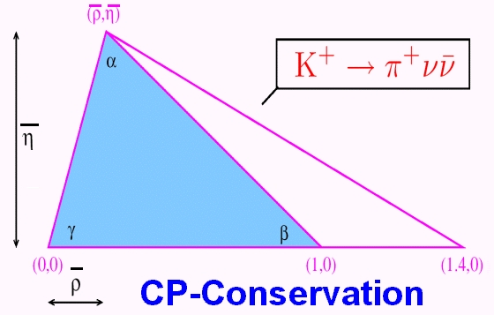

Figure 1. The decay K⁺→π⁺νν is represented by the right segment of the triangle.

The most precise experimental results have been obtained by the E787 and E949 experiments at BNL by studying of the stopped kaon decays [5]: B(K⁺→π⁺νν) = (1.73+1.15-1.05)×10-10. Existing gap between the theoretical precision and the large experimental error motivates a strong experimental effort. Significant new constraints can be obtained with a measurement of the rate of this reaction at the level of 10% or better.
Large statistics of kaon decays, which is planned to record in the proposed experiment, and the presence of detectors for accurate measurement of the decaying charged kaon kinematics and their decay products make it possible to search for a series of other rare kaon decays and to study their characteristics, including a check of the prediction [6] about the existence of Goldstone fermion superpartners - pseudoscalar sgoldstino P.
Apart from that, a series of precision measurements may be performed for the kaon rare decay modes in order to check the validity of the Chiral perturbation theory (ChPT) that provides a low energy approximation for the strong interactions description. A search for the rare decays, that are forbidden or extremely suppressed in the frameworks of SM opens a possibility to discover a new physics or to set a new limits on the validity of SM and some its extensions. It includes the search for the new light candidates to the dark matter that may be generated in rare kaon decays.
Physical motivation is presented in more details in Chapter 2 of the Proposal of the experiment [1] and in Chapter 3 of the report [4].

The strategy of the experiment
The strategy of the NA62 experiment is based on the measurement of the high energy K⁺ decays in flight. In this case, the kaons production cross section is optimized as a function of the proton energy, and the photons detection is efficient due to their high energies in the laboratory system. The experimental setup is shown in the Figure 2.
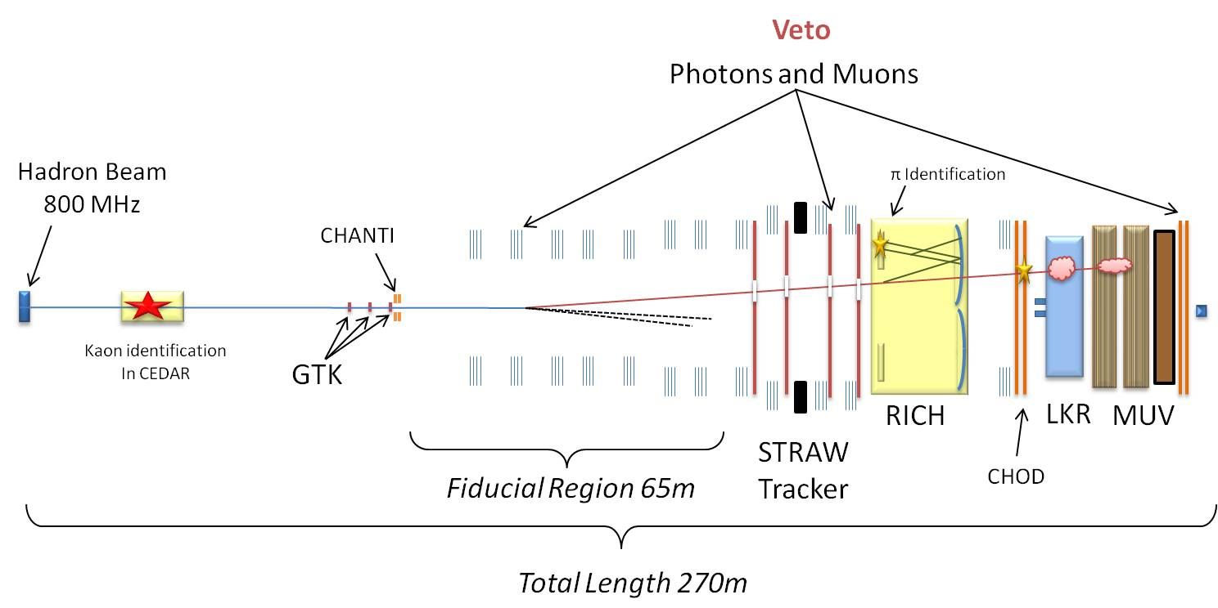
Figure 2. Schematic view of the NA62 experimental setup.
Charged products of the studied K⁺ decay are registered primarily by the straw tracker which allows one to register a single track and to measure the corresponding momentum with a good accuracy. In order to extract the signal, the distribution of the missing mass square for K⁺ and positively charged track is analyzed in assumption that the track is produced by π⁺. The missing mass distribution without experimental resolution for the K⁺→π⁺νν decay is shown in the left diagram of the Figure 3 by solid red line. The NA62 signal acceptance areas are chosen taking into account the resolution of the setup (Region I and Region II in the Figure 3). The left diagram shows the distributions of background decays, which can be separated from the signal by means of kinematics, and the right one shows cinematically inseparable background.
To suppress the background of the two-particle decays the kinematic cuts and the particle identification (PID) are necessary. Backgrounds from K⁺ three- and four-body decays are also considerable, that assumes a detailed analysis of their properties and implementation of specific rejection techniques to each of them. The K⁺ decay modes with the largest probabilities are listed in Table 1 with the methods of their suppression.
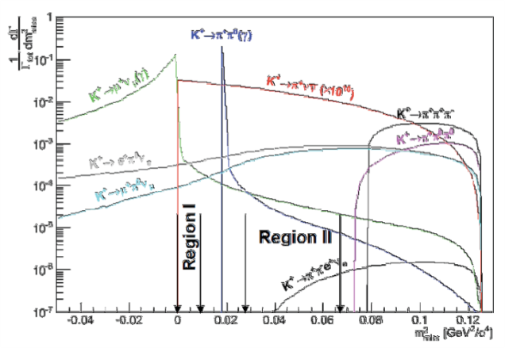
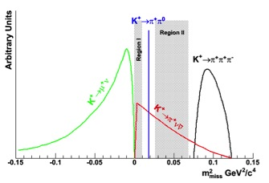

Figure. 3. Мissing mass m²_{miss} = (P_{K} – P_{track})² distribution for the signal (red line) and background events. Background decay modes that may be separated from the signal by kinematics are shown on the left plot, while the inseparable background is on the right plot.
There are also K⁺ decay modes (with branching ratios > 10⁻⁵), for example, K_{e4} (K⁺→π⁺π⁻e⁺ν) and K_{μ4}, which can have a topology similar to the studied decay in cases when both the negatively charged pion and the e⁺(μ⁺) escape detection. So it is mandatory that the π ⁻ be observed and that the detector therefore be rendered hermetic with respect to negatively charged particles of momentum < 60 GeV/c. This is provided by a system with 4 tracking detectors (chambers composed of straw tubes) forming the active elements of the Magnetic Spectrometer [3].

Table 1. The most frequent K⁺ decay modes.

Decay Mode | Branching Ratio | Background Rejection method
K⁺ →μ⁺ν | 63% (called K_{μ2}⁺) | μ PID, Two-Body Kinematics
K⁺ →π⁺π⁰ | 21% | Photon Veto, Two-Body Kinematics
K⁺ →π⁺π⁺π⁻ | 6% | Charged Particle Veto, Kinematics
K⁺ →π⁺π⁰π⁰ | 2% | Photon Veto, Kinematics
K⁺ →π⁰μ⁺ν | 3% (called K_{μ3}⁺) | Photon Veto, μ PID
K⁺ →π⁰e⁺ν | 5% (called K_{e3}⁺) | Photon veto, E/p

Additional physical goals
Apart from the main goal, NA62 collaboration plans to investigate a series of the kaon rare decay modes. JINR group participates in the analysis of the four-lepton decays K⁺→e⁺νμ⁺μ⁻, K⁺→e⁺νe⁺e⁻, K⁺→μ⁺νe⁺e⁻ and K⁺→μ⁺νμ⁺μ⁻ (not yet observed) with the branching ratios of the order of 10⁻⁸. Their precision measurement will improve our knowledge of the ChPT parameters and will check its validity. The search for the forbidden modes K⁺→e⁻νμ⁺μ⁺, K⁺→μ⁻νe⁺e⁺ is also foreseen in order to check the limits of SM.
As it is mentioned above, large statistics of kaon decays in the proposed experiment and the presence of detectors for precise measurement of incoming charged kaon and its decay products kinematics provide us with a possibility to check the prediction [6] about the existence of Goldstone fermion superpartners — pseudoscalar sgoldstino P (see Figure 4, left part). The HyperCP experiment [7] has registered 3 decays Σ→ πμ⁺μ⁻ where the mass of P→ μ⁺μ⁻, if it exists, is 214.3 MeV. Taking into account, that the doubled muon rest mass is 211.3 MeV, muons have to be generated almost in rest in the kaon system (full decay free energy in such a case is 4.83 MeV). So both charged pion and muons could move along the beam axis and avoid the detector sensitive areas in the NA48/2 experiment. But in the NA62 experiment the precise measurement of incoming K⁺ parameters provides a possibility to reconstruct the complete event kinematics without π⁺ registering for the decay P→ γγ. Moreover, for the case of decay P→ μ⁺μ⁻ and with one lost track it is still possible to use the tracker information about two another tracks downstream the magnet (their momenta will be < 20 GeV, so they will not follow the charged beam after magnet) and the RICH data.
It is planned to register ~100 events of decay with branching ratio ~10⁻¹⁰ and with an acceptance of about 10% in the NA62 experiment. This means that it will be possible to register about 50 of π⁺π⁰P decays, similar to π⁺π⁰π⁰ (acceptance 5%), even with a trigger, downscaled by a factor of 100 for the upper limit of branching ratio near 10⁻⁸, that is three orders of magnitude lower, than the limit from ISTRA experiment [8] (see Figure 4, right part).

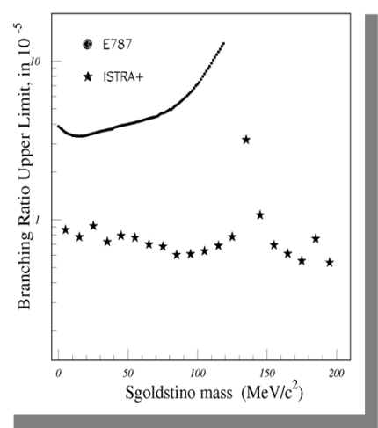

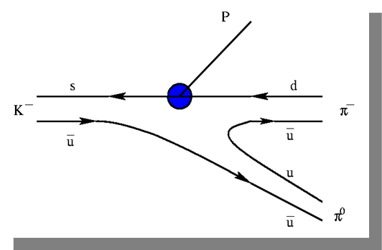

Figure 4. A diagram of supersimmetric Goldstone fermion partners production (left) and
the upper limit of sgoldstino branching ratio from ISTRA experiment [7] (right).

A search for heavy neutral lepton (HNL) production in charged kaon decays is also foreseen on the basis of NA62 data. Non-zero masses and mixing of the Standard Model (SM) neutrinos are now well established. However many SM extensions have been proposed, involving massive «sterile» neutrinos, also called heavy neutral leptons, which mix with the ordinary light «active» neutrinos. For example, the Neutrino Minimal Standard Model [9] postulates three HNLs, explaining dark matter and baryon asymmetry of the universe. The idea of the search for HNL in NA62 is based on the missing mass distributions for K⁺→e⁺ and K⁺→μ⁺ topologies with the measured kaon and lepton momenta. Heavy neutral lepton production should be visible as the peak on the missing mass distribution at the apriory unknown nonzero value of the mass.

Main characteristics of the experimental setup

The above tasks define the NA62 experimental setup design (see Figure 2). The main design idea was the redundant measurement of particle characteristics. It is required to control non-Gaussian tails for the precise measurement of event kinematics. NA62 experimental setup includes the following detector systems:
- The CEDAR identifies the K⁺ component in the beam with respect to the other beam particles by employing an upgraded differential Čerenkov (CEDAR) counter.
- The Gigatracker (GTK) consists of three Si micro-pixel stations measuring time, direction and momentum of the beam particles before entering the decay region.
- The STRAW tracker consists of 4 straw chambers. It measures the coordinates and momentum of secondary charged particles originating from the decay region. In order to minimize multiple scattering the chambers are built of ultra-light material and are installed inside the vacuum tank. The four Straw chambers are arranged around a large aperture dipole magnet (MNP33, black at the scheme), providing a vertical B-field of 0.36 T.
- The RICH detector consists of 17m long radiator filled with Neon gas at 1 atm. allowing the separation of pions and muons between 15 and 35 GeV/c.
- A system of Photon-Veto detectors provides hermetic coverage of the decay region from zero to large (~50 mrad) angles. This is assured by:
  - the existing high-resolution Liquid Krypton electromagnetic calorimeter (LKr),
  - the Intermediate Ring (IRC) and Small-Angle (SAC) Calorimeters and,
  - a series of 12 annular photon-veto (LAV or Veto) detectors for large angles.

  - The Muon-Veto detectors (MUV) are composed of the two-part hadron calorimeter followed by the additional layer of iron and the transversally segmented hodoscope. This system supplements and provides redundancy with respect to the RICH in the detection and rejection of muons.
These detectors are complemented by “guard-ring” counters (CHANTI) surrounding the last GTK station, and the charged-particle hodoscope (CHOD), covering the acceptance and located between the RICH and the LKr.
All these detectors are operated and inter-connected with a high-performance trigger and data-acquisition (TDAQ) system. The main detectors are described in details in [1,3].
The usage of a high intensity unseparated K⁺ beam required several challenging solutions that have been done during the setup design and construction:
- the detector is able to perform charged particle tracking at 1 GHz total rate, ~60 MHz/cm² with a minimal material and excellent time resolution for the kaon momentum measurement;
- the differential Cerenkov counter for the positive kaons identification (CEDAR) is built;
- hermetic photon vetoes are constructed, they are divided in three angular regions and use three different detection techniques for γ-rejection;
- μ/π separation is performed by the RICH counter for μ rejection and for track kinematics reconstruction;
- and finally, the magnetic spectrometer for momentum measurement of kaon decay charged products together with RICH provides a redundancy in missing mass reconstruction to suppress a possible non-gaussian tails.

The NA62 experimental setup has been constructed and tested during the autumn 2014 run with CERN SPS beams. Experts from JINR and CERN have provided the construction and installation of the track spectrometer detectors designed and built during the two NA62 project stages completed in JINR earlier (in 2010-2012 and in 2013-2015).

Construction of the magnetic spectrometer modules based on straw tubes
A spectrometer configuration based on the straw tracker has been adopted for the detection and measurement of charged decay products upstream the RICH counter. To minimize the multiple scattering of the outgoing decay products the spectrometer detectors are installed in vacuum. The straw tracker is designed without internal frames and flanges. It is important to diminish the background arising from the beam halo. The straw tracker consists of 4 chambers based on straw tubes and positioned upstream and downstream the MNP33 spectrometer magnet.
Each chamber consists of four coordinate views - X, Y, U, V. Desirable momentum and angle precision for secondary particles is estimated to be Δp/p≤ 1% and Δθ_{πK} ≤ (50 – 60) μrad. These requirements are achieved by means of minimum matter along the particle trajectory and the spatial resolution of the tracker about ~80 μm for a space point.
The main element of the detector is an ultra-light straw tube ~2.4 m long (2.1 m of effective length) and 9.8 mm in diameter. The tubes are manufactured from 36 µm thin polyethylene terephthalate (PET) foils, coated inside the tube with two thin metal layers (0.05 μm of Cu and 0.02 μm of Au) in order to provide electrical conductivity on the cathode and to suppress the straw tube gas diffusion. The anode wire (Ø=30 mm) is made of gold-plated tungsten.
Studies performed with three straw prototypes allowed us to estimate the achievable characteristics of the constructed detectors with different gas mixtures and various read-out electronics, radiation resistance of straw tubes, as well as to design the optimal scheme of straw positioning inside the mechanical framework that allows to achieve a high efficiency of tracks registration by the spectrometer detectors. These works are described in details in the report on the 2010 - 2012 stage of the NA62 project.
After the installation of straw chambers into the NA62 experimental setup in 2014 (see. Fig. 5) their actual position has been measured with respect to the beam axis with an accuracy of 0.3 mm. Vacuum tests of straw detectors have been conducted in real experimental conditions - the level of the gas leak was in the normal range. All the necessary cables and gas communications for the chambers have been laid. The gas supply system with a protection from the effects of a possible straw damage in a setup vacuum volume has been mounted as well. 4 MPOD modules with high-voltage and low-voltage power supplies have been installed for powered straw tracker (see. Fig.6, left). JINR staff members have developed a user-friendly management interface of these modules (Fig.6, right). Integration of these 4 modules into the common "NA62 slow control” system of the NA62 experiment were carried out as well.

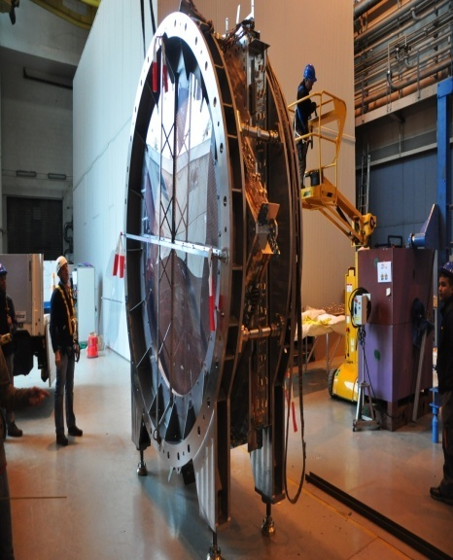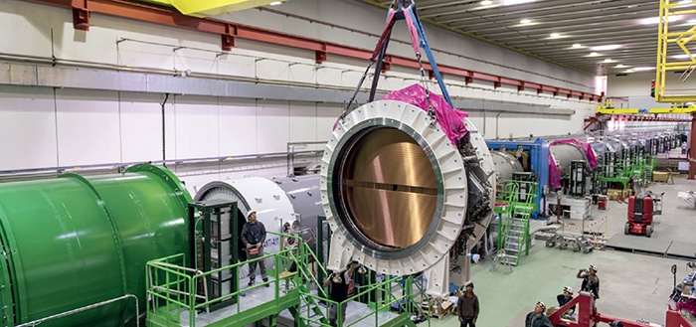
Figure 5. Straw chamber assembled of 2 modules (left) and its installation into the NA62 experimental setup (right).

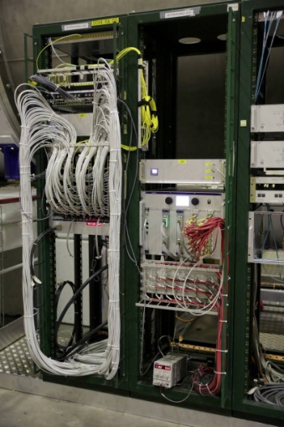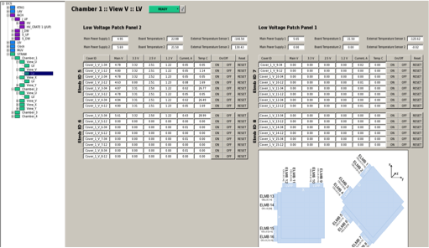
Figure 6. MPOD module with high- and low-voltage power supplies for one straw chamber (left) and user interface control panel (right).

A shape of the experimental leading edge time distribution in a straw tube has been compared with the simulation one. A good agreement of these spectra (see. Fig. 7) allowed one to use at the first stage the simulated relation between the drift time and the coordinate of a particle in a straw. Time shifts of the track hit T₀ for each straw are adjusted with respect to the reference time given by the charged particles hodoscope CHOD of the NA62 set-up.
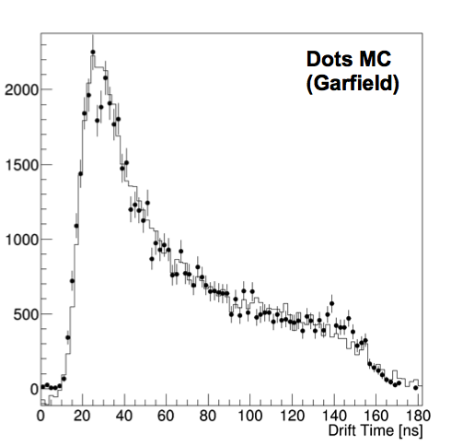
Figure 7. The typical shape of the leading drift time distribution in the straw tube:
points – the simulation results, solid line - the experimental data.

The main results of the preparation and carrying out of the 2016 - 2017 runs
During the physics NA62 run in 2016 a stable data taking was performed at the intensity of 13×10¹¹ protons per pulse on the target used for the kaon flux generation (40% of nominal intensity). The intensity was limited by the beam time structure (including 50 Hz variations) that was leading to the increased maximum values of the beam intensity during the burst, that were much higher than it was expected. As a result, the backend electronics of some detectors (including the Spectrometer electronics) was not able to process the data during the peaks of intensity. Nevertheless, about 4×10¹¹ kaon decays have been collected with a special mixture of trigger conditions useful for the Κ → π⁺νν mode analysis.
Due to the firmware development, for the NA62 run in 2017 the data taking was possible at 60% of nominal intensity, that seems to be a maximum of the given time structure of the beam. During this run nearly 3×10¹² kaon decays have been recorded.
The similar run conditions are expected for the run of 2018. The total expected statistics to be collected in 2016-2018 will correspond to 10 – 15 signal events for the SM predicted branching ratio. So there is a preliminary plan to perform the data taking also after the long shutdown scheduled for 2019-2020 in order to complete the Κ → π⁺νν measurement with the statistics initially foreseen by the experiment Proposal.
The intermediate results of the main mode analysis are based on the 5% of the 2016 run statistics. The blind analysis strategy is adopted, so the data used for the selection cuts optimization will not participate in the final signal measurement – that is why only a very small part of collected data may be considered at the present stage of the analysis.
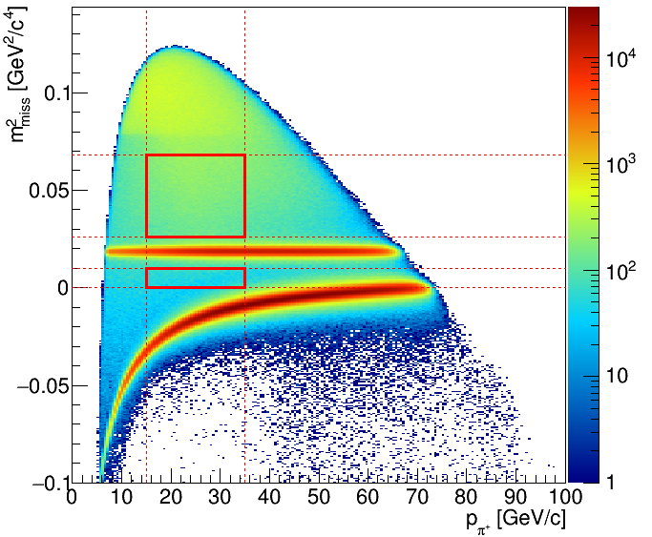
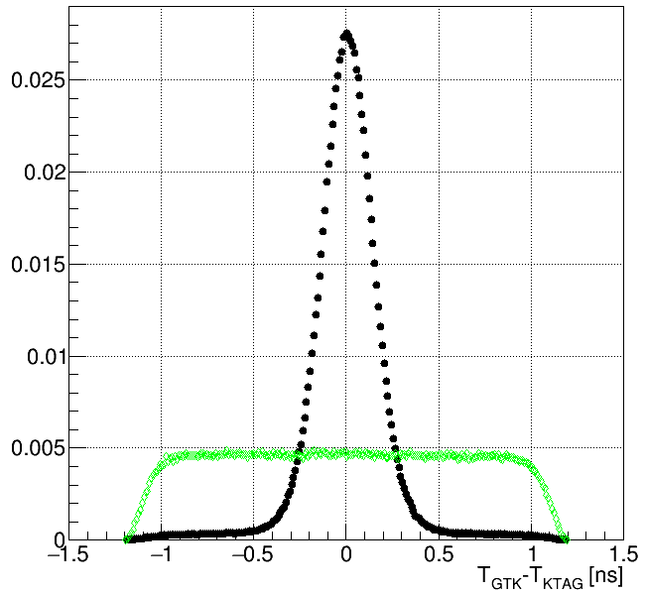

Figure 8. Left: GTK and KTAG (CEDAR) time difference distributions for the kaons corresponding to the selected K⁺ →π⁺π⁺π⁻ decays (black points) and for the accidental combinations (green points).
Right: Missing mass versus the positively charged track momentum for the data collected with a minimum bias trigger in 2016. Red boxes show signal regions.
Fig. 8 (left plot) demonstrates the time resolution for the two detectors measuring the incoming charged kaon: Gigatracker and KTAG (CEDAR). The time difference peak is formed by the KTAG time resolution of ~ 100 ps and KTAG resolution of 80 ps. The probability of accidental kaon mis-tagging is estimated to be 1.7%. The typical closest distance between the kaon and pion tracks forming a physical vertex is ~ 1.5 mm.
The right plot of the Fig. 8 shows the kinematical plots for the minimum bias data. The largest background sources are K⁺→π⁺π⁺π⁻ (dominating above 0.07 GeV²/c⁴), K⁺→π⁺π⁰ (the peak near 0.02 GeV²/c⁴) and K⁺→μ⁺ν (the negative missing mass zone). One can see, that the main backgrounds are detected with the expected characteristics, so their kinematical suppression is expected to be efficient.
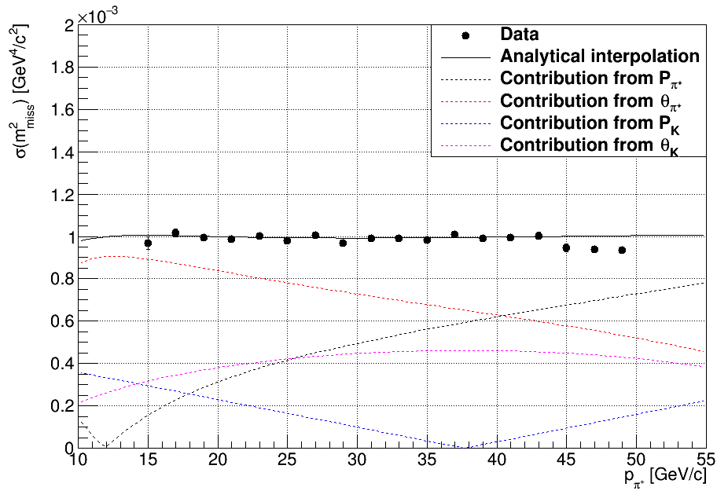

Figure 9. Resolution of the missing mass measured from the K⁺ →π⁺π⁰ data (black dots) shown with the separate contributions from different sources estimated from MC simulation.
Fig. 9 shows the reached resolution of the missing mass with respect to the design level corresponding to 1. One can see, that the design level is well reproduced, so the contributions from the Spectrometer side (listed on the plot as pion-related values) do not exceed the expected values. The measured kinematical suppression is ~ 6×10⁻⁴ for π⁺π⁰ and ~ 3×10⁻⁴ for μ⁺ν decay, that corresponds to the expectations of the experimental design.
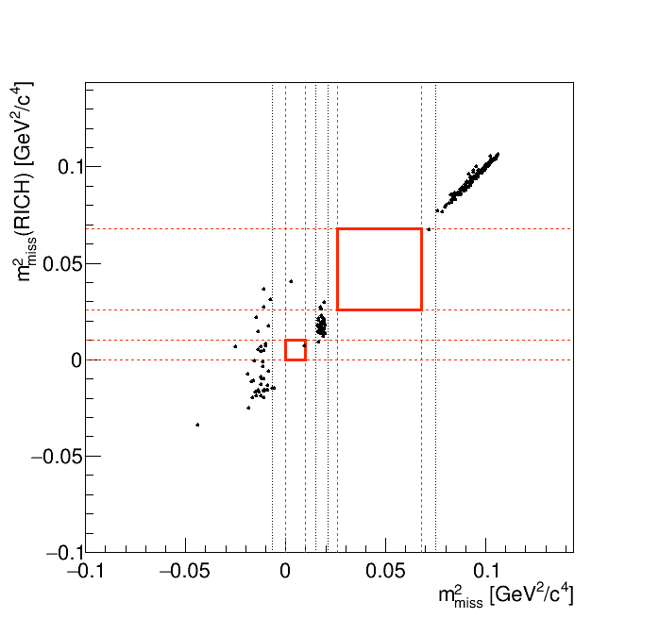
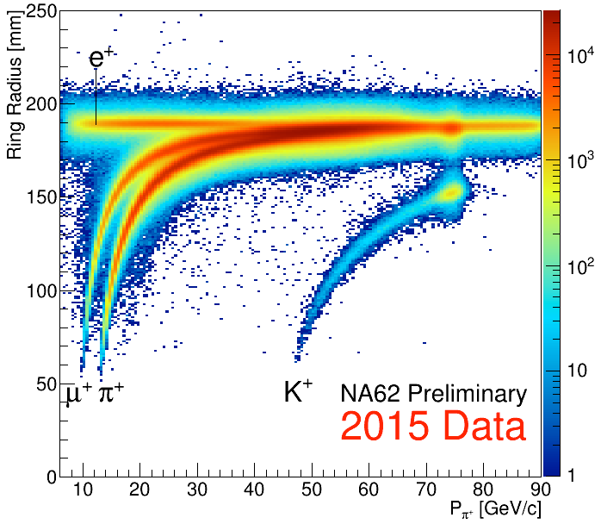

Figure 10. Left: RICH ring radius vs the track momentum (data collected in 2015). Right: the signal extraction result from 5% of 2016 data set. The missing mass values for the two definitions are plotted: track missing mass and RICH one.
Fig. 10 illustrates the efficiency of the particles identification by means of RICH data that is used for the separation between the charged pions and muons. For the signal region of pion momentum (< 35 GeV) muons efficiency is below 0.01 for the pions detection efficiency of 80%. But the combined identification performance using RICH together with calorimeters corresponds to the muons suppression at the level < 10⁻⁷.
The NA62 calorimeters (Lkr, LAV, IRC and SAC) are used for the photons suppression. The K⁺→π⁺π⁰ efficiency measured from data with the photons suppression applied is (1.2 ± 0.2)×10⁻⁷, while the expected accidental loss of the signal is ~15%.
The expected amount of signal events in the considered 5% of 2016 data set (2.3 ×10¹⁰ kaon decays) is much less than one, and no events in the signal region have been found (see the right plot of Fig. 10).

NA48/2 and NA62 data analysis in 2016 - 2018

NA48/2 and NA62 experimental data obtained in 2003 – 2010 were analyzed in parallel with the NA62 data taking:
- On the basis of NA48/2 data, a new upper limit on the rate of the lepton number violating decay K±→π±μ⁺μ⁻ has been obtained: B(K±→π± μ⁺μ⁻) < 8.6×10⁻¹¹ at 90% CL [10,32,33]. Searches for two-body resonances have been resulted in the upper limits for the products of branching ratios B(K±→μ±N₄)B(N₄→πμ) and B(K±→π±X)B(X→μ⁺μ⁻). These limits depend on the hypothetical particle lifetime (10⁻⁹ and 10⁻¹¹ for the resonance lifetime below 100 ps).
- On the basis of NA62 data collected in 2007, a measurement of π ⁰ electromagnetic transition form factor slope parameter has been measured to be a=(3.68±0.57)×10⁻² [11]. The obtained result is in good agreement with the theoretical expectations and earlier measurements. It is the most precise experimental determination of the slope in the time-like momentum transfer region.
- A peak search has been performed in the reconstructed missing mass spectrum of K⁺→μ⁺ν decays collected by NA62 experiment in 2007. In the absence of a signal, limits in the range 2×10⁻⁶ to 10⁻⁵ have been set on the squared matrix element |U_{μ4}|² describing the mixing between the muon and heavy neutrino states, for the heavy neutrino masses in the range 300-375 MeV/c² [12,13].
- The paper on the measurement of form factors of K_{e3} and K_{μ3} decays based on NA48/2 data is in preparation after the internal reviewing. Preliminary results on the form factors of the semileptonic decays of charged kaons have been presented at the conferences [14]. Dubna group has the responsibility for the final result publishing.
- The analysis of the new rare decay K±→ π±π⁰e+e- based on NA48/2 data is in its final stage, it is the first experimental evidence of this channel. The preliminary value of the measured branching fraction of this decay Br(π±π0e+e-)= (4.22 ± 0.06_{stat}±0.04_{syst}±0.13_{ext})×10⁻⁶ is obtained [14].
- The study of K_{µ4}⁰⁰ rare decay on the basis of NA48/2 data is in progress, a preliminary result on the branching ratio is obtained. This decay mode also has not been experimentally observed earlier.
- The analysis of the four-lepton kaon decays is started on the basis of the NA62 data collected in 2016 and 2017 years.
In parallel with the experimental works the following methodical and theoretical results have been obtained:
- The interactive software tool for the straw spectrometer geometrical, data taking and power supply mapping has been developed for the use in NA62 collaboration.
- The calibration and monitoring tool for the control of the straw time measurement stability on the burst-by-burst basis has been developed. It is implemented for the correction of data collected in 2016 and for the special on-line monitoring during the run 2017.
- The analysis software tool has been developed for the control of the straw wire positions and the tube transverse displacements. It uses the two-dimensional plots of the hit times and the distances between the reconstructed Spectrometer track and the wire where the hit is recorded.
- A review of the kaon decay studies performed by NA48, NA48/1 and NA48/2 collaborations has been prepared and published [15].
- The NA62 drift chamber design has been published [16]. A 2150×2150 mm 2 registration area drift chamber capable of working in vacuum is presented. Thin-wall tubes (straws) of a new type are used in the chamber. A large share of these 9.80 mm diameter drift tubes are made in Dubna from metalized 36 µm Mylar film welded along the generatrix using an ultrasonic welding machine created at JINR. The main features of the chamber and some characteristics of the drift tubes are described.
- The NA62 spectrometer acquisition system has been described in the paper [17]. The front-end and read-out systems of the detector are presented along with the first results of the detector performance.
- For the development of charged particle detectors based on straw tubes operating in vacuum, a special measurement technique is required for the evaluation of their mechanical properties. The known equations that govern straw behaviour under internal pressure are reviewed, and a new experimental method of a strained pressurized straw tube study is proposed. The Poisson's ratio of the straw wall, which defines the stability conditions of a built-in tube, is measured for the NA62 spectrometer straw [18].
- It is shown that positions of wires in straws and thus the anode spacing in the drift chambers can be directly determined with a high accuracy (~5–10 µm) using a microscope mounted on a high-precision optical bench. These data are important for decreasing errors during reconstruction of charged particle track coordinates in the drift chambers [19,35].
- A design of the device for fabricating thin-wall (straw) drift tubes using polyethylene terephthalate film 36 μm thick by ultrasonic welding is published as well as the technique for controlling their quality [20,34].
- The interactions of transversely and longitudinally polarized vector mesons with nucleons have been studied theoretically [21,22]. The measurements of vector meson photoproduction in the incoherent region provide a unique opportunity to extract the yet unmeasured total cross section for longitudinally polarized mesons.
- The production of two-meson electromagnetic bound states and free meson pairs in relativistic collisions has been considered. It is shown that using of exact Coulomb wave functions for dimeson atom (DMA) allows one to calculate the yield of discrete states with the desired accuracy. The relative probabilities of production of DMA and meson pairs in the free state are estimated. The amplitude of DMA transition from 1S to 2P state, which is essential for the pionium Lamb shift measurements, has been obtained [23].
- The meson-nucleon total cross sections can be extracted by measuring the absorption of mesons in production off nuclei as the nuclear absorption depends on the meson-nucleon total cross section and consequently on the vector meson polarization. The possibility of difference in interaction of transverse and longitudinally polarized vector mesons with nucleons is discussed [24].

Obtained results in 2016-2018 were presented at the international conferences, including 12 presentations given by the representatives of JINR group [14,22,24-33]. During the NA62 experimental runs in 2016-2018 the JINR group members will perform in total about 250 shifts.
The series of scientific works of Dubna group “Development and construction of gas-filled detectors based on a new type of straw tubes for operation in vacuum in the track spectrometer of the NA62 experimental set-up” was awarded a first JINR prize (2017) in the nomination of scientifically-methodical works. Two patents for inventions are obtained by the JINR group members [34,35].
During the execution of the NA62 Project of 2019 – 2021 the Dubna group plans the following works:
- to perform the fine calibration and alignment of straw detector on the basis of collected data;
- to improve the straw detector Monte Carlo simulation used for the main NA62 analysis;
- to participate in the analysis of some background sources for the K⁺→ π⁺νν decay.
- to perfom data processing and analysis of the collected experimental data to measure the four-lepton decay modes of charged kaon;
- to search for the light sgoldstio signatures;
- to perform the diagnostics and necessary repair of the Spectrometer straw chambers and their low and high voltage power supply during the shutdown in 2019-2020.
- to participate in the next NA62 data taking run in 2021.
- to support the Spectrometer during the data taking run in 2021.

Costs estimation
The total expenses for the creation of new elements of detectors for the NA62 experiment are estimated at the level of 40 million Swiss francs (CHF) where the JINR contribution according the MoU is 1.5 million Swiss francs. In the realization of previous stages of the NA62 project at JINR 12 experts of different fields have been involved. We propose to have 2 more PhD students for the participation in the third part of the Project.
The total JINR expenses during 2016-2018 years to the third stage of the project (the theme of 1096) realization are $504.7k. About $10 thousand have been paid by CERN and collaboration NA62 for the support of the straw detector; about $10k is allocated by CERN for travel support of the JINR experts to CERN. The NA62 Collaboration allocates 30K CHF in 2016 for JINR engineers needed to support of common works into the Collaboration during the preparation of the experiment.
The volume of the necessary funding for the years 2019-2021 from the JINR budget is $370k. Most of the funds required for the participation of JINR employees in experimental run 2021 of the NA62 set-up and maintenance the work for a development of straw detectors and on-line software systems for control this work, for the payment of JINR contributions into the collaboration common fund in accordance with the obligations under the MoU, to provide computer and technical support of simulation, processing and analysis of accumulated experimental data. Funding from other sources will be at least $10k.
Resources, required for the project realization, are presented below as their description and as the list of project costs.

References

- NA62 COLLABORATION; F.Ambrosino et al. Proposal to Measure K→πνν rare decay at the CERN SPS. CERN-SPSC-2005-013, 2005.
- NA62 COLLABORATION; F.Hahn et al. NA62 Technical Design Document. NA62-10-07, CERN, 2010, 414 pp.
- Eduardo Cortina Gil et al. The beam and detector of the NA62 experiment at CERN. JINST 12 (2017) no.05, P05025.
- NA62 COLLABORATION; F.Ambrosino et al. NA62 Status Report. CERN-SPSC-2007-035.
- A.V.Artamonov et al. (E949 Collaboration). New Measurement of the K⁺ → π⁺νν branching ratio. Phys. Rev. Lett. 101 191802, 2008.
- D.S.Gorbunov, V.A. Rubakov. Phys.Rev.D73:035002, 2006.
- J.Antos at al. Search for CP Violation in the Decays of X⁻ X⁺ and Hyperons. Fermilab Proposal P-871. FNAL 1994.
- O.G.Tchikilev et al. (ISTRA) Phys.Lett. B602:149-156, 2004.
- T.Asaka and M.Shaposhnikov, Phys. Lett. B620 (2005) 17.
- J.R.Batley et al. Searches for lepton number violation and resonances in K±→πμμ decays. Phys.Lett. B769 (2017) 67-76.
- C.Lazzeroni et al. Measurement of the π electromagnetic transition form factor slope. Phys.Lett. B768 (2017) 38-45.
- E.Cortina Gil et al. Search for heavy neutral lepton production in K+ decays. CERN-EP-2017-311. 2017. 15 pp.
- C.Lazzeroni et al. Search for heavy neutrinos in K+→μ+ν decays. Phys.Lett. B772 (2017) 712-718.
- D.Madigozhin. New and recent results from NA48/2. Proceedings of the 52nd Recontres de Moriond. QCD and High Energy Interactions. ARISF. 2017.
- A.Cecucci, E.Goudzovski, V.Kekelidze, D.Madigozhin, I.Potrebenikov. Kaon decay studies at CERN SPS in the last decades. Phys.Part.Nucl. 47 (2016) no.4, 567-590.
- N.Azorskiy et al. A drift chamber with a new type of straws for operation in vacuum. Nucl.Instrum.Meth. A824 (2016) 569-570.
- N.Azorskiy et al. The NA62 spectrometer acquisition system. JINST 11 (2016) no.02, C02064.
- L.Glonti et al. Longitudinal tension and mechanical stability of a pressurized straw tube. JINR preprint E1-2017-20. 20 pp.
- L.Glonti et al. Determination of the anode wire position by visible light in a new type straw for NA62 experiment tracker. Nucl.Instrum.Meth. A824 (2016) 532-534.
- N.I.Azorskii et al. New type of drift tubes for gas-discharge detectors operating in vacuum: production technology and quality control. Phys.Part.Nucl.Lett. 14 (2017) no.1, 144-149.
- E.Chudakov, S.Gevorkyan, A.Somov. Photoproduction of ω mesons off nuclei and impact of polarization on the meson-nucleon interaction. Phys.Rev. C93 (2016) no.1, 015203.
- S.Gevorkyan. The impact of vector mesons polarization on meson-nucleon interaction. 16th Workshop on High Energy Spin Physics (DSPIN-15). J.Phys.Conf.Ser. 678 (2016) no.1, 012033.
- L.Afanasyev, S.Gevorkyan, O.Voskresenskaya. Production of dimeson atoms in high-energy collisions. Eur.Phys.J. A53 (2017) no.4, 78.
- S.Gevorkyan. Vector mesons polarization versus color transparency. 23rd International Baldin Seminar on High Energy Physics Problems : Relativistic Nuclear Physics & Quantum Chromodynamics. (Baldin ISHEPP 23). EPJ Web Conf. 138 (2017) 08004.
- Yu.Potrebenikov. A new system of STRAW chambers operating in vacuum for the NA62 experiment. J.Phys.Conf.Ser. 800 (2017) no.1, 012047.
- S.Shkarovskiy. NA62 spectrometer to search for K⁺→π⁺νν. 14th Topical Seminar on Innovative Particle and Radiation Detectors (IPRD16). Siena. Italy. 2016. JINST 12 (2017) no.02, C02027.
- S.Shkarovskiy. Recent measurement of Kl3 form factors at NA48. 23th International Workshop on High Energy Physics and Quantum Field Theory (QFTHEP 2017). EPJ Web Conf. 158 (2017) 03007.
- S.Shkarovskiy. Recent QCD-related Results from Kaon Physics at CERN (NA48/2 and NA62). 9th Workshop "Excited QCD" 2017. Acta Phys.Polon.Supp. 10 (2017) 1153-1158.
- S.Shkarovskiy. Recent results from the NA48 experiment at CERN. 3rd International Conference on Particle Physics and Astrophysics (ICPPA 2017). J.Phys.Conf.Ser. 934 (2017) no.1, 012031.
- E.Goudzovski. Kaon experiments at CERN: recent results and prospects. 14th International Workshop on Meson Production, Properties and Interaction (MESON 2016). EPJ Web Conf. 130 (2016) 01019.
- E.Goudzovski. Neutral pion form factor measurement at NA62. 38th International Conference on High Energy Physics (ICHEP 2016). PoS ICHEP2016 (2017) 642.
- D.Madigozhin et al. Searches for lepton number violation and resonances in the K±→πμμ decays at the NA48/2 experiment. New Trends in High-Energy Physics. Budva, Becici, Montenegro. 2016.
- A.Zinchenko et al. Searches for lepton number violation and resonances in the K±→πμμ decays by NA48/2 at CERN. 14-th International Conference on Meson-Nucleon Physics and the Structure of the Nucleon. July 25-30, 2016, Kyoto, Japan.
- S.A.Movchan et al. A device for the production of cylinder tubes for the gas-filled drift detectors of ionizing radiation. Patent #2555693. 8.06.2016.
- L.Glonti et al. A device for the measurement of wire positions in gas wire chambers. Patent #2602492. 15.09.2016.

Requested resources for Proposal realization

 | Units. | Requirement  resources in 2019-2021 | The offer of the Laboratory  on distribution of resources
 |  |  | 1-year | 2-year | 3-year
The basic units and the equipment:
Necessary resources:  a) Laboratory Fabric  b) DB of the Laboratory | norm-hour  norm-hour
c) The accelerator  d) The reactor  e) Computers | hour.  hour.  hour.
Working costs | thousand US $
Source of financing:  budget  including foreign currency means | Thousand US $  Thousand US $ | 380  370 | 103  100 | 103  100 | 174  170
Contributions of collaborants  Grants (INTAS+ISTC)  Sponsors  Contracts  Other sources | thousand US $  thousand US $  thousand US $  thousand US $  thousand US $ | 10 | 0 | 5 | 5

Cost calculation from JINR budget.

№ | Expenses item | Unit | 2019 | 2020 | 2021 | 2019 – 2021
 | Direct costs for the project
0. | Operational costs | K USD | 35 | 35 | 35 | 105
1. | Accelerators
2. | Design office
3. | Workshops
4. | Materials and consumables | K USD | 5 | 5 | 10 | 20
5. | Equipment | K USD | 10 | 10 | 15 | 35
6. | Payments for R&D works performed according contracts | K USD
7. | Travel expenses, including: | K USD | 53 | 53 | 114 | 220
 | a) to countries a) outside the ruble zone | K USD | 50 | 50 | 110 | 210
 | b) to the ruble zone countries | K USD | 3 | 3 | 4 | 10
 | c) according to protocols
 | Total direct expenses | K USD | 103 | 103 | 174 | 380

Schedule

 |  | Year
## | Item | 2019 |  |  |  | 2020 |  |  |  |  | 2021
 |  | I | II | III | IV | I | II | III | IV | I |  | II | III | IV
1 | Calibration of the straw detectors
2 | Data taking
3 | Data processing and analysis of collected data
4 | Participation in a simulation of mass production
5 | Monitoring of straw detectors during the runs

