**The Flerov Laboratory of Nuclear Reactions**

**Category:** Applied Physics Research

**Title**: **Composite and Hybrid Functional Nanomaterials Based on Track Membranes**

**Authors:** A.N. Nechaev, P.Yu. Apel, A. Rossouw, I.I. Vinogradov,   
O.V. Kristavtchuk, E.V. Andreev, L.I. Kravets, V.I. Kukushkin, B.L. Gorberg,   
L.F. Petrik

#### List of publications:

1. **A. Rossouw, O. Kristavchuk, A. Olejniczak, C. Bode-Aluko, B. Gorberg, A. Nechaev, L. Petrik, W. Perold, P. Apel. Modification of polyethylene terephthalate track etched membranes by planar magnetron sputtered Ti/TiO₂ thin films**. (2021). Thin Solid Films. <https://doi.org/10.1016/j.tsf.2021.138641>
2. **A. Rossouw, A. Olejniczak, K. Olejniczak, I. Vinogradov, O. Kristavchuk, A. Nechaev, S. Dmitriev, W. Perold, B. Gorberg, L. Petrik. Ti and TiO₂ magnetron sputtering in roll-to-roll fabrication of hybrid membranes**. (2022). Surfaces and Interfaces. [https://doi.org/10.1016/j.surfin.2022.101975](https://doi.org/10.1016/j.surfin.2022.101975" \t "_new)
3. **C. Bode-Aluko, O. Pereao, K. Laatikainen, A. Nechaev, L. Petrik. Morphology, Modification and Characterisation of Electrospun Polymer Nanofiber Adsorbent Material Used in Metal Ion Removal**. (2019). Journal of Polymers and the Environment. [https://doi.org/10.1007/s10924-019-01497-w](https://doi.org/10.1007/s10924-019-01497-w" \t "_new)
4. **O. Pereao, K. Laatikainen, C. Bode-Aluko, I. Kochnev, O. Fatoba, A. Nechaev, L. Petrik. Adsorption of Ce³⁺ and Nd³⁺ by diglycolic acid functionalised electrospun polystyrene nanofiber from aqueous solution**. (2019). Separation and Purification Technology. [https://doi.org/10.1016/j.seppur.2019.116059](https://doi.org/10.1016/j.seppur.2019.116059" \t "_new)
5. **I.I. Vinogradov, E.V. Andreev, N.S. Yushin, A.S. Sokhatskii, V.A. Altynov, M.V. Gustova, T.N. Vershinina, I. Zin’kovskaya, A.N. Nechaev, P.Yu. Apel. A Hybrid Membrane for the Simultaneous Selective Sorption of Cesium in the Ionic and Colloid Forms**. (2023). Theoretical Foundations of Chemical Engineering. [https://doi.org/10.1134/S0040579523040498](https://doi.org/10.1134/S0040579523040498" \t "_new)
6. **I.I. Vinogradov, N.A. Drozhzhin, L.I. Kravets, A. Rossouw, T.N. Vershinina, A.N. Nechaev. Formation of Hybrid Membranes for Water Desalination by Membrane Distillation**. (2024). Colloid Journal. [https://doi.org/10.1134/S1061933X24600519](https://doi.org/10.1134/S1061933X24600519" \t "_new)
7. **O. Pereao, C. Uche, P.S. Bublikov, C. Bode-Aluko, A. Rossouw, I.I. Vinogradov, A.N. Nechaev, B. Opeolu, L. Petrik. Chitosan/PEO nanofibers electrospun on metallized track-etched membranes: fabrication and characterization**. (2020). Materials Today Chemistry. <https://doi.org/10.1016/j.mtchem.2020.100416>
8. **P.A. Markov, I.I. Vinogradov, E. Kostromina, P.S. Eremin, I.R. Gilmutdinova, I.S. Kudryashova, A. Greben, A.P. Rachin, A.N. Nechaev. A wound dressing based on a track-etched membrane modified by a biopolymer nanoframe: physicochemical and biological characteristics**. (2022). European Polymer Journal. [https://doi.org/10.1016/j.eurpolymj.2022.111709](https://doi.org/10.1016/j.eurpolymj.2022.111709" \t "_new)
9. **G.M. Ndilowe, C.A. Bode-Aluko, D. Chimponda, O. Kristavchuk, I. Kochnev, A. Nechaev, L. Petrik. Fabrication of silver-coated PET track-etched membrane as SERS platform for detection of acetaminophen**. (2021). Colloid and Polymer Science. [https://doi.org/10.1007/s00396-021-04900-y](https://doi.org/10.1007/s00396-021-04900-y" \t "_new)
10. **G. Zhdanov, E. Nyhrikova, N. Meshcheryakova, O. Kristavchuk, A. Akhmetova, E. Andreev, E. Rudakova, A. Gambaryan, I. Yaminsky, A. Aralov, V. Kukushkin, E. Zavyalova. A Combination of Membrane Filtration and Raman-Active DNA Ligand Greatly Enhances Sensitivity of SERS-Based Aptasensors for Influenza A Virus**. (2022). Frontiers in Chemistry. [https://doi.org/10.3389/fchem.2022.937180](https://doi.org/10.3389/fchem.2022.937180" \t "_new)

#### ****Abstract****

**Motivation:**

The relevance of developments in the field of composite and hybrid nanomaterials is driven by the growing demand for high performance filtration, separation and adsorption technologies. The research of the team of authors focuses on the creation of track membranes (TMs) with new functional properties by modifying the hydrophilic-hydrophobic balance of the surface, imparting photocatalytic activity and creating specific selectivity. These properties are in demand in applications such as water desalination, rare earth extraction, radioactive contaminant purification and rapid virus detection. TMs modified with nanomaterials open up perspectives for innovative solutions in membrane technologies and medicine.

**Purpose:**

Our primary research goal is to enhance the performance and versatility of TMs. Magnetron sputtering and electrospinning techniques provide a targeted and precisely controlled modification of the TM surface. Their use opens the way to the creation of composite and hybrid membranes with tailored functionalities, including increased durability, selective adsorption, and resistance to fouling, making them promising candidates for water purification, biotechnology and medicine. Figure 1 summarises the concept and approaches developed in the articles to create new functional TMs.

**Methods and innovative approaches:**

Our group's research includes several key nanotechnological approaches to enhance the performance and functionalities of TMs. One of these is the "bottom-up" nanotechnology approach associated with the physicochemical deposition of nanoscale films, fibres and colloidal nanoparticles. With the current method, the following objectives have been solved:

* **Enhance Surface Hydrophilicity and Design Membranes with Photocatalytic Activity;**

Through planar magnetron sputtering, we deposited titanium (Ti) and titanium dioxide (TiO₂) thin films onto track-etched polyethylene terephthalate (PET) membranes. These coatings improved the hydrophilicity and photocatalytic activity, reducing the potential for organic fouling — a key advancement for water treatment systems. This self-cleaning ability, combined with improved wettability, results in membranes that require less maintenance and have increased longevity, aligning well with environmental and industrial needs [1, <https://doi.org/10.1016/j.tsf.2021.138641>].

* **Selective Adsorption of Toxic Ions and Recovery of Rare Earth Metals;**

Through polymer electrospinning method onto metallized TMs, it is possible to create hybrid membranes with a nanofiber layer. Functionalizing of electrospun nanofibers with selective ligands leads to specific and efficient capturing of metal ions. This process enhances adsorption capacity and selectivity, addressing critical needs for selective recovery of valuable or toxic metals from wastewater, which is of great importance in environmental and industrial applications [3, <https://doi.org/10.1007/s10924-019-01497-w> ; 4, <https://doi.org/10.1016/j.seppur.2019.116059> & 7, <https://doi.org/10.1016/j.mtchem.2020.100416>].

* **Highly Selective Caesium Removal;**

Composite membranes for selective adsorption of caesium radionuclides were developed by combing properties of chitosan nanofibers and ferrocyanide complexes. Selective adsorption of radionuclides — a crucial property for environmental remediation [5, <https://doi.org/10.1134/S0040579523040498>].

* **Enhance Surface Hydrophobicity and Design Membranes for Desalination;**

Electrospinning of polyvinylidene fluoride onto metallized TMs leads to sharp increasing of membranes’ hydrophobicity. Hybrid membranes expressed high efficiency and performancein desalination processes. Both key parameters such as salt rejection coefficient and condensate flux were higher than those of commercially produced fluoropolymer membranes [6, <https://doi.org/10.1134/S1061933X24600519>].

* **Design Composite Membranes Modified by** **Surface-Enhanced Raman Scattering Active Nanoparticles;**

A method based on using complexing agent for track-etched membranes modification by silver nanoparticles was developed and optimized. Performance experiments were carried out to confirm the presence of surface-enhanced Raman scattering effect and to determine the enhancement factor. As a results, the composite membranes expressed the enhancement factor as high a**s** 2·108 [9, <https://doi.org/10.1007/s00396-021-04900-y>].

**Proposed innovation areas:**

Examples of composite metallized membranes industrial production using magnetron sputtering methods are described in articles.

The roll-to-roll magnetron sputtering of Ti/TiO₂ coatings offers a scalable manufacturing process for these membranes allowing for commercial production. That large-scale fabrication of composite membranes was organized based on existing magnetron coaters УМН-180 and ММ-180 in «ИВТЕХНОМАШ» LLC. These composite membranes are required in biotechnology and separation technologies [2, <https://doi.org/10.1016/j.surfin.2022.101975>]. The electrospinning method to produce hybrid membranes modified by nanofibers from various polymers is also scalable manufacturing process. As an example, using electrospinning device NANON-01A (CAP FLNR) 600 cm2 per unit of highly hydrophobic membrane for **desalination were obtained.**

The applications of these composite and hybrid TMs span a wide range of sectors:

* **Environmental Remediation:** hybrid membranes that selectively adsorb radionuclides address urgent needs in contaminated water management, particularly in areas affected by radioactive pollution.
* **Medical and Diagnostic Fields:** our membranes modified with biopolymers such as chitosan and collagen offer biocompatibility and customizable properties that enhance wound healing. These attributes make them promising materials for advanced wound dressing applications [8, <https://doi.org/10.1016/j.eurpolymj.2022.111709>].
* **Diagnostics and Rapid Virus Detection:** By integrating track-etched membranes into surface-enhanced Raman spectroscopy (SERS) platforms, we increase detection sensitivity, providing a quicker and cheaper alternative to PCR tests for viruses. This rapid testing potential is invaluable in the context of pandemics, offering a pathway for quicker diagnostics. For example, using SERS-based sensors in microfluidic devices offers an opportunity to determine up to a hundred influenza A viruses in biological samples [10, <https://doi.org/10.3389/fchem.2022.937180>].

#### ****Conclusion****

Thus, the presented works are a cycle of interconnected studies. The main part of this consists in the fact that all methods to obtain nanostructured track membranes (TMs) were tested in real conditions and efficiency of application was confirmed. The results were published in highly cited Russian and international journals. A significant part of the work was carried out with the support of cooperation between JINR and South Africa.

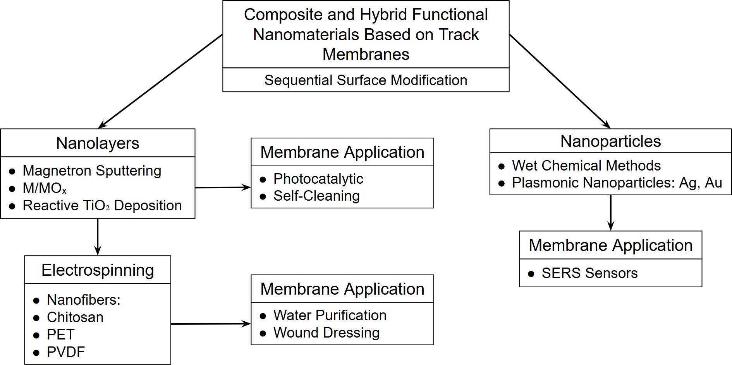

Figure 1. Scheme of production methods and application ways of composite and hybrid functional nanomaterials based on track membranes (TMs)