**The study of the chemical and physical properties**

**of superheavy elements at the SHE factory**

FLNR JINR

Svirikhin A.I.

In 2023, the gas-filled separator GRAND (DGFRS-3), commissioned in 2022, was equipped with the modernised GABRIELA-III detection system (Fig. 1), comprising 5 clover-type gamma HPGe-detectors. In combination with a large area focal plane DSSD (100x100 mm2), the GABRIELA-III detection system provides unprecedented efficiency of gamma ray detection among similar installations. The GRAND separator, equipped with multi-task detector systems, operating on high-intensity beams of multi-charged ions of the DC-280 cyclotron, is capable of solving problems on detailed study of chemical and physical properties of the heaviest nuclei, previously unavailable in statistically significant quantities.

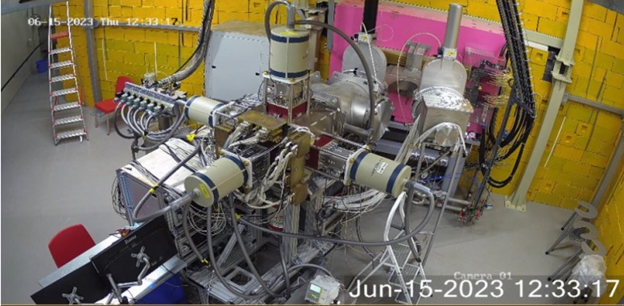

*Fig. 1 GABRIELA-III detection system in the focal plane of the separator*

*GRAND (left output). The right output in the focal plane,*

*where the recoil nuclei collection chamber of the CryoDetector is located.*

Let us list some of the experiments already performed on the GRAND separator in preparation for experiments on the properties of super-heavy nuclei (Z ≤ 115).

With the new GABRIELA detection system, an experiment was performed in reactions with 26Mg ions and lead sulfide targets (204,206,208Pb) to study complete fusion reactions leading to the formation of short-lived neutron-deficient plutonium isotopes (226-231Pu). During the experiment, reaction cross sections were measured, data on the radioactive decay of 228-231Pu were updated, and events that can be attributed to the radioactive decay of new, previously unknown, isotopes 226,227Pu were recorded.

Further, an experiment was carried out on the GRAND separator to study isomeric states of the neutron-deficient, short-lived 250No nucleus. In the course of studying the behaviour of isomeric states at high excitation energies of the compound nucleus, the maximum of the excitation function of complete fusion reaction 48Ca + 204Pb = 252No* corresponding to the reaction channel with 4 neutron evaporation was reached. In this reaction channel, the observation of the decay of the previously unknown isotope 248No was expected. In addition, new data on the decay of the isotope 249No, previously synthesised in the LNR, were obtained; this nucleus is formed in the 3-neutron evaporation reaction channel.

An important feature of the GRAND separator is its ability to act as a "preseparator" in experiments to study the chemical properties of super-heavy nuclei. In 2022-2024, numerous test experiments with heavy ion beams were carried out using the CryoDetector facility located in one of the two focal planes of the GRAND separator (Fig. 1). Moreover, at the end of 2022, the first experiment was caried out to study the behaviour of Fl (Z=114), presumably in the elemental state, by gas adsorption thermochromatography. The short-lived radionuclide 287Fl (T1/2 = 0.36 s) was produced online in the reaction 242Pu(48Ca, 3n)287Fl (reaction cross section = 10 picobarns). After separation of reaction products in the GRAND separator, the studied nuclei were collected in a gas chamber (RPC), installed in the focal plane and separated from the separator gas volume by a thin mylar film. From the gas collector at 200C, only highly volatile elements (e.g., Hg, Rn) or their compounds were transported through a Teflon capillary in a carrier gas, a mixture of additionally purified inert He-Ar gases, to the chemical detection unit.

The use of GRAND as a preseparator for the "Cryodetector" unit allowed us to increase the purification of the extracted Fl atoms from undesirable products of nuclear side reactions (short-lived isotopes of transplutonium elements) by 3-4 orders of magnitude. This significantly increases the statistical reliability of the obtained spectrometric data, which is a new standard in the studies of STE chemistry. The use of the preseparator also made it possible to place the measuring system of the "Cryodetector" near the focal plane of the separator at the minimum possible distance of 25 cm from the recoil nuclei collection chamber, which made it possible to reduce the time of gas transport to the chemical detector to 0.1 s.

In December 2022, during the run at the DC280 cyclotron, in the CryoDetector recorded two decay chains of 287Fl at temperatures of approximately -100 and -70 0C, tentatively confirming earlier conclusions about the high volatility and inertness of Fl in the elemental state.

The team formed around the GRAND facility has now prepared the separator and detection systems for a further programme of experiments. In 2024, a new target assembly, with a diameter of 480 mm, was installed and tested. Until then, the standard diameter of the target wheel was 240 mm. This size was determined by the maximum achievable ion beam current that could be delivered to the target without risk of thermal destruction. Switching to a disc diameter of 480 mm allows working at ion intensities exceeding 6 pμA.

In testing the new target assembly, the well-known reaction 48Ca + 206Pb = 2n + 252No was used. With 48Ca ion intensity of 6 pµA, an impressive result of more than 3 nobelium nuclei per second was achieved at the focal plane of the GRAND separator. Such experimental parameters open the broadest possibilities for a detailed study of the physical properties of heavy and superheavy nuclei (see Table 1).

|  |  |  |  |
| --- | --- | --- | --- |
| Reaction | Niclei | Number of nuclei in the focal plane of the separator | Properties of nuclei available for study |
| 48Ca + 204-208Pb | 249-254No | ≤ 2.5х106 / 24ч | α-,β-,γ-spectroscopy, fission fragment spectroscopy (TKE, ff-masses, neutron multiplicity) |
| 48Ca + 242Pu | 286,287Fl  282,283Cn*… | ≤ 10/ 24ч | Transactinide chemistry, decay modes, α-,β-,γ-spectroscopy, spontaneous fission characteristics (TKE, neutron multiplicity) |
| 48Ca+243Am | 288Mc  Nh,Rg,Mt*… | ≤ 1/ 24ч  ≤ 10/ 24ч** | Transactinide chemistry, decay modes, α-,β-,γ-spectroscopy, spontaneous fission characteristics (TKE, neutron multiplicity) |

*\* - decay products of the “mother” nucleus*

*\*\* - in case of compliance with the requirements for operation of radio-chemistry LAB of the 1st class*

After the completion of testing of the new target assembly on the 48Ca beam, work continued at the GRAND facility in preparation for long-term experiments to study the properties of superheavy elements. As a target, 242Pu (480 mm diameter disc) will be used in the upcoming experiments. After the completion of a cycle of test work to optimise the RPC and CryoDetector, an experiment to study the chemical properties of flerovium (287Fl) and darmstadtium (283Ds) is planned. The changes made in the design of RPC and detection system, as well as the possibility to operate at increased ion beam intensity, allow us to expect the registration of several dozens of decays of flerovium and darmstadtium nuclei during the 30 days experiment.

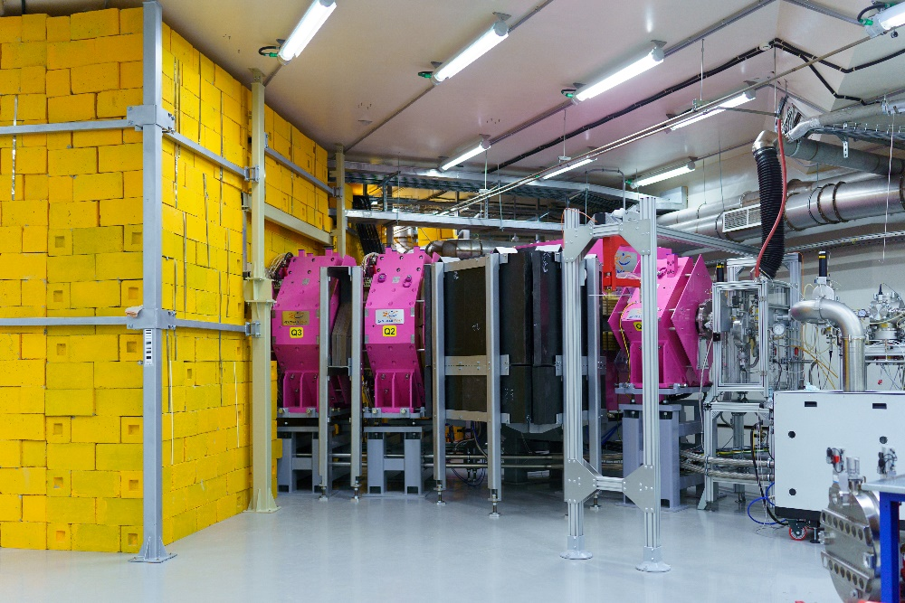

*Fig.2 GRAND separator, December 2024.*

The unique capabilities of the GRAND facility have also made it possible to plan several ambitious works on the detailed study of the radioactive decay properties of flerovium nuclei and their daughter products.

Using the new separator and the GABRIELA detection system, it is possible to obtain previously unavailable spectrometric data on the α-decay of the even-even nucleus 286Fl. The several hundred α-decays of this nucleus that can be recorded during a 60-day experiment could provide data on the lowest levels (0+, 2+ ) of the ground state transition of the nucleus 282Ds. These data directly indicate the degree of deformation of the studied nucleus, i.e., the distance of the nucleus from the hypothetical region of spherical superheavy nuclei ("Island of Stability").

Experiments using the SFiNX detection system are possible on the available 242Pu target, which is able to "accept" a 48Ca beam with an intensity of more than 6 μA*particles. This combined detection system, equipped with helium-3 neutron counters, located in the focal plane of the GRAND separator, can be used to measure spontaneous fission properties such as the total kinetic energy of the fragments and the multiplicity of prompt neutrons from spontaneous fission. These data, obtained for the spontaneous fission of flerovium, darmstadtium, and their daughter products, could provide very useful information on the state of fission barriers and the fission dynamics of superheavy nuclei near the "Island of stability".

In addition, using "light" targets (204-208Pb) on intense 48Ca, 50Ti beams, such quantities of fissile nobelium and reserfordium nuclei can be obtained in short experiments that information on the mass distributions of fission fragments of these heavy nuclei becomes available. Information on extremely exotic modes of spontaneous (low-excited) fission is becoming available: bimodal fission, super-symmetric fission, super-asymmetric fission, fission with light particle escape. In order to realize these measurements, it is necessary to stimulate work on new detection systems in combination with existing or under construction recoil separators that can fully exploit the extensive capabilities of the SHE Factory.