**APPROVED**

**JINR DIRECTOR**

**/**

**" " ___ 202_**

**SCIENTIFIC AND TECHNICAL REASONING FOR THE OPENING / RENEWAL**

**OF THE PROJECT IN RESEARCH AREA**

**WITHIN THE TOPICAL PLAN FOR JINR RESEARCH**

**1. General information on the project**

**1.1. Theme code**

02-1-1083-2009/…

**1.2. Project**

**1.3. Laboratory**

LHEP

**1.4. Scientific field**

Particle Physics and High-Energy Heavy-Ion Physics

**1.5. The name of the Project**

Physical studies at the CMS experiment and the second phase of detector upgrade for operation in high luminosity conditions

**1.6. Project Leaders**

V.Yu. Karjavine

**1.7. Project Deputy Leaders**

S.V. Shmatov

**1.8. Scientific supervisor of the project**

V.A. Matveev

**2. Scientific rationale and organisational structure**

**2.1. Annotation**

JINR physicists have been involved in Compact Muon Solenoid (CMS) project at the Large Hadron Collider (LHC) since its conceptual proposal was done in 1992. The main effort of JINR in the CMS Project was concentrated on the design, construction, commissioning, operation and upgrade of the CMS inner Endcap detectors, where RDMS bears full responsibility on Endcap Hadron Calorimeter (HE) and First Forward Muon Station (ME1/1).

JINR physicists are playing an active role in the realization of the CMS physics research program, support the efficient operation of the detector and participate in data collection. During the two extended technical shutdowns of the LHC in 2013–2015 (Long Shutdown 1, LS1) and in 2019–2022 (Long Shutdown 2, LS2) the CMS detector was significantly upgraded to maintain optimal performance under the LHC’s increased luminosity of up to 2×10³⁴ cm⁻²s⁻¹ and the design proton-proton collision energy of 14 TeV in the center-of-mass system.

The present project is aimed to performing comprehensive research in the field of elementary particle physics with the CMS detector at LHC to study fundamental laws of nature. Special attention will be given to addressing the experiment’s highest-priority tasks: verification of proposed mechanisms for elementary particle mass generation (studying the properties of the Higgs boson discovered in 2012 and searching for new scalar particles), searches for supersymmetry and dark matter candidates, and testing theoretical hypotheses of low-energy gravity at the TeV scale. The research program will additionally explore possibilities for unifying the three fundamental interactions, particularly within the framework of extended gauge theories.

Starting from 2030, the LHC is scheduled to start operating at high luminosity up to 7.5×10³⁴ cm⁻²s⁻¹ (the second phase of LHC operation – High-Luminosity LHC, HL–LHC), which will increase the statistics by more than an order of magnitude ( $L_{int}$ > ~ 3000 fb⁻¹). During the third long shutdown (LS3, 2026–2029), the upgrade of the CMS detector is planned to ensure efficient operation of all CMS subsystems under HL–LHC conditions. The primary tasks of JINR team at this stage of the project includes participation in the construction of the High–Granularity Calorimeter (HGCal) and upgrades of the Cathode Strip Chambers (CSCs) of the ME1/1 forward muon station of the CMS endcap muon system.

One of the important objectives of the project is the investigating the detectors’ physical characteristics to verify their stability, efficiency, and longevity under high-load conditions at increased LHC luminosity. Special attention in the project tasks is devoted to developing event reconstruction algorithms for the HGCal and ME1/1 detectors and corresponding software for distributed data processing and analysis based on grid technologies with using JINR’s computing infrastructure for the CMS experiment (Tier-1 and Tier-2 centers).

**2.2 Scientific Justification (**Objectives, Relevance, Novelty, Methods, Expected Results, and Risks**)**

JINR physicists have participated in the Compact Muon Solenoid (CMS) project for over thirty years since its creation. The collaboration has been conducted within the framework of the Russian Federation and JINR member states consortium (RDMS) in the CMS Collaboration. JINR made crucial contributions to the construction of the CMS detector, primarily focused on developing the endcap detector systems, with full responsibility for the design, construction and operation of the Hadron Calorimeter (HCAL) and the ME1/1 forward muon station.

In accordance with the Seven-Year Development Plan for 2024–2030 and the Memorandum of Understanding between JINR and the CMS Collaboration (MoU), JINR will continue active participation in the CMS physics research program at LHC and in implementing the second phase of detector system upgrades during the LHC shutdown in 2026–2030.

The present project aims to conduct comprehensive research in elementary particle physics using the CMS experimental facility at LHC to study fundamental laws of nature. Particular attention will be given to addressing the experiment's highest-priority tasks: verification of one of the proposed mechanisms for elementary particle mass generation through investigation of the Higgs boson discovered in 2012 and searches for new scalar particles, searches for supersymmetry and dark matter candidate particles, and testing theoretical hypotheses of low-energy gravity at TeV-scale energies. Other important problems physicists hope to solve using LHC include searching for ways to unify the three fundamental interactions, for example within extended gauge theories. Furthermore, the JINR group's physics program in CMS includes a comprehensive set of studies focused on examining Standard Model (SM) predictions in the new energy domain, investigating QCD properties at previously inaccessible values of transferred four-momentum and energy fractions, analyzing patterns of nuclear interactions at high energies, searching for quark-gluon plasma, and other important phenomena.

During the LS3 from 2026 to 2029, the second phase of CMS upgrades is planned to ensure efficient operation of all systems under HL–LHC conditions. The main focus areas at this project stage include participation in developing the High-Granularity Calorimeter (HGCal) and upgrading the Cathode Strip Chambers (CSCs) of the ME1/1 forward muon station in the CMS endcap muon system.

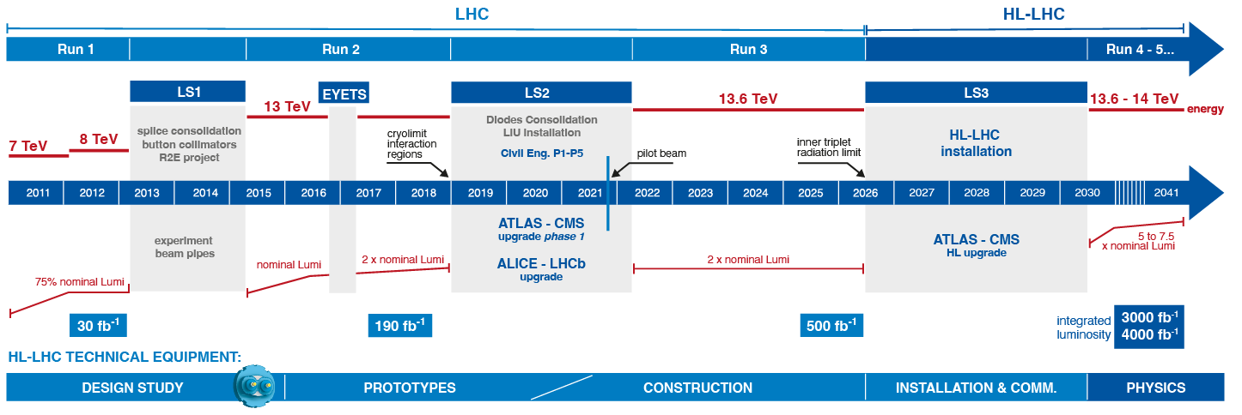A primary objective of this project involves investigating the physical characteristics of detectors to verify their operational stability, detection efficiency, and long-term durability under high-load conditions during increased LHC luminosity. Particular emphasis is placed on advancing event reconstruction algorithms for the HGCAL and ME1/1 detectors, along with developing corresponding software frameworks for distributed data processing and analysis utilizing grid computing technologies, as well as maintenance and operation of CMS computing nodes of Tier-1 and Tier-2 levels based in JINR.

Figure 1. LHC operating schedule.

The first operational phase of the LHC (LHC RUN1) was conducted from 2009 to 2012 with proton-proton collisions at 7 and 8 TeV in the center-of-mass frame. In 2015, a new operational phase (LHC RUN2) commenced at a center-of-mass energy of $\sqrt{s}$ = 13 TeV, continuing until the second long shutdown (Long Shutdown 2, LS2) in late 2018. During this period, the CMS experiment recorded an integrated luminosity of approximately 190 fb⁻¹.

The ongoing RUN3 data-taking period, which will continue until mid-2026, is expected to achieve an integrated luminosity of $L_{int}=$ 500 fb⁻¹ at $\sqrt{s}$ = 13.6 TeV.

Starting in 2030, the LHC will operate in its high-luminosity phase (High Luminosity LHC, HL–LHC), reaching peak luminosities up to 7.5×10³⁴ cm⁻²s⁻¹. This upgrade will increase the accumulated statistics by more than an order of magnitude, with a projected integrated luminosity of $L_{int}$ ~3000 fb⁻¹.

The operational timeline of the LHC/HL–LHC and the expected integrated luminosity for each phase are presented on Figure 1.

The **main objectives of the project** are:

* development and implementation of a research program for precision testing of the Standard Model (SM) and searches for new physics beyond it;
* upgrade and operation of the CMS experimental complex at the LHC to ensure its functionality in HL–LHC mode, including participation in the construction of high-granularity endcap calorimeters (HGCal) and modernization of the cathode strip chambers (CSC) in the ME1/1 forward muon station of the CMS endcap muon system.

The project comprises five main components that define its **structure**:

* development and implementation of the CMS physics research program focused on searches for new physics beyond the Standard Model, studies of Higgs boson properties, and other SM tests;
* CMS detector upgrades for HL–LHC operation, including participation in the construction of the high-granularity calorimeter (HGCal) and modernization of the CMS endcap muon system detectors;
* study of detector performance, providing their operational reliability, data acquisition and quality control;
* development of methods and algorithms for physical object reconstruction and event selection, along with creating corresponding software for distributed data processing and analysis using grid technologies;
* development of software for the distributed data processing and analysis system based on grid technologies, ensuring reliable and uninterrupted operation of JINR grid infrastructure for the CMS experiment (Tier-1 and Tier-2 centers).

The **key tasks of the project** include:

1. Processing and analysis of CMS experimental data with statistics corresponding to an integrated luminosity of up = 500 fb-1to obtain new physics results in the following areas:

* searches for new physics in dilepton final states and verification of beyond-Standard-Model scenarios (TeV–scale gravity, extended gauge models, dark matter candidate particles, processes with lepton number violation, etc.);
* searches for new physics in channels with two leptons/two b-quarks and missing transverse energy in the final state, testing beyond-SM predictions (searches for extended Higgs sector and dark matter candidates);
* exploration of Higgs boson properties and searches for new scalar bosons beyond the SM in decay channels to leptons and b-quark pairs;
* studies of Drell–Yan muon pair production processes to test SM predictions at the new energy scale, to measure the weak mixing angle, and to verify quark and gluon structure distribution functions;
* studies of QCD jet properties and refinement of fragmentation functions.

1. Development of methods and algorithms for object reconstruction and event selection, along with creating corresponding software for distributed data processing and analysis with grid technologies.
2. Fulfillment of JINR's obligations regarding participation in the HGCal construction:

* development of an experimental setup for testing HGCal cassettes with sensor elements and participation in cassette assembly and testing;
* creation of a prototype low-voltage power supply system for HGCal and its integration into the experimental setup.

1. Fulfillment of JINR's obligations for upgrading ME1/1 muon station detectors for HL–LHC operation and their testing, including cosmic ray data collection.
2. Studies of detector performance, ensuring their operability and data acquisition:

* study of muon chamber characteristics during RUN3 data collection;
* obtaining new results on degradation of CSC chamber performance under HL-LHC conditions.

1. Preparation of endcap muon system detectors and HGCal for data collection during LHC RUN4 (expected to begin in 2030):

* сommissioning after upgrades;
* ensuring a stable operation of hadron calorimeter and ME1/1 muon station during data collection;
* data taking and processing of data obtained during RUN4.

Additionally, the project includes work on upgrading and operating CMS detector systems not covered by JINR's formal commitments (BRIL, ECAL, ZDC, etc.). These activities will not be funded through the project budget but will be performed using CMS collaboration resources by JINR-associated personnel.

The project's primary computing resource is the grid infrastructure of JINR Multifunctional Information and Computing Complex (MICC), integrated into the global WLCG (Worldwide LHC Computing Grid) infrastructure.

1. **Physics research program at the CMS experiment**

Discussion on LHC research at design energy[1] and in high-luminosity (HL–LHC) mode has been discussed for over a decade. The main goal of new LHC experiments will undoubtedly be to further study the Higgs boson nature and search for possible deviations from standard model predictions, which could indicate new physics. The main question the LHC experiments aim to answer remains: is there new physics at the TeV energy scale?

Numerous searches for deviations from SM predictions have yielded no results. however, they have established limits on the masses of hypothetical particles and the energy scales of new phenomena (new gauge bosons, extra dimensions, composite particle structures, leptoquarks, etc.) based on RUN1 and RUN2 data. This could imply that new physics processes either occur beyond the LHC's current energy (mass) limits or have such low cross-sections that they lie beyond the present experimental sensitivity.

During RUN3 and at HL–LHC operations, measurements will extend to significantly broader regions of model parameters for all beyond SM physics scenarios compared to existing ones. The increased statistics will not only expand the expected mass limits for new particles (by a factor of 1.2–3) predicted by various beyond SM models but will also allow differentiation of hypotheses about their origin (determining spin and coupling constants) if such particles are discovered.

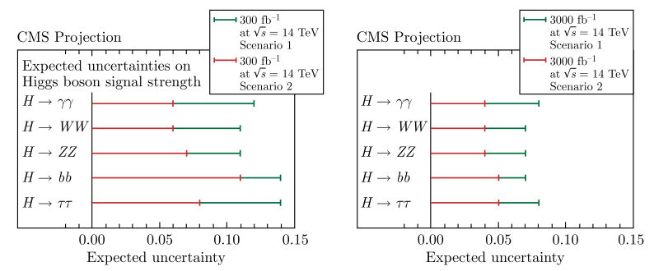**Investigating the properties of the Higgs boson and the search for new physics.** One of the main research tools will be the study of the properties of the Higgs boson. Based on the data from the first and second LHC runs, the new boson's properties have been thoroughly studied. At present, there is no reason to doubt that this new particle is a scalar consistent with Higgs field fluctuation hypotheses. However, the current measurement precision of coupling constants is not sufficient to rule out new physics possibilities - any contributions from new particles production (or Higgs boson decay channels) might be too small to detect with current precision. The increased statistics from LHC RUN3 and HL–LHC are expected to significantly improve this precision (Fig. 2).

Figure 2. Estimated accuracy of Higgs boson signal intensity measurements for 300 ${fb}^{-1}$ (left) and 3000 ${fb}^{-1}$ (right).

More than a decade has passed since the 2012 discovery of the Higgs boson, during which physicists have gathered enough data to make fairly precise measurements of its characteristics - mass has been measured with 0.1% precision, and its width and coupling constants have been determined, spin and parity have been identified, most decay channels and production mechanisms of Higgs boson have been experimentally confirmed. This systematic knowledge accumulation has turned the Higgs boson into a tool for new physics search (Fig. 3).

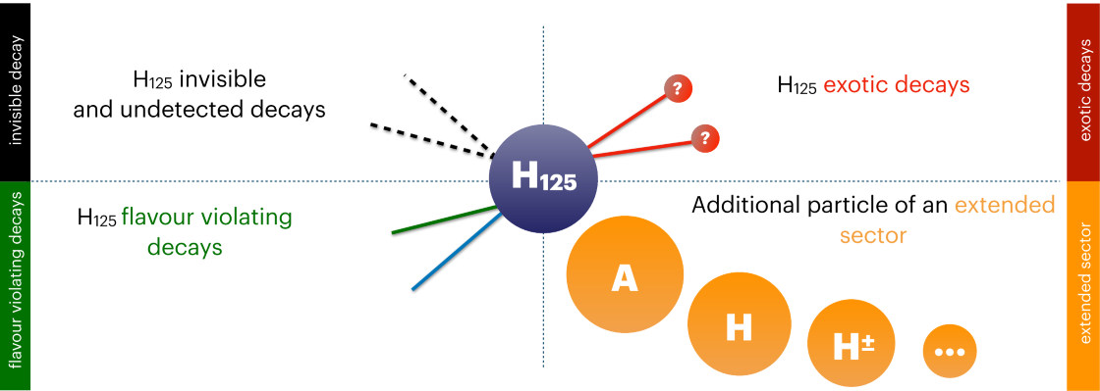New physics is primarily expected to show up as contributions to rare or exotic Higgs boson decay processes, such as decays to light leptons (muons and electrons), invisible decays i.e. decays to particles that are not registered in the detector (for example, neutrinos in the SM or dark matter candidate particles), lepton flavor violation (LFV) decays and others. These could potentially be detected in both the known SM Higgs boson and in scalar states from an extended Higgs sector.

Figure 3. Possible ways to find new physics using the Higgs boson.

Another approach involves using the Higgs boson to directly search for exotic particles predicted by various theoretical scenarios. If the Higgs boson's mass exceeds the expected masses of these hypothetical particles, researchers look for Higgs decays into these particles and their subsequent decays into Standard Model particles. Massive hypothetical particles might also decay into Higgs bosons, which are then detected through conventional methods.

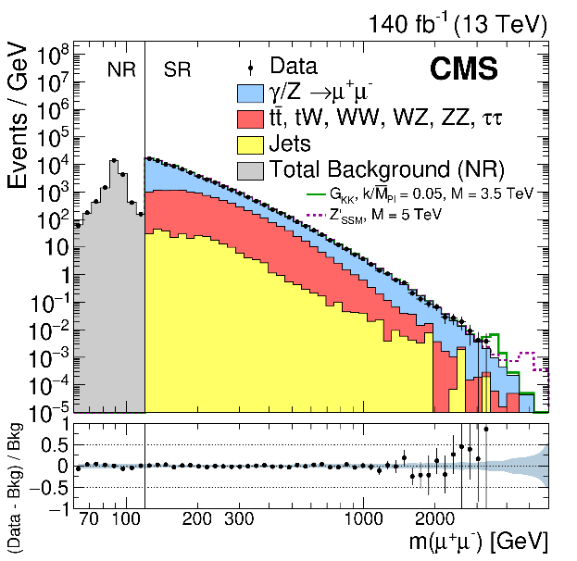Thus, traditional searches for physics beyond the Standard Model, such as supersymmetry (SUSY), non-supersymmetric signals of physics beyond the Standard Model (Beyond the Standard Model, BSM), and the search for SUSY and BSM in third–generation quark channels (Beyond two Generations, B2G), Higgs boson–based searches have been added.

Figure 4. The muon pair invariant mass distributions obtained in our analysis at $\sqrt{s}=$ 13 TeV.

**Search for new physics (traditional signals).** One of the priorities of modern particle physics is the search for violations of the SM predictions. Such violations in a channel with a pair of leptons can serve as a sign of new physics, for example, production of new neutral gauge bosons Z′ from models of the Grand Unification (GUT), Kaluza–Klein (KK) graviton states in scenarios of multidimensional gravity with a reduced fundamental scale, or candidates for dark matter (DM) particles. In addition, this channel is sensitive to the existence of new light Higgs states predicted in models with a non-minimal construction of the Higgs sector with two doublets and one singlet of Higgs fields (2HDM+S/a) and in other more extended versions.

The search for new resonances will use the maximum likelihood method by analyzing the invariant mass distribution of lepton pairs (Fig. 4). This approach ensures results are independent of absolute background level uncertainties. To reduce systematic effects (luminosity, acceptance, trigger efficiencies, and offline reconstruction), the dilepton cross-section was normalized to the Z–boson cross-section. Bayesian probability estimation was used to interpret the invariant mass distribution shape.

If no evidence is observed events over the expected background with a confidence level (C.L.) 95%, an upper limit on the dilepton production cross-section in the presence of new heavy resonances can be set (Fig. 5). Model-independent upper limits on spin-1 and spin-2 resonance cross-sections will be measured in the narrow width approximation. Resonance search results can be interpreted in extended gauge models based on GUT groups E6 and SO(10), and in models of multidimensional gravity with reduced scale interaction with the multidimensional space anti-de Sitter AdS5 metric (Randall-Sandrum scenario, type 1 – RS1). In general, model-independent limits can constrain new resonance masses in any theoretical model (Fig. 5). Two new heavy resonance scenarios are considered as references: spin-1 (additional gauge boson Z′) and spin-2 (KK RS1-graviton modes).

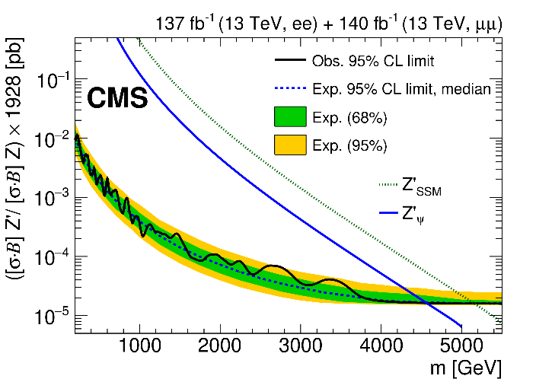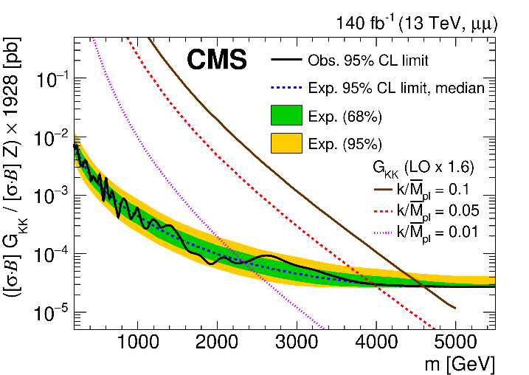

Figure 5. The model-independent upper limit (at 95% CL) on the muon pair production cross-section (solid black line), normalized to the Z-boson cross-section, for spin-1 (left) and spin-2 (right) resonances. The dashed line shows the expected limit assuming the SM (based on simulations).

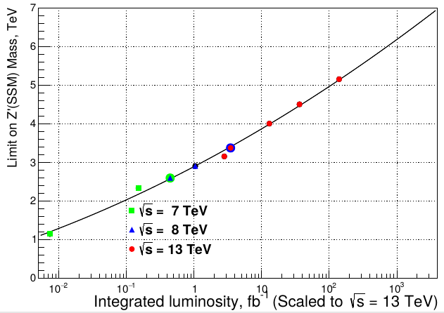By generalizing the results obtained/ with RUN1 and RUN2 data, projections (Fig. 6) were estimated for the mass limits of the new heavy boson Z′ of the extended gauge sector of the SM, which can be achieved when the LHC operates in the high luminosity mode ($L_{int}=$ 1000–3000 ${fb}^{-1}$). For the SSM model, the kinematic limit is predicted in the region of about 7 TeV at energy $\sqrt{s}$ = 13 TeV, which corresponds to 7–8 TeV at $\sqrt{s}$ = 14 TeV.

Figure 6. Mass limits observed at $\sqrt{s}$ = 7, 8 and 13 TeV for the hypothetical gauge boson Z′ in the SSM model as a function of the integrated luminosity.

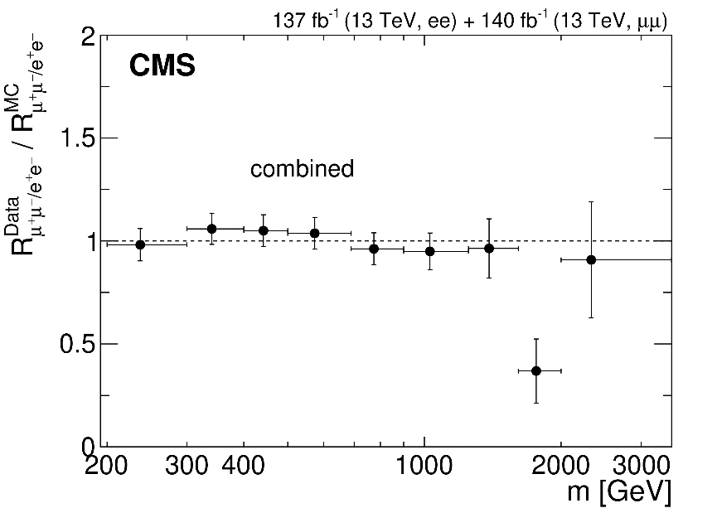When searching for non-resonant signals in the lepton pair spectrum, the method of counting the number of events in the signal region of invariant masses of lepton pairs bounded from below will be used to interpret the observed mass spectra. The results will be interpreted using scenario of large additional dimensions ADD with two renormalization schemes (HLZ and GRW) and within fermion contact interaction models.

Figure 7. Ratio of the Z-boson probability decays through the electron and muon channels obtained in the CMS experiment; the CM prediction (dashed line) is also shown for comparison.

An important research direction in analyzing dilepton production is testing an interaction universality in the lepton sector, i.e., searches for processes that violate lepton number conservation (Lepton Flavour Universality Violation, LFUV). The CMS was able to test this hypothesis for the first time in the region of large invariant masses using RUN2 data (Fig. 7). No significant indications of such electronic or muon ‘preferences’ in decays were found (although there are small deviations associated with an excess of events in the electron channel in the region of the largest masses, which need to be verified with RUN3 data).

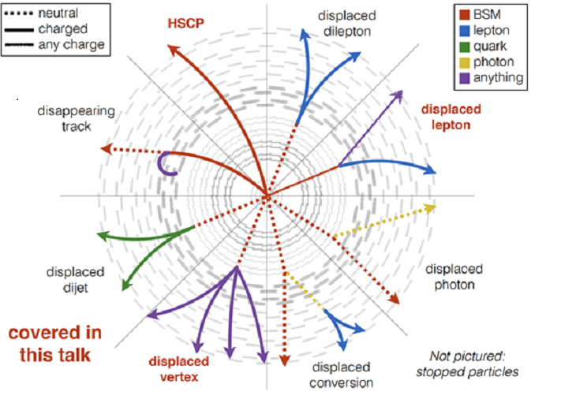**Search for new physics (signals with displaced interaction point)**. From its foundation, the CMS experiment has been focused on recording events where the tracks of charged particles or hadron jets are come from the point (interaction vertex) where colliding proton beams intersect and the whole reconstruction is based on the aligning tracks to this nominal interaction point (the interaction point, IP).

Figure 8. Topologies of events with long-lived LLP particle production.

At the same time, there are physical scenarios (dark matter axion theories, extended supersymmetric models, models of baryogenesis etc.), that predict the production of long-lived particles (LLPs), which produced at the beam intersection point, may travel for a long time without decaying (see Fig. 8). Thus the decay point, the vertex, is significantly shifted from the proton-proton interaction point. This displacement can be a few millimeters or hundreds of meters. If the decay vertex is within the detector, it is possible to attempt to reconstruct such an event without being matched to the IP and even without using information from the detector systems closest to the IP. For example, the LLP may travel through the entire tracker without decaying, so its reconstruction could be done only based on signals from the calorimeter system and/or the muon system. There are more than a dozen configurations of such topologies and physical objects forming events can be leptons, photons, jets, form various combinations, and decaying vertices lie at almost any detector system.

**Measurements** of standard model parameters. Precision measurements of the characteristics of Standard Model processes are an important test of theories of strong and electroweak interactions at a new energy scale and one of the key bases for search experiments. The project plans to:

* study the lepton pair production in the Drell–Yan process for precision measurements of the cross-sections of this process, measurements of the running coupling constant of QCD and parton distribution functions (PDF), effective mixing angles, etc;
* charged particle multiplicity measurements inside jets to develop quark-gluon discriminators and study hadronization mechanisms;
* spectroscopy of $B, B_{S}, B_{c}^{+}$–hadrons, including their rare and multiparticle decays.

In addition, theoretical calculations of observables (cross-sections and forward-backward asymmetry) in a wide kinematic range of leptons, produced via the Drell–Yan mechanism will be done, taking into account radiative corrections (both electroweak and those from higher-order perturbative QCD).

Moreover, it is planned on updating the HepMC generator package, integrating the SHERPA3 generator into the CMS SW, validating results with experimental data, and developing mathematical methods and software for the Geant4 simulation package.

1. **CMS detectors upgrade for operation at high-luminosity HL-LHC**

To implement the planned research program at HL–LHC, the detectors of all CMS subsystems must be significantly upgraded. First, they must be adapted to operate under conditions of significantly increased radiation loads, and second, the detectors, trigger system, and software package for reconstruction and analysis of events must allow the extraction of the necessary information under conditions of a large number of simultaneous interactions during collisions of proton bunches, the so-called "overlapped" events, or "pile-up". If the average number of such events at the first stages of data taking did not exceed 20–40, then, as expected, at the third stage it will be 60, and under HL–LHC conditions the pile-up will increase almost by factor 5 and reach ≈140–200. Thus, the multiplicity of interactions in one beam intersection will increase by factor 5, which imposes additional requirements on the performance of detectors, readout electronics, and data acquisition systems. It will also be necessary to develop new methods for processing and analyzing experimental information.

**Upgrade of the endcap muon system detectors**

During two long technical stops of the LHC in 2013–2015 and 2019–2022, the first phase of the CMS upgrade was carried out, ensuring efficient operation of all subsystems at the LHC luminosity of up to 2×1034 cm−2s−1 with an increase in the proton–proton collision energy to the design value of 13.6 TeV in the center-of-mass system. JINR specialists have made a substantial contribution to the upgrade of the muon system. 108 detectors of four muon stations located in the high background area are equipped with new high-speed electronics.

The second phase of the CMS upgrade for operation in the HL–LHC mode will begin in 2026 and will affect all key detector elements of the CMS: the tracker, calorimeters, and the muon system. JINR is actively involved in the upgrade of the CMS muon system and in the development and construction of a high granularity calorimeter (HGCal). JINR physicists are performing a comprehensive study of the detector parameters under conditions of significantly increased radiation loads in the high-luminosity HL–LHC mode. A large volume of research and development work has been carried out aimed at studying the radiation properties of materials and choosing technical solutions in the development of new detector systems. During the long-term shutdown of the LHC in 2026–2029, a significant upgrade of the first disk detectors of the CMS endcaps will be carried out. A new hadron calorimeter HGCAL, a new muon station ME0 and time-of-flight detectors will be installed. In this regard, all detectors, cables and pipes of the cooling and gas mixture supply systems will be dismantled. The detectors of the first muon station ME1/1,2,3 (216 chambers in total) will be dismantled and moved to a specially created laboratory area, where they will be partially upgraded and tested.

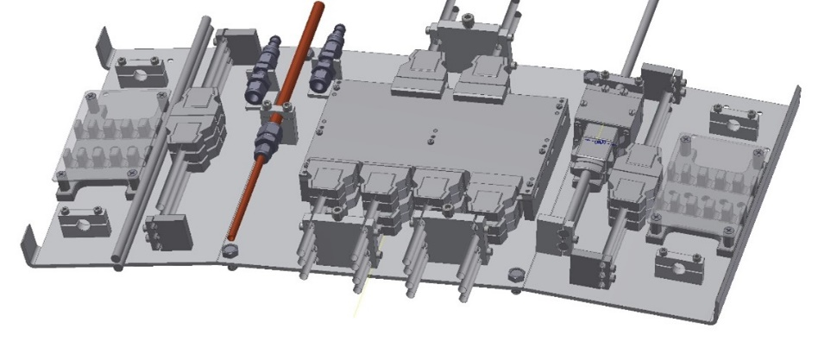

Figure 9. Sketch of the ME1/1 connection panel.

JINR's participation in the upgrade program of the CMS endcap detectors of the first disk consists of the following:

* development, manufacturing and installation in the detector of new ME1/1 patch-panels (72 pcs.) (sketch of the patch-panel is shown in Fig. 9);
* manufacture of new high-voltage power supply cables for the ME1/1 chambers;
* equipment of the lab-area for the CSC upgrade;
* development and manufacture of loading machines for installation of the ME1/1 CSC (Fig. 10);
* dismantling and transportation of the chambers;
* upgrading the chambers and tasting them, including data taking with cosmic rays;
* installation of the chambers, connecting services and the readout system;
* testing the chambers and commissioning the muon station.

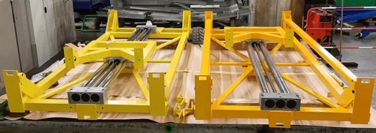

Figure 10. Devices for installation of the ME1/1 chambers.

The ME1/1 cambers patch-panels (ME1/1 PP) located on the YE1 disk provide the ability to disconnect cables and services (gas and cooling pipes) in case of dismantling the ME1/1 chambers. The ME1/1 PP is a complex device that, in addition to the cable and service connection connectors of two CSCs, includes 2 active interface boards (PPIB) for exchanging information with electronic modules in peripheral crates.

**Construction of the High Granularity Calorimeter HGCAL**

The high granularity calorimeter HGCal will replace the CMS hadron and electromagnetic endcap calorimeters, as the current detectors cannot withstand the high radiation expected during the HL–LHC operation mode. HGCal will be able to withstand integral radiation doses an order of magnitude higher than the design values ​​for the original CMS design. The maximum expected neutron fluence in the calorimeter area closer to the interaction point is 1.5×1016 neg/cm2 (where neg/cm2 is the number of equivalent neutrons with an energy of 1 MeV per cm2). To obtain good energy resolution and to be able to cope with the increased pile-up, the detector will have higher granularity and a good time resolution of ∼30 ps for measuring the detection time of incident particles. High granularity of the calorimeter will not only reduce the pile-up effect but will also provide the possibility to improve the reconstruction of the particle flow. The general idea of ​​the “particle flow” reconstruction algorithms is that energy deposits are not grouped separately within the electromagnetic and hadronic parts of the calorimeter, but are associated with individual particles, for the reconstruction of which the information from the tracker is used. For example, to determine the energy of charged hadrons, a weighted average of the momentum in the tracker and the energy measured in the calorimeter is calculated, which allows achieving the best possible energy resolution. The use of “particle flow” algorithms will significantly improve the energy resolution compared to traditional algorithms, especially for low values ​​of the transverse momentum of the jet pT.

**HGCal structure.** HGCal is a sampling calorimeter covering the pseudorapidity range from 1.5 to 3. Figure 11 shows the HGCal device schematic (upper half of the end cap) and its main parameters.

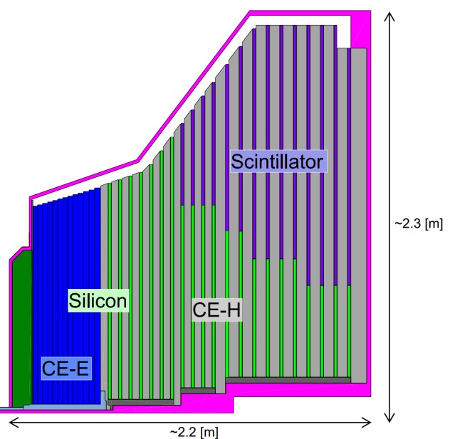

**Electromagnetic Calorimeter (CE-E):** Si, Cu & CuW & Pb absorbers, 26 layers, 27.7Х0 &~1.5λ

**Hadron Calorimeter (CE-H):** Si & scintillator, steel absorbers, 21 layers, ~8.5λ

**Main parameters:**

47-layer sampling calorimeter

Coverage area 1.5 < h < 3.0

~620 m2 Si sensors in ~27000 modules

~6M Si channels [cell size 0.5 or 1.2 cm2]

~370 m2 scintillators on ~3700 boards

~240K scint. channels (size 4-30 cm2)

Weight of one end part: 215 tons

Power consumption of one end part: ~125 kW

Operating temperature: -30oC

Figure 11. Schematic and main parameters of the HGCAL calorimeter

In the electromagnetic section (CE-E), in the region of increased radiation level and high event rates, silicon sensors will be used. In the hadron section (CE-H), at large radii, scintillation tiles will be used, readout by silicon photomultipliers (SiPM). The detectors will be mounted on disks, which will be separated by absorbing material: copper and lead in the electromagnetic section and steel in the hadron section. A total of 620 m2 of silicon sensors and 400 m2 of scintillation tiles containing more than 6 million data reading channels will be installed on the two end parts of HGCAL as detecting elements. To improve the reliability of the silicon sensors (reduce the leakage currents of the sensors after irradiation), the entire HGCal will operate at a temperature of -30°C.

**Silicon sensors and CE-E silicon modules.** The silicon sensors of the CE-E electromagnetic section are manufactured on hexagonal 8-inch wafers, which have three different thicknesses of active silicon sensors (120, 200 and 300 µm), optimized for areas with different radiation levels. The sensors, segmented into cells, together with the printed circuit board with integrated electronics, the insulating The kapton foil and the base plate for mechanical support, form 26,000 silicon modules (Fig. 12, left)**.**

Изображение выглядит как электроника, схема, Электронная техника, Электронный компонент

Контент, сгенерированный ИИ, может содержать ошибки.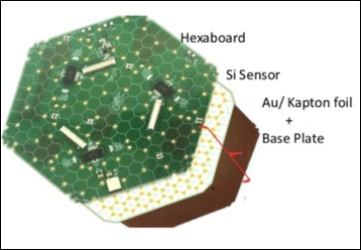

Figure 12. Silicon module design (left) and scintillator cells mounted on a printed circuit board (right).

**Scintillators and scintillator modules**. For the CE-H hadron section, two types of scintillator material are envisaged: polyvinyl toluene (PVT) and polystyrene (PS). For readout, the most efficient “SiPM-on-tile” technology is used, in which the SiPM collects light from the cell through a dimple on the surface. The dimple evens out the response across the cell, and a reflective winding enhances the light collection. The hadron section contains 280,000 channels with scintillator cell sizes ranging from 4 to 30 cm2, and the SiPM area is 2 to 4 mm2. The SiPMs are mounted on a printed circuit board, onto which the scintillators are then mounted (Fig. 13).

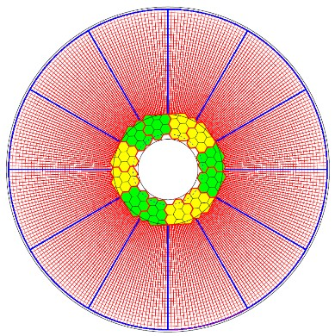

Figure 13. Arrangement of silicon wafers and scintillation cells in the CE-H ring layer.

To match the CMS end grain geometry, the scintillator cells will be arranged radially. As a result, the cells closer to the beam line will be significantly smaller (4 cm2) than the cells at the outer edge (32 cm2). The area measured by the scintillator is divided into modules that form ring segments of up to 40–50 cm2 (Fig. 13).

**Cassettes.** HGCal cassettes are 30- or 60-degree segments integrating sensor modules and auxiliary electronics on a copper cooling plate. These are the main units of the HGCal detectors, which are subsequently assembled into CE-E section disks, and in the CE-H section they are installed between the absorber layers. Cassettes with silicon modules are used in the first seven layers of the hadron calorimeter, and the remaining 14 cassettes are combined: silicon modules are installed in the high radiation area and scintillator plates installed in the area of ​​large radii. A total of 660 cassettes of various configurations (with a total weight of over 430 tons) are used in the calorimeter (Fig. 14).

Изображение выглядит как текст, снимок экрана

Контент, сгенерированный ИИ, может содержать ошибки.

Figure 14. Configuration of different types of HGCal cassettes.

The time resolution of the HGCal as a whole is estimated as 100 ps while Individual sensors of the calorimeter have a time resolution of up to 20 ps. The time resolution of the scintillation part of the calorimeter depends on the size of the scintillator in the cell. For cells of minimal area, it is about 100 ps and for the peripheral cells ~150 ps. The spatial resolution of the electromagnetic part of the calorimeter is 1.5–2.5 mm (depending on the energy 250–40 GeV, for lower energies the resolution is worse). The two-track resolution is about 30 mm for two photons, and about 200 mm for jets. The longevity of the HGCAL is estimated at up to 4500 fb-1, which is 1.5 times higher than planned for the HL–LHC period (3000 fb-1).

In preparation for the second phase of the CMS upgrade, JINR is actively involved in creating a test setup for testing the performance and monitoring the characteristics of the HGCAL cassettes. The cassettes will be tested under conditions close to real, at a temperature of -300C. Ten cassettes are installed in a rack located inside a 3.0×3.0×2.5 m heat-insulated chamber. Figure 15 shows the two heat-insulated chambers manufactured in JINR and assembled at CERN.

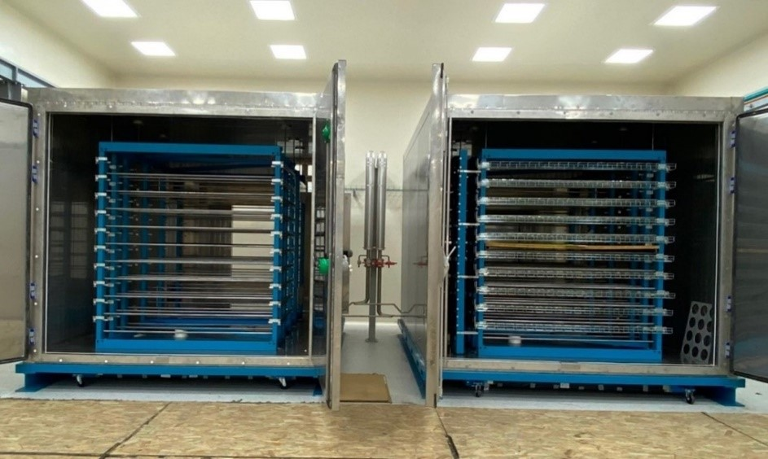

Figure 15. Thermally insulated chambers of the HGCal cassette test stand.

On the top and bottom of the heat-insulated chamber are scintillation trigger planes 2.4×3.0 m each (Fig. 16), which are used for cassettes performance testing, measuring the characteristics of the sensors and readout electronics located on the cassettes using cosmic rays. The JINR group has developed a Monte Carlo model of a cosmic ray test bench, with the help of which the sizes of trigger planes and the configuration of scintillator plates have been optimized.

Further JINR participation in the HGCal project is related to the testing and assembly of the HGCal calorimeter during the long shutdown LS3 in 2026–2030. The main areas of activity of the JINR group during this period are the following:

* development of a prototype of the HGCal low-voltage power supply system and its integration into the experimental setup;
* study of responses and particle track reconstruction in the test setup for testing the active elements of the HGCal, as well as evaluation of the efficiency of the modules;
* participation in the HGCal launching, calibration and signal monitoring in HGCal cells;
* development of new approaches to jet reconstruction algorithms in HGCal.

The CMS installation is scheduled to be tested and the RUN4 dataset to be launched in 2030.

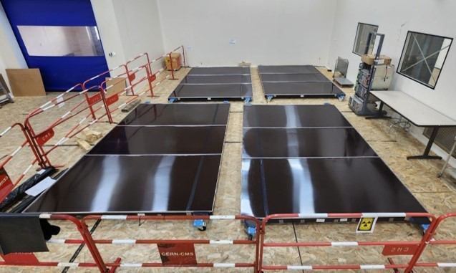

Figure 16. Scintillation trigger planes of the stand for testing HGCal cassettes.

1. **Study of endcap muon chambers performance**

**Study of the muon chamber performance during the RUN3 data taking period.** Analysis of the RUN3 experimental data shows stable and efficient operation of the cathode strip chambers (CSC) in the CMS endcap muon system.

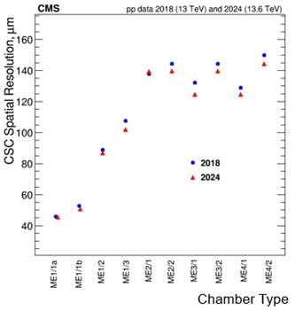

Figure 17. Spatial resolution of the CMS endcap muon stations based on RUN2 (2018) and RUN3 (2024) data.

The CSC spatial resolution values ​​obtained in proton-proton collisions for the ME stations at RUN3 in 2024 are in good agreement with the RUN2 data (2018) and indicate the stability of the CSC operation (Fig. 17). The chambers of the forward muon station ME1/1, the construction and operation of which is the responsibility of JINR, show a spatial resolution of no worse than 50 µm, which fully corresponds to the design value. It is planned to continue studying the CSC characteristics in pp collisions in 2025–2026 till the end of RUN3.

**Study of CSC characteristics at the GIF++ facility.**

JINR physicists play an active part in the preparation and implementation of studies of the cathode strip chambers characteristics at the GIF++ facility at CERN. The tests are carried out on the H4 muon beam of the SPS accelerator with the GIF++ 137Cs gamma-ray source with an activity of 12 TBq using absorption coefficients from 4.6 to 100. The studies are aimed at studying the characteristics of the detectors working with gas mixtures with different CF4 contents, as well as studying the effect of radiation aging of CSC and the chamber operation performance under high background conditions. The results of the studies show that degradation of the characteristics of the ME1/1 and ME2/1 chambers is not observed up to the accumulated charge per centimeter of the anode wire length of 890 μC and 805 μC, respectively. The total accumulated charge values ​​for both chambers are 3 times higher than expected during operation of detectors in the high luminosity period HL-LHC.

1. **Development of algorithms for reconstruction of physical objects and events selection.**

The gradual increase in the luminosity and energy of the LHC beam directly affects the operation of the detectors and the quality of the reconstruction of the trajectories of the registered particles. Due to this, fast and precise tracking algorithms are needed, as well as the development, testing and implementation of new detectors capable of operating effectively in such complex data acquisition conditions.

A particular interest in the search for new physics are processes in which the production of new particles with a transverse momentum much greater than their mass (boosted objects) is expected. Therefore, their decay products are spatially close, in particular, they produce very narrow and/or spatially intersecting (merged) jets. To separate such events, a good spatial resolution of the calorimeters is necessary. A calorimeter with high longitudinal and transverse segmentation facilitates the measurement of the particle flow energy, where the information from all detector subsystems is optimally combined. When designing the CMS HGCal, it is considered that the main reconstruction algorithm will be particle-flow, i.e. the energy flows of particles will be reconstructed. Therefore, the accuracy of spatial reconstruction is of paramount importance. In particular, the transverse segmentation should be smaller than the Moliere radius in both the electromagnetic and hadronic parts. This ensures the possibility of good separation of double jets, especially under high interaction density conditions for the HL–LHC. The potential of the CMS HGCal is to be able to identify individual particles within the jets, like what bubble chambers did in the early days of particle physics.

The spatial and timing granularity of the shower also helps to reduce event overlap by associating jets/particles with specific primary vertices via positioning. Event separation is further improved by precise temporal measurement of particle fluxes in the first-level electronics. The large number of longitudinal layers facilitates the exploitation of differences in longitudinal shower evolution for different physical species, such as electrons or photons and jets resulting from vector boson fusion (VBF) or overlapping events. Together with other CMS detectors, such as the tracker and muon systems (CSC), HGCal will enable particle flow reconstruction. Reconstruction with this detector will enable new methods of identification, clustering and reconstruction using machine learning methods.

The development of algorithms and software for the CMS experiment will be performed in the following directions:

* reconstruction of cosmic muon trajectories in the experimental setup for testing active elements of the High Granularity Calorimeter (HGCal) being developed, as well as evaluation of the efficiency of the HGCal modules;
* methods and algorithms for tracking under high luminosity conditions and, therefore, many overlapped events (pile-up);
* algorithms for recognizing overlapping signals, including those based on wavelet analysis and Kolmogorov-Arnold neural networks, in multilayer coordinate detectors with amplitude representation of the signal, increasing the accuracy of measuring the azimuthal coordinate of charged particles on a separate layer;
* a relative analysis of the two proposed approaches use of discrete wavelet analysis for recognizing the coordinates of closely flying particles from overlapping signals in cathode strip chambers (CSC). Estimation of the parameters of operation of CSC detectors and the level of background particle loading on experimental data under various data collection conditions.
* development of the "reference road" algorithm for reconstruction of three-dimensional track segments, increasing the efficiency of local trajectory reconstruction;
* development of algorithms for global reconstruction of charged particle trajectories based on the Kalman filter, providing precision accuracy and high efficiency at high interaction rates, high multiplicity and density of charged particles and allowing to consider the effects of particle interaction with the detector substance and the influence of the magnetic field;
* methodology accounting the impact the influence of mutual misalignment of detector systems in experimental setups on the reconstruction of the trajectory of charged particles (alignment), allowing to minimize the geometric imbalance of both the internal components of coordinate detectors and the entire system as a whole;
* methodology for experimental separation of jets initiated by quarks and gluons.

1. **Support and development of the JINR grid infrastructure for the CMS experiment of Tier-1 and Tier-2 centers.**

The JINR grid infrastructure for the CMS experiment includes Tier-1 and Tier-2 centers, which are actively used for modeling, processing and storing data and ensure 100% availability and reliability of services. In 2024, JINR Tier-1 successfully processed more than 2.1 billion events. In terms of the successfully completed tasks (18%), JINR Tier-1 ranks second among all Tier-1 centers of the CMS experiment in the world (Fig. 18).

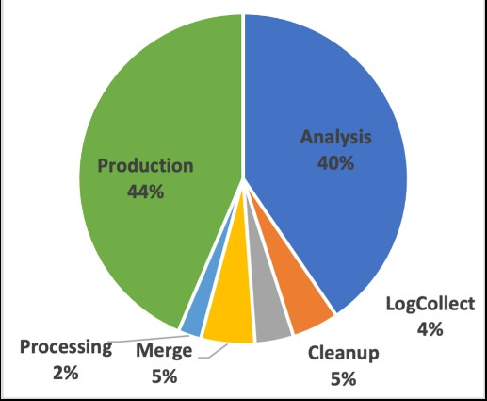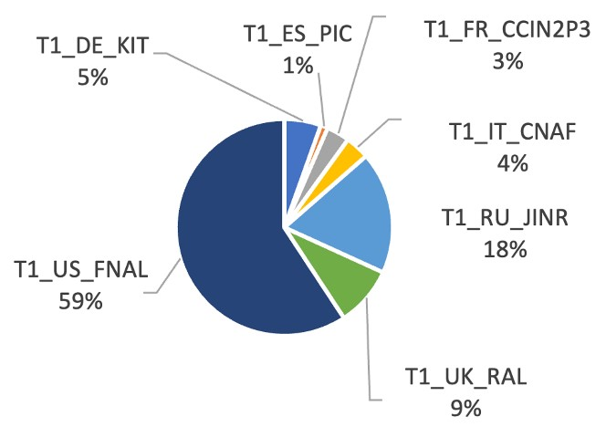

Figure 18. Number of events processed by Tier-1 CMS centers (left). Ratio of types of work performed by the JINR Tier-2 center in 2024 (right).

More than 1.2 million CMS jobs were performed by the JINR Tier-2 center during 2024, most of them event production and Monte Carlo analysis. Figure 23 shows the percentage of job types performed by the JINR Tier-2 center in 2024.

**Expected results upon completion of the project (by 2030).**

1. Implementation of the physics research program at the CMS experimental setup with the design energy of proton beam interactions and integrated luminosity up to 500 fb-1.

2. Fulfillment of JINR obligations to the second phase of the CMS upgrade for operation under HL– LHC conditions, including the creation of the high granularity calorimeter HGCAL and the upgrade of the endcap muon system detectors.

3. Commissioning HGCal and muon chambers after upgrade and ensuring efficient operation during RUN4 data taking period.

4. Development of the algorithm and software compleх for reconstruction of trajectory of charge particle tracks and jets, selection of physics processes with leptons and jets under HL–LHC conditions.

5. Development of the algorithm and software compleх for distributed data processing and analysis under HL–LHC conditions.

**2.3. Estimated completion date**

2026–2030 гг. (5 years)

**2.4. Participating JINR laboratories**

LHEP, LIT, LTP

**2.4.1.** **MICC resource requirements**

The Tier-1 computing center of JINR is part of the CMS Grid infrastructure, designed for processing and storing experimental information from the CMS experiment.

|  |  |  |  |  |  |
| --- | --- | --- | --- | --- | --- |
| **Computing resources** | **Distribution by years** | | | | |
| 1st year | 2nd year | 3rd year | 4th year | 5th year |
| Data storage (TB)  - EOS  - Ribbons |  |  |  |  |  |
| Tier 1 (core-hour) |  |  |  |  |  |
| Tier 2 (core-hour) |  |  |  |  |  |
| SC Talker (core-hour)  - CPU  - GPU |  |  |  |  |  |
| Clouds (CPU cores) |  |  |  |  |  |

**2.5. Participating countries, scientific and educational organizations**

|  |  |  |  |  |
| --- | --- | --- | --- | --- |
| **Organization** | **Country** | **City** | **Participants** | **Agreement type** |
| HEPHY | Austria | Vein | Wulz K.-E. + 57 people | Joint work |
| ННЛА | Armenia | Yerevan | Tumasyan A. + 6 people | Joint work |
| ГГУ | Belarus | Gomel | Andreev V.V. | Exchange of visits |
|  |  |  | Maksimenko N.V. + 1 person | Joint work |
| НИИ ЯП БГУ |  | Minsk | Litomin A.V. | Joint works |
|  |  |  | Makarenko V.V. + 3 people | Exchange of visits |
|  |  |  | Chekhovsky V.A. + 2 people |  |
| UAntwerp | Belgium | Antwerp | Van Mechelen P. + 15 people | Joint work |
| ULB |  | Brussels | Vanlaer P. + 31 people | Joint work |
| VUB |  |  | D'Hondt J. + 11 people | Joint work |
| Ugent |  | Ghent | Titgat M. + 21 people | Joint work |
| KU Leuven |  | Leuven | Lero P. + 4 people | Joint work |
| UCL |  | Louvain-la-Neuve | Dalaere K. + 26 people | Joint work |
| UMONS |  | Mons | Dobi E. | Joint work |
| INRNE BAS | Bulgaria | Sofia | Sultanov G. + 17 people | Joint work |
| SU |  |  | Litov L. + 13 people | Joint work |
| CBPF | Brazil | Rio de Janeiro | Alves G. + 8 people | Joint work |
| UERJ |  |  | Mundim L. + 39 people | Joint work |
| Unesp |  | Sao Paulo | Novaes S. + 23 people | Joint work |
| Ун-т | United Kingdom | Bristol | Goldstein J. + 24 people. | Joint work |
| RAL |  | Didcot | Shepherd-Zemistoklius K. + 37 people. | Joint work |
| Imperial College |  | London | Buchmuller O. + 51 people. | Joint work |
| Wigner RCP | Hungary | Budapest | Sickler F. + 8 people | Joint work |
| Atomki | Bulgaria | Debrecen | Molnar J. + 6 people | Joint work |
| UD |  |  | Uzhvari B. + 2 people | Joint work |
| RWTH | Germany | Aachen | Became A. + 14 people. | Joint work |
|  |  |  | Feld L. + 17 people |  |
|  |  | Hamburg | Hebbecker T. + 53 people. |  |
| DESY |  |  | Gallo E. + 110 people | Joint work |
| Ун-т |  | Karlsruhe | Schleper P. + 76 people | Joint work |
| KIT |  | Athens | Muller T. + 90 people. | Joint work |
| INP NCSR "Demokritos" | Греция |  | Lucas D. + 10 people | Joint work |
| NTU |  | Ioannina | Tsipolitis G. + 8 people | Joint work |
| UoA |  | Tbilis | Sfikas P. + 26 people | Joint work |
| UI |  | Mons | Fudas K. + 14 people | Joint work |
| GTU | Georgia | Sofia | Tsamalaidze Z. + 11 people | Joint work |
| HEPI-TSU |  |  | Tsamalaidze Z. + 1 person. | Joint work |
| NISER | India | Jatni | Svein S.K. + 24 people | Joint work |
| SINP |  | Kolkata | Sarkar S. + 31 people | Joint work |
| BARC |  | Mumbai | Pant L.M. + 8 people | Joint work |
| TIFR |  |  | Dugad S. + 14 people | Joint work |
|  |  |  | Mazumdar K. + 19 people |  |
| PU |  | Chandigarh | Bhatnagar V. + 19 people | Joint work |
| IPM | Iran | Tehran | Mohammadi M. + 6 people. | Joint work |
| UCD | Ireland | Dublin | Grunwald M. + 1 person. | Joint work |
| CIEMAT | Spain | Madrid | Alcaraz Maestre H. + 49 people | Joint work |
| UAM |  |  | De Troconiz J. + 1 person. | Joint work |
| UO |  | Oviedo | Kavas H. + 12 people | Joint work |
| IFCA |  | Santander | Martinez Rivero K. + 35 people. | Joint work |
| INFN | Italy | Bari | Pugliese G. + 54 people | Joint work |
| INFN |  | Bologna | Fabbri F. + 44 people | Joint work |
| INFN |  | Genoa | Ferro F. + 10 people | Joint work |
| INFN LNS |  | Catania | Tricomi A. + 8 people | Joint work |
| INFN |  | Milan | Gezzi A. + 41 people | Joint work |
| INFN |  | Naples | Fabozzi F. + 20 people | Joint work |
| INFN |  | Pavia | Brazheri A. + 19 people | Joint work |
| INFN |  | Padua | Rossin R. + 81 people | Joint work |
| INFN |  | Perugia | Moscatelli F. + 37 people | Joint work |
| INFN |  | Pisa | Venturi A. + 58 people | Joint work |
| INFN |  | Rome | Paramatti R. + 29 people | Joint work |
| INFN |  | Trieste | Della Ricca D. + 7 people | Joint work |
| INFN |  | Baltimore | Solano A. + 77 people | Joint work |
| INFN |  | Batavia | Paoletti S. + 31 people | Joint work |
| INFN LNF |  | Boston | Piccolo D. + 8 people | Joint work |
| UCY | Cyprus |  | Razis P.A. + 13 people | Joint work |
| "Tsinghua" | China | Boulder | Hu J. + 6 people | Joint work |
| IHEP CAS |  | Buffalo | Chen M. + 54 people | Joint work |
| PKU |  | Gainesville | Mao Ya + 30 people | Joint work |
| ZJU |  | Davis | Hao M. + 9 people | Joint work |
| VU | Lithuania | Detroit | Rinkevicius A. + 33 people. | Joint work |
| Cinvestav | Mexico | Ithaca | Castilla Valdez H. + 10 people. | Joint work |
| BUAP |  | Cambridge, MA | Salazar Ibarguen U. A. + 8 people. | Joint work |
| TU/e | Netherlands | College Park | Erts A. + 2 people | Joint work |
| UC | New Zealand | College Station | Butler F. + 4 people | Joint work |
| Ун-т |  | Columbus | Krofchek D. + 2 people | Joint work |
| QAU | Pakistan | Lubbock | Hourani H.R. + 26 people | Joint work |
| CNU | Republic of Korea | Livermore | Moon D.H. + 5 people | Joint work |
| KU |  | Lincoln | Choi S. + 18 people | Joint work |
| SJU |  | Lawrence | Kim H. + 4 people | Joint work |
| SKKU |  | Los Angeles | Choi Y. + 9 people | Joint work |
| SNU |  | Manhattan | Yang W. + 23 people | Joint work |
| Yonsei Univ. |  | Minneapolis | Yo H.D. + 2 people | Joint work |
| KIST |  | Madison | Ryu G. + 4 people | Joint work |
| INS "VINCA" | Serbia | Nashville | Adzic P. + 9 people | Joint work |
| UIowa | USA | Knoxville | Onel Ya. + 48 people | Joint work |
| JHU |  | Baltimore | Schwartz M. + 19 people | Joint work |
| Fermilab |  | Batavia | Canepa A. + 197 people | Joint work |
| BU |  | Boston | Rolf D. + 31 people | Joint work |
| NU |  |  | Barberi E. + 26 people | Joint work |
| CU |  | Boulder | Kumalat D.P. + 20 people | Joint work |
| UB |  | Buffalo | Kharchilava A. + 15 people | Joint work |
| UF |  | Gainesville | Mitselmacher G.V. + 38 people | Joint work |
| UCDavis |  | Davis | Conway D. + 33 people | Joint work |
| WSU |  | Detroit | Karchin P.E. + 2 people | Joint work |
| Cornell Univ. |  | Ithaca | Reed A. + 46 people | Joint work |
| MIT |  | Cambridge, MA | Paus K. + 40 people | Joint work |
| UMD |  | College Park | Skudzha A. + 34 people | Joint work |
| Texas A&M |  | College Station | Safonov A. + 27 people | Joint work |
| OSU |  | Columbus | Hill K. + 10 people | Joint work |
| TTU |  | Lubbock | Akchurin N. + 17 people | Joint work |
| LLNL |  | Livermore | Wright D. + 1 person | Joint work |
| UNL |  | Lincoln | Bloom K. + 24 people | Joint work |
| KU |  | Lawrence | Bean A. + 39 people | Joint work |
| UCLA |  | Los Angeles | Cousins ​​R. + 20 people. | Joint work |
| KSU |  | Manhattan | Maravin Yu. + 14 people. | Joint work |
| U of M |  | Minneapolis | Rusak R. + 22 people | Joint work |
| UW-Madison |  | Madison | Dasu Sh. + 55 people | Joint work |
| VU |  | Nashville | Jones V. + 44 people | Joint work |
| UTK |  | Knoxville | Spaner S. + 6 people | Joint work |
| ND |  | Notre Dame | Jessop K. + 36 people | Joint work |
| RU NB |  | New Brunswick | Gershtein Yu. + 82 people. | Joint work |
| RU |  | New York | Gulianos K. + 2 people | Joint work |
| UM |  | Oxford, MS | Cremaldi L.M. + 6 people | Joint work |
| Caltech |  | Pasadena | Newman H. + 29 people | Joint work |
| CMU |  | Pittsburgh | Paulini M. + 13 people | Joint work |
| PU |  | Princeton | Olsen D. + 44 people | Joint work |
| Brown |  | Providence | Narain M. + 46 people | Joint work |
| UCR |  | Riverside | Hanson G. + 20 people | Joint work |
| UR |  | Rochester | Bodek A. + 8 people | Joint work |
| SDSU |  | San Diego | Branson D. + 34 people. | Joint work |
| UCSB |  | Santa Barbara | Incandela D. + 36 people. | Joint work |
| FSU |  | Tallahassee | Prosper H. + 26 people | Joint work |
| UA |  | Tuscaloosa | Hederson K. + 11 people. | Joint work |
| BU |  | Waco | Hatakama K. + 14 people | Joint work |
| Purdue Univ. |  | West Lafayette | Parashar N. + 4 people | Joint work |
| Rice Univ. |  | Houston | Padley B.P. + 28 people | Joint work |
| UIC |  | Chicago | Gebber S.E. + 26 people | Joint work |
| UVa |  | Charlottesville | Cox B. + 20 people | Joint work |
| NU |  | Evanston | Velasco M. + 14 people | Joint work |
| NTU | Taiwan | Taipei | Hu G. + 38 people | Joint work |
| NCU |  | Taoyuan | Ku Ch.-M. + 28 people | Joint work |
| CU | Türkiye | Adana | Dumanoglu L. + 34 people | Joint work |
| METU |  | Ankara | Zeyrek M. + 25 people | Joint work |
| BU |  | Istanbul | Gyulmets E. + 17 people | Joint work |
| YTU |  |  | Kankokak K. + 10 people | Joint work |
| LUT | Finland | Lappeenranta | Tuva T. + 4 people | Joint work |
| HIP |  | Helsinki | Voutilainen M. + 41 people. | Joint work |
| UH |  |  | Voutilainen M. + 4 people. | Joint work |
| UL | France | Lyon | Gascon S. + 51 people | Joint work |
| IN2P3 |  | Paris | Bode F. + 55 people | Joint work |
| IRFU |  | Saclay | Besancon M. + 30 people | Joint work |
| IPHC |  | Strasbourg | Bloch D. + 40 people | Joint work |
| RBI | Croatia | Zagreb | Brizlevich V. + 10 people | Joint work |
| Ун-т |  | Split | Kovac M. + 1 person | Joint work |
|  |  |  | Pulyak I. + 12 people |  |
| Ун-т | Montenegro | Podgorica | Rachevic N. + 4 people | Joint work |
| PSI | Switzerland | Villigen | Kotlinski D. + 11 people | Joint work |
| ETH |  | Zurich | Vallny R. + 70 people | Joint work |
| UZH |  |  | Canelli M.F. + 27 people | Joint work |
| ЦЕРН |  | Geneva | Camporesi T. + 302 people | Agreement |
| NICPB | Estonia | Tallinn | Radal M. + 20 people | Joint work |

**2.6. Co-executing organisations** *(those collaborating organisations/partners without whose financial, infrastructural participation the implementation of the research programme is impossible. An example is JINR's participation in the LHC experiments at CERN).*

**3. Staffing**

**3.1. Staffing needs in the first year of implementation** (total number of participants)

|  |  |  |  |
| --- | --- | --- | --- |
| **№№ п/п** | **Category of employees** | **Core staff**  **Amount of FTE** | **Associated Personnel**  **Amount of FTE** |
| 1. | scientific staff | 24,5 | 15,2 |
| 2. | engineers | 7,9 | 0 |
| 3. | professionals | 2,5 | 0 |
| 4. | employees | 1 | 0 |
| 5. | workers |  | 0 |
|  | **Total:** | **34,5** | **15,2** |

**3.2. Human resources available**

**3.2.1. JINR core staff** (total number of participants)

|  |  |  |  |  |  |
| --- | --- | --- | --- | --- | --- |
| **№ п/п** | **Category of employees** | **Name** | **Division** | **Position** | **FTE**  **Amount** |
| 1 | scientific staff | Matveev V.A. | JINR Management | Scientific Director | 0,1 |
| 2 | scientific staff | Aleksakhin V.Yu. | LHEP, SEDP CMS | head of sector | 1 |
| 3 | scientific staff | Afanasyev S.V. | LHEP, SEDPTI | head of sector | 0,2 |
| 4 | scientific staff | Budkovsky D.V. | LHEP, SEDP CMS | engineer | 0,8 |
| 5 | engineer | Bunin P.D. | LHEP, SEDP CMS | senior engineer | 1 |
| 6 | scientific staff | Golunov A.O. | LHEP, SEDP CMS | leading engineer | 1 |
| 7 | scientific staff | Gorbunov I.N. | LHEP, SEDP CMS | senior research fellow | 1 |
| 8 | scientific staff | Gorbunov N.V. | LHEP, SEDP CMS | head of sector | 1 |
| 9 | engineer | Head N.S. | LHEP, SEDP CMS | senior specialist | 1 |
| 10 | engineer | Ershov Yu.V. | LHEP, SEDP CMS | leading engineer | 1 |
| 11 | scientific staff | Kamenev A.Yu. | LHEP, SEDP CMS | senior research fellow | 1 |
| 12 | scientific staff | Karzhavin V.Yu. | LHEP, SEDP CMS | head of department | 1 |
| 13 | specialist | Kilchakovskaya S.V. | LHEP, SEDPTI | technician | 1 |
| 14 | specialist | Kobylets L.G. | LHEP, SEDP CMS | engineer | 1 |
| 15 | engineer | Kozlov D. N. | LHEP, SEDP CMS | laboratory assistant | 0,5 |
| 16 | engineer | Kurenkov A.M. | LHEP, SEDP CMS | leading engineer | 1 |
| 17 | engineer | Kutinova O.V. | LHEP, SEDPTI | research intern | 0,3 |
| 18 | scientific staff | Lanev A.V. | LHEP, SEDP CMS | leading researcher | 1 |
| 19 | scientific staff | Makankin A.M. | LHEP, SEDP CMS | senior engineer | 0,4 |
| 20 | engineer | Malakhov A.I. | LHEP, SEDPTI | head of department | 0,2 |
| 21 | scientific staff | Milnov G.D. | LHEP, SEDPTI | junior research fellow | 0,3 |
| 22 | scientific staff | Perelygin V.V. | LHEP, SEDP CMS | senior research fellow | 1 |
| 23 | scientific staff | Sakulin D.G. | LHEP, SEDPTI | engineer | 0,3 |
| 24 | scientific staff | Smirnov V.A. | LHEP, SEDPTI | сhief researcher | 1 |
| 25 | engineer | Sukhov E.V. | LHEP, SEDPTI | junior research fellow | 0,4 |
| 26 | engineer | Ustinov V.V. | LHEP, SEDPTI | junior research fellow | 0,4 |
| 27 | scientific staff | Shalaev V.V. | LHEP, SEDP CMS | research fellow | 1 |
| 28 | scientific staff | Shulga S.G. | LHEP, SEDP CMS | leading researcher | 1 |
| 29 | scientific staff | Zarubin A.V. | LHEP, SEDP CMS | leading researcher | 1 |
| 30 | scientific staff | Zhizhin I.A. | LHEP, SEDP CMS | research fellow | 1 |
| 31 | scientific staff | Zaitsev A.A. | LHEP, SEDPTI | senior research fellow | 0,2 |
| 32 | scientific staff | Shmatov S.V. | LIT Management | LIT director | 0,3 |
| 33 | scientific staff | Korenkov V.V. | LIT Management | scientific dirctor | 0,2 |
| 34 | engineer | Golunov A.O. | LIT, SIDECD DIS | software engineer, 1st category | 0,4 |
| 35 | engineer | Dolbilov A.G. | LIT Management | chief Engineer | 0,2 |
| 36 | engineer | Kashunin I.A. | LIT, SIDECD DIS | software engineer, 2nd category | 0,4 |
| 37 | scientific staff | Khvedelidze A. | LIT, DCP | head of sector | 0,2 |
| 38 | scientific staff | Kodolova O.L. | LIT, DCP | leading researcher | 1 |
| 39 | scientific staff | Korsakov Yu.V. | LIT, DCP | research intern | 1 |
| 40 | scientific staff | Mitsyn V.V. | LIT, SIDECD DIS | senior research fellow | 0,5 |
| 41 | scientific staff | Moibenko A.N. | LIT, SIDECD DIS | senior research fellow | 0,4 |
| 42 | scientific staff | Nikitenko A.N. | LIT, DCP | leading researcher | 1 |
| 43 | scientific staff | Voitishin N.N. | LIT Management | dep. director | 0,5 |
| 44 | scientific staff | Ososkov G.A. | LIT, DCP | сhief researcher | 0,3 |
| 45 | scientific staff | Oleinik D.A. | LIT, SIDECD DIS | senior research fellow | 0,1 |
| 46 | scientific staff | Palchik V.V. | STDSIS | leading researcher | 1 |
| 47 | scientific staff | Petrosyan A.S. | LIT, SIDECD DIS | senior research fellow | 0,1 |
| 48 | scientific staff | Satyshev I. | LIT, SIDECD DIS | research fellow | 0,4 |
| 49 | scientific staff | Slizhevsky K.V. | LIT, SIDECD DIS | research intern | 1 |
| 50 | scientific staff | Strizh T.A. | LIT Management | dep. scientific  director | 0,2 |
| 51 | scientific staff | Tolochko E.N. | LIT, DCP | research fellow | 0,3 |
| 52 | engineers | Trofimov V.V. | LIT, SIDECD DIS | leading programmer | 0,4 |
| 53 | scientific staff | Kazkov D. I. | LTP Management | LTP director | 0,1 |
| 54 | scientific staff | G.A.Kozlov | LTP, SOTPB | leading researcher | 0,5 |
| 55 | scientific staff | Savina M.V. | LTP, SOTPB | senior research fellow | 0,7 |
| 56 | scientific staff | Teryaev O.V. | LTP Management | deputy director | 0,1 |
| 57 | scientific staff | Zykunov V.A. | LTP, SOTPB | leading researcher | 0,5 |

**3.2.2. JINR associated personnel** (total number of participants)

|  |  |  |  |
| --- | --- | --- | --- |
| **№№ п/п** | **Category of employees** | **Partner organisation** | **Amount of FTE** |
| 1. | scientific employees | SNPRI MSU, ITEP, INR RAS, TSU, MIPT, MEPhI, FIAN, NSU/INF | 15,2 |
| 2. | engineers |  |  |
| 3. | professionals |  |  |
| 4. | workers |  |  |
|  | **Total:** |  | **15,2** |

**4. Financial support**

**4.1. Total estimated cost of the project / subproject**

The total estimated cost of the project is **6577 kUSD**

The cost estimate of this project is related to the official JINR commitments to participate in the CMS experiment, which are reflected in the Memorandum of Understanding on the construction of the CMS detector (CERN-RRB-2024-039) and the corresponding addendums: Addendum No. 10 (CERN-MoU-2024-010), Addendum No. 13 (CERN-MoU-2019-008), Addendum No. 14 (CERN-MoU-2019-009), Addendum No. 15 (CERN-MoU-2019-036), Memorandum of Understanding on the participation of JINR in the HGCAL CMS project (CMS2020-010).

**Main cost items**

* JINR's contribution to the CMS experiment is defined in document CERN-MoU-2024-010 (Appendix No. 10 to the memorandum of cooperation in the creation of CMS), as well as in document CERN-RRB-2024-116.
* Category A contribution (M&O-A) is determined by the number of JINR authors in CMS, which is currently 24. For the 5-year period of this project, the contribution under category A is 1300 kUSD (260 kUSD per year).
* Category B contribution (M&O-B) will be 365 kUSD (73 kUSD per year).
* Equipment costs will be 962 kUSD, includes the purchase of electronic boards (front-end tileboards and DAQ) for 792 kUSD both will be accounted to CORE. In addition, manufacturing of high-voltage cables for the ME1/1 muon station will be accounted as in-kind category B contribution.
* Material costs for the work on upgrading the muon system and HGCal will amount to 500 kUSD (80 kUSD per year).
* Travel expenses in total for 5 years will amount to 3450 kUSD (690 kUSD per year), including 565 kUSD will be accounted as CORE, 1070 kUSD as category B contributions, 825 kUSD will needed to fulfill JINR obligations on upgrades (2460 kUSD in total). The rest funds are required to fulfill JINR obligations on central shifts, Experimental Physics responsibilities (EPR), works for physics analysis and computing, administrative services in the CMS secretariat.

The total contribution to CORE is 1357 kUSD and to Category B is 1435 kUSD. The proposed schedule, required resources and cost estimate for this project are given below.

**4.2. Extrabudgetary funding sources**

Estimated funding from co-executors/customers - total.

**Project Leader _**__________/________________/

Date of submission of the project to DSOA: _________

Date of decision of the laboratory's STC: _________ document number: _________

Year of the project opening: 2026

(for renewable projects) -- Project start year: _______

**Schedule proposal and resources required for the implementation of the Project**

|  |  |  |  |  |  |  |  |  |
| --- | --- | --- | --- | --- | --- | --- | --- | --- |
| **Names of costs, resources,**  **sources of funding** | | | **Cost (thousands**  **of dollars)**  **resource requirements** | **Cost,**  **distribution by year** | | | | |
| 1st year | 2nd year | 3rd year | 4th year | 5th year |
|  | | International cooperation (IC) | 5115 | 1023 | 1023 | 1023 | 1023 | 1023 |
| Materials | 500 | 100 | 100 | 100 | 100 | 100 |
| Equipment and third-party services (commissioning) | 962 | 413 | 293 | 123 | 123 | 10 |
| Commissioning work |  |  |  |  |  |  |
| Services of research organisations |  |  |  |  |  |  |
| Acquisition of software |  |  |  |  |  |  |
| Design/construction |  |  |  |  |  |  |
| Service costs (*planned in case*  *of direct project affiliation)* |  |  |  |  |  |  |
| **Resources required** | **Normo-hours** | Resources |  |  |  |  |  |  |
| * the amount of FTE, |  |  |  |  |  |  |
| * accelerator/installation, |  |  |  |  |  |  |
| * reactor,…. |  |  |  |  |  |  |
| **Sources of funding** | **Budgetary resources** | JINR budget *(budget items)* | 6577 | 1536 | 1416 | 1246 | 1246 | 1133 |
| **Extrabudgetary (supplementary estimates)** | Contributions by  co-contractors  Funds under contracts with customers  Other sources of funding |  |  |  |  |  |  |

Project Leader _________/________________/

Laboratory Economist _________/________________/

Изображение выглядит как текст, документ, рукописный текст, Параллельный

Контент, сгенерированный ИИ, может содержать ошибки.

**APPROVAL SHEET FOR PROJECT**

NAME OF THE PROJECT: Physics research at the CMS experiment and the second phase of

detector upgrade for operation in high luminosity conditions

SHORT NAME OF THE PROJECT: CMS

PROJECT CODE: ___________________

THEME CODE: 02-1-1083-2009

PROJECT LEADERS: Karjavine V.Y.

|  |  |  |  |  |
| --- | --- | --- | --- | --- |
|  |  |  |  | |
| AGREED |  |  |  | |
| JINR VICE-DIRECTOR | ___________  SIGNATURE | _________  NAME | _________  DATE |  |
| CHIEF SCIENTIFIC SECRETARY | ___________  SIGNATURE | _________  NAME | _________  DATE |  |
| CHIEF ENGINEER | ___________  SIGNATURE | _________  NAME | _________  DATE |  |
| LABORATORY DIRECTOR | ___________  SIGNATURE | _________  NAME | _________  DATE |  |
| CHIEF LABORATORY ENGINEER | ___________  SIGNATURE | _________  NAME | _________  DATE |  |
| LABORATORY SCIENTIFIC SECRETARY | ___________  SIGNATURE | _________  NAME | _________  DATE |  |
| THEME LEADER | __________  SIGNATURE | _________  NAME | _________  DATE |  |
| PROJECT LEADER | __________  SIGNATURE | _________  NAME | _________  DATE |  |
| PROJECT LEADER | __________  SIGNATURE | _________  NAME | _________  DATE |  |
| APPROVED BY THE PAC | __________  SIGNATURE | _________  NAME | ________  DATE | |

1. Since mid-2022, the LHC has been operating at an energy of 13.6 TeV c.m. frame (the design value is 14 TeV c.m. frame).