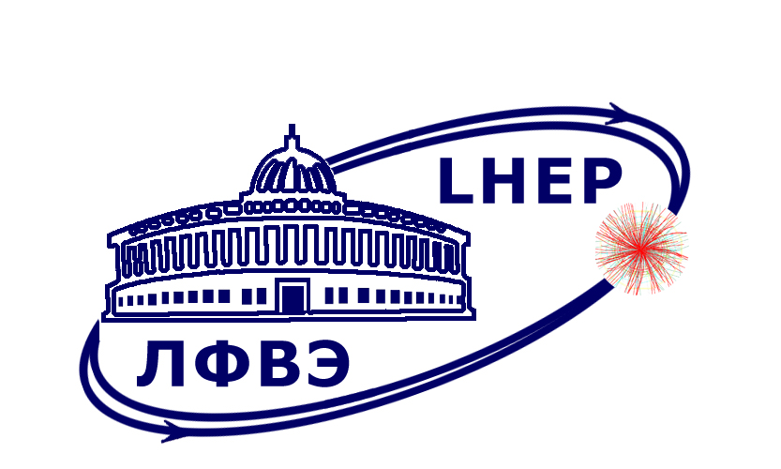
МЕЖДУНАРОДНАЯ МЕЖПРАВИТЕЛЬСТВЕННАЯ
ОРГАНИЗАЦИЯ
ОБЪЕДИНЕННЫЙ ИНСТИТУТ
ЯДЕРНЫХ ИССЛЕДОВАНИЙ
ЛАБОРАТОРИЯ ФИЗИКИ ВЫСОКИХ
ЭНЕРГИЙ им. В.И.Векслера и А.М.Балдина
INTERNATIONAL INTERGOVERNMENTAL
ORGANIZATION
JOINT INSTITUTE FOR
NUCLEAR RESEARCH
Veksler and Baldin LABORATORY
OF HIGH ENERGY PHYSICS

Научно-методический семинар

17 апреля (четверг) 2025 г., 11⁰⁰ по мск.
Очная часть: комната 347, корп. 215, ЛФВЭ.
Онлайн: https://lhep-volna.jinr.ru/seminar

« Model of experiments and a method of analysis of data for determination of absorbed dose of samples for applied research at the NICA facility »

Nelli Pukhaeva / Пухаева Нелли Ефимовна
( ЛФВЭ / Отделение №5 / Сектор рентгеновской спектроскопии )

Model of experiments for applied research at the NICA facility are developed and manufactured. Model includes two ionization chambers IK-1, IK-2, strip and phosphor chambers for measure profile with coordinate and intensity of beam with holders for various samples with different geometry. At those chambers, the materials of electrodes are used different, at the IK-1 it is foil-clad fiberglass, for the IK-2 are taken foil-clad polyimide. One of the ionization chambers will be assembled before irradiated samples, other mounted after. The strip chamber will be added for measure the coordinate of beam or it will replace the IK-2 ionization chambers. By the phosphor chambers will be tracked and follow the profile of beam. The chambers IK-1 and IK-2 have been tested on a ⁶⁰Co gamma source and a 150 MeV proton beam at the accelerator “Prometheus” at the Tsyba MRRC (Obninsk).
A method for analysis of the intensity and profile data for the experiments of applied research is being developed. By using the 3.8 GeV/nucleon ¹²⁴Xe⁵⁴⁺ ion beam, data first part of the method was developed. There will be an expanded by the addition of the information from the ionization, strip and phosphor chambers. The method is necessary to provide the precise determination of the fluence and absorbed dose for irradiated materials.
The study is performed within the ARIADNA Collaboration.

http://indico.jinr.ru Подразделения >> Лаборатория физики высоких энергий
им. В.И. Векслера и А.М. Балдина (ЛФВЭ) >> Семинары >> Методика, детекторы и прикладная физика (Научно-методическая секция)

