4. Experiments on the physical and chemical properties of SHE at FLNR: status and plans.

FLNR JINR

Isaev A.V., Svirikhin A.I.

<asvirikhin@jinr.ru>

At present, the experimental base of FLNR allows not only to plan works on the synthesis of new elements with Z>118, but also to solve problems on the detailed study of the properties of already known heavy and superheavy nuclei. Table 1 gives a rough idea of the properties of the heaviest nuclei available for study.

Table 1: Experimental capabilities of “SHE Factory” at FLNR
Reaction | Niclei | Number of nuclei in the focal plane of the separator | Properties of nuclei available for study
⁴⁸Ca + ²⁰⁴⁻²⁰⁸Pb | ²⁴⁹⁻²⁵⁴No | ≤ 2.5х10⁶ / 24ч | α-,β-,γ-spectroscopy, fission fragment spectroscopy (TKE, ff-masses, neutron multiplicity)
⁴⁸Ca + ²⁴²Pu | ^{286,287}Fl  ^{282,283}Cn*… | ≤ 10 / 24ч | Transactinide chemistry, decay modes, α-,β-,γ-spectroscopy, spontaneous fission characteristics (TKE, neutron multiplicity)
⁴⁸Ca+²⁴³Am | ²⁸⁸Mc  Nh,Rg,Mt*… | ≤ 1 / 24ч  ≤ 10 / 24ч** | Transactinide chemistry, decay modes, α-,β-,γ-spectroscopy, spontaneous fission characteristics (TKE, neutron multiplicity)
* - decay products of the “mother” nucleus
** - in case of compliance with the requirements for operation of radio-chemistry LAB of the 1st class

The main component of this experimental facility, the DC-280 cyclotron, allows the production of stable high-intensity beams of heavy ions, which are directed into three experimental halls of the “SHE Factory” complex.
The flagship facility, located at the direct beam-line of the DC-280 (cave 114) and aimed at synthesizing new superheavy elements, is the gas-filled separator DGFRS-2. Since 2019, the DGFRS-2 facility has produced extensive new data on the decay properties of known superheavy nuclei and synthesized several new isotopes. The separator has demonstrated the capabilities for stable operation in a long-term run with ion current on the target reaching 6 pμA. It is on this separator that work on the synthesis of 119 and 120 elements is planned in the coming years.
In 2022, the GRAND separator (DGFRS-3) was commissioned in cave 113 of “SHE Factory”. This is a gas-filled separator, which is a copy of DGFRS-2, but has the ability to place in the focal plane of various detection systems aimed at detailed study of the properties of heavy nuclei.
Let us list some options for completing the focal plane of the GRAND separator:
- In 2023, the separator was equipped with the modernized GABRIELA-III detection system (Fig. 1), comprising 5 clover-type germanium gamma detectors (HPGe). In combination with a large area focal multistrip detector (100x100 mm²), the GABRIELA-III detection system provides unprecedented gamma-ray detection efficiency among similar installations. Previous generations of the GABRIELA detection system were successfully used in experiments on detailed study of decay properties of nuclei fused in total fusion reactions at the VASSILISSA(SHELS) separator (at the U400 FLNR cyclotron). The combination of the GRAND separator and the GABRIELA detection system has already been used in experiments with ²⁶Mg ions and lead sulfide targets (^{204,206,208}Pb) at the STE Factory. An experiment was carried out to study complete fusion reactions leading to the formation of short-lived neutron-deficient plutonium isotopes (²²⁶⁻²³¹Pu). Further, an experiment was carried out on the GRAND separator to study isomeric states of the neutron-deficient, short-lived ²⁵⁰No nucleus. In the course of studying the behavior of isomeric states at high excitation energies of the compound nucleus, the maximum of the excitation function of the full fusion reaction ⁴⁸Ca + ²⁰⁴Pb = ²⁵²No* corresponding to the reaction channel with 4 neutron evaporation was reached. In the current variant of germanium detectors placement in the experimental hall, the GABRIELA detection system needs additional protection from the powerful neutron background, which is generated at the separator beam stopper by a high-intensity ion flux (up to 6 pμA) and poses the most serious threat to the performance of clover-type HPGe detectors during long-term experiments.
- Since 2022, numerous test experiments on heavy ion beams have been carried out using the Cryodetector unit placed in one of the two focal planes of the GRAND separator (Fig. 1). At the end of 2022, the first experiment to study the 2tilize2 of flerovium (²⁸⁷Fl nucleus) by gas adsorption thermochromatography was set up. At the moment, the gas transport system allows the delivery of nuclei with half-lives of at least 200 ms (T_{1/2} ²⁸⁷Fl = 360 ms) to the detection assembly “Cryodetector”.
- the experimental plans include the placement at the focal plane of GRAND separator the combined SfiNX detection system consisting of 116 3-helium neutron counters surrounding a focal “well”-shaped multistrip detector (similar to the one used in the GABRIELA system). This assembly, well proven in experiments at the focal plane of the SHELS separator, allows the study of the spontaneous fission characteristics of the heaviest known nuclei. In addition, using “light” targets (²⁰⁴⁻²⁰⁸Pb) on intense ⁴⁸Ca, ⁵⁰Ti beams, during short experiments, it is possible to obtain such quantities of fissile nobelium and reserfordium nuclei that information on the mass distributions of fission fragments of these heavy nuclei becomes available. Information on extremely exotic modes of spontaneous (low-excited) fission is becoming available: bimodal fission, super-symmetric fission, super-asymmetric fission, triple fission (with light particle escape). In our group, work is underway to design new detection systems to solve these problems, which, in combination with the GRAND separator, will be able to fully 2tilize the extensive capabilities of the STE Factory.

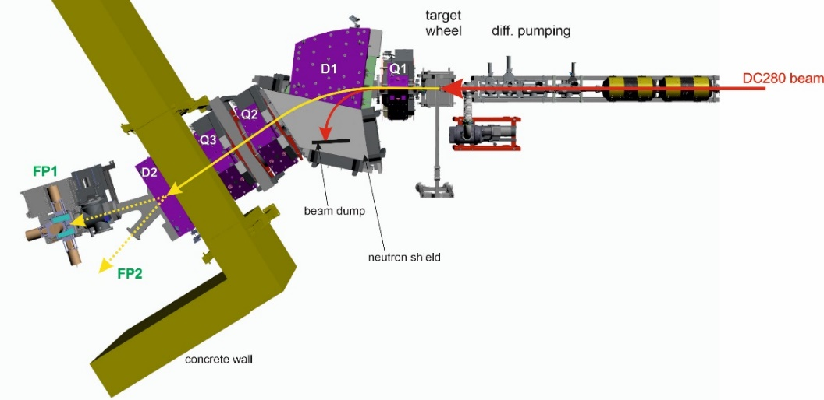

Fig. 1 GABRIELA-III detection system in the focal plane of the separator
GRAND (FP1 is the "physical" output). On the right is the output in the focal plane,
where the recoil nuclei collection chamber of the Cryodetector is located (FP2 pin).

- The possibility of placing the prospective MR-TOF-MS facility (Fig. 2) in the focal plane of the GRAND separator is being considered. In combination with a cryogenic gas ion trap, this precision mass spectrometer will allow measuring the masses of SHE nuclei with the highest accuracy M/ΔM ≤ 1.5∙10⁶. The range of masses available for measurement is А=12÷500, the calculated efficiency of transport of recoil nuclei from the focal plane of the GRAND separator to the resonant region of the MR-TOF system reaches 30%. These parameters allow us to measure the masses of nuclei with Z ≤ 114 in experiments lasting up to 60 days.

Fig.2 Variant of cryogenic gas ion trap and MR-TOF-MS spectrometer placement
in the focal plane of the GRAND separator.

In addition to the above-mentioned installations, a project on creation of a new type of separator, a gas-filled superconducting solenoid - GASSOL, is being implemented at the “SHE Factory”. The separator will be located in the cave 115 of the "Factory", the unit is manufactured by "Xi'an Superconducting Magnet Technology Co.，LTD" (PRC), delivery is scheduled for the end of 2025. At present, factory tests of the superconducting solenoid are being carried out for compliance with the design parameters (Fig. 3).

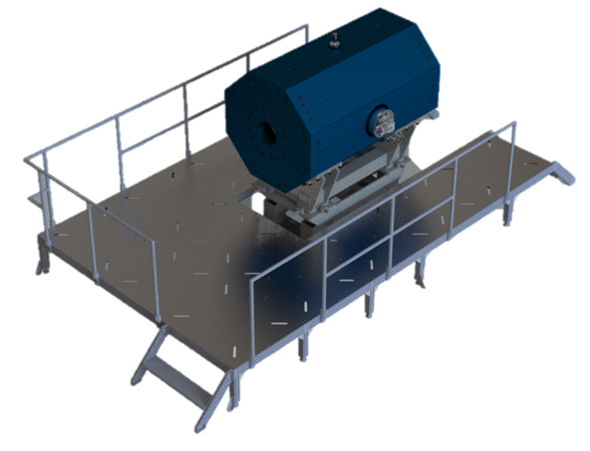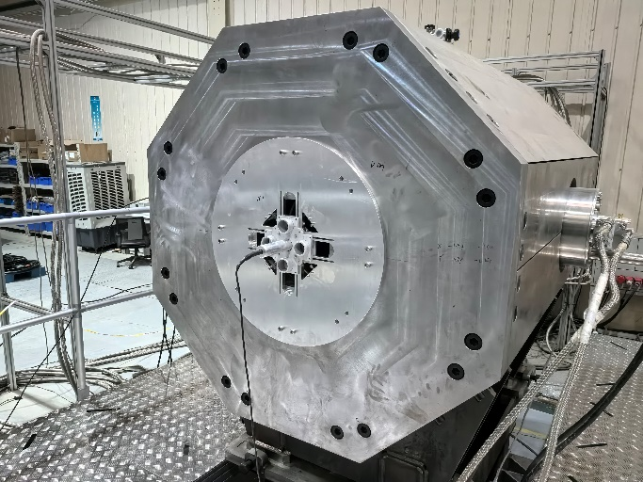

Fig.3 Left panel: general view of the GASSOL separator with platform.
Right panel: factory tests of the superconducting solenoid.

The main feature of this separator is that the recoil nuclei produced in the complete fusion reactions form a "spot" of very small size in the focal plane of the separator. This, for example, makes it possible to place in the focal plane a “recoil chamber” of small volume, which significantly reduces the time of transport of recoil nuclei from the chamber to the "Cryodetector". This feature of the separator significantly expands the possibilities of studying the chemical properties of SHE, allowing to register nuclei with half-lives of a few milliseconds.

