Annex 3.
Form of opening (renewal) for Project / Subproject of LRIP

APPROVED
JINR DIRECTOR
/
" " 2025

PROJECT PROPOSAL FORM
Opening/renewal of a research project/subproject of the large research infrastructure project within the Topical plan of JINR

- General information on the research project of the theme/subproject of the large research infrastructure project (hereinafter LRIP subproject)
  - Theme code / LRIP (for extended projects) - the theme code includes the opening date, the closing date is not given, as it is determined by the completion dates of the projects in the topic.
“Neutron Nuclear Physics”
  - Project/LRIP subproject code (for extended projects and subprojects)
  - Laboratory
FLNP
  - Scientific field
Nuclear Physics
  - Title of the project/LRIP subproject
Development of the concept of an ultracold neutron (UCN) source at the IBR-2 pulsed reactor
  - Project/LRIP subproject leader(s)
Valery Shvetsov, German Kulin
  - Project/LRIP subproject deputy leader(s) (scientific supervisor(s))
Alexander Frank

- Scientific case and project organization
List of abbreviations
UCN – ultracold neutrons
VCN – very cold neutrons
PNA – pulsed neutron accumulation
JINR – Joint Institute for Nuclear Research
FLNP – Frank Laboratory of Neutron Physics
EDM – electric dipole moment
PNPI – Petersburg Nuclear Physics Institute of B. P. Konstantinov
ND – nonstationary diffraction
AME – accelerating matter effect
EP – equivalence principle
AE – acceleration effect
WEP – weak equivalence principle
LDD – local decelerating device
SP – source-prototype
  - Abstract
The objective of the project is to develop a conception of a world level ultracold neutron (UCN) source at the IBR-2 pulsed reactor. The conceptual design of the source will be based on a number of engineering proposals with no analogues in the world practice. For the first time, the principle of pulsed neutron accumulation (PNA) is planned to be implemented that allows obtaining a significant gain in the neutron gas density in the material trap. The authors proposed an original solution to the issue of preserving the pulsed structure of the neutron flux during their transportation has been found that is absolute must for implementation of the PNA principle. A new approach to this issue consists of obtaining UCNs right near the trap by decelerating faster neutrons in a superconducting magnetic resonance system. The occurrence of a strong magnetic field near the trap allows finding a new approach to the issue of a pulsed valve at the trap entrance. The expected density of neutrons accumulated in the trap is 250 n/cm³.
The scientific program on the future source will be based on development of the results obtained in the previous years by JINR physicists in cooperation with other scientific centers. The priority areas are expected to be the precise verification of the weak equivalence principle by gravitational quantum spectrometry and the study of the universal Acceleration Effect in the quantum sector. During the implementation of the project, a prototype source will be created, the construction of which will make it possible to verify the correctness of the technical solutions taken to create the projected source, as well as to conduct experimental studies necessary to create a complete conception of the projected Source.
  - Scientific justification (purpose, relevance and scientific novelty, methods and approaches, methodologies, expected results, risks)
    - Relevance of developing an UCN source in JINR and the research program
      - Investigations of fundamental problems of neutron optics in FLNP JINR
It is known that the honor of discovering ultracold neutrons belongs to the group headed by F. L. Shapiro, FLNP JINR [1]. The primary motivation for the use of ultracold neutrons was the capability of long-term storage of such neutrons in the trap [2] that should have significantly increased the accuracy of experiments to search for the electric dipole moment (EDM) of the neutron [3]. Summing up the results of the first stage of the investigations with UCNs [4], F. L. Shapiro outlined the possible applications of ultracold neutrons, making the investigation of the properties of the neutron as an elementary particle a priority. Moreover, besides the experiments on the search for the EDM and the measurement of the neutron decay constant, implying the possible long-term storage of neutrons in the trap, he also named the experiments in which containment in the trap is not required. In particular, these experiments included the ones aimed at searching for the electric charge of the neutron and work on development of a neutron microscope. Thereby, at the initial stage of the investigations with UCNs, there were two significantly different tendencies in the approaches to experiments with UCNs.
Today as well, there is such division of experiments with UCNs into two groups. The greatest efforts and resources are currently used in the search for the EDM of the neutron [5] and the investigation of its decay [6-9] in experiments on the storage of UCNs in material or magnetic traps. However, at the same time, there was the second tendency based on the unique properties of UCNs. In particular, in the late 1980s and the early 1990s of the last centuries, considerable efforts were focused on the development of neutron microscopy with UCNs [10, 11]. Obviously, the neutron microscope based on the possibilities of applied neutron optics requires high brilliance of the radiation source but does not assume the possibility of neutron storage in the trap. Along with the discovery of UCNs, the capability of using neutrons of very low energies resulted in the possible implementation of quantum experiments with UCNs [12, 13] that also do not imply long-term neutron storage but as a rule, require a significant neutron flux density. Such experiments were of particular significance in the number of investigations with UCNs carried out in FLNP JINR.
In addition to the internationally recognized priority in the discovery of UCNs, the contribution of JINR researchers to development of the experimental basis of UCN physics that is reflected in the corresponding monographs [14, 15] is of great significance. The FLNP group, in collaboration with the PNPI group, carried out an experiment to measure the neutron decay constant [16] that served as the beginning of a new stage of precision measurements of this fundamental quantity that continues to the present time. The investigations of the FLNP researches of the so-called anomaly in the storage of UCNs and of the processes of small energy transfers during their storage [17-19] in traps are widely known.
In addition, research in the field of fundamental neutron optics and experimental quantum mechanics has been carried out in the Laboratory for many years. The goal of this research has been both to develop new experimental techniques based on the use of quantum phenomena and to study fundamental problems involving the investigation of neutron wave propagation in matter.
The precision spectrometry of UCNs based on the quantum analog of the Fabry-Perot optical interferometer [20, 21] was developed and became the methodological basis for a series of investigations on UCN optics. Among them is the research of the dispersion law of neutron waves in matter [22-24] initiated by previous work [25]. Unique is the experiment [26] to study the specificities of neutron wave propagation in gadolinium films. The results of the experiment confirmed the validity of the theory of optics of highly absorbing medium.
A vivid demonstration of the possible observing of nonstationary quantum phenomena in experiments with UCNs was the first observation of nonstationary diffraction (ND) of UCNs on moving periodic structures and demonstration of neutron acceleration and deceleration using high-frequency phase modulation of the neutron wave [27]. For the first time, the capability of neutron focusing in time based on ND was shown [28]. Later, the phenomenon of nonstationary UCN diffraction allowed implementing a new type of gravitational experiment and verifying the equivalence principle for the neutron with an accuracy of about 10⁻³ [29].
The major result was the registration of the neutron energy change in the experiment with UCNs that pass through a refracting sample moving with acceleration. The spectrometric accuracy of the experiments was a record for that time of about 10⁻¹¹eV [30].
      - Current fundamental problems of neutron optics
Addressing the current fundamental problems of neutron optics, one should first of all focus on the relatively poor knowledge of the fundamental problem of the type of the dispersion law of neutron waves in matter. The fact is that the analysis of most neutron optical phenomena is based on the concept of the effective potential attributed to the medium or of the so-called potential dispersion law. It is on this semi-qualitative theory that the calculations of the neutron reflection coefficient from matter, so relevant for estimating the storage time of UCNs in traps are based.
There are, however, experiments, the results of which greatly differ from the results of such calculations [31]. Moreover, theoretical arguments have been found in favor of the complete inapplicability of the efficient potential for neutrons with much lower energies than UCNs [32, 33]. If it is true, then there may be small corrections to the current theory for UCNs as well. However, the current experiments [23, 25] do not provide a definite answer about the validity of such an assumption.
As for cold neutrons, the theory definitely predicts that there are corrections to the potential dispersion law for them [34, 35], yet there are no experiments confirming or refuting these predictions. Thus, the issue of the dispersion law of neutron waves in matter requires a thorough theoretical and experimental study.
The second fundamental problem of scientific interest arose due to the observation of the energy change of neutrons when passing through a sample that moved with acceleration [30]. It is known that in addition to the prediction of this effect for neutron waves [36], a similar effect was previously predicted, although not observed for light [37]. Reporting on a more detailed study of the previously discovered phenomenon, the authors of [38] concluded that it is a very general physical effect, valid for waves of any origin and called the Accelerated Matter Effect (AME) by them. At the same time, AME directly follows from the equivalence principle (EP). This perception of the close interaction between the AME and the EP allowed eventually coming to the formulation of the universal Acceleration Effect (AE) [39], that is to say, any object scattering a wave or transmitting a signal shifts the frequency if the object itself moves with acceleration. In other words, it was about an effect as general as the Doppler effect but unlike the latter, it differs in that the frequency shift is defined not by the velocity of the object but by its acceleration.
It should be emphasized that from the assumption of universality of AE directly follows the conclusion about its validity in the quantum sector. The calculation based on the numerical solution of the Schrödinger equation has shown that in the case UCNs pass through a number of simplest quantum objects moving with acceleration, the energy actually changes [40] and this result is to be experimentally confirmed. A major consequence of the validity of the acceleration law in the quantum sector is the prediction of inelastic and non-isotropic nature of neutron scattering on an atomic nucleus moving with acceleration. It follows that the propagation of a neutron wave in an accelerating medium should be different from the case of a medium in an inertial system [41], since the idea of the isotropic and elastic nature of neutron-nuclear scattering is fundamental for neutron optics. Thus, the validity of the assumption made almost 20 years ago in [30] has obtained serious arguments in its favor. However, in need of reliable scientific confirmation, this hypothesis is a serious challenge for both theorists and experimentalists.
Among the topical fundamental problems of neutron optics is the issue of precision measurement of the free-fall acceleration for the neutron g_{n}. The equality of this value to the local value of the free-fall acceleration of macroscopic bodies is a proof of the validity of the so-called weak equivalence principle (WEP). Note, in this regard, a recent experiment [42]. Its methodological basis is the effect of quantization of the vertical movement of neutrons during their storage on a horizontal mirror, predicted in 1978 [43] and first observed almost a quarter of a century later [44]. This phenomenon served as a basis for the development of a new approach to UCN spectroscopy and allowed achieving an experimental sensitivity of an order of 10⁻¹⁴ eV [45, 46]. However, the discrepancy with the classically measured value of g is four times higher than the statistical error that probably indicates unaccounted methodological errors. Accordingly, the issue of precision measurement of the neutron free-fall acceleration aimed at verifying the weak equivalence principle is still very relevant.
      - Basic areas of research with future UCN source of JINR
The future UCN source research program of JINR is aimed at studying the fundamental problems of neutron optics mentioned above and is development of the scientific results obtained in the previous years by the FLNP group of JINR in cooperation with colleagues from other scientific centers. Today, two basic areas of future research can apparently be defined.
First, it is a systematic investigation of neutron wave propagation in matter for establishing the true dispersion law, that is, dependence of the wave number in the medium on the neutron energy. It is assumed that this kind of research will be carried out both for the samples at rest and for the samples moving with acceleration.
The methodological basis for these investigations will be the neutron resonance interferometry technique, the theoretical background of which was founded by [47,48] and the capability of practical implementation of which was presented in [49-51]. There is no experience in the implementation of this technique for very cold and ultracold neutrons.
The second area, methodologically closely related to the first one, will be the verification of the theoretical prediction [40] about the validity of the concept of the Acceleration Effect in the quantum sector. The observed effect value will be in this case two orders smaller than the observed one in the experiments [30, 38] that is an extremely challenging task.
It should be emphasized that in both mentioned cases, an experiment does not imply long neutron confinement in the device and the measurements will be carried out with a neutron beam the energy of which is in a narrow energy range.
The goal of the third research area will be development of a new approach to gravitational resonance spectroscopy. In contrast to the current technique [44-46] of studying the quantum states of neutrons stored on a material mirror, this approach will be based on the measurement of the transition frequency between the quantum levels of neutrons in a quantum well formed by the joint action of gravity and the inhomogeneous magnetic field of the mirror. In this case, neutrons that are in a kind of gravitomagnetic trap [52] will not be in contact with the material of the magnetic mirror. Prospects of this approach refer to a greater sensitivity of the spectrum of states to the value of the free-fall acceleration than that of the current technique. Therefore, one can hope that development of the gravitomagnetic spectroscopy technique will allow increasing the sensitivity of experiments to test the weak equivalence principle for the neutron.
    - Project content
      - Project objective
The objective of this project is to develop a conception of JINR UCN source with parameters corresponding to the current world level.
      - Special feature of the future UCN source of the IBR-2 reactor
The IBR-2 reactor with a rated power of 2 MW operates in the pulse mode with a pulse repetition rate of 5 Hz and a pulse duration of about 250 µs. As will be shown below, such reactor parameters make it rather difficult to develop an UCN source with satisfactory performance.
The fact is that at present there are two basic approaches to the issue of developing intense UCN sources. They differ in the choice of converter material, in which thermal or cold neutrons are converted into ultracold ones. In the first case, such a substance is superfluid helium at a temperature of about 1K or below, in the second case, it is solid orthodeuterium at a temperature of about 5K. In all cases, it is either a stationary thermal neutron flux [53-54] or quasi-stationary thermal neutron flux [55] when the converter is irradiated using the neutron flux for a relatively short time sufficient to produce UCNs that fill the trap; the time interval between pulses may be of the order of the storage time of the UCNs in the trap.
In the case of a superfluid helium converter, the production volume of UCNs is usually based on the extracted cold neutron beam and is outside the basic neutron source shielding. Obviously, the flux of such neutrons falling on the converter is by several orders of magnitude lower than in the main moderator of the source. Therefore, this approach is efficient only in the case of reactors with high average flux [53] which IBR-2 does not belong to. Apparently, the relatively low average flux of cold neutrons on the beam withdrawn from the IBR-2 reactor does not allow considering the possible use of a superfluid helium source.
In the case of a solid deuterium converter, the latter is positioned at the site with the highest possible neutron flux that at one time means a significant thermal load on structural components from the concomitant radiation. At the same time, the experimental facility is usually positioned at some, sometimes considerable distance from the UCN production site that requires an UCN transport neutron guide.
As a rule, the volume of solid deuterium far exceeds the volume which ultracold neutrons can escape from into the neutron guide. It allows deuterium to be used as an extra moderator that increases the yield of UCNs. In addition to the significant cryogenic power required to cool a significant mass of substance to low temperatures, an extra radiation shielding is required. The potential explosion risk of deuterium requires special safety measures. The construction of such a source at the IBR-2 reactor is considerably more difficult than in the case of a pool-type reactor [54] or of a spallation target [55]. This is due to both the inevitable proximity of the UCN converter to the core that significantly increases the thermal load on the converter and that the IBR-2 reactor is tens of times more sensitive to geometry changes than stationary reactors. It considerably increases the potential explosion risk of the converter with solid deuterium. Therefore, the variant of an UCN source at the IBR-2 reactor based on the use of such a converter was rejected.
An alternative to the approach using a high-efficiency converter and a time-averaged neutron flux is an attempt of using the circumstance in which the IBR-2 reactor is characterized by a record high value of the pulse density at a relatively moderate value of the average neutron flux density. The idea behind such an approach is to fill the UCN trap only during the pulse and to efficiently isolate it the rest of the time [4]. In the case of relatively small losses, the equilibrium flux of UCNs in the trap can significantly exceed the time-averaged flux at its entrance. Thus, we are talking about a high-brilliant source at a relatively moderate production rate of UCNs.
The practical implementation of this idea is hindered by the fact that due to the biological shielding, the trap is distant from the moderator in which UCNs are produced. In this case, at least ten meters-long transport neutron guide is required to supply the trap. Positioning an isolating valve near the moderator-converter - the UCN source, causes the neutron guide to become a part of the trap that greatly reduces the storage time of the UCNs in the trap-neutron guide system and significantly reduces the density of neutrons accumulated in the trap. Positioning a valve at the entrance to the trap is useless since the variation of UCN time of flight from the source to the trap results in a loss of the pulse structure of the beam.
Consequently, to develop an UCN source with pulse accumulation in the trap, the conditions of small duration of neutron bunches entering the trap remote from the neutron production site should be ensured in one way or another. At present, there is no practical experience in meeting this task.
      - New engineering proposals that defined approaches to the conception of Source
Possible approaches to the UCN source design with pulsed accumulation in the trap were analyzed in [56-58]. The following factors were considered when selecting them: the expected UCN density in the trap, the complexity of implementation and current engineering proposals that give reason to hope for the project feasibility. As a result, the choice was made in favor of a previously unused variant, the key feature of which is a two-stage approach to the production and transport of UCNs from the moderator to the trap.
The idea is that to the source initially come VCNs with a relatively wide velocity spectrum, the flux of which near the production site has a pulsed structure. Their velocities are much higher than the velocity of UCNs. Using a mirror neutron guide, such neutrons are transported to a local decelerator that slows down neutrons to the UCN energy and supplies the trap with a pulsed gate at the entrance. A key feature of this device is that the energy of all neutrons decreases by a fixed value E, much larger than the UCN energy. The velocity spread of neutrons that can be trapped after energy release meets the ratio ΔV/V ≈ U/2E ≪ 1, where U is the UCN energy. At the same time, the time of flight spread Δt/t = ΔV/V from the pulse source to the decelerator and accordingly, to the trap, is much smaller for such neutrons not only than the time of flight, but also than the repetition period of reactor pulses. Therefore, the flux of VCNs that are converted into UCNs after deceleration, has a pulsed structure [59]. A nonstationary gradient spin flipper [60, 61] with a strong magnetic field can serve as a local decelerating device (LDD).
Although the range of velocities of “useful” VCNs is relatively narrow, it still has a finite quantity. It results in some spatial and time spreading of “useful” neutron bunch during transport. In addition, the deceleration time of neutrons in the magnetic field of the flipper also depends on the velocity at the entrance. Thus, without special measures, the deceleration time spread is added to the transport time spread that increases the duration of the UCN bunch at the entrance to the trap.
An essential engineering proposal is installing a time lens with weak focusing at the entrance to the LDD [58]. Such a lens changes the velocities of neutrons entering into it in such a way that neutrons with the lowest velocities enter the flipper first and those with the highest velocities - last. Since the deceleration time depends on the neutron velocity at the entrance to the flipper, the time of flight spread during transport can be fully or partially compensated by the deceleration time spread. It can radically reduce the duration of the bunch.

      - Source design
        - Justification of the projected Source scheme

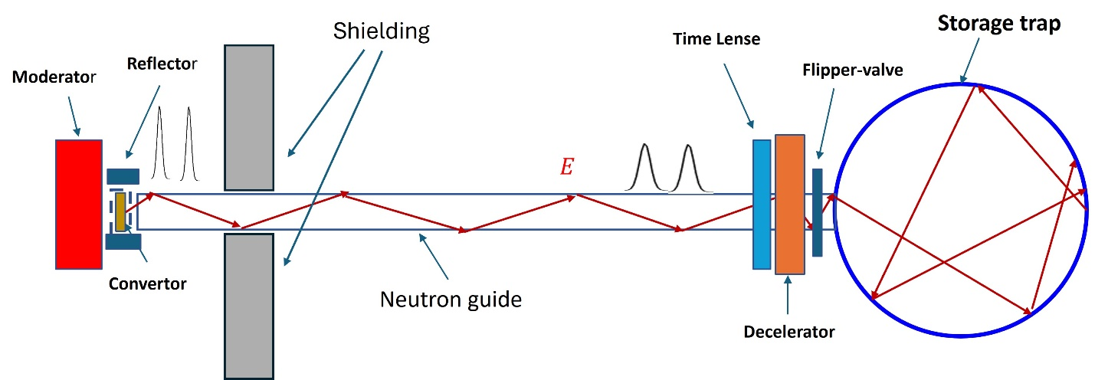
Fig.1. Schematic of the projected UCN source at the IBR-2 reactor
The design of the projected source is schematically represented in Figure 1. Very cold neutrons are produced using the moderator-converter. To increase the thermal neutron flux, the converter is surrounded by a cylindrical water reflector.
Of the wide range of VCNs produced using the converter, neutrons with velocities in the range of 20.9 ± 0.2 m/s are usable. Using a mirror weakly curved neutron guide, neutrons are transported to the decelerator while passing through a single or two time lenses that transform the neutron velocity.
The energy changes in flipper-decelerator due to the nonstationary spin flip in the strong magnetic field. The proximity of the magnetic system of the flipper to the trap allows its field to be used as a barrier to the neutrons in the trap. This magnetic barrier, together with an extra pulse flipper positioned near the declining field of the main flipper-decelerator will serve as a pulse valve locking the trap.
The function of the time lens is briefly described in the previous section.
The picture of the evolution of the “useful” neutron bunch on the phase plane (z-z₀, V_{s}-V_{z0}) is presented in Figure 2, z₀(t) is the position of the bunch center at t time and V_{z0} is the average value of the bunch velocity.
a) | 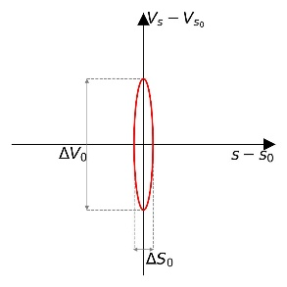 |  |  | 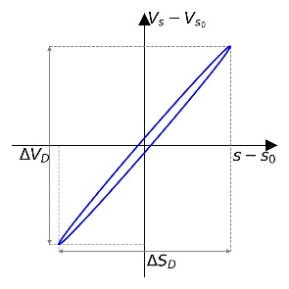
 | 1 |  |  | 2
b) | 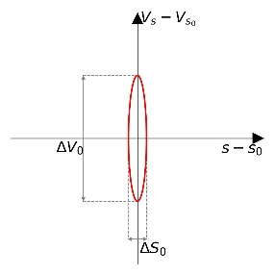 | 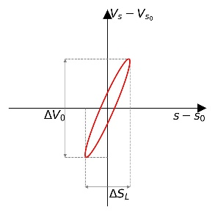 | 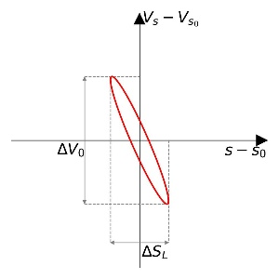 | 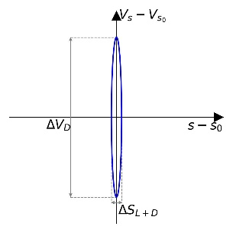
 | 1 | 3 | 4 | 5
Fig.2. Phase portrait of the neutron bunch propagating along the neutron guide with no compensating lens (a) and in the case of exact compensation of time of flight spread by the deceleration time spread (b). The numbering corresponds to the following positions of the bunch: 1 - at the exit from the converter, 2 and 5 - at the entrance to the trap, 3 and 4 - before and after the passage of the lens.

        - Positioning of the source and its basic components
The source will be positioned on beamline 3 of the IBR-2 reactor, initially intended for this goal in the reactor design. All components of the source will be positioned on a movable platform that will allow moving the source to the operating position when the beamline end and the converter are positioned in close proximity to the reactor core or moving it several meters away from the core that will allow closing the standard gate of the beamline.
Convertor
The convertor is used for producing neutrons with an energy of 2 µeV. The basic and alternative variants of the converter are considered. The basic variant assumes that the converter will be a thin chamber with liquid hydrogen cooled using gaseous helium, which there is appropriate cryogenic infrastructure at the 3rd beamline of the IBR-2 reactor for. The mass of hydrogen used will be less than 10 g that gives reason to hope that the safety issue will be met.
Flipper-decelerator
The flipper-decelerator is not only the basic, but the most complex component of the source that allows making a two-stage approach to production of UCNs. It is aimed at reducing the energy of all neutrons by the same value. A nonstationary gradient spin-flipper will serve as a device to meet this task. Spin flipping in such a device occurs under the high-frequency magnetic field directed perpendicular to a permanent but coordinate-dependent magnetic field. The energy change during spin flipping occurs due to the exchange of neutron energy with the electromagnetic field quantum with the frequency . Neutrons with a single spin projection value are slowed down to the energy of UCNs and can be trapped. Such a technique of neutron slowing down was proposed many years ago [62]. The very fact of neutron energy change at resonance spin flip was shown in the experiment [63]. The possibility of neutron acceleration and deceleration based on the resonance flip of the neutron spin has been experimentally used in the research devoted to time focusing of UCNs [64, 65].
Although the gradient or adiabatic spin flipper is widely used in the practice of neutron experiments (see for example [66]), development of a flipper moderator with the parameters required for these goals is a rather difficult task. In order to slow down neutrons with an energy of 2 µeV to an energy of 100 neV that are typical for UCNs, spin flip should occur in a magnetic field hundreds of times higher than the values usual for such devices. There is no experience of developing a neutron spin flipper with such parameters in the world practice. The preliminary design of the flipper was developed by the project participants in close cooperation with SuperOx. The magnetic field with a maximum strength of 18 T of the required configuration may be produced using a superconducting solenoid with a room temperature bore of 150 mm in diameter that allows positioning a neutron guide and a cylindrical birdcage-type resonator in it. The resonator will produce a magnetic field with a strength of about 0.5 mT rotating in a plane perpendicular to a stationary field with a frequency of about 520 MHz. A large volume of implemented model calculations testifies to the high efficiency of such a flipper [69].
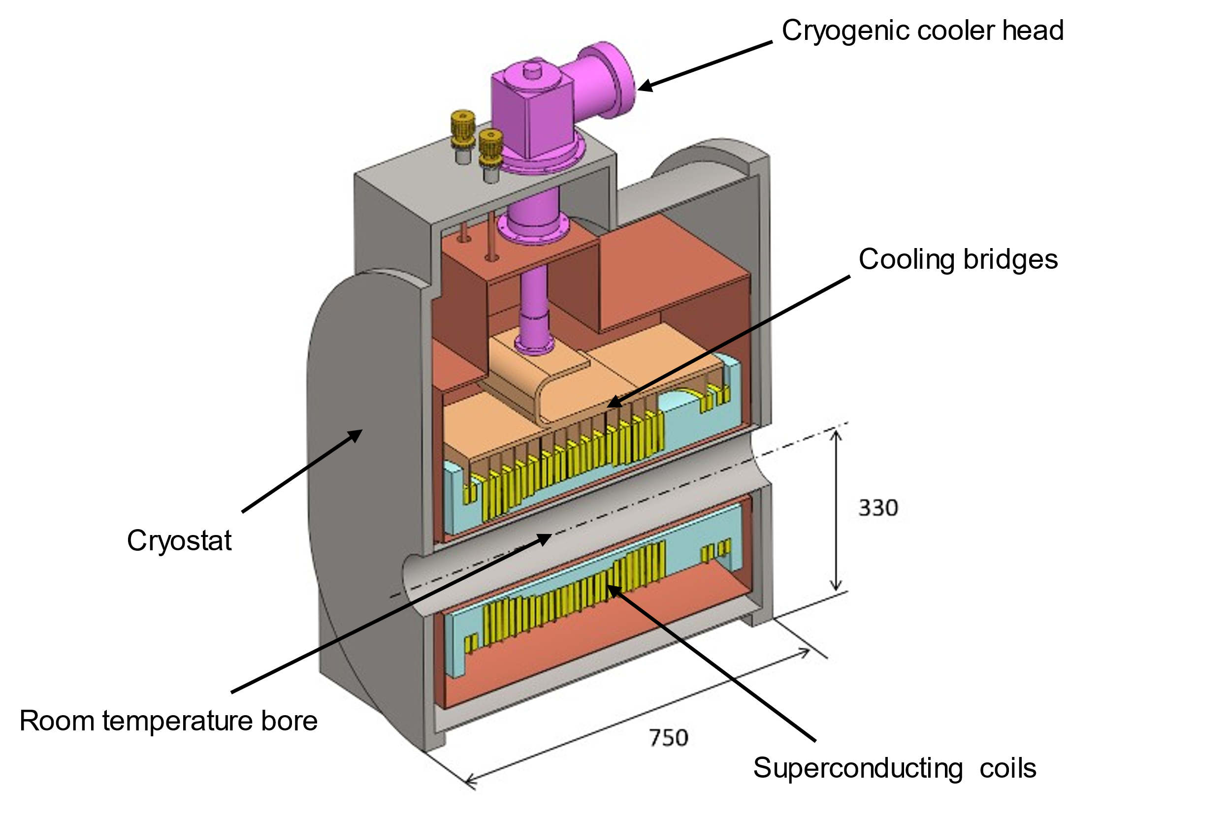 | 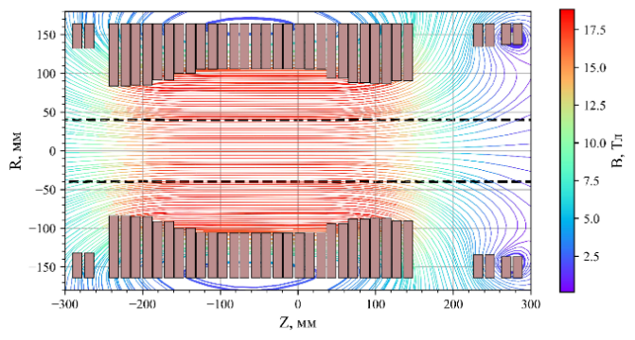
Fig. 3. Magnetic system of the flipper-decelerator. Left: layout of the structure and cryostat, right: winding configuration and magnetic field strength map

Neutron guide
The S-shaped neutron guide is 13-15 meters long and is designed for the transport of very cold neutrons at velocities of about 20 m/sec. It will have two curved sections with a radius of curvature of about 20 meters that will significantly reduce the background of neutrons with velocities higher than 50 m/s. The quality of its inner surface is subject to rather high requirements. The small micro-roughnesses should ensure transmittance at the level of tens of percent and the permissible level of shape defects (waviness) should ensure equality of monochromatic neutron time of flight at the level of 2-3 ms at its best. The choice of material and design of the neutron guide will be done during the implementation of this project.

Time lens
The current approaches to development of neutron time lenses are analyzed in [58]. A variant of a magnetic lens was selected to be a time lens for mutual compensation of the transport time and deceleration time spread, the functional principle of which is based on the magnetic variation in a certain space region during the neutron time of flight in this region [70].
The energy transferred by the lens ΔE = ± μΔB (μ is the magnetic moment of the neutron) is estimated by the variation value of the magnetic field ΔB during the residence time of the neutron.
Probably, it is hardly possible to both accelerate and to decelerate neutrons using a single lens, the source is expected to have two such lenses operating at two consecutive time intervals. One of them will be decelerating and the other - accelerating. The maximum value of energy transferred by the lens will be 90-95 neV. It means that the magnetic field should vary by about 1.5 T. In this case, the magnetic field variation should be for a time of about 7 ms. Development of such a lens is a rather complex technical task, the solution to which is to be found during the next stage of work on the source.

References
- V. I. Luschikov, Ya. N. Pokotilovski, A. V. Strelkov, F. L. Shapiro// Sov. Phys. JETP Lett. 9, 23 (1969)
- Ya. B. Zel'dovitch//Sov. Phys. JETP 9,1389 (1959).
- F. L. Shapiro//Sov. Phys. Usp. 11 345 (1968)
- Shapiro//Ultracold Neutrons. In: Erő, J., Szűcs, J. (eds) Nuclear Structure Study with Neutrons. Springer, Boston, MA pp. 259–284.
- J.W. Martin // J.Phys.Conf.Ser.1643(2020) 012002
- A. Serebrov, V. Varlamov, A. Kharitonov, et al. //Phys.Lett. B, V. 605, P. 72 (2005)
- F. M. Gonzalez et al. (UCNτ Collaboration) // Phys. Rev. Lett., V.127, P. 162501 (2021).
- F. E.Wietfeldt. Symmetry 2024, 16, 956.
- B. Plaster et al. (UCNA Collaboration). EPJ Web of Conferences 219, 04004 (2019)
- A. Steyerl, W. Drexel, T. Ebisawa, E. Gutsmiedl, K.-A. Steinhauser, et al. //Rev. de Physique Appliquee, 23 (2), (1988) 171-180.
- A.I.Frank//Nucl.Instr.Meth.A,1989, v.284.p.161- 170.
- A.S. Gerasimov, M.V. Kazarnovskii //Zh. Eksp. Teor. Fiz.,71, 1700 (1976)
- V.I. Luschikov and A.I. Frank//JETP Letters, 28, 560 (1978)
- V. K. Ignatovich. //The Physics of Ultracold Neutrons. Clarendon Press.
- R. Golub, D Richardson, S.K Lamoreaux.// Ultra-Cold Neutrons.
- Alfimenkov V. P., Varlamov V. E., Vasil'ev A. V et al. //JETP Lett. 52 (1990) 584
- P. Geltenbort, V. V. Nesvizhevsky, D. G. Kartashov et al. Jetp Letters, 70, 1999, 170- 175.
- V V. Nesvizhevsky, E V Lychagin, A. Yu. Muzychka et al. // Physics Letters B, 479, (2000), 353-357
- D G Kartashov, Е V Lychagin, A Yu Muzychka, G V Nekhaev, V V Nesvizhevsky// International Journal of Nanoscience, Vol 6, No 6 (2007), 501-513
- M.I. Novopoltsev, Yu.N. Pokotilovskii and I.G. Shelkova//Nuc. Inst. and Meth. A264 (1988) 518-520
- A.I. Frank, S. N. Balashov, V. I. Bodnarchuk, et al. Proc. SPIE Vol. 3767, 360-371 (1999)
- A.I. Frank, S.N. Balashov, I.V. Bondarenkoet al. JINR Communication E3-2004-216.
- G.V. Kulin, A.N. Strepetov, A.I. Franket al.// Physics Letters A, 378, 2553-2556 (2014)
- A.I. Frank, V.G.Nosov// Physics of Atomic Nuclei, 58, 402 (1995)
- I.V. Bondarenko, A. V. Krasnoperov, and A. I. Frank, et al, JETP Letters, 67, pp.786-792, 1998.
- A. I. Frank, V. I. Bodnarchuk, P. Geltenbort et al.// Phys. At. Nuclei, 66, 2003, 1831-1845
- A.I.Frank, S.N.Balashov, I.V.Bondarenko et al. Physics Letters A 311 (2003) 6-12.
- S.N. Balashov, I.V. Bondarenko, A.I. Frank et al. Physica B, 350 (2004) pp. 246-249
- A.I. Frank, P. Geltenbort, M. Jentschel et al. Nuclear Inst. Meth. A, 611, (2009), 314
- A.I. Frank, P.Geltenbort, G.V.Kulin, et al. JETP Letters, 84 (2006) pp. 363–367.
- V.P. Alfimenkov, A.V. Strelkov, V.N. Shvetsov et al. Jetp Lett. 55, (1992) 84-87/
- A. I. Frank and V. G.Nosov, Phys. At. Nucl. 58, 402 (1995).
- V. G. Nosov and A. I. Frank, Phys. Rev. A 55, 1129 (1997).
- V. F. Sears, Phys. Rep. 82, 1 (1982).
- Warner and J. E. Gubernatis, Phys. Rev. B 32, 6347 (1985).
- F. V. Kowalski, Phys. Lett. A 182, 335 (1993).
- K. Tanaka, Phys. Rev. A 25, 385 (1982).
- A.I. Frank, P. Geltenbort, M. Jentschel et al. Physics of Atomic Nuclei, 71 (2008). 1656-1654.
- A.I. Frank. Physics-Uspekhi 53, 500 (2020).
- M.A. Zakharov, G.V. Kulin and A.I.Frank. Eur. Phys. J. D 75, 47 (2021).
- A.I.Frank, M.A. Zakharov, G.V. Kulin. Acceleration Effect in quantum mechanics and neutron optics. XXVII International symposium on nanophysics and nanoelectronics, Nizhny Novgorod, IPPHYS RAS (2023), Pp. 924-925 (In Russian)
- Jakob Micko, J. Bosina, S. S. Cranganore et al. arXiv:2301.08583v1 [hep-ex]
- V.I. Luschikov and A.I. Frank. JETP Letters, 28, (1978) 560
- V. V. Nesvizhevsky, H. G. Borner, A. K. Petukhov et al.// Nature, V.415, P. 297, (2002).
- T. Jenke, P. Geltenbort, H. Lemmel and H. Abele. //Nature Physics, V.7, P.468 (2011)
- R. Sednik, J. Bosina, P. Geltenbort et al., // EPJ Web of Conferences 219, 05003 (2019)
- R.Golub and R.Gahler, Phys.Lett.A, 123, 43-48 (1987)
- R.Gahler and R.Golub, J. Phys. (Paris), 49, 1195-1202 (1988)
- S. V. Grigoriev, W. H. Kraan, F. M. Mulder, and M. Th. Rekveldt//Phys.Rev. A 62, (2000) 063601
- S.V. Grigoriev, Yu. O. Chetverikov, A.V. Syromyatnikov et al.//Phys.Rev.A 68,(2003) 033603
- S. V. Grigoriev, W. H. Kraan, and M. Th. Rekveldt// Phys.Rev. A 69, (2004) 043615
- A. I. Frank, V. G. Nosov// JETP Letters, 79, (2004) 313–315.
- A. P. Serebrov, V. A. Lyamkin, A. K. Fomin & M. S. Onegin Tech. Phys. 68 (Suppl 2), S400–S407 (2023).
- G. Medlin, E. Korobkina, C. Teander, B. Wehrin. Nucl. Eng. 2024, 5(4), 486-499
- B. Lauss, Phys. Procedia 51,98 (2014).
- A. I. Frank, G. V. Kulin, N. V. Rebrova, M. A. Zakharov, Physics of Particles and Nuclei 53 (1) (2022) 33–44.
- N. N. Nesvizhevsky, A. O. Sidorin, Production of Ultracold Neutrons in an Escaping Decelerating Trap, Physics of Particles and Nuclei Letters 19 (2022) 162–175.
- A.I. Frank, G.V. Kulin, M.A. Zakharov et al. arXiv:2412.06460v1 [physics.ins-det], doi:10.48550/arXiv.2412.06460; PEPAN Vol. 56, issue 5 (2025) in press.
- A.I. Frank, G.V. Kulin, M.A. Zakharov. Phys. of Particle and Nuclei Letters, 20 (2023), 664–667.
- A. I. Egorov, V. M. Lobashov, V. A. Nazarenko, et al., Sov. J. Nucl. Phys. 19 (2) (1974) 147–152.
- V. I. Luschikov, Y. V. Taran, NIM 228 (1984) 159–160
- G. M. Drabkin, R. A. Zhitnikov, Sov. Journ. of Exp. and Theor.Phys. 11 (1960), 729–730.
- B. Alefeld, G. Badurek, H. Rauch, Zeit. für Phys. B Condensed Matter 41 (1981) 231–235
- Arimoto Y., Gertenbort P., Imajo S. et al. Phys. Rev. A 86 (2012) 023843.
- Imajo S., Iwashita Y., Mishima K. et al. Proc. JPS Conf., Tsukuba, Japan (2021) 011091.
- S. V. Grigoriev, A. Okorokov, V. Runov, Nucl. Instr. Meth. A. 384 (1997) 451–456.
- 67. C. E. Hayes, W. A. Edelstein, J. F. Schenck et al. Journal of Magnetic Resonance, 63(3) (1985) 622–628.
- 68. P. T. Bernat, Design and Simulation of a Birdcage Coil using CST Studio Suite for Application at 7T, PhD thesis, UPC, Escola T‘ecnica Superior d’Enginyeria de Telecomunicaci o de Barcelona, Departament de Teoria del Senyal i Comunicacions (2013).
- A. A. Popov, K. S. Osipenko, V. I. Scherbakov et. al. arXiv:2503.10878v1 [physics.ins-det]. Submitted to Natural Science Review
- L. Niel, H. Rauch, Z.Phys. B Condensed Matter 74 (1) (1989) 133–139.

      - Project sophistication level
The work on the justification of the project was carried out within the framework of the Activity “Development of the conceptual design of the ultracold neutron (UCN) source at the pulsed reactor” that is an integral part of the project 03-4-1146-3-2024/2028 of the JINR Topical Plan.
The results of the work on the project include:
- Simulation of time parameters of transport of VCNs in a mirror neutron guide was carried out. The key requirements to the quality of its surface, providing satisfactory time parameters were formulated.
- A technical specification for the design of a superconducting magnetic system of a flipper- decelerator with a magnetic field of 20T was formulated.
- In close cooperation with SuperOx, a draft design of the superconducting magnetic system of the flipper-decelerator was offered and a thorough calculation of the magnetic field was carried out.
- Preliminary calculation of the RF resonator was implemented.
- The investigation of physical properties of the magnetic system with design parameters was carried out using computer simulation techniques.
During the work on the project, 5 articles were prepared for scientific journals, three of which were published [56, 59, 71], one was accepted for publication [58], and one is under review [63]. Also, all these articles were published as electronic preprints.
A master's thesis and 3 bachelor's theses were defended by the team members.

      - Tasks to be solved during the Project implementation
At present, the principal scheme of the projected source has been defined. The authors will have to address a significant number of rather complex scientific and technical problems during the project implementation. The list of the most important ones is presented below.
- Construction design and selection of materials for the head section of the beamline with the converter. The safety problem concerning the proposed use of a cryogenic, a small volume liquid-hydrogen converter.
- Construction design and selection of materials of the neutron guide providing the required time responses of transport of VCNs.
- Design of the engineering infrastructure of the source on beamline 3, providing the possible moving of the source from the operating to the standby position with a closed shutter.
- Designing radiation shielding of the head of the beamline in the standby position.

It is planned to construct a source-prototype (SP) at the place where the projected source is planned. It will differ from the projected source in that it will not have LDD and will use a cryogenic converter based on mesitylene, which does not require complex safety measures. Additionally, the inner surface of the neutron guide will not need to meet as strict requirements as the neutron guide in the planned source. At the same time, in main features, the design of the SP will have many similarities with the design of the projected source.
During the process of creating SP, it will be necessary to address the tasks listed in paragraphs 1-4, except for issues related to the use of liquid hydrogen. Since many engineering challenges are common to both sources, creating SP will allow us to verify the correctness of many technical decisions accepted for the projected source.
It is expected to obtain at the SP a moderate flux of VCN and UCN that will allow carrying out a large number of physical experiments to test the elements of the future source. SP will be equipped with a monochromator and a chopper for time-of-flight investigations. It is planned to carry out with him a series of research to investigate possible distortions of the velocity spectrum of VCNs caused by surface defects. It is also important that the creation of a source-prototype will play a significant pedagogical role, as it will provide the first practical experience of VCNs and UCNs for an essential part of the newly established group.

      - Expected results
1. The key result of the project will be development of a conception of world level UCN source. It is expected that, in a trap with a volume of about 50 liters, it will be possible to accumulate neutron gas with a density of about 250 n/cm³, which exceeds the levels of current sources.
2. During the implementation of the project, a prototype of the source will be created, the construction of which will make it possible to verify the correctness of the technical solutions accepted to create the projected source, as well as to conduct experimental investigations necessary to create a complete conception of the projected Source.
SWOT analysis
The project will be implemented mainly by the staff of DNP FLNP that has extensive experience in both fundamental and applied research with UCNs and by a number of staff members that have experience in designing UCN sources. The staff consists of both a great number of young (under 35 years old, 8 people) and more experienced (15 people) employees. Many of them have PhDs and doctorates.
Development of a prototype of UCN source operating at an average reactor flux density scheduled under the project will allow carrying out most of investigations on beamline 3 of the IBR-2 reactor required for successful implementation of the project that should result in minimization of risks.
  - Estimated completion date
Project completion date: 2026 – 2027
  - Participating JINR laboratories
    - MICC resource requirements
Computing resources | Distribution by year
 | 1st year | 2nd year | 3rd year | 4th year | 5th year
Data storage (TB)
- EOS
- Ribbons
Tier 1 (core-hour)
Tier 2 (core-hour)
SC Talker (core-hour)
- CPU
- GPU
Clouds (CPU cores)

  - Participating countries, scientific and educational organizations

Country or international organization | City | Institute or laboratory | Participants | Status

  - Co-executing organisations (those collaborating organisations/partners without whose financial, infrastructural participation the implementation of the research programme is impossible. An example is JINR's participation in the LHC experiments at CERN).

- Staffing

  - Staffing needs in the first year of implementation (total number of participants)

№№  n/a | Category employee | Core staff  Amount of FTE | Associated Personnel  Amount of FTE
1. | research scientists | 5.4
2. | engineers | 1.7
3. | specialists | 1.6
4. | office workers | 0
5. | technicians | 0
 | Total: | 8.7
  - Human resources available
    - JINR core staff (total number of participants)

№№  n/a | Category of employees | Division | Position | Amount of FTE
1. | research scientists | FLNP | Head of Division | 0.3
 |  |  | Head of Department | 0.1
 |  |  | Head of Sector | 1.1
 |  |  | Head of Group | 0.7
 |  |  | Chief  Researcher | 0.7
 |  |  | Senior Researcher | 1.2
 |  |  | Research Assistant | 1.3
2. | egeneers | FLNP | Leading Engineer | 0.2
 |  |  | Senior Engineer | 0.6
 |  |  | Engineer | 0.9
3. | specialists | FLNP | Senior Laboratory Assistant | 0.2
 |  |  | Laboratory Assistant | 1.4
4. | technicians
Total: |  |  |  | 8.7

    - JINR associated personnel

Category of personnel | Partner organization | Amount of FTE
research scientists
engineers
specialists
technicians
Total:

- Financing
  - Total estimated cost of the project/LRIP subproject
The total cost estimate of the project (for the whole period, excluding salary).
The details are given in a separate table below.

640 thous. USD

  - Extra funding sources
Expected funding from partners/customers – a total estimate.

Project Leader __________/___________/
Project Leader __________/___________/

Date of submission of the project (LRIP subproject) to the Chief Scientific Secretary: _________
Date of decision of the Laboratory's STC: 17.04.2025 document number: __№63____
Year of the project (LRIP subproject) start: _______
(for extended projects) – Project start year: _______

Proposed schedule and resource request for the Project / LRIP subproject
Expenditures, resources,  funding sources |  |  | Cost (thousands  of US dollars)/  Resource requirements | Cost/Resources,  distribution by years
 |  |  |  | 1st year | 2nd year | 3rd year | 4th year | 5th year
 |  | International cooperation
 |  | Materials | 50 | 30 | 20
 |  | Equipment, third-party company services | 90 | 40 | 50
 |  | Commissioning
 |  | R&D contracts with other research organizations | 240 | 140 | 100
 |  | Software purchasing | 10 | 10
 |  | Design/construction | 250 | 100 | 150
 |  | Service costs (planned in case of direct project affiliation)
Resources required | Standard hours | Resources
 |  | - the amount of FTE, | 30086 | 15043 | 15043
Sources of funding | JINR Budget | JINR budget (budget items) | 640 | 320 | 320

Project (LRIP subproject) Leader _________/________________/
Project (LRIP subproject) Leader _________/________________/

Head of the Logistics,
Accounting and Economic Issues Group _________/________________/

APPROVAL SHEET FOR PROJECT
NAME OF THE PROJECT Development of the concept of an ultracold neutron source at the IBR-2 pulse reactor
SHORT NAME OF THE PROJECT: ______________________
PROJECT CODE: ______________________
THEME CODE: ______________________
PROJECT LEADER (s) V.N. Shvetsov, G.V. Kulin

AGREED
JINR VICE-DIRECTOR | ____________  SIGNATURE | ____________  NAME | ___________  DATE
CHIEF SCIENTIFIC SECRETARY | ___________  SIGNATURE | ____________  NAME | ___________  DATE
CHIEF ENGINEER | ____________  SIGNATURE | ____________  NAME | ___________  DATE
LABORATORY DIRECTOR | ____________  SIGNATURE | ____________  NAME | ___________  DATE
CHIEF LABORATORY ENGINEER | ____________  SIGNATURE | ____________  NAME | ___________  DATE
LABORATORY SCIENTIFIC SECREATARY | ____________  SIGNATURE | ____________  NAME | ___________  DATE
THEME LEADER | ____________  SIGNATURE | ____________  NAME | ___________  DATE
THEME LEADER | ____________  SIGNATURE | ____________  NAME | ___________  DATE
THEME LEADER | ____________  SIGNATURE | ____________  NAME | ___________  DATE
PROJECT LEADER | ____________  SIGNATURE | ____________  NAME | ___________  DATE
PROJECT LEADER | ____________  SIGNATURE | ____________  NAME | ___________  DATE

APPROVED BY THE PAC ___________ ___________ ___________
SIGNATURE NAME DATE

