Review of NA61/SHINE project: Proposal for Extension of JINR Participation

The initial proposal for extension of NA61/SHINE project was discussed during the 47th session of the Program Advisory Committee, June 26-27, 2017. The updated version of the project takes into account the recommendations made one year ago and successfully addresses the following questions:
- Optimises the number of the project members and their participation shares in the project;
- Presents detailed analysis plans;
- Increases the involvement of young researchers and puts accent on their training and development;
- Exploits the possibilities for synergy with the NICA activities.

The NA61/SHINE experiment was approved at CERN in June 2007 and started data taking in 2008. The physics program of the experiment consists of three main subjects:
- Study of nucleus-nucleus collisions with the aim to identify the properties of the onset of deconfinement and find evidence for the critical point of strongly interacting matter.
- Study of proton-proton and proton-nucleus interactions needed as reference data for better understanding of nucleus-nucleus reactions.
- Measurements of hadron production in hadron-nucleus interactions needed for neutrino (T2K) and cosmic ray experiments (Pierre Auger Observatory and KASCADE).

The NA61/SHINE experiment has collected significant amount of data with different beams and targets: p+p, p+C, p+Al, p+Be, p+Pb, Be-Be, Ar+Sc, Pb+Pb, π⁺+C, π⁺+Be, see Figure 1: NA61/SHINE data taking for graphical representation of a part of collected data at different energies.

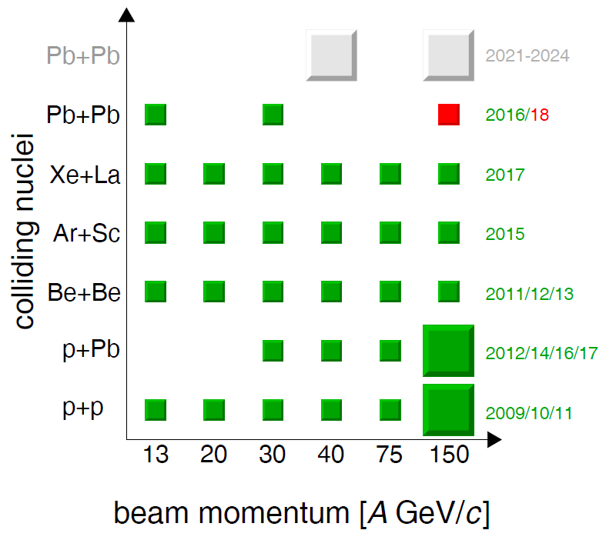
Figure 1: NA61/SHINE data taking
The authors of the project underline the following important physics results obtained by the experiment:
- Observation of a rapid change of the system size dependence of hadron production properties – the onset of fireball;
- Reduction of systematic uncertainties of the T2K final results by a factor of about 2,
- Precise investigation of mechanisms for muon production in ultra-high energy cosmic ray showers in the air.

The physics program of the NA61/SHINE extension includes the following measurements:
- Charm hadron production in Pb+Pb collisions for heavy ion physics;
- Nuclear fragmentation cross sections for cosmic ray physics;
- Hadron production in hadron-induced reactions for neutrino physics.

The JINR group contributions and responsibilities are:
- Maintenance and operation of TOF-L/R detectors;
- TOF-L/R data calibration;
- R&D for TOF based on MRPC;
- Software developments and maintenance of the software library;
- Raw data reconstruction and DST production;
- Data analysis.

The JINR group plans to work on the following physics studies:
- Production of light nuclei in nuclear interactions since formed near the freeze-out and may provide information on the space-time structure of this late stage of the collision;
- Charge dependence of particle yields and anisotropic flow harmonics in the forward rapidity region, which is sensitive to the effects induced by the strong electric and magnetic fields generated in the heavy ion collision.
- Hyperon and hypernuclei production in Ar+Sc, Xe+La, Pb+Pb interactions to improve our knowledge on the strange particle-nucleus interaction in a many body environment.

During the latest session of SPSC on 08/06/2018 the Committee decided to allocate beam time after the long shutdown LS2: “The SPSC recognises the broad interest of the NA61 physics program after Long Shutdown LS2 as outlined in the addenda CERN-SPSC-P-330-ADD10/11. The Committee recommends approval of beam times in 2021 for detector commissioning with hadron beams, for the measurement of hadron production with the T2K target with proton beams, and for the measurement of open charm production with Lead ion beams.”

In addition the upgrade of the TOF system has obtained financial support from the JINR Directorate to speed up the tests and the commissioning of the TOF detectors for NICA using beams at CERN.

The reviews of the referees V.V.Burov and I.A.Tyapkin are positive and support the requested extension. They underline the quality of the physics program, the fact that NA61/SHINE studies are complementary to the studies being carried out at the Nuclotron (JINR), RHIC (BNL) and that the obtained experimental results are needed for planning the research at the acceleration complexes of NICA (JINR) and FAIR (GSI). In addition the referees point to the modest financial requests fully justified by the expected results. The participation in NA61 is considered as a significant contribution to the development of the long-term research programs in the field of heavy ion relativistic physics at JINR in Dubna. The referees note that the present proposal takes into account the recommendations of the 47th JINR РАС meeting.

I am very satisfied with the overall structure of the project and the way the PAC recommendations have been implemented. I completely agree with the opinion of both referees and propose to extend the JINR participation in the NA61/SHINE experiment in 2019-2021.

Peter Hristov
17/06/2018

