Status of the Factory of Superheavy Elements

I. Kalagin, A. Popeko, and V. Utyonkov

- DC-280 cyclotron
The construction of the basic configuration of Factory of Superheavy Elements (SHE) was completed. The building of the SHE Factory was construction. The automated system for radiation control and extra large integral systems are currently being adjusted, and the works on their connection with the automated cyclotron control system are also approaching the final phase. The commission of the Rostechnadzor (Federal Environmental, Industrial and Nuclear Supervision Service of Russia) inspected the building of the SHE Factory in October 2018. The documentation is now being prepared for the receipt of a Statement of Compliance and the Rostechnadzor permit for the commissioning of the building. The documentation is ready to be sent to the FMBA (Federal Biomedical Agency) of Russia to obtain a permit for integrated commissioning works with the acceleration of the ion beam at the DC-280 cyclotron (Fig. 1) and to prepare a sanitary and epidemiological conclusion for the approval of works at the DC-280 cyclotron. The autonomous commissioning of the cyclotron systems was performed, and the integrated commissioning works without the acceleration of the ion beam began at the DC-280 cyclotron. The acceleration of the ion beam and dosimetric measurements both inside and outside of the building necessary to apply for the sanitary and epidemiological conclusion will begin upon the receipt of the permit from the FMBA of Russia.
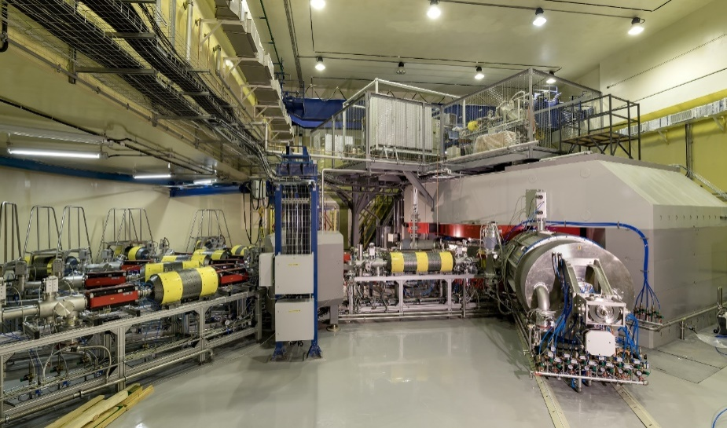
Fig. 1. Cyclotron DC-280
- Separators
The first experimental facility, aimed at continuing study of the superheavy nuclei at the SHE Factory, is a new gas-filled separator DGFRS-2.The separator was designed in FLNR and manufactured by SIGMAPHI (France). In 2018, installation of the main components of the separator has been completed (Fig. 2).The first quadrupole lens Q₁ focuses vertically the nuclei knocked out of the target to increase the efficiency of their transport through the gap of the magnet D₁, where the products of the complete-fusion reactions (ERs) are separated from the bulk of the beam particles and the products of background reactions.The ERs are then focused by two quadrupole lenses Q₂and Q₃. The magnet D₂is installedfor additional separation of ERs from background particles.
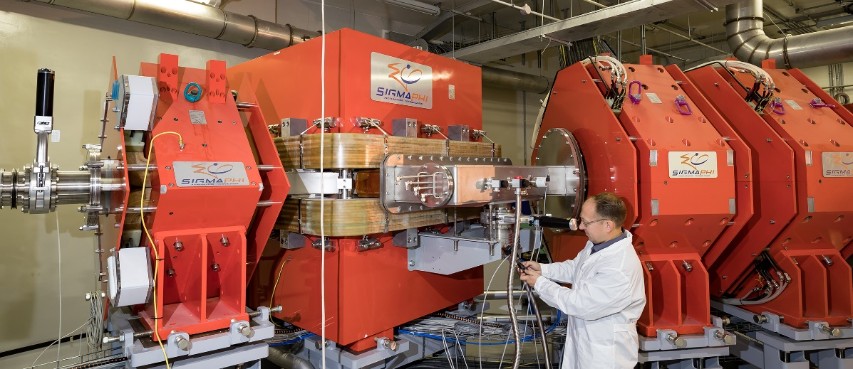
Fig. 2. Gas-filled recoil separator (DGFRS-2) at SHE Factory
Other essential components of DGFRS-2 have been designed and manufactured: these are the system of differential pumping of gas that is to provide gradient of pressurefrom 1 Torr in the separator to 10⁻⁷ Torr in the beam line together with the rotating entrance window and the target modules; at the end of the year we expectdelivery of detection system module and of the supports for the parts of the beam line and detector module.Also are mounted the power and signal cables to provide power supply and control of magnets and vacuum system of DGFRS-2, water cooling pipes are assembled and the compressed airline is brought to the setup. The test launch of magnets and parts of the differential pumping systemwas carried out. An electronic system for registration of the synthesized nuclei was developed and constructed.

- Programme of Day-1 experiments at the SHE Factory
At present, the region of known superheavy nuclei (SHN) with Z ≤118 and their α-decay descendants forms a relatively narrow “ridge” in the nuclear landscape. In order to more fully understand the role of shell stabilization in this region, it is essential to considerably extend the area of synthesized SHN which require a significant increase in the overall sensitivity of experiment.
The project of priority experiments which are planned to be performed for testing the capabilities of DGFRS-2 coupled with DC-280 will be presented. These include experiments on the production of Z=90-104 isotopes in ⁴⁸Ca- and ⁵⁰Ti-induced reactions. At this step, the image size of synthesized nuclei, their transmission and dispersion of DGFRS-2 could be measured. In the next stage, study of the ²⁴³Am+⁴⁸Ca reaction is planned to be carried out for measurement of yields of Mc isotopes with large statistics at different beam energies.First, the optimal parameters of DGFRS-2 could be determined. The sensitivity of this experiment at the maximum reaction cross section could reach about 15 decay chains per day. In addition, several issues may be clarified in these studies with large sensitivity, e.g.,the excitation-function values at low energies, registration of α decay of ²⁸¹Rg,descendant nucleus of the 2n evaporation channel, ²⁸⁹Mc, possible observation of isomeric state for ²⁷⁷Mt, level of the pxn channels and electron-capture branch for nuclei, synthesis of the still unknown ²⁸⁶Mc. The production of elements Cn and Fl in the ²⁴²Pu+⁴⁸Ca reaction with use of the chemistry setup placed behind DGFRS-2 and investigation of their chemical properties is discussed as well. These experiments could shed light on chemical properties of these elements with a yield of Fl of about 5 atoms per day. The first research experiments, including synthesis of new elements 119 and 120 in the reactions of ²⁴⁹Bk and ²⁴⁹⁻²⁵¹Cf with ⁵⁰Ti, will be also considered.Due to increased beam intensity of DC-280 cyclotron and larger transmission of DGFRS-2 the production rate of the nuclides under study could reach one event per month.

