The Project “ALICE”
(Theme 02-1-1088-2009/2019:
Investigations of interactions of heavy ions and protons at LHC collider)
extension for 2020-2022 years.

Project members:
B.V. Batyunya, A.S. Vodopyanov, A.G. Fedunov. S. Grigoryan, N.V. Gorbunov, E.M. Kislov, А.О. Kondratiev*, N.А. Kuzmin, А.V. Kuznetsov, L.V. Malinina**, K.R. Mikhaylov***, P.V. Nomokonov, Yu.P. Petukhov, V.N. Pozdnyakov, E.P. Rogochaya, G.E. Romanenko****, I.A. Roufanov, B.D. Roumyantsev, G.G. Stiforov, Yu.L. Vertogradova.
* Dubna University.
** Also Moscow State University, Institute of Nuclear Physics, Moscow.
*** Also Institute for Theoretical and Experimental Physics, Moscow.
**** Moscow State University.
Project leader A.S. Vodopyanov

Section I. Introduction
The ALICE is a multipurpose experiment to study the interactions of heavy ions, which was created to study the physics of the strongly interacting matter and the quark-gluon plasma in nucleus – nucleus collisions at the LHC. Currently, more than 1,800 specialists from 174 institutes from 42 countries are participating in this experiment.
The main efforts of the JINR group in the data analysis and the physical simulation will be focused on the study of femtoscopic (due to Bose-Einstein and final state interaction) correlations, the production light vector mesons in ultra-peripheral Pb-Pb collisions and the production of heavy quarkonia. In addition, the JINR group will continue to participate in the maintenance and development of the GRID-ALICE analysis at JINR and in modernization of photon spectrometer of the setup.

Section II. Femtoscopic correlation study.

It is believed that a compressed, highly interacting system resulting from a collision is subject to longitudinal and transverse expansion. Experimentally, such an expansion can manifest itself through Bose-Einstein correlations for pairs of identical particles or through correlations of pairs of non-identical particles due to strong interactions in the final state.
During 2017-2019, the JINR group carried out a number of different types of analysis of femtoscopic correlations of charged kaons (K^{ch}K^{ch}) in pp, p-Pb and Pb-Pb collisions at energies of 13 TeV, 2.76 TeV and 5.02 TeV (per pair of nucleons), respectively. Experience gained in previous years on methodological studies (the selection of individual particles and pairs, the identification of kaons and consideration of a background) and various Monte-Carlo event generators were used. The dependences of the femtoscopic radii on the event multiplicity (centrality) and the pair transverse momentum (kT) were studied, a comparison was made with particles of other types and predictions of theoretical models. Part of the results was presented at international conferences and published, according to some other results, research is continuing. These results were presented in more detail in the review of “ALICE” project (theme 02-1-1088 : Investigations of interactions of heavy ions and protons at LHC collider) for terms 2017-2019
The main conclusions of these results are as follows:
– A new 1-dimension femtoscopic correlation analysis was performed for pairs of non-identical K+ and K- kaons produced in Pb-Pb interactions at the energy √s_{NN} =2.76 TeV). Much attention was paid to the most accurate measurement of the purity of selected kaons using the method developed in the JINR group.
When describing the experimental results in the model of particle interaction in the final state R. Lednitsky and V. Lyuboshits, a new special choice of model parameters was used (in collaboration with R. Lednitsky). The radius of the kaon source, mass of the f0 meson, coupling constants
for the channels f0 → K K-, f0 → ππ and the ratio of different mechanisms of φ meson production are free. As a result of these studies, it was shown that the radii of sources for non-identical and identical kaon pairs coincide in magnitude with the same dependencies on centrality of events and the transverse momentum of the pair. This result is consistent with the predictions of hydrodynamic models.
– For the first time in the world, an experimental study of femtoscopic correlations of kaon pairs in
p-Pb (as in other p-A) collisions was performed. It was found that the sizes of the source of kaon emission coincided with the sizes obtained for the pp collisions with the same multiplicities of events, which differs from the results of the correlation study for pion pairs. An interesting question of the comparison with Pb-Pb collision is still open due to lack statistics.
It was also shown that the experimental results are consistent with the predictions of the EPOS hydrodynamic model, taking into account the cascade model at the hadron interactions in the final state.
The presented results were obtained during the Run1 of the LHC in the lower energies 7 TeV and 2.76 TeV (per nucleon pair) for pp and Pb-Pb collisions respectively and in lower statistics (1/3 from the full one) for p-Pb collisions. At this moment, during the Run2 of the LHC, the new data at the larger energy 13 TeV and 5.04 TeV for pp and Pb-Pb collisions respectively and at the large statistics (three time more for the p-Pb) have been prepared. These data allow to carry out new more detailed investigations of the femtoscopic correlations and their energy dependence.
The following researches are planned for 2020-2022:
– In 2020, it is planned to complete a 1-D analysis of femtoscopic correlations for kaon pairs in p-Pb and Pb-Pb collisions at energies of 5.02 and 2.76 TeV per pair of nucleons accordingly with the preparation and release of publications.
– To produce a 3-D analysis of femtoscopic correlations of kaon pairs in p-Pb and Pb-Pb stockings at energies of 5.02 TeV (per pair of nucleons) at the maximum statistics obtained at the 2nd stage of LHC operation (Run-2), respectively, 160 million and 78 million events.
– To compare the obtained results with the results of other experiments and predictions of various theoretical models: e.g., HKM, EPOS, QGSM, DPMJET.
– To produce 1-D analysis of femtoscopic correlations for identical kaon pairs in pp collisions at 13 TeV with selection of spherical and jet events. Check an indication in the absence of a dependence of R_{inv} on k_{T} pairs for spherical events, observed in the ALICE experiment for charged pions [3].
– To investigate 1-D femtoscopic correlations for non-identical K+K- pairs in p-Pb collisions at 5.02 TeV.
– In 2022, it is planned to study the possibilities of analyzing the femtoscopic correlations of pairs of φ mesons in pp interactions at 13 TeV on simulated and real events.

Section III. Study of quarkonia (J/ψ, ϒ) production in dimuon decay mode.
The physics program of ALICE includes studies of the charmonia (J/ψ, ψ(2S)) and bottomonia (ϒ family) production in p-p, p-Pb and Pb-Pb collisions. An important part of these studies is the development of MC generators for the simulation of different processes. Smbat Grigoryan, member of the ALICE JINR group, is one of the responsibles for the creation and work of the generators of heavy flavor hadrons and quarkonia in dimuon decay mode. The previously developed and continuously updated generators are used to analyze the high energy and large statistics data obtained during Run-2. A detailed results are obtained on the determination of the nuclear modification factor (R_{AA}) for ϒ(1S) and ϒ(2S) production in Pb-Pb collisions at 5.02 TeV.
The ALICE JINR group proposed a new thermal model based on the Tsallis-distribution [11] and the Blast-wave model [12]. The new model describes well the production spectra of pions and quarkonia (J/ψ, Υ) in pp collisions in a wide range of energies (5 GeV — 13 TeV).
These results were presented in more detail in the review of “ALICE” project (theme 02-1-1088 : Investigations of interactions of heavy ions and protons at LHC collider) for terms 2017-2019 with the following conclusions:
Event generators and software for analysis of heavy quarkonia production, developed with
the participation of the JINR group, provided new results which include the nuclear modification
factors for ϒ (1s) and ϒ (2s) in Pb-Pb collisions at 5.02 TeV. The obtained values agree
qualitatively and partly quantitatively with the prediction of theoretical models.
The JINR-ALICE group proposed a new thermal model based on the Tsallis distribution and the
Blast-wave model. The model describes the spectra of the resulting pions and
quarkonia (J/ψ, Υ) in p-p collisions in a wide energy range (5 GeV - 13 TeV) and can be used to
analyze the experimental results.

This activity is important point in the ALICE and the JINR plans for 2020-2022 years are as follows:
– take part in maintenance and updating of the software for quarkonia production and the generator
of hadrons with heavy flavors, using the latest results of LHC experiments and new theoretical
developments;
– work on the interpretation of results on quarkonia production in p-p, Pb-Pb and p-Pb collisions;
– prepare a version of the phenomenological thermal model based on Tsallis distributions to
describe of experimental data for various hadrons (from pions to quarkonia) formed in p-A and AA
collisions.

Section IV. Study of ultra-peripheral heavy-ion collisions.
Ultra-relativistic heavy ions are the source of a strong (~Z²) electromagnetic field – a flux of quasi-real photons in the framework of the Weizsäcker-Williams approach [15]. In the case of large (> sum of radii) the impact parameters of the colliding ions, interactions are called ultra-peripheral collisions (UPC). In such interactions a photoproduction of vector mesons can occur — the photon of the field of one nucleus fluctuates into a bound quark-antiquark pair, which is then elastically scattered on the other nucleus through the exchange of pomeron. During 2017-2019, the JINR-ALICE group participated in studies of the production of the single vector mesons (photon-pomeron interactions) J/ψ and ρ⁰ in Pb-Pb ultra-peripheral collisions at energy of 5.02 TeV (per pair of nucleons). A process can proceed on the nucleus as a whole (coherent photoproduction) or on the nucleon of a nucleus (incoherent process).
These results were presented in more detail in the review of “ALICE” project (theme 02-1-1088 : Investigations of interactions of heavy ions and protons at LHC collider) for terms 2017-2019 with the following conclusions:
Using the large statistics of 2015-2018 data, the differential cross section for coherent J/ψ production in Pb-Pb ultra-peripheral collisions at energy of 5.02 TeV was measured. The experimental data are described by theoretical models with a moderate gluon shadowing.
The differential cross section for coherent ρ⁰ photoproduction was measured in ultra-peripheral Pb-Pb collisions with the data collected in 2015 at energy of 5.02 TeV. The agreement of experimental results with the prediction of a number of theoretical models is found.
A preliminary result obtained in the analysis of four pion final state expresses ρ⁰(1450) resonance production and a detailed study of the characteristics of the observed resonance on the full statistics is planned.
Taking into account the large statistics obtained during the Run2 of the LHC the following investigations are planned in 2020-2022 years:
– complete the study of the coherent J/ψ production (with maximal statistics) and ρ⁰ (on statistics of 2015) in Pb-Pb collisions at 5.02 TeV with the preparation and release of publications;
– with whole statistics of Pb-Pb data at 5.02 TeV, analyze the coherent and incoherent photoproduction of ρ⁰ and the incoherent photoproduction of J/ψ;
– carry out the analysis of the four-pion events to measure parameters of ρ⁰ (1450) resonance;
– measure the photoproduction cross section of ρ⁰ in p-Pb collisions at 5.02 TeV and compare it with the results of experiments at the HERA collider;
– start analysis of the pair production of vector mesons in two-photon interactions with an emphasis on the search for ρ⁰+J/ψ states.
Section V. Maintenance and development of the ALICE-GRID system at JINR
In the period from 2017–2019, software, computing nodes and data storage systems were updated at JINR, as well as testing of new software xrootd, EOS, CVMFS.
Figure 1 shows the relative contributions of Russian institutions to the number of calculated tasks in the GRID system in 2018. It shows that among second-level computer centers (tier-2), JINR takes the leading position (15.8%). The total contribution of Russian centers to ALICE-GRID is 5.7%, as can be seen from Fig.2.
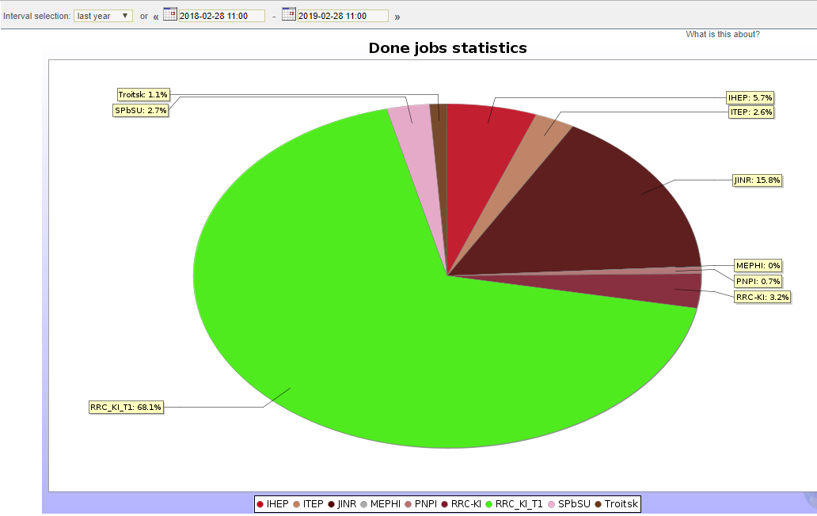

Fig.1. The relative contributions of Russian institutions to the number of calculated tasks in the GRID system in 2018 (from a total contribution of 5.7% to ALICE-GRID).

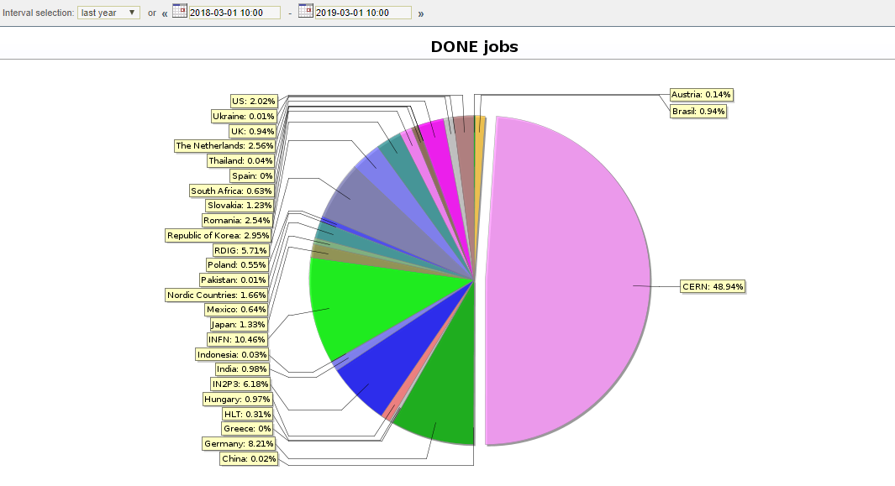

Fig.2. The relative contributions of all institutions to the number of calculated tasks in the ALICE-GRID system in 2018.

The GRID JINR activity in 2020-2022 years is necessary in the ALICE and the JINR plays are follows:
- maintenance the GRID structure of the ALICE experiment in JINR, transition to new software, regular replacement of obsolete computing nodes and storage systems by new ones;
- participation in the implementation of the project on the use of supercomputer capacity and in the development of other GRID technologies in ALICE;
- support for stable functioning of the local cluster.

Section VI. CONCLUSION

The overall full time equivalent for the project is FTE = 14.5.

